Production of synthetic wheat lines to exploit the genetic diversity of emmer wheat and D genome containing Aegilops species in wheat breeding

Ghader Mirzaghaderi^{1*}, Zinat Abdolmalaki¹, Rahman Ebrahimzadegan¹, Farshid Bahmani¹, Fatemeh Orooji¹, Mohammad Majdi¹, Ali-Akbar Mozafari²
* Corresponding author (Email: gh.mirzaghaderi@uok.ac.ir)
¹ Department of Agronomy and Plant Breeding, Faculty of Agriculture, University of Kurdistan, P. O. Box 66177–15175, Sanandaj, Iran
² Department of Horticultural Sciences, Faculty of Agriculture, University of Kurdistan, P. O. Box: 416, Sanandaj, Iran

Supplementary file

Correlations between morphological traits of emmer wheat genotypes. Range of each trait (min. and max.) based on mean data has been shown at the bottom of figure.

Clustered heat map of the standardized data from morphological traits showing differences between the emmer wheat genotypes which were used in the crosses with Ae. tauschii.

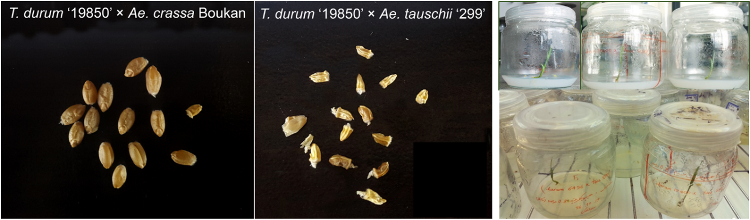
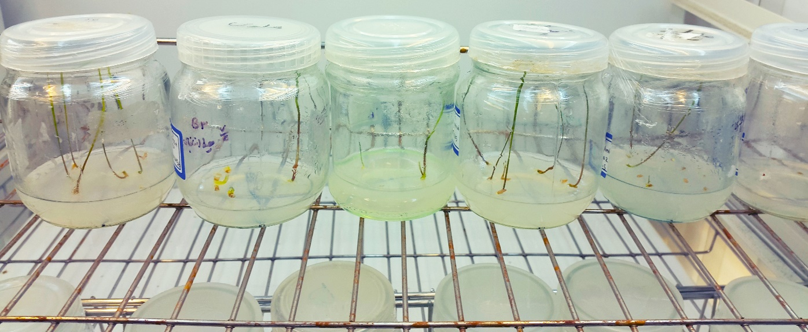

F₁ seeds from crosses between tetraploid wheat and Aegilops species. Most of the F₁ seeds from wheat and Ae. tauschii crosses lacked endosperm and required embryo rescue to germinate. On the other hand, most of the seeds from crosses between tetraploid Aegilops species (e.g. Ae. crassa) as female parents and wheat as male parents were plumped seeds that contained endosperm.

FISH using GAA-oligonucleotide probes and C-banding on accession 49667 of T. dicoccum showing a general agreement in banding patterns.

Spike morphology of a sample of amphiploids or BC₁ lines from crosses between tetraploid wheat and Aegilops (Ae. tauschii, Ae. crassa, Ae. ventricosa and Ae. cylindrica) genotypes. 1: F₂ (T. durum ‘78’ × Ae. tauschii ‘600’); 2: F₂ (Ae. crassa ‘Bookan × T. durum ‘14’); 3: F₂ (T. durum ‘1477’ × Ae. tauschii ‘299’); 4: F₂ (T. durum ‘12595’× Ae. tauschii ‘13939’); 5: F₁ (T. dicoccum ‘IG-88753’ × Ae. tauschii ‘299’); 6: F₁ (T. timopheevii ‘131212’ × Ae. tauschii ‘1548’; 7, 9: F₁ (T. dicoccum ‘IG-127691’ × Ae. tauschii ‘299’); 8: F₁ (T. dicoccum ‘49666’ × Ae. tauschii ‘1211’); 10: F₁ (T. dicoccum ‘Tirgaran’× Ae. tauschii ‘1211’); 11: F₁ (T. dicoccum ‘Bainjub’ × Ae. tauschii ‘1211’); 12: F₁ (T. dicoccum ‘Tirgaran’×At‘299’); 13: F₁ (Ae. crassa ‘Bookan’× T. dicoccum ‘Tirgaran’); 14: F₂ (Ae. crassa ‘Sanandaj’× T. durum ‘6268’); 15: F₂ (Ae. crassa ‘1873’× T. durum ‘40’); 16: F₂ (Ae. crassa ‘Bookan’× T. durum ‘6268’); 17: F₂ (Ae. cylindrica ‘l236’× T. durum ‘17’).

A) F₁ ybrid plants from crosses between T. durum ‘40’ as female parent with Ae. crassa (A), Ae. cylindrica (B) and Ae. tauschii (C) as male parents. In cases A and B, a representative picture from its microspores shows both reduced (unviable) and unreduced (bigger and stainable) microspores. The hybrid plants from crosses between T. durum ‘40’ as female parent and Ae. cylindrica as male parent were sterile. The corresponding picture from their microspores indicates lack of viable pollen and compete sterility in this hybrid type.

Acetocarmine stained mitotic metaphase chromosome spreads in nine different cells belonging to a single Ae. cylindrica ‘236’-T. durum ‘17’ amphiploid plant with D^{c}D^{c}C^{c}C^{c}AABB genome. All the spreads show 55 chromosomes indicating deletion of a single chromosome in this monosomic genotype.

Acetocarmine stained mitotic metaphase chromosome spreads in Ae. ventricosa -T. turgidum amphiploids. A-F) Six different cells of a single Ae. ventricosa ‘1511’-T. turgidum ‘13’ amphiploid plant all showing 54 chromosomes. G-L) Six different cells of a single Ae. ventricosa ‘AE 357’-T. turgidum ‘11’ amphiploid plant all showing 53 chromosomes.

DAPI stained mitotic metaphase chromosome spreads of four different Ae. crassa- T. durum amphiploids show 2n = 8x = 56 chromosomes. A) Ae. crassa ‘Bookan × T. durum ‘14’, B) Ae. crassa ‘Sanandaj’× T. durum ‘6268’, C) Ae. crassa ‘TA1873’× T. durum ‘40’, D) Ae. crassa ‘TA1874’× T. durum ‘6268’.

