Supplement Figures

Persistence of pdm2009-H1N1 internal genes of swine influenza in pigs, Thailand

Chanakarn Nasamran^{1,2}, Taveesak Janetanakit^{1,2}, Supasama Chiyawong^{1,2},
Supanat Boonyapisitsopa^{1,2}, Napawan Bunpapong^{1,2} , Duangduean Prakairungnamthip^{1,3},

Aunyaratana Thontiravong^{1,3}, Alongkorn Amonsin^{1,2*}

Author affiliations:
¹ Center of Excellence for Emerging and Re-emerging Infectious Diseases in Animals,
Faculty of Veterinary Science, Chulalongkorn University, Bangkok, Thailand
² Department of Veterinary Public Health, Faculty of Veterinary Science, Chulalongkorn University, Bangkok, Thailand
³ Department of Microbiology, Faculty of Veterinary Science, Chulalongkorn University, Bangkok, Thailand

*Corresponding author: Professor Dr. Alongkorn Amonsin
Mailing address: Department of Veterinary Public Health, Faculty of Veterinary Science, Chulalongkorn University, Bangkok, Thailand 10330
Phone: +66 2218 9578 Fax: +66 2218 9577
E-mail: Alongkorn.a@chula.ac.th

Supplement Figures
Supplement Figure 1. Phylogenetic tree of PB2 gene of S-IAV-H1N1 and S-IAV-H3N2. Circles indicate S-IAV-H1N1 isolated in this study. The phylogenetic tree was generated by neighbor- joining method with Kimura 2-parameter with 1,000 bootstrap replicates and Beast program with Bayesian Markov chain Monte Carlo (BMCMC) with 50,000,000 generations and an average standard deviation of split frequencies <0.05. Bootstrap value (>70% %) and posterior probability (>0.70) values are shown on branches to support tree topology.
Supplement Figure 2. Phylogenetic tree of PB1 gene of S-IAV-H1N1 and S-IAV-H3N2. Circles indicate S-IAV-H1N1 isolated in this study. The phylogenetic tree was generated by neighbor- joining method with Kimura 2-parameter with 1,000 bootstrap replicates and Beast program with Bayesian Markov chain Monte Carlo (BMCMC) with 50,000,000 generations and an average standard deviation of split frequencies <0.05. Bootstrap value (>70% %) and posterior probability (>0.70) values are shown on branches to support tree topology.
Supplement Figure 3. Phylogenetic tree of PA gene of S-IAV-H1N1 and S-IAV-H3N2. Circles indicate S-IAV-H1N1 isolated in this study. The phylogenetic tree was generated by neighbor- joining method with Kimura 2-parameter with 1,000 bootstrap replicates and Beast program with Bayesian Markov chain Monte Carlo (BMCMC) with 50,000,000 generations and an average standard deviation of split frequencies <0.05. Bootstrap value (>70% %) and posterior probability (>0.70) values are shown on branches to support tree topology.
Supplement Figure 4. Phylogenetic tree of NP gene of S-IAV-H1N1 and S-IAV-H3N2. Circles indicate S-IAV-H1N1 isolated in this study. The phylogenetic tree was generated by neighbor- joining method with Kimura 2-parameter with 1,000 bootstrap replicates and Beast program with Bayesian Markov chain Monte Carlo (BMCMC) with 50,000,000 generations and an average standard deviation of split frequencies <0.05. Bootstrap value (>70% %) and posterior probability (>0.70) values are shown on branches to support tree topology.
Supplement Figure 5. Phylogenetic tree of M gene of S-IAV-H1N1 and S-IAV-H3N2. Circles indicate S-IAV-H1N1 isolated in this study. The phylogenetic tree was generated by neighbor- joining method with Kimura 2-parameter with 1,000 bootstrap replicates and Beast program with Bayesian Markov chain Monte Carlo (BMCMC) with 50,000,000 generations and an average standard deviation of split frequencies <0.05. Bootstrap value (>70% %) and posterior probability (>0.70) values are shown on branches to support tree topology.
Supplement Figure 6. Phylogenetic tree of NS gene of S-IAV-H1N1 and S-IAV-H3N2. Circles indicate S-IAV-H1N1 isolated in this study. The phylogenetic tree was generated by neighbor- joining method with Kimura 2-parameter with 1,000 bootstrap replicates and Beast program with Bayesian Markov chain Monte Carlo (BMCMC) with 50,000,000 generations and an average standard deviation of split frequencies <0.05. Bootstrap value (>70% %) and posterior probability (>0.70) values are shown on branches to support tree topology.

Supplement Figure 1.
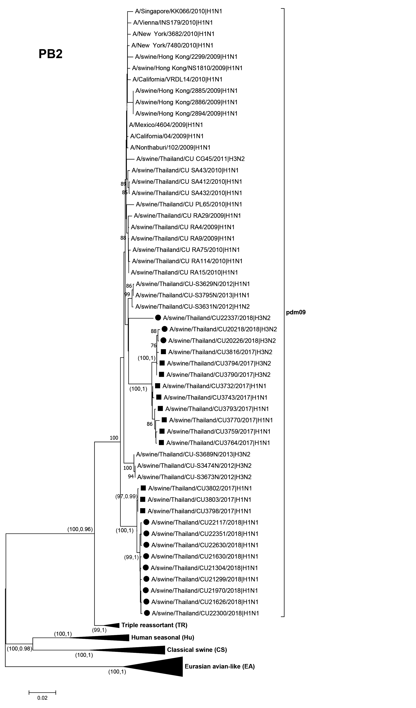

Supplement Figure 2.
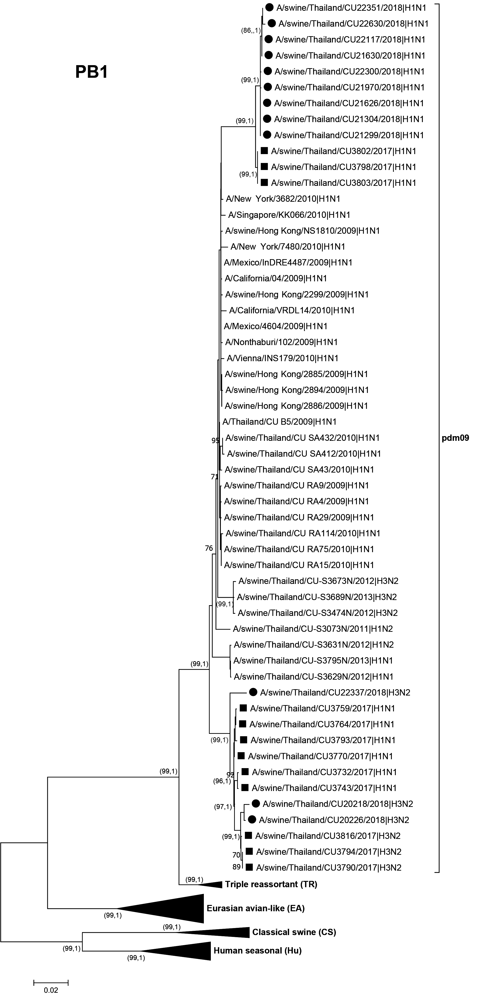
Supplement Figure 3.
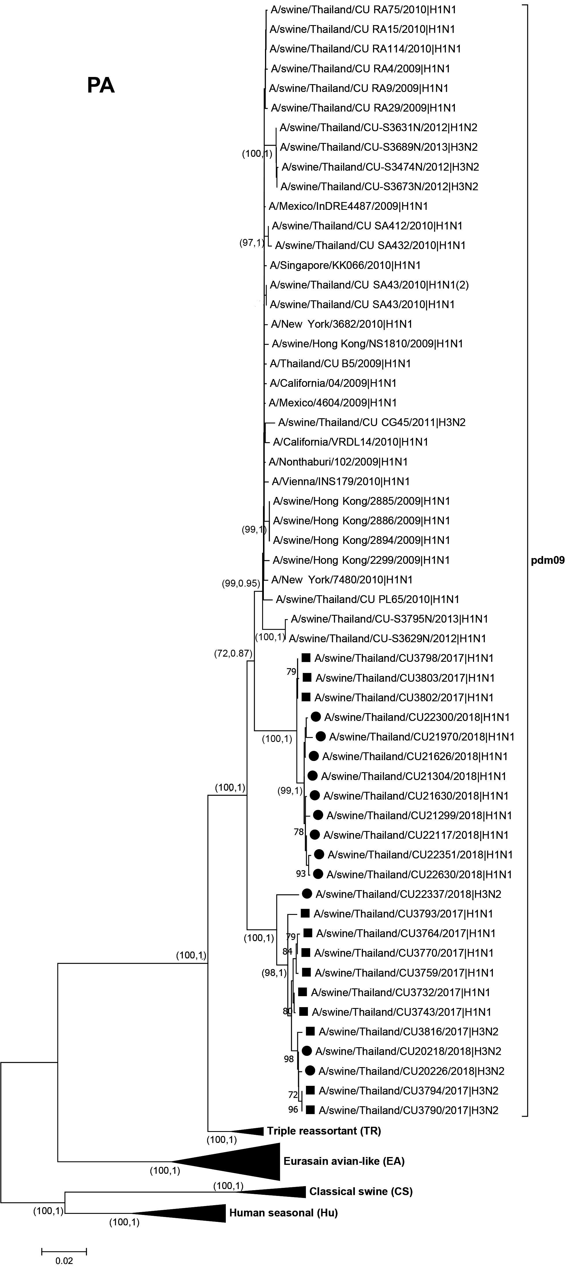
Supplement Figure 4.
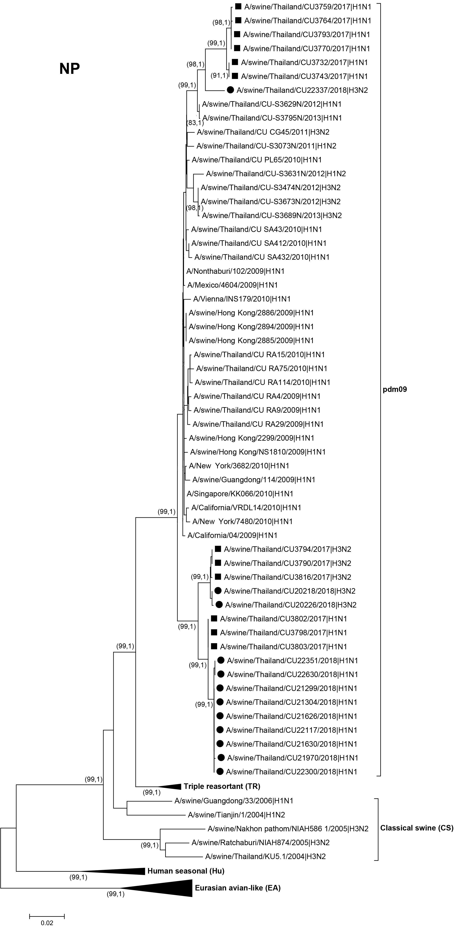
Supplement Figure 5.
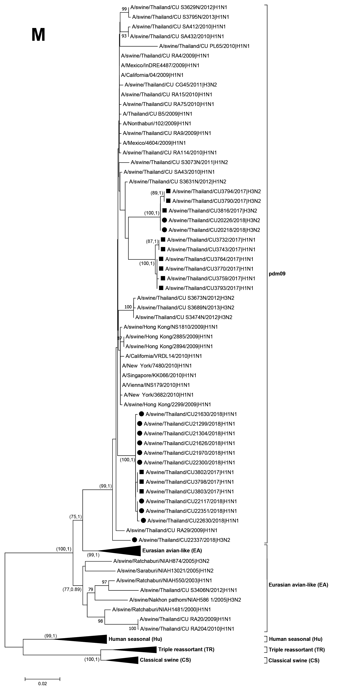
Supplement Figure 6.
