Supplementary Material

Temporal lung changes on thin-section CT in patients with COVID-19 pneumonia

Zhiyan Zhang^{1#}, Runhui Tang^{1#}, Heyang Sun², Haiyang Dai¹, Kangyin Chen¹, Xinmiao Ye¹, Wei Ye¹, Shengkai Li¹, Bowen Lan^{1*}, Li Li^{3*}, Chun-Quan Ou^{3†}

¹ Department of Medical Imaging, The Central People’s Hospital of Huizhou, No. 41, Eling Road North, Huicheng District, Huizhou, 516001, Guangdong Province, China
² Department of Urinary Surgery, The Central People’s Hospital of Huizhou, No. 41, Eling Road North, Huicheng District, Huizhou, Guangdong Province, China
³ State Key Laboratory of Organ Failure Research, Department of Biostatistics, Guangdong Provincial Key Laboratory of Tropical Disease Research, School of Public Health, Southern Medical University, No. 1023, Shatai Road South, Baiyun District, Guangzhou, 510515, Guangdong Province, China

# Joint first authors

* Joint corresponding authors:
Li Li, email: lylygdsg@163.com
Bowen Lan, email: lanbowenbw@163.com

† Senior author
Supplementary Material Figure S1. Boxplots of total CT scores across different groups used in the sensitivity analysis. We classified total CT scans into four groups (Groups 1-4) based on the dates on which the CT scans were obtained at the 1st, 2nd, 3rd week or long than three weeks after illness onset. Thick lines and red points in boxes indicate medians and means of scores, respectively. Lower and upper bounds of boxes represent the 1st (Q1) and 3rd quartiles (Q3) of total CT scores. IQR=Q3-Q1. Thin lines located outside boxes are the minimum total CT scores and the smaller of the maximum total CT scores and Q3+1.5IQR. Circles were used to indicate values outside the ranges between Q1-1.5IQR and Q3+1.5IQR.

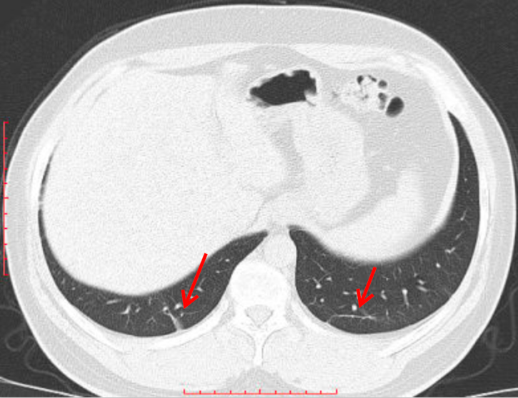

Supplementary Material Figure S2. Image of a CT scan showing fibrous stripes.

Supplementary Material Figure S3. Histograms of age and total CT scores on admission and durations of hospitalization of the 45 follow-up patients.

Supplementary Material Table S1. Features of thin-section CT scans of patients with coronavirus disease 2019 (COVID-19) pneumonia in the sensitivity analysis.
Variable | All scans (n=127) | Group 1 (n=19) | Group 2 (n=35) | Group 3 (n=42) | Group 4 (n=31) | P
Time from illness onset to CT  examination – days |  |  |  |  |  | <0.001
Median (IQR) | 16.0 (10.5–21.0) | 6.0 (3.5– 7.0) | 11.0 (10.0–13.5) | 18.0 (16.0–20.0) | 27.0 (24.0–33.5)
Mean ± SD | 16.9 ± 8.9 | 5.1 ± 2.1 | 11.4 ± 2.1 | 17.9 ± 2.1 | 29.1 ± 6.7
Lung lobes involved – no./total no. (%) |  |  |  |  |  | <0.001
Single lobe | 13/127 (10.2) | 4/19 (21.1) | 3/35 (8.6) | 2/42 (4.8) | 4/31 (12.9)
Multiple lobes | 114/127 (89.8) | 15/19 (78.9) | 32/35 (91.4) | 40/42 (95.2) | 27/31 (87.1)
Lung involvement – no./total no. (%) |  |  |  |  |  | 0.057
Left | 5/127 (3.9) | 0/19 (0.0) | 1/35 (2.9) | 2/42 (4.8) | 2/31 (6.5)
Right | 6/127 (4.7) | 3/19 (15.8) | 3/35 (8.6) | 0/42 (0.0) | 0/31 (0.0)
Left & right | 116/127 (91.3) | 16/19 (84.2) | 31/35 (88.6) | 40/42 (95.2) | 29/31 (93.5)
Distribution – no./total no. (%) |  |  |  |  |  | 0.349
Pure peripheral | 59/127 (46.5) | 11/19 (57.9) | 12/35 (34.3) | 17/42 (40.5) | 19/31 (61.3)
Pure peribronchovascular | 16/127 (12.6) | 2/19 (10.5) | 7/35 (20.0) | 5/42 (11.9) | 2/31 (6.5)
Peripheral & peribronchovascular | 28/127 (22.0) | 5/19 (26.3) | 9/35 (25.7) | 10/42 (23.8) | 4/31 (12.9)
Diffuse | 24/127 (18.9) | 1/19 (5.3) | 7/35 (20.0) | 10/42 (23.8) | 6/31 (19.4)
Imaging features – no./total no. (%)
Ground-glass opacities | 93/127 (73.2) | 16/19 (84.2) | 27/35 (77.1) | 32/42 (76.2) | 18/31 (58.1) | 0.021
Halo sign | 10/127 (7.9) | 4/19 (21.1) | 4/35 (11.4) | 2/42 (4.8) | 0/31 (0.0) | -
Reversed halo sign | 9/127 (7.1) | 2/19 (10.5) | 3/35 (8.6) | 3/42 (7.1) | 1/31 (3.2) | -
Interlobular septal thickening | 42/127 (33.1) | 6/19 (31.6) | 14/35 (40.0) | 13/42 (31.0) | 9/31 (29.0) | 0.017
Crazy-paving pattern | 20/127 (15.7) | 3/19 (15.8) | 5/35 (14.3) | 6/42 (14.3) | 6/31 (19.4) | 0.690
Air bronchogram | 20/127 (15.7) | 5/19 (26.3) | 6/35 (17.1) | 7/42 (16.7) | 2/31 (6.5) | 0.143
Consolidation | 26/127 (20.5) | 4/19 (21.1) | 10/35 (28.6) | 9/42 (21.4) | 3/31 (9.7) | 0.147
Subpleural curvilinear line | 23/127 (18.1) | 3/19 (15.8) | 8/35 (22.9) | 9/42 (21.4) | 3/31 (9.7) | 0.003
Fibrous stripes | 52/127 (40.9) | 4/19 (21.1) | 17/35 (48.6) | 20/42 (47.6) | 11/31 (35.5) | 0.001
Atelectasis | 2/127 (1.6) | 1/19 (5.3) | 1/35 (2.9) | 0/42 (0.0) | 0/31 (0.0) | -
Pleural effusion | 2/127 (1.6) | 1/19 (5.3) | 1/35 (2.9) | 0/42 (0.0) | 0/31 (0.0) | -
Pericardial effusion | 4/127 (3.1) | 0/19 (0.0) | 0/35 (0.0) | 2/42 (4.8) | 2/31 (6.5) | -
Thoracic lymphadenopathy | 3/127 (2.4) | 0/19 (0.0) | 1/35 (2.9) | 0/42 (0.0) | 2/31 (6.5) | -
Notes: We classified the scans into four groups (Group 1-4) based on the dates on which the CT scans were obtained at the 1st, 2nd, 3rd week and long than three weeks after illness onset. Continuous data were summarized as median with interquartile range (IQR) in brackets and mean ± standard deviation (SD). Categorical variables were presented as counts with percentages in brackets. The linear mixed-effects regression model was applied to compare the time from illness onset to CT examination among four groups. The mixed-effects logistic regression model was used to compare the categorical variables with two levels and with more than 10 scans showing the imaging feature. The Fisher’s exact test was applied to lung involvement and distribution.

