Supplementary Information
Manuscript title: Restoration of degraded grasslands, but not invasion by Prosopis juliflora, avoids trade-offs between climate change mitigation and other ecosystem services

Authors: Purity Rima Mbaabu^{1, 2, 3*}, Daniel Olago², Maina Gichaba², Sandra Eckert⁴, René Eschen⁵, Silas Oriaso², Simon Kevin Choge¹, Theo Edmund Werner Linders^{5,6,7}, Urs Schaffner⁵

Supplementary Figure S1. SOC per volume (g cm⁻³) for the five land cover types and four soil depth increments. Error bars indicate standard errors. The arrows represent a hypothetical transition from one land cover state to the next over time.

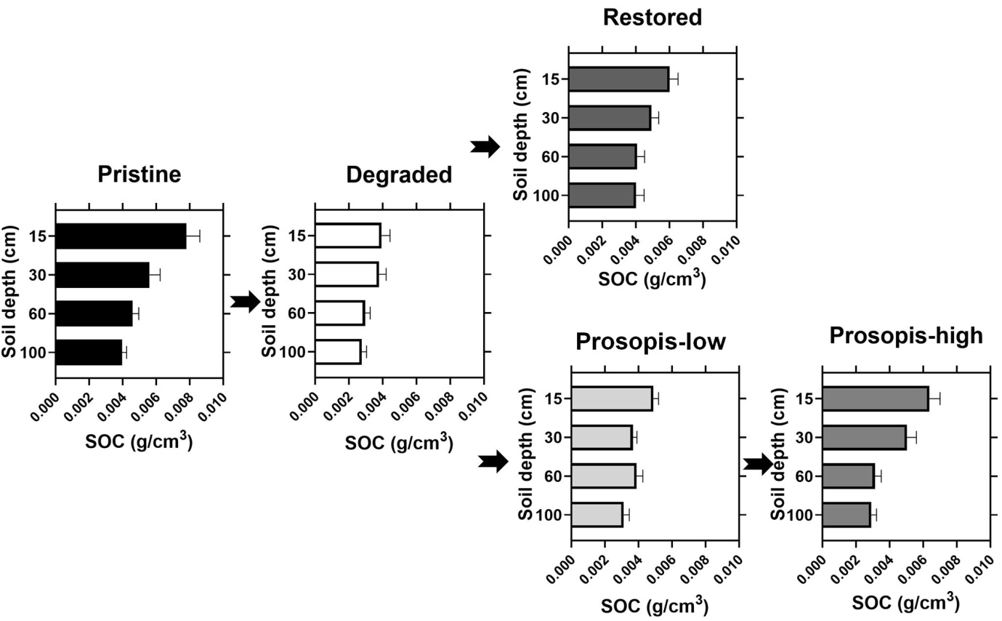

Supplementary Figure S2. Interaction effect of land cover type and soil depth on SOC concentration (%SOC).
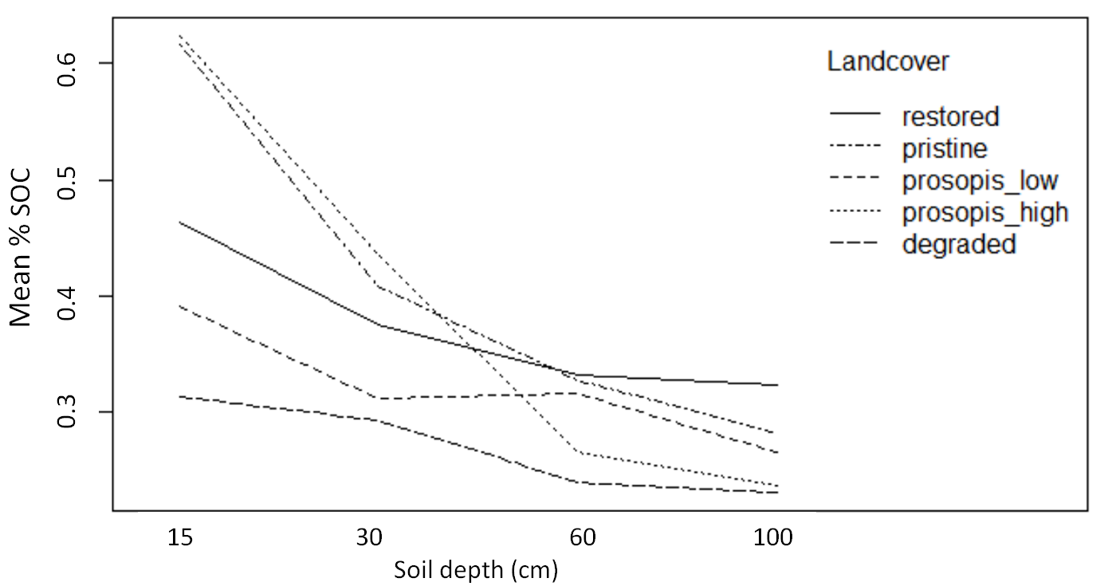

Supplementary Figure S3. Interaction effect of land cover type and soil depth on SOC per volume (SOC g cm⁻³).
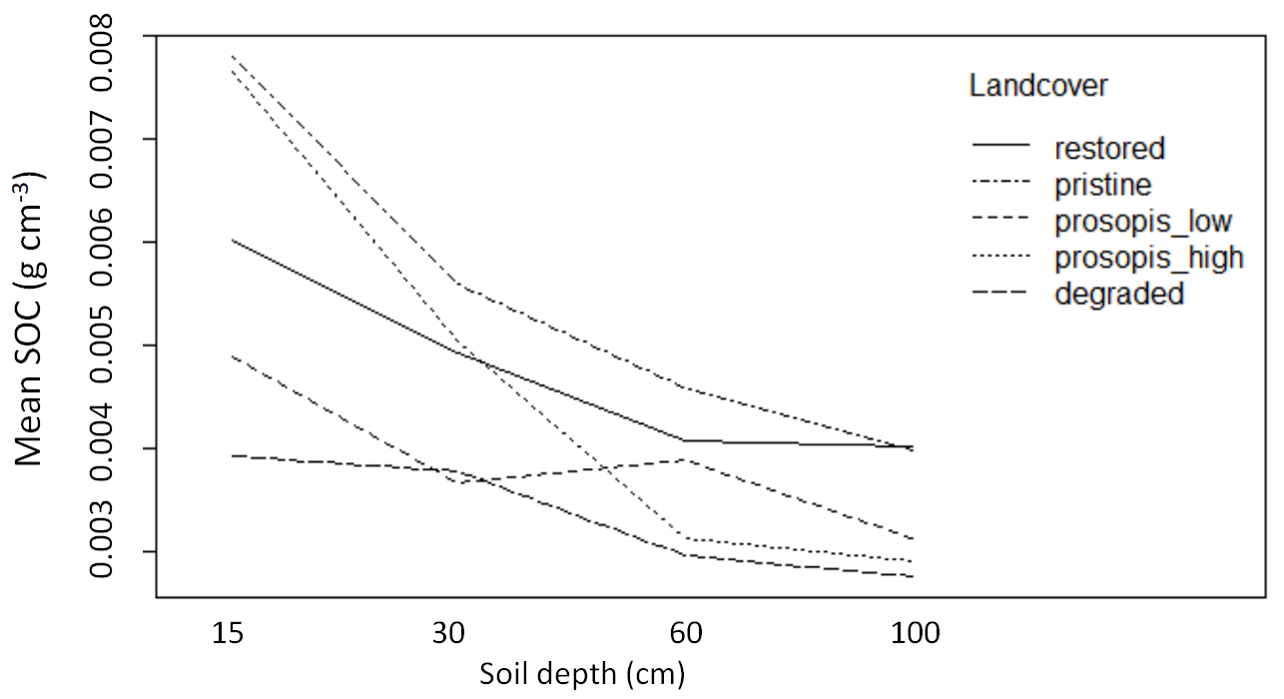

Supplementary Table S1. Effect of land cover type and soil depth on SOC concentration (%SOC). Land cover-soil depth combinations sharing the same letter do not differ significantly from each other (Tukey HSD Post-Doc test; α = 0.05).

 |  | Num DF |  | Den DF |  | F-value |  |  | p-value
(Intercept) |  | 1 |  | 174 |  | 1097.7480 |  |  | <.0001
Land cover |  | 4 |  | 58 |  | 4.8207 |  |  | 0.002
Soil depth |  | 3 |  | 174 |  | 36.6325 |  |  | <.0001
Landcover:soil depth |  | 12 |  | 174 |  | 2.2609 |  |  | 0.011
Land cover | Soil depth (cm) |  | %SOC |  | SE |  | df | lower CL |  |  | upper CL |  | Tukey  HSD
Pristine | 0-15 |  | 0.5767 |  | 0.0693 |  | 58 | 0.3953 |  |  | 0.8414 |  | f
Degraded | 0-15 |  | 0.2816 |  | 0.0267 |  | 62 | 0.2089 |  |  | 0.3796 |  | abcd
Prosopis-low | 0-15 |  | 0.3772 |  | 0.0413 |  | 58 | 0.2671 |  |  | 0.5324 |  | bcdef
Prosopis-high | 0-15 |  | 0.5648 |  | 0.0678 |  | 58 | 0.3871 |  |  | 0.8241 |  | ef
Restored | 0-15 |  | 0.4483 |  | 0.0439 |  | 58 | 0.3292 |  |  | 0.6102 |  | def
Pristine | 15-30 |  | 0.3870 |  | 0.0465 |  | 58 | 0.2652 |  |  | 0.5646 |  | bcdef
Degraded | 15-30 |  | 0.2695 |  | 0.0256 |  | 62 | 0.1999 |  |  | 0.3633 |  | abc
Prosopis-low | 15-30 |  | 0.3044 |  | 0.0333 |  | 58 | 0.2156 |  |  | 0.4297 |  | abcd
Prosopis-high | 15-30 |  | 0.3967 |  | 0.0476 |  | 58 | 0.2718 |  |  | 0.5787 |  | cdef
Restored | 15-30 |  | 0.3539 |  | 0.0347 |  | 58 | 0.2599 |  |  | 0.4817 |  | bcdef
Pristine | 30-60 |  | 0.3188 |  | 0.0383 |  | 58 | 0.2185 |  |  | 0.4652 |  | abcde
Degraded | 30-60 |  | 0.2234 |  | 0.0212 |  | 62 | 0.1657 |  |  | 0.3012 |  | ab
Prosopis-low | 30-60 |  | 0.3019 |  | 0.0331 |  | 58 | 0.2138 |  |  | 0.4262 |  | abcd
Prosopis-high | 30-60 |  | 0.2456 |  | 0.0295 |  | 58 | 0.1683 |  |  | 0.3583 |  | ab
Restored | 30-60 |  | 0.3047 |  | 0.0298 |  | 58 | 0.2238 |  |  | 0.4148 |  | abcd
Pristine | 60-100 |  | 0.2786 |  | 0.0334 |  | 58 | 0.1909 |  |  | 0.4064 |  | abcd
Degraded | 60-100 |  | 0.2101 |  | 0.0199 |  | 62 | 0.1558 |  |  | 0.2832 |  | a
Prosopis-low | 60-100 |  | 0.2504 |  | 0.0274 |  | 58 | 0.1773 |  |  | 0.3535 |  | abc
Prosopis-high | 60-100 |  | 0.2273 |  | 0.0273 |  | 58 | 0.1558 |  |  | 0.3317 |  | ab
Restored | 60-100 |  | 0.2942 |  | 0.0288 |  | 58 | 0.2161 |  |  | 0.4005 |  | abc

Supplementary Table S2. Effect of land cover type and soil depth on SOC per volume (SOC g cm⁻³). Land cover-soil depth combinations sharing the same letter do not differ significantly from each other (Tukey HSD Post-Doc test; α = 0.05).
 |  | Num DF |  |  | Den DF |  |  | F-value |  |  |  | p-value
(Intercept) |  | 1 |  |  | 174 |  |  | 25021.776 |  |  |  | <.0001
Land cover |  | 4 |  |  | 58 |  |  | 6.148 |  |  |  | 0.0003
Soil depth |  | 3 |  |  | 174 |  |  | 37.796 |  |  |  | <.0001
Land cover:soil depth |  | 12 |  |  | 174 |  |  | 1.981 |  |  |  | 0.0285
Land cover | Soil depth (cm) |  |  | SOC per  volume |  | SE |  |  | df |  | lower CL |  |  | upper CL |  |  | Tukey  HSD
Pristine | 0-15 |  |  | 0.0074 |  | 0.0009 |  |  | 58 |  | 0.0051 |  |  | 0.0109 |  |  | k
Degraded | 0-15 |  |  | 0.0035 |  | 0.0003 |  |  | 62 |  | 0.0026 |  |  | 0.0048 |  |  | abcdefghi
Prosopis-low | 0-15 |  |  | 0.0048 |  | 0.0005 |  |  | 58 |  | 0.0034 |  |  | 0.0068 |  |  | cdfhijk
Prosopis-high | 0-15 |  |  | 0.0069 |  | 0.0008 |  |  | 58 |  | 0.0047 |  |  | 0.0101 |  |  | jk
Restored | 0-15 |  |  | 0.0057 |  | 0.0005 |  |  | 58 |  | 0.0042 |  |  | 0.0078 |  |  | ijk
Pristine | 15-30 |  |  | 0.0053 |  | 0.0006 |  |  | 58 |  | 0.0036 |  |  | 0.0077 |  |  | ghijk
Degraded | 15-30 |  |  | 0.0035 |  | 0.0003 |  |  | 62 |  | 0.0026 |  |  | 0.0048 |  |  | abcdefghi
Prosopis-low | 15-30 |  |  | 0.0036 |  | 0.0003 |  |  | 58 |  | 0.0025 |  |  | 0.0051 |  |  | abcdefghi
Prosopis-high | 15-30 |  |  | 0.0047 |  | 0.0005 |  |  | 58 |  | 0.0032 |  |  | 0.0068 |  |  | efghijk
Restored | 15-30 |  |  | 0.0046 |  | 0.0005 |  |  | 58 |  | 0.0034 |  |  | 0.0063 |  |  | bdghijk
Pristine | 30-60 |  |  | 0.0044 |  | 0.0005 |  |  | 58 |  | 0.0030 |  |  | 0.0065 |  |  | abcdefghij
Degraded | 30-60 |  |  | 0.0028 |  | 0.0003 |  |  | 62 |  | 0.0021 |  |  | 0.0037 |  |  | acef
Prosopis-low | 30-60 |  |  | 0.0036 |  | 0.0004 |  |  | 58 |  | 0.0026 |  |  | 0.0052 |  |  | abcdefghi
Prosopis-high | 30-60 |  |  | 0.0029 |  | 0.0004 |  |  | 58 |  | 0.0020 |  |  | 0.0043 |  |  | abcdefgh
Restored | 30-60 |  |  | 0.0037 |  | 0.0004 |  |  | 58 |  | 0.0027 |  |  | 0.0050 |  |  | abcdefgh
Pristine | 60-100 |  |  | 0.0039 |  | 0.0005 |  |  | 58 |  | 0.0027 |  |  | 0.0057 |  |  | abcdefghij
Degraded | 60-100 |  |  | 0.0026 |  | 0.0002 |  |  | 62 |  | 0.0019 |  |  | 0.0035 |  |  | a
Prosopis-low | 60-100 |  |  | 0.0029 |  | 0.0003 |  |  | 58 |  | 0.0021 |  |  | 0.0041 |  |  | abeg
Prosopis-high | 60-100 |  |  | 0.0028 |  | 0.0003 |  |  | 58 |  | 0.0019 |  |  | 0.0040 |  |  | abcd
Restored | 60-100 |  |  | 0.0036 |  | 0.0004 |  |  | 58 |  | 0.0027 |  |  | 0.0049 |  |  | abcdefgh

Supplementary Table S3. Effect of land cover type and soil depth on bulk density (g cm⁻³). Land cover-soil depth combinations sharing the same letter do not differ significantly from each other (Tukey HSD Post-Doc test; α = 0.05).
 |  | Num DF |  |  | Den DF |  |  | F-value |  |  |  | p-value
(Intercept) |  | 1 |  |  | 174 |  |  | 11326.942 |  |  |  | <.0001
Land cover |  | 4 |  |  | 58 |  |  | 5.106 |  |  |  | 0.0014
Soil depth |  | 3 |  |  | 174 |  |  | 1.549 |  |  |  | 0.2036
Land cover:soil depth |  | 12 |  |  | 174 |  |  | 2.482 |  |  |  | 0.0051
Land cover | Soil depth (cm) |  |  | Bulk  density |  | SE |  |  | df |  | lower CL |  |  | upper CL |  |  | Tukey  HSD
Pristine | 0-15 |  |  | 1.30 |  | 0.0392 |  |  | 58 |  | 1.18 |  |  | 1.42 |  |  | abc
Degraded | 0-15 |  |  | 1.26 |  | 0.0310 |  |  | 62 |  | 1.17 |  |  | 1.36 |  |  | abc
Prosopis-low | 0-15 |  |  | 1.27 |  | 0.0358 |  |  | 58 |  | 1.16 |  |  | 1.38 |  |  | abc
Prosopis-high | 0-15 |  |  | 1.22 |  | 0.0392 |  |  | 58 |  | 1.10 |  |  | 1.35 |  |  | abc
Restored | 0-15 |  |  | 1.29 |  | 0.0320 |  |  | 58 |  | 1.19 |  |  | 1.39 |  |  | abc
Pristine | 15-30 |  |  | 1.37 |  | 0.0392 |  |  | 58 |  | 1.25 |  |  | 1.49 |  |  | bc
Degraded | 15-30 |  |  | 1.30 |  | 0.0310 |  |  | 62 |  | 1.20 |  |  | 1.40 |  |  | abc
Prosopis-low | 15-30 |  |  | 1.18 |  | 0.0358 |  |  | 58 |  | 1.07 |  |  | 1.29 |  |  | ab
Prosopis-high | 15-30 |  |  | 1.18 |  | 0.0392 |  |  | 58 |  | 1.06 |  |  | 1.31 |  |  | ab
Restored | 15-30 |  |  | 1.31 |  | 0.0320 |  |  | 58 |  | 1.21 |  |  | 1.41 |  |  | abc
Pristine | 30-60 |  |  | 1.40 |  | 0.0392 |  |  | 58 |  | 1.27 |  |  | 1.52 |  |  | c
Degraded | 30-60 |  |  | 1.25 |  | 0.0310 |  |  | 62 |  | 1.15 |  |  | 1.35 |  |  | abc
Prosopis-low | 30-60 |  |  | 1.23 |  | 0.0358 |  |  | 58 |  | 1.12 |  |  | 1.34 |  |  | abc
Prosopis-high | 30-60 |  |  | 1.16 |  | 0.0392 |  |  | 58 |  | 1.04 |  |  | 1.29 |  |  | a
Restored | 30-60 |  |  | 1.22 |  | 0.0320 |  |  | 58 |  | 1.12 |  |  | 1.32 |  |  | abc
Pristine | 60-100 |  |  | 1.40 |  | 0.0392 |  |  | 58 |  | 1.28 |  |  | 1.52 |  |  | c
Degraded | 60-100 |  |  | 1.23 |  | 0.0310 |  |  | 62 |  | 1.13 |  |  | 1.32 |  |  | abc
Prosopis-low | 60-100 |  |  | 1.17 |  | 0.0358 |  |  | 58 |  | 1.06 |  |  | 1.28 |  |  | a
Prosopis-high | 60-100 |  |  | 1.22 |  | 0.0392 |  |  | 58 |  | 1.10 |  |  | 1.35 |  |  | abc
Restored | 60-100 |  |  | 1.23 |  | 0.0320 |  |  | 58 |  | 1.13 |  |  | 1.33 |  |  | abc
Supplementary Table S4. Effect of land cover type on total SOC per unit area (t ha⁻¹). Land cover types sharing a letter are not significantly different from each other (Tukey HSD Post-Doc test; α = 0.05).
 | Df | Sum of Squares |  | Mean Square |  | F-value | p-value
Landcover | 4 | 2539 |  | 634.7 |  | 5.532 | 0.000766***
Residuals | 58 | 6654 |  | 114.7
Land cover | total SOC | SE | Asymp.LCL |  | Asymp.UCL |  | Tukey HSD
Degraded | 31.52287 | 2.677832 | 24.64416 |  | 38.40159 |  | a
Prosopis-low | 36.98844 | 3.092094 | 29.04558 |  | 44.93130 |  | ab
Prosopis-high | 40.04675 | 3.387220 | 31.34578 |  | 48.74772 |  | abc
Restored | 44.67903 | 2.765653 | 37.57473 |  | 51.78334 |  | bc
Pristine | 49.75775 | 3.387220 | 41.05678 |  | 58.45872 |  | c

Supplementary Table S5. Effect of land cover type on plant species richness (number of species plot⁻¹). Land cover types sharing a letter do not differ significantly from each other (Tukey HSD Post-Doc test; α = 0.05).

 | Df |  | Sum of Squares | Mean Square | F-value | p-value
Land cover | 4 |  | 6.245 | 1.5612 | 8.656 | <0.0001***
Residuals | 58 |  | 10.461 | 0.1804
Land cover |  | species richness | SE | Asymp.LCL | Asymp.UCL | Tukey HSD
Degraded |  | 7.23 | 0.77 | 5.50 | 9.49 | a
Restored |  | 8.59 | 0.94 | 6.48 | 11.38 | ab
Prosopis-high |  | 8.97 | 1.20 | 6.35 | 12.66 | ab
Prosopis-low |  | 12.26 | 1.50 | 8.94 | 16.79 | bc
Pristine |  | 18.21 | 2.45 | 12.90 | 25.72 | c

Supplementary Table S6. Effect of land cover type on dry herbaceous biomass (dry weight g m⁻²). Land cover types sharing a letter do not differ significantly from each other (Tukey HSD Post-Doc test; α = 0.05).
 | Df |  | Sum of Squares | Mean Square | F-value | p-value
Land cover | 4 |  | 14578 | 3644 | 33.97 | <0.0001***
Residuals | 58 |  | 6223 | 107
Land cover |  | Biomass | SE | Asymp.LCL | Asymp.UCL | Tukey HSD
Prosopis-high |  | 13.90 | 3.28 | 5.49 | 22.31 | a
Prosopis-low |  | 21.29 | 2.99 | 13.61 | 28.97 | a
Degraded |  | 23.03 | 2.59 | 16.38 | 29.68 | a
Restored |  | 46.73 | 2.67 | 39.86 | 53.60 | b
Pristine |  | 55.20 | 3.28 | 46.79 | 63.61 | b

Supplementary Table S7. Aboveground carbon stock (mean and standard deviation) expressed in tonnes per hectare for pristine, degraded, restored and Prosopis invaded areas. These were determined using dry woody Prosopis aboveground biomass (for Prosopis invaded areas) derived by applying a Prosopis-species allometric equation on the diameter (at 0.3 m from ground) of all individual Prosopis trees in randomly sampled 5x5 m subplots following the methods described by Linders et al.,¹. The Prosopis species allometric equation was developed by Linders et al.,¹ using Prosopis data from Kenya by Muturi et al.,². For grasslands and degraded areas, dry herbaceous biomass was used to estimate aboveground carbon stocks. For all land cover types, a conversion factor of 0.47 was used to convert dry aboveground biomass to carbon stocks³. For Prosopis, aboveground carbon was estimated from a subset of Prosopis-low and Prosopis-high plots where we have aboveground woody biomass data.

Land cover | n | Above-ground C (t ha⁻¹) | SD
Pristine | 10 | 6.02 | 3.17
Degraded | 16 | 0.69 | 0.81
Restored | 15 | 3.19 | 1.55
Prosopis-high | 5 | 12.46 | 6.36
Prosopis-low | 4 | 3.00 | 1.68

References

1. Linders, T. E. W. et al. The Impact of Invasive Species on Social-Ecological Systems: Relating Supply and Use of Selected Provisioning Ecosystem Services. Ecosyst. Serv. 41, 101055; https://doi.org/10.1016/j.ecoser.2019.101055 (2020).
2. Muturi, G. M., Kariuki, J. G., Poorter, L. & Mohren, G. M. J. Allometric Equations for Estimating Biomass in Naturally Established Prosopis Stands in Kenya. J. Hortic. For. 4, (4); https://doi.org/10.5897/JHF11.066 (2012).
3. IPCC. Chapter 2. Generic Methodologies Applicable to Multiple Land-Use Categories. In In: 2006 IPCC Guidelines for National Greenhouse Gas Inventories.; Eggleston, H., Buendia, L., Miwa, K., Ngara, T., Tanabe, K., Eds.; Agriculture, forestry and other land use.; IGES, Japan, 4, p 2.1-2.59 (2006).

