Plant health status effects on arbuscular mycorrhizal fungi associated with Lavandula angustifolia and Lavandula intermedia infected by Phytoplasma in France

Marie-Noëlle Binet ¹ . Camille Marchal ¹ . Justine Lipuma ². Roberto Geremia ¹ . Olivier Bagarri ³ . Bert Candaele ⁴ . Delphine Fraty ⁴ . Benjamin David ² . Sophie Perigon ¹ . Viviane Barbreau ⁵ . Bello Mouhamadou ^{1 *}

SUPPLEMENTARY MATERIALS

Table S1. Effects of the plant health status on the colonization intensity in the roots of healthy and diseased plants of L. angustifolia and L. intermedia under different agricultural practices. Values are the results of PERMANOVA and significance (***p < 0.001, **p < 0.01, *p < 0.05, ns; not significant).
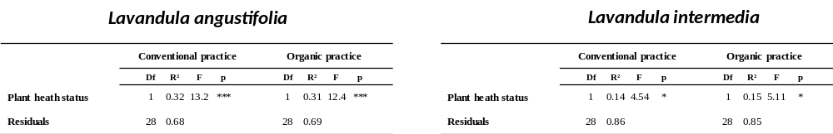

Table S2. Effects of the plant health status on the distribution of AMF in the roots of healthy and diseased plants of L. angustifolia and L. intermedia under different agricultural practices. Values are the results of PERMANOVA and significance (***P < 0.001, **P < 0.01, *P < 0.05, ns, not significant).

Lavandula augustifolia
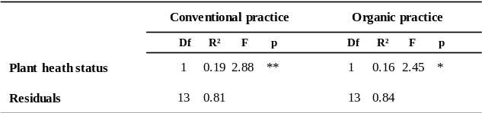

Lavandula intermedia
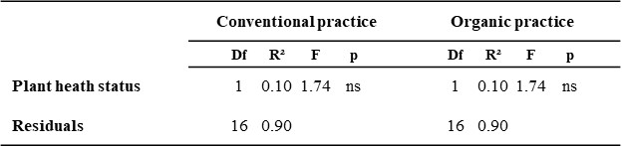
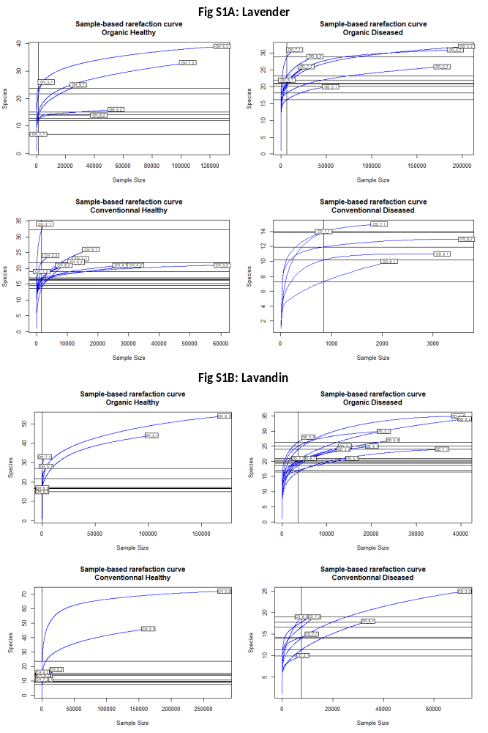
Fig. S1 Rarefaction curves from the number of sequences from L. angustifolia and L. intermedia samples

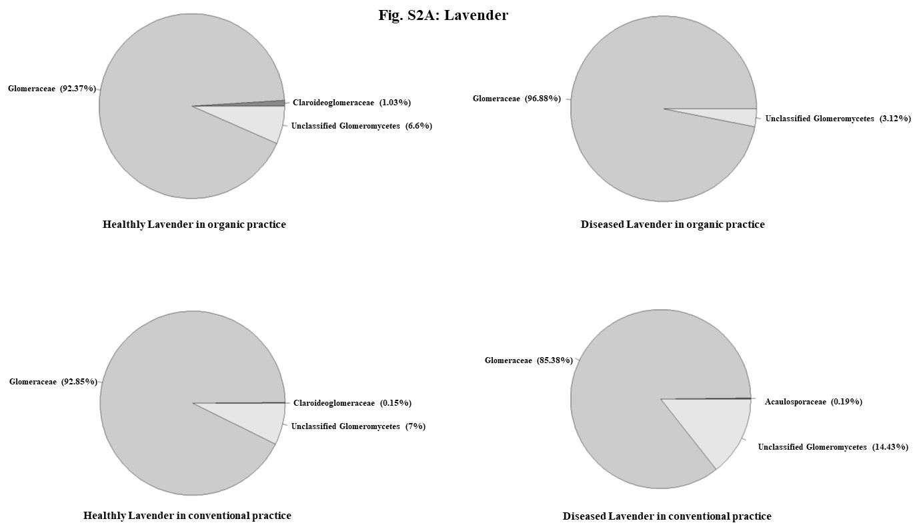

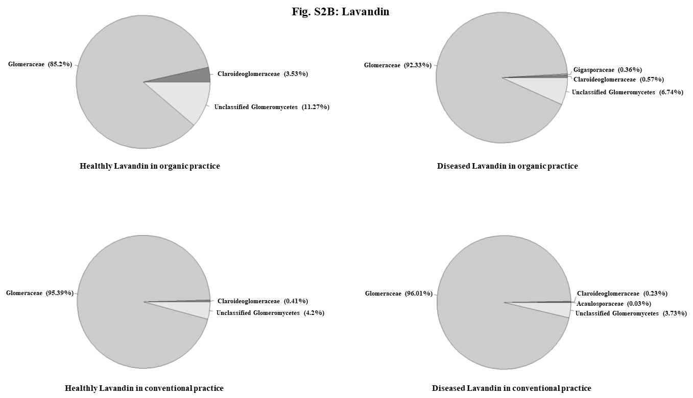

Fig. S2 Distribution of AMF communities associated to lavender and lavandin roots.

