Non-contact monitoring of the depth temperature profile for medical laser scanning technologies
AUTHORS: Kosir Jure^{1*}, Vella Daniele¹, Jezersek Matija¹
¹ Faculty of Mechanical Engineering, University of Ljubljana, Askerceva 6, Ljubljana, Slovenia

Supplementary information
Supplementary figure S1. Measurements of depth temperature profiles. For all three cycles measurement z_{max} shifts deeper into the tissue when cooling settings CS were raised from lowest to highest. (a) The sample was not sufficiently thermalized at room temperature (RT), as a result the peak temperature T_{max} increases its intensity. (b) Peak temperature T_{max} remained relatively constant, as sample was more thermalized at RT. (c) Highest thermalization of the sample at RT, T_{max} decreases its intensity and shifts deeper with increasing CS, as predicted in theory¹. (d) The penetration depth of the peak temperature z_{max} as a function of h_{t}.

Description of arbitrary function parameters

In our case, parameter B was set to a constant value of 7. Parameters A and C were incrementally increased within a control flow statement (for-loop). The outer loop incremented the parameter C from 0.1 to 2 and the inner loop incremented parameter A from 0 to 15. Both parameters were incremented by a step of 0.1. By manipulating parameters A and C of the function, the bulk temperature T_{bulk} (at z=34 mm) also changed, whereas it had to be constant for all the generated temperature distributions T_{e}(z). This effect on T_{bulk} was corrected for each T_{e}(z) generated by introducing a parameter D [°C/mm], calculated as:

 | $$D=\frac{T_{bulk_i}- T_{bulk_f}}{z_{s}}$$ | (S1)
Where T_{bulk_i} stands for the bulk temperature after the parameters A and C were modified, T_{bulk_f} for desired bulk temperature, and z_{s} for the thickness of the sample.

Estimation of DTP from in-vivo measurement

To validate the core principle of estimation method, we employed a mathematical model that best described homogeneous tissue used in validation experiments. However, considering an in-vivo procedure, the estimation of the depth temperature profile (DTP) becomes a challenge. Hence, we adopted an in-vivo study, which best corresponds with our experimental conditions of laser-tissue interaction. In a study by Milanic et al.², an estimation of DTP_{MCML} was obtained by weighted Monte Carlo photon multi-layer procedure. We adopted the corresponding surface temperature response T_{surf_in-vivo}(t), measured during the inactive period (refer to Milanic et al.², Fig. 4a), and employed it as an input to our estimation algorithm. The mathematical model, used in our validation experiments, was further advanced to a more complex in-vivo model (IVM), whereas the same arbitrary function (equation (1)) was used to generate T_{e}(z)’s. The IVM (see subsection In-vivo tissue model (IVM), equations (S2)–(S7)) was used to recalculate T_{surf_e}(t). The environmental conditions, and tissue parameters were used as reported in this study² and are listed in Table S1.
Combining the algorithm presented in Fig. 1 (of the main text) with T_{surf_in-vivo}(t), the in-vivo DTP_{INV} was estimated and compared to the DTP_{MCML}. Figure S2a shows the T_{surf_e}(t) that best fits to the real data.
The outcome of the estimation is presented in Fig. S2b. In this case the deviations between DTP_{MCML} and DTP_{INV} can be misleading, as both depth temperature profiles represent an estimation of the actual temperature distribution within the tissue. However, the shape of the estimated DTP_{inv90s} (at t_{m} = 90s ) reveales great similarity to MCML approach (Fig. S2b), which is well known to be the most used theoretical approach in this research field. From the comparison of the two DTPs we estimated a deviation of the peak temperature and position respectively, ΔT_{max}= 0.5 °C and Δz_{max}= 0.4 mm.
In Fig. S2b we include an estimation of DTP_{INV30s}, where a shorter measuring time t_{m} of 30 s was used in the data matching function. Comparing it with DTP_{MCML}, deviation in the peak was ΔT_{max}= 0.9 °C and Δz_{max}= 0.1 mm.

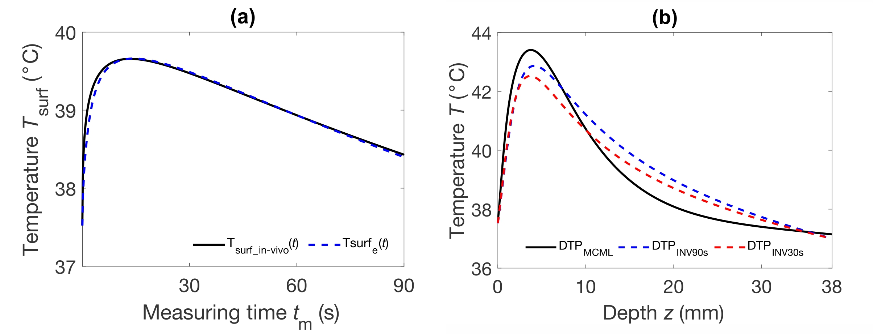
Supplementary figure S2. (a) Fitting of measured T_{surf_in-vivo}(t) to a database calculated with IVM, using measuring time of 90 s. (b) Estimated DTP_{INV90s} and DTP_{INV30s} compared to the DTP_{MCML}.

In-vivo tissue model (IVM)

For estimation of DTP in case of in-vivo measurement, we present two-layer tissue model with two planar homogeneous layers representing skin (epidermis and dermis) and fat tissue. In a living tissue, a blood perfusion also attributes to overall heat exchange³, hence this effect was introduced to the 1D equation for calculations of temperature field T(z,t) evolution. The 1D bioheat-diffusion equation now reads as follows⁴:

(S2)

Where$ρ$ stands for mass density, $c_{p}$ for specific heat of tissue, and k for thermal conductivity. In a blood perfusion term the $c_{p,b}$ represents specific heat of blood, $ω_{b}$ blood perfusion rate and T_{b} blood temperature. As the response of the vascular system to heat is temperature dependent below a certain threshold (T_{F}), and it can be modeled with a temperature dependent scaling function, introduced by Drizdal et al. ⁵:

$$F\left(T\right)=\left\{\begin{aligned} , \\ ,otherwise\end{aligned}\right.$$ | (S3)

Where $α$ accounts for the temperature depenceny of the blood perfusion rate, and $β$ represents the steepness of the blood flow change (values listed in Table S1). In study of Milanic et al. ², the interface boundary condition applied at the air–tissue boundary was modified, as radiative heat losses were attributed to heat-transfer coefficient h_{T} (10 W/m²K). Air temperature T_{air} was 21 °C. The boundary condition now reads as follows:

(S4)

At the skin-fat interface a boundary condition must also be considered. Therefore, we adopted a “conductivity matching condition” approach for finite difference scheme calculations of heat transfer problem, where a matching point lies at an interface⁶. Geometrical properties of each layer are listed in Table S1. When computing equation (S2), the following condition was applied at the boundary point:

(S5)

Where the D represents diffusion of particular layer. Subscript “b” stands for boundary, “s” for skin, and “f” for fat. The two terms in equation (S5), are given by equation (S6) and (S7):
(S6)

(S7)

Where a “b-” in subscript denotes a region left of the boundary, and “b+” the region on the right of the boundary. Δx represents a distance between the two points.
For each layer, a thermal diffusivity D ($k/ρc$) was calculated with parameters specific for each layer: $c_{skin}$=3500 (J/kgK), $c_{fat}$=2870 (J/kgK), $ρ_{skin}$=1090 (kg/m³), $ρ_{fat}$=860 (kg/m³). For our calculations, the specific heat of blood $c_{p,b}$=3800 (J/kgK)^{5, 7} and T_{b}= 37 °C were used ².

Supplementary table S1: Thermal and blood perfusion properties for in-vivo tissue model².
Layer | D (m²/s) | k (W/m²K) | d (mm) | $$α$$ | $β$ (°C²) | T_{F} (°C) | $ω_{b}$ (kg/m³s)
Skin | 1.07∙10⁻⁷ | 0.41 | 1.5 | 10 | 10 | 44 | 0.76
Fat | 1.215∙10⁻⁷ | 0.3 | 36.5 | 1 | 12 | 45 | 0.22

References
1. Milanic, M., Muc, B. T., Jezersek, M. & Lukac, M. Experimental and numerical assessment of hyperthermic laser lipolysis with 1,064 nm Nd:YAG laser on a porcine fatty tissue model. Lasers Surg. Med. 50, 125–136 (2018).
2. Milanic, M., Muc, B. T., Lukac, N. & Lukac, M. Numerical Study of Hyper-Thermic Laser Lipolysis With 1,064 nm Nd:YAG Laser in Human Subjects. Lasers Surg. Med. 51, 897–909 (2019).
3. Song, C. W., Park, H. J., Lee, C. K. & Griffin, R. Implications of increased tumor blood flow and oxygenation caused by mild temperature hyperthermia in tumor treatment. Int. J. Hyperth. 21, 761–767 (2005).
4. Pennes, H. H. Analysis of Tissue and Arterid Blood Temperatwes. J. Appl. Phys. 1, 20 (1948).
5. Dřždǎl, T., Togni, P., Víšek, L. & Vrba, J. Comparison of constant and temperature dependent blood perfusion in temperature prediction for superficial hyperthermia. Radioengineering 19, 281–289 (2010).
6. Hickson, R. I., Barry, S. I., Mercer, G. N. & Sidhu, H. S. Finite difference schemes for multilayer diffusion. Math. Comput. Model. 54, 210–220 (2011).
7. Melo, A. R., Loureiro, M. M. S. & Loureiro, F. Blood Perfusion Parameter Estimation in Tumors by means of a Genetic Algorithm. Procedia Comput. Sci. 108, 1384–1393 (2017).

