The complete chloroplast genome sequences of five pinnate-leaved Primula species and phylogenetic analyses
Wenbin Xu, Boshun Xia, Xinwei Li*
Wuhan Botanical Garden, Chinese Academy of Sciences, Wuhan 430074, China (*Corresponding author. E-mail address: forfortomorrow@163.com).

Abstract
The pinnate-leaved species (P. cicutarrifolia, P. hubeiensis, P. jiugongshanensis, P. merrilliana, P. ranunculoides and P. filchnerae) are a very particular group in the genus Primula. In the present paper, we sequenced, assembled and annotated the chloroplast genomes of five of them (P. cicutarrifolia, P. hubeiensis, P. jiugongshanensis, P. merrilliana, P. ranunculoides). The five chloroplast genomes ranged from ~ 150 to 152 kb, containing 113 genes (four ribosomal RNA genes, 29 tRNA genes and 80 protein-coding genes). The six pinnate-leaved species exhibited synteny of genes and possessed similar IR boundary regions in chloroplast genomes. The gene accD was pseudogenized in P. filchnerae. In the chloroplast genomes of the six pinnate-leaved Primula species, SSRs, repeating sequences and divergence hotspots were identified; ycf1 and trnH-psbA were the most variable markers among CDSs and noncoding sequences, respectively. Phylogenetic analyses showed that the six Primula species were separated into two distant clades: one was formed by P. filchnerae and P. sinensis and the other clade was consisting of two subclades, one formed by P. hubeiensis and P. ranunculoides, the other by P. merrilliana, P. cicutarrifolia and P. jiugongshanensis. P. hubeiensis was closely related with P. ranunculoides and therefore it should be placed into Sect. Ranunculoides. P. cicutarrifolia did not group first with P. ranunculoides but with P. merrilliana, although the former two were once united in one species, our results supported the separation of P. ranunculoides from P. cicutarrifolia as one distinct species.
Key words: Primula, chloroplast genome, phylogeny, pinnate-leaved species.

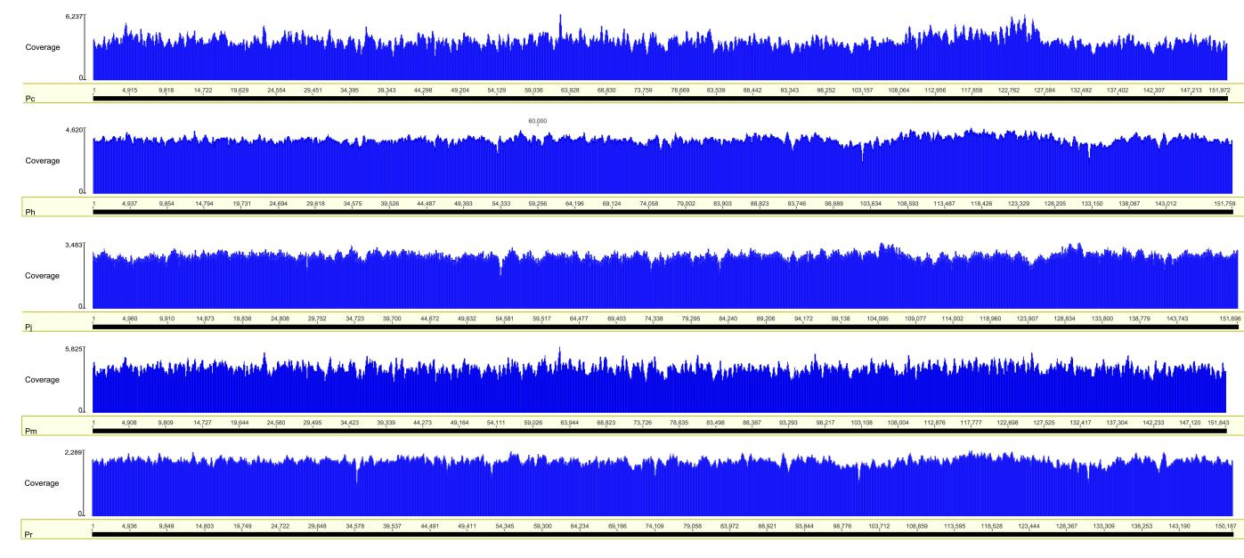
Figure S1 Sequencing coverage of the five cp genomes estimated by mapping filtered data to the five cp genomes in Geneious R9. Pc: P. cicutarrifolia; Ph: P. hubeiensis; Pj: P. jiugongshanensis; Pm: P. merrilliana; Pr: P. ranunculoides.

Figure S2 MAUVE alignment of six Primula species chloroplast genomes.

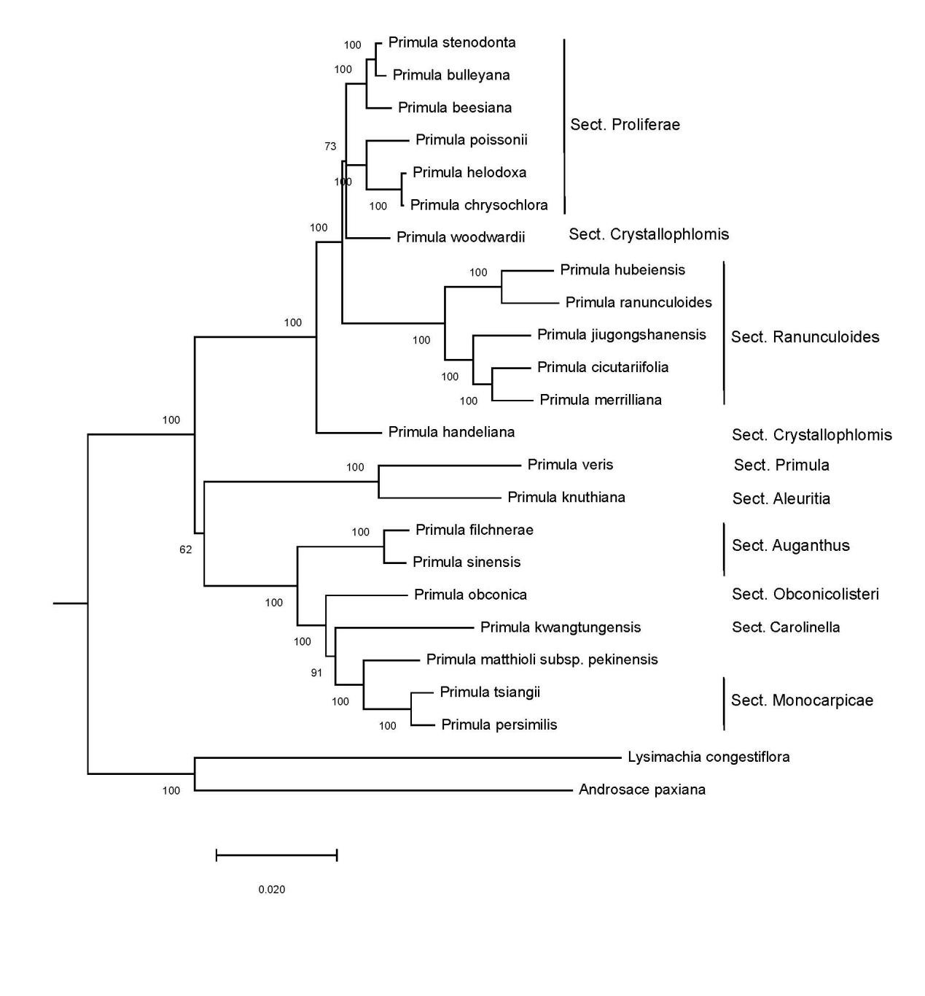
Figure S3 ML phylogenetic tree of Primula species based on the gene ycf1.

Table S1. NCBI accessions of chloroplast genomes for sequence divergence analysis and ML phylogenetic tree construction.
Species | accession
Androsace paxiana | KU513437
Lysimachia congestiflora | NC_045275
Primula beesiana | MN504639
Primula chrysochlora | NC_034678
Primula handeliana | NC_039348
Primula helodoxa | MN504640
Primula knuthiana | NC_039350
Primula kwangtungensis | NC_034371
Primula matthioli subsp. pekinensis | KY235373
Primula obconica | KX618681
Primula persimilis | NC_034331
Primula poissonii | NC_024543
Primula sinensis | NC_030609
Primula stenodonta | NC_034677
Primula tsiangii | MN065496
Primula veris | NC_031428
Primula woodwardii | NC_039349
Primula bulleyana | MN428416
Primula cicutariifolia | MT268974
Primula filchnerae | MK888698
Primula hubeiensis | MT268976
Primula jiugongshanensis | MT937162
Primula merrilliana | MT268977
Primula ranunculoides | MT268978

Table S2. NCBI accessions of gene fragments used for ML and NJ phylogenetic tree construction. Conceptions of sections and subgenera follow Hu & Kelso (1996) and Richards (2003), respectively.
Species | Subgenus | Section | rbcL | matK | ITS
Primula fasciculata | Subgenus Aleuritia | Section Aleuritia | JF943647 | JF955710 | JF977991
Primula gemmifera | Subgenus Aleuritia | Section Aleuritia | JF943651 | JF955714 | JF977994
Primula kialensis | Subgenus Aleuritia | Section Aleuritia | JF943655 | JF955718 | JF977998
Primula membranifolia | Subgenus Aleuritia | Section Aleuritia | JF943664 | JF955727 | JF978007
Primula munroi | Subgenus Aleuritia | Section Aleuritia | JF943670 | JF955733 | JF978013
Primula prattii | Subgenus Aleuritia | Section Aleuritia | JF943690 | JF955753 | JF978033
Primula pulchella | Subgenus Aleuritia | Section Aleuritia | JF943695 | JF955758 | JF978038
Primula yunnanensis | Subgenus Aleuritia | Section Aleuritia | JF943727 | JF955792 | JF978068
Primula agleniana | Subgenus Aleuritia | Section Crystallophlomis | JF943586 | JF955649 | JF977932
Primula boreio_calliantha | Subgenus Aleuritia | Section Crystallophlomis | JF943611 | JF955674 | JF977957
Primula chionantha | Subgenus Aleuritia | Section Crystallophlomis | JF943625 | JF955688 | JF977971
Primula diantha | Subgenus Aleuritia | Section Crystallophlomis | JF943637 | JF955700 | JF977983
Primula melanops | Subgenus Aleuritia | Section Crystallophlomis | JF943662 | JF955725 | JF978005
Primula szechuanica | Subgenus Aleuritia | Section Crystallophlomis | JF943720 | JF955785 | JF978063
Primula calliantha | Subgenus Aleuritia | Section Crystallophlomis | JF943618 | JF955681 | JF977964
Primula denticulata | Subgenus Aleuritia | Section Denticulata | JF943633 | JF955696 | JF977979
Primula bella | Subgenus Aleuritia | Section Minutissimae | JF943599 | JF955662 | JF977945
Primula bellidifolia | Subgenus Aleuritia | Section Muscarioides | JF943602 | JF955665 | JF977948
Primula deflexa | Subgenus Aleuritia | Section Muscarioides | JF943629 | JF955692 | JF977975
Primula calderiana | Subgenus Aleuritia | Section Petiolares | JF943615 | JF955678 | JF977961
Primula epilosa | Subgenus Aleuritia | Section Petiolares | JF943641 | JF955704 | JF977985
Primula moupinensis | Subgenus Aleuritia | Section Petiolares | JF943665 | JF955728 | JF978008
Primula ovalifolia | Subgenus Aleuritia | Section Petiolares | JF943679 | JF955742 | JF978022
Primula sonchifolia | Subgenus Aleuritia | Section Petiolares | JF943716 | JF955781 | JF978059
Primula tardiflora | Subgenus Aleuritia | Section Petiolares | JF943722 | JF955787 | JF978065
Primula anidosora | Subgenus Aleuritia | Section Proliferae | KP638648 | KP638608 | KP638568
Primula aurantiaca | Subgenus Aleuritia | Section Proliferae | HM018322 | HM018224 | HM018175
Primula beesiana | Subgenus Aleuritia | Section Proliferae | KP638651 | KP638611 | KP638571
Primula bulleyana | Subgenus Aleuritia | Section Proliferae | KP638653 | KP638613 | KP638573
Primula burmanica | Subgenus Aleuritia | Section Proliferae | KP638654 | KP638614 | KP638574
Primula chrysochlora | Subgenus Aleuritia | Section Proliferae | KP638656 | KP638616 | KP638576
Primula chungensis | Subgenus Aleuritia | Section Proliferae | HM018323 | HM018225 | HM018176
Primula cockburniana | Subgenus Aleuritia | Section Proliferae | KP638661 | KP638621 | KP638581
Primula helodoxa | Subgenus Aleuritia | Section Proliferae | HM018325 | HM018227 | HM018178
Primula mallophylla | Subgenus Aleuritia | Section Proliferae | KP638664 | KP638624 | KP638584
Primula melanodonta | Subgenus Aleuritia | Section Proliferae | KP638666 | KP638626 | KP638586
Primula miyabeana | Subgenus Aleuritia | Section Proliferae | KP638669 | KP638629 | KP638589
Primula poissonii | Subgenus Aleuritia | Section Proliferae | HM018338 | HM018240 | HM018191
Primula prenantha | Subgenus Aleuritia | Section Proliferae | KP638674 | KP638634 | KP638594
Primula pulverulenta | Subgenus Aleuritia | Section Proliferae | HM018317 | HM018219 | HM018170
Primula secundiflora | Subgenus Aleuritia | Section Proliferae | HM018352 | HM018254 | HM018205
Primula serratifolia | Subgenus Aleuritia | Section Proliferae | HM018319 | HM018221 | HM018172
Primula smithiana | Subgenus Aleuritia | Section Proliferae | HM018318 | HM018220 | HM018171
Primula wilsonii | Subgenus Aleuritia | Section Proliferae | KP638682 | KP638642 | KP638602
Primula alpicola | Subgenus Aleuritia | Section Sikkimemsis | JF943591 | JF955654 | JF977937
Primula sikkimensis | Subgenus Aleuritia | Section Sikkimemsis | JF943708 | JF955773 | JF978051
Primula spicata | Subgenus Aleuritia | Section Soldanelloides | JF943718 | JF955783 | JF978061
Primula blinii | Subgenus Aleuritia | Section Souliei | JF943609 | JF955672 | JF977955
Primula filchnerae | Subgenus Auganthus | Section Auganthus | MK888698 |  | MT298893
Primula sinensis | Subgenus Auganthus | Section Auganthus | JF943711 | JF955776 | JF978054
Primula heucherifolia | Subgenus Auganthus | Section Cortusoides | JF943653 | JF955716 | JF977996
Primula polyneura | Subgenus Auganthus | Section Cortusoides | JF943688 | JF955751 | JF978031
Primula septemloba | Subgenus Auganthus | Section Cortusoides | JF943703 | JF955768 | JF978046
Primula aromatica | Subgenus Auganthus | Section Malvacea | JF943596 | JF955659 | JF977942
Primula blattariformis | Subgenus Auganthus | Section Malvacea | JF943605 | JF955668 | JF977951
Primula malvacea | Subgenus Auganthus | Section Malvacea | JF943660 | JF955723 | JF978003
Primula duclouxii | Subgenus Auganthus | Section Monocarpicae | JF943639 | JF955702 | KM198444
Primula obconica | Subgenus Auganthus | Section Obconicolisteri | JF943674 | JF955737 | JF978017
Primula oreodoxa | Subgenus Auganthus | Section Obconicolisteri | JF943677 | JF955740 | JF978020
Primula pycnoloba | Subgenus Auganthus | Section Pycnoloba | JF943698 | JF955761 | JF978041
Primula amethystina | Subgenus Auriculastrum | Section Amethystina | JF943593 | JF955656 | JF977939
Primula faberi | Subgenus Auriculastrum | Section Amethystina | JF943644 | JF955707 | JF977988
Primula chapaensis | Subgenus Carolinella | Section Carolinella | JF943620 | JF955683 | JF977966
Primula partschiana | Subgenus Carolinella | Section Carolinella | JF943684 | JF955747 | JF978027
Primula rugosa | Subgenus Carolinella | Section Carolinella | JF943701 | JF955764 | JF978044
Primula wangii | Subgenus Carolinella | Section Carolinella | JF943726 | JF955791 | JF978067
Primula hubeiensis | Subgenus Pinnatae | Sect. Ranunculoides | MT268976 |  | MT298894
Primula ranunculoides | Subgenus Pinnatae | Sect. Ranunculoides | MT268978 |  | MT298896
Primula merrilliana | Subgenus Pinnatae | Sect. Ranunculoides | MT268977 |  | MT298892
Primula cicutariifolia | Subgenus Pinnatae | Sect. Ranunculoides | MT268974 |  | MT298895
Primula jiugongshanensis | Subgenus Pinnatae | Sect. Ranunculoides | MT937162 |  | MT928878
Androsace paxiana |  |  | KU513437 |  | AF323705
Lysimachia congestiflora |  |  | NC_045275 |  | FJ529519

