Supplementary Information (SI)
Direct Observation of Morphological Transition for an Adsorbed Single Polymer Chain
Yukari Oda†,‡, Daisuke Kawaguchi†,‡, Yuma Morimitsu†, Satoru Yamamoto‡,
and Keiji Tanaka*†,‡,§

† Department of Applied Chemistry, Kyushu University, Fukuoka 819-0395, Japan
‡ Centre for Polymer Interface and Molecular Adhesion Science, Kyushu University, Fukuoka 819-0395, Japan
§ International Institute for Carbon-Neutral Energy Research (WPI-I2CNER), Kyushu University, Fukuoka 819-0395, Japan

*To whom correspondence should be addressed
FAX: +81-92-802-2880 TEL: +81-92-802-2878
E-mail: k-tanaka@cstf.kyushu-u.ac.jp

Supporting Data
Effect of tip radius on apparent chain width. The diameter of a polymer chain is apparently broadened in an AFM image by the convolution effect of the tip radius (R = 7 nm), a possible value for the real chain radius (r) was extracted following the equation (1);^{S1}
D = 2(r•R)^{1/2} (1)
where D is half of the apparent chain width in the AFM image. Figure S1 shows a schematic illustration of the relationship between a chain radius and a tip radius.
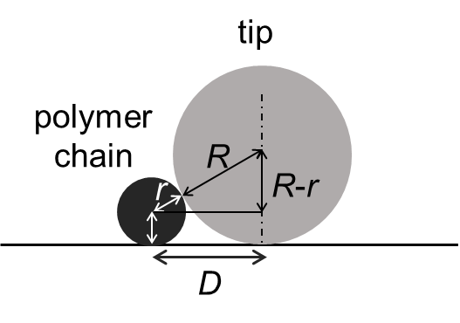
Figure S1. A schematic illustration of the relationship between a chain radius and a tip radius.

Temperature effect on chain conformation. Figures S2 and S3 show histograms of the height and width populations for PMMA300k chains at 298, 313, and 328 K. The height was estimated by tracing a contour line. The width was estimated by obtaining the cross-sectional view along a contour line at random. Figure S4 shows AFM images for PMMA300k chains acquired at 298 and 328 K, and 298 K after cooling down. Figure S5 shows AFM images for chains acquired at 298, 378, and 393 K.

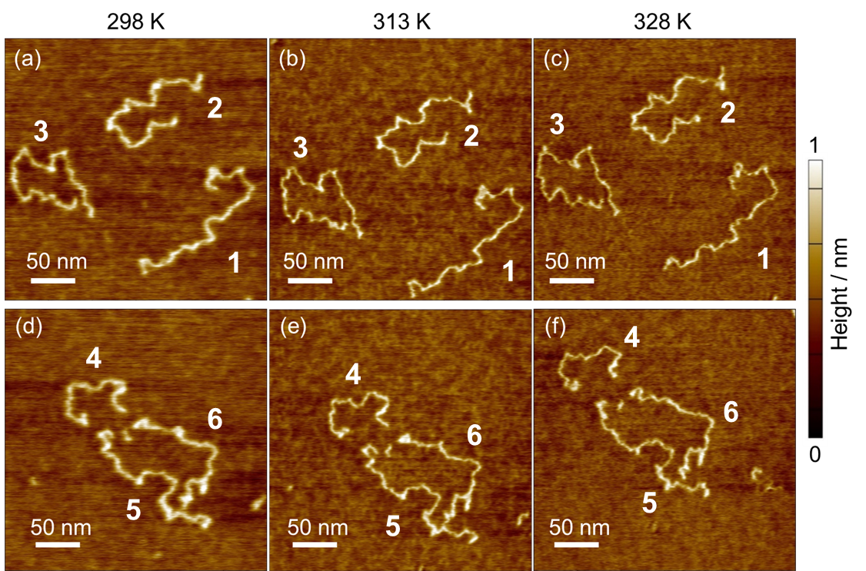
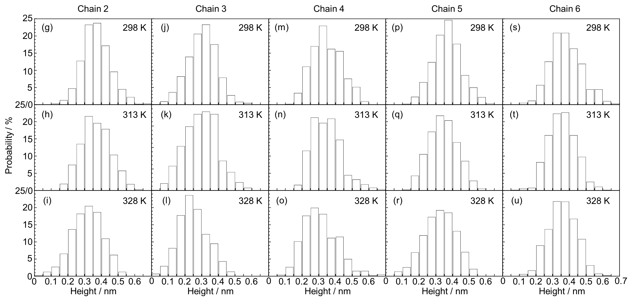
Figure S2. (a-f) Height images for PMMA300k chains on mica acquired at 298, 313, and 328 K, which were the same as panels (a-f) of Figure 3. (g-u) Height histograms for chains 2, 3, 4, 5 and 6 shown in panels (a-f) along the contour lines at (g, j, m, p, s) 298, (h, k, n, q, t) 313, and (i, l, o, r, u) 328 K.

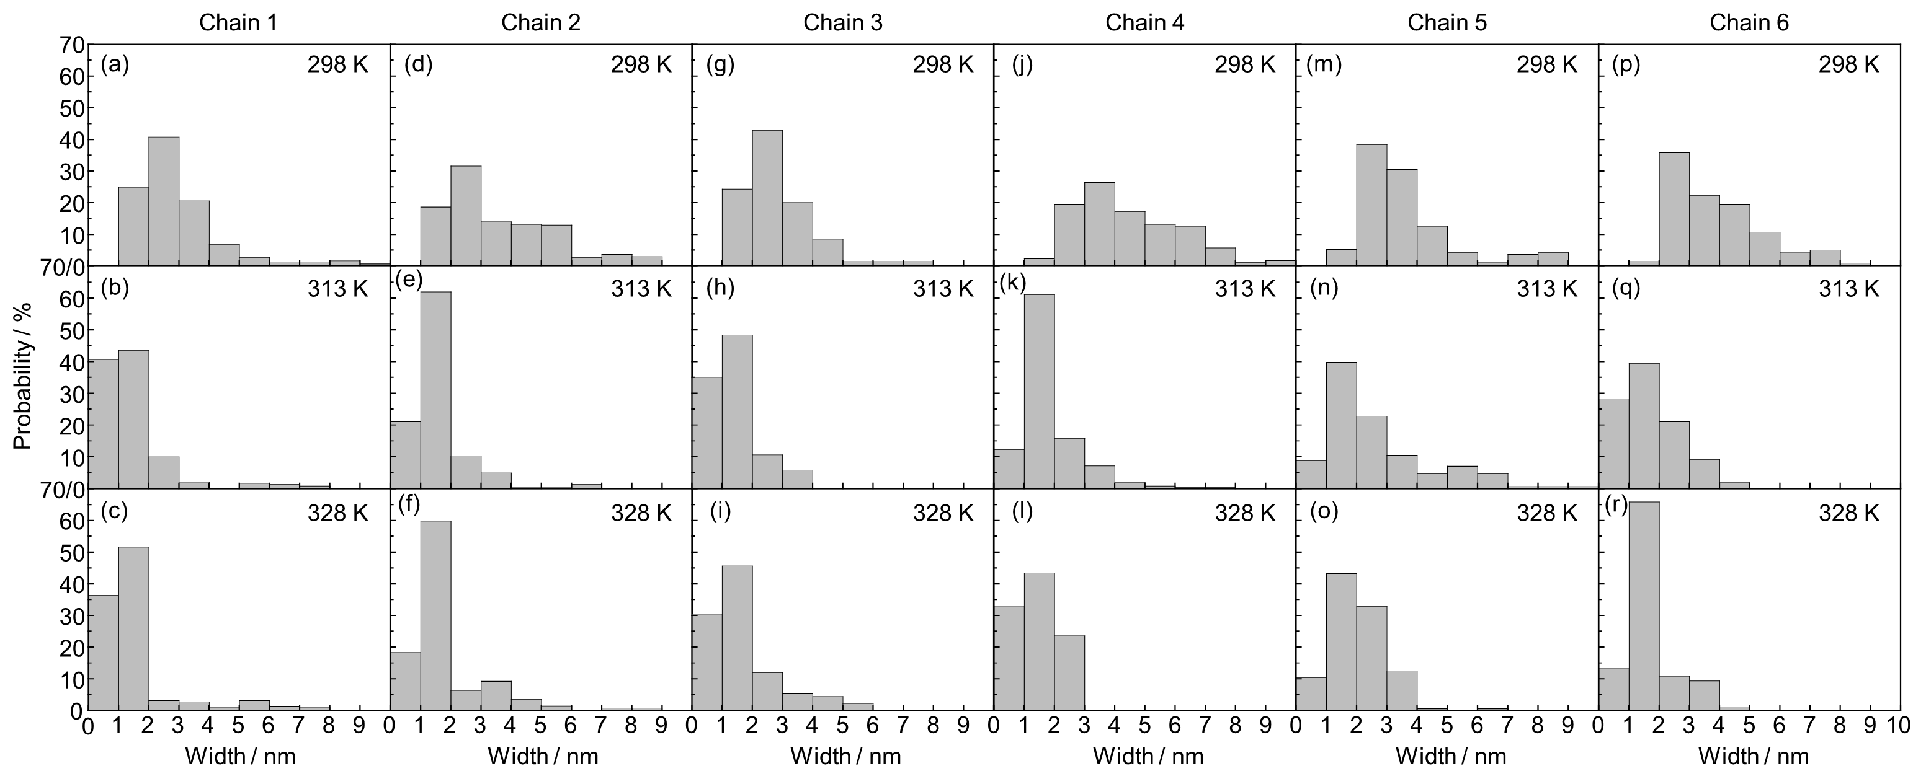
Figure S3. (a-r) Width histograms for chains 1, 2, 3, 4, 5 and 6 shown in panels (a-f) in Figure S2 along the contour lines at (a, d, g, j, m, p) 298, (b, e, h, k, n, q) 313, and (c, f, i, l, o, r) 328 K.
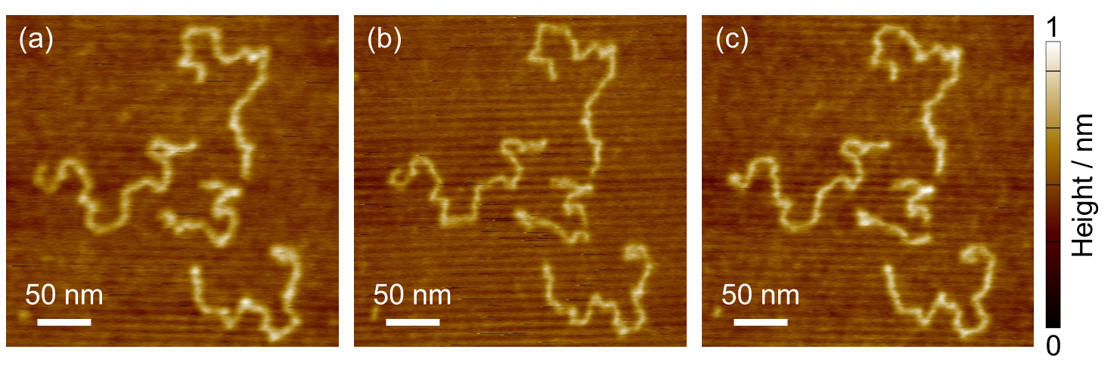
Figure S4. AFM images for PMMA300k chains acquired at (a) 298 and (b) 328 K, and (c) 298 K after 328 K.
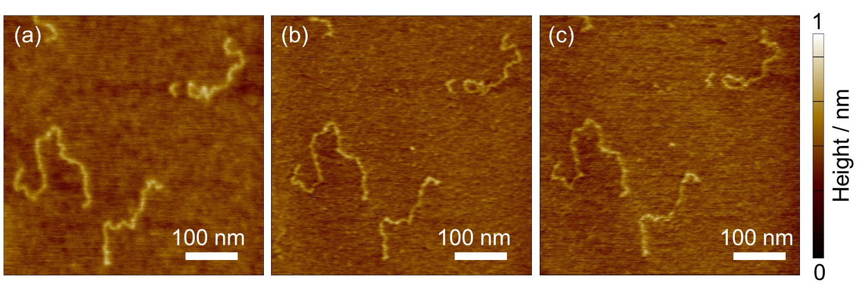
Figure S5. AFM images for PMMA300k chains acquired at (a) 298, (b) 378, and (c) 393 K.
Reference
S1) Vesenka, J., Guthold, M., Tang, C. L., Keller, D., Delaine, E. & Bustamante, C. Substrate preparation for reliable imaging of DNA molecules with the scanning force microscope. Ultramicroscopy 42-44, 1243-1249 (1992).

