Network and pathway expansion of genetic disease associations identifies successful drug targets

Authors

Aidan MacNamara: aidan.macnamara@gmail.com, Functional Genomics, GSK, Stevenage, UK
Nikolina Nakic: nikolina.x.nakic@gsk.com, Functional Genomics, GSK, Stevenage, UK
Ali Amin: ali.x.amin@gsk.com, Human Genetics, GSK, Stevenage, UK
Cong Guo: karl.x.guo@gsk.com, Human Genetics, GSK, Collegeville PA
Karsten B. Sieber: karsten.b.sieber@gsk.com, Human Genetics, GSK, Collegeville PA
Mark Hurle: mark.r.hurle@gsk.com, Human Genetics, GSK, Collegeville PA
Alex Gutteridge (contact): alex.x.gutteridge@gsk.com, Functional Genomics, GSK, Stevenage, UK

Supplementary Figure 1: Enrichment of successful drug targets (left) and number of targets implicated (right) using the naïve approach of first and second neighbors across different network sources (HuRI, InBio Map, STRING, OmniPath)

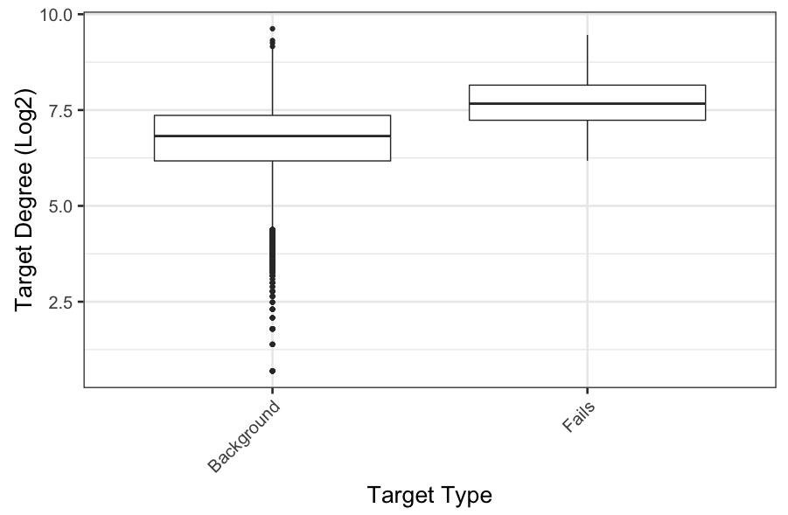
Supplementary Figure 2: A comparison of the node degree (the number of connections in a network that a gene has) between genes that have the most clinical failures (n = 500) against all other genes.

Method | Odds | Confidence Intervals 95% |  | P
HCGH | 3.77 | 2.82 | 5.06 | 0.0000
Complex | 3.68 | 1.68 | 8.05 | 0.0014
Pascal Co-Expresssion | 3.09 | 1.59 | 5.99 | 0.0003
Ligand Receptor | 2.00 | 1.67 | 2.41 | 0.0000
Pascal PPI | 1.92 | 1.16 | 3.16 | 0.0088
HotNet2 Inbio Map | 1.88 | 1.47 | 2.42 | 0.0000
Pascal Metabase | 1.78 | 1.35 | 2.34 | 0.0000
HotNet2 OmniPath | 1.37 | 1.11 | 1.69 | 0.0035
Pascal Reactome | 1.35 | 0.99 | 1.84 | 0.0587
Pathway 1st Neighbor | 1.26 | 0.98 | 1.62 | 0.0728
HotNet2 STRING | 1.22 | 0.79 | 1.88 | 0.4206
HuRI 1st Neighbor | 1.13 | 0.79 | 1.63 | 0.5248
InBio Map 1st Neighbor | 1.07 | 0.91 | 1.25 | 0.4200
InBio Map 1st/2nd Neighbor | 1.06 | 0.99 | 1.14 | 0.0791
HotNet2 HuRI | 1.01 | 0.71 | 1.44 | 0.9386
Random | 1.01 | 0.96 | 1.06 | 0.8275
STRING 1st Neighbor | 0.98 | 0.90 | 1.05 | 0.5227
OmniPath 1st Neighbor | 0.92 | 0.76 | 1.11 | 0.3888
OmniPath 1st/2nd Neighbor | 0.90 | 0.84 | 0.98 | 0.0150
Pathway 1st/2nd Neighbor | 0.72 | 0.63 | 0.83 | 0.0000
HuRI 1st/2nd Neighbor | 0.72 | 0.63 | 0.81 | 0.0000
All Pathway | 0.71 | 0.66 | 0.76 | 0.0000
STRING 1st/2nd Neighbor | 0.49 | 0.42 | 0.56 | 0.0000

Supplementary Table 1: The odds ratio and 95% confidence intervals of successful drug enrichment across all methods

Supplementary Figure 3: Enrichment of successful drug targets (left) and number of targets implicated (right) across all methods.

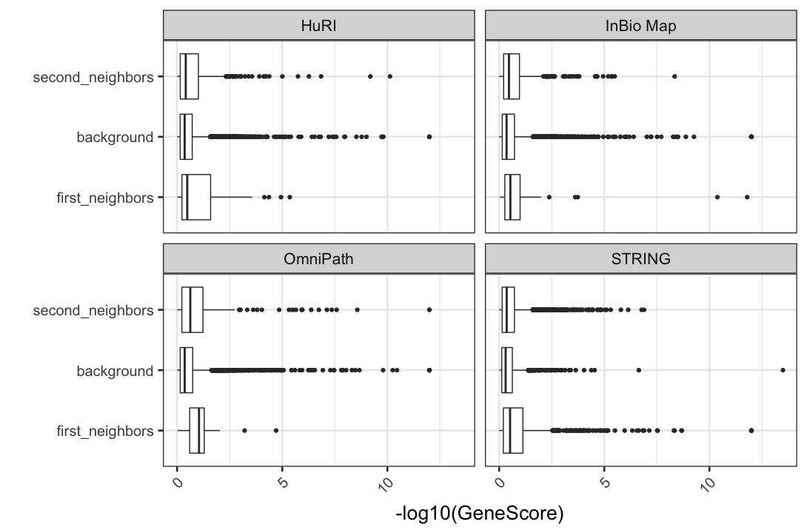

Supplementary Figure 4: A comparison of the Pascal gene score across the 4 networks for first and second neighbors of HCGHs.

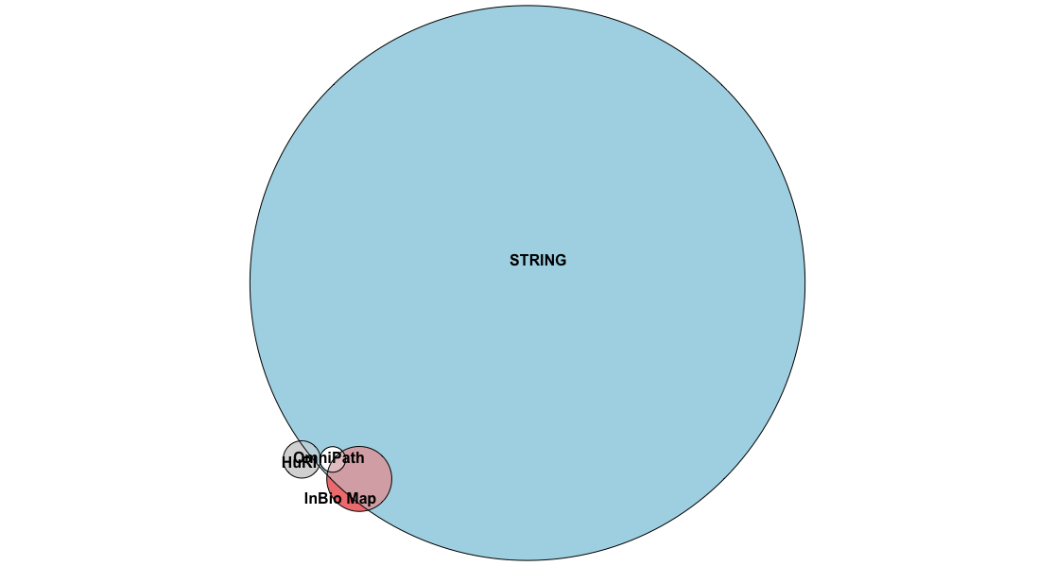
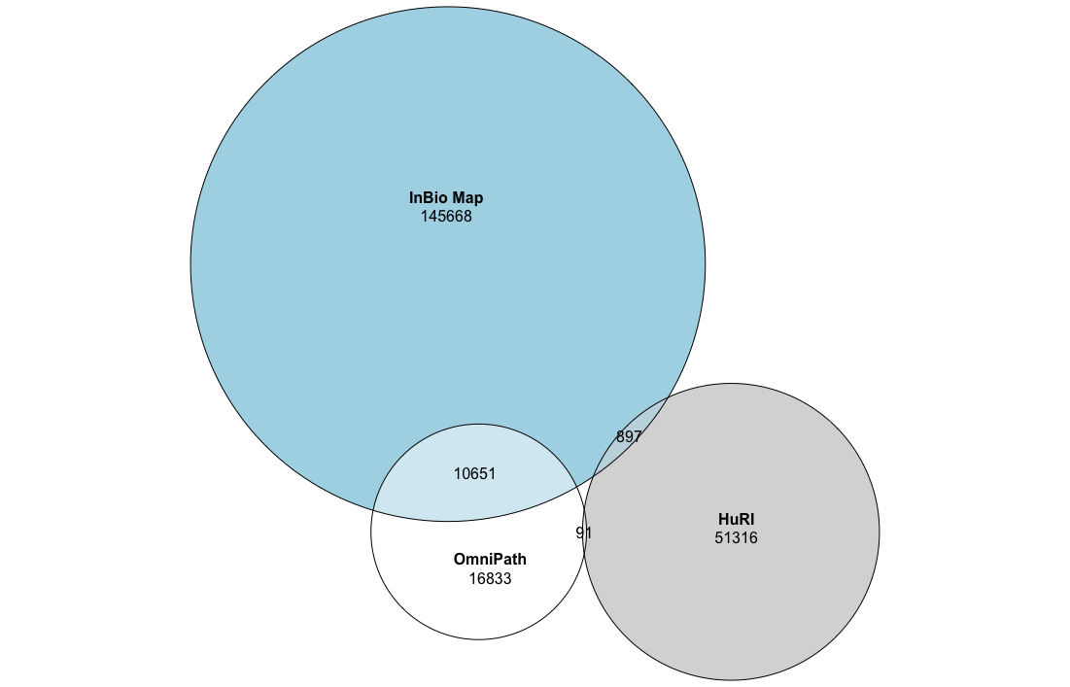

Supplementary Figure 5: The overlap in unique interactions across the different network resources used.

Supplementary Figure 6: Enrichment of successful drug targets (left) and number of targets implicated (right) for Pascal and Magma (with the HCGH reference)

