Role of PARP1-mediated autophagy in EGFR-TKI resistance in non-small cell lung cancer

Zhimin Zhang^{1*}, Xiaojuan Lian^{2*}, Wei Xie¹, Jin Quan², Maojun Liao¹, Yan Wu³, Zhen-Zhou Yang^{3#*}, Ge Wang^{1#*}

Authors' Affiliations:
¹ Cancer Center, Daping Hospital, Army Medical University, Chongqing 400042, China;
² Oncology, Jiangjin Strict Central Hospital, Chongqing 402260, China;
³ Oncology, Second Hospital Affiliated to Chongqing Medical University, Chongqing 400010, China.

* These authors contributed equally to this article.

# Corresponding Author: Zhenzhou Yang, Department of Oncology, Second Hospital Affiliated to Chongqing Medical University, Chongqing 400010, China, #76 Linjiang Road, Chongqing, China, 400042, China. E-mail address: yangzhenzhou@163.com and Ge Wang, Cancer Center, Daping Hospital, Army Medical University, #10 Changjiang Zhilu, Daping, Yuzhong District, Chongqing 400042, China. E-mail address: wangge@126.com.

Figure. S1
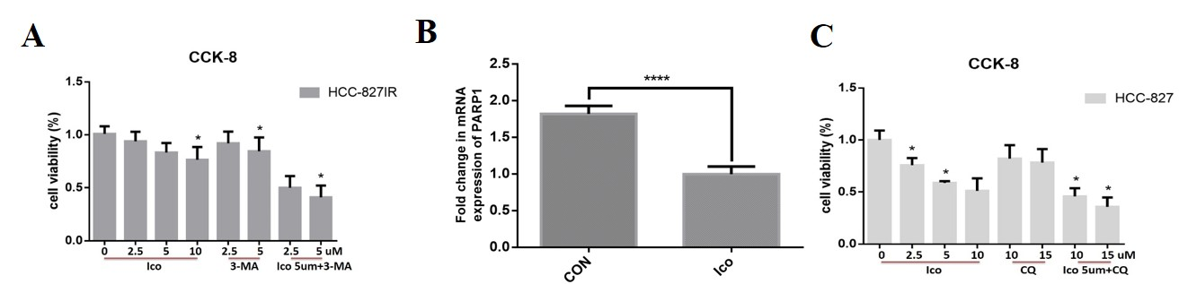
(A) HCC-827IR cells were treated with 0, 2.5, 5, or 10 µM Ico; 2.5 or 5 µM 3-MA (a specific autophagy inhibitors); or a combination of both for 48 h. Cell viability was determined by the CCK-8 assay. (B) The PARP1 mRNA expression level of HCC-827 cells were measured using qRT-PCR in the indicated cells. The indicated cells were transfected with the indicated oligonucleotides or infected with the indicated lentivirus. After 72 h, cells were subjected to qRT-PCR analysis. (C) HCC-827 cells were treated with 0, 2.5, 5, or 10 µM Ico; 10 or 15 µM CQ; or a combination of both for 48 h. Cell viability was determined by the CCK-8 assay. *p < 0.05 vs untreated ****p < 0.0001 vs untreated. The data represent means ± SD of three independent experiments.
Figure. S2
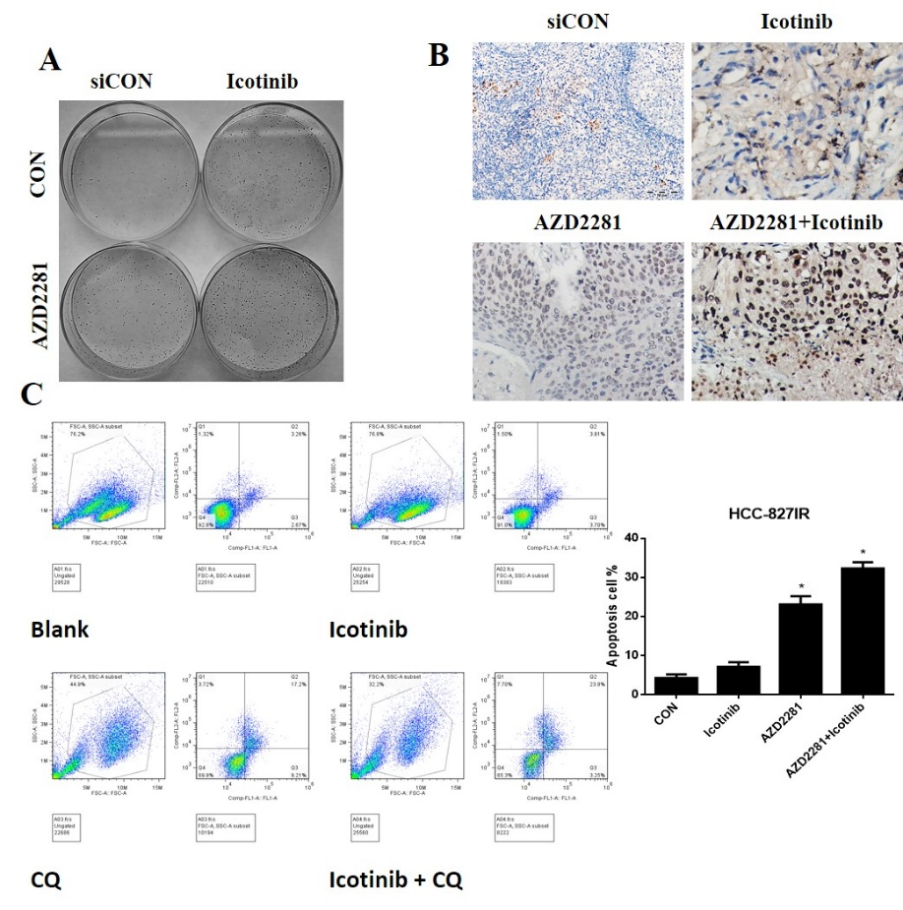
HCC-827IR cells were treated with 5 µM Ico; 4 µM AZD2281; or a combination of both. Colony proliferation assay determined cell proliferation. (B) Nude mouse HCC-827IR xenograft models were divided into four groups (10 mice/group) and treated for 14 days with 50 mg/kg Ico once daily and/or 30 mg/kg AZD2281 once daily by intraperitoneal injection. Tumor tissues isolated from xenografts after treatment with Ico, AZD2281, or Ico + AZD2281 were subjected to immunohistochemical stain of Ki-67 expression. The data shown represent the mean ± standard error, n=10. *P<0.05 versus the vehicle group. (C) HCC-827IR cells were treated with 5 µM Ico; 10 µM CQ; or a combination of both for 24 h. Cell apoptosis were subjected to flow cytometry analysis. The data represent means ± SD of three independent experiments, *p < 0.05 vs untreated.

Table. Clinical characteristics of NSCLC patients.
Characteristic | NO. (%)
Age
≥65 years | 32(27%)
＜65 years | 87(73%)
Gender
Male | 65(53%)
Female | 54(45%)
Histological type
adenocarcinoma | 98(91%)
Squamous cell carcinoma | 11(9%)
Expression levels of PARP1
Low (-/+) | 76(64%)
High (++/+++) | 43(36%)
Expression of p62
Low (-/+) | 77(65%)
High (++/+++) | 42(35%)
mutation sites of EGFR
Exon 19 deletion | 56(47%)
L858R | 63(53%)

