Supplementary Information

A diagnostic LAMP assay for the destructive grapevine insect pest, phylloxera (Daktulosphaira vitifoliae)

Arati Agarwal ¹, J. Paul Cunningham ^{1, 2}, Isabel Valenzuela ¹ & Mark J. Blacket ^{1*}

¹ Agriculture Victoria Research, AgriBio, 5 Ring Road. Bundoora, Victoria 3083, Australia.
² School of Applied Systems Biology, La Trobe University, Bundoora, Victoria 3083, Australia.

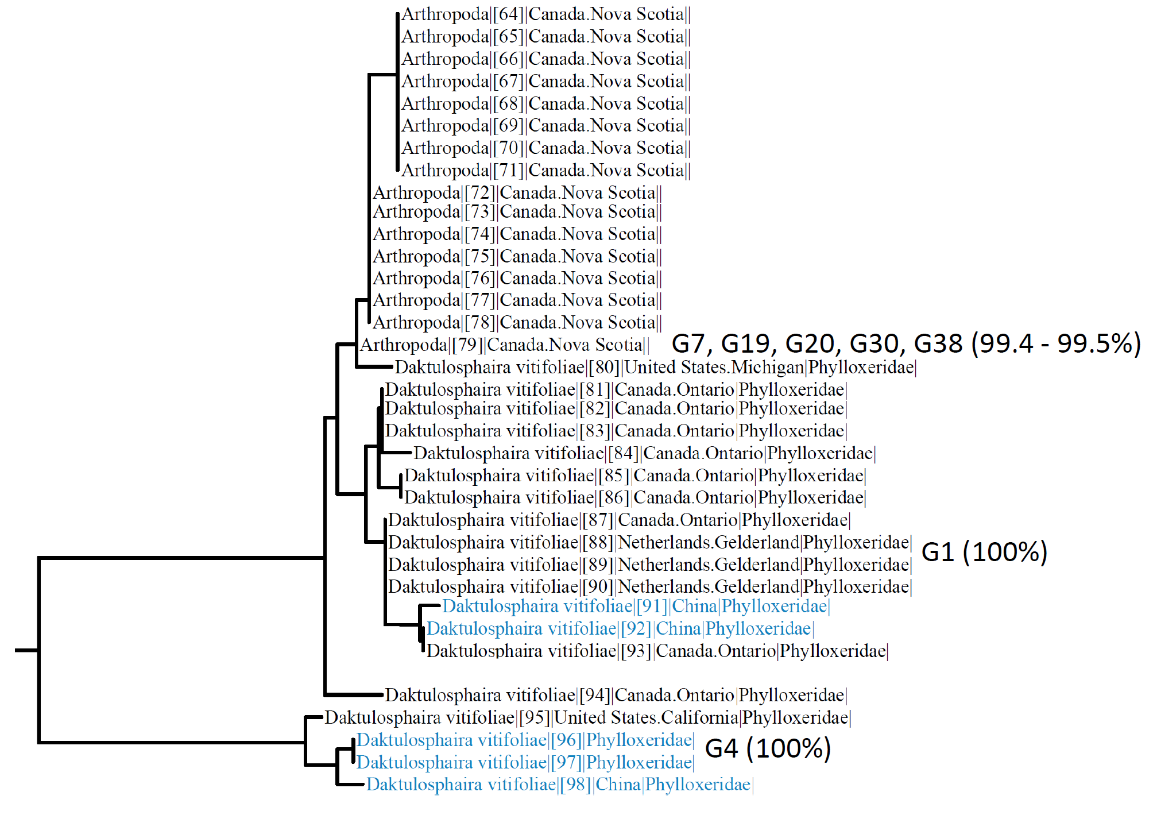
Supplementary Figure 1. Closest matches of Australian phylloxera strains with reference DNA barcode sequences on BOLD (accessed July 2020). Percentage match of each strain with closest BOLD reference sequence shown in brackets.
Supplementary Table 1. Target and non-target Aphidomorpha (Phylloxeroidea & Aphidoidea) used for LAMP primer design.

Species | Superfamily | Family | Reason for including species | Refererence | Accession number (BOLD)
Daktulosphaira vitifoliae | Phylloxeroidea | Phylloxeridae | Phylloxera, the target species. | 1, 2 | 230 x sequences on BOLD
Phylloxerina salicis | Phylloxeroidea | Phylloxeridae | To account for Phylloxeroidea diversity, present in Australia. | 1 | GBMHH6688-15
Adelges normannianae | Phylloxeroidea | Adelgidae | To account for Phylloxeroidea diversity, present in Australia. | 1 | GBMHH1826-13
Pineus pini | Phylloxeroidea | Adelgidae | To account for Phylloxeroidea diversity, present in Australia. | 1 | GBMHH187-10
Aphis craccivora | Aphidoidea | Aphididae | Aphid species known from grapevines (host). | 2 | ACEA141-14
Aphis fabae | Aphidoidea | Aphididae | Aphid species known from grapevines (host). | 2 | ACEA050-14
Aphis gossypii | Aphidoidea | Aphididae | Aphid species known from grapevines (host). | 2 | ACE1143-14
Aphis illinoisensis | Aphidoidea | Aphididae | Aphid species known from grapevines (host). | 2 | RFBAE1197-10
Aphis hederae | Aphidoidea | Aphididae | Aphid species known from grapevines (host). | 2 | ACEA062-14
Aulacorthum solani | Aphidoidea | Aphididae | Aphid species known from grapevines (host). | 2 | ACEA131-14
Macrosiphum euphorbiae | Aphidoidea | Aphididae | Aphid species known from grapevines (host). | 2 | ACEA250-14
Geoica wertheimae | Aphidoidea | Aphididae | A close relative (not present on BOLD) is known from grapes. | 2 | RDBA251-05
Prociphilus caryae | Aphidoidea | Aphididae | A close relative (not present on BOLD) is known from grapes. | 2 | BBHCN1096-10
Aploneura lentisci | Aphidoidea | Aphididae | Root aphid present in Victoria, Australia. | 1, 2 | ACEA790-14

References:
1. Ratnasingham, S. & Hebert, P. D. N. BOLD: The barcode of life data system. Mol. Ecol. Notes 7, 355–364 (2007).
2. Blackman, R. L. & Eastop, V. F. Aphids on the World’s Crops: An Identification and Information Guide 2nd edn. (Wiley, London,
2000).

