An Integrated Approach to Biomarker Discovery Reveals Gene Signatures Highly Predictive of Cancer Progression- SUPPLEMENTARY MATERIAL
Kevin L. Sheng¹, Lin Kang¹, Kevin J. Pridham², Logan E. Dunkenberger^{2*}, Zhi Sheng^{2,3,4}, Robin T. Varghese¹
¹Edward Via College of Osteopathic Medicine, 2265 Kraft Drive, Blacksburg, VA 24060, USA.
²Fralin Biomedical Research Institute at VTC, 2 Riverside Circle, Roanoke, VA 24016, USA.
³Department of Internal Medicine, Virginia Tech Carilion School of Medicine, Roanoke, VA 24016, USA.
⁴Faculty of Health Science, Virginia Tech, Blacksburg, VA 24061, USA.
*previous affiliation

SUPPLEMENTARY TABLES
Table S1. Clinical characteristics of the training and validation cohorts.
 | Training |  |  | Validation
Variables | TCGA LUAD | TCGA LUSC | TCGA GBM (T) | GEO LUAD | GEO LUSC | TCGA GBM (V) | REMBRT  GBM
No. of Patients | 517 | 504 | 389 | 246 | 207 | 126 | 200
Gender
Male | 240 | 131 | 236 | 100 | 142 | 75 | 99
Female | 277 | 373 | 153 | 48 | 12 | 51 | 55
N/A | 0 | 0 | 0 | 98 | 53 | 0 | 46
Med. Age (Years) | 66 | 68 | 59 | 60.5 | 63.5 | 60 | 57
Race
Caucasian | 393 | 351 | 341 |  |  | 112 | 139
African American | 53 | 31 | 22 |  |  | 8 | 2
Asian | 8 | 9 | 11 |  |  | 0 | 1
N/A | 63 | 113 | 15 | 246 | 207 | 6 | 58
AJCC TNM Stage
Stage I | 279 | 245 |  | 81 | 48
Stage II | 124 | 163 |  | 3 | 5
Stage III | 85 | 85 |  | 1 | 2
Stage IV | 26 | 7 |  | 0 | 0
N/A | 3 | 4 |  | 161 | 152
Smoking History
Non-Smoker | 75 | 18
Current Smoker | 122 | 134
Reformed Smoker | 307 | 335
N/A | 13 | 17 |  | 246 | 207
Subtype
Classical |  |  | 107 |  |  | 36
Mesenchymal |  |  | 112 |  |  | 41
Proneural |  |  | 170 |  |  | 49
N/A |  |  | 0 |  |  | 0 | 200
Table S2. BIC score optimization to determine the cutoff for highly-expressed genes. PGSs were identified using the working pipeline described in the Methods section. The cutoffs returning a PGS with the lowest BIC score, which corresponds to the lowest overfitting potential, are highlighted in grey.
 | Cutoff Value | Genes in PGS | BIC
LUAD | 50 | 19 | 671.251
LUAD | 100 | 22 | 662.856
LUAD | 150 | 30 | 684.074
LUAD | 200 | 59 | 785.492
LUSC | 50 | 20 | 567.156
LUSC | 100 | 23 | 559.984
LUSC | 150 | 34 | 580.935
LUSC | 200 | 53 | 635.626
GBM | 50 | 28 | 778.526
GBM | 100 | 31 | 767.708
GBM | 150 | 48 | 819.793
GBM | 200 | 48 | 802.173

Table S3. Passage numbers for primary GBM cells.
Primary GBM Cell | Passage Number
VTC-001 | 3
VTC-004 | 3
VTC-010 | 5
VTC-037 | 3
VTC-058 | 5
VTC-093 | 6

Table S4. qRT-PCR primers used for detecting mRNA levels of PGS genes in GBM.
Gene | Primers Sequence 5’-3’ (forward, reverse)
RPS11 | AGCAGCCGACCATCTTTC  ATAGCCTCCTTGGGTGTCTTG
UBB | AAGCCTAAACTGCCTCTC  GTTGCGTCACTTATCACC
TUBB | GCAGTCACCTTCATTGGCAAT  GCGGAACATGGCAGTGAACT
RPS6 | CGCCAAGTATGTTGTAAGAAAGCCCT  GCTGCAGGACACGTGGAGTAACA
EEF1A1 | CAGGACACAGAGACTTTATC  AGTGTGTAAGCCAGAAGGG
EEF2 | AGAAGCTGTGGGGTGACAG  GATCAGCTGGCAGAAGGTG
PKM | GTGCGAGCCTCAAGTCACTCCACA  TATAAGAAGCCTCCACGCTGCCCA
C3 | GCTGAAGCACCTCATTGTGA  CTGGGTGTACCCCTTCTTGA
ENO1 | GAGCTCCGGGACAATGATAA  CTGTTCCATCCATCTCGATC
HSP90AB1 | TTTGGGAACCATTGCCAAGTC  CACCAAACTGCCCAATCATGG
FTL | GCGTCTCCTGAAGATGCAAA  AGGAAGTGAGTCTCCAGGAAGT
CFL1 | GAAGGAGGATCTGGTGTTTATCTTCT  CCTTGGAGCTGGCATAAATCAT
YWHAE | GGATACGCTGAGTGAAGAAAGC  TATTCTGCTCTTCACCGTCACC
CKB | GCTGCGACTTCAGAAGCGA  GGCATGAGGTCGTCGATGG
TUBA1A | GCAACAACCTCTCCTCTTCG  GAATCATCTCCTCCCCCAAT
FLNA | GCACTTACAGCTGCTCCTACG  CCAGCTCCCACATTCACC
APP | AACCAGTGACCATCCAGAAC  ACTTGTCAGGAACGAGAAGG
CD63 | AGCAGATGGAGAATTACCC  CTCCCAATCTGTGTAGTTAG
ACTB | TTCCTGGGCATGGAGTC  CAGGTCTTTGCGGATGTC
VIM | AGCCGAAAACACCCTGCAAT  CGTTCAAGGTCAAGACGTGC
CTSB | GGCCCCCTGCATCTATCG  AGGTCTCCCGCTGTTCCACTG
MME | CATCGGCATGGTCATAGGACA  TGTTGAGTCCACCAGTCAACGA
GLUL | CACACAATCTTGGCATTTCC  ACTCAGGGGAGCAAAGGAAG
MT3 | ATGGACCCTGAGACCTGCC  TTGCACACACAGTCCTTGGC
ACTG1 | TGTTTCCTTCCATCGTCGGG  CATGTCGTCCCAGTTGGTGA
HLA-C | TCCTGGTTGTCCTAGCTGTC  CAGGCTTTACAAGTGATGAG
B2M | GATGAGTATGCCTGCCGTGT  TGCGGCATCTTCAAACCTCC
CRYAB | AGGTGTTGGGAGATGTGATTGA  GGATGAAGTAATGGTGAGAGGGT
LRP1 | ACATATAGCCTCCATCCTAATC  TTCCAATCTCCACGTTCAT
S100B | AGACGGTCATGCAAGAAAGC  GCTACAACACGGCTGGAAAG
FN1 | AGATCTACCTGTACACCTTGAATGACA  CATGATACCAGCAAGGAATTGG

Table S5. Stability of GAPDH, ACTB, and B2M expression in six primary GBM cell lines. RefFinder assigns weights to reference gene stability rankings from four algorithms and calculates their geometric mean. Lower geometric means confer greater expression stability.
Gene | RefFinder | Comparative ∆Ct | BestKeeper | NormFinder | GeNorm
GAPDH | 1.00 | 1.22 | 0.61 | 0.211 | 0.680
ACTB | 1.68 | 1.27 | 0.87 | 0.647 | 0.680
B2M | 3.00 | 1.80 | 1.32 | 1.738 | 1.429

Table S6. Significance of shRNA log₂ fold change <0 for survival genes. One-tailed one-sample t-tests first analyzed the significance of fold change <0 for each shRNA targeting each candidate survival gene. False discovery rate-adjusted P-values (Q-values) were then calculated using Fisher’s combined probability test to determine the combined significance of all shRNA log₂ fold change <0. Genes with average shRNA fold change >0 are shown in red.
LUAD |  | LUSC |  | GBM
Gene | Q-value | Gene | Q-value | Gene | Q-value
RPS8 | 4.247E-43 | RPS8 | 5.382E-43 | RPS11 | 1.561E-61
RPL5 | 2.955E-55 | RPS11 | 1.068E-55 | UBB | 5.165E-43
RPS11 | 1.054E-55 | RPS18 | 1.442E-51 | RPS3 | 1.870E-51
RPS18 | 9.482E-52 | EEF2 | 3.447E-38 | RPS4X | 1.433E-38
EEF2 | 3.401E-38 | RPS4X | 2.489E-34 | TUBB | 4.876E-36
RPS4X | 2.455E-34 | RPS3 | 1.167E-43 | RPS6 | 1.774E-39
RPS3 | 8.635E-44 | RPL37 | 1.820E-38 | HSP90AA1 | 7.630E-22
ATP1A1 | 1.896E-34 | ATP1A1 | 1.922E-34 | EEF1A1 | 4.590E-31
RPS6 | 6.508E-41 | RPS6 | 7.917E-41 | EEF2 | 2.763E-26
TUBB | 1.127E-28 | TUBB | 1.142E-28 | CALM2 | 3.081E-25
CEACAM5 | 5.806E-26 | HSP90AA1 | 2.686E-26 | DPYSL3 | 3.397E-25
HSP90AA1 | 2.650E-26 | SFTPB | 3.156E-26 | PSAP | 1.151E-17
SFTPB | 3.113E-26 | EIF4G1 | 4.571E-21 | PTN | 2.892E-16
RPS16 | 4.335E-27 | RPS16 | 4.395E-27 | CDK4 | 1.249E-26
ACTB | 5.152E-17 | ACTB | 5.432E-17 | SPP1 | 6.570E-19
GAPDH | 1.312E-24 | GAPDH | 1.425E-24 | MBP | 5.758E-17
GNB2L1 | 9.111E-23 | GNB2L1 | 9.852E-23 | PKM | 1.152E-17
PKM | 1.012E-17 | PKM | 1.070E-17 | PTPRZ1 | 5.770E-27
EEF1A1 | 1.451E-18 | EEF1A1 | 1.471E-18 | GAPDH | 2.041E-19
CFL1 | 1.868E-22 | TFRC | 7.954E-16 | A2M | 1.674E-18
HSP90B1 | 2.593E-17 | CFL1 | 2.012E-22 | UBC | 5.444E-19
ENO1 | 3.071E-18 | HSP90B1 | 2.738E-17 | CALM1 | 9.975E-13
UBC | 7.652E-16 | ENO1 | 3.113E-18 | C3 | 5.265E-22
PSAP | 7.165E-20 | UBC | 7.757E-16 | SLC1A3 | 7.348E-21
A2M | 4.804E-15 | PSAP | 7.263E-20 | GNB2L1 | 8.158E-17
HSPA5 | 1.989E-04 | HSPA5 | 1.989E-04 | ENO1 | 6.686E-17
SFTPC | 4.079E-12 | SPP1 | 1.688E-13 | HSP90AB1 | 4.738E-19
PGC | 4.227E-19 | APP | 4.062E-07 | FTL | 5.026E-21
KRT19 | 3.572E-14 | KRT6A | 3.805E-19 | CFL1 | 6.756E-19
CD74 | 4.827E-15 | KRT19 | 4.205E-14 | YWHAE | 4.947E-15
NAPSA | 9.726E-15 | CD74 | 5.231E-15 | CKB | 1.484E-08
HSPA8 | 1.839E-13 | JUP | 2.079E-09 | CD81 | 4.035E-18
P4HB | 3.351E-15 | HSPA8 | 2.029E-13 | TUBA1A | 4.360E-29
CEACAM6 | 6.077E-13 | FTL | 1.619E-20 | FLNA | 1.836E-10
FTL | 1.597E-20 | ALDOA | 3.376E-15 | CLU | 3.944E-17
ALDOA | 3.216E-15 | S100A9 | 9.933E-13 | IGFBP7 | 2.989E-16
C3 | 2.176E-13 | NDRG1 | 9.728E-13 | GPM6B | 4.439E-08
CD63 | 9.534E-18 | FLNA | 1.343E-07 | SPARC | 1.298E-11
FLNA | 1.325E-07 | S100A11 | 1.839E-13 | NES | 1.480E-13
SPARC | 4.750E-10 | KRT17 | 2.327E-12 | APP | 1.595E-06
HSP90AB1 | 1.694E-09 | SPARC | 5.029E-10 | CD63 | 9.474E-19
APLP2 | 2.557E-09 | HSP90AB1 | 1.792E-09 | ALDOA | 1.208E-12
CANX | 1.740E-15 | PGK1 | 1.622E-10 | ACTB | 1.091E-13
VIM | 1.001E-12 | KRT5 | 1.323E-07 | COL1A2 | 2.962E-14
GLUL | 2.978E-09 | GLUL | 3.145E-09 | CALR | 2.163E-15
CALR | 8.774E-13 | SLC2A1 | 6.172E-08 | VIM | 1.798E-13
CTSB | 1.862E-14 | CALR | 9.856E-13 | CHI3L1 | 2.054E-15
PABPC1 | 3.860E-12 | CTSB | 2.202E-14 | CD74 | 1.243E-12
KRT18 | 2.481E-10 | PABPC1 | 4.104E-12 | CANX | 1.277E-11
ACTG1 | 6.504E-13 | KRT14 | 5.620E-13 | CTSB | 1.083E-15
PIGR | 1.136E-14 | ACTG1 | 7.326E-13 | MYL6 | 1.340E-07
COL3A1 | 3.334E-10 | COL3A1 | 3.533E-10 | MME | 5.566E-11
COL1A2 | 1.238E-08 | COL1A2 | 1.306E-08 | GLUL | 2.343E-10
LGALS3BP | 1.596E-08 | HSPB1 | 5.633E-08 | MT3 | 1.176E-13
LYZ | 4.403E-08 | CD9 | 3.188E-10 | ACTG1 | 4.093E-14
SFTPA2 | 6.670E-07 | SFTPA2 | 6.761E-07 | FTH1 | 3.312E-09
SFTPA1 | 2.748E-07 | NAT1 | 7.000E-05 | HLA-C | 3.859E-10
NAT1 | 6.686E-05 | B2M | 2.868E-05 | PLP1 | 6.797E-11
B2M | 2.738E-05 | FTH1 | 2.663E-05 | QKI | 2.088E-08
FTH1 | 2.541E-05 | FN1 | 8.189E-04 | PCDHGC3 | 8.640E-07
FN1 | 7.717E-04 | CTSD | 2.598E-04 | SERPINA3 | 2.780E-02
CTSD | 2.446E-04 | KRT15 | 2.935E-02 | BRI3 | 2.782E-08
LPCAT1 | 2.506E-06 | SDC1 | 2.798E-08 | HSPA8 | 1.357E-09
SLC34A2 | 7.538E-05 | LDHA | 2.833E-07 | AQP4 | 3.333E-07
SERPINA1 | 3.826E-06 | GSTP1 | 1.246E-02 | GFAP | 1.795E-06
LDHA | 2.794E-07 | ANXA2 | 8.001E-05 | NAT1 | 1.356E-07
ANXA2 | 7.646E-05 | MYH9 | 4.997E-02 | B2M | 6.925E-04
MYH9 | 4.997E-02 | HLA-C | 9.233E-06 | IGFBP5 | 1.804E-14
HLA-C | 8.805E-06 | AKR1C1 | 1.819E-02 | CRYAB | 9.417E-04
YWHAZ | 4.506E-02 | YWHAZ | 4.502E-02 | LRP1 | 1.732E-08
HLA-A | 6.246E-03 | KRT13 | 1.886E-03 | HLA-A | 3.333E-07
COL1A1 | 1.304E-01 | HLA-A | 6.523E-03 | SPARCL1 | 1.083E-04
HLA-DRA | 6.860E-01 | COL1A1 | 1.303E-01 | S100B | 1.872E-04
 |  | HLA-DRA | 6.859E-01 | FN1 | 4.728E-02
 |  |  |  | CST3 | 6.713E-04
 |  |  |  | PMP2 | 4.811E-02
 |  |  |  | ITM2B | 1.148E-01
 |  |  |  | HLA-DRA | 6.206E-01

Table S7. Genes in LUAD-PGS.
Gene Symbol | Full Gene Name
ACTB | Actin Beta
FTL | Ferritin Light Chain
SFTPA2 | Surfactant Protein A2
CD74 | Cluster of Differentiation 74 Molecule
FN1 | Fibronectin 1
B2M | Beta-2-Microglobulin
CTSD | Cathepsin D
CEACAM6 | Carcinoembryonic Antigen-Related Cell Adhesion Molecule 6
EEF2 | Eukaryotic Translation Elongation Factor 2
PGC | Progastricsin
UBC | Ubiquitin C
HSP90AB1 | Heat Shock Protein 90 Alpha Family Class B Member 1
SERPINA1 | Serpin Family A Member 1
HSPA8 | Heat Shock Protein Family A (Hsp70) Member 8
HSP90AA1 | Heat Shock Protein 90 Alpha Family Class A Member 1
GNB2L1 (RACK1) | Receptor For Activated C Kinase 1
CEACAM5 | Carcinoembryonic Antigen-Related Cell Adhesion Molecule 5
CD63 | Cluster of Differentiation 63 Molecule
PIGR | Polymeric Immunoglobulin Receptor
KRT18 | Keratin 18
GLUL | Glutamate-Ammonia Ligase
KRT19 | Keratin 19
Table S8. Genes in LUSC-PGS.
Gene Symbol | Full Gene Name
GAPDH | Glyceraldehyde-3-Phosphate Dehydrogenase
KRT5 | Keratin 5
ACTG1 | Actin Gamma 1
ENO1 | Enolase 1
PKM | Pyruvate Kinase M1/2
CTSB | Cathepsin B
PSAP | Prosaposin
MYH9 | Myosin Heavy Chain 9
KRT14 | Keratin 14
RPS4X | Ribosomal Protein S4 X-Linked
CALR | Calreticulin
FLNA | Filamin A
HSPA8 | Heat Shock Protein Family A (Hsp70) Member 8
SFTPA2 | Surfactant Protein A2
RPS11 | Ribosomal Protein S11
HSP90B1 | Heat Shock Protein 90 Beta Family Member 1
HSPB1 | Heat Shock Protein Family B (Small) Member 1
SDC1 | Syndecan 1
HLA-C | Major Histocompatibility Complex, Class I, C
APP | Amyloid Beta Precursor Protein
ATP1A1 | ATPase Na+/K+ Transporting Subunit Alpha 1
HSPA5 | Heat Shock Protein Family A (Hsp70) Member 5
RPL37 | Ribosomal Protein L37

Table S9. Genes in GBM-PGS.
Gene Symbol | Full Gene Name
RPS11 | Ribosomal Protein S11
UBB | Ubiquitin B
TUBB | Tubulin Beta Class I
RPS6 | Ribosomal Protein S6
EEF1A1 | Eukaryotic Translation Elongation Factor 1 Alpha 1
EEF2 | Eukaryotic Translation Elongation Factor 2
PKM | Pyruvate Kinase M1/2
C3 | Complement C3
ENO1 | Enolase 1
HSP90AB1 | Heat Shock Protein 90 Alpha Family Class B Member 1
FTL | Ferritin Light Chain
CFL1 | Cofilin 1
YWHAE | Tyrosine 3-Monooxygenase/Tryptophan 5-Monooxygenase Activation Protein Epsilon
CKB | Creatine Kinase B
TUBA1A | Tubulin Alpha 1A
FLNA | Filamin A
APP | Amyloid Beta Precursor Protein
CD63 | Cluster of Differentiation 63 Molecule
ACTB | Actin Beta
VIM | Vimentin
CTSB | Cathepsin B
MME | Membrane Metalloendopeptidase
GLUL | Glutamate-Ammonia Ligase
MT3 | Metallothionein 3
ACTG1 | Actin Gamma 1
HLA-C | Major Histocompatibility Complex, Class I, C
B2M | Beta-2-Microglobulin
CRYAB | Crystallin Alpha B
LRP1 | Low-Density Lipoprotein Receptor Related Protein 1
S100B | S100 Calcium Binding Protein B
FN1 | Fibronectin 1

Table S10. Frequency and prognostic significance of mutations in LUAD-PGS genes in the TCGA LUAD cohort. Kaplan-Meier survival curves analyzed disease-free survival times between mutant or wild-type patients for each PGS gene. P-values calculated using log-rank tests are shown. Genes with mutations significantly correlated with patient prognosis are highlighted in grey.
Gene | Mutant Patients | Wild-Type Patients | KM log-rank P-value
ACTB | 12 | 173 | 0.2126
FTL | 2 | 183 | 0.5284
SFTPA2 | 1 | 184 | 0.4086
CD74 | 1 | 184 | 0.8161
FN1 | 7 | 178 | 0.3636
B2M | 6 | 179 | 0.3174
CTSD | 0 | 185 | N/A
CEACAM6 | 3 | 182 | 0.3841
EEF2 | 3 | 182 | 0.0022
PGC | 12 | 173 | 0.6639
UBC | 8 | 177 | 0.1792
HSP90AB1 | 12 | 173 | 0.2348
SERPINA1 | 3 | 182 | 0.1377
HSPA8 | 7 | 178 | 0.8296
HSP90AA1 | 7 | 178 | 0.1986
GNB2L1 (RACK1) | 1 | 184 | 0.3223
CEACAM5 | 6 | 179 | 0.1066
CD63 | 4 | 181 | 0.7312
PIGR | 15 | 170 | 0.8551
KRT18 | 3 | 182 | 0.9135
GLUL | 15 | 170 | 0.7759
KRT19 | 1 | 184 | 0.2955

Table S11. Frequency and prognostic significance of mutations in LUSC-PGS genes in the TCGA LUSC cohort. Kaplan-Meier survival curves analyzed disease-free survival times between mutant or wild-type patients for each PGS gene. P-values calculated using log-rank tests are shown. Genes with mutations significantly correlated with patient prognosis are highlighted in grey.
Gene | Mutant Patients | Wild-Type Patients | KM log-rank P-value
GAPDH | 9 | 112 | 0.6864
KRT5 | 0 | 121 | N/A
ACTG1 | 8 | 113 | 0.2008
ENO1 | 1 | 120 | 0.8653
PKM | 5 | 116 | 0.1453
CTSB | 8 | 113 | < 0.0001
PSAP | 4 | 117 | 0.1688
MYH9 | 8 | 113 | 0.5038
KRT14 | 6 | 115 | 0.4735
RPS4X | 2 | 119 | 0.5029
CALR | 2 | 119 | 0.3733
FLNA | 12 | 109 | 0.0689
HSPA8 | 3 | 118 | 0.5524
SFTPA2 | 8 | 113 | 0.5463
RPS11 | 3 | 118 | 0.9702
HSP90B1 | 2 | 119 | < 0.0001
HSPB1 | 1 | 120 | 0.6272
SDC1 | 4 | 117 | 0.7084
HLA-C | 1 | 120 | N/A
APP | 5 | 116 | 0.9992
ATP1A1 | 5 | 116 | 0.2789
HSPA5 | 2 | 119 | 0.3398
RPL37 | 21 | 100 | 0.1694

Table S12. Frequency and prognostic significance of mutations in GBM-PGS genes in the TCGA GBM cohort. Kaplan-Meier survival curves analyzed disease-free survival times between mutant or wild-type patients for each PGS gene. P-values calculated using log-rank tests are shown. Genes with mutations significantly correlated with patient prognosis are highlighted in grey.
Gene | Mutant Patients | Wild-Type Patients | KM log-rank P-value
RPS11 | 0 | 191 | N/A
UBB | 0 | 191 | N/A
TUBB | 0 | 191 | N/A
RPS6 | 2 | 189 | 0.7997
EEF1A1 | 2 | 189 | 0.6429
EEF2 | 2 | 189 | 0.2193
PKM | 1 | 190 | 0.1026
C3 | 4 | 187 | 0.9628
ENO1 | 2 | 189 | 0.2802
HSP90AB1 | 2 | 189 | 0.6302
FTL | 0 | 191 | N/A
CFL1 | 1 | 190 | 0.5808
YWHAE | 1 | 190 | 0.1983
CKB | 1 | 190 | 0.5163
TUBA1A | 2 | 189 | 0.1250
FLNA | 8 | 183 | 0.6733
APP | 1 | 190 | 0.0033
CD63 | 1 | 190 | 0.5421
ACTB | 3 | 188 | 0.1451
VIM | 0 | 191 | N/A
CTSB | 1 | 190 | 0.1589
MME | 1 | 190 | 0.0198
GLUL | 1 | 190 | 0.6717
MT3 | 0 | 191 | N/A
ACTG1 | 0 | 191 | N/A
HLA-C | 0 | 191 | N/A
B2M | 0 | 191 | N/A
CRYAB | 2 | 189 | 0.9699
LRP1 | 9 | 182 | 0.7616
S100B | 0 | 191 | N/A
FN1 | 2 | 189 | 0.4096

SUPPLEMENTARY FIGURES
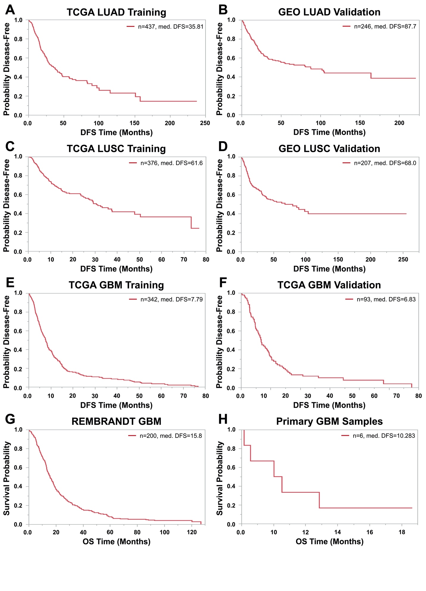
Figure S1. Unstratified survival of training and validation cohorts. Kaplan-Meier survival curves of all patients in training and validation cohorts for LUAD [A,B], LUSC [C,D], and GBM [E-H] are shown. Median DFS or OS times are shown in months. DFS—disease-free survival, OS—overall survival.
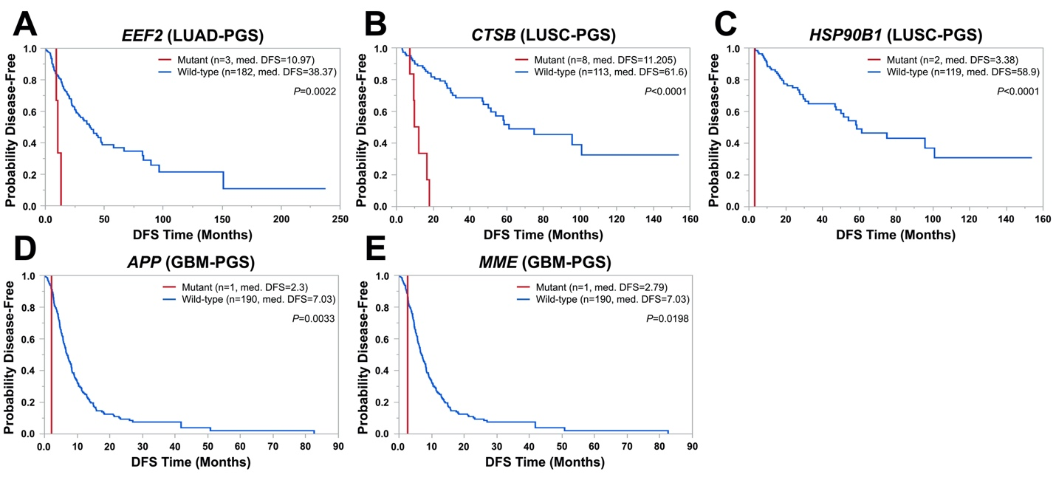
Figure S2. Mutations in PGS genes correlate with poor patient prognosis. Kaplan-Meier survival curves of disease-free survival (DFS) time in patients with mutant or wild-type EEF2 in LUAD [A], CTSB [B] or HSP90B1 [C] in LUSC, and APP [D] or MME [E] in GBM. Median DFS times are shown in months. P-values were calculated using log-rank tests.
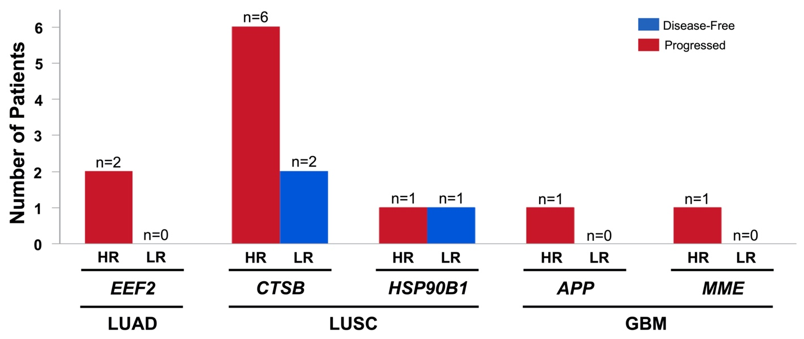
Figure S3. Correlation of mutations in PGS genes with PGS risk groups. Frequencies of high-risk progression (HR) or low-risk progression (LR) stratification in patients with mutant PGS genes are shown. The DFS status of patients in each risk group are shown as blue (disease-free) or red (progressed).
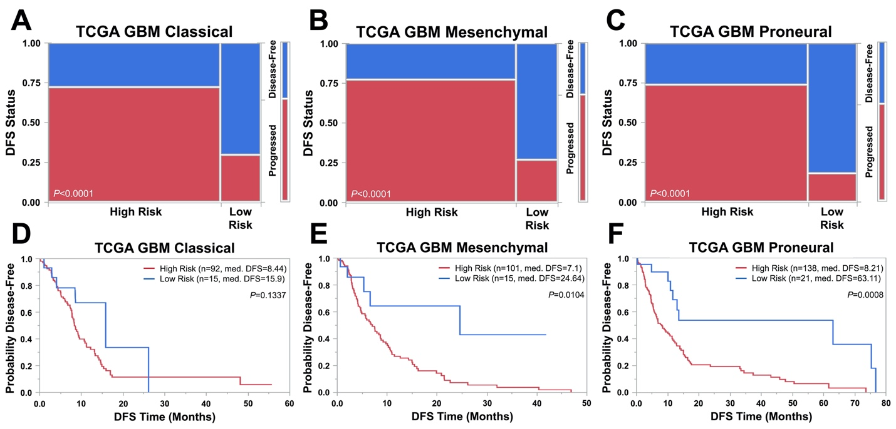
Figure S4. PGS risk groups correlate with tumor progression incidence and disease-free survival in GBM subtypes. [A-C] Patients stratified as high-risk progression (risk score > 0) or low-risk progression (risk score < 0) by GBM-PGS were analyzed for correlations with tumor progression incidence. Fisher’s Exact Tests determined significance of correlation. [D-F] Kaplan-Meier survival curves of disease-free survival (DFS) time between high- and low-risk patients. Median DFS times for each risk group are shown in months. P-values were calculated using log-rank tests. DFS—disease-free survival.
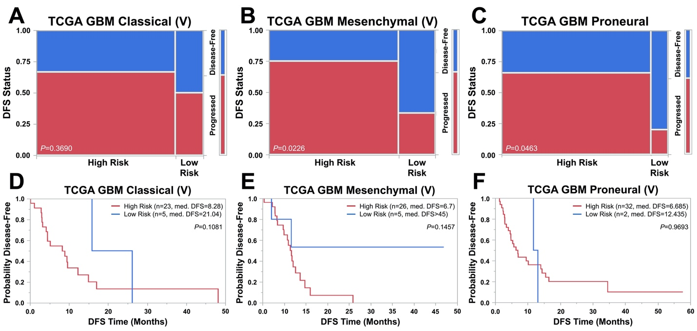
Figure S5. Correlation of PGS risk groups with tumor progression in GBM subtypes in the TCGA GBM validation cohort. [A-C] Patient risk stratification by GBM-PGS in each GBM subtype in the 126-patient TCGA GBM validation cohort. P-values were calculated via Fisher’s Exact Tests. [D-F] Kaplan-Meier survival curves of disease-free survival (DFS) time between high- and low-risk patients. Median DFS times for each risk group are shown in months. P-values were calculated using log-rank tests. DFS—disease-free survival.

