Facile Synthesis and Defect Optimization of 2D-layered MoS₂ on TiO₂ Heterostructure for Industrial Effluent, Wastewater Treatments

Ramalingam Gopal^{1*}, Maria Magdalane Chinnapan², Arjun Kumar Bojarajan¹, Naresh Kumar Rotte ², Joice Sophia Ponraj^{3,4}, Ravi Ganesan⁵, Ivanov Atanas ⁶, Manivannan Nadarajah ⁷, Rajesh Kumar Manavalan⁸, Joao Gaspar⁴
¹Quantum Materials Research Lab (QMRL), Department of Nanoscience and Technology, Alagappa University, Karaikudi - 630003, Tamil Nadu, India.
²Department of Chemistry, St. Xavier College (Autonomus), Tirunelveli 627002, Tamil Nadu, India.
³Centre for Advanced Materials, Integrated-Inter-Department of LiWET Communications, Aaivalayam - Dynamic Integrated Research Academy and Corporations (A-DIRAC), Coimbatore 641046, India
⁴Department of Micro and Nanofabrication, INL–International Iberian Nanotechnology Laboratory, 4715-330 Braga, Portugal
⁵Department of Physics, Alagappa University, Karaikudi 630003, Tamil Nadu, India.
⁶Department of Mechanical, Aerospace and Civil Engineering (MACE), Brunel University, Uxbridge, UK
⁷Department of Design, Brunel University, Uxbridge, UK
⁸Institute of Natural Science and Mathematics, Ural Federal University, 620002 Yekaterinburg, Russia
*Corresponding authors: Dr.G.Ramalingam, Alagappa University, Karaikudi-India.
Email:ramanloyola@gmail.com
C.Maria Magdalane, Department of Chemistry, St.Xavier College (Autonomus), Tirunelveli 627002, Tamilnadu, India. Email:cmagdalane@yahoo.com
Supplementary Information
Characterizations:
X-ray diffraction patterns were recorded using Bruker advance diffractometer with a scanning rate of 5° per min with Cuk_{α} radiation source (λ=1.54060 Å) operating at 40 kV. The optical properties were analyzed using Shimadzu UV-2550 spectrophotometer in the range of 200 to 800 nm. Emission spectra with excitation wavelength of 320 nm were performed by the ultraviolet-visible-near infrared spectrophotometer (Varian Cary Eclipse Photo Luminescence, Oxford Low temperature LN2 77K set up). PHI - VERSAPROBE III – X-ray Photoelectron Spectroscopy was used with Monochromatic X-ray Beam (15 µm). Transmission electron microscopy measurements (TEM) were conducted through JEOL 2100 instrument with an operating voltage of 25KeV. Elemental analysis was performed on energy-dispersive X-ray spectrometer included in the high resolution-TEM. Electrochemical impedance spectroscopy was carried out using BioLogic SP-300 electrochemical workstation operated at 10² to 10⁶ Hz frequency range with 0.5 M KCl solution containing 5.0 mM K₃[Fe(CN)₆]/K₄ [Fe(CN)₆] under open circuit potential conditions.
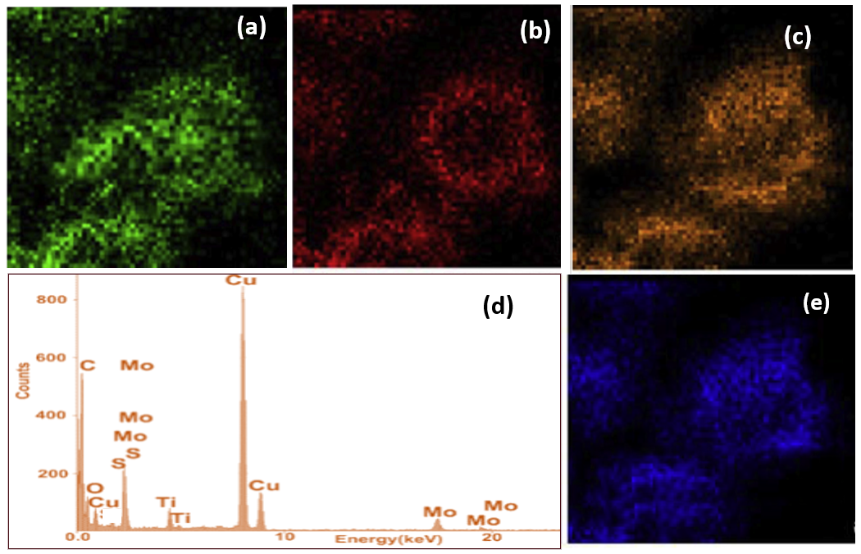
Figure S1. Elemental spectrum (EDAX) and mapping images of Ti, O, Mo, S and figure namely identified (a), (b), (c) and (e) respectively.

Table. ST1.Obtained data from equivalent circuit [R_{s}(Q_{dl}(R_{CT}(Q _{dl} (R_{E}W))))]for PT, MT, L-MT
Code | Rs /Ω cm² | Q_{dl}/ F cm⁻² | n | R_{CT} /Ω cm² | Q_{dl}/ F cm⁻² | n | R_{E} /Ω cm² | W/cm s⁻¹
L-MT | 34.06 | 1.05x10⁻⁸ | 0.9039 | 336.7 | 2.4x10⁻⁵ | 0.8732 | 0.3509 | 1x10⁻²⁰
MT | 46.57 | 3.96x10⁻⁹ | 0.9582 | 426.8 | 4.211x10⁻⁵ | 0.8217 | 1.25x10¹¹ | 1x10⁻²⁰
PT | 373 | 1.353x10⁻⁵ | 0.8635 | 488.2 | 0.001714 | 0.56 | 5320 | 0.02407

Table ST2. Evaluation of photocatalysis and comparison with reported ones in dye degradation.
Nanocomposite | Dye | Deg.Time Deg.( %) | Light source | (mg)Cat / (mg/L)Dye, mlDye | Ref
3DMoS₂@TiO₂ @poly (methyl methacrylate) | Methyl Orange (MO) | 50 min  95.7% | UV Light | 100mg/10(mg/L), 100 ml | ²⁵
MoS₂ titania nanoheterojunctions | Methylene Blue(MB) | 100 min  90% | 20 W  tungsten halogen lamp | 10mg/10(mg/L), 100ml | ³⁰
TiO₂/MoS₂  composite | MO | 10 min  97% | 500 W xenon long-arc lamp | 400mg/(20mg/L), 100ml | ⁵⁷
3D MoS₂ nanosheet/TiO₂ nanofiber heterostructures | Rhodamine B(Rh B), MO | 120 min  98.2%, 97.0% | 50 W  high-pressure  mercury lamp | 10mg/10(mg/L), 100ml | ⁵⁸
CdS–TiO₂–Au | MO | 300 min 98% | 400 W metal halogen lamp | 150 mg/10(mg/L), 100 ml | ⁵⁹
1D CdS NWs@TiO₂ NPs | Mixture of MO Rh B MB | 120 sec 120 sec 180 sec  98.2% 99.2% ~100% | Sunlight | 15 mg/10(mg/L), 10 ml  15 mg/10(mg/L) , 10 ml  15 mg/10(mg/L) , 10 ml | ⁶⁰
CdS/TiO₂ heteronanofibers | MB | 170 min 86% | 800 W xenon lamp | 100 mg/20(mg/L), 200 ml | ⁶¹
Co/Ti LDH | CR | 75 min 99.7% | 300 W tungsten lamp | 15 mg/5(mg/L), 200 ml | ⁶²
ZrO₂/TiO₂ | RhB | 50min  100% | UV light (18 W, l = 254 nm) | 30 mg/10(mg/L), 30 ml | ⁶³
SnO₂/TiO₂ | Malachite green (MG) | 75 min, 94%. | 400 W metal halogen lamp | 60 mg/30(mg/L), 100 ml | ⁵⁴
L-cysteine capped MoS₂@TiO₂  (L-MT) | CR | 120 min, 97%. | 400 W metal halogen lamp | 60 mg/15(mg/L), 100 ml | Present work

