Supporting information

Temporal variations of ⁹⁰Sr and ¹³⁷Cs in atmospheric depositions after the Fukushima Daiichi Nuclear Power Plant accident with long-term observations

Takeshi Kinase^{1,*}, Kouji Adachi¹, Tsuyoshi Thomas Sekiyama¹, Mizuo Kajino¹, Yuji Zaizen¹, and Yasuhito Igarashi^{2,3}

¹Meteorological Research Institute, 1-1 Nagamine, Tsukuba, Ibaraki, 305-0052, Japan.
²Institute for Integrated Radiation and Nuclear Science, Kyoto University (KURNS), 2, Asashiro-Nishi, Kumatori, Sennan, Osaka, 590-0494, Japan
³Ibaraki University, 2-1-1, Bunkyo, Mito, Ibaraki, 310-8512, Japan
*corresponding author: tkinase@mri-jma.go.jp

This file contains the following contents (11 pages in total, 8 figures, 1 table):

Figure S1: Locations of the sampling sites
Figure S2: Ratio of ¹³⁴Cs and ¹³⁷Cs
Figure S3: Measurements of ¹³⁷Cs in aerosol samples
Figure S4: Comparison of the Chernobyl and FDNPP accidents
Figure S5 and S6: Seasonal variations in ¹³⁷Cs deposition
Figure S7: Physical and chemical features of the deposition sample
Figure S8: Activity ratios of ⁹⁰Sr and ¹³⁷Cs depositions between sites A and B
Text and Table S1: Calculations of effective half-lives of ¹³⁷Cs in atmospheric depositions and aerosol

Locations of the sampling sites

Site A is located on the Kanto Plain, and site B is located at the top of Mt. Haruna, which is situated along the northwest edge of the Kanto Plain (Figure S1). Site A is surrounded by a mixed environment of urban and rural areas, including both human activities (e.g., traffic) and natural activities. Site B is surrounded by a mixed forest consisting of deciduous and coniferous trees. The altitude of the free troposphere sometimes descends below site B, and the long-range transport of kosa (Asian dust) may reach site B^{1–4}. Land use data were obtained from the Ministry of Land, Infrastructure, Transport and Tourism, Japan⁵, and a land use map was generated by their mapping system on the referenced website (https://nlftp.mlit.go.jp/ksj/index.html)⁵.

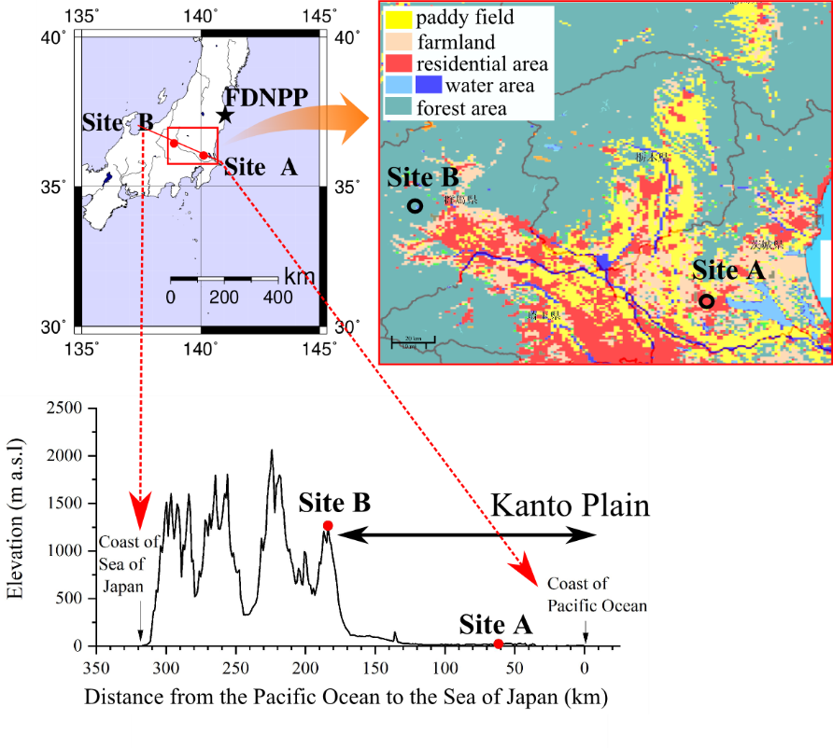
Figure S1. Horizontal and vertical maps of the study area.

Ratio of ¹³⁴Cs and ¹³⁷Cs

Figure S2 shows the correlations between the observed and calculated ¹³⁴Cs/¹³⁷Cs ratios in the atmospheric deposition samples after the FDNPP accident. The theoretical values of ¹³⁴Cs/¹³⁷Cs at the given sampling times were calculated using the physical half-life based on the March 2011 data. The correlations and slopes approached unity at sites A and B. These correlations indicate that most of the ¹³⁷Cs originated from the FDNPP accident because it was the only detectable source of ¹³⁴Cs thereafter. The detection limit obtained by multiplying each counting error measured in 2018 by three was 16.4 mBq m⁻² for the detected ¹³⁴Cs in the deposition samples.

Figure S2. Relations of ¹³⁴Cs/¹³⁷Cs between the observed and calculated values.

Measurements of ¹³⁷Cs in the aerosol samples

Figure S3 shows the variation in the activity concentration in the aerosol samples (the atmospheric activity concentration). The effective half-lives of the short- and long-lived components of the aerosol samples were 48.4 days and 1.6 years, respectively. The effective half-life in regard to the atmospheric activity concentration was shorter than that of deposition (Table S1). The seasonal variation in the aerosol activity was different from that in the observed deposition and was high in winter and spring and low in summer. These results indicate that the radionuclide amounts in the deposition samples are independent of the radionuclide amounts in the aerosols. The detection limit of ¹³⁷Cs is 5.71×10⁻⁴ in the atmospheric aerosol samples, which is determined by multiplying each counting error measured in 2018 by three.

Figure S3. Atmospheric activity concentration of ¹³⁷Cs after the accident from 2011 to 2018. All data are marked with gray points, and the monthly median values are marked with black points. The pink lines indicate the regression curves. The green and blue lines indicate the exponential curves determined via fitting analysis.

Comparison of the Chernobyl and FDNPP accidents

A comparison of the decrease rates during the initial periods after the Chernobyl and FDNPP accidents is shown in Figure S4. Multiple (three) exponential fitting curves were adopted for the comparisons. The t₁, t₂, and t₃ values are the effective half-lives in regard to the first-term (direct emission), second-term (tropospheric circulation and removal), and third-term (resuspension) decreases, respectively, in ¹³⁷Cs deposition. The initial decrease rates after the Chernobyl accident were lower than those after the FDNPP accident. A possible reason is the differences in the plume advection height. In the Chernobyl accident case, plumes passed across site A at altitudes between 1500 and 6300 m⁶, resulting in only the wet deposition process being the dominant process in terms of radionuclide deposition. However, in the FDNPP accident case, plumes passed near the ground surface, resulting in an ~100 times higher surface soil contamination than that in the Chernobyl case and more detectable resuspension than that in the Chernobyl case. In addition, the chemical and physical properties of the host particles could be different. In particular, insoluble radioactive particles, which generally tend to be larger than soluble particles, were deposited only in the FDNPP case⁷. These discrepancies could cause the observed differences in decrease rate between the two accident cases.

Figure S4. Decrease rates during the initial periods after the (a) Chernobyl and (b) FDNPP accidents and their calculated effective half-live.

Seasonal variation in ¹³⁷Cs deposition

The variations in the ¹³⁷Cs activity in atmospheric deposition are shown in Figures S5 and S6.
Seasonal variations were found at sites A and B before the FDNPP accident. After the FDNPP accident, the observed seasonal variations decreased at both sites because of the contamination surrounding sites A and B.

Figure S5. Monthly plot of ¹³⁷Cs deposition after (a) and before (b) the accident at site A.

Figure S6. Monthly plot of ¹³⁷Cs deposition after (a) and before (b) the accident at site B.

Physical and chemical features of the deposition sample

Figure S7 shows SEM and elemental mapping images of deposition samples collected in October 2016 at site B. Most of the cubic-like particles are salt particles such as KCl, indicating that K occurred in the soluble state in the deposition samples. On the other hand, Ca and Mg occurred in the matrix, which was a mixture of organics and salts. Mineral particles containing Si, Al, and Fe were relatively less abundant.

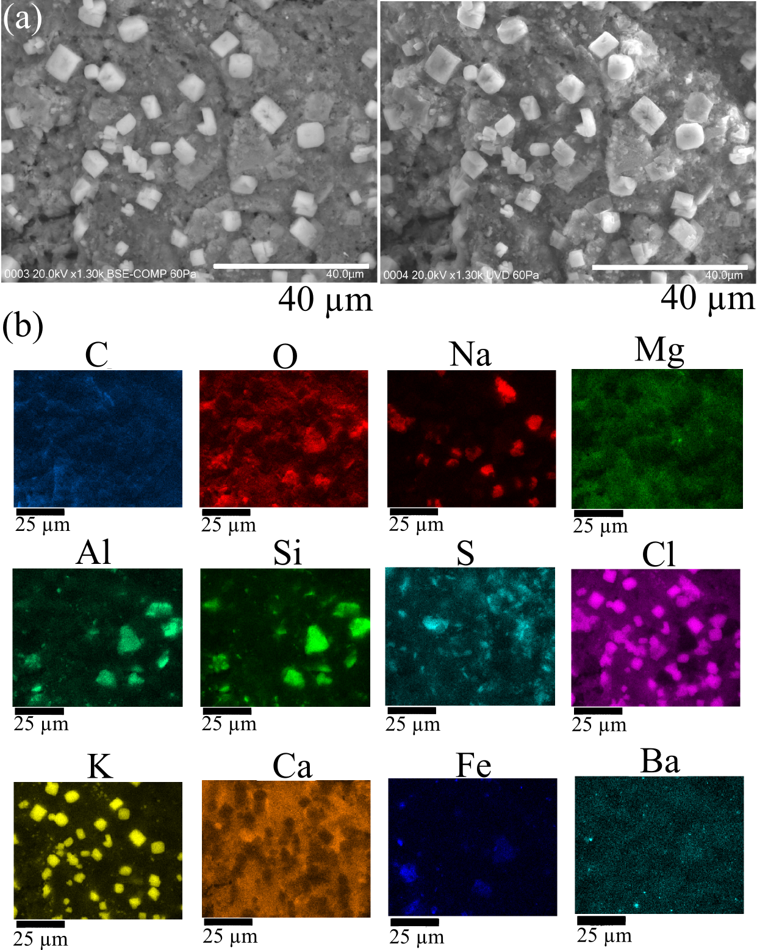
Figure S7. SEM images and composition of deposition samples collected in October 2016 at site B. (a) SEM images and (b) elemental maps of C, O, Na, Mg, Al, Si, S, Cl, K, Ca, Fe, and Ba.
Activity ratios in ⁹⁰Sr and ¹³⁷Cs deposition between sites A and B

The activity ratios of ⁹⁰Sr and ¹³⁷Cs in atmospheric deposition at sites B and A (R_{B/A}) are shown in Figure S8. Before the FDNPP accident, site B exhibited higher ⁹⁰Sr and ¹³⁷Cs activity than site A. The R_{B/A} values in terms of the annual ⁹⁰Sr and ¹³⁷Cs depositions reached minimum and maximum values between 2007 and 2009 of 7.6 (6.1–10.5) and 2.7 (1.6–3.7), respectively. After the FDNPP accident, these ratios largely changed, and the R_{B/A} values for both ⁹⁰Sr and ¹³⁷Cs deposition reached 0.60 in March 2011 because of the higher contamination at site A than that at site B due to the passing of at least three direct plumes over site A⁷ (Figure S3). After 2012, the R_{B/A} value exhibited opposite trends between ⁹⁰Sr and ¹³⁷Cs, i.e., the R_{B/A} value for ¹³⁷Cs decreased and that for ⁹⁰Sr increased over time.
The radioactivity in ¹³⁷Cs deposition at site A decreased faster than that at site B, resulting in an increase in the annual R_{B/A} value to 4.8 in 2012. After 2012, the R_{B/A} values in the annual ¹³⁷Cs deposition gradually decreased and reached nearly unity in 2016. The R_{B/A} value of ¹³⁷Cs from 2016–2018 remained stable but lower than that before the FDNPP accident.
In contrast to the ¹³⁷Cs ratio, the R_{B/A} value in ⁹⁰Sr deposition increased over time. After 2012, the R_{B/A} value remained higher than unity and reached ~13.0 in 2017, which is higher than the average value before the accident.

Figure S8. Annual changes in the activity ratios at sites B and A for (a) ¹³⁷Cs and (b) ⁹⁰Sr in atmospheric deposition after the accident.

Calculation of the effective half-life of ¹³⁷Cs in atmospheric deposition and aerosols

We estimated the effective half-life using multiple exponential functions, obtained by fitting atmospheric deposition and aerosol data from site A and B w.r.to time, as follows:

${}_{}^{137}Cs deposition/aerosol=y_{0}+A_{1}× e^{\frac{-0.693}{t_{1}}×x}+A_{2}× e^{\frac{-0.693}{t_{2}}×x}$ (1)

where, A₁ and A₂ are the estimated radioactivity of the short- and long-lived components, respectively, in March 2011, and t₁ and t₂ are the corresponding effective half-lives. x is the elapsed times from January 2012, and y₀ is the background level of ¹³⁷Cs. The y₀ value of deposition at site A was calculated using data from 1990 as shown below:

$y_{0}=A_{2}×e^{\frac{-0.693}{t2}×x_{p}}$ (2)

where, x_{p} is the elapsed time from January 1990. The y₀ value of deposition at site B was calculated based on the average values between July 2009 and June 2010. The y₀ value of the atmospheric ¹³⁷Cs (aerosol) was calculated using the detection limit. The fitting process was weighted by each measurement value. In regard to the atmospheric ¹³⁷Cs, the median values in each month were adopted. The detailed results of the calculations are summarized in Table S1. In table S1, standard errors of t₂ values of the atmospheric deposition at sites A and B were estimated as larger values than t₂ values. Because we could use only seven years for this analysis, observation data is not sufficient for accurate estimations of t₂ values (approximately five years).

 | y₀ (mBq m⁻²  & mBq m⁻³) | A₁  (mBq m⁻² & mBq m⁻³) | t₁ (days) | Standard error (days) | A₂  (mBq m⁻² & mBq m⁻³) | t₂ (days) | Standard  error  (days)
Atmospheric deposition at site A | Calculated by eq. (2) | 22770.0 | 194.7 | 71.7 | 3023.1 | 1713.7 | 2349.4
Atmospheric deposition at site B | 23.0 | 61065.8 | 147.9 | 57.6 | 5747.5 | 2160.6 | 4506.7
Atmospheric deposition at site A  between 1990 and 2010 | 0 | 0 | 0 | 0 | 22.2 | 3098.8 | 1702.4
Atmospheric aerosol samples at site A | 5.7×10⁻⁴ | 0.042 | 48.4 | 15.4 | 0.029 | 582.9 | 45.8
Table S1. Summary of the regression curve calculation results for ¹³⁷Cs in atmospheric deposition and aerosol samples.

REFERENCES
- Hirose, K., Igarashi, Y., Aoyama, M. & Inomata, Y. Depositional behaviors of plutonium and thorium isotopes at Tsukuba and Mt. Haruna in Japan indicate the sources of atmospheric dust. J. Environ. Radioact. 101, 106–112, DOI: https://doi.org/10.1016/j.jenvrad.2009.09.003 (2010).
- Inomata, Y., Igarashi, Y., Naoe, H.. Takahashi, H., Shimizu, A., Sugimoto, N. & Tanaka, T. Y. Influence of blocking effect of mountain and local front on two Asian-dust events observed at Mt. Haruna and Tsukuba in Kanto, Japan, in 2007. Atmos. Environ. 45, 4429–4441, DOI: https://doi.org/10.1016/j.atmosenv.2011.05.038 (2011).
- Takahashi, H., Noe, H., Igarashi, Y., Inomata, Y. & Sugimoto, N. Aerosol concentrations observed at Mt. Haruna, Japan, in relation to long-range transport of Asian mineral dust aerosols. Atmos. Environ. 44, 4638–4644 DOI: https://doi.org/10.1016/j.atmosenv.2010.08.007 (2010).
- Zaizen, Y., Naoe, H., Takahashi, H. & Okada, K. Modification of Asian-dust particles transported by different routes – A case study. Atmos. Environ. 97, 435–446, DOI: https://doi.org/10.1016/j.atmosenv.2014.05.005 (2014).
- Ministry of Land, Infrastructure, Transport and Tourism, Japan. Land Use Information (translated from the original page title written in Japanese), http://nlftp.mlit.go.jp/ksj/index.html (last accessed June 12, 2020).
- Higuchi, H., et al., Radioactivity in surface air and precipitation in Japan after the Chernobyl accident. J. Environ. Radioact. 6, 131–144, DOI: https://doi.org/10.1016/0265-931X(88)90056-2, (1988).
- Adachi, K. Kajino, M. Zaizen, Y. & Igarashi, Y. Emission of spherical cesium-bearing particles from an early stage of the Fukushima nuclear accident. Sci. Rep. 3, 2554, DOI: https://doi.org/10.1038/srep02554 (2013).

