TITLE: DEVELOPMENT OF A HUMAN PRIMARY GUT-ON-A-CHIP TO MODEL INFLAMMATORY PROCESSES

AUTHORS:
Claudia Beaurivage^{1,2}, Auste Kanapeckaite¹, Cindy Loomans¹, Kai S. Erdmann², Jan Stallen¹, Richard A.J. Janssen^{1,*}

¹Galapagos BV, Leiden, South Holland, 2333CL, The Netherlands
²Department of Biomedical Science, Faculty of Science, University of Sheffield, Sheffield, South Yorkshire, S10 2TN, United Kingdom
* Corresponding author

SUPPLEMENTARY INFORMATION
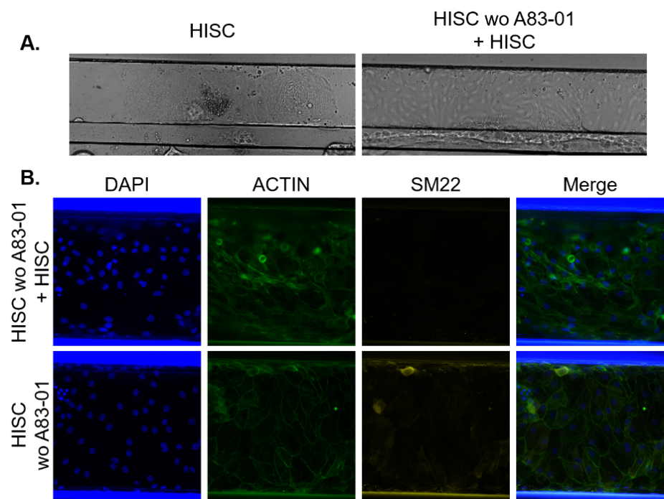
Figure S1. Optimized HISC medium favours IEC attachment
A. Representative 10X brightfield stitched images of HIO donor growing in microfluidic conditions for 8 days in HISC medium (left panel) or in HISC without A83-01 for 2 days followed by HISC for 6 days (right panel, wo=without). B. Representative 20X photographs of polarization marker ACTIN and EMT marker SM22 in HIO (donor 1) grown in microfluidic conditions for 8 days in HISC medium without A83-01 for 2 days followed by 6 days of HISC medium (top panel) or in HISC without A83-01 for 8 days (bottom panel). Blue depicts nuclei by DAPI staining. Images were created with the Image J software (version 1.47v, https://imagej.nih.gov/ij/).

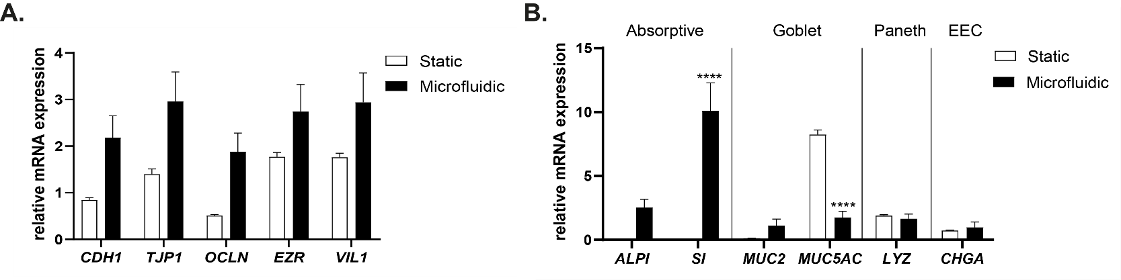
Figure S2. HIO cultured under microfluidic conditions show higher expression of polarization and differentiation markers
mRNA expression level of (A.) polarization markers CDH1, TJP1, OCLN, EZR and VIL1 and (B.) differentiation markers ALPI, SI, MUC2, MUC5AC, LYZ and CHGA in HIO donor 3. HIO were grown in static condition or in monolayers subjected to fluid flow (microfluidic) for 8 days. Graph shows average relative expression values normalized to RPS18, HPRT1, GUSB and YWHAZ ± SEM with two-way ANOVA with Sidak’s post-hoc test compared to the static condition (n=3).

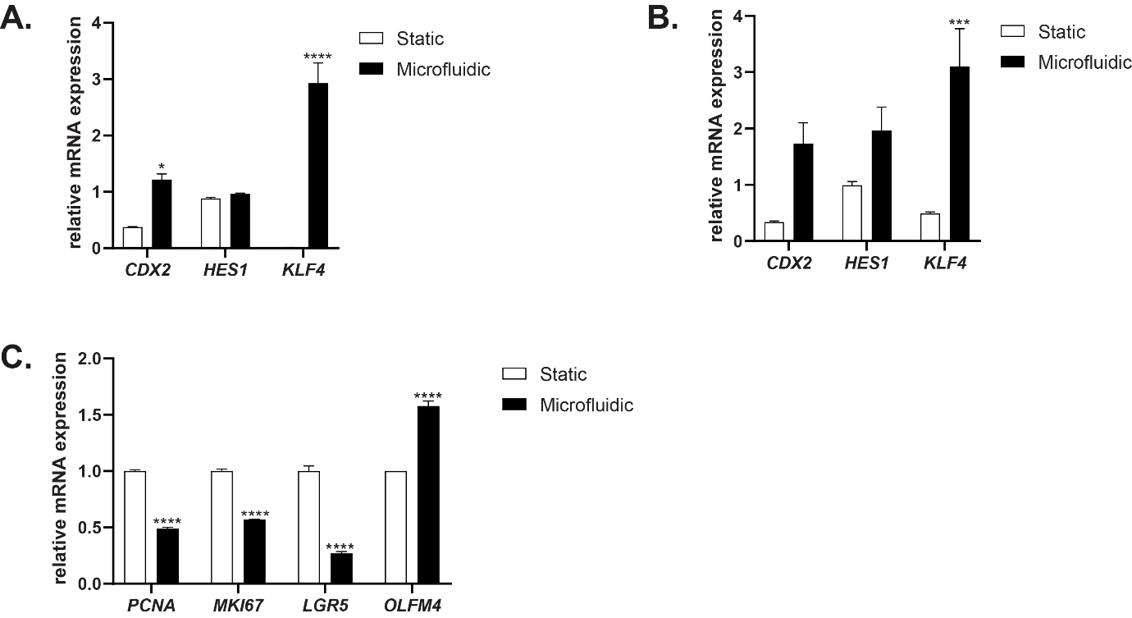

Figure S3. HIO cultured under microfluidic conditions seem to favour differentiation over proliferation pathways
A-B. mRNA expression level of differentiation transcription factors CDX2, HES1 and KLF4 in HIO donor 2 (A.) and HIO donor 3 (B.). C. mRNA expression level of proliferation markers PCNA and MKI67 and stem cell markers LGR5 and OLFM4 in HIO donor 3. A-C. HIO were grown static condition or in monolayers subjected to fluid flow (microfluidic) for 8 days. Graph shows average relative expression values normalized to RPS18, HPRT1, GUSB and YWHAZ ± SEM with with two-way ANOVA with Sidak’s post-hoc test compared to the static condition (n=3).
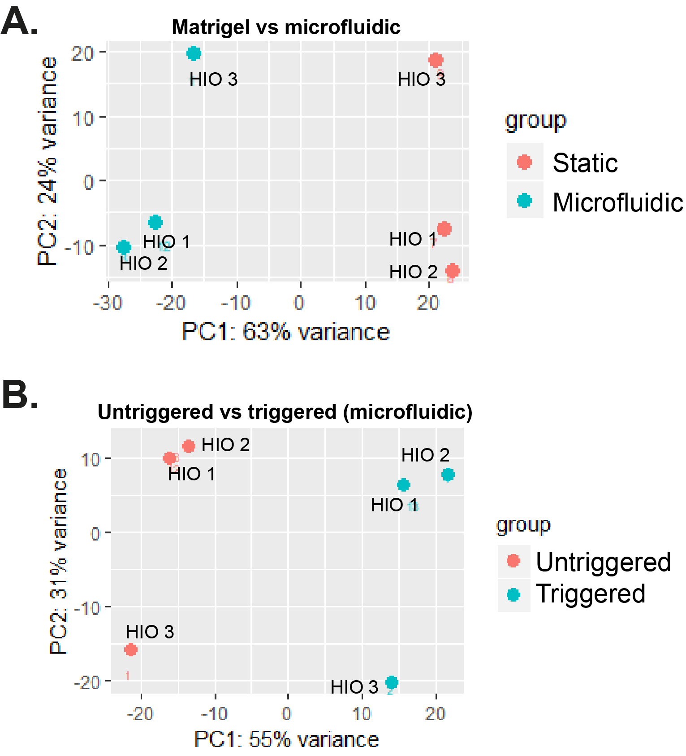
Figure S4. Principal component analysis (PCA) plots
A. 3 HIO donors were grown in static (red) or microfluidic conditions (blue). B. 3 HIO donors were grown in microfluidic conditions and triggered using LPS [100 ng/mL] and IFN-γ [20 ng/mL] for 24 h (blue) or left untriggered (red). In the 2 plots, a clear separation between the 2 experimental groups is observed. HIO donor 3 also shows a clear distinction, but is segregated from HIO donor 1 and 2 in all groups.

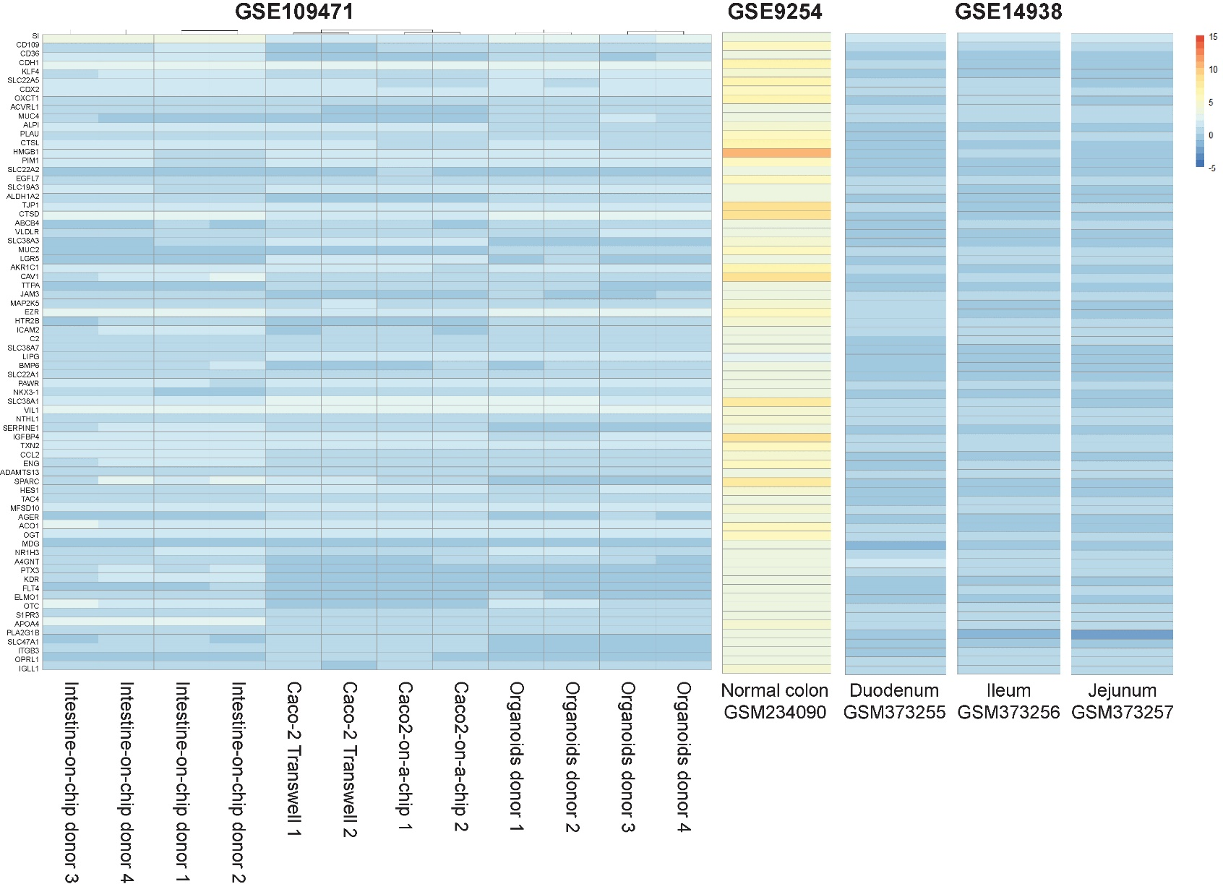
Figure S5. RNA expression profiles of Caco-2 gut-on-a-chip resemble small intestinal segments
Heatmap representation of the RNA expression profile of 72 genes defining intestinal identity in HIO from three donors grown in static or microfluidic conditions for 8 days, compared with human normal colon from study GSE9254 (LaPointe et al., 2008) and human normal small intestine sections (duodenum, jejunum, ileum) from study GSE14938 (She et al., 2009).
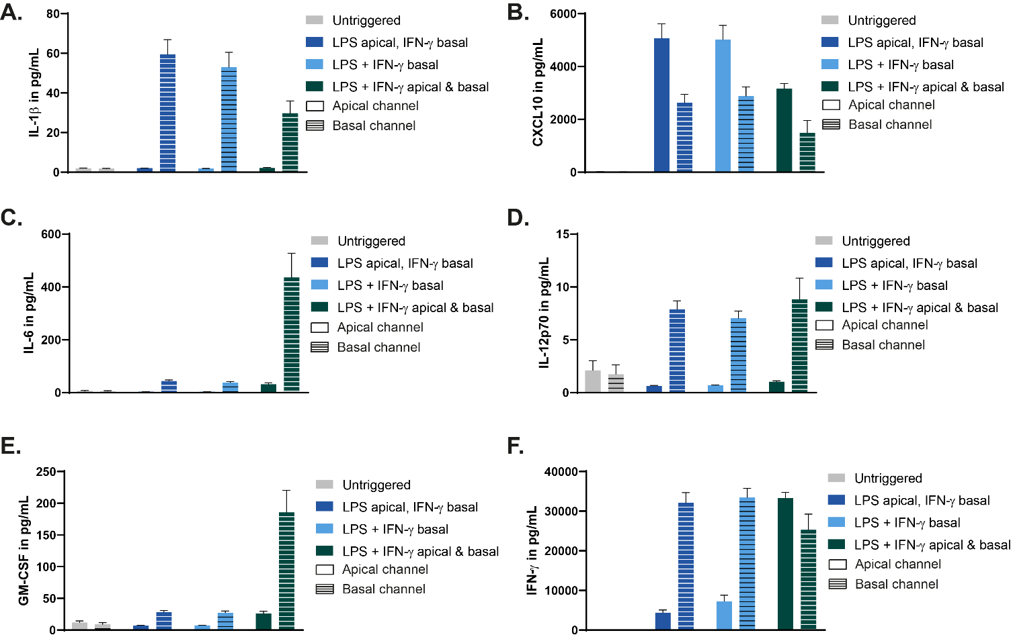

Figure S6. Asymmetric responses of IEC to inflammatory stimuli
A-F. Apical and basolateral secretion of IL-1β (A.), CXCL10 (B.), IL-6 (C.), IL-12p70 (D.), GM-CSF (E.) and IFN-γ (F.) in IEC from HIO donor 2 at Day 8 after application of LPS [100 ng/mL] and IFN-γ [20 ng/mL] for 24 h. Trigger constituents were either segregated in different channels (LPS apical, IFN- γ basal; dark blue bars), applied together in the basal channel only (pale blue bars) or applied together simultaneously in the apical and basal channels (green bars). Bars represent average cytokine production [pg/mL] ± SEM (n=4-10).

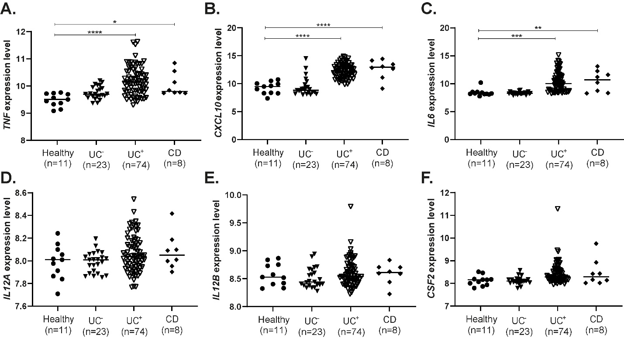
Figure S7. The expression of multiple inflammatory cytokines is overexpressed in the colonic mucosa of IBD patients
A-G. Gene expression of TNF (A.), CXCL10 (B.), IL6 (C.), IL12A (D.), IL12B (E.) and CSF2 (F.) in mucosal colonic biopsies of human patients from GSE59071 (UC⁻= inactive ulcerative colitis, UC⁺=active ulcerative colitis, CD=Crohn’s disease) (Vanhove et al., 2015). Each symbol represents expression data from one individual patient, horizontal bars denote median values. One-way ANOVA with Dunnett’s post-hoc test compared to healthy samples (n=8-74).

