SUPPLEMENTARY INFORMATION
Title
Heatwaves during low tide are critical for the physiological performance of intertidal macroalgae under global warming scenarios

Author list
Marta Román¹², Salvador Román¹², Elsa Vázquez¹², Jesús Troncoso¹², Celia Olabarria¹²

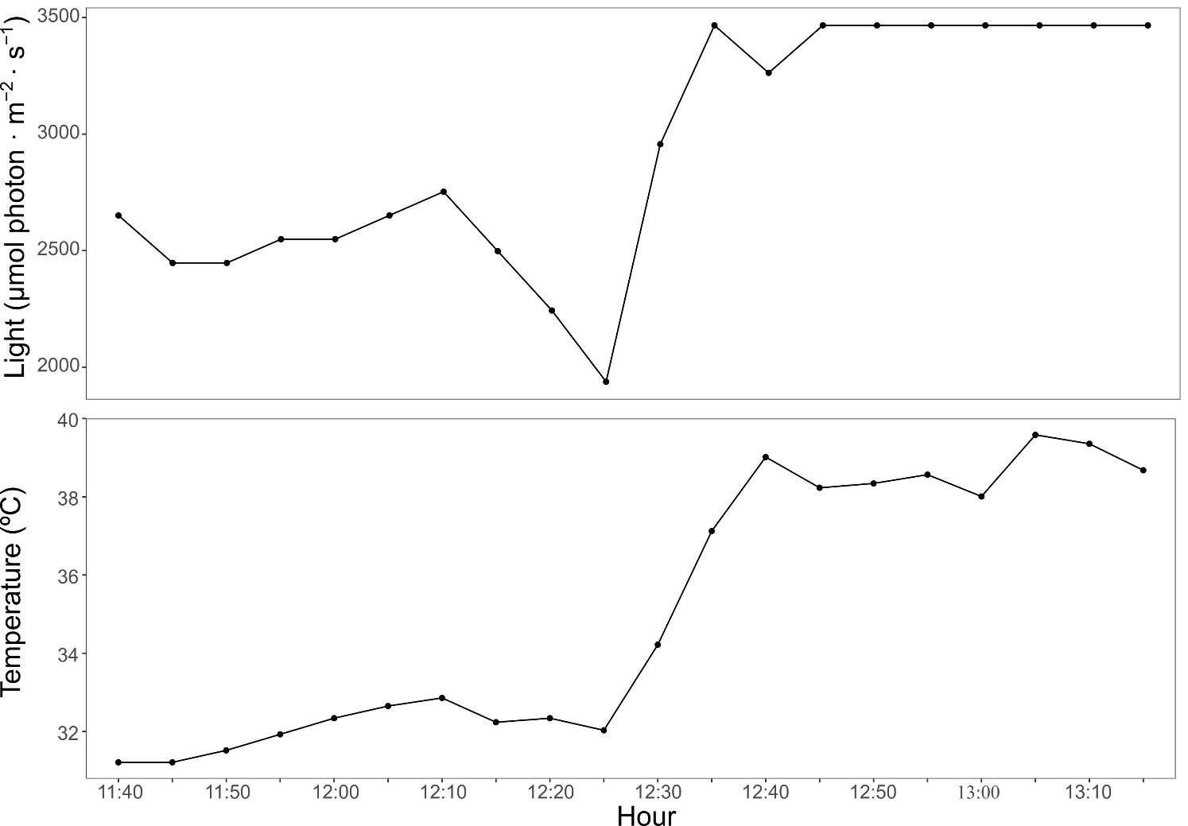

SUPPLEMENTARY FIGURE S1. Light and temperature profiles registered by a data logger placed on the bare rock during the field measurements.

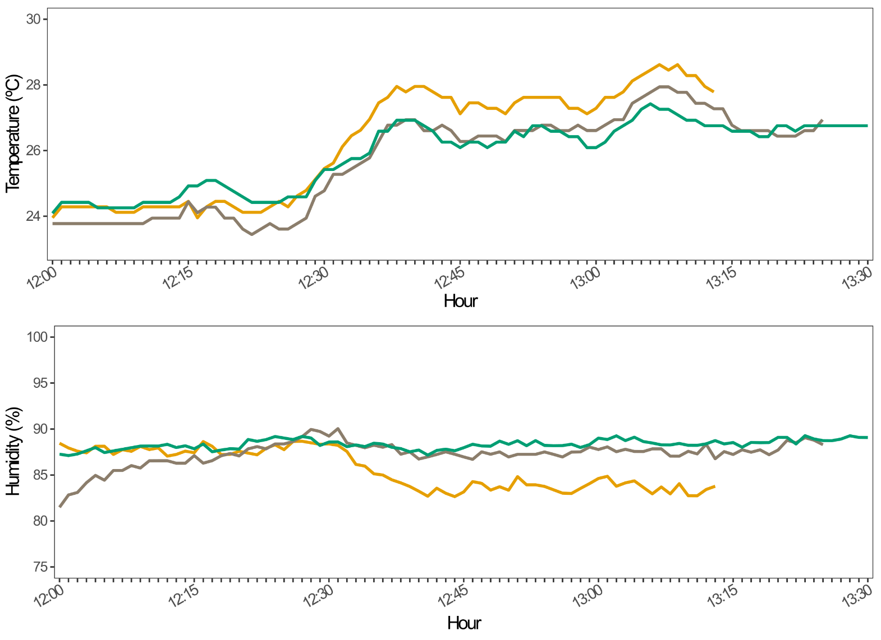
SUPPLEMENTARY FIGURE S2. Temperature and humidity profiles below the canopies of the three macroalgae during the field measurements. Maximum standard errors (±) for B. bifurcata, C. tamariscifolia and C. tomentosum (n=3), respectively: Temperature= 1.6, 1.4, 1.9; Humidity = 3.5, 2.9, 3.2.

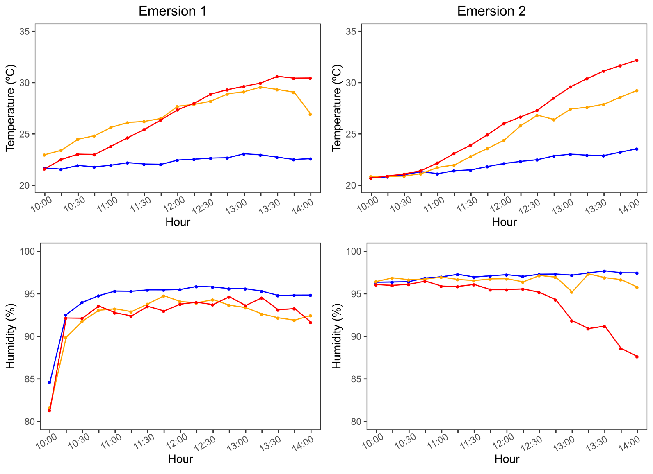
SUPPLEMENTARY FIGURE S3. Temperature and humidity profiles below the canopies of the three macroalgae during experimental emersion. The blue line represents the control emersion (~23.2ºC), the yellow line represents the emersion under atmospheric heatwave (~32.7ºC) and the red line represents the emersion under extreme atmospheric heatwave (~35.7ºC). Maximum standard errors (±) for control, atmospheric heatwave and extreme atmospheric heatwave emersion periods (n= 6), respectively: Temperature= 0.5, 1.5, 0.8; Humidity = 1.4, 3.9, 3.0.

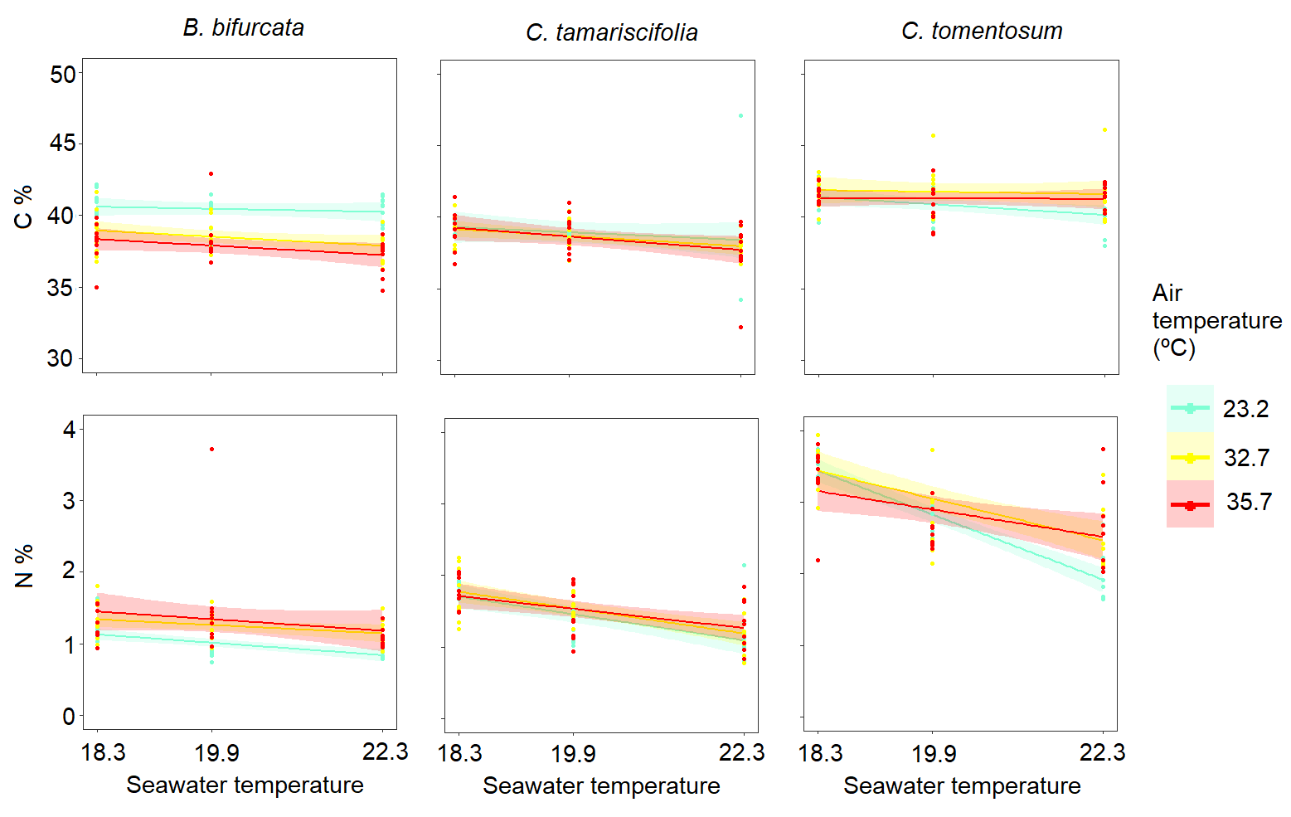
SUPPLEMENTARY FIGURE S4. C % and N % as a function of seawater temperature (control~ 18.3 ºC, marine heatwave~ 19.9 ºC and extreme marine heatwave~ 22.3 ºC) in fronds exposed to air temperature treatments (control ~23.2 ºC, atmospheric heatwave ~32.7 ºC and extreme atmospheric heatwave ~35.7 ºC) during emersion. The points are the replicates and the smoothed curves are the data fitted by GLMs with a confidence interval of 95%.

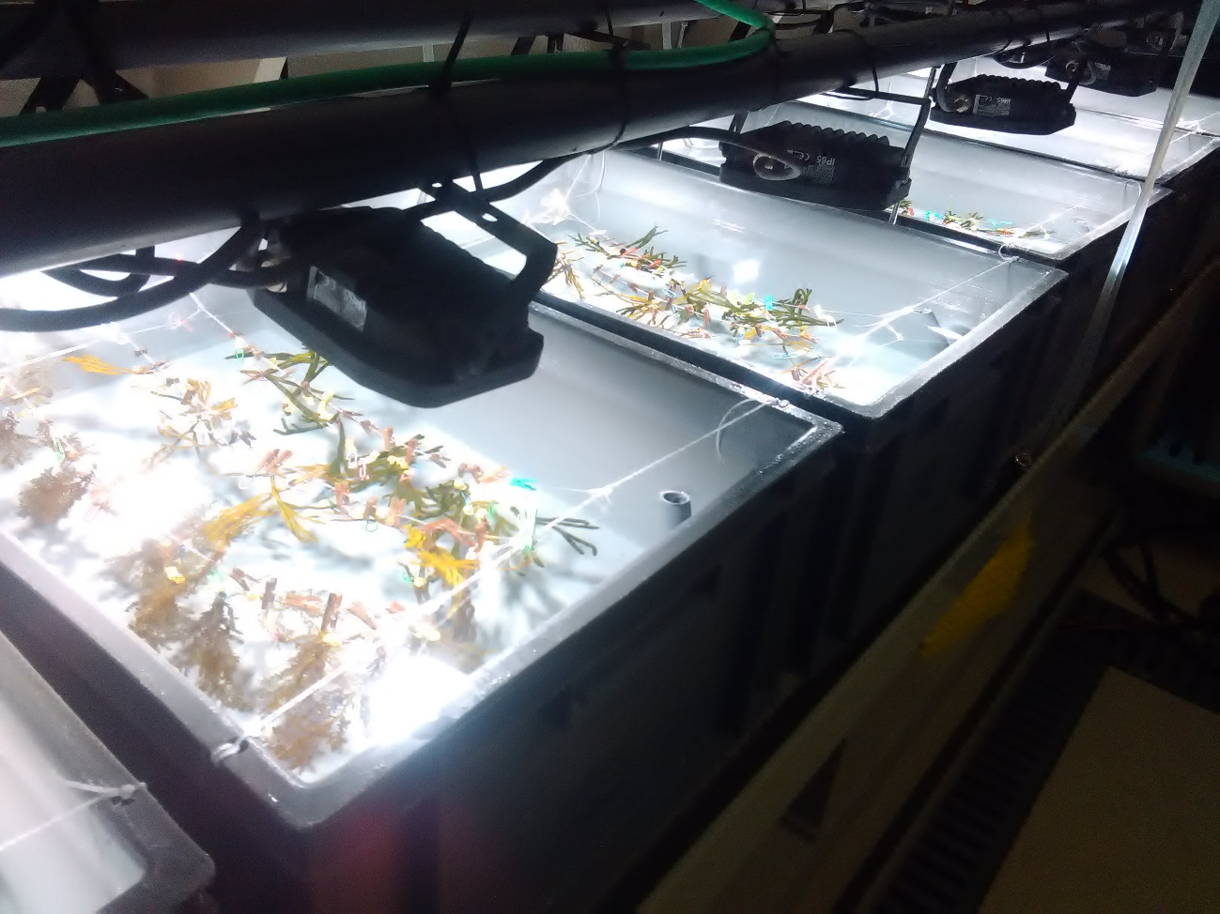
SUPPLEMENTARY FIGURE S5. Experimental set-up showing the distribution of macroalgal fronds in the tanks of seawater at different temperatures.

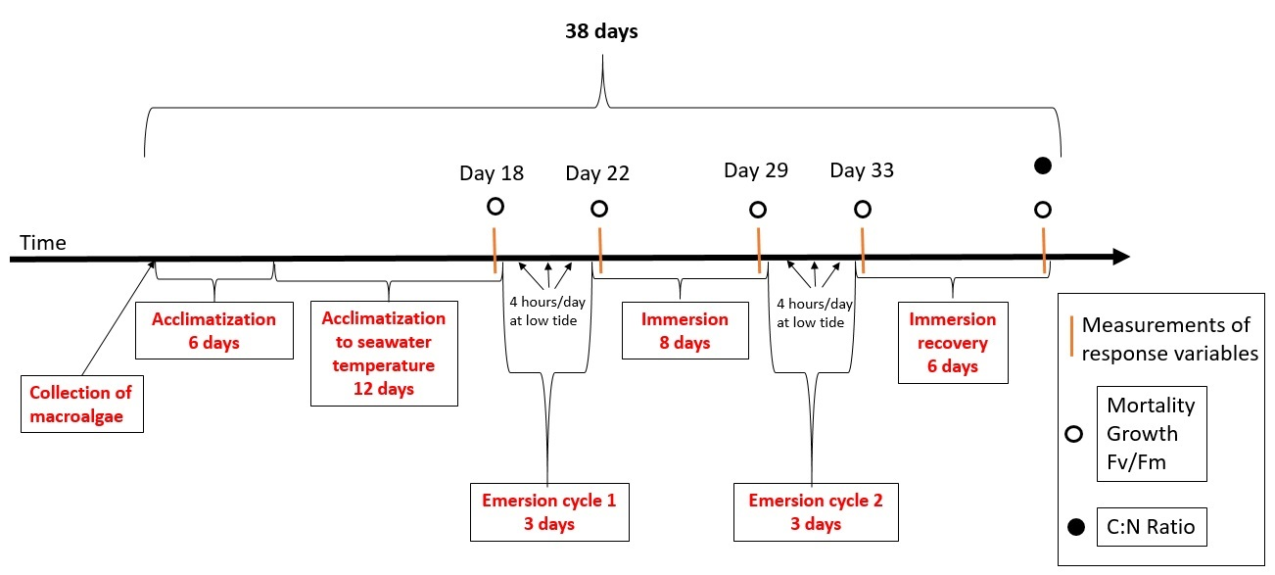
SUPPLEMENTARY FIGURE S6. Timing of the laboratory experiment.

