Supplementary Information
Characteristics and Electrochemical Performances of Silicon/Carbon nanofiber/Graphene Composite Films as Anode Materials for Binder-Free Lithium-Ion Batteries

Ruye Congª, Jin-Yeong Choiª, Ju-Beom Song^{b}, Minsang Jo^{C}, Hochun Lee^{C},
Chang-Seop Lee^{a,*}

ªDepartment of Chemistry, Keimyung University, Daegu 42601, Korea
^{b}Department of Chemical Education, Kyungpook National University, Daegu 41566, Korea
^{C}Department of Energy Science and Engineering, DGIST, Daegu 42988, Korea

*Corresponding author: Chang-Seop Lee
Department of Chemistry, Keimyung University, Daegu 42601, Korea
Phone No: +82-53-580-5192; Fax No: +82-53-580-5056
E-mail: surfkm@kmu.ac.kr

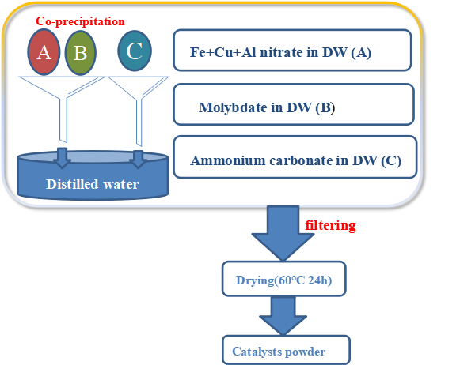
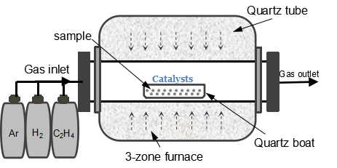
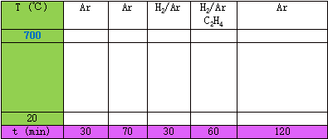

Fig. S1. Process for preparing the catalysts and the synthesis of carbon nanofibers.

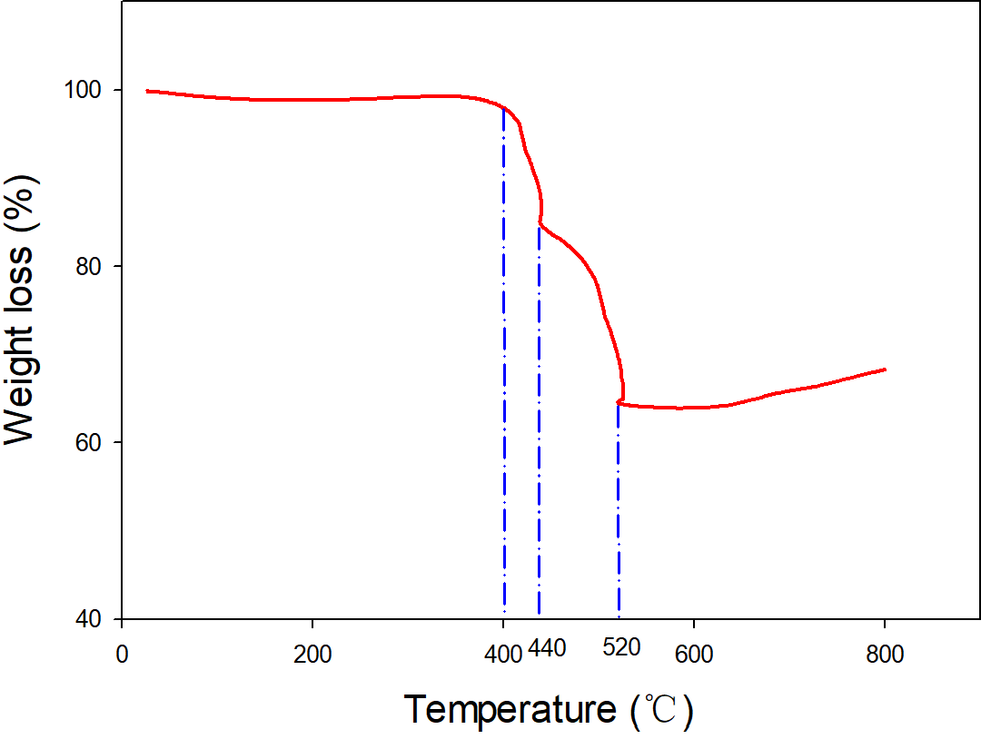
Si:64.25 wt%
CNFs:20.75 wt%
rGO:15 wt%
rGO

CNFs

Fig. S2. TGA curves of the Si:CNF/rGO =1:1 composite.

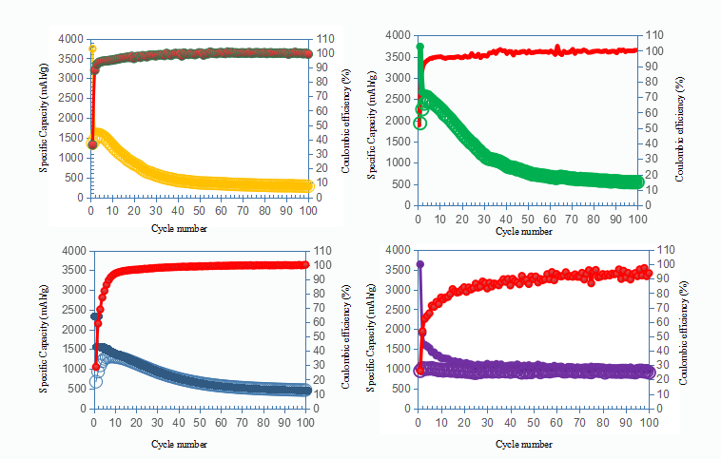
a
d
c
b

Fig. S3. Cycling performances of the synthesized Si/rGO (a), Si:CNF/rGO = 3:2 (b), Si:CNF/rGO = 2:3 (c), and Si:CNF/rGO = 1:1 (d) composite electrodes at a current density of 0.1A·g⁻¹.

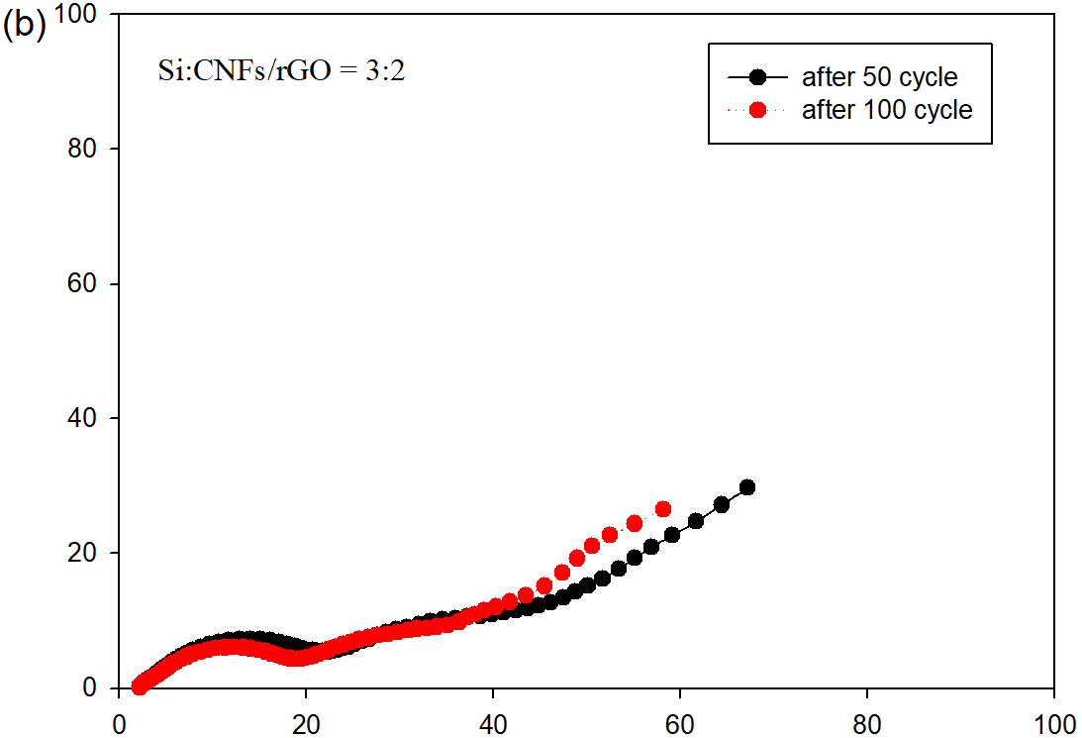
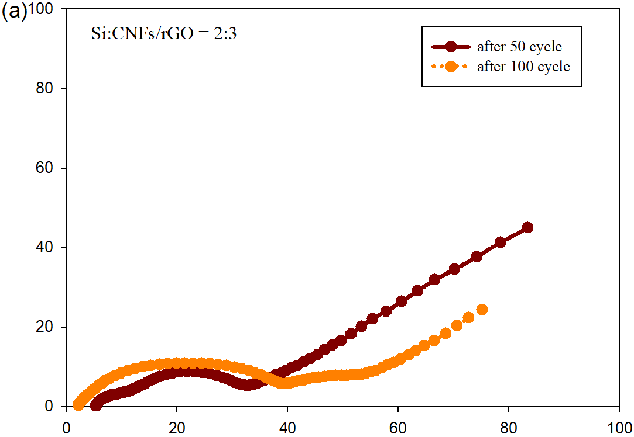
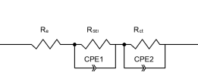
Z''/Ω
Z'/Ω
Z''/Ω
Z'/Ω

Fig. S4. Nyquist plots and electrochemical impedance spectra of the Si:CNF/rGO = 2:3 and Si:CNF/rGO = 3:2 anodes after 50 and 100 cycles.

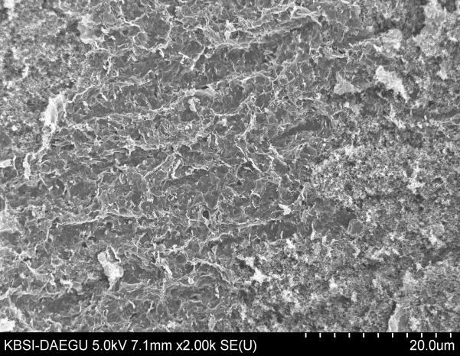
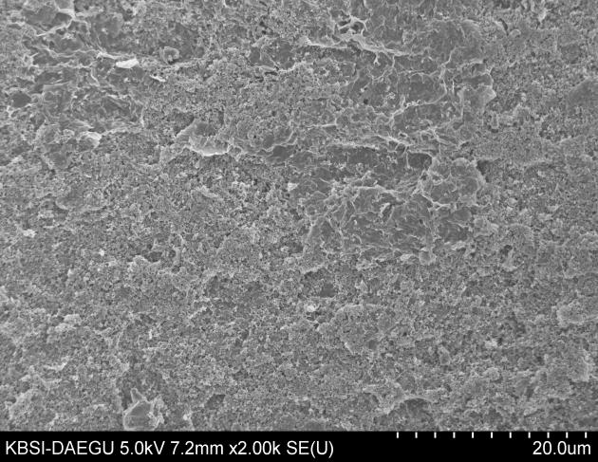
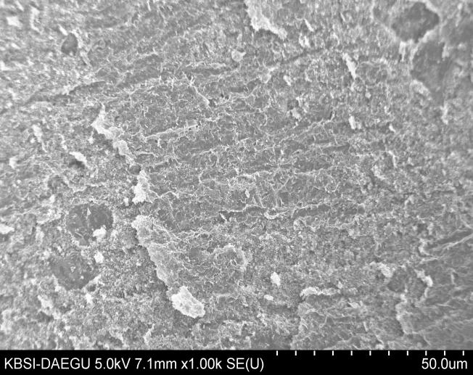
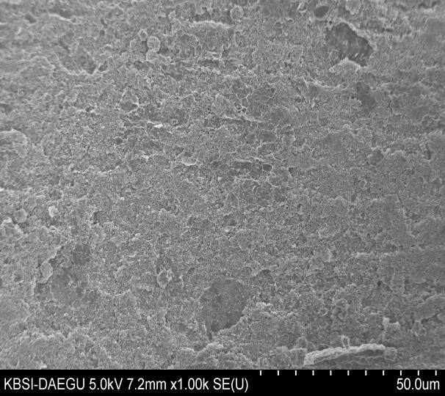
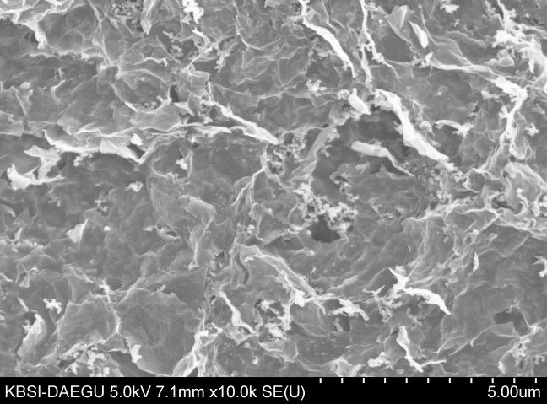
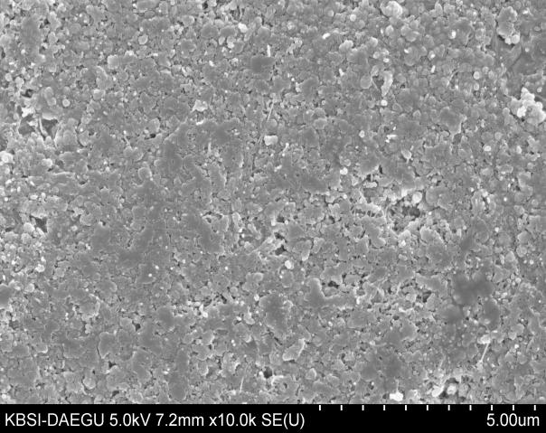
20μm
20μm
50μm
50μm
5μm
5μm
(a)
(f)
(e)
(d)
(c)
(b)

Fig. S5 (a,b,c) SEM images of the surface of Si/CNF/rGO electrodes before the first cycle, (d,e,f) SEM images of the surface of Si/CNF/rGO electrodes after 100th cycles at a current density of 100mAg⁻¹.

Table S1. EDX spectral results of the Si:CNF/rGO = 1:1, 3:2, and 2:3 composites.

Sample | Silicon |  | Carbon |  | Oxygen
Sample | Mass (%) | Atom% | Mass (%) | Atom% | Mass (%) | Atom%
Si:CNF/rGO = 1:1 | 38.16 | 21.37 | 54.59 | 71.50 | 7.25 | 7.13
Si:CNF/rGO = 3:2 | 48.94 | 30.08 | 41.37 | 59.46 | 9.69 | 10.46
Si:CNF/rGO = 2:3 | 29.27 | 15.71 | 56.43 | 70.81 | 14.31 | 13.48

Table S2. Raman spectroscopy results of the GO, rGO, CNFs, Si/rGO, and Si/CNF/rGO samples (see Fig. 4(b)).

 | ID/IG
Si/CNF/rGO | 1.02
Si/rGO | 1.04
CNFs | 0.99
rGO | 0.96
GO | 1.09

Table S3. Discharge capacity, coulomb efficiency, and capacity retention rate of the Si/rGO and Si:CNF/rGO = 1:1, 3:2, and 2:3 composite electrodes.

Samples | Max. discharge  capacity  (mAh/g) | Discharge capacity (mAh/g) |  | Coulomb efficiency (%) |  | Capacity retention rate (%)
Samples | Max. discharge  capacity  (mAh/g) | After 50 cycle | After 100 cycle | first cycle | 100 cycle | After 50 cycle | After 100 cycle
Si/rGO | 3,743.8 | 362.2 | 277.3 | 36.3 | 99.2 | 9.7 | 7.4
Si:CNF/rGO = 1:1 | 3,634.9 | 1,064.1 | 964.7 | 26.0 | 93.8 | 29.3 | 26.5
Si:CNF/rGO = 3:2 | 3,734.3 | 775.1 | 545.9 | 51.7 | 100.0 | 20.8 | 14.6
Si:CNF/rGO = 2:3 | 2,339.1 | 647.5 | 462.9 | 28.8 | 100.0 | 27.7 | 19.8

Table S4. R_{CT} and R_{SEI} values calculated from the EIS spectra (see Fig. 7).

Samples | R_{CT} (Ω) | R_{SEI} (Ω)
Si/rGO | 546.8 | 58.2
Si:CNF/rGO = 1:1 | 247.3 | 12.0
Si:CNF/rGO = 2:3 | 372.0 | 36.7
Si:CNF/rGO = 3:2 | 374.3 | 17.9

