Supplementary Information

Supplement to: Beta-blockers provide a differential survival benefit in patients with coronary artery disease undergoing contemporary post-percutaneous coronary intervention management

Investigators: Pil Hyung Lee, Gyung-Min Park, Seungbong Han, Yong-Giun Kim, Jong-Young Lee, Jae-Hyung Roh, Jae-Hwan Lee, Young-Hak Kim, Seung-Whan Lee
Contents | Page
I. Supplemental Tables
A. Table 1. Definition of covariates | 3
B. Table 2. Type of beta-blocker used | 4
C. Table 3. Characteristics of propensity-score matched patients according to the beta-blocker use | 5
II. Supplemental Figures
A. Fig. 1. Covariate balance before and after matching for each comparison | 7
B. Fig. 2. Trends in beta-blocker use  C. Fig. 3. Kaplan-Meier cumulative event curves for mortality in the unmatched cohort  D. Fig. 4. Subgroup analysis for the primary outcome in the matched AMI cohort | 8  9  11

I. Supplemental Tables
Supplemental Table 1: Definition of covariates
Diagnosis | Definition
Diabetes mellitus | E10.0, E10.1, E10.6, E10.8–E11.1, E11.6, E11.8–E12.1, E12.6, E12.8–E13.1, E13.6, E13.8–E14.1, E14.6, E14.8, E14.9, E10.2–E10.5, E10.7, E11.2–E11.5, E11.7, E12.2–E12.5, E12.7, E13.2–E13.5, E13.7, E14.2–E14.5, E14.7 OR a minimum of one prescription of anti-diabetic drugs (sulfonylureas, metformin, α-glucosidase inhibitors, thiazolidinediones, meglitinides, dipeptidyl peptidase-4 inhibitors, sodium-glucose cotransporter 2 inhibitors, glucagon like peptide-1 receptor agonists, and insulins)
Hyperlipidemia | E78.0–E78.5 OR a minimum of one prescription of anti-hyperlipidemic drugs (statins, ezetimibe, fibric acid derivatives, omega-3 fatty acids, and nicotinic acid)
Hypertension | I10.x, I11.x–I13.x, I15.x OR a minimum of one prescription of anti-hypertensive drugs (angiotensin-converting enzyme inhibitors or Angiotensin II receptor blockers, calcium-channel blockers, β-blockers, and thiazide type diuretics)
History of heart failure | I09.9, I11.0, I13.0, I13.2, I25.5, I42.0, I42.5–I42.9, I43.x, I50.x, P29.0
Cardiac arrhythmia | I44.1–I44.3, I45.6, I45.9, I47.x–I49.x, R00.0, R00.1, R00.8, T82.1, Z45.0, Z95.0
Valvular heart disease | A52.0, I05.x-I08.x, I09.1, I09.8, I34.x–I39.x, Q23.0–Q23.3, Z95.2–Z95.4
Peripheral vascular disorder | I70.x, I71.x, I73.1, I73.8, I73.9, I77.1, I79.0, I79.2, K55.1. K55.8, K55.9, Z95.8, Z95.9
Cerebrovascular disease | G45.x, G46.x, H34.0, I60.x–169.x
Chronic pulmonary disease | I27.8, I27.9, J40.x–J47.x, J60.x–J67.x, J68.4, J70.1, J70.3
Moderate-to-severe liver disease | I85.0, I85.9, I86.4, I98.2, K70.4, K71.1, K72.1, K72.9, K76.5, K76.6, K76.7
Renal disease | I12.0, I13.1, N03.2–N03.7, N05.2–N05.7, N18.x, N19.x, N25.0, Z49.0–Z49.2, Z94.0, Z99.2
Malignancy | C00.x–C97.x
Rheumatic disease | M05.x, M06.x, M31.5, M32.x–M34.x, M35.1, M35.3, M36.0

Supplemental Table 2: Type of beta-blocker used
Drugs | Overall  n=87,980 | AMI  n=38,246 | Angina  n=49,734
Carvedilol | 32,179 | 17,497 | 14,682
Bisoprolol | 22,094 | 11,316 | 10,778
Nebivolol | 6,169 | 3,162 | 3,007
Propranolol | 2,828 | 1,169 | 1,659
Atenolol | 1,245 | 341 | 904
Metoprolol | 1,077 | 373 | 704
Bevantolol | 142 | 51 | 91
Celiprolol | 129 | 42 | 87
Amosulalol | 71 | 14 | 57
Betaxolol | 60 | 8 | 52
Sotalol | 38 | 5 | 33
Arotinolol | 27 | 7 | 20
Beta-blocker was changed to a different beta-blocker during hospitalization | 5,696 | 3,036 | 2,660
AMI, acute myocardial infarction

Supplemental Table 3: Characteristics of propensity-score matched patients according to the beta-blocker use
Characteristics | AMI  n=14,666 |  |  | Angina  n=36,274
Characteristics | No beta-blocker n=7,333 | Beta-blocker n=7,333 | P-value | No beta-blocker n=18,137 | Beta-blocker n=18,137 | P-value
Baseline characteristics

Age, years | 65 (55–75) | 65 (55–75) | 0.632 | 66 (57–74) | 66 (57–74) | 0.418
Male | 5,513 (75.2) | 5,518 (75.2) | 0.245 | 12,345 (68.1) | 12,295 (67.8) | 0.653
Diabetes | 2,070 (28.2) | 2,131 (29.1) | 0.610 | 6,971 (38.4) | 7,057 (38.9) | 0.939
Hyperlipidemia | 2,264 (30.9) | 2,260 (30.8) | 0.625 | 9,527 (52.5) | 9,627 (53.1) | 0.903
Hypertension | 3,624 (49.4) | 3,591 (49.0) | 0.426 | 12,195 (67.2) | 12,344 (68.1) | 0.246
History of heart failure | 290 (4.0) | 289 (3.9) | 0.103 | 1,351 (7.4) | 1,434 (7.9) | 0.618
Arrhythmia | 243 (3.3) | 242 (3.3) | 0.779 | 1,608 (8.9) | 1,623 (8.9) | 0.911
Valvular disease | 18 (0.2) | 18 (0.2) | 0.243 | 75 (0.4) | 76 (0.4) | 0.871
Peripheral vascular disease | 651 (8.9) | 638 (8.7) | 0.289 | 2,406 (13.3) | 2,443 (13.5) | 0.779
Cerebrovascular disease | 689 (9.4) | 726 (9.9) | 0.352 | 2,726 (15.0) | 2,729 (15.0) | 0.065
Chronic pulmonary disease | 888 (12.1) | 860 (11.7) | 0.854 | 2,782 (15.3) | 2,758 (15.2) | 0.077
Moderate-to-severe liver disease | 3 (0.04) | 2 (0.03) | 0.371 | 6 (0.03) | 5 (0.03) | 0.070
Renal disease | 259 (3.5) | 237 (3.2) | 0.428 | 992 (5.5) | 1,013 (5.6) | 0.177
Cancer | 143 (2.0) | 144 (2.0) | 0.148 | 402 (2.2) | 411 (2.3) | 0.356
Rheumatologic disease | 10 (0.2) | 9 (0.1) | 0.999 | 33 (0.2) | 34 (0.2) | 0.464
Charlson comorbidity index | 1 (0–2) | 1 (0–2) | 0.280 | 1 (0–2) | 1 (0–2) | 0.079
Type of treatment for PCI
Drug-eluting stent | 6,806 (92.8) | 6,818 (93.0) | 0.914 | 16,901 (93.2) | 16,894 (93.1) | 0.157
Bioresorbable vascular scaffold | 38 (0.5) | 41 (0.6) | 0.999 | 117 (0.6) | 112 (0.6) | 0.999
Bare-metal stent | 40 (0.5) | 50 (0.7) | 0.343 | 114 (0.6) | 112 (0.6) | 0.999
Number of stent per person | 1 (1–2) | 1 (1–2) | 0.261 | 1 (1–2) | 1 (1–2) | 0.056
Medication at discharge
Antiplatelet agents | 7,325 (99.9) | 7,320 (99.8) | 0.228 | 18,064 (99.6) | 18,060 (99.6) | 0.360
Statin | 6,735 (91.8) | 6,722 (91.7) | 0.153 | 16,311 (89.9) | 16,250 (89.6) | 0.440
ACEI/ARB | 3,734 (50.9) | 3,799 (51.8) | 0.526 | 9,062 (50.0) | 9,117 (50.3) | 0.124
Data are expressed as n (%) and median (interquartile range).
ACEI, angiotensin-converting enzyme inhibitor; AMI, acute myocardial infarction; ARB, angiotensin receptor blocker; PCI; percutaneous coronary intervention

I. Supplemental Figures
Supplemental Fig. 1: Covariate balance before and after matching for each comparison
A  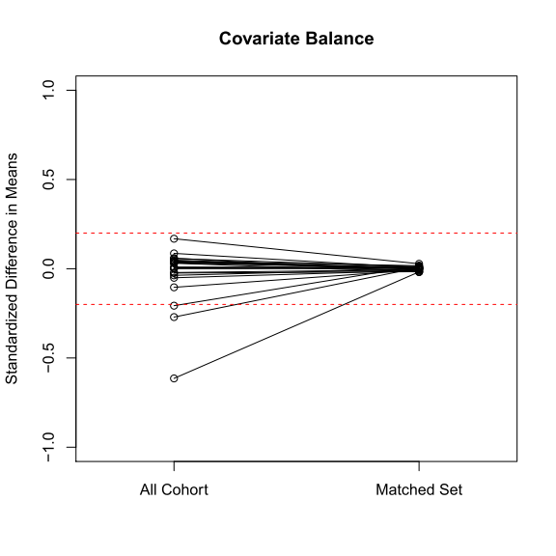 | B  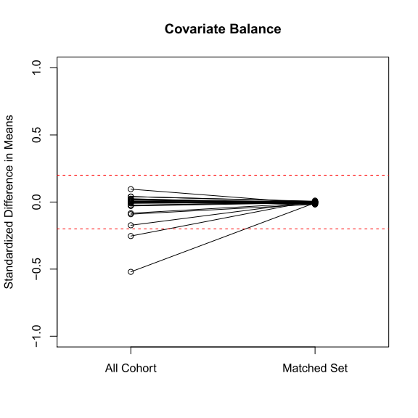
A; Acute myocardial infarction population, B; Angina pectoris population
Supplemental Fig. 2: Trends in beta-blocker use
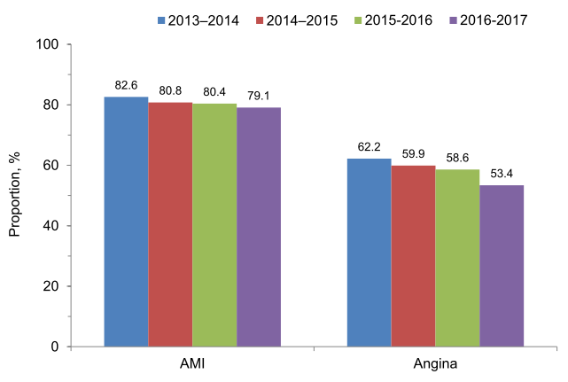
AMI, acute myocardial infarction
Supplemental Fig. 3: Kaplan-Meier cumulative event curves for mortality in the unmatched cohort
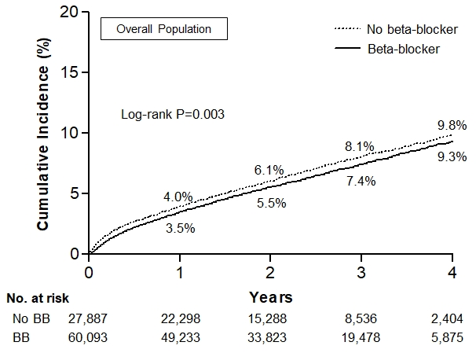
A
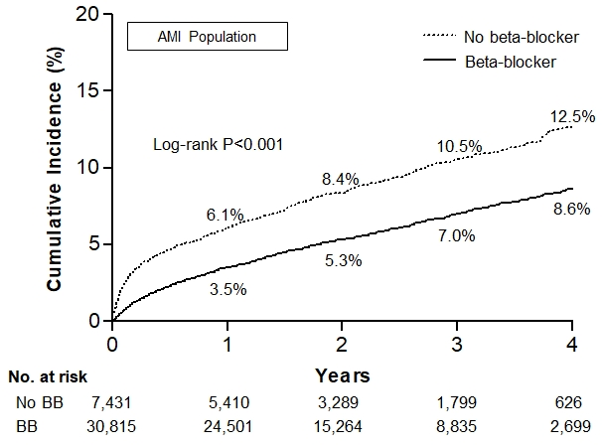
B
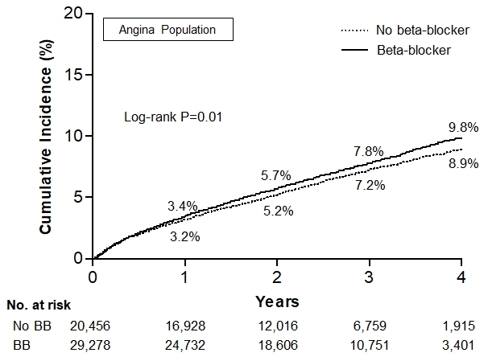
C
The cumulative incidence rates for all-cause death between the beta-blocker and no beta-blocker therapy groups in the overall population (A), patients with AMI (B), and patients with angina (C).
The numbers in each figure represent the cumulative incidence rates at each time point.
AMI, acute myocardial infarction; BB, beta-blocker
Supplemental Fig. 4: Subgroup analysis for the primary outcome in the matched AMI cohort

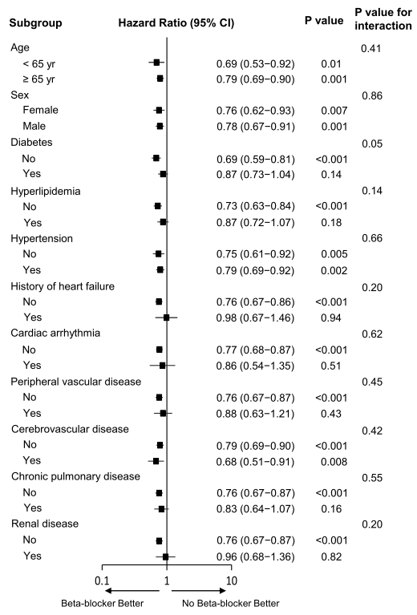

Hazard ratios are for the beta-blocker group compared with the no beta-blocker group. The P-value for interaction represents the likelihood of interaction between the subgroups and the treatment.
AMI, acute myocardial infarction; CI, confidence interval

