Polysaccharide hydrogel based 3D printed tumor models for chemotherapeutic drug screening
Aragaw Gebeyehu^{#1}, Sunil Kumar Surapaneni^{#1}, John Huang², Arindam Mondal¹, Vivian Ziwen Wang², Nana Fatima Haruna², Arvind Bagde¹, Peggy Arthur¹, Shallu Kutlehria¹, Nil Patel¹, Arun Rishi³ and Mandip Singh¹*
#Aragaw Gebeyehu and #Sunil Kumar Surapaneni contributed equally to this work and listed as co-first authors.
¹College of Pharmacy and Pharmaceutical Sciences, Florida A&M University, Tallahassee,
FL32307, USA
²TheWell Bioscience, North Brunswick, New Jersey, 08902, USA
³John D. Dingell VA Medical Center, Detroit, MI, 48201, USA; Department of Oncology,
Karmanos Cancer Institute, Wayne State University School of Medicine, Detroit, MI, 48201, USA
*Corresponding Author:
Prof. Mandip Singh, Ph.D.
College of Pharmacy and Pharmaceutical Sciences, Florida A&M University, Tallahassee, Florida, 32307, USA.
Tel: +1- 850-561-2790 Fax: 850-599-3813; E-mail: mandip.sachdeva@gmail.com

Figure S1: Bioprintability of NSCLC-PDX cell laden scaffolds with Inks H1, H2, H3 and H5
B)
A)
Ink H1
Ink H2

D)
C)
Ink H3
Ink H5
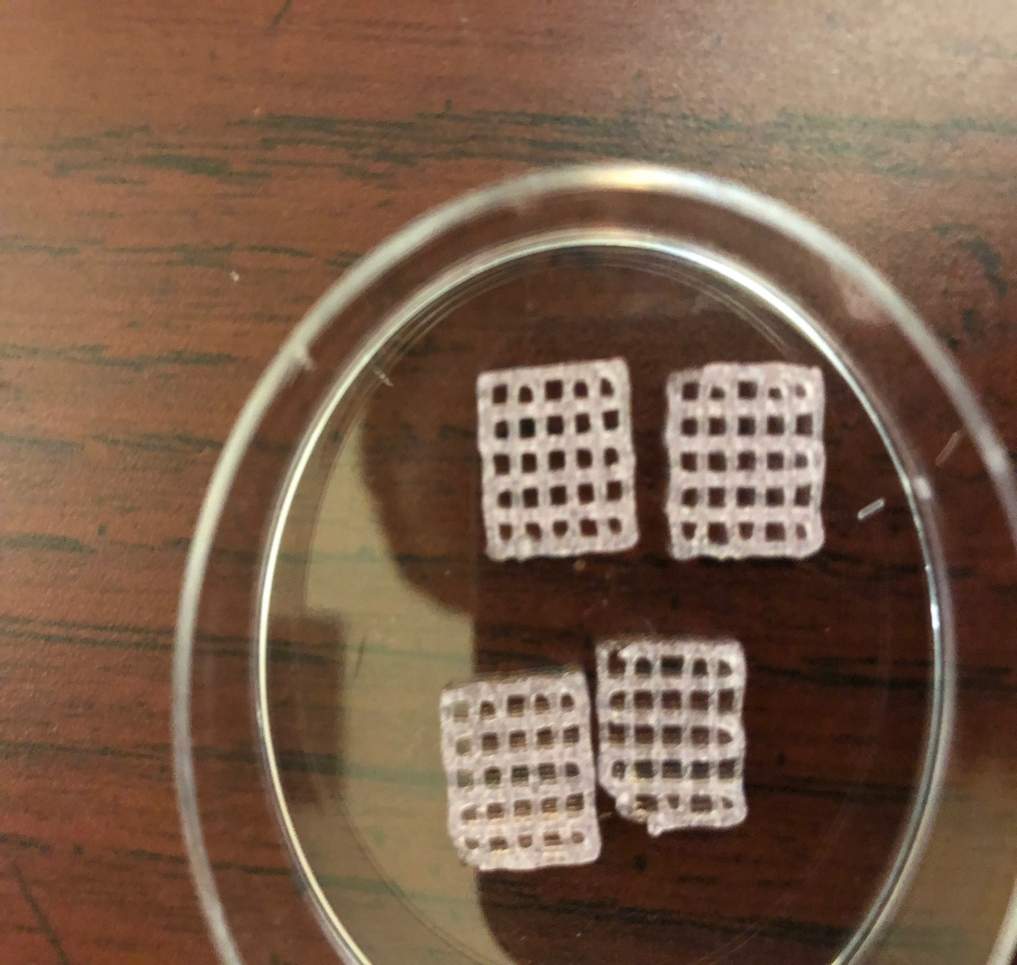
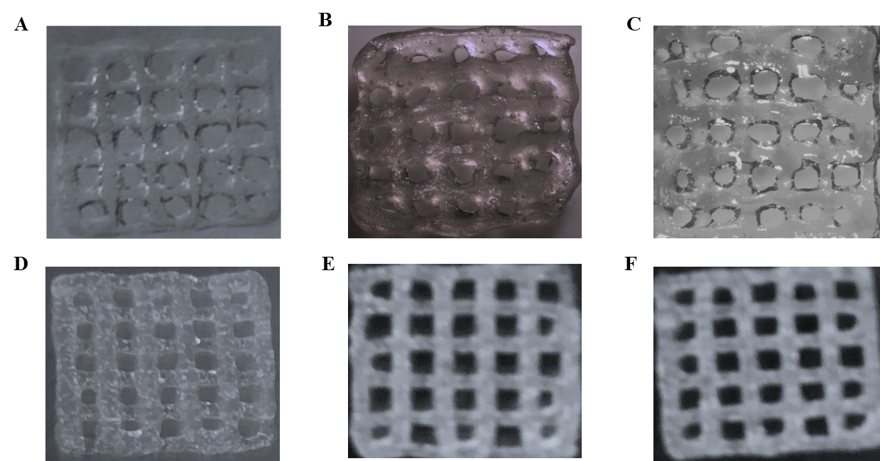

Figure S2: Cell viability of NSCLC-PDX cell laden scaffolds printed with Inks H3, H5, H2 and H1
Figure S3: Extrusion pressure required for printability of NSCLC-PDX cells with Inks H3, H5, H2 and H1

