Ultrathin Polymeric Films for Interfacial Passivation in Wide Band-gap Perovskite Solar Cells
Parnian Ferdowsi ¹, Efrain Ochoa-Martinez ¹, Sandy Sanchez Alonso ², Ullrich Steiner¹ and Michael Saliba^{3,}*

1 Adolphe Merkle Institute, University of Fribourg, CH 1700, Fribourg, Switzerland.
² Laboratory of Photomolecular Science (LSPM), École Polytechnique Fédéral de Lausanne (EPFL), Station 6, 1015 Lausanne, Switzerland.
³Institute for Photovoltaics (ipv), University of Stuttgart, Pfaffenwaldring 47, 70569 Stuttgart, Germany. (Email: michael.saliba@ipv.uni-stuttgart.de, miliba@gmail.com)

Table of content
Supplementary Figure S1. Top view SEM image of MAPbBr₃ through FIRA | Page 2
Supplementary Figure S2. 2-D, 3-D AFM image and the corresponding line profiling analysis of (a) PCBM, and (b) PMMA-coated on Si substrate. Note that the PMMA and PCBM layer for profile-AFM measurement was deposited by spin-coating 0.1 mg/mL PMMA and 5 mg/mL PCBM in CB at 4000 rpm for 30 s on the top of Si substrate | Page 2
Supplementary Figure S3. Statistical distribution of the photovoltaic parameters for cells with/without PMMA (0.1 mg/ml) at the MAPbBr₃/HTL interface through anti-solvent | Page 3
Supplementary Figure S4. Statistical distribution of the photovoltaic parameters for cells with/without PMMA, PMMA: PCBM passivation layers through anti-solvent: “P” is the control device and the other three devices include two passivation layers, on top (PMMA, 0.1 mg/ml) and bottom of perovskite (PMMA (1 mg/ml): PCBM (5 mg/ml), different ratio)) | Page 3
Supplementary Figure S5. Statistical distribution of the photovoltaic parameters for cells with pure PMMA (1 mg/ml), pure PCBM (5 mg/ml) and PMMA: PCBM (1:20) at the bottom of perovskite in addition of PMMA (0.1 mg/ml) on top of the perovskite through anti-solvent: (PMMA on top is the control device and the other three devices include two passivation layers, on top and bottom of perovskite) | Page 4
Supplementary Figure S6. IR annealing time optimization for FIRA | Page 4
Supplementary Figure S7. Different solvent ratio (DMF: DMSO) to optimize the perovskite solution for FIRA | Page 5
Supplementary Figure S8. Current density-voltage curves of old devices with and without PMMA and PCBM passivation layers, made by anti- solvent method, from both reverse and forward scans under 20 mV s⁻¹ scan rate. | Page 5
Supplementary Figure S9. Current density-voltage curves of old devices with and without PMMA and PCBM passivation layers, made by FIRA-annealing, from both reverse and forward scans under 20 mV s⁻¹ scan rate. | Page 6
Supplementary Table S1. PCBM and PMMA thickness at several points of layer on the top of Si substrate from AFM data | Page 6
Supplementary Table S2. Photovoltaic parameters of the old devices with/without passivation layers through anti-solvent and FIRA, from both reverse and forward scans under 20 mV s⁻¹ scan rate | Page 7

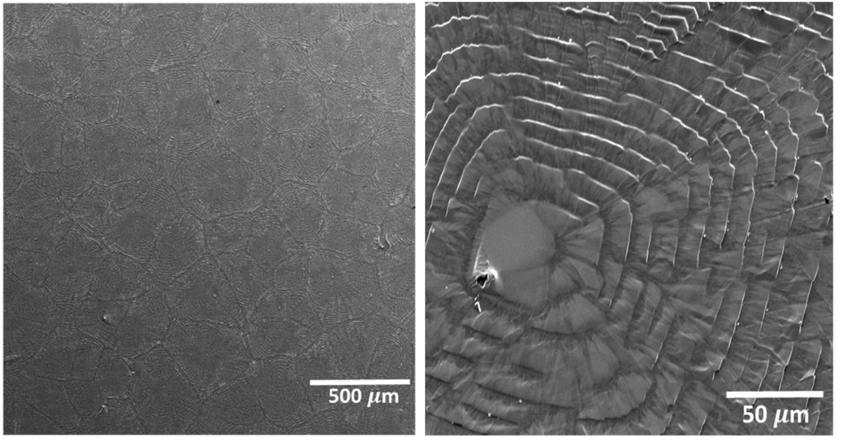
Supplementary Figure S1. Top view SEM image of MAPbBr₃ through FIRA
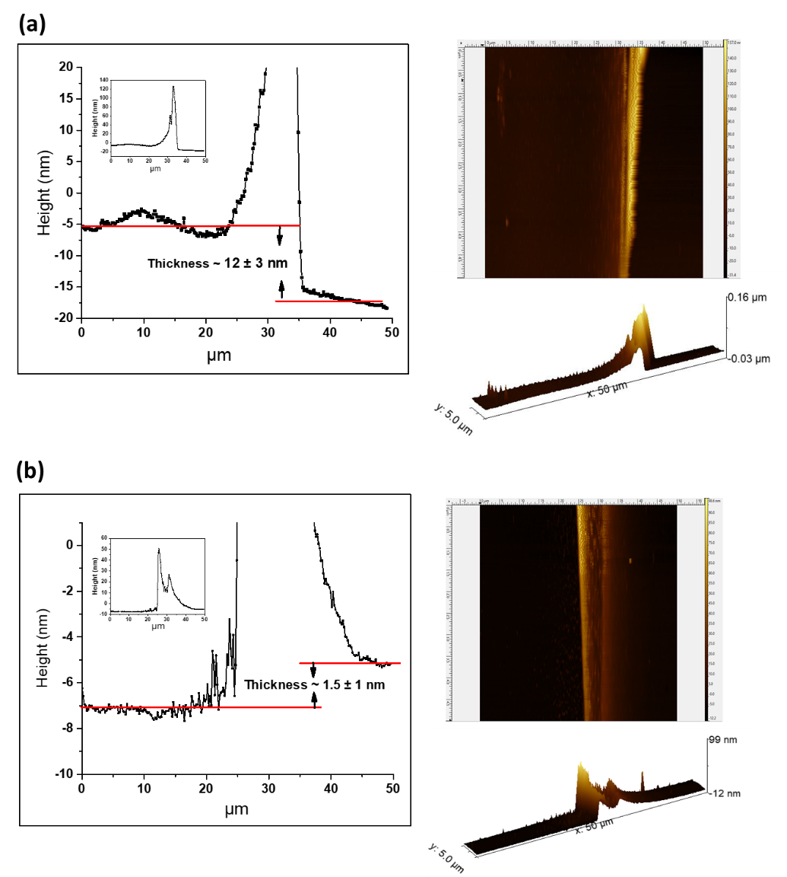
Supplementary Figure S2. 2-D, 3-D AFM image and the corresponding line profiling analysis of (a) PCBM, and (b) PMMA-coated on Si substrate with 50-picometer resolution. Note that the PMMA and PCBM layer for profile-AFM measurement was deposited by spin-coating 0.1 mg/mL PMMA and 5 mg/mL PCBM in CB at 4000 rpm for 30 s on the top of Si substrate.

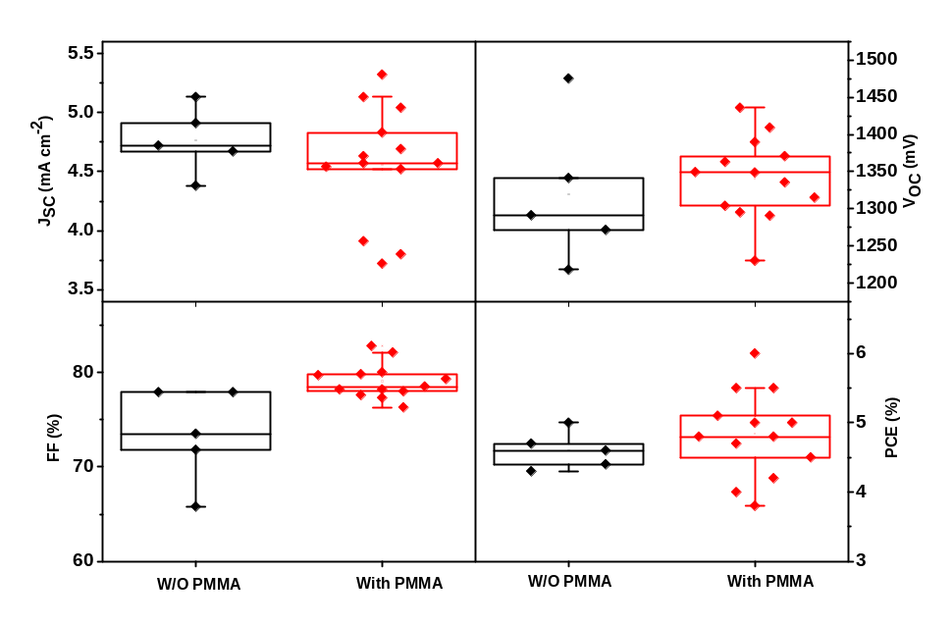
Supplementary Figure S3. Statistical distribution of the photovoltaic parameters for cells with/without PMMA (0.1 mg/ml) at the MAPbBr₃/HTL interface through anti-solvent.

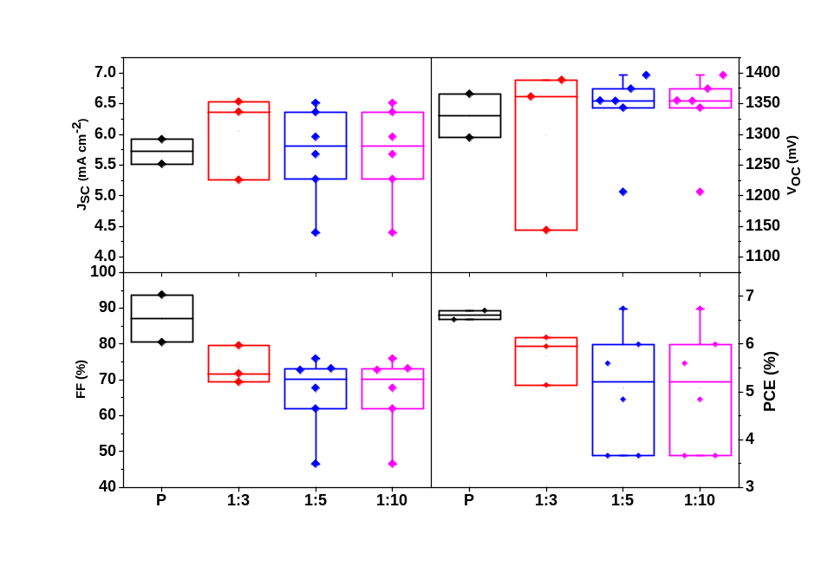
Supplementary Figure S4. Statistical distribution of the photovoltaic parameters for cells with/without PMMA, PMMA: PCBM passivation layers through anti-solvent: “P” is the control device and the other three devices include two passivation layers, on top (PMMA, 0.1 mg/ml) and bottom of perovskite (PMMA (1 mg/ml): PCBM (5 mg/ml), different ratio)).
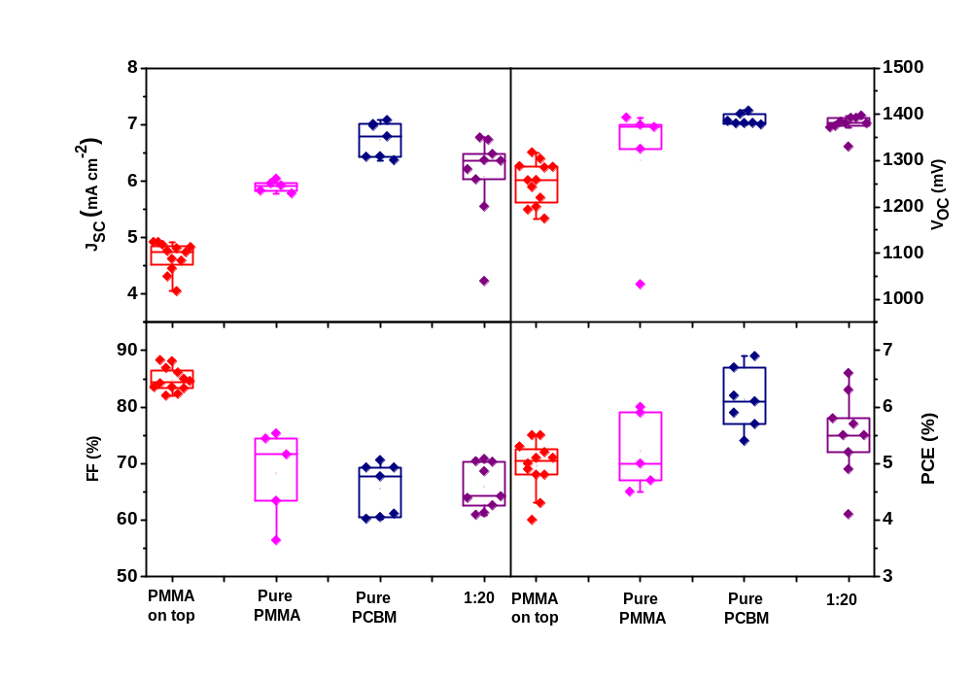
Supplementary Figure S5. Statistical distribution of the photovoltaic parameters for cells with pure PMMA (1 mg/ml), pure PCBM (5 mg/ml) and PMMA: PCBM (1:20) at the bottom of perovskite in addition of PMMA (0.1 mg/ml) on top of the perovskite through anti-solvent: (PMMA on top is the control device and the other three devices include two passivation layers, on top and bottom of perovskite).
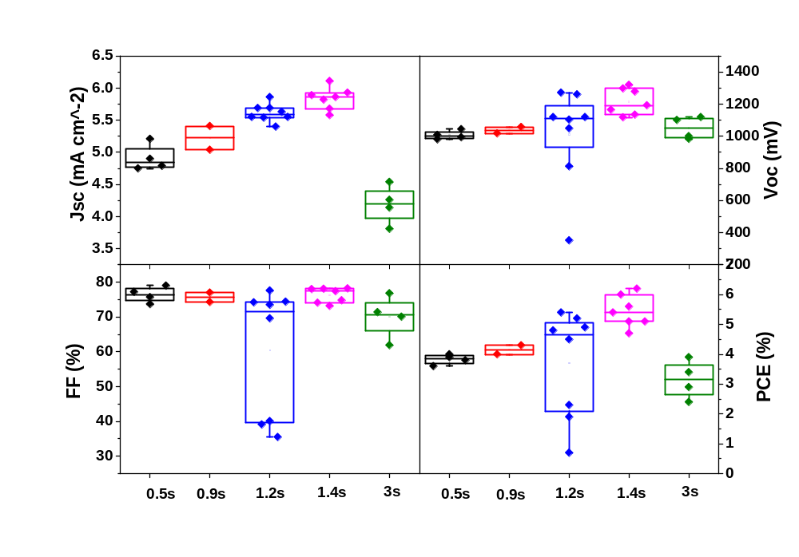
Supplementary Figure S6. IR annealing time optimization for FIRA

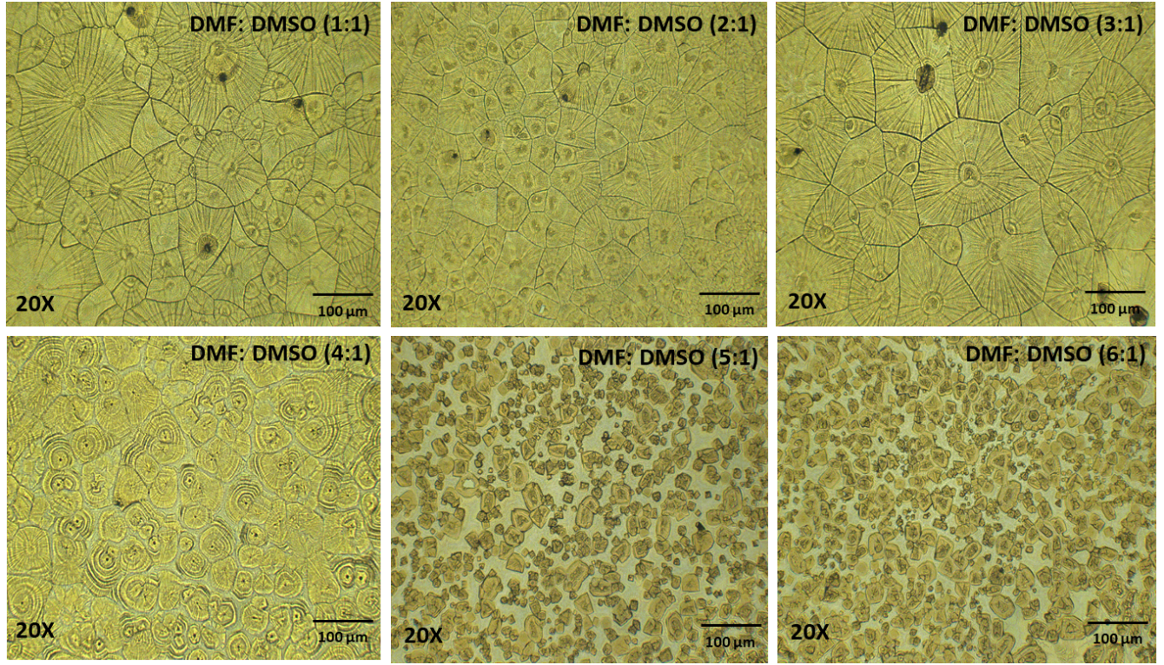
Supplementary Figure S7. Different solvent ratio (DMF: DMSO) to optimize the perovskite solution for FIRA

The devices were remeasured at 20 mV s⁻¹ from both the reverse and forward scans. The results showed that the devices with passivation layers shows negligible hysteresis between reverse and forward J–V scans, achieving a 71.4 and 89.8% PCE of their initial performance for anti-solvent and FIRA devices, respectively.

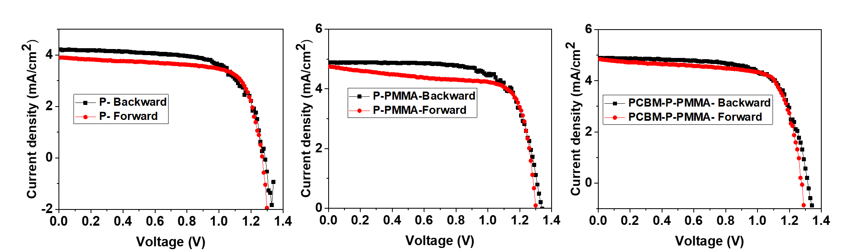

Supplementary Figure S8. Current density-voltage curves of old devices with and without PMMA and PCBM passivation layers, made by anti- solvent method, from both reverse and forward scans under 20 mV s⁻¹ scan rate.

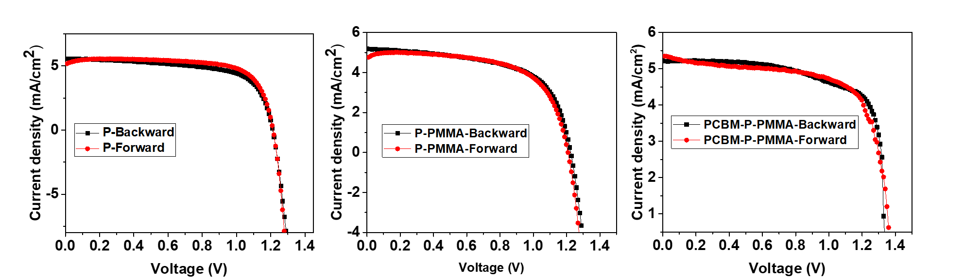
Supplementary Figure S9. Current density-voltage curves of old devices with and without PMMA and PCBM passivation layers, made by FIRA-annealing, from both reverse and forward scans under 20 mV s⁻¹ scan rate.

Supplementary Table S1. PCBM and PMMA thickness at several points of layer on the top of Si substrate from AFM data
PCBM | Left | Backward | Inside | 15nm | AVERAGE= 12 $±3$
PCBM | Left | Backward | Outside | 10nm | AVERAGE= 12 $±3$
PCBM | Left | Forward | Inside | 8nm | AVERAGE= 12 $±3$
PCBM | Left | Forward | Outside | 15nm | AVERAGE= 12 $±3$
PCBM | Right | Backward | Inside | 10nm | AVERAGE= 12 $±3$
PCBM | Right | Backward | Outside | 15nm | AVERAGE= 12 $±3$
PCBM | Right | Forward | Inside | 8nm | AVERAGE= 12 $±3$
PCBM | Right | Forward | Outside | 15nm | AVERAGE= 12 $±3$
PMMA | Left | Backward | Inside | >1nm | AVERAGE= 1.5$±1$
PMMA | Left | Backward | Outside | 1nm | AVERAGE= 1.5$±1$
PMMA | Left | Forward | Inside | 2.5nm | AVERAGE= 1.5$±1$
PMMA | Left | Forward | Outside | 1nm | AVERAGE= 1.5$±1$
PMMA | Right | Backward | Inside | 1nm | AVERAGE= 1.5$±1$
PMMA | Right | Backward | Outside | 2.5nm | AVERAGE= 1.5$±1$
PMMA | Right | Forward | Inside | 1 | AVERAGE= 1.5$±1$
PMMA | Right | Forward | Outside | 2.5nm | AVERAGE= 1.5$±1$

Supplementary Table S2. Photovoltaic parameters of the old devices with/without passivation layers through anti-solvent and FIRA, from both reverse and forward scans under 20 mV s⁻¹ scan rate
 | Sample  (Anti-solvent) | V_{OC} (V) |  | J_{SC} (mA/cm²) |  | FF |  | PCE (%) |  | PCE degradation percentage (%)
 | Sample  (Anti-solvent) | RS | FS | RS | FS | RS | FS | RS | FS | RS
Anti-solvent | P | 1.29 | 1.27 | 4.21 | 3.90 | 67.7 | 72.1 | 3.67 | 3.57 | 81.6
Anti-solvent | P-PMMA | 1.33 | 1.29 | 4.68 | 4.57 | 70.4 | 72.4 | 4.37 | 4.26 | 77.5
Anti-solvent | PCBM-P-PMMA | 1.32 | 1.28 | 4.89 | 4.84 | 70.2 | 72.7 | 4.51 | 4.50 | 71.4
FIRA | P | 1.23 | 1.21 | 5.18 | 4.76 | 60.5 | 66.3 | 3.84 | 3.81 | 79.2
FIRA | P-PMMA | 1.21 | 1.21 | 5.56 | 5.18 | 65.6 | 76.6 | 4.42 | 4.81 | 79.2
FIRA | PCBM-P-PMMA | 1.34 | 1.37 | 5.22 | 5.25 | 72.9 | 68.6 | 5.10 | 5.03 | 89.8

