Octenidine-based hydrogel shows anti-inflammatory and protease-inhibitory capacities in wounded human skin
Saskia Seiser^{1*}, Lukas Janker^{2,3*}, Nina Zila¹, Michael Mildner¹, Ana Rakita¹, Johannes Matiasek⁴, Andrea Bileck^{2,3}, Christopher Gerner^{2,3}, Verena Paulitschke¹, Adelheid Elbe-Bürger^{1§}
1Department of Dermatology, Medical University of Vienna, Vienna, Austria
2Department of Analytical Chemistry, University of Vienna, Vienna, Austria
3Joint Metabolome Facility, University of Vienna and Medical University of Vienna, Vienna, Austria
4Department of Plastic, Aesthetic and Reconstructive Surgery, St. Josef Hospital, Vienna, Austria
*share first authorship
§corresponding author; e-mail: adelheid.elbe-buerger@meduniwien.ac.at

Figure S1

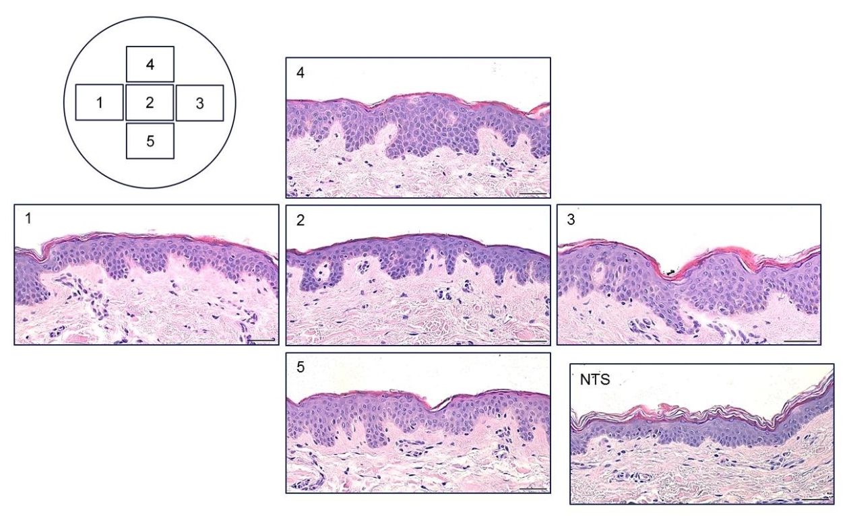

Figure S2

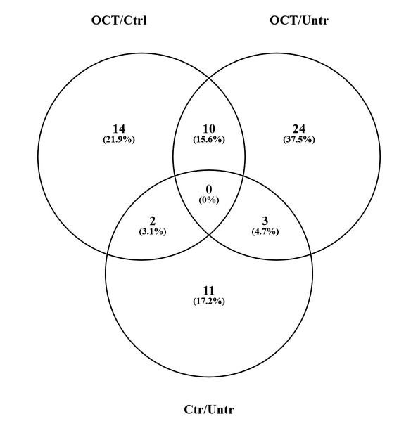

Figure S3
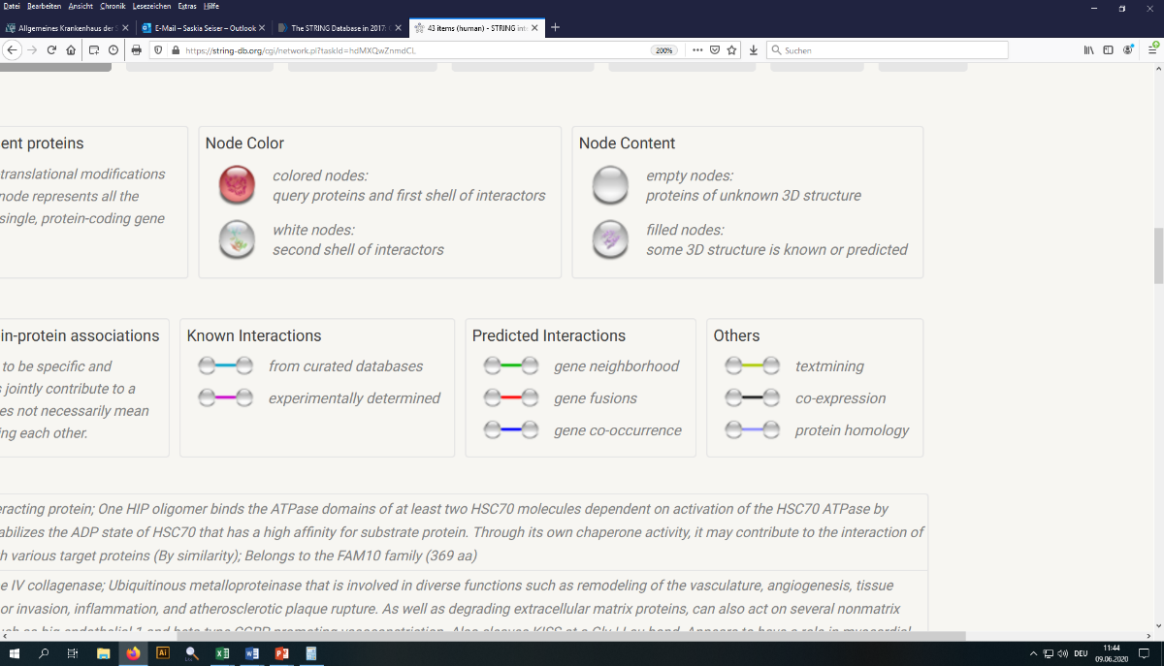
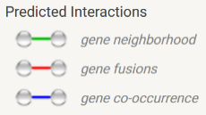
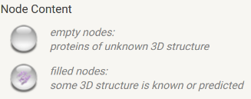
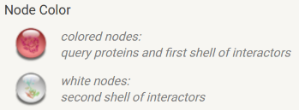
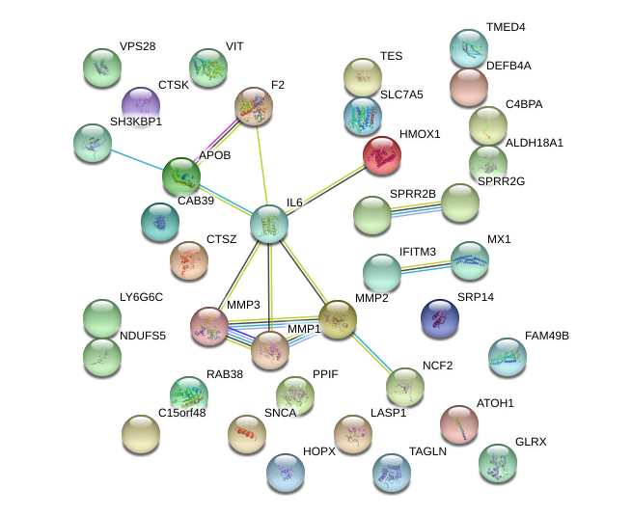

Figure S4
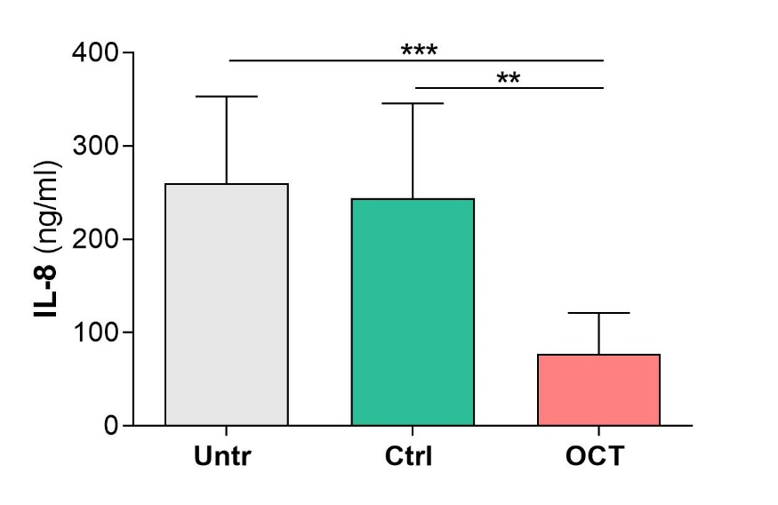

Table S1. Differentially regulated proteins in OCT- and control gel-treated wounded skin
Acc. Nr. | Gene names | Protein names | Difference | p-value
Q15418 | RPS6KA1 | Ribosomal protein S6 kinase alpha-1 | 2.72936 | 0.0406338
P57729 | RAB38 | Ras-related protein Rab-38 | -2.31488 | 0.0024860
Q5T5C0 | STXBP5 | Syntaxin-binding protein 5 | -2.16046 | 0.0441092
Q96NZ8 | WFIKKN1 | WAP, Kazal, immunoglobulin, Kunitz and NTR domain-containing protein 1 | -2.05995 | 0.0460281
Q96B49 | TOMM6 | Mitochondrial import receptor subunit TOM6 homolog | -1.89169 | 0.0123562
P37108 | SRP14 | Signal recognition particle 14 kDa protein | -1.79208 | 0.0164122
P07196 | NEFL | Neurofilament light polypeptide | -1.78873 | 0.0307429
Q9BPY8 | HOPX | Homeodomain-only protein | -1.66531 | 0.0057730
Q8N766 | EMC1 | ER membrane protein complex subunit 1 | 1.58853 | 0.0429446
O14618 | CCS | Copper chaperone for superoxide dismutase | -1.5529 | 0.0442306
P49593 | PPM1F | Protein phosphatase 1F | -1.54092 | 0.0150490
Q9BSD7 | NTPCR | Cancer-related nucleoside-triphosphatase | 1.22018 | 0.0147584
P23610 | F8A1 | Factor VIII intron 22 protein | 1.19871 | 0.0161568
P35442 | THBS2 | Thrombospondin-2 | -1.10232 | 0.0452981
Q8TEX9 | IPO4 | Importin-4 | 1.01008 | 0.0403239
Proteins involved in tissue repair processes
Q96B97 | SH3KBP1 | SH3 domain-containing kinase-binding protein 1 | -2.50139 | 0.0010320
O75190 | DNAJB6 | DnaJ homolog subfamily B member 6 | -2.42276 | 0.0000329
Q9BYE4 | SPRR2G | Small proline-rich protein 2G | -1.29277 | 0.0014479
Q9Y696 | CLIC4 | Chloride intracellular channel protein 4 | -1.09563 | 0.0126506
Proteins involved in immune response
P05231 | IL6 | Interleukin-6 | -2.41779 | 0.0081152
Q99538 | LGMN | Legumain | 2.20007 | 0.0198880
P20591 | MX1 | Interferon-induced GTP-binding protein Mx1 | -1.35853 | 0.0097801
O95867 | LY6G6C | Lymphocyte antigen 6 complex locus protein G6c | -1.3394 | 0.0168512
Q9C002 | NMES1 | Normal mucosa of esophagus-specific gene 1 protein | -1.18638 | 0.0169618
P61026 | RAB10 | Ras-related protein Rab-10 | -1.09958 | 0.0363097
Proteins involved in both, tissue repair and immune response
P03956 | MMP1 | Interstitial collagenase | -1.26249 | 0.0011988

Table S2. Differentially regulated proteins in OCT-treated and untreated wounded skin
Acc. Nr. | Gene names | Protein names | Difference | p-value
Q92858 | ATOH1 | Protein atonal homolog 1 | -3.12793 | 0.0002307
Q7Z7H5 | TMED4 | Transmembrane emp24 domain-containing protein 4 | 2.39738 | 0.0446175
Q9BPY8 | HOPX | Homeodomain-only protein | -2.38045 | 0.0005303
P57729 | RAB38 | Ras-related protein Rab-38 | -2.13996 | 0.0019076
O43920 | NDUFS5 | NADH dehydrogenase [ubiquinone] iron-sulfur protein 5 | -1.98058 | 0.0064109
Q14847 | LASP1 | LIM and SH3 domain protein 1 | -1.90196 | 0.0219411
Q9UBR2 | CTSZ | Cathepsin Z | -1.68655 | 0.0419445
P37108 | SRP14 | Signal recognition particle 14 kDa protein | -1.50146 | 0.0324033
P30405 | PPIF | Peptidyl-prolyl cis-trans isomerase F, mitochondrial | -1.42846 | 0.0401322
P35754 | GLRX | Glutaredoxin-1 | -1.3358 | 0.0012070
P54886 | ALDH18A1 | Delta-1-pyrroline-5-carboxylate synthase | -1.23201 | 0.0453780
Q9Y376 | CAB39 | Calcium-binding protein 39 | -1.18201 | 0.0004578
Q01650 | SLC7A5 | Large neutral amino acids transporter small subunit 1 | -1.15907 | 0.0284621
Q9UK41 | VPS28 | Vacuolar protein sorting-associated protein 28 homolog | -1.15247 | 0.0438657
Q9UGI8 | TES | Testin | -1.09905 | 0.0330494
Proteins involved in tissue repair processes
Q96B97 | SH3KBP1 | SH3 domain-containing kinase-binding protein 1 | -2.99325 | 0.0023696
P43235 | CTSK | Cathepsin K | -2.27851 | 0.0065599
P35325 | SPRR2B | Small proline-rich protein 2B | -1.60542 | 0.0435721
Q9BYE4 | SPRR2G | Small proline-rich protein 2G | -1.41857 | 0.0008890
Q01995 | TAGLN | Transgelin | -1.06854 | 0.0483124
Q6UXI7 | VIT | Vitrin | 1.05801 | 0.0498010
proteins involved in immune response
P05231 | IL6 | Interleukin-6 | -2.12485 | 0.0259179
Q01628 | IFITM3 | Interferon-induced transmembrane protein 3 | -1.90649 | 0.0366628
Q9C002 | NMES1 | Normal mucosa of esophagus-specific gene 1 protein | -1.49802 | 0.0091243
P20591 | MX1 | Interferon-induced GTP-binding protein Mx1 | -1.35044 | 0.0033264
O15263 | DEFB4A | Beta-defensin 4A | -1.16194 | 0.0110583
Q9NUQ9 | FAM49B | Protein FAM49B | -1.14202 | 0.0358444
P04003 | C4BPA | C4b-binding protein alpha chain | 1.11854 | 0.0386461
O95867 | LY6G6C | Lymphocyte antigen 6 complex locus protein G6c | 1.94051 | 0.0123234
proteins involved in both, tissue repair and immune response
P03956 | MMP1 | Interstitial collagenase | -1.54141 | 0.0002663
P09601 | HMOX1 | Heme oxygenase 1 | -1.68656 | 0.0313425
P37840 | SNCA | Alpha-synuclein | -1.43251 | 0.0167263
P08254 | MMP3 | Stromelysin-1 | -1.42857 | 0.0184192
P19878 | NCF2 | Neutrophil cytosol factor 2 | -1.32954 | 0.0228254
P08253 | MMP2 | 72 kDa type IV collagenase | -1.02733 | 0.0072739
P00734 | F2 | Prothrombin | 1.26839 | 0.0023982
P04114 | APOB | Apolipoprotein B-100 | 1.71104 | 0.0305505

Table S3. Differentially regulated proteins in control gel-treated and untreated wounded skin
Acc. Nr. | Gene names | Protein names | Difference | p-value
Q92858 | ATOH1 | Protein atonal homolog 1 | 2.90260 | 0.0467329
Q8N4B1 | FAM109A | Sesquipedalian-1 | 1.99453 | 0.0338739
Q15418 | RPS6KA1 | Ribosomal protein S6 kinase alpha-1 | 1.31693 | 0.0181723
P57735 | RAB25 | Ras-related protein Rab-25 | 1.11329 | 0.0214313
Q5BKU9 | OXLD1 | Oxidoreductase-like domain-containing protein 1 | 1.05709 | 0.0120118
P51911 | CNN1 | Calponin-1 | -1.01570 | 0.0274797
Q14839 | CHD4 | Chromodomain-helicase-DNA-binding protein 4 | -1.07617 | 0.0420545
Q9UBX7 | KLK11 | Kallikrein-11 | -1.45470 | 0.0382948
Q8IW45 | CARKD | ATP-dependent (S)-NAD(P)H-hydrate dehydratase | -1.92203 | 0.0332909
Q2M389 | KIAA1033 | WASH complex subunit 7 | 1.11104 | 0.0472920
O95445 | APOM | Apolipoprotein M | -2.89068 | 0.0386007
Q8TEX9 | IPO4 | Importin-4 | -2.99654 | 0.0314189
Proteins involved in tissue repair processes
P21941 | MATN1 | Cartilage matrix protein | 3.74950 | 0.0031799
Q6UXI7 | VIT | Vitrin | 1.10172 | 0.0103093
Proteins involved in immune response
Q01650 | SLC7A5 | Large neutral amino acids transporter small subunit 1 | -1.12076 | 0.0198887
Q9BT09 | CNPY3 | Protein canopy homolog 3 | -1.74096 | 0.0000938

Table S4. Differentially regulated proteins in the epidermal compartment of OCT- and control gel-treated skin
Acc. Nr. | Gene names | Protein names | Difference | p-value
Proteins involved in tissue repair processes
Q13480 | GAB1 | GRB2-associated-binding protein 1 | 2.65622 | 0.0000351
P40126 | TYRP2 | L-dopachrome tautomerase | -1.75076 | 0.0080068
P30876 | RPB2 | DNA-directed RNA polymerase II subunit RPB2 | -1.07747 | 0.0030789
Proteins involved in immune response
O14576 | DC1I1 | Cytoplasmic dynein 1 intermediate chain 1 | -2.13067 | 0.0077364
P50238 | CRIP1 | Cysteine-rich protein 1 | -1.60604 | 0.0091073
Q9Y6K5 | OAS3 | 2'-5'-oligoadenylate synthase 3 | 1.55990 | 0.0078750
P26583 | HMGB2 | High mobility group protein B2 | -1.39601 | 0.0003445
Q9H9Q4 | NHEJ1 | Non-homologous end-joining factor 1 | -1.39500 | 0.0062450
O94855 | SC24D | Protein transport protein Sec24D | 1.39158 | 0.0088761
Proteins involved in tissue repair and immune response
Q04206 | TF65 | Transcription factor p65 | 1.29788 | 0.0003202

Table S5. Differentially regulated proteins in the epidermal compartment of OCT-treated and untreated skin
Acc. Nr. | Gene names | Protein names | Difference | p-value
Proteins involved in tissue repair processes
Q13480 | GAB1 | GRB2-associated-binding protein 1 | 2.00244 | 0.0093988
Proteins involved in immune response
P50238 | CRIP1 | Cysteine-rich protein 1 | -1.67531 | 0.0079399
P42898 | MTHR | Methylenetetrahydrofolate reductase | 2.97058 | 0.0069516
O94855 | SC24D | Protein transport protein Sec24D | 1.96976 | 0.0065865
P26583 | HMGB2 | High mobility group protein B2 | -1.10077 | 0.0065148
P05161 | ISG15 | Ubiquitin-like protein ISG15 | -2.51395 | 0.0055573
O95867 | LY66C | Lymphocyte antigen 6 complex locus protein G6c | 1.78426 | 0.0036757
P05067 | A4 | Amyloid-beta precursor protein | -1.50652 | 0.0004426

Table S6. Differentially regulated proteins in the dermal compartment of OCT-treated and untreated skin
Acc. Nr. | Gene names | Protein names | Difference | p-value
Proteins involved in tissue repair processes
P56192 | SYMC | Methionine--tRNA ligase, cytoplasmic | -2.94322 | 0.006886
Q01995 | TAGL | Transgelin | -2.90751 | 0.000173
Q9UBR2 | CATZ | Cathepsin Z | -2.53883 | 0.000414
P21291 | CSRP1 | Cysteine and glycine-rich protein 1 | -2.23585 | 0.000004
Q9NVD7 | PARVA | Alpha-parvin | -2.04670 | 0.000009
O94760 | DDAH1 | N(G),N(G)-dimethylarginine dimethylaminohydrolase 1 | -2.01723 | 0.007180
P13861 | KAP2 | cAMP-dependent protein kinase type II-alpha regulatory subunit | -1.67402 | 0.004539
P19971 | TYPH | Thymidine phosphorylase | -1.58886 | 0.002436
Q96AC1 | FERM2 | Fermitin family homolog 2 | -1.55430 | 0.003212
P12955 | PEPD | Xaa-Pro dipeptidase | -1.51804 | 0.000000
P23381 | SYWC | Tryptophan--tRNA ligase, cytoplasmic | -1.51312 | 0.000935
Q9BUT1 | BDH2 | 3-hydroxybutyrate dehydrogenase type 2 | -1.37434 | 0.002510
Q07157 | ZO1 | Tight junction protein ZO-1 | -1.26865 | 0.003675
P17174 | AATC | Aspartate aminotransferase, cytoplasmic | -1.21726 | 0.002259
P16152 | CBR1 | Carbonyl reductase [NADPH] 1 | -1.16584 | 0.006820
O14773 | TPP1 | Tripeptidyl-peptidase 1 | -1.14612 | 0.008816
P21333 | FLNA | Filamin-A | -1.12147 | 0.000025
P55786 | PSA | Puromycin-sensitive aminopeptidase | -1.08291 | 0.003088
P00558 | PGK1 | Phosphoglycerate kinase 1 | -1.07120 | 0.006314
P07737 | PROF1 | Profilin-1 | -1.06118 | 0.002302
O00299 | CLIC1 | Chloride intracellular channel protein 1 | -1.00769 | 0.001064
Proteins involved in immune response
O14684 | PTGES | Prostaglandin E synthase | -2.63726 | 0.0034558
Q92841 | DDX17 | Probable ATP-dependent RNA helicase DDX17 | -2.34598 | 0.0008377
O94855 | SC24D | Protein transport protein Sec24D | -2.22605 | 0.0055047
Q92598 | HS105 | Heat shock protein 105 kDa | -2.17689 | 0.0039631
O00584 | RNT2 | Ribonuclease T2 | -2.08322 | 0.0056919
P50502 | F10A1 | Hsc70-interacting protein | -1.98708 | 0.0052170
Q9BZZ2 | SN | Sialoadhesin | 1.97282 | 0.0095737
Q13451 | FKBP5 | Peptidyl-prolyl cis-trans isomerase FKBP5 | -1.96579 | 0.0068919
Q14019 | COTL1 | Coactosin-like protein | -1.84080 | 0.0074469
Q12846 | STX4 | Syntaxin-4 | -1.74888 | 0.0016726
Q86U42 | PABP2 | Polyadenylate-binding protein 2 | -1.67606 | 0.0024224
P09211 | GSTP1 | Glutathione S-transferase P | -1.51409 | 0.0006849
P61077 | UB2D3 | Ubiquitin-conjugating enzyme E2 D3 | -1.44377 | 0.0006054
Q15436 | SC23A | Protein transport protein Sec23A | -1.40439 | 0.0017876
O95747 | OXSR1 | Serine/threonine-protein kinase OSR1 | 1.38121 | 0.0063146
P04406 | G3P | Glyceraldehyde-3-phosphate dehydrogenase | -1.34162 | 0.0008971
Q9UL46 | PSME2 | Proteasome activator complex subunit 2 | -1.33391 | 0.0028324
P0CG47 | UBB | Polyubiquitin-B | -1.28325 | 0.0063860
P62937 | PPIA | Peptidyl-prolyl cis-trans isomerase A | -1.23512 | 0.0016956
P09661 | RU2A | U2 small nuclear ribonucleoprotein A' | -1.22781 | 0.0000885
P30520 | PURA2 | Adenylosuccinate synthetase isozyme 2 | -1.22047 | 0.0007854
P11142 | HSP7C | Heat shock cognate 71 kDa protein | -1.10203 | 0.0021443
P11766 | ADHX | Alcohol dehydrogenase class-3 | -1.09246 | 0.0072677
O94979 | SC31A | Protein transport protein Sec31A | -1.08827 | 0.0090472
P13693 | TCTP | Translationally-controlled tumor protein | -1.07958 | 0.0038294
P00441 | SODC | Superoxide dismutase [Cu-Zn] | -1.06168 | 0.0051658
Proteins involved in tissue repair and immune response
P55008 | AIF1 | Allograft inflammatory factor 1 | -2.00399 | 0.0030479
P07858 | CATB | Cathepsin B | -2.00399 | 0.0039826
P03956 | MMP1 | Interstitial collagenase | -1.88942 | 0.0033735
P51452 | DUS3 | Dual specificity protein phosphatase 3 | -1.85337 | 0.0052820
Q9Y624 | JAM1 | Junctional adhesion molecule A | 1.65474 | 0.0016910
P14780 | MMP9 | Matrix metalloproteinase-9 | -1.63819 | 0.0011585
Q86UX7 | URP2 | Fermitin family homolog 3 | -1.59003 | 0.0003360
P19174 | PLCG1 | 1-phosphatidylinositol 4,5-bisphosphate phosphodiesterase gamma-1 | -1.57649 | 0.0028109
P48357 | LEPR | Leptin receptor | 1.55480 | 0.0088802
P42224 | STAT1 | Signal transducer and activator of transcription 1-alpha/beta | -1.52244 | 0.0023136
P08253 | MMP2 | 72 kDa type IV collagenase | -1.40932 | 0.0075503
P04075 | ALDOA | Fructose-bisphosphate aldolase A | -1.22280 | 0.0021401
P18206 | VINC | Vinculin | -1.18235 | 0.0000531
P07711 | CATL1 | Cathepsin L1 | -1.10075 | 0.0096080
P26006 | ITA3 | Integrin alpha-3 | 1.03767 | 0.0029981

Table S7. Differentially regulated proteins in the dermal compartment of OCT- and control gel-treated skin
Acc. Nr. | Gene names | Protein names | Difference | p-value
Proteins involved in tissue repair processes
Q13491 | GPM6B | Neuronal membrane glycoprotein M6-b | 2.47664 | 0.0026752
P21291 | CSRP1 | Cysteine and glycine-rich protein 1 | -2.38177 | 0.0000986
Q9UBR2 | CATZ | Cathepsin Z | -2.01755 | 0.0022841
Q6UXI7 | VITRN | Vitrin | 1.31395 | 0.0048861
P19971 | TYPH | Thymidine phosphorylase | -1.05160 | 0.0009497
Proteins involved in tissue repair and immune response
Q86UX7 | URP2 | Fermitin family homolog 3 | -1.02973 | 0.0046244

Table S8. Differentially regulated proteins in the epidermal and dermal compartment of control gel-treated and untreated skin
Epidermis
Acc. Nr. | Gene names | Protein names | Difference | p-value
Q13573 | SNW1 | SNW domain-containing protein 1 | 1.06982 | 0.0058638
Q8NFH5 | NUP35 | Nucleoporin NUP35 | 1.11644 | 0.0088378
Dermis
Acc. Nr. | Gene names | Protein names | Difference | p-value
O95070 | YIF1A | Protein YIF1A | -1.88296 | 0.0068725
Q03154 | ACY1 | Aminoacylase-1 | -1.86772 | 0.0078767
Proteins involved in tissue repair processes
P56192 | SYMC | Methionine--tRNA ligase, cytoplasmic | -2.96737 | 0.0069484
Proteins involved in immune response
P09661 | RU2A | U2 small nuclear ribonucleoprotein A' | -1.23095 | 0.0089302
Q14019 | COTL1 | Coactosin-like protein | -1.13469 | 0.0001337
Proteins involved in tissue repair and immune response
P19174 | PLCG1 | 1-phosphatidylinositol 4,5-bisphosphate phosphodiesterase gamma-1 | -1.78229 | 0.0035769

