Metabolic changes and anti-tumor effects of a ketogenic diet combined with anti-angiogenic therapy in a glioblastoma mouse model

Authors
Masahiro Maeyama¹ , Kazuhiro Tanaka¹ , Masamitsu Nishihara² , Yasuhiro Irino³ , Masakazu Shinohara^{4,5} , Hiroaki Nagashima⁶ , Hirotomo Tanaka¹ , Satoshi Nakamizo¹ , Mitsuru Hashiguchi¹ , Yuichi Fujita¹ , Masaaki Kohta¹ , Eiji Kohmura¹, Takashi Sasayama¹

Affiliations
¹Department of Neurosurgery, Kobe University Graduate School of Medicine, 7-5-1, Kusunoki-cho, Chuo-ku, Kobe 650-0017, Japan
²Department of Neurosurgery, Nishi-Kobe Medical Center, Kobe, Japan
³Division of Evidence-Based Laboratory Medicine, Kobe University Graduate School of Medicine
⁴Integrated Center for Mass Spectrometry, Kobe University Graduate School of Medicine
⁵Division of Epidemiology, Kobe University Graduate School of Medicine
⁶Department of Neurosurgery, Massachusetts General Hospital Research Institute, Boston, Massachusetts, USA.

Supplemental Table S1
Metabolome analysis of tumor tissue.

Supplemental Table S2
Metabolome analysis of normal brain tissue.

Supplemental Table S3
The results of DNA microarray analysis of each groups.

Supplemental Table S4
Dietary components of CLEA Rodent Diet CL-2 and KetoCal 4:1.

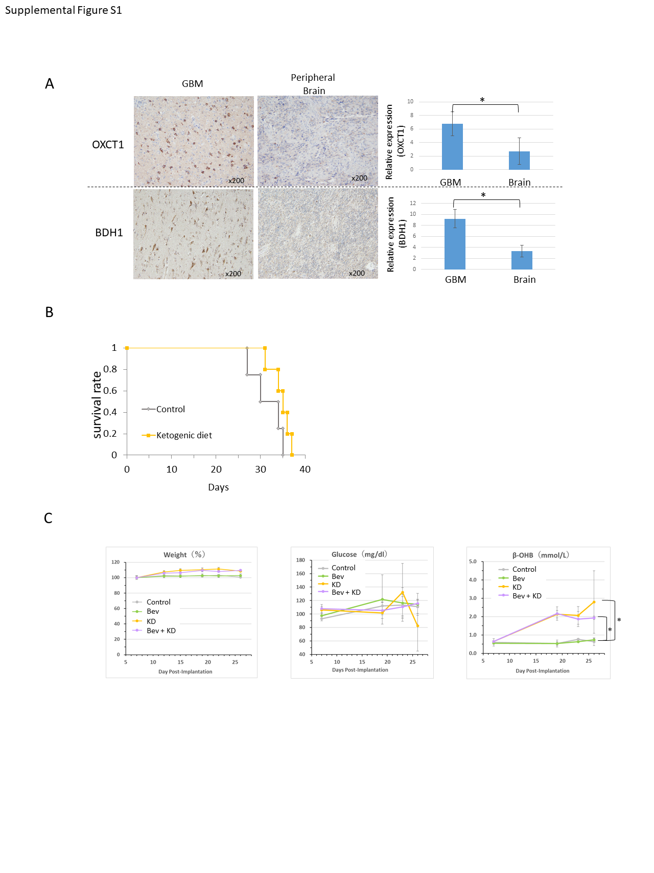Supplemental figure S1

A: Immunostaining of ketone metabolizing enzymes (OXCT1 and BDH1) in brain and GBM. An intensity of immunostainings is quantified using image J software. B: Survival analysis of mice on a ketogenic diet. U87 cells are brain-transplanted into mice fed a normal diet (control) or a ketone diet and analyze for survival time. There is no significant difference between the two groups (p=0.32). C: Changes in body weight, blood glucose, and blood ketone body concentration in each group during the course of treatment. (*p<0.05)
Supplemental figure S2
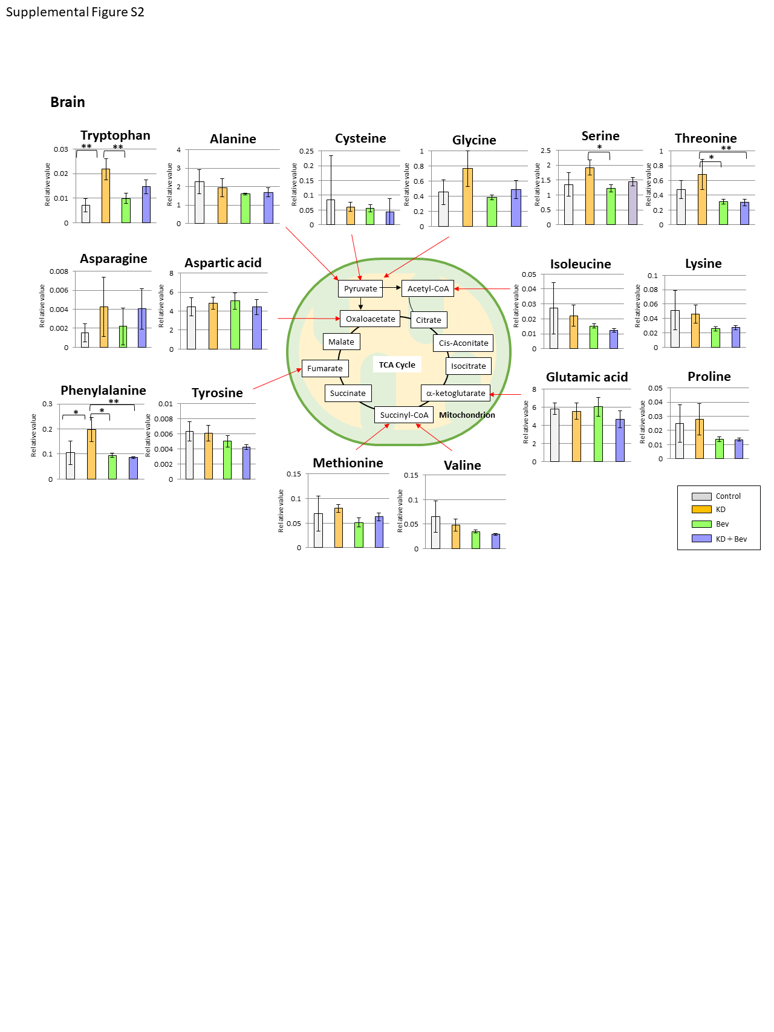

Comparison of the amino acids levels in the control, ketogenic diet (KD), bevacizumab (Bev), and ketogenic diet plus bevacizumab (KD+Bev) groups in normal bran tissues. Aspartic acid and glutamic acid are most different from the tumor. (*p<0.05, **p<0.01, and Tukey-Kramer test).

Supplemental figure S3
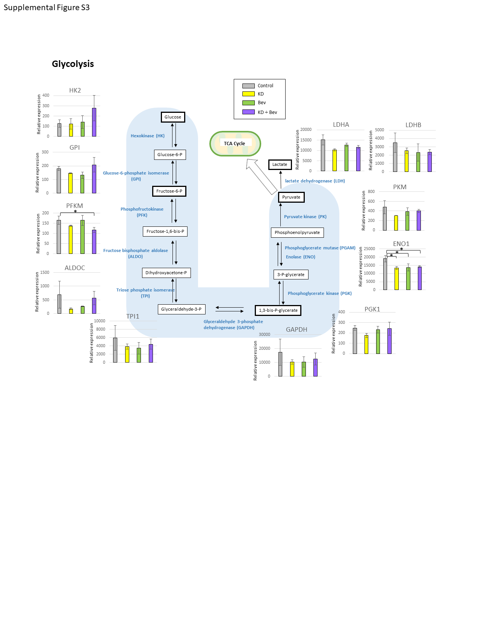

Comparison of mRNA expression levels of glycolytic enzymes (*p<0.05, **p<0.01, and Tukey-Kramer test).

