Supplementary Information
Environmentally Friendly Pd(II) Recovery from Spent Automotive Catalysts Using Resins Impregnated with a Pincer-Type Extractant
Manabu Yamada¹, Shun Kimura², Muniyappan Rajiv Gandhi³ & Atsushi Shibayama⁴

¹ Research Center of Advanced Materials for Breakthrough Technology, Graduate School of Engineering Science, Akita University, 1-1 Tegatagakuen-machi, Akita 010-8502, Japan; ²Applied Chemistry Course, Department of Materials Science, Graduate School of Engineering Science, Akita University, 1-1 Tegatagakuen-machi, Akita 010-8502, Japan; ³ Quality Control Department, Panipat Refinery & Petrochemical Complex, Indian Oil Corporation Limited, Haryana, 132140, India; ⁴ Graduate School of International Resources Science, Akita University, 1-1 Tegatagakuen-machi, Akita 010-8502, Japan

*Corresponding author. Tel +81 18 889 3068; fax: +81 18 889 3068.
E-mail address: myamada@gipc.akita-u.ac.jp

Table of content

Table S1. Physical and chemical properties of XAD resin.
Figure S1. (a) The chemical structure of XAD-7 and (b) cluster model of XAD-7 surface.
Figure S2. The relationship between impregnated amounts of 1 into XAD-7 and Pd(II) quantity adsorbed by 1-EIR. Sorption condition: [HCl] = 0.1~8.0 M, [Pd(II)] = 100 ppm (= mg L⁻¹), 1-EIR = 0.1 g, shaking speed = 280 rpm, shaking time = 24 h.
Figure S3. Effect of shaking time for Pd(II) adsorption capability of 1-EIR. Sorption condition: [HCl] = 0.1 M, [Pd(II)] = 100 ppm (= mg L⁻¹), 1-EIR = 0.1 g, shaking speed = 280 rpm, shaking time = 0 ~ 240 min.
Figure S4. Photographs a) before and b) after Pd(II) adsorption by 1-EIR.
Figure S5. Nitrogen isotherms of XAD-7 (red circle) and 1-EIR (blue circle).
Figure S6. Brunauer-Emmett-Teller (BET) plots and the sorption parameters of a) XAD-7 and b) 1-EIR.
Figure S7. Pore size distribution of XAD-7 (red circle) and 1-EIR (blue circle) by Dollimore-Heal (DH) method.
Figure S8. The sizes of a PdCl₄²⁻ species and a CH₄N₂S molecule.
Figure S9. Photographs a) before and b) after Soxhlet extraction of residual Pd(II) in 1-EIR.
Figure S10. Full scan X-ray photoelectron spectroscopy (XPS) after Soxhlet extraction from the undesorbed Pd(II) in 1-EIR.
Figure S11. ¹H NMR spectra of the Pd(II)–extractant 1 complex flaked from Pd(II)-loaded 1-EIR.
Figure S12. a) Freundlich and b) Langmuir isotherms for Pd(II) sorption by 1-EIR. Sorption conditions: 1-EIR = 0.1 g, [HCl] = 0.1 M; [Pd(II)] = 500–700 ppm (= mg L⁻¹); temperature = 293–313 K; shaking time = 24 h; shaking speed = 80 rpm.
Figure S13. Van’t Hoff plot relating ln K₀ against 1/T for Pd(II) sorption by 1-EIR. Sorption conditions: 1-EIR = 0.1 g, [HCl] = 0.1 M; [Pd(II)] = 500–700 ppm (= mg L⁻¹); temperature = 293–313 K; shaking time = 24 h; shaking speed = 80 rpm.
Figure S14. Pseudo-first-order for Pd(II) sorption by 1-EIR. Sorption condition: [HCl] = 0.1 M, [Pd(II)] = 600 ppm (= mg L⁻¹), 1-EIR = 0.1 g, shaking speed = 280 rpm, shaking time = 0.5~12 h.
Figure S15. Pseudo-second-order for Pd(II) sorption by 1-EIR. Sorption condition: [HCl] = 0.1 M, [Pd(II)] = 600 ppm (= mg L⁻¹), 1-EIR = 0.1 g, shaking speed = 280 rpm, shaking time = 0.5~12 h.
Figure S16. Particle diffusion for Pd(II) sorption by 1-EIR. Sorption condition: [HCl] = 0.1 M, [Pd(II)] = 600 ppm (= mg L⁻¹), 1-EIR = 0.1 g, shaking speed = 280 rpm, shaking time = 0.5~12 h.
Figure S17. Intraparticle diffusion for Pd(II) sorption by 1-EIR. Sorption condition: [HCl] = 0.1 M, [Pd(II)] = 600 ppm (= mg L⁻¹), 1-EIR = 0.1 g, shaking speed = 280 rpm, shaking time = 0.5~12 h..
Table S2. Application of kinetic models to the sorption of Pd(II) ions onto 1-EIR at r.t.
Figure S18. Selective Pd(II) sorption of 1-EIR from a simulated 13 metals containing HCl solution. Sorption condition: [HCl] = 0.1 M, [Metals] = each 100 ppm (= mg L⁻¹), 1-EIR = 0.1 g, shaking speed = 280 rpm, shaking time = 3 h.
Table S3. Metal species and metal concentration in the leachate of automotive catalyst.

Table S1. Physical and chemical properties of XAD resin.
Constituents
Matrix structure | Acrylic
Classification | Nonionic Spherical
Specific surface area (m²/g) | 500
Pore ​​volume (cm³/g) | 0.6
Pore diameter (Å) | 100
Apparent density (g/L) | ~655
Moisture holding capacity (%) | 61-69
Harmonic mean diameter (mm) | 0.43 - 0.69
Uniformity coefficient | ≦ 2.0
Effective pH range | 0-14
Polarity | Intermediate polarity

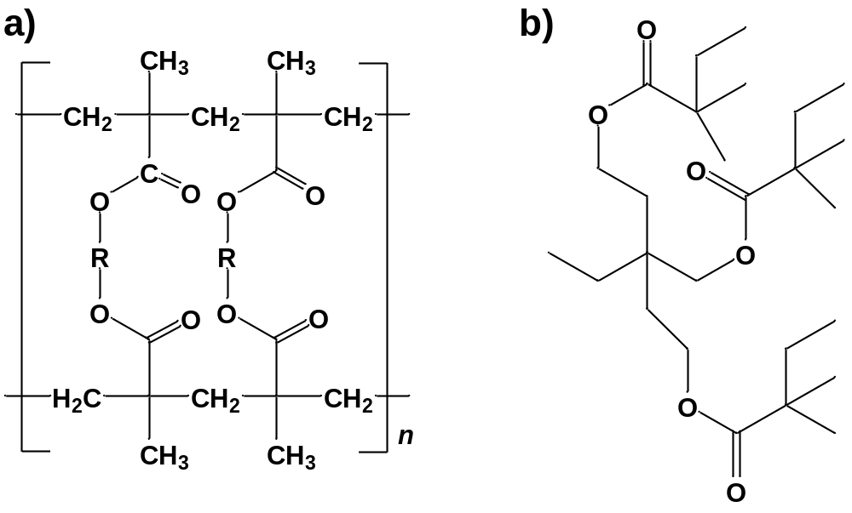

Figure S1. (a) The chemical structure of XAD and (b) cluster model of XAD surface.

Figure S2. The relationship between impregnated amounts of 1 into XAD-7 and Pd(II) quantity adsorbed by 1-EIR. Adsorption condition: [HCl] = 0.1~8.0 M, [Pd(II)] = 100 ppm (= mg L⁻¹), 1-EIR = 0.1 g, shaking speed = 280 rpm, shaking time = 24 h.

Figure S3. Effect of shaking time for Pd(II) adsorption capability of 1-EIR. Sorption condition: [HCl] = 0.1 M, [Pd(II)] = 100 ppm (= mg L⁻¹) , 1-EIR = 0.1 g, shaking speed = 280 rpm, shaking time = 0 ~ 240 min.
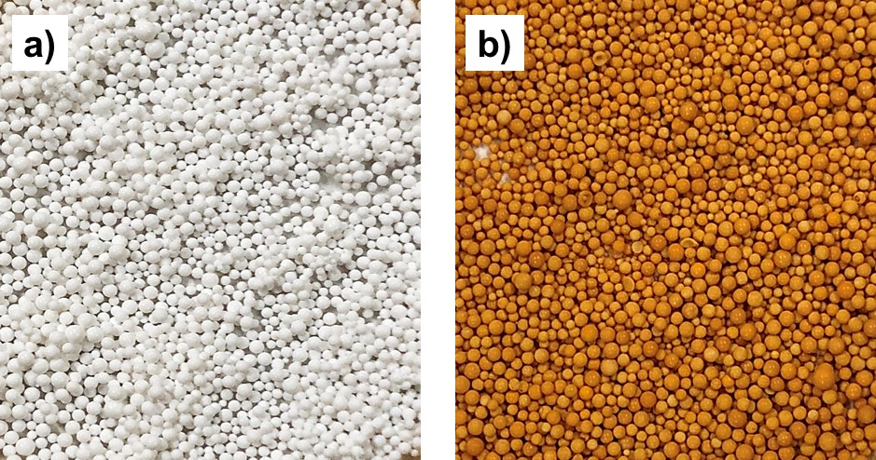
Figure S4. Photographs a) before and b) after Pd(II) adsorption by 1-EIR.

Figure S5. Nitrogen isotherms of XAD-7 (red circle) and 1-EIR (blue circle).

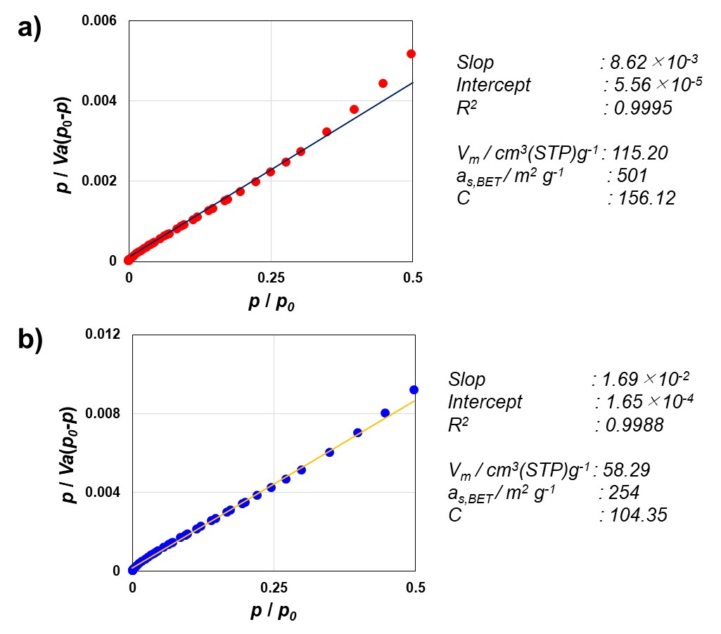
Figure S6. Brunauer-Emmett-Teller (BET) plots and the sorption parameters of a) XAD-7 and b) 1-EIR.

Figure S7. Pore size distribution of XAD-7 (red circle) and 1-EIR (blue circle) by Dollimore-Heal (DH) method.

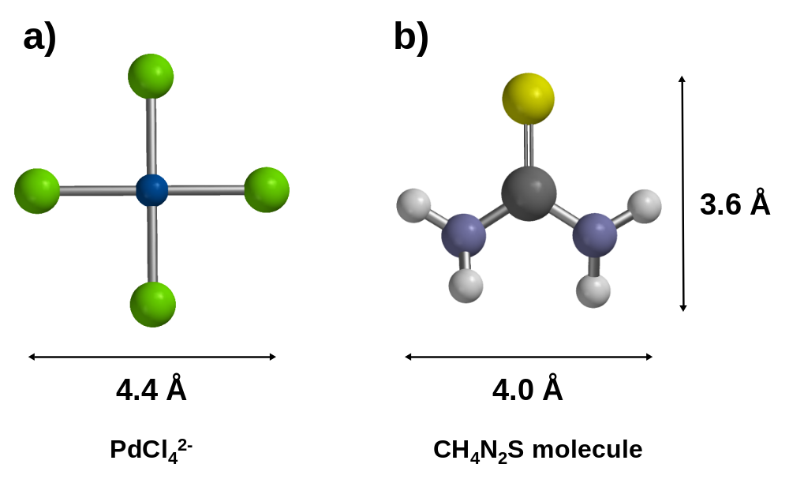
Figure S8. The sizes of a PdCl₄²⁻ species and a CH₄N₂S molecule.

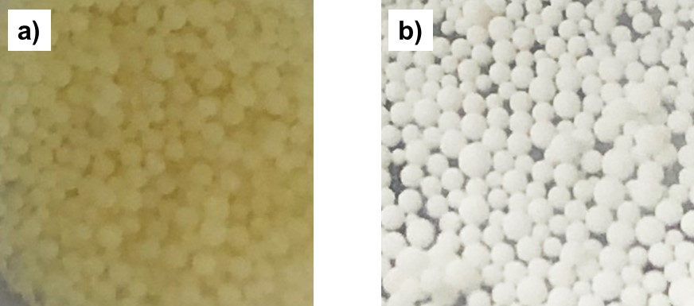
Figure S9. Photographs a) before and b) after Soxhlet extraction of residual Pd(II) in 1-EIR.

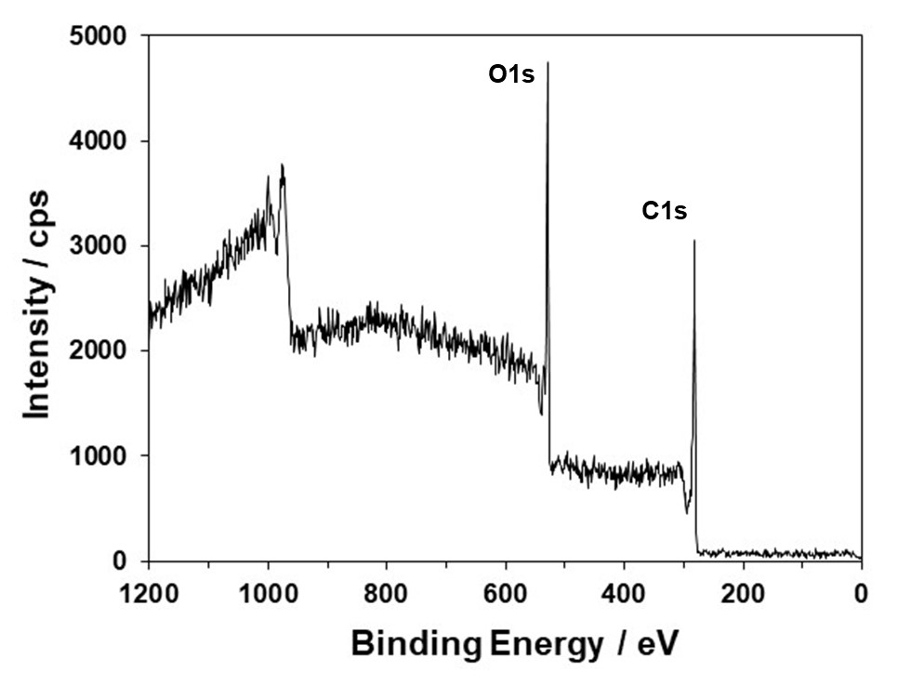
Figure S10. Full scan X-ray photoelectron spectroscopy (XPS) after Soxhlet extraction from the undesorbed Pd(II) in 1-EIR.

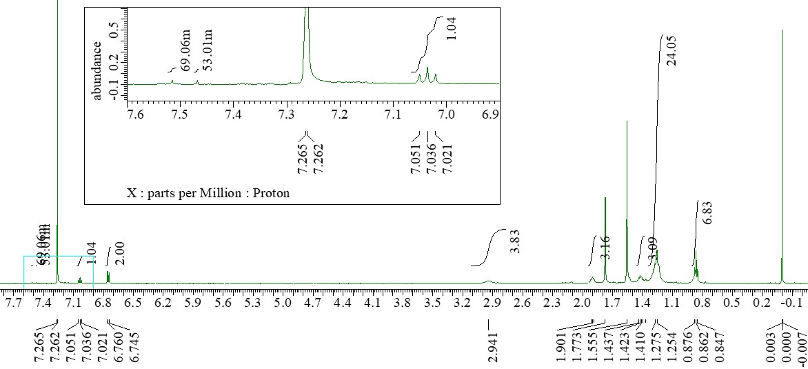
Figure S11. ¹H NMR spectra of the Pd(II)–extractant 1 complex flaked from Pd(II)-loaded 1-EIR.

Figure S12. a) Freundlich and b) Langmuir isotherms for Pd(II) sorption by 1-EIR. Sorption conditions: 1-EIR = 0.1 g, [HCl] = 0.1 M; [Pd(II)] = 500–700 ppm (= mg L⁻¹); temperature = 293–313 K; shaking time = 24 h; shaking speed = 80 rpm.

Figure S13. Van’t Hoff plot relating ln K₀ against 1/T for Pd(II) sorption by 1-EIR. Sorption conditions: 1-EIR = 0.1 g, [HCl] = 0.1 M; [Pd(II)] = 500–700 ppm (= mg L⁻¹); temperature = 293–313 K; shaking time = 24 h; shaking speed = 80 rpm.

Figure S14. Pseudo-first-order for Pd(II) sorption by 1-EIR. Sorption condition: [HCl] = 0.1 M, [Pd(II)] = 600 ppm (= mg L⁻¹), 1-EIR = 0.1 g, shaking speed = 280 rpm, shaking time = 0.5~12 h.

Figure S15. Pseudo-second-order for Pd(II) sorption by 1-EIR. Sorption condition: [HCl] = 0.1 M, [Pd(II)] = 600 ppm (= mg L⁻¹), 1-EIR = 0.1 g, shaking speed = 280 rpm, shaking time = 0.5~12 h.

Figure S16. Particle diffusion for Pd(II) sorption by 1-EIR. Sorption condition: [HCl] = 0.1 M, [Pd(II)] = 600 ppm (= mg L⁻¹), 1-EIR = 0.1 g, shaking speed = 280 rpm, shaking time = 0.5~12 h.
.

Figure S17. Intraparticle diffusion for Pd(II) sorption by 1-EIR. Sorption condition: [HCl] = 0.1 M, [Pd(II)] = 600 ppm (= mg L⁻¹), 1-EIR = 0.1 g, shaking speed = 280 rpm, shaking time = 0.5~12 h.

Table S2. Application of kinetic models to the sorption of Pd(II) ions onto 1-EIR at r.t.
Kinetic models | Parameters | Pd(II) = 600 ppm  1-EIR
Pseudo-first-order | k_{ad} (min⁻¹) | 5.0E -4
 | r | 0.8650
Pseudo-second-order | q_{e} (mg/g) | 25.00
 | k (g/mg min) | 3.163E -4
 | h (mg/g min) | 0.2164
 | r | 0.9985
Particle diffusion | k_{p} (mg/g min) | 5.9E -3
 | r | 0.9999
Intraparticle diffusion | k_{i} (mg/g min^{0.5}) | 0.8773
 | r | 0.9938

Figure S18. Selective Pd(II) sorption of 1-EIR from a simulated 13 metals containing HCl solution. Sorption condition: [HCl] = 0.1 M, [Metals] = each 100 ppm (= mg L⁻¹), 1-EIR = 0.1 g, shaking speed = 280 rpm, shaking time = 3 h.

Table S3. Metal species and metal concentration in the leachate of automotive catalyst
Metal ions | [M]_{aq,init} (mg/L)
Pd(II)  Pt(IV)  Rh(III)  La(III)  Ce(III)  Y(III)  Zr(IV)  Ba(II)  Al(III)  Fe(III) | 111.4  53.6  41.4  84.4  569.1  4.0  19.8  307.7  291.5  7.7

