Addition of probiotics to antibiotics improves the clinical course of pneumonia in young people without comorbidities: a randomized controlled trial

Chang Hun Lee^{1,2}, Yun Jung Choi³, Seung Young Seo², Seong Hun Kim², In Hee Kim², Sang Wook Kim², Soo Teik Lee², and Seung Ok Lee^{2,*}

¹Department of Internal Medicine, Naval Pohang Hospital, Pohang, South Korea
²Division of Gastroenterology, Department of Internal Medicine, Jeonbuk National University Medical School, Research Institute of Clinical Medicine of Jeonbuk National University-Biomedical Research Institute of Jeonbuk National University Hospital, Jeonju, South Korea
³Division of Rheumatology, Department of Internal Medicine, Jeonbuk National University Medical School, Research Institute of Clinical Medicine of Jeonbuk National University-Biomedical Research Institute of Jeonbuk National University Hospital, Jeonju, South Korea

Address correspondence to:
Seung Ok Lee, MD, PhD. Department of Internal Medicine, Jeonbuk National University Medical School, Research Institute of Clinical Medicine of Jeonbuk National University-Biomedical Research Institute of Jeonbuk National University Hospital, 20 Geonjiro, Dukjingu, Jeonju, Jeonbuk, 54907, South Korea. Phone: 82-63-250-1289; E-mail: solee@jbnu.ac.kr

Contents
1. Supplementary Figure
2. Supplementary Tables

1. Supplementary Figure
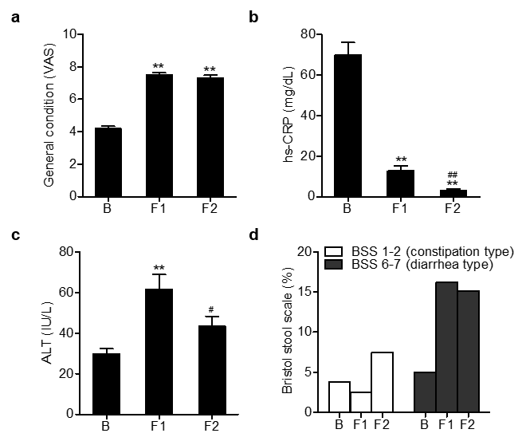
Figure S1. Changes of clinical and biochemical parameters during the study enrollment. Values are mean ± SEM. **, P < 0.01 versus baseline, ##, P < 0.05, and ##, P < 0.01 versus F1. baseline; F1, 1 week after treatment; F2, 2 weeks after treatment.

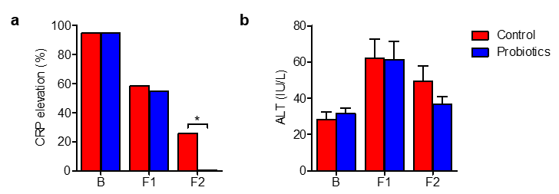
Figure S2. Comparison of clinical manifestations depending on the administration of the probiotic. Values are mean ± SEM. *, P < 0.05. B, baseline; F1, 1 week after treatment; F2, 2 weeks after treatment.

2. Supplementary Tables
Table S1. Microbiologic data as a diagnostic test for etiology of pneumonia

Characteristics | Control group  (n=40) | Probiotic group  (n=40) | P value
Sputum AFB + | 0 (0.0%) | 0 (0.0%) | 1.000
Sputum culture + | 0 (0.0%) | 2 (5.0%) | 0.474
Blood culture + | 1 (2.5%) | 0 (0.0%) | 1.000
Pneumococcus urinary antigen | 0 (0.0%) | 1 (2.6%) | 0.990
Mycoplasma | 14 (35.0%) | 18 (47.4%) | 0.379
Respiratory virus PCR + | 23 (57.5%) | 24 (60.0%) | 1.000
Adenovirus | 13 (32.5%) | 17 (42.5%) | 0.488
RSV | 0 (0.0%) | 1 (2.5%) | 1.000
Influenza | 0 (0.0%) | 1 (2.5%) | 1.000
Parainfluenza | 1 (2.5%) | 0 (0.0%) | 1.000
Bocavirus | 0 (0.0%) | 0 (0.0%) | -
Metapneumovirus | 0 (0.0%) | 0 (0.0%) | -
Coronavirus | 0 (0.0%) | 0 (0.0%) | -
Rhinovirus | 14 (35.0%) | 16 (40.0%) | 0.817

AFB, acid fast bacillus; PCR, polymerase chain reaction; RSV, respiratory syncytial virus.

Table S2. Clinical and laboratory parameters 1 week after treatment
Characteristics | Control group  (n=40) | Probiotic group  (n=40) | Overall  (n=80) | P value
General condition (VAS) | 7.2 ± 1.2 | 7.8 ± 1.1 | 7.5 ± 1.2 | 0.016
Clinical manifestations
Fever | 0 (0.0%) | 0 (0.0%) | 0 (0.0%) | -
Chills | 1 (2.5%) | 0 (0.0%) | 1 (1.2%) | 1.000
Headache | 38 (95.0%) | 39 (97.5%) | 77 (96.2%) | 1.000
Myalgia | 1 (2.5%) | 0 (0.0%) | 1 (1.2%) | 1.000
Cough | 19 (47.5%) | 24 (60.0%) | 43 (53.8%) | 0.370
Coryza | 6 (15.0%) | 6 (15.0%) | 12 (15.0%) | 1.000
Sputum | 19 (47.5%) | 16 (40.0%) | 35 (43.8%) | 0.652
Sore throat | 0 (0.0%) | 0 (0.0%) | 0 (0.0%) | -
Chest pain | 4 (10.0%) | 4 (10.0%) | 8 (10.0%) | 1.000
Abdominal pain | 1 (2.5%) | 0 (0.0%) | 1 (1.2%) | 1.000
Bristol Stool Scale |  |  |  | 0.215
Type 1 or 2 | 2 (5.0%) | 0 (0.0%) | 2 (2.5%)
Type 3, 4, or 5 | 30 (75.0%) | 35 (87.5%) | 65 (81.2%)
Type 6 or 7 | 8 (20.0%) | 5 (12.5%) | 13 (16.2%)
Vital Sign
Systolic BP, mmHg | 117.9 ± 10.9 | 116.9 ± 10.0 | 117.4 ± 10.4 | 0.670
Diastolic BP, mmHg | 73.2 ± 8.9 | 74.3 ± 9.2 | 73.8 ± 9.0 | 0.596
HR, beat per min | 65.7 ± 8.4 | 69.9 ± 8.5 | 67.8 ± 8.7 | 0.029
RR, breath per min
Body temperature, ℃ | 36.3 ± 0.2 | 35.5 ± 5.2 | 35.9 ± 3.7 | 0.312
Fever subsidence | 25 (100.0%) | 26 (100.0%) | 51 (100.0%) | 1.000
Fever duration (days) | 3.3 ± 1.3 | 2.3 ± 0.7 | 2.8 ± 1.1 | 0.003
WBC, /μl | 5445.8 ± 1978.8 | 5840.8 ± 1567.7 | 5643.2 ± 1784.9 | 0.325
Hemoglobin, g/dl | 14.4 ± 1.1 | 14.1 ± 1.3 | 14.3 ± 1.2 | 0.254
Platelet, /μl | 271.1 ± 80.1 | 317.3 ± 206.5 | 294.2 ± 157.3 | 0.193
PT (INR) | 1.2 ± 0.1 | 1.1 ± NA | 1.2 ± 0.1
hs-CRP, mg/dl | 13.7 ± 21.5 | 11.5 ± 23.9 | 12.6 ± 22.6 | 0.662
CRP elevation | 23 (57.5%) | 22 (55.0%) | 45 (56.2%) | 1.000
ESR, mm/hr | 14.8 ± 11.2 | 6.2 ± 3.6 | 10.5 ± 9.0 | 0.140
ALP, IU/l | 73.3 ± 62.8 | 60.7 ± 15.5 | 66.9 ± 45.6 | 0.231
AST, IU/l | 41.8 ± 34.1 | 34.2 ± 17.2 | 38.0 ± 27.1 | 0.215
AST elevation | 12 (30.0%) | 10 (25.0%) | 22 (27.5%) | 0.802
ALT, IU/l | 62.2 ± 65.0 | 61.4 ± 63.4 | 61.8 ± 63.8 | 0.953
ALT elevation | 20 (50.0%) | 22 (55.0%) | 42 (52.5%) | 0.823
Total bilirubin, mg/dl | 0.4 ± 0.2 | 0.4 ± 0.2 | 0.4 ± 0.2 | 0.644
Protein, g/dl | 6.5 ± 0.5 | 6.4 ± 0.4 | 6.5 ± 0.5 | 0.296
Albumin, g/dl | 3.9 ± 0.3 | 3.8 ± 0.3 | 3.8 ± 0.3 | 0.598
BUN, mg/dl | 10.4 ± 2.3 | 9.6 ± 2.7 | 10.0 ± 2.5 | 0.163
Creatinine, mg/dl | 0.8 ± 0.2 | 0.8 ± 0.1 | 0.8 ± 0.1 | 0.225
Na, mmol/l | 136.8 ± 2.4 | 137.1 ± 3.2 | 137.0 ± 2.8 | 0.652
K, mmol/l | 4.5 ± 0.3 | 4.4 ± 0.4 | 4.4 ± 0.3 | 0.604
Cl, mmol/l | 101.9 ± 2.3 | 102.8 ± 2.5 | 102.3 ± 2.5 | 0.083
LD, IU/l | 185.4 ± 41.6 | 172.5 ± 42.7 | 178.9 ± 42.4 | 0.194

Table S3. Clinical and laboratory parameters 2 weeks after treatment
Characteristics | Control group  (n=29) | Probiotic group  (n=24) | Overall  (n=53) | P value
General condition (VAS) | 6.9 ± 1.4 | 7.8 ± 1.0 | 7.3 ± 1.3 | 0.007
Clinical manifestations
Fever | 0 (0.0%) | 0 (0.0%) | 0 (0.0%) | -
Chills | 0 (0.0%) | 0 (0.0%) | 0 (0.0%) | -
Headache | 2 (6.9%) | 1 (4.2%) | 3 (5.7%) | 1.000
Myalgia | 0 (0.0%) | 0 (0.0%) | 0 (0.0%) | -
Cough | 15 (51.7%) | 9 (37.5%) | 24 (45.3%) | 0.448
Coryza | 13 (44.8%) | 6 (25.0%) | 19 (35.8%) | 0.226
Sputum | 13 (44.8%) | 4 (16.7%) | 17 (32.1%) | 0.059
Sore throat | 0 (0.0%) | 0 (0.0%) | 0 (0.0%) | -
Chest pain | 3 (10.3%) | 1 (4.2%) | 4 (7.5%) | 0.745
Abdominal pain | 1 (3.4%) | 0 (0.0%) | 1 (1.9%) | 1.000
Bristol Stool Scale |  |  |  | 0.013
Type 1 or 2 | 4 (13.8%) | 0 (0.0%) | 4 (7.5%)
Type 3, 4, or 5 | 18 (62.1%) | 23 (95.8%) | 41 (77.4%)
Type 6 or 7 | 7 (24.1%) | 1 (4.2%) | 8 (15.1%)
Vital Sign
Systolic BP, mmHg | 123.1 ± 11.1 | 120.0 ± 13.6 | 121.7 ± 12.3 | 0.389
Diastolic BP, mmHg | 72.2 ± 10.2 | 69.9 ± 9.3 | 71.2 ± 9.8 | 0.408
HR, beat per min | 67.9 ± 10.5 | 66.5 ± 7.7 | 67.2 ± 9.3 | 0.606
RR, breath per min | 16.7 ± 2.1 | 16.7 ± 4.8 | 16.7 ± 3.5 | 0.946
Body temperature, ℃ | 36.4 ± 0.3 | 35.5 ± 3.5 | 36.0 ± 2.4 | 0.238
WBC, /μl | 5499.6 ± 1235.1 | 5828.8 ± 1528.2 | 5654.5 ± 1376.6 | 0.400
Hemoglobin, g/dl | 14.0 ± 1.1 | 14.1 ± 1.3 | 14.0 ± 1.2 | 0.683
Platelet, /μl | 285.3 ± 64.8 | 312.1 ± 77.2 | 297.9 ± 71.5 | 0.184
hs-CRP, mg/dl | 4.5 ± 6.5 | 1.2 ± 0.8 | 3.0 ± 5.0 | 0.015
CRP elevation | 7 (25.9%) | 0 (0.0%) | 7 (13.7%) | 0.023
ALP, IU/l | 69.1 ± 19.7 | 68.9 ± 15.5 | 69.0 ± 17.7 | 0.957
AST, IU/l | 33.0 ± 20.8 | 25.6 ± 6.2 | 29.5 ± 16.0 | 0.089
AST elevation | 5 (18.5%) | 1 (4.2%) | 6 (11.8%) | 0.249
ALT, IU/l | 49.5 ± 43.6 | 36.5 ± 21.5 | 43.4 ± 35.3 | 0.178
ALT elevation | 11 (40.7%) | 9 (37.5%) | 20 (39.2%) | 1.000
Total bilirubin, mg/dl | 0.7 ± 0.3 | 0.8 ± 0.4 | 0.8 ± 0.3 | 0.088
Protein, g/dl | 6.8 ± 1.4 | 7.0 ± 0.4 | 6.9 ± 1.1 | 0.443
Albumin, g/dl | 4.4 ± 0.6 | 4.4 ± 0.3 | 4.4 ± 0.5 | 0.954
BUN, mg/dl | 12.3 ± 2.6 | 12.0 ± 2.8 | 12.2 ± 2.7 | 0.663
Creatinine, mg/dl | 1.5 ± 3.0 | 0.9 ± 0.2 | 1.2 ± 2.2 | 0.281
Na, mmol/l | 137.9 ± 1.6 | 138.0 ± 1.7 | 138.0 ± 1.7 | 0.787
K, mmol/l | 4.1 ± 0.2 | 4.3 ± 0.3 | 4.2 ± 0.3 | 0.010
Cl, mmol/l | 101.8 ± 1.5 | 102.0 ± 1.9 | 101.9 ± 1.7 | 0.658
LD, IU/l | 198.4 ± 56.3 | 162.6 ± 27.9 | 180.9 ± 47.8 | 0.010

