Neonatal mice resist Plasmodium yoelii infection until exposed to para-aminobenzoic acid containing diet after weaning

Marcela Parra, Jiyeon Yang$, Megan Weitner#$, and Mustafa Akkoyunlu*.
US Food and Drug Administration, Center for Biologics Evaluation and Research, Division of Bacterial Allergenic and Parasitic Diseases, Silver Spring, MD.

Supplemental Figures

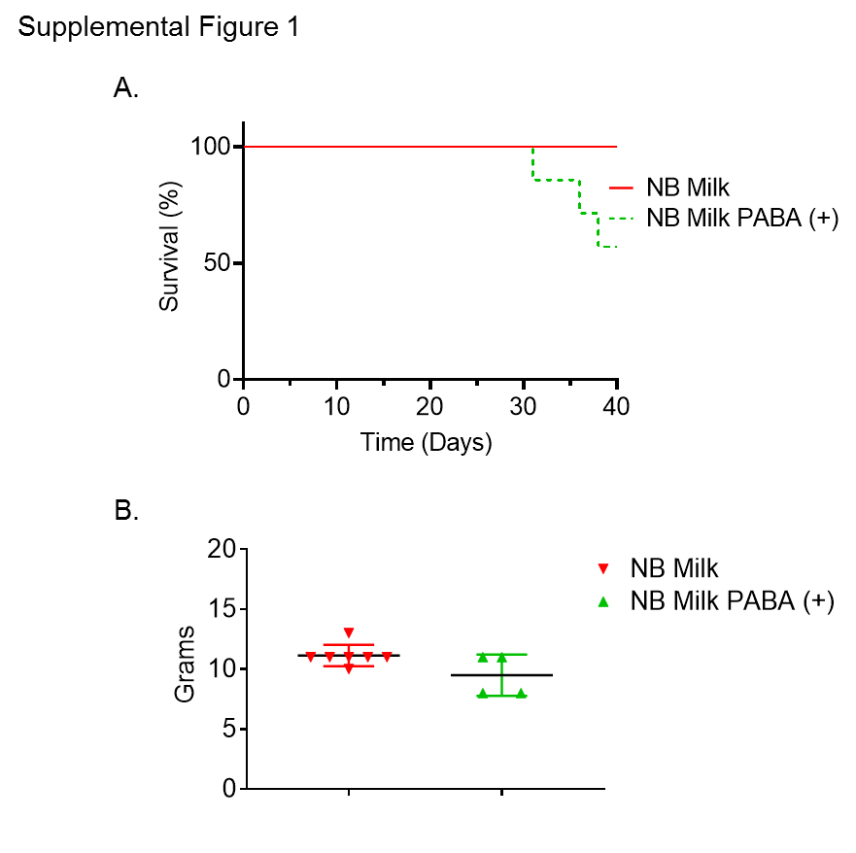
Supplemental Figure 1. The effect of PABA containing milk-based diet on survival and body weight in P. yoelii infected NB mice. (A and B) Two groups of 7 6- to 7-days old NB mice were infected with 1 x 10⁶ PyNL parasites. Mice were weaned at day 21 post birth and were fed with a milk-based diet or a milk-based diet containing PABA (PABA (+)) for 24 days. Experiment was performed once. A) Survival of mice was assessed until 40 days after infection. Results are expressed as survival curves analyzed using the Log-rank (Mantel Cox) test for 7 weanlings fed with milk-based diet and for 7 weanlings fed with PABA supplemented milk-based diet. B) Mice were weighed at day 38 post infection. Results are expressed as mean grams ± SEM for 7 weanlings fed with milk-based diet and for 4 weanlings fed with PABA supplemented milk-based diet. Student’s t test was used for statistical evaluation. Experiment was performed once.
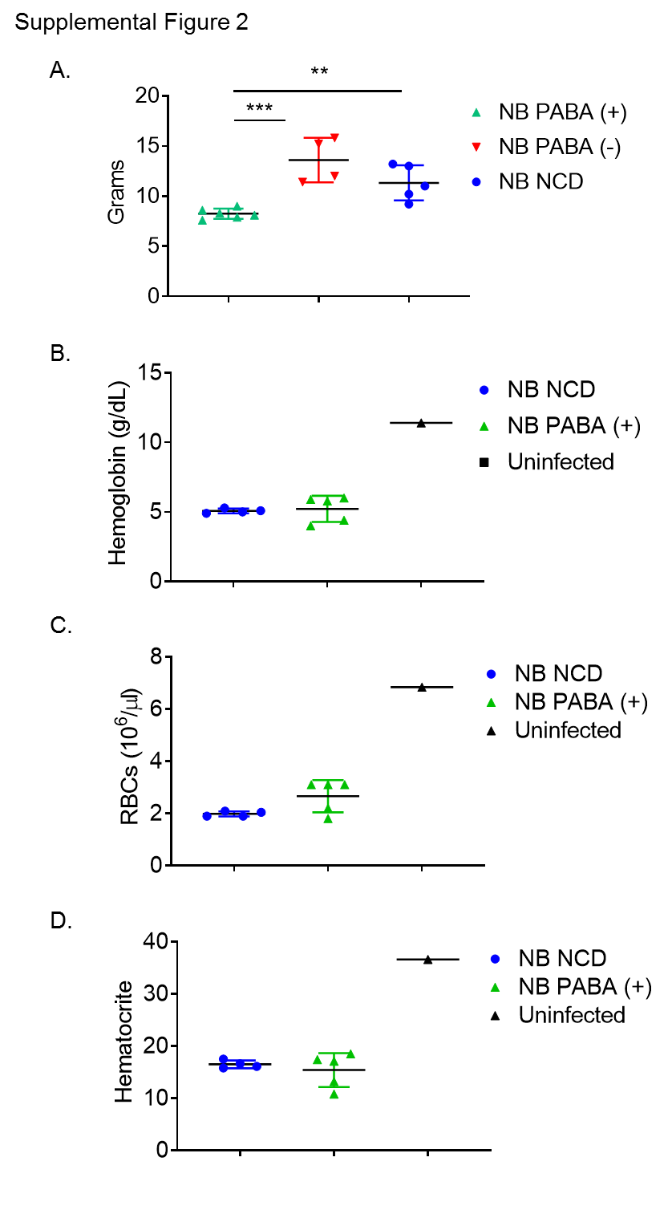
Supplemental Figure 2. Weight and CBC values of P. yoelii infected NB mice fed with PABA-deficient diet. A) Three groups of 6- to 7-days old NB mice were infected with 1 x 10⁶ PyNL parasites. At weaning time (day 21 post birth) 6 mice were fed with PABA-containing diet (PABA (+)), 4 mice were fed with PABA-deficient diet (PABA (-)) and 5 mice were fed with NCD. Mice were weighed at day 23 post infection. Results are expressed as mean grams ± SEM. Student’s t test was used for statistical evaluation. **p<0.01 and ***p<0.0001. Two groups of 6- to 7-days old NB mice were infected with 1 x 10⁶ PyNL parasites. Mice were weaned at day 21 post birth and were fed with either PABA-containing (PABA (+)) or NCD. One 28-day old uninfected mouse served as control. Hemoglobin (B), RBC (C) and hematocrit (D) values were determined at 21 days post infection. Results are expressed as mean ± SEM for 4 to 5 mice per group. Experiment was performed once.

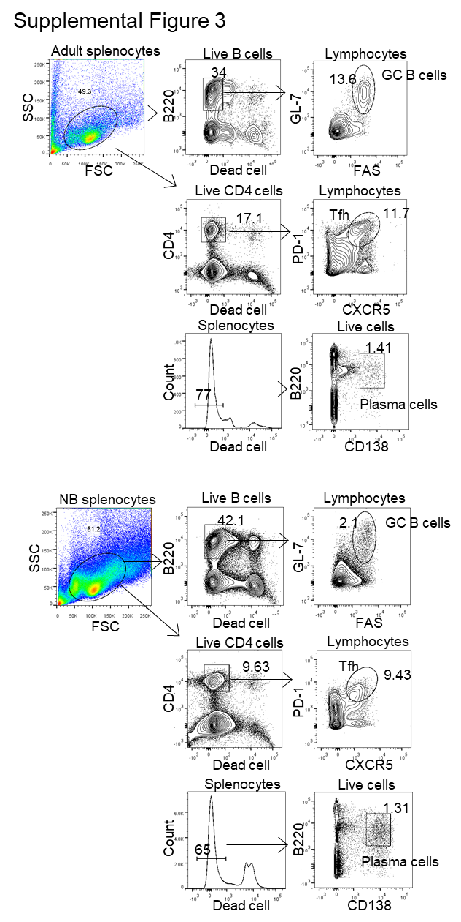

Supplemental Figure 3. Gating strategy for Tfh, GC B cells and Plasma cells. Adult (7- to 8-week-old) and neonatal (6- to 7-day-old) mice were infected i.p. with 1 x 10⁶ PyNL parasites. Representative gating images of splenic Tfh cells, GC B cells and plasma cells are from mice at 20 days post parasite challenge.

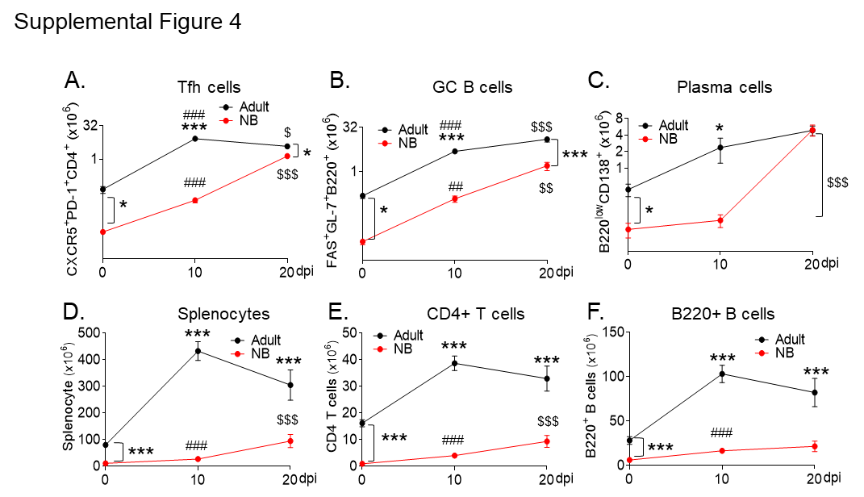
Supplemental Figure 4. Splenic Tfh, GC B cell and plasma cell, CD4 cell, B cell, splenocyte numbers in P. yoelii infected NB mice.
Six to 7-day-old NB and 8- to12-week-old adult mice were infected i.p. with 1 x 10⁶ PyNL parasites. Splenocytes were analyzed in flow cytometry on days 0, 10 and 20 after parasite challenge. Formation and resolution kinetics of CD4⁺PD-1⁺CXCR5⁺ (Tfh cells), B220⁺GL-7⁺FAS⁺ (GC B cells) and B220^{low}CD138⁺ (plasma cells) are plotted as cell number per spleen. Results are expressed as mean ± SEM (n=4); *p<0.05, and ***p<0.001 indicate adult vs NB mice; ##p<0.01, and ###p<0.001 indicate 0 dpi vs 10 dpi in both adult and NB mice, and §§§p<0.001 indicates 10 dpi vs 20 dpi in both adult and NB mice.

