Polymorphisms in Plasmodium falciparum Dihydropteroate synthetase and Dihydrofolate reductase genes in Nigerian children with uncomplicated malaria using high-resolution melting technique

Adeyemi T. Kayode^{1,2}, Fehintola V. Ajogbasile^{1,2}, Kazeem Akano^{1,2}, Jessica N. Uwanibe^{1,2}, Paul E. Oluniyi^{1,2}, Philomena J. Eromon¹, Onikepe A. Folarin^{1,} Akintunde Sowunmi^{3,4}, Dyann F. Wirth⁵, and Christian T. Happi*^{1, 2,5}

¹African Centre of Excellence for Genomics of Infectious Diseases, Redeemer's University, Ede, Nigeria
²Department of Biological Sciences, Redeemer's University, Ede, Nigeria
³Institute of Advanced Medical Research and Training, College of Medicine, University of Ibadan, Nigeria
⁴Department of Pharmacology and Therapeutics, University of Ibadan, Ibadan, Nigeria
⁵Department of Immunology and Infectious Diseases, Harvard T.H. Chan School of Public Health, Boston, MA, USA

*Corresponding Author
Christian T. Happi, PhD
African Centre of Excellence for Genomics of Infectious Diseases,
Department of Biological Sciences, Redeemer's University, Ede, Nigeria
happic@run.edu.ng

Supplementary Fig. S1
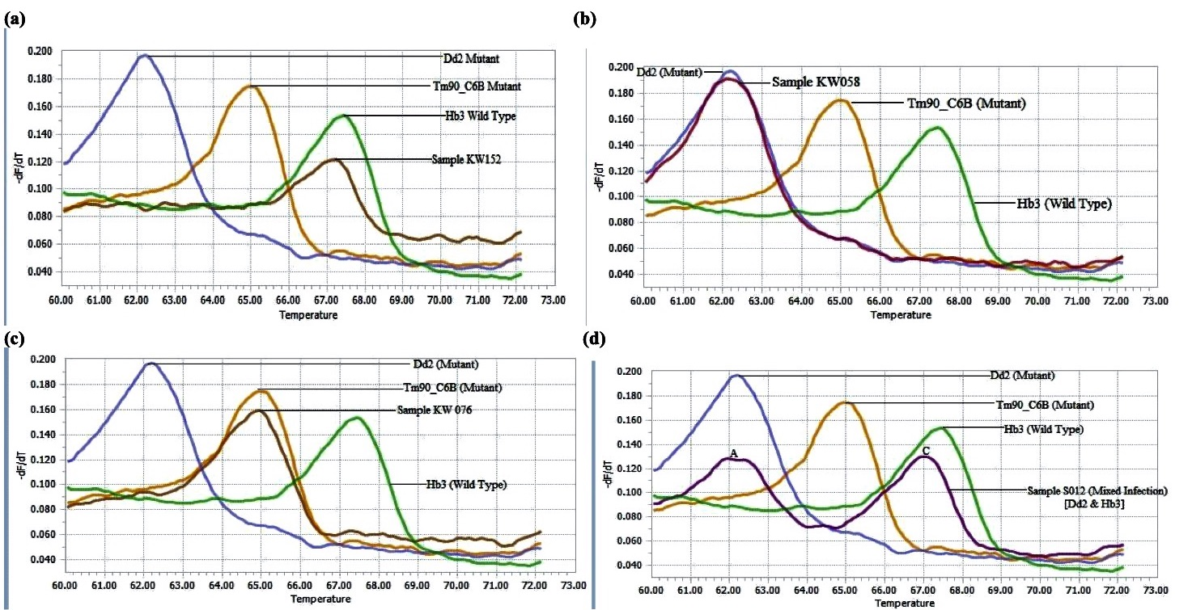
High resolution melt curves of Dhfr codon 51.59. In Fig. S1a, sample had identical melt curve as the HB3 wildtype control thus habouring the N₅₁ and C₅₉ wild type alleles. In Fig. S1b, sample had identical melt curve as the Dd2 mutant control thus habouring the I₅₁ and R₅₉ mutant alleles. In Fig. S1c, sample had identical melt curve as the TM906CB mutant control thus habouring the N₅₁ and R₅₉ alleles. In Fig. S1d, sample had identical melt curves as the Dd2 mutant and HB3 wild type controls thus designated as mixed allelic infection.

Supplementary Fig. S2

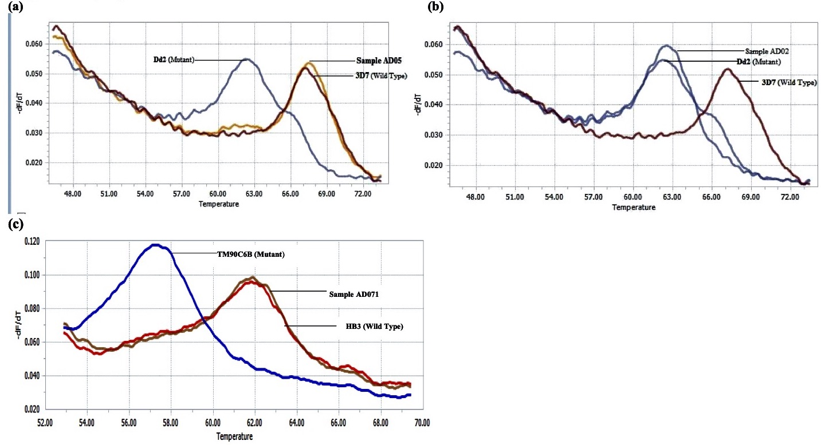
High resolution melt curves of Dhfr codon 108 and 164. In Fig. S2a, sample had identical melt curve as the 3D7 wildtype control thus habouring the S₁₀₈ wild type allele. In Fig. S2b, sample had identical melt curve as the Dd2 mutant control thus habouring the N₁₀₈ mutant allele. In Fig. S2c, sample had identical melt curves as the HB3 wild type control thus habouring the I₁₆₄ wild type allele. None of the sample had a melt curve curve as the TM90C6B mutant control.

Supplementary Fig. S3

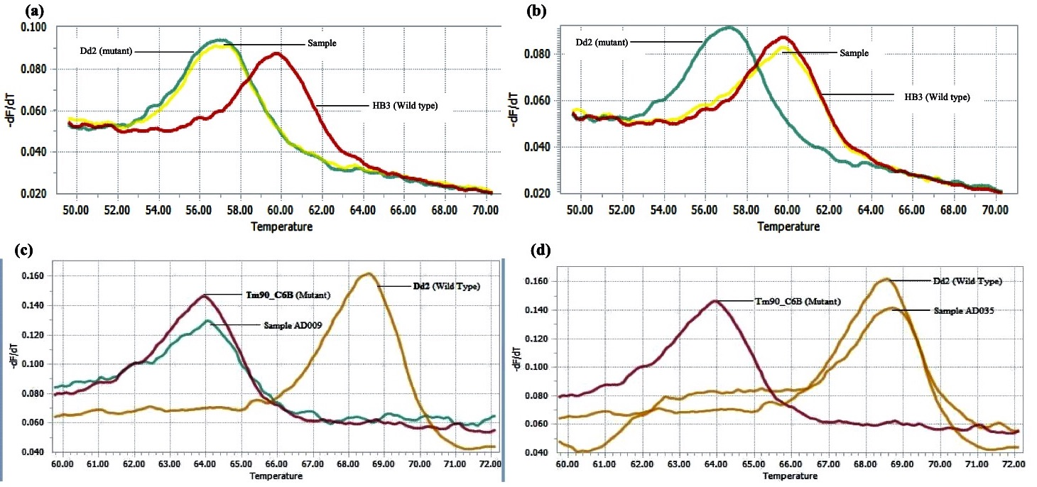
High resolution melt curves of Dhps codon 437 and 581. In Fig. S3a, sample had identical melt curve as the Dd2 mutant control thus habouring the G₄₃₇ mutant allele. In Fig. S3b, sample had identical melt curve as the HB3 wild type control thus habouring the S₄₃₇ wild type allele. In Fig. S3c, sample had identical melt curve as the TM906CB mutant control thus habouring the G₅₈₁ mutant allele. In Fig. S3d, sample had a identical melt curves as the Dd2 wild type control thus habouring the A₅₈₁ wild type allele.

Supplementary Fig. S4

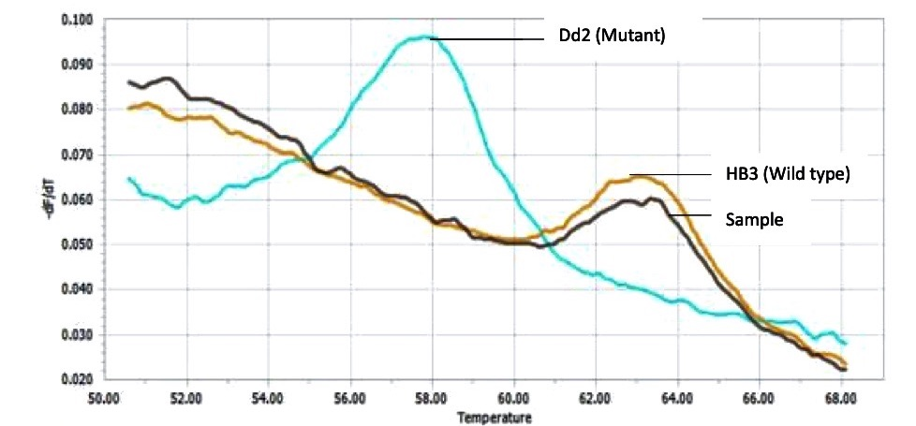

High resolution melt curves of Dhps codon 613. Sample had identical melt curve as the HB3 wildtype control thus habouring the A₆₁₃ wild type allele. None of the samples had melt curves identical to the Dd2 mutant control.

