Supplementary Information to: UNEXPECTED LARGER DISTRIBUTION OF PALEOGENE STEM-ROLLERS (AVES, CORACII): NEW EVIDENCE FROM THE EOCENE OF PATAGONIA, ARGENTINA

Federico J. Degrange^{1*}, Diego Pol², Pablo Puerta² & Peter Wilf³

¹Centro de Investigaciones en Ciencias de la Tierra (CICTERRA), UNC, CONICET, Avenida Vélez Sársfield 1611, X5016GCA, Córdoba, Argentina. fjdino@gmail.com
²Museo Paleontológico Egidio Feruglio-CONICET. Av. Fontana 140, U9100GYO, Trelew, Chubut, Argentina. dpol@mef.org.ar, ppuerta@mef.org.ar
³Department of Geosciences and Earth and Environmental Systems Institute, Pennsylvania State University, University Park, Pennsylvania 16802, United States. pwilf@psu.edu

1. Phylogenetic analysis

The phylogenetic analysis used in this contribution was based on an equally weighted parsimony analysis using TNT [1]. The two most parsimonious trees recovered in the implicit enumeration tree search had 205 steps in length and a consistency index CI=0.424 and a retention index RI=0.655. Below we include the results of the Bremer support and jackknife analysis (Figs. S1, S2). In addition to these two support analyses we tested positioning Ueekenkcoracias in other clades of Picocoraciae using the constrained tree searches through the force command to find out how many extra steps were required to place the new species in different placements of the phylogenetic tree.
In addition to this approach, we have also run the same dataset using other methods that use alternative optimality criteria. For instance, analyses of the same dataset parsimony under implied weights [2] yielded trees in which Ueekenkcoracias is placed in the same phylogenetic position, as the basalmost stem-roller (Fig. S3). This result is obtained under a broad range of weighting functions (constant k ranging between 3 and 15).
Similarly, we have run a Bayesian analysis using MrBayes 3.2 [3] under the Mkv model for 10,000,000 generations. Four independent runs were performed, setting the coding options as variable or informative and the rates as equal or gamma distributed. All analyses conducted coincide in in the phylogenetic position Ueekenkcoracias as the basalmost stem-roller (Fig. S4). The posterior probability values for Coracii (including Ueekenkcoracias) were always above 80% (Fig. S4). However other nodes within the clade are lower, such as the group clustering all other Coracii with the exception of Ueekenkcoracias (e.g., 56%; Fig. S4). This relatively low posterior probability value is in concordance with the low support values of this nodes obtained in the parsimony analysis (see below).

2. Data matrix

Tyto 000000110000100000000000000001000010?00001000000000000001000000000010010000000
Colius 100000100001000000001000010100000010?0100000000010000001000?010000100000000010
Harpactes 000000100000002100000100000000000000?01000000001000000000000100000001000001001
Septencoracias ?00?000????0????0??00???00????000001000001000?0??111?0100???00100?011011100111
Primobucco 10??0001?0??101?0??1?000???000000001000001000????11?101?0???1???0?0?1011100011
Eocoracias ?0???0?100??201?0???00?0??00?0001001?00?00001????11??01?0???0???00??10???00000
Paracoracias 11??001100??201?0??10?????0?0000000??00?00001????1???01?0???10??0????01?1?0101
Geranopterus ??0?????????21??????????1000??0??01101?0??00?????1?1101???????100101101110??01
Coracias 111101111010211010010100110000000011110000001000011110100100101101011011100101
Atelornis 11110011100021100001010010000000111111000000000001111010010?101101101010100100
Baryphthengus 00010010?100101111000001100100001010?10000000000011000110111100010000000010100
Todus 1001001010000011110000011?0100101010?1001000000001100011011110001010?000?10100
Merops 001000000000001110000001110010001011010000000000011000110101000000101001011100
Alcedo 001110111010000110000001101000101010?10000001000011100110101101010101001011100
Dacelo 001110111010101110000001100000001010?10000000000011100110101100010101011011100
Upupa 1001111??1?1001020101010011011111120?11110011101101000101100010000100100010000
Phoeniculus 1001111??1?1000020101011011011111120?11110011101111000111100010000100100010100
Bucorvus 1001011000?1101020001010010001101020?10000000101011000100100010010000100010000
Nystalus 111100110011201010101210001000001110?1000010000001100100000001001010?100000100
Pteroglossus 0200011??1?1101020001021010100112010?10000100010010002000000010110100100010100
Picoides 0000000??1?110101?001021110100112110?10000100010100002001000111110100100010100
Ueekenkcoracias ????????????????????????????????????????????????0??1??000?????????????011?00??

3. Supplementary Figures

Figure S1. Bremer Support values. This analysis was conducted using the script Bremer.run in TNT [1] for the equally weighted parsimony analysis.
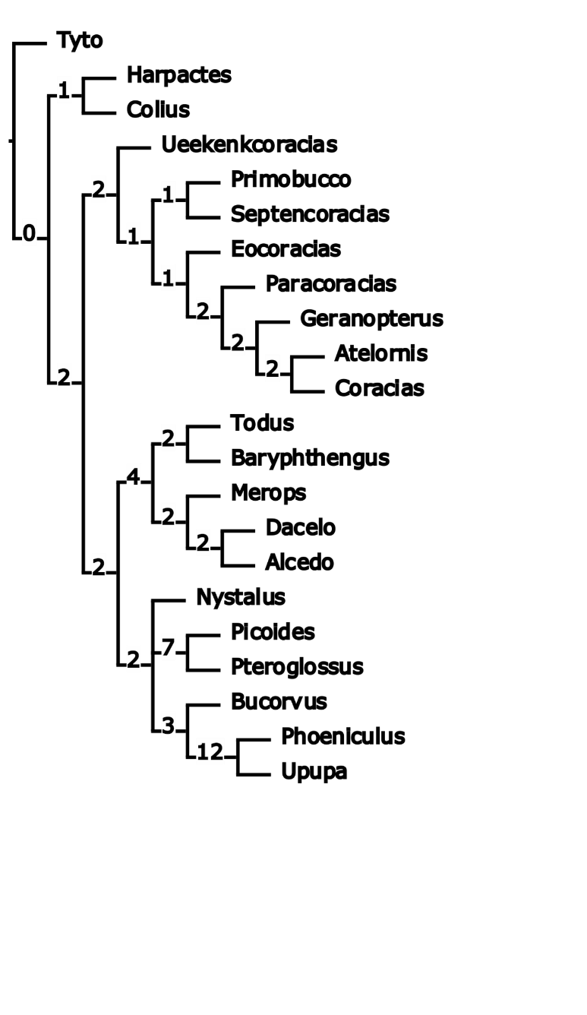
Figure S2. Jackknife Support values. This analysis was conducted using the command resample in TNT [1] for the equally weighted parsimony analysis. Values shown by the nodes represent the GC and absolute frequencies.
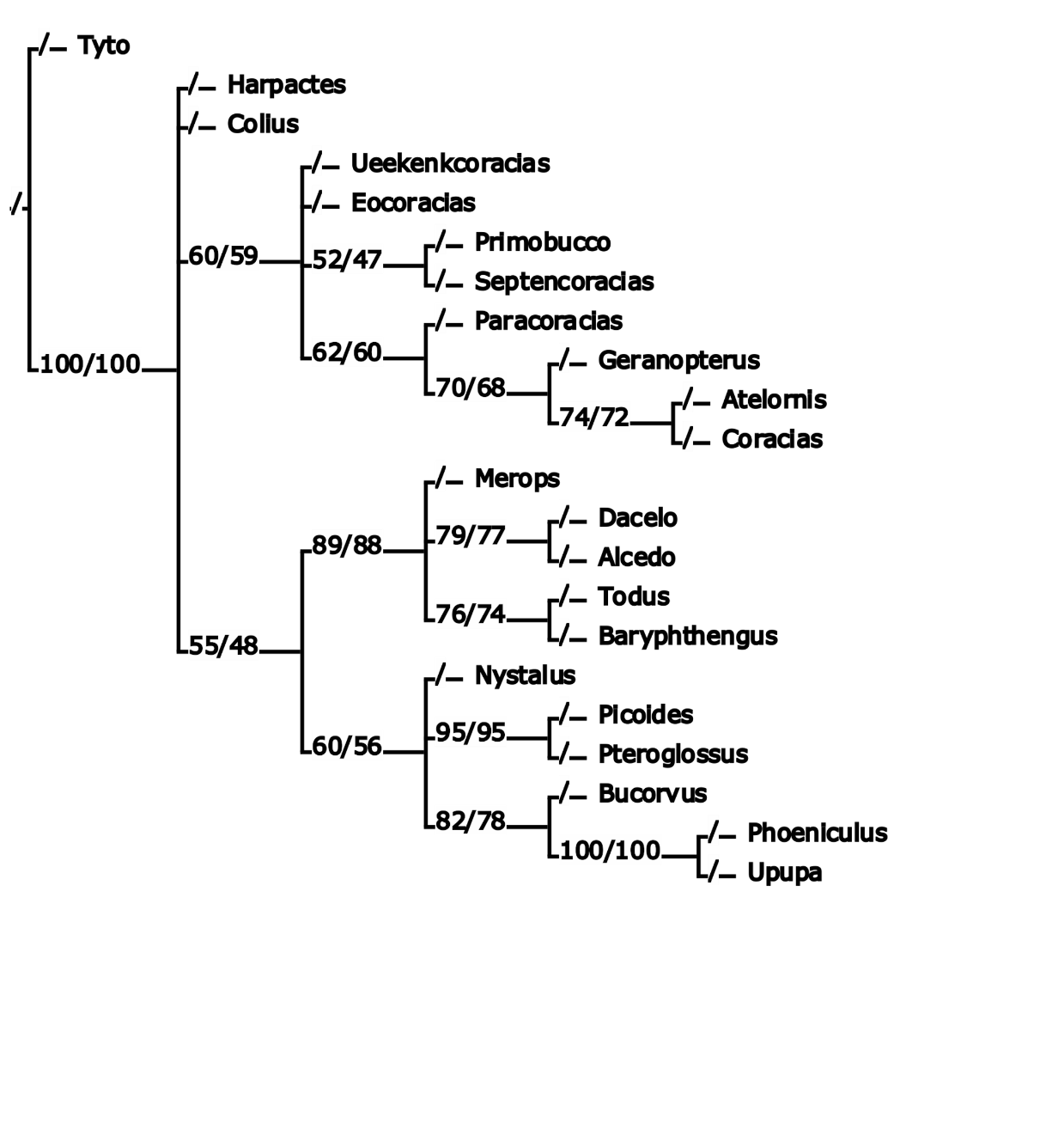

Figure S3. Implied weights analysis. This tree was obtained using a K value of 5 in TNT [1], similar results were obtained for other weighting constant values.

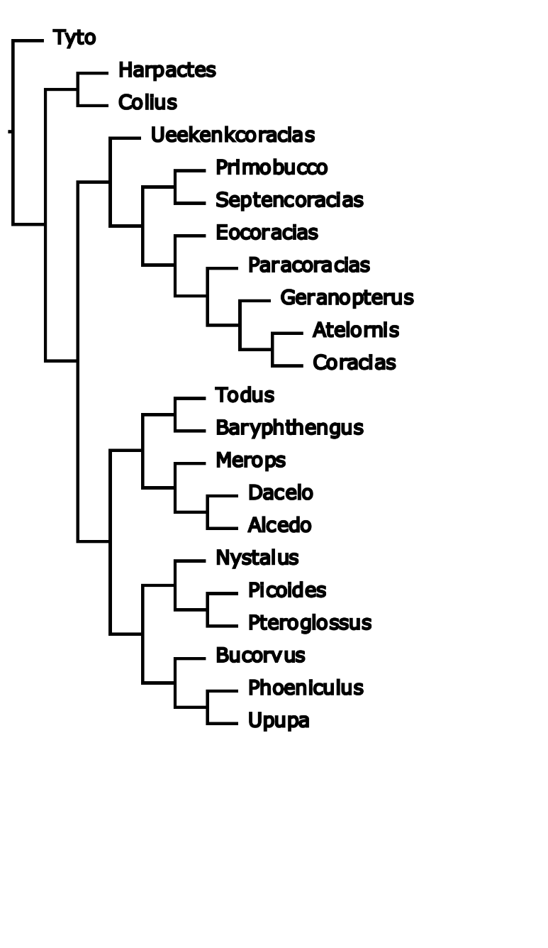

Figure S4. Bayesian analysis. Maximum credibility tree of the analysis conducted in Mr. Bayes setting the coding options as informative and the rates as gamma distributed.

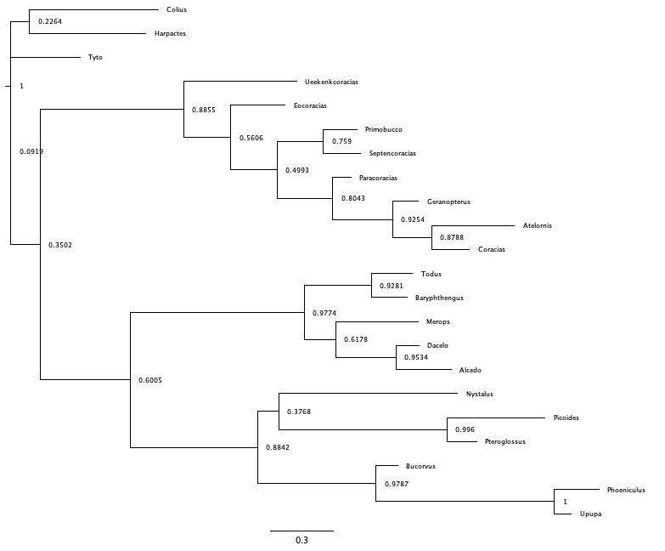
4. Supplementary references

1. Goloboff, P.A. & Catalano, S.A. TNT version 1.5, including a full implementation of phylogenetic morphometrics. Cladistics 32, 221–238 (2016).
2. Goloboff P.A. Estimating character weights during tree search. Cladistics 9, 83–91 (1993).
3. Ronquist, F., Teslenko, M., Van Der Mark, P. Ayres, D.L., Darling, A., Hohna, S., Larget, B., Liu, L., Suchard, M.A. & Huelsenbeck, J.P. MrBayes 3.2: Efficient bayesian phylogenetic inference and model choice across a large model space. Syst. Biol. 61, 539–542 (2012).

