Cardiovascular safety and efficacy of metformin-SGLT2i versus metformin-sulfonylureas in type 2 diabetes: systematic review and meta-analysis of randomized controlled trials
Desye Gebrie*^{1, 2}, Desalegn Getnet³, Tsegahun Manyazewal²

¹School of Pharmacy, College of Health Sciences, Mekelle University, Mekelle, Ethiopia
²Addis Ababa University, College of Health Sciences, Center for Innovative Drug Development and Therapeutic Trials for Africa (CDT-Africa), Addis Ababa, Ethiopia
³Pharmacology and Toxicology Course and Research Team, Department of Pharmacy, College of Health Sciences, Adigrat University, Adigrat, Ethiopia

Correspondence: Desye Gebrie: desye.gebrie@mu.edu.et. ¹School of Pharmacy, College of Health Sciences, Mekelle University, Mekelle, Ethiopia; ²Addis Ababa University, College of Health Sciences, Center for Innovative Drug Development and Therapeutic Trials for Africa (CDT-Africa), Addis Ababa, Ethiopia, P.O. Box 9086.

Co-authors’ Email Address
Desalegn Getnet: desget361@gmail.com
Tsegahun Manyazewal: tsegahunm@gmail.com

Supplementary files (S1-S15)
S1: PubMed search strategies
# | Searches | Results
1 | "metformin"[MeSH Terms] OR "metformin"[All Fields] OR "metformine"[All Fields] OR "metformin s"[All Fields] OR "metformins"[All Fields] OR "biguanid"[All Fields] OR "biguanides"[MeSH Terms] OR "biguanides"[All Fields] OR "biguanide"[All Fields] OR "biguanids"[All Fields] | 36,949
2 | ("sodium-glucose"[All Fields] AND "co transporter"[All Fields] AND "2"[All Fields] AND ("antagonists and inhibitors"[MeSH Subheading] OR ("antagonists"[All Fields] AND "inhibitors"[All Fields]) OR "antagonists and inhibitors"[All Fields] OR "inhibitors"[All Fields] OR "inhibitor"[All Fields] OR "inhibitor s"[All Fields])) OR ("sodium glucose transporter 2 inhibitors"[Pharmacological Action] OR "sodium glucose transporter 2 inhibitors"[MeSH Terms] OR "sodium glucose transporter 2 inhibitors"[All Fields] OR "sglt 2 inhibitors"[All Fields]) OR ("sodium glucose transporter 2 inhibitors"[Pharmacological Action] OR "sodium glucose transporter 2 inhibitors"[MeSH Terms] OR "sodium glucose transporter 2 inhibitors"[All Fields] OR ("sglt2"[All Fields] AND "inhibitors"[All Fields]) OR "sglt2 inhibitors"[All Fields]) OR ("2 3 4 ethoxybenzyl 4 chlorophenyl 6 hydroxymethyltetrahydro 2h pyran 3 4 5 triol"[Supplementary Concept] OR "2 3 4 ethoxybenzyl 4 chlorophenyl 6 hydroxymethyltetrahydro 2h pyran 3 4 5 triol"[All Fields] OR "dapagliflozin"[All Fields]) OR ("canagliflozin"[MeSH Terms] OR "canagliflozin"[All Fields]) OR ("empagliflozin"[Supplementary Concept] OR "empagliflozin"[All Fields]) OR ("ertugliflozin"[Supplementary Concept] OR "ertugliflozin"[All Fields]) | 5,266
3 | 1 AND 2 | 994
4 | "sulfonylurea compounds"[MeSH Terms] OR ("sulfonylurea"[All Fields] AND "compounds"[All Fields]) OR "sulfonylurea compounds"[All Fields] OR "sulfonylurea"[All Fields] OR "sulfonylureas"[All Fields] OR "sulphonylurea"[All Fields] OR "sulphonylureas"[All Fields] OR ("gliclazide"[MeSH Terms] OR "gliclazide"[All Fields]) OR ("glimepiride"[Supplementary Concept] OR "glimepiride"[All Fields]) OR ("glibenclamid"[All Fields] OR "glyburide"[MeSH Terms] OR "glyburide"[All Fields] OR "glibenclamide"[All Fields] OR "glyburide s"[All Fields]) OR ("glibenclamid"[All Fields] OR "glyburide"[MeSH Terms] OR "glyburide"[All Fields] OR "glibenclamide"[All Fields] OR "glyburide s"[All Fields]) OR ("glipizide"[MeSH Terms] OR "glipizide"[All Fields]) OR ("tolbutamide"[MeSH Terms] OR "tolbutamide"[All Fields]) | 30,198
5 | 1 AND 4 | 5,305
6 | "diabetes mellitus, type 2"[MeSH Terms] OR "type 2 diabetes mellitus"[All Fields] OR "T2DM"[All Fields] OR (("maturate"[All Fields] OR "maturated"[All Fields] OR "maturating"[All Fields] OR "maturation"[All Fields] OR "maturational"[All Fields] OR "maturations"[All Fields] OR "maturative"[All Fields] OR "mature"[All Fields] OR "matured"[All Fields] OR "maturer"[All Fields] OR "maturers"[All Fields] OR "matures"[All Fields] OR "maturing"[All Fields] OR "maturities"[All Fields] OR "maturity"[All Fields]) AND "set"[All Fields] AND ("diabetes mellitus"[MeSH Terms] OR ("diabetes"[All Fields] AND "mellitus"[All Fields]) OR "diabetes mellitus"[All Fields])) OR ("diabetes mellitus, type 2"[MeSH Terms] OR "type 2 diabetes mellitus"[All Fields] OR ("non"[All Fields] AND "insulin"[All Fields] AND "dependent"[All Fields] AND "diabetes"[All Fields] AND "mellitus"[All Fields]) OR "non insulin dependent diabetes mellitus"[All Fields]) | 157,378
7 | (("cardiovascular system"[MeSH Terms] OR ("cardiovascular"[All Fields] AND "system"[All Fields]) OR "cardiovascular system"[All Fields] OR "cardiovascular"[All Fields] OR "cardiovasculars"[All Fields]) AND ("outcome"[All Fields] OR "outcomes"[All Fields])) OR ("cardiovascular diseases"[MeSH Terms] OR ("cardiovascular"[All Fields] AND "diseases"[All Fields]) OR "cardiovascular diseases"[All Fields] OR ("cardiovascular"[All Fields] AND "disease"[All Fields]) OR "cardiovascular disease"[All Fields]) OR "CVD"[All Fields] | 2,613,638
8 | "randomized controlled trial"[Publication Type] OR "randomized controlled trials as topic"[MeSH Terms] OR "randomized controlled trials"[All Fields] OR "randomised controlled trials"[All Fields] OR "RCRs"[All Fields] OR "clinical trial"[Publication Type] OR "clinical trials as topic"[MeSH Terms] OR "clinical trials"[All Fields] | 1,350,235
9 | 6 AND 7 AND 8 | 8,673
10 | 3 AND 5 AND 9 | 1463

S2: Subgroup analysis of death events between patients who were on metformin-SGLT2I and metformin-sulfonylureas combination therapies by duration of treatment.
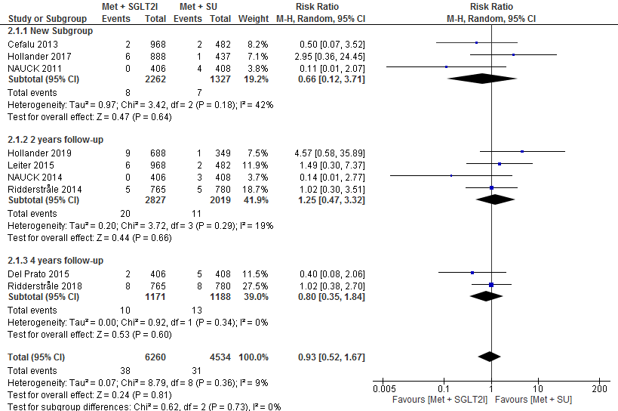
S3: Comparison of cardiovascular events between patients who were on metformin-SGLT2I and metformin-sulfonylureas combination therapies

- 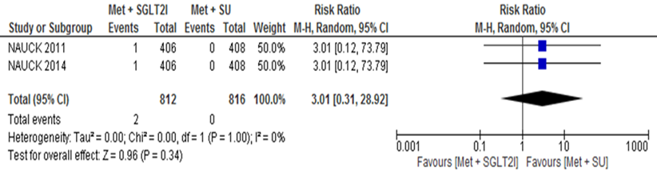
- 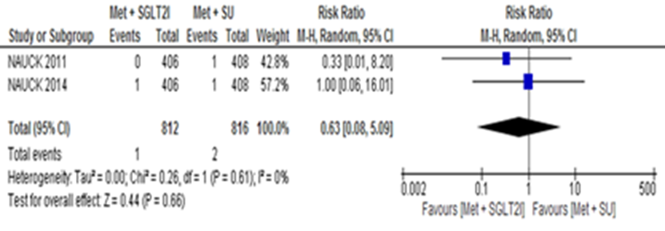
- 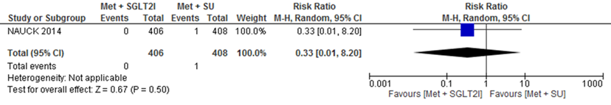
- 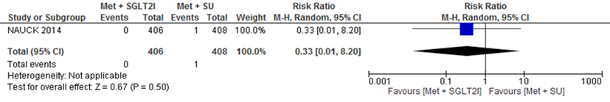
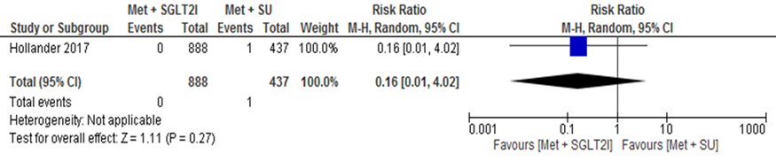
A: Worsening of coronary artery disease; B: Acute myocardial infraction; C: Coronary artery occlusion; D: Aortic aneurism; E: Atherosclerosis
S4: Subgroup analysis of adverse event between patients who were on metformin-SGLT2I and metformin-sulfonylureas combination therapies by durationof treatment.
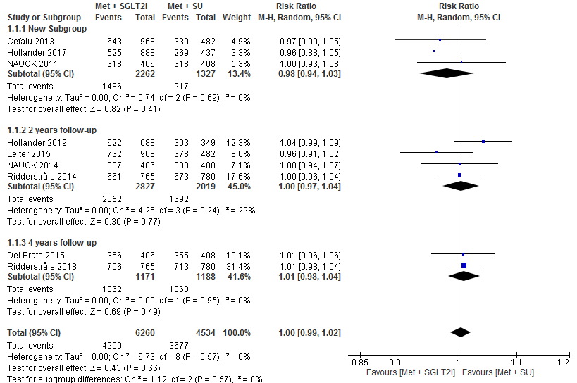
S5: Comparison of adverse events related to study drug between patients who were on metformin-SGLT2I and metformin-sulfonylureas combination therapies.
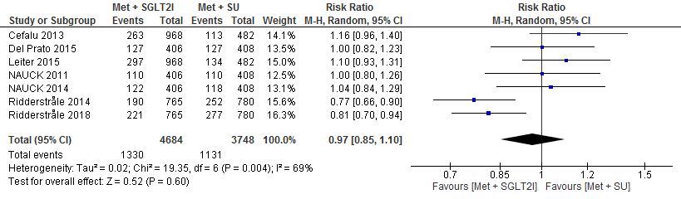
S6: Subgroup analysis of serious adverse event between patients who were on metformin-SGLT2I and metformin-sulfonylureas combination therapies by duration of treatment.
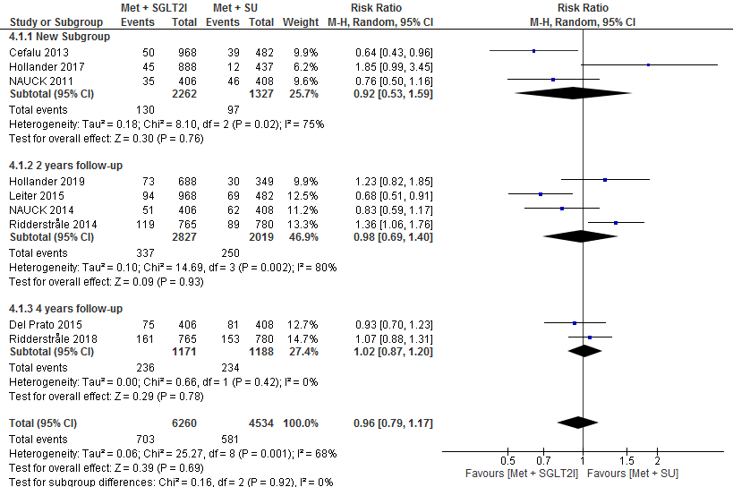
S7: Comparison of serious adverse events related to study drug between patients who were on metformin-SGLT2I and metformin-sulfonylureas combination therapies.
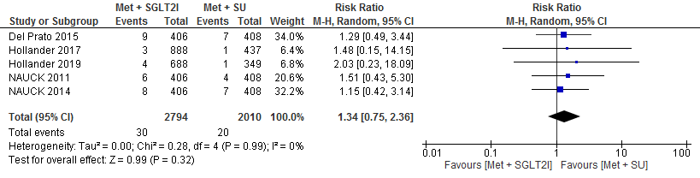
S8: Subgroup analysis of hypoglycemic event between patients who were on metformin-SGLT2I and metformin-sulfonylureas combination therapies by duration of treatment.
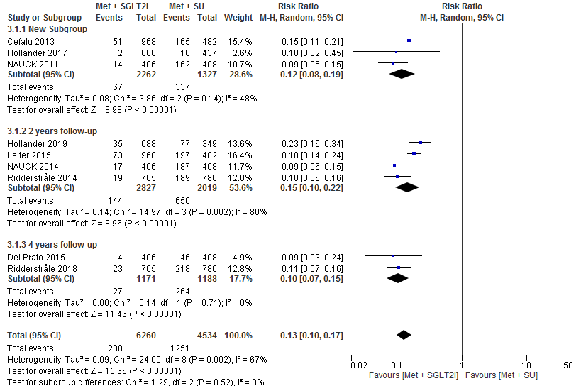
S9: Subgroup analysis of change in HbA1c (%) from baseline between patients who were on metformin-SGLT2I and metformin-sulfonylureas combination therapies by duration of treatment.
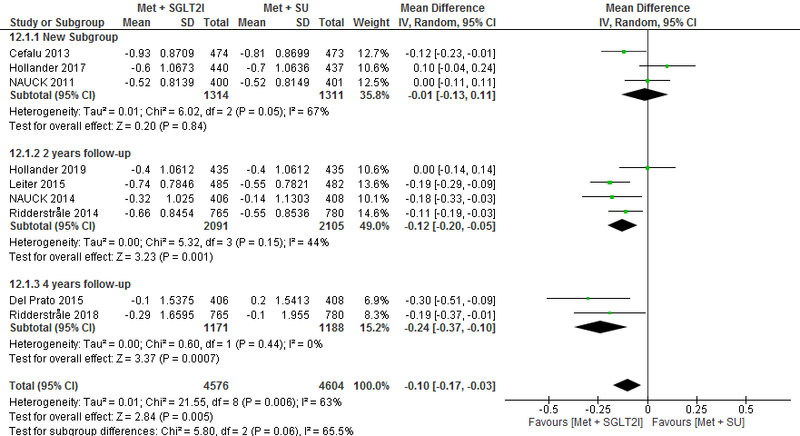
S10: Subgroup analysis of change in body weight (Kg) from baseline between patients who were on metformin-SGLT2I and metformin-sulfonylureas combination therapies by duration of treatment.
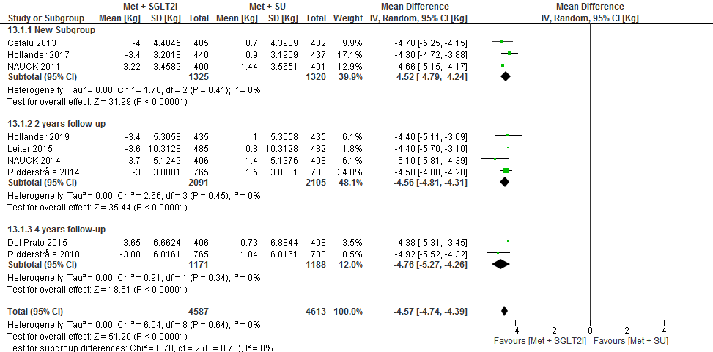
S11: Subgroup analysis of change in FPG (mmol/L) from baseline between patients who were on metformin-SGLT2I and metformin-sulfonylureas combination therapies by duration of treatment.
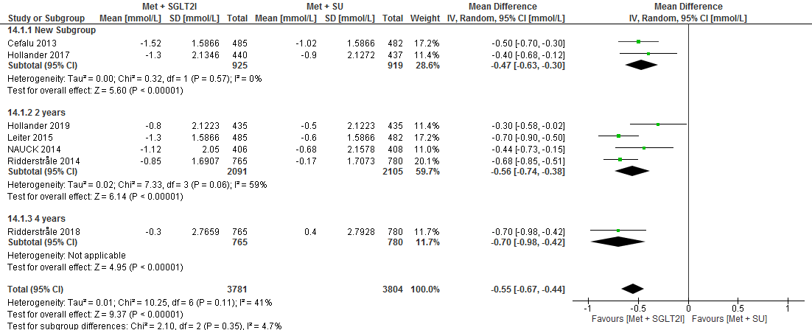

S12: Sensitivity analysis for the risk of advers events by removing the highest weight study (Ridderstale, 2018)
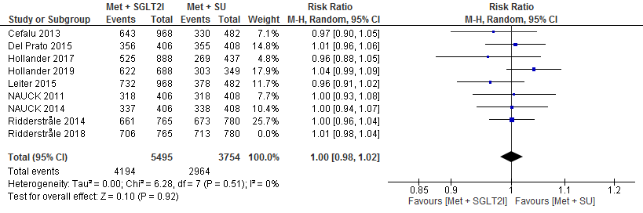
S13: Comparison of risk of genital mycotic infection between patients who were on metformin-SGLT2I and metformin-sulfonylureas combination therapies.
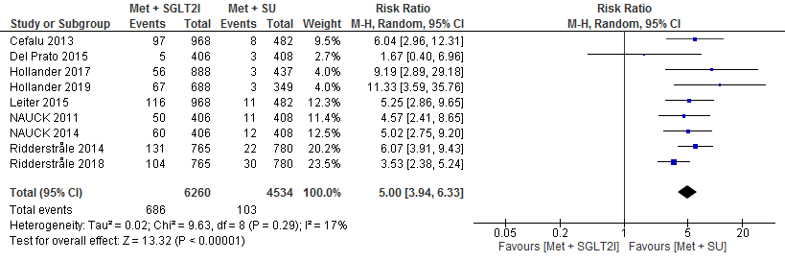
S14: Comparison of HDL-C between patients who were on metformin-SGLT2I and metformin-sulfonylureas combination therapies.
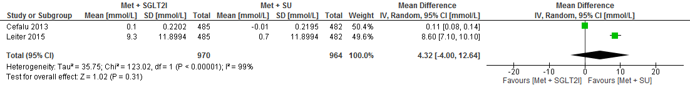
S15: Comparison of LDL-C between patients who were on metformin-SGLT2I and metformin-sulfonylureas combination therapies.
