GluN2B and GluN2A-containing NMDAR are differentially involved in extinction memory destabilization and restabilization during reconsolidation

Andressa Radiske¹, Maria Carolina Gonzalez^{1,2}, Diana A. Nôga¹, Janine I. Rossato^{1,3}, Lia R. M. Bevilaqua¹, and Martín Cammarota¹

¹Memory Research Laboratory, Brain Institute, Federal University of Rio Grande do Norte, Av. Nascimento de Castro 2155, RN 59056-450, Natal, Brazil. ²Edmond and Lily Safra International Institute of Neuroscience, Av. Alberto Santos Dumont 1560, RN 59280-000, Macaiba, Brazil. ³Departament of Physiology, Federal University of Rio Grande do Norte, Av. Sen. Salgado Filho 3000, RN 59064-741, Natal, Brazil. *Correspondence should be addressed to Martín Cammarota at martin.cammarota@neuro.ufrn.br.

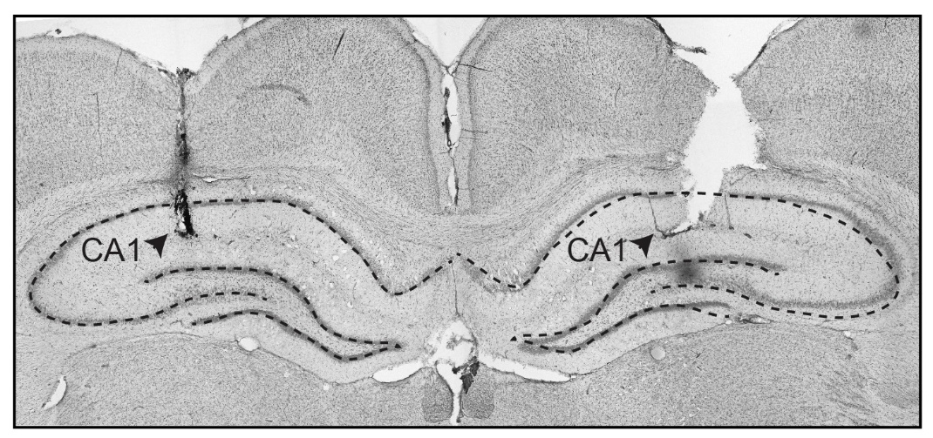

Supplementary Figure S1. Representative photomicrograph of Nissl-stained section showing infusion cannula track terminating in the CA1 region of the dorsal hippocampus.

