Supplementary Information

Fucoxanthin from microalgae Phaeodactylum tricornutum inhibits pro-inflammatory cytokines by regulating both NF-κB and NLRP3 inflammasome activation
A-Hyeon Lee, Hye-Yoon Shin, Jong-Hwi Park, Song Yi Koo, Sang Min Kim, and Seung-Hoon Yang

* Corresponding Author
Seung-Hoon Yang, Department of Medical Biotechnology, College of Life Science and Biotechnology, Dongguk University, Seoul 04620, Republic of Korea
Tel.: +82 31 961 5156; fax: +82 31 961 5108.
E-mail address: shyang@dongguk.edu (S.H. Yang).

Supplementary Information:
Supplementary Figure 1
Supplementary Figure 2
Supplementary Figure 3

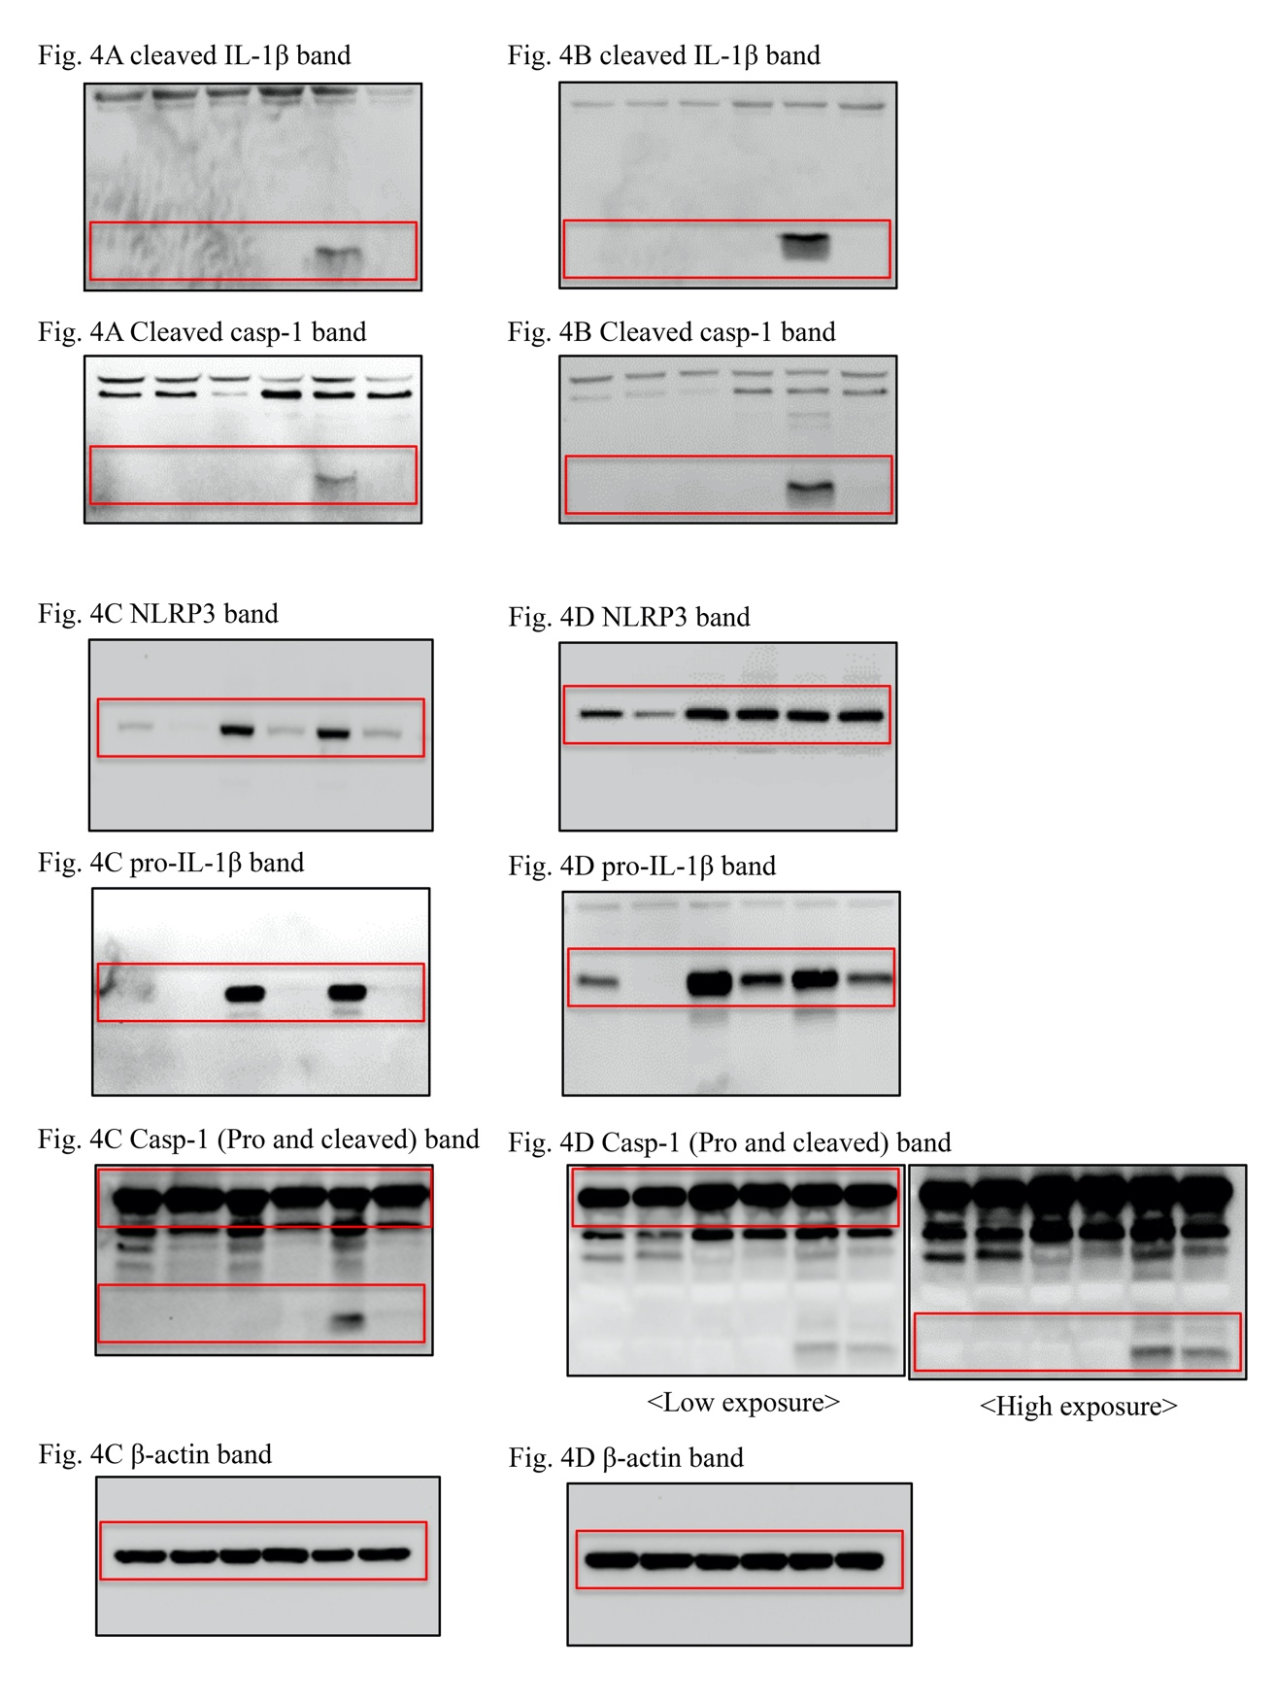
Figure S1. The original blots of cropped images shown in the main figures 4.
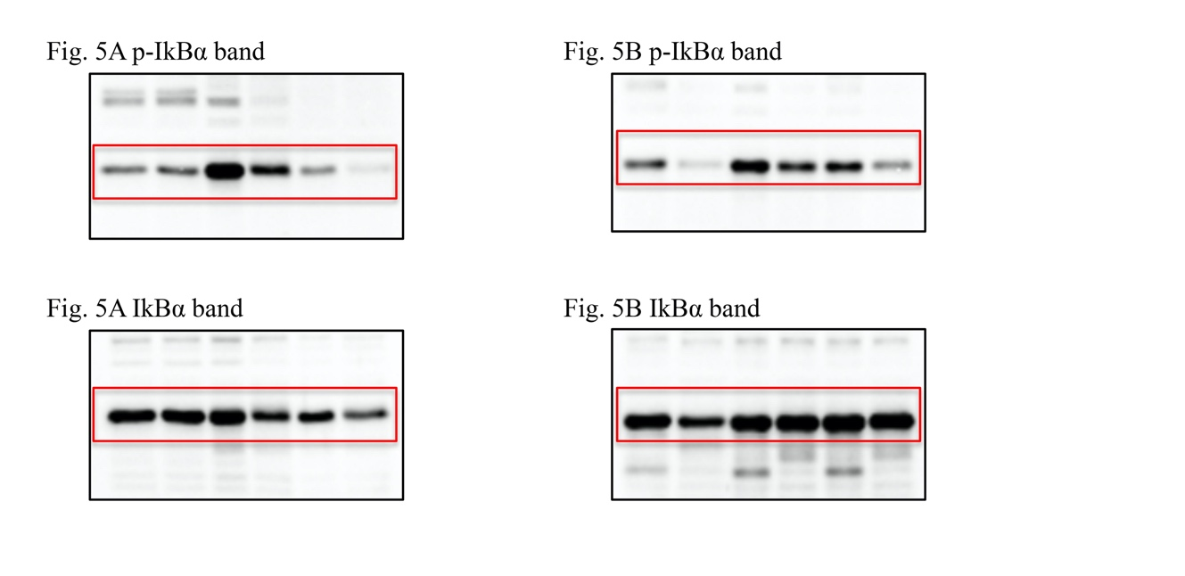
Figure S2. The original blots of cropped images shown in the main figures 5.

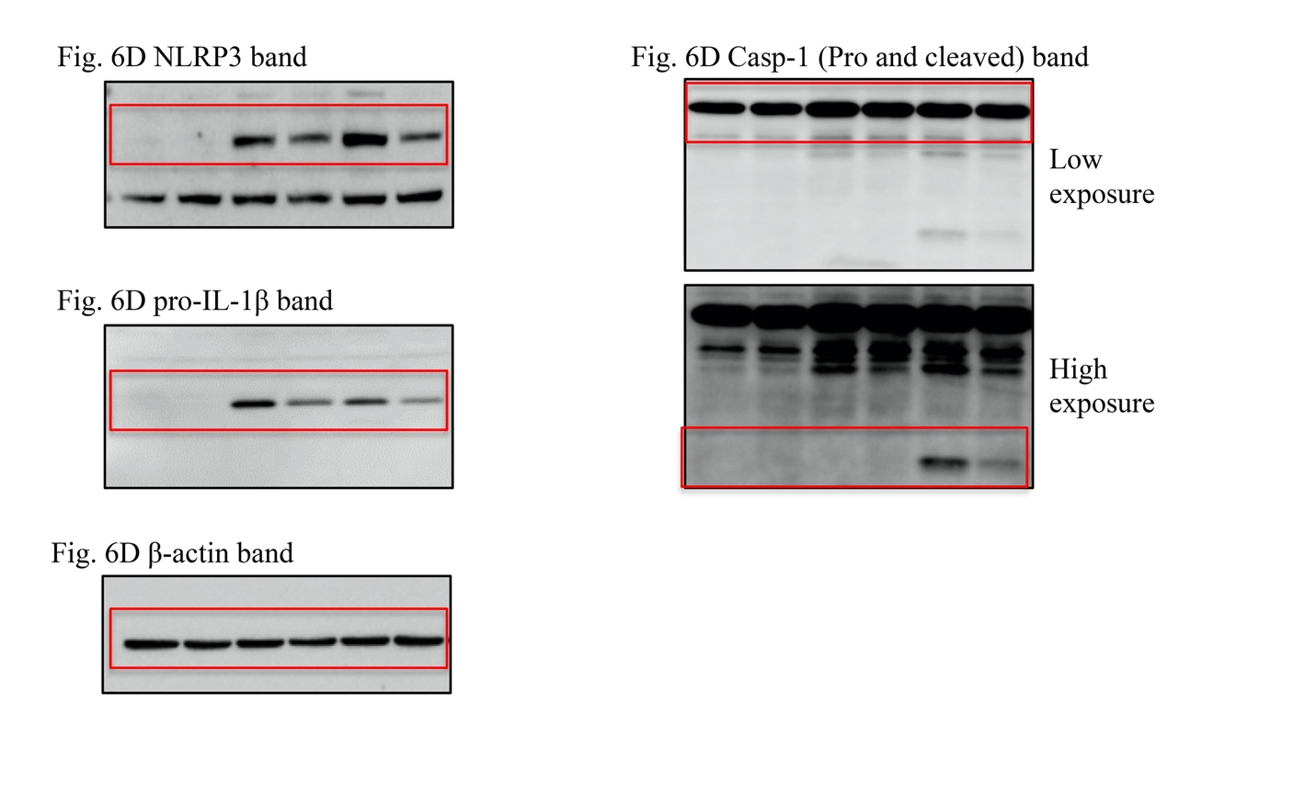
Figure S3. The original blots of cropped images shown in the main figures 6.

