Regulation of mitochondrial dynamics in 2-methoxyestradiol-mediated osteosarcoma cell death
Magdalena Gorska-Ponikowska#*^{1,2,3}, Paulina Bastian#¹, Agata Zauszkiewicz-Pawlak⁴, Agata Ploska^{5,6}, Adrian Zubrzycki⁴, Alicja Kuban-Jankowska¹, Stephan Nussberger ², Leszek Kalinowski^{5,6}, Zbigniew Kmiec⁴
- Department of Medical Chemistry, Medical University of Gdansk, Poland;
- Department of Biophysics, Institute of Biomaterials and Biomolecular Systems, University of Stuttgart, Stuttgart, Germany;
- Euro-Mediterranean Institute of Science and Technology, Palermo, Italy;
⁴ Department of Histology, Medical University of Gdansk, Poland;
⁵ Department of Medical Laboratory Diagnostics, Medical University of Gdansk, Gdańsk, Poland
⁶ Biobanking and Biomolecular Resources Research Infrastructure Poland (BBMRI.PL), Gdańsk, Poland
# Equally contributed to the study
* Correspondence: Magdalena Gorska-Ponikowska, Department of Medical Chemistry, Medical University of Gdansk, Debinki 1, 80-211 Gdansk, Poland, tel: +48 583491450; magdalena.gorska-ponikowska@gumed.edu.pl

Fig.1 Electron microscopic analysis of osteosarcoma 143B cells treated with 2-ME. A. Control osteosarcoma 143B Cells. The cells were incubated in serum- and amino acid-free medium with 2-ME at the concentration of 10 nM (B), 100 nM (C) and 1 µM 2-ME (D) for 8 h, fixed and processed for transmission electron microscopy. Electron micrographs are obtained at magnifications (20-30K).

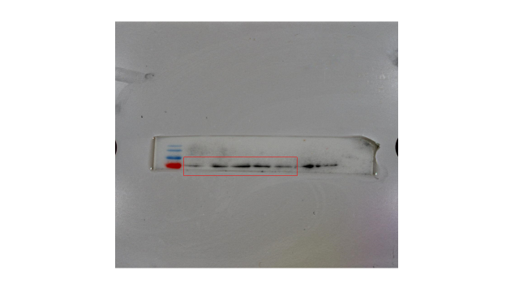
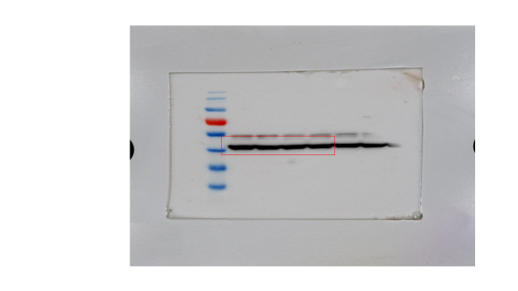

Fig. 2 Treatment with 2-ME at 10 nM, 100 nM, and 1 μM concentrations upregulates Drp1 protein level in osteosarcoma 143B cells evaluated by Western blotting. Drp1 and β-actin protein bands, respectively, are indicated in red. Original blots are presented.

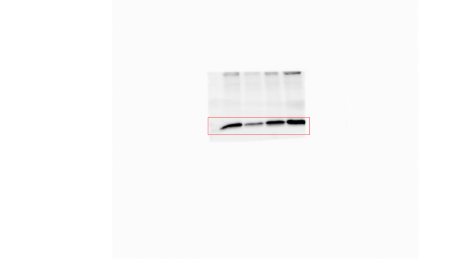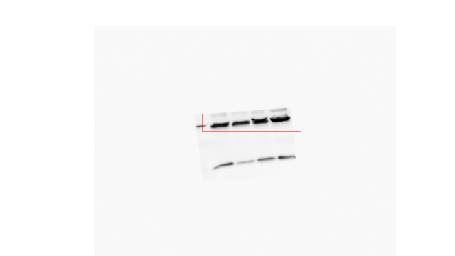
Fig. 3. Pre-treatment with 5 µM MDIVI-1 for 6 h decreases 2-ME-mediated upregulation of cytochrome C protein level in OS 143B cells evaluated by Western blotting. Cytochrome C and β-actin protein bands, respectively, are indicated in red. Original blots are presented.

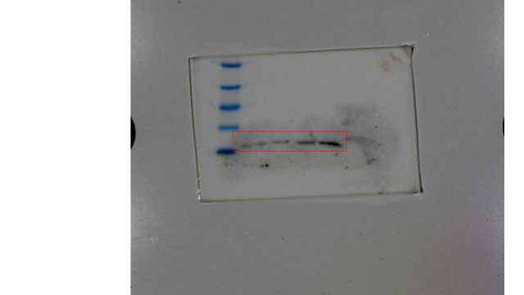
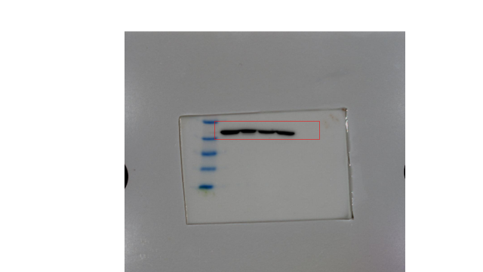
Fig. 4

Pre-treatment with 5 µM MDIVI-1 for 6 h decreases 2-ME-mediated upregulation of BAX protein level in OS 143B cells evaluated by Western blotting. BAX and β-actin protein bands, respectively, are indicated in red. Original blots are presented.

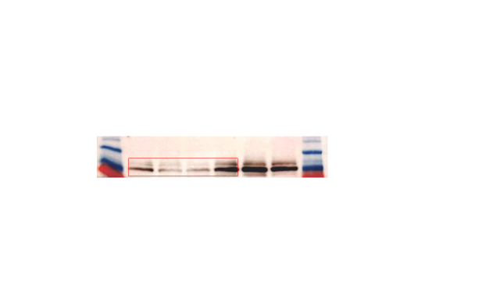

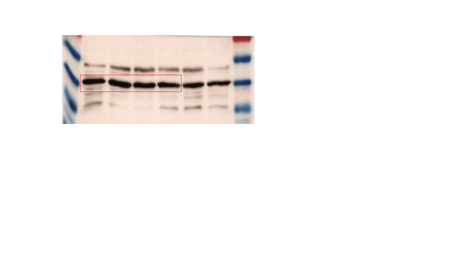Fig.5
Pre-treatment with 5 µM MDIVI-1 for 6 h decreases 2-ME-mediated upregulation of Drp-1 protein level in OS 143B cells evaluated by Western blotting. Drp 1 and β-actin protein bands, respectively, are indicated in red. Original blots are presented.

