Transcriptome and phytochemical analyses provide insights into the organic sulfur pathway in Allium hirtifolium

Aboozar Soorni^{1*}, Amir Mohammad Akrami¹, Reza Abolghasemi², Maryam Vahedi³

¹ Department of Biotechnology, College of Agriculture, Isfahan University of Technology, Isfahan 84156-83111, Iran
² Department of Horticulture, College of Agriculture, Isfahan University of Technology, Isfahan 84156-83111, Iran
³Department of Horticultural Science, Faculty of Agricultural Sciences and Engineering, College of Agriculture and Natural Resources, University of Tehran, Karaj, Iran

Corresponding Author:
Aboozar Soorni
Email address: soorni@iut.ac.ir

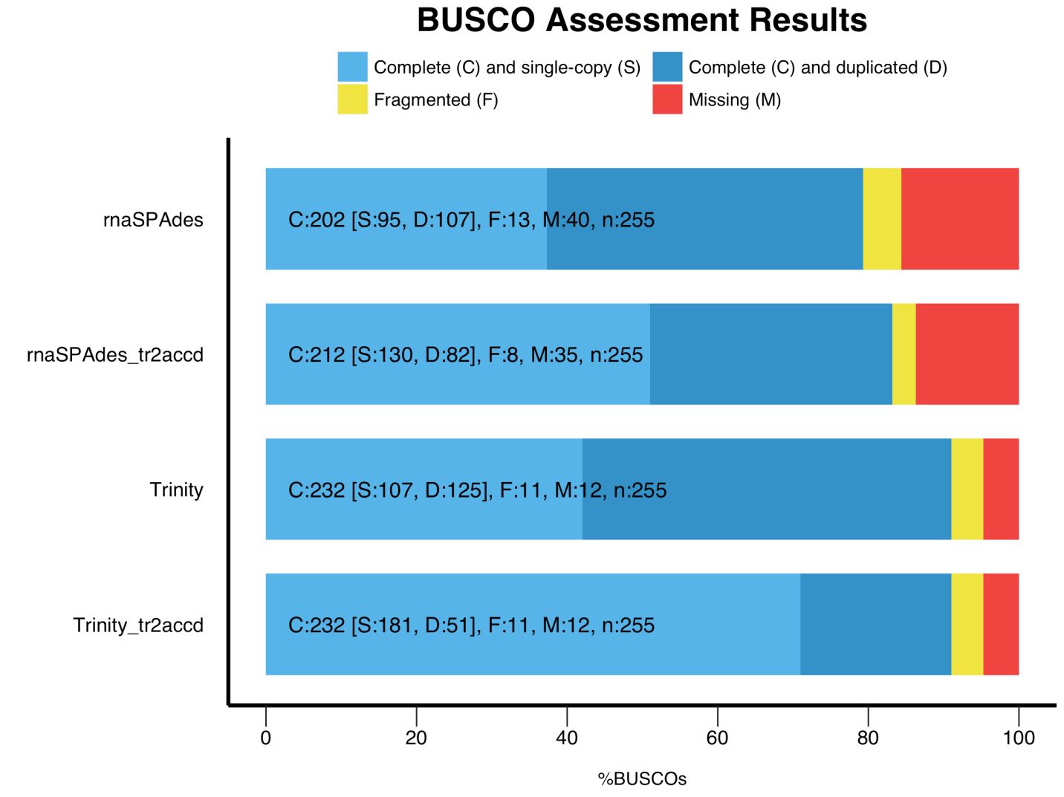
Figure S1. The completeness assessment results of the Trinity, rnaSPAdes, and tr2accd transcriptome assemblies of A. hirtifolium using BUSCO. Colors refer to the percentage of the complete single-copy orthologs, complete and duplicated orthologs, and fragmented ortholog

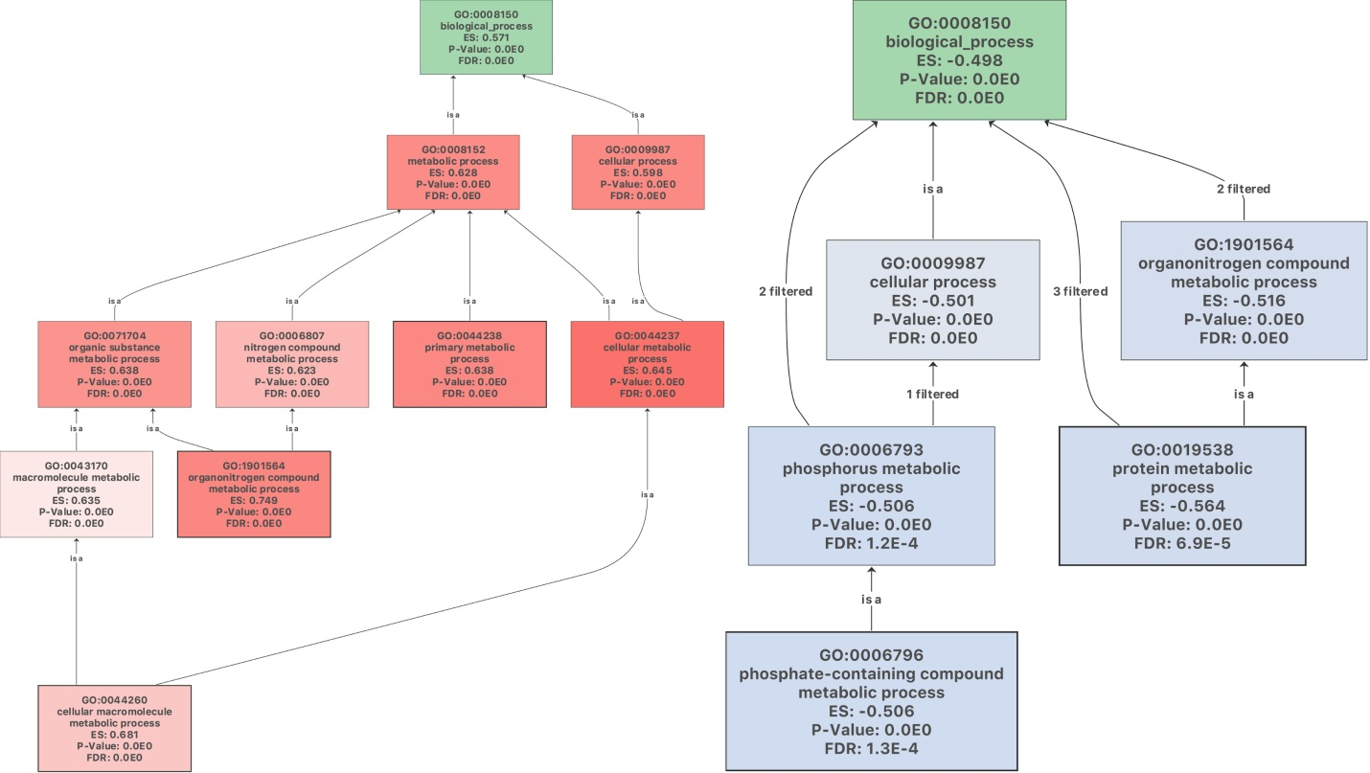
Figure S2. GO enrichment analysis of differentially expressed genes (DEGs) related to the biological process.
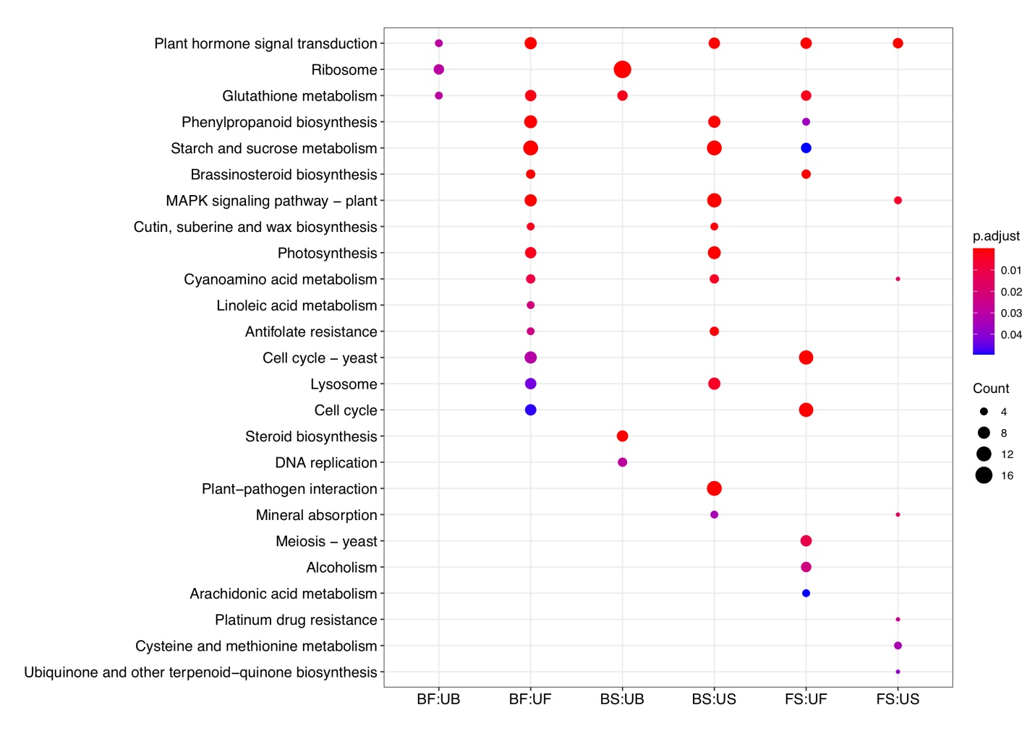
Figure S3. KEGG pathway enrichment analysis of DEGs.

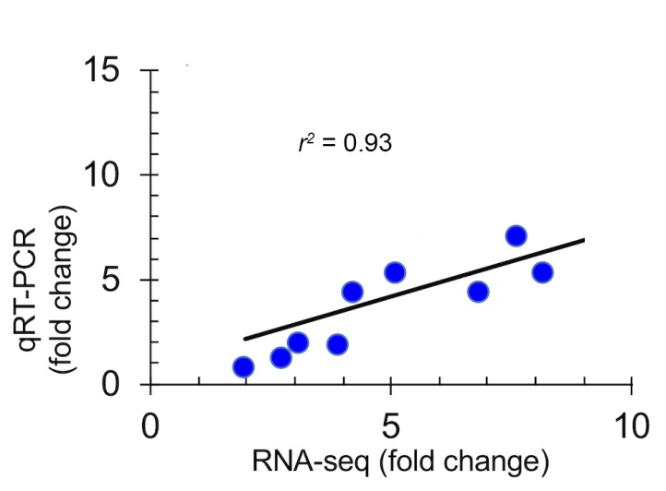
Figure S4. Pearson correlation between fold changes in genes expression determined by qRT-PCR and RNA-seq.
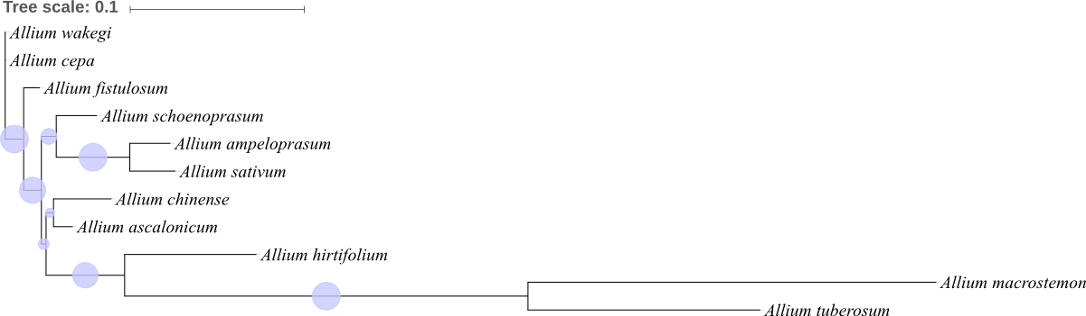
Figure S5. Phylogenetic analysis of Allium species using alliinase gene through the maximum likelihood method.

Table S1. Summary of GO classification analysis in differentially expressed genes

GO Summary
 |  | bulb vs. Flower | bulb vs. Stem | Flower vs. Stem | Total
Annotated Genes |  | 5,706 | 5,989 | 4,300 | 9,465
GO Terms | Biological Process | 4,495 | 4,837 | 3,324 | 7,547
GO Terms | Cellular Component | 4,693 | 4,989 | 3,622 | 7,914
GO Terms | Molecular Function | 4,923 | 5,229 | 3,695 | 8,204

Table S2. Name and sequence length of chloroplast genes extracted from transcriptome data of A. hirtifolium
Gene | Length | Gene | Length | Gene | Length | Gene | Length
accD | 1229 | psaB | 2204 | rbcL | 1438 | rps18 | 305
atpA | 1417 | psaC | 245 | rpl14 | 368 | rps19 | 125
atpB | 1496 | psbA | 662 | rpl20 | 353 | rps3 | 662
atpF | 554 | psbB | 1526 | rpl33 | 200 | rps4 | 605
atpI | 741 | psbC | 1417 | rpl36 | 113 | ycf1 | 1417
ccsA | 783 | psbD | 1061 | rpoA | 985 | ycf2 | 1526
clpP | 113 | psbE | 251 | rpoB | 1358 | ycf3 | 505
matK | 231 | psbI | 110 | rpoC1 | 1584 | ycf4 | 554
psaA | 1276 | psbK | 185 | rpoC2 | 2235 | - | -

