β-glucanase from Aspergillus niger: Production, Immobilization and Biotechnological Applications
Hamed M. El-Shora¹*, Reyad M. El-Sharkawy², Aiah M. Khateb³, Doaa B. Darwish^{1,4}
¹Department of Botany, Faculty of Science, Mansoura University, Egypt.
²Botany and Microbiology Department, Faculty of Science, Benha University, Egypt.
³Department of Medical Laboratory Technology, College of Applied Medical Sciences, Taibah University
⁴Department of Biology, Faculty of Science, University of Tabuk, Tabuk, Saudi Arabia
* Corresponding author: shoraem@yahoo.com; shora@mans.edu.eg

Contributed equally to this work

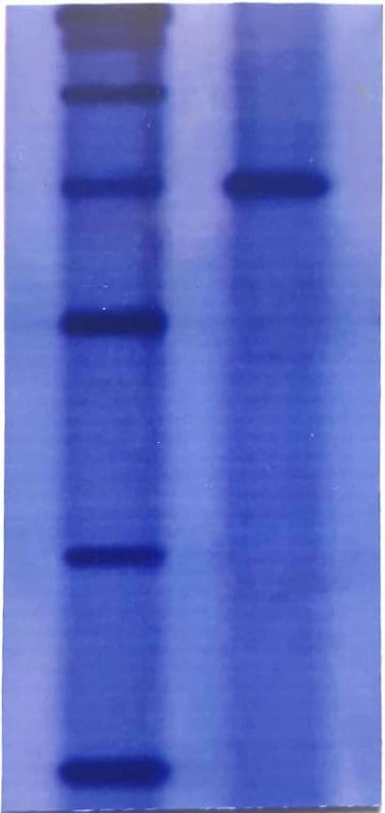
Purified enzyme
Supplementary Figure S1. Uncropped gel image of purified β-glucanase produced by A. niger in Figure 5.

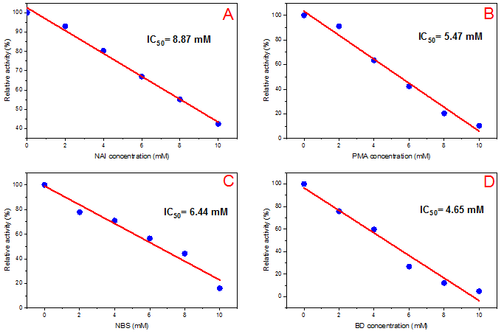
Supplementary Figure S2. Effect of NAI (A), PMA (B), NBS (C) and 2.3-BD (D) on purified β-glucanase produced by A. niger.

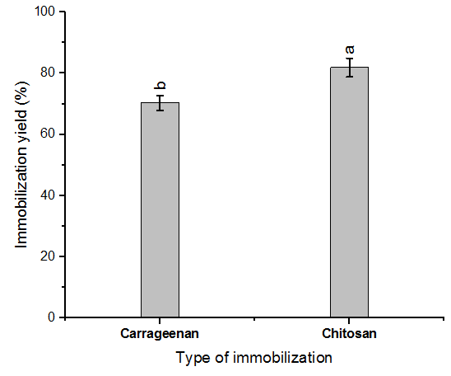

Supplementary Figure S3. Immobilization of β-glucanase from A. niger by covalent binding and cross-linking methods. Enzyme activity was assayed at 40ºC using CMC as substrate. Vertical bars were displayed as mean ± standard deviation.

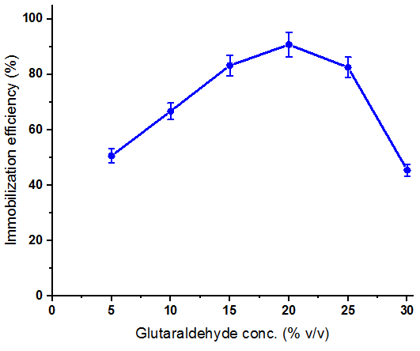

Supplementary Figure S4. Influence of glutaraldehyde concentrations on immobilization efficiency of β-glucanase from A. niger on chitosan.

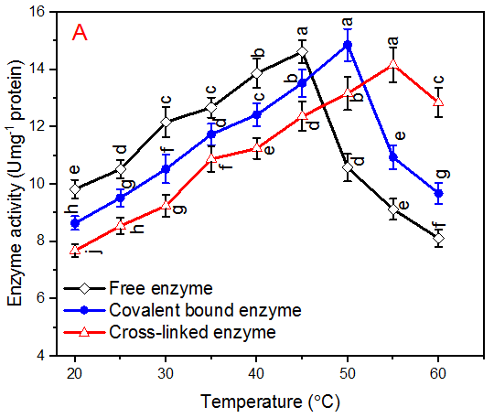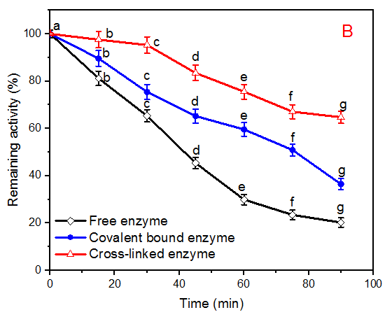
Supplementary Figure S5. (A) Effect of temperature on free and immobilized β-glucanase from A. niger, (B) Thermostability of free and immobilized β-glucanase from A. niger at 70ºC. Enzyme activity was assayed at 40ºC using CMC as substrate. Vertical bars were displayed as mean ± standard deviation, * p < 0.05, n=3.

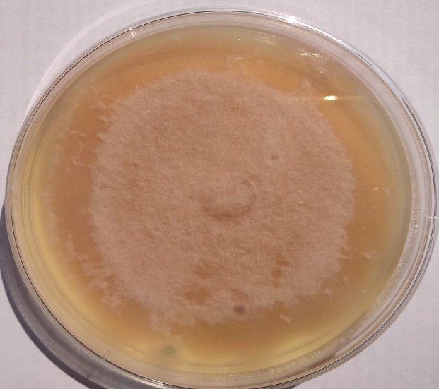
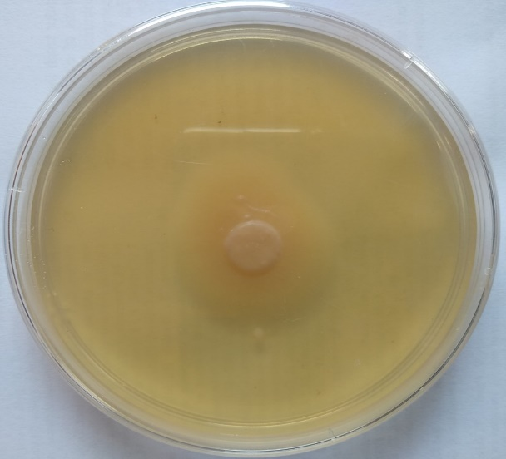
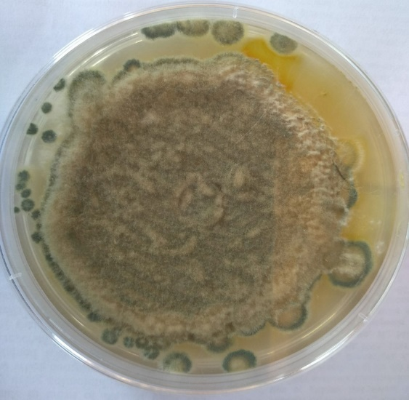
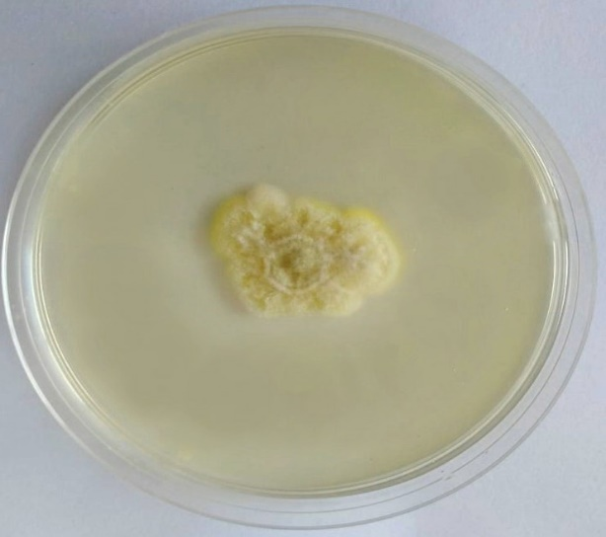
A
C
D
B

Supplementary Figure S6. Growth inhibition of F. oxysporum (A,C) and P. digitatum (B,D) by β-glucanase. The inhibition activity was measured by placing agar disk of fully grown mycelium into SDA medium containing purified β-glucanase: (A-B) negative control and (C-D) purified β-glucanase.

Figure S7. Graphical abstract

