Supplementary Data: Figure S4

Premature differentiation of nephron progenitors and dysregulation of gene pathways critical to kidney development in a model of preterm birth

Aleksandra Cwiek¹, Masako Suzuki³, Kim deRonde¹, Mark Conaway⁴ ⁵, Kevin M. Bennett⁶, Samir El Dahr⁷, Kimberly Reidy^{2#}, Jennifer R Charlton^{1#}*

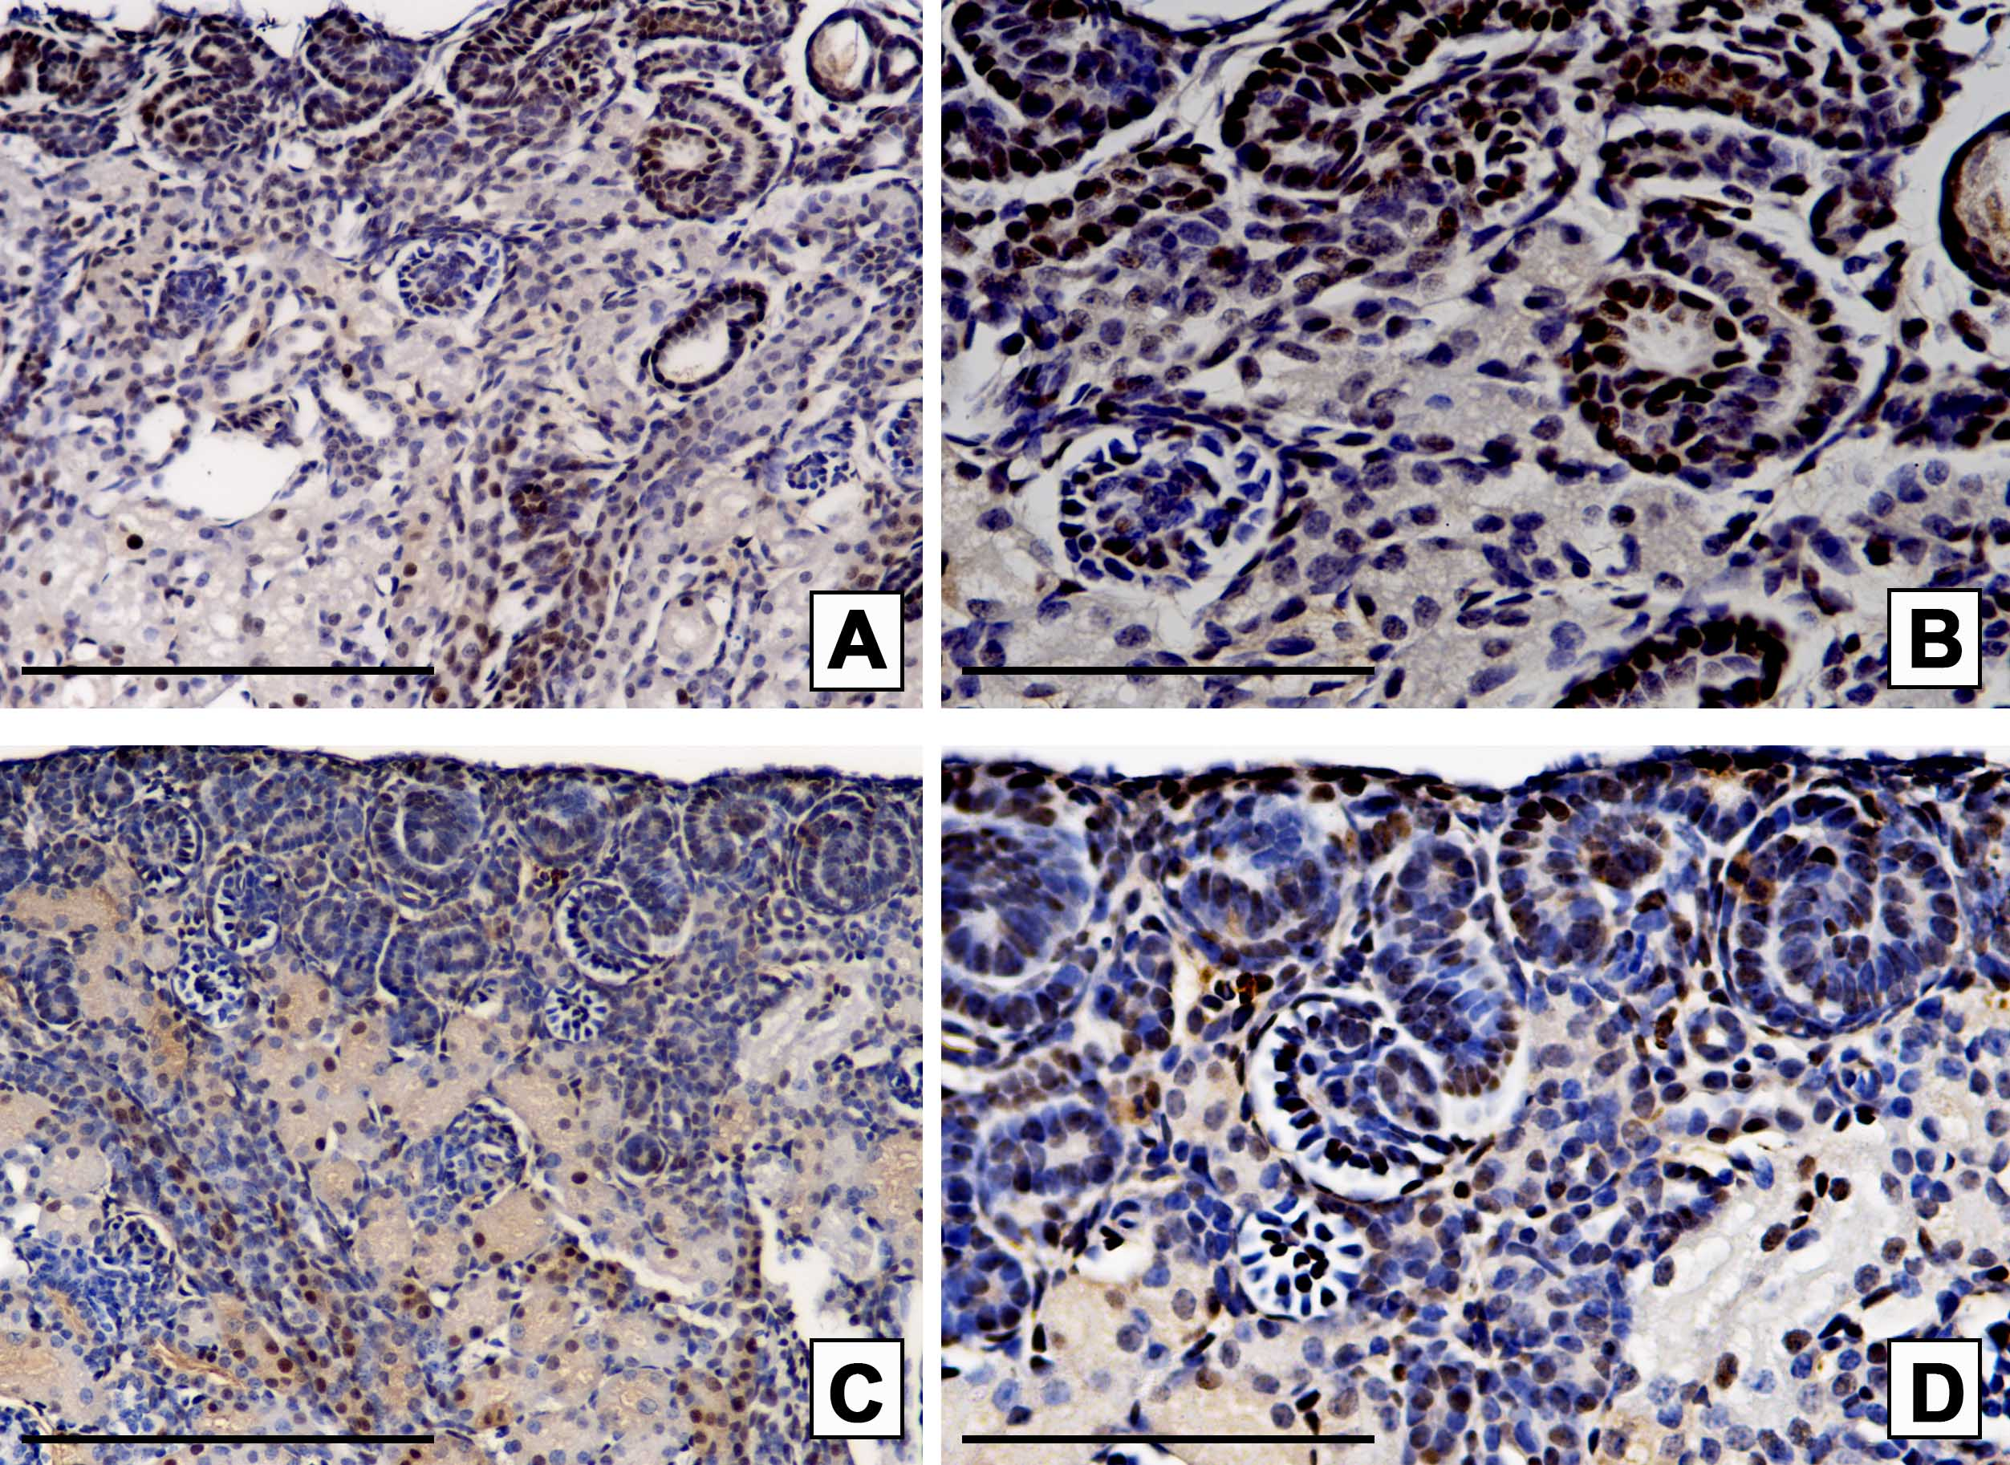

Supplementary Figure S4. Proliferating cell nuclear antigen staining in the kidney of preterm and term groups at 23 days post conception. Proliferation in the nephrogenic zone is ongoing in both the preterm and term groups at 23 dpc. In the preterm group, panel A and B, the nephrogenic zone contains developing nephrons with PCNA positive cells, but proliferating cap mesenchyme cells are absent and the zone is narrower than in the term group shown in panels C and D. The nephrogenic zone also appears more disorganized in the preterm group (panela A/B). Scale bar=100 microns.

