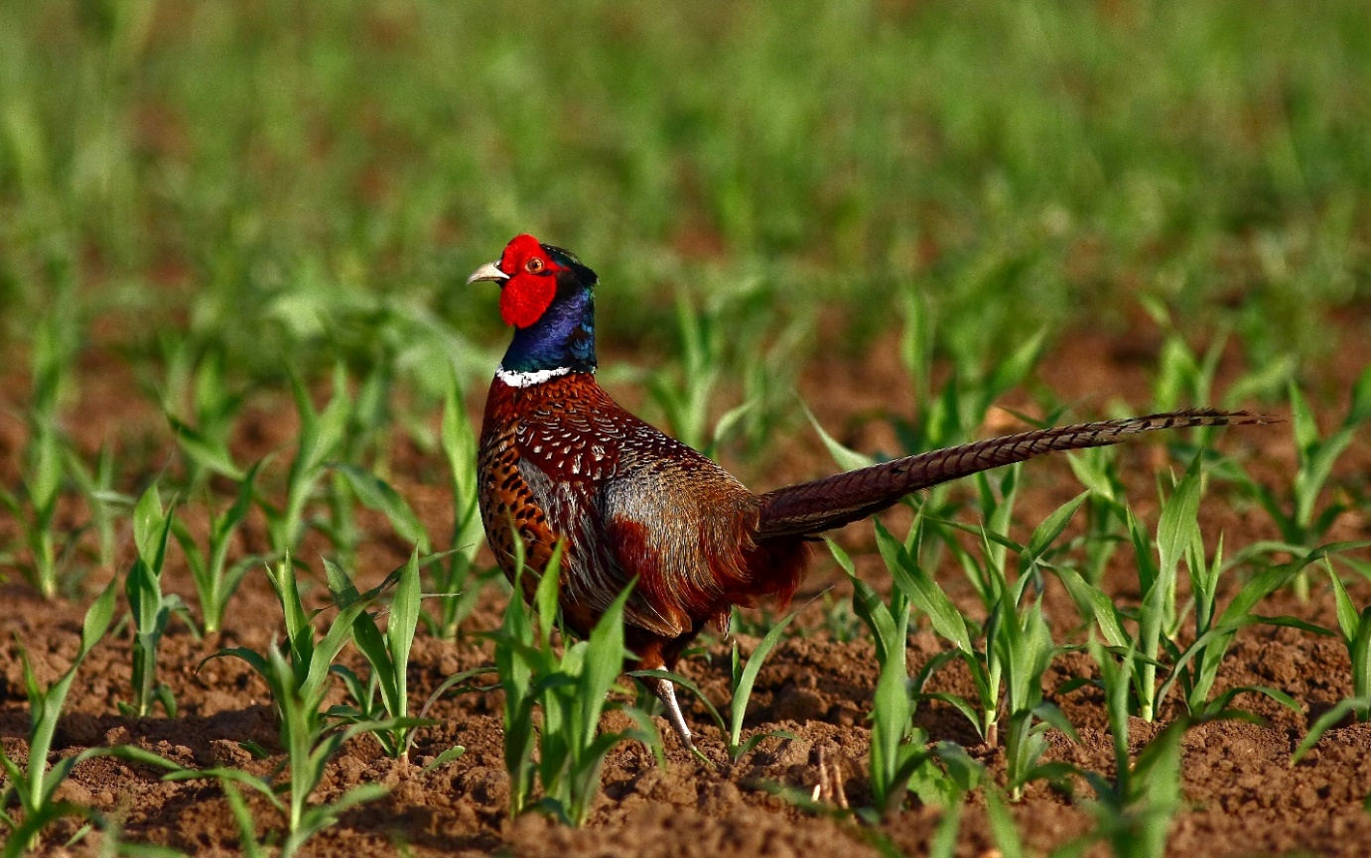
Figure S3. Wild-born pheasant from Hungary (Photo: Szendrei, L.)

