Supplementary Figures

A duplicated copy of id2b in the male-specific region of the arapaima genome extends the spectrum of candidate sex-determining genes
Mateus C. Adolfi^{1*+}, Kang Du^{1,2+}, Susanne Kneitz³, Cédric Cabau⁴, Margot Zahm⁴, Christophe Klopp⁵, Romain Feron^{6,7}, Rômulo V. Paixão⁸, Eduardo S. Varela⁹, Fernanda L. de Almeida⁸, Marcos A. de Oliveira¹⁰, Rafael H. Nóbrega¹⁰, Céline Lopez-Roques¹¹, Carole Iampietro¹¹, Jérôme Lluch¹¹, Werner Kloas¹², Sven Wuertz¹², Fabian Schaefer¹², Matthias Stöck^{12,13}, Yann Guiguen⁶, Manfred Schartl^{1,2}

1 Developmental Biochemistry, Biocenter, University of Wuerzburg, Am Hubland, 97074, Wuerzburg, Germany
2 The Xiphophorus Genetic Stock Center, Department of Chemistry and Biochemistry, Texas State University, San Marcos, Texas, TX 78666, USA
3 Biochemistry and Cell Biology, Biocenter, University of Wuerzburg, Am Hubland, 97074 Wuerzburg, Germany
4 Sigenae, GenPhySE, Université de Toulouse, INRAE, ENVT, FR
5 MIAT, Université de Toulouse, INRA, Chemin de Borde Rouge, Castanet-Tolosan Cedex, F-31326, France.
6 INRAE, LPGP, Rennes, France
7 Department of Ecology and Evolution, University of Lausanne, and Swiss Institute of Bioinformatics, 1015, Lausanne, Switzerland
8 Embrapa Amazônia Ocidental, Manaus, Amazonas, Brazil
9 Embrapa Pesca e Aquicultura, Palmas, Tocantins, Brazil
10 Reproductive and Molecular Biology Group, Department of Morphology, Institute of Biosciences, UNESP, Botucatu, Brazil
11 GeT-PlaGe, INRAE, Genotoul, Castanet-Tolosan, France.
12 Leibniz-Institute of Freshwater Ecology and Inland Fisheries, IGB, Müggelseedamm 301 & 310, D-12587 Berlin, Germany
13 Amphibian Research Center, Hiroshima University, Higashi-Hiroshima 739-8526, Japan

* corresponding author: mateus.adolfi@biozentrum.uni-wuerzburg.de
+ These authors contributed equally to this work.

Figure S1
Figure S1. Selection analysis of Id2a and Id2b. Phylogeny plot showing arapaima Id2bbY (yellow) has a higher ω value (ω1=0.97) than Id2ba (ω2=0.25).
Figure S2
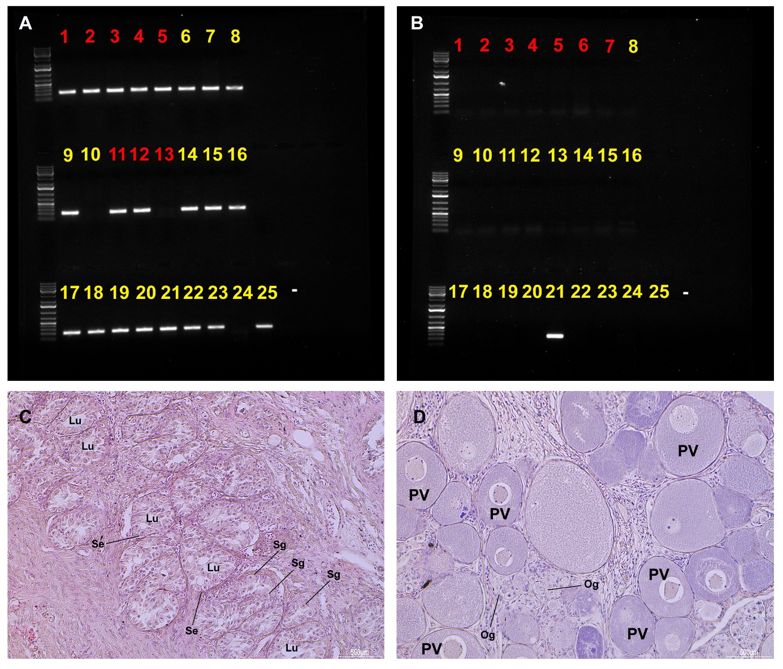
Figure S2. Genotyping analyses of id2bbY. Agarose gel electrophoresis gel resolution of the specific PCR amplification products of male (A) and female (B) used in the RAD-tag analyses from Senador Guiomard (yellow numbers) and Cacoal (red numbers) populations. Histological structure of juvenile testis (C) and ovary (D) from the samples used in the tests for genotyping. Lu. Lumen, Og. Oogonia, PV. Previtellogenic oocyte, Se. Sertoli cell, Sg. Spermatogonia.
Figure S3
Figure S3. Selection analysis of Id2bbY and Id2b of teleosts. Phylogeny plot showing arapaima Id2bbY (yellow) has a higher ω value (ω1=0.97) than Id2ba(ω2=0.25).
Figure S4
Figure S4. Locations of the Brazilian arapaima populations used in the analyses. Map was generated in R v4.0.2/RStudio v1.3.959 (RStudio Team, 2020) using R packages ‘ggplot2’ (v3.3.2) (Wickham, 2016) and ‘sf’ (v0.9-6) (Pebesma, 2018).
- Pebesma, E., 2018. Simple Features for R: Standardized Support for Spatial Vector Data. The R Journal 10 (1), 439-446, https://doi.org/10.32614/RJ-2018-009
- RStudio Team. (2020). RStudio: Integrated Development Environment for R. Boston, MA: RStudio, PBC.
- Wickham, H. (2016). ggplot2: Elegant Graphics for Data Analysis. Springer-Verlag New York.

Figure S5
Figure S5. cDNA sequence comparison between id2ba and id2bbY. Nucleotide alignment of both id2ba and id2bbY showed high similarity in the open reding frame (red). The id2bbY specific primers (arrows) were designed in the 3’UTR region of the gene.

