Fig. S1. Morpho-anatomical developmental stages of Ginkgo ovules. c, collar; e, endotecium; en, endotesta; i, integument; mg, megagametophyte; ms, microsporangium; n, nucellus; ov, ovule; pc, pollen chamber; sc, sclerotesta; sr, sarcotesta. Scales: 50μm (a); 75μm (c, d,n); 100μm (f, h-i); 1mm (b, e); 1cm (g,m).

Fig. S3. Number of reads obtained per sample.

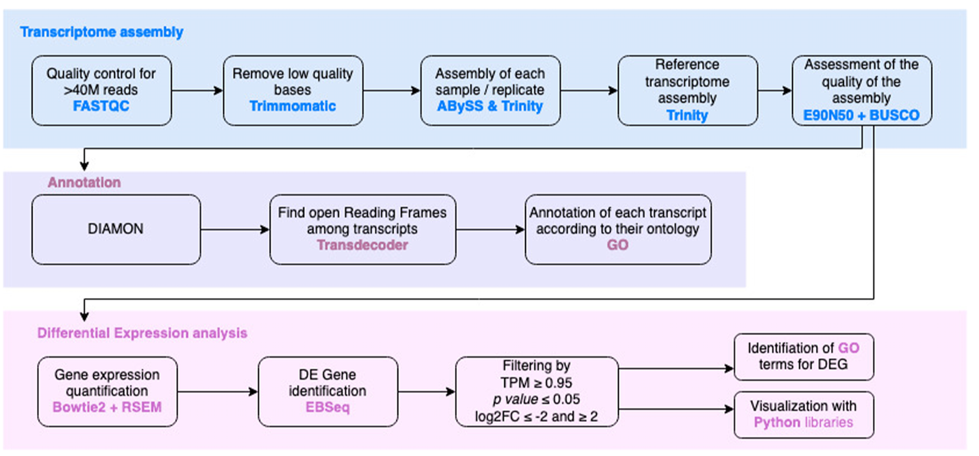
Fig. S4. Pipeline followed for the bioinformatic analyses.

Fig. S5. Statistics for the assemblies performed with Trinity and AbySS for each sample based on a weighted median statistic (N50).

Fig. S6. Expression-based contiguity statistics for the G. biloba reference transcriptome. The assembly has E90N50 of >1.8kb.

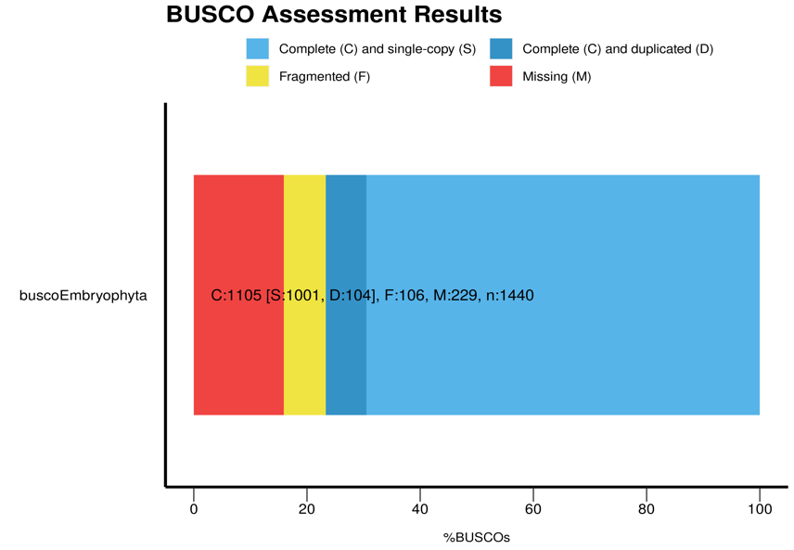
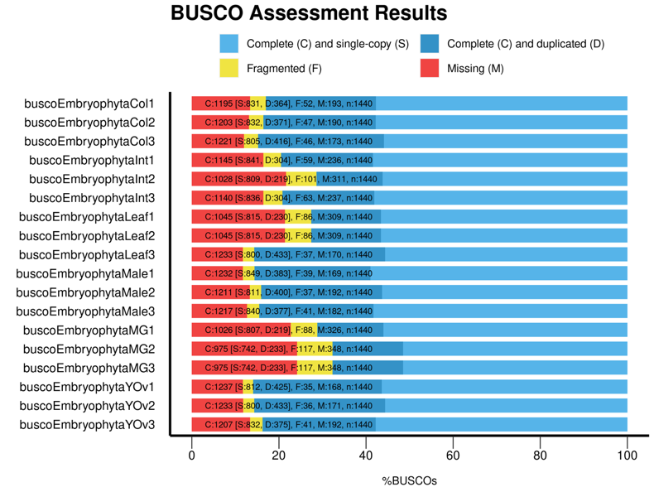
a
b
Supplementary Figure 6. (Previous page) Maximum Likelihood analysis of the euANT gene lineage.

Fig. S7. BUSCO analyses for Ginkgo biloba assemblies.

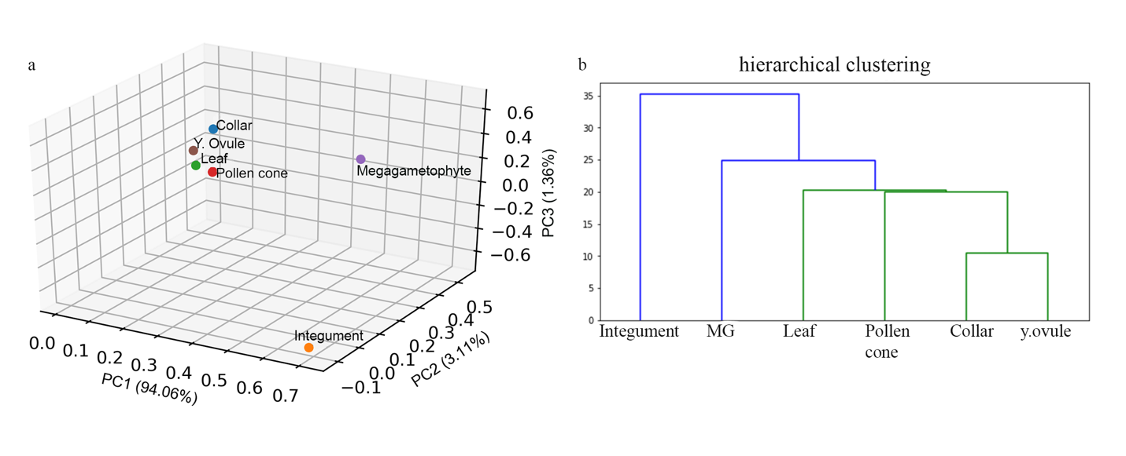

Fig. S8. Data structure a. Principal Component Analysis. b. Dendrogram by hierarchical clustering.

Fig. S9. Blast2GO statistics. a general statistic of the final annotation. b Pie chart of the Cellular component. c Pie chart of the Molecular function. d Pie chart of the Biological process.

Fig. S10 Sense probes in ovules (ov), pollen cones (p) and leaves (l).

Fig. S11. Expression of GbC3HDZ4 using in situ hybridization. a ovule at stage 2. b ovule at stage 3. c ovule at stage 4. d ovule at stage 5. e ovule at stage 7. f microsporagium. g cross section of a leaf.
Fig. S12. Arabidopsis EFP browser results showing the expression of the four FAF paralogs on the entire plant (left) and at different seed stages (right).
Table S1. Comparison between the integument and all the other tissues, showing number of shared genes. This was the comparison used for the transcriptomic analyses.

 | Collar | Megagametophyte | Leaf | Pollen cone | Young Ovule | Total # of genes in Integument
Integument | 21 | 632 | 95 | 150 | 13 | 2137

Table S6 Arabidopsis GenBank and Ginkgo OneKP accession numbers with the percentage of Identity between Arabidopsis and Ginkgo homologs.
Arabidopsis Gene | Accession number (Arabidopsis) | Ginkgo gene name | Ginkgo accession number | % of ID
ANT | AT4G37750 | GibiANT |  | 80.98
BEL1 | At5g41410 | GibiBEL1 | SGTW_scaffold_2006438 | 78.74
KAN1 | At5g16560 | GibiKAN | SGTW_scaffold_2015986 | 83.16
KAN2 | At1g32240 |  |  | 77.66
KAN3 | At4g17695 |  |  | 81.36%
KAN4 | At5g42630 |  |  | Not detected
UCN | At1g51170 | GibiUCN | SGTW_scaffold_2036567 | 70.95
 |  | GibiUCN2 | SGTW_scaffold_2038117 | 73.45

Table S7 Primers used for In situ hybridization experiments in Ginkgo biloba
Gene | Primer sequence
GbC3HDZ1 Fwd | Ccaggttcacgagcaggag
GbC3HDZ1 Rev | ccactagtaccatctgttc
GbC3HDZ1Fwd ISH(sense) | CTTAATACGACTCACTATAGGGCcaggttcacgagcaggag
GbC3HDZ1 Rev ISH | CTTAATACGACTCACTATAGGGccactagtaccatctgttc
GbC3HDZ2 fwd | cctgtagtgttccatcttcac
GbC3HDZ2 Rev | ggagactcgagttcctgctg
GbC3HDZ2 RevISH | CTTAATACGACTCACTATAGGGggagactcgagttcctgctg
GbC3HDZ3 Fwd | cttcagctgcaatgaaagca
GbC3HDZ3 Rev | ctaatgtacggttaggagtcg
GbC3HDZ3 RevISH | CTTAATACGACTCACTATAGGGctaatgtacggttaggagtcg
GbC3HDZ4 Fwd | gttcagctactttgagaactc
GbC3HDZ4 Rev | gtgcaagacatgccatatcc
GbC3HDZ4 RevISH | CTTAATACGACTCACTATAGGGgtgcaagacatgccatatcc
GbC3HDZ5 Fwd | gtaaaacacctataagagaa
GbC3HDZ5 Rev | CATTCCATGACAGAAGCTG
GbC3HDZ5 Rev | gtgcgtgatagactgcacc
GbC3HDZ5 Rev ISH | CTTAATACGACTCACTATAGGGCATTCCATGACAGAAGCTG
GbC3HDZ5 RevISh | CTTAATACGACTCACTATAGGGgtgcgtgatagactgcacc
GbC3HDZ5Fwd | ATGCCCAGCATTATGGAGAAG
GbWUS Fwd | GGAATCCGTTCATGAGCAAGT
GbWUS Rev | TCCAGTGCCGATTCACTCC
GbWUSfwdISH sense | CTTAATACGACTCACTATAGGGGGAATCCGTTCATGAGCAAGT
GbWUS Rev ISH | CTTAATACGACTCACTATAGGGTCCAGTGCCGATTCACTCC
GibiBEL12fwd | ctgaggactatagccttgtc
GibiBEL12revISH | CTTAATACGACTCACTATAGGGgcaggatgaactgctgaag
GibiBEL12fwdISH sense | CTTAATACGACTCACTATAGGGgcaggatgaactgctgaag
GibiKAN fwd | GGATCATCAAGGAGGCTTAT
GibiKAN rev ISH | CTTAATACGACTCACTATAGGGTGTTGGCAGGACTTGAAGC
GibiKAN FwdISH sense | CTTAATACGACTCACTATAGGGTGTTGGCAGGACTTGAAGC
GibiUCN Fwd | gacgtcttgtaaaccacaac
GibiUCN Rev | acatccaaatcagggtccttc
GibiUCN Rev ISH | CTTAATACGACTCACTATAGGGACATCCAAATCAGGGTCCTTC
GibiUCN Fwd ISH sense | CTTAATACGACTCACTATAGGGgacgtcttgtaaaccacaac
GibiUCN2 Fwd | gatggcaagtgccattcattc
GibiUCN2 Rev | ctttgacagacaggctcatg
GibiUCN2 revISH | CTTAATACGACTCACTATAGGGctttgacagacaggctcatg

