Investigating climatic influence on extirpations through models should consider the timing of the last fossil occurrence: a case study
Appendix S1. List of the coded bioclimatic variables from PaleoClim (https://www.paleoclim.org/). A quarter is a period of three months (1/4 of the year).
This scheme follows that of ANUCLIM, except that for temperature seasonality the standard deviation was used because a coefficient of variation does not make sense with temperatures between -1 and 1.
BIO1 = Annual Mean Temperature
BIO2 = Mean Diurnal Range (Mean of monthly (max temp - min temp))
BIO3 = Isothermality (BIO2/BIO7) (×100)
BIO4 = Temperature Seasonality (standard deviation of the mean monthly temperature ×100)
BIO5 = Max Temperature of Warmest Month
BIO6 = Min Temperature of Coldest Month
BIO7 = Temperature Annual Range (BIO5-BIO6)
BIO8 = Mean Temperature of Wettest Quarter
BIO9 = Mean Temperature of Driest Quarter
BIO10 = Mean Temperature of Warmest Quarter
BIO11 = Mean Temperature of Coldest Quarter
BIO12 = Annual Precipitation
BIO13 = Precipitation of Wettest Month
BIO14 = Precipitation of Driest Month
BIO15 = Precipitation Seasonality (Coefficient of Variation: ratio of the standard deviation of the monthly total precipitation to the mean monthly total precipitation).
BIO16 = Precipitation of Wettest Quarter
BIO17 = Precipitation of Driest Quarter
BIO18 = Precipitation of Warmest Quarter
BIO19 = Precipitation of Coldest Quarter
Appendix S2. Dendrogram based on distance built on Pearson’s correlation (less distance = more correlation).
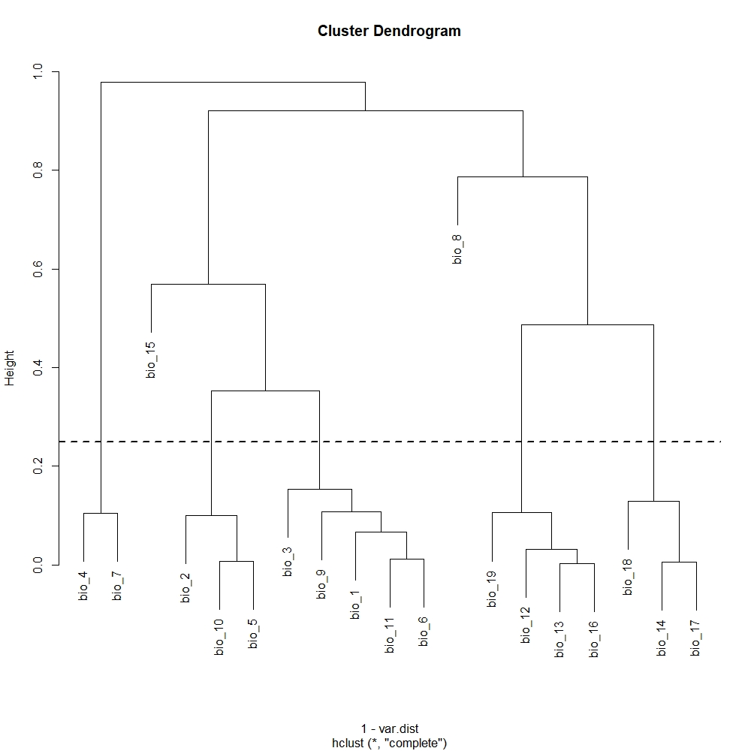
Appendix S3. Pearson’s pairwise comparison table.
 | pearson.correlation.coefficient.bio_1 | pearson.correlation.coefficient.bio_10 | pearson.correlation.coefficient.bio_11 | pearson.correlation.coefficient.bio_12 | pearson.correlation.coefficient.bio_13 | pearson.correlation.coefficient.bio_14 | pearson.correlation.coefficient.bio_15 | pearson.correlation.coefficient.bio_16 | pearson.correlation.coefficient.bio_17 | pearson.correlation.coefficient.bio_18 | pearson.correlation.coefficient.bio_19 | pearson.correlation.coefficient.bio_2 | pearson.correlation.coefficient.bio_3 | pearson.correlation.coefficient.bio_4 | pearson.correlation.coefficient.bio_5 | pearson.correlation.coefficient.bio_6 | pearson.correlation.coefficient.bio_7 | pearson.correlation.coefficient.bio_8 | pearson.correlation.coefficient.bio_9 | mean
bio_1 | 1 | 0.958429 | 0.969197 | -0.54866 | -0.52169 | -0.55603 | 0.478073 | -0.52457 | -0.55011 | -0.71214 | -0.30894 | 0.847078 | 0.871682 | -0.46858 | 0.931471 | 0.933426 | -0.10133 | 0.520836 | 0.898573 | 9.460047
bio_10 | 0.958429 | 1 | 0.861108 | -0.63267 | -0.59772 | -0.63612 | 0.454911 | -0.60256 | -0.63291 | -0.72603 | -0.42521 | 0.899211 | 0.734865 | -0.20014 | 0.992279 | 0.800956 | 0.176091 | 0.614859 | 0.822933 | 19.59333
bio_11 | 0.969197 | 0.861108 | 1 | -0.43675 | -0.4179 | -0.45304 | 0.468954 | -0.41902 | -0.44343 | -0.66086 | -0.17835 | 0.742984 | 0.926276 | -0.66996 | 0.821105 | 0.988464 | -0.33257 | 0.391467 | 0.915166 | -0.66606
bio_12 | -0.54866 | -0.63267 | -0.43675 | 1 | 0.968385 | 0.907235 | -0.38395 | 0.976023 | 0.926558 | 0.829363 | 0.89455 | -0.70355 | -0.42412 | -0.08557 | -0.63875 | -0.33803 | -0.37411 | -0.44211 | -0.45281 | 499.8089
bio_13 | -0.52169 | -0.59772 | -0.4179 | 0.968385 | 1 | 0.802916 | -0.23475 | 0.996672 | 0.825916 | 0.778282 | 0.899888 | -0.6662 | -0.40693 | -0.07126 | -0.60067 | -0.32364 | -0.34336 | -0.41951 | -0.42387 | 64.55867
bio_14 | -0.55603 | -0.63612 | -0.45304 | 0.907235 | 0.802916 | 1 | -0.56232 | 0.814135 | 0.993962 | 0.876342 | 0.709611 | -0.70304 | -0.43676 | -0.05841 | -0.65169 | -0.36026 | -0.3591 | -0.35262 | -0.52523 | 22.93672
bio_15 | 0.478073 | 0.454911 | 0.468954 | -0.38395 | -0.23475 | -0.56232 | 1 | -0.25285 | -0.55891 | -0.50707 | -0.1701 | 0.440796 | 0.462069 | -0.24348 | 0.449578 | 0.431745 | -0.02133 | 0.204995 | 0.503217 | 37.68456
bio_16 | -0.52457 | -0.60256 | -0.41902 | 0.976023 | 0.996672 | 0.814135 | -0.25285 | 1 | 0.836183 | 0.784036 | 0.906778 | -0.67197 | -0.40771 | -0.07632 | -0.60597 | -0.32428 | -0.34964 | -0.42961 | -0.42492 | 176.2738
bio_17 | -0.55011 | -0.63291 | -0.44343 | 0.926558 | 0.825916 | 0.993962 | -0.55891 | 0.836183 | 1 | 0.871595 | 0.738422 | -0.70382 | -0.43002 | -0.07206 | -0.64732 | -0.34779 | -0.37146 | -0.36606 | -0.50766 | 77.47311
bio_18 | -0.71214 | -0.72603 | -0.66086 | 0.829363 | 0.778282 | 0.876342 | -0.50707 | 0.784036 | 0.871595 | 1 | 0.51305 | -0.7554 | -0.64357 | 0.205739 | -0.7254 | -0.58967 | -0.12266 | -0.21338 | -0.75619 | 138.7585
bio_19 | -0.30894 | -0.42521 | -0.17835 | 0.89455 | 0.899888 | 0.709611 | -0.1701 | 0.906778 | 0.738422 | 0.51305 | 1 | -0.51904 | -0.17179 | -0.27631 | -0.43895 | -0.08009 | -0.48062 | -0.50973 | -0.1337 | 117.6282
bio_2 | 0.847078 | 0.899211 | 0.742984 | -0.70355 | -0.6662 | -0.70304 | 0.440796 | -0.67197 | -0.70382 | -0.7554 | -0.51904 | 1 | 0.739811 | -0.11959 | 0.925459 | 0.647261 | 0.310735 | 0.507718 | 0.74991 | 9.971503
bio_3 | 0.871682 | 0.734865 | 0.926276 | -0.42412 | -0.40693 | -0.43676 | 0.462069 | -0.40771 | -0.43002 | -0.64357 | -0.17179 | 0.739811 | 1 | -0.71199 | 0.708835 | 0.908483 | -0.36812 | 0.286994 | 0.845954 | 31.3563
bio_4 | -0.46858 | -0.20014 | -0.66996 | -0.08557 | -0.07126 | -0.05841 | -0.24348 | -0.07632 | -0.07206 | 0.205739 | -0.27631 | -0.11959 | -0.71199 | 1 | -0.13579 | -0.73517 | 0.894592 | 0.138489 | -0.56086 | 827.3414
bio_5 | 0.931471 | 0.992279 | 0.821105 | -0.63875 | -0.60067 | -0.65169 | 0.449578 | -0.60597 | -0.64732 | -0.7254 | -0.43895 | 0.925459 | 0.708835 | -0.13579 | 1 | 0.752975 | 0.257077 | 0.610016 | 0.801104 | 26.49263
bio_6 | 0.933426 | 0.800956 | 0.988464 | -0.33803 | -0.32364 | -0.36026 | 0.431745 | -0.32428 | -0.34779 | -0.58967 | -0.08009 | 0.647261 | 0.908483 | -0.73517 | 0.752975 | 1 | -0.44236 | 0.341433 | 0.891958 | -6.01903
bio_7 | -0.10133 | 0.176091 | -0.33257 | -0.37411 | -0.34336 | -0.3591 | -0.02133 | -0.34964 | -0.37146 | -0.12266 | -0.48062 | 0.310735 | -0.36812 | 0.894592 | 0.257077 | -0.44236 | 1 | 0.329956 | -0.2181 | 32.51165
bio_8 | 0.520836 | 0.614859 | 0.391467 | -0.44211 | -0.41951 | -0.35262 | 0.204995 | -0.42961 | -0.36606 | -0.21338 | -0.50973 | 0.507718 | 0.286994 | 0.138489 | 0.610016 | 0.341433 | 0.329956 | 1 | 0.180826 | 13.55825
bio_9 | 0.898573 | 0.822933 | 0.915166 | -0.45281 | -0.42387 | -0.52523 | 0.503217 | -0.42492 | -0.50766 | -0.75619 | -0.1337 | 0.74991 | 0.845954 | -0.56086 | 0.801104 | 0.891958 | -0.2181 | 0.180826 | 1 | 7.27389

Appendix S4. Future projections for 2070 performed using R package ‘biomod2’, under different GCMs. GCMs: BC = BCC-CSM1-1, CE = CESM1-CAM5-1-FV2, CN = CNRM-CM5, GF = GFDL-CM3, GD = GFDL-ESM2G, GS = GISS-E2-R, HD = HadGEM2-AO, HE = HadGEM2-ES, IP = IPSL-CM5A-LR, MI = MIROC-ESM-CHEM, MR = MIROC-ESM, MC = MIROC5, MG = MRI-CGCM3, NO = NorESM1-M. See www.worldclim.org for details about the models. RCPs: 45 = 4.5, 26 = 2.6 (see main text).
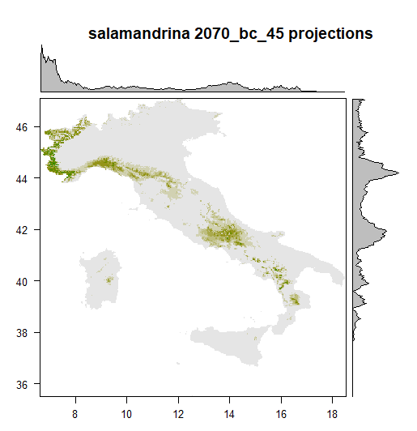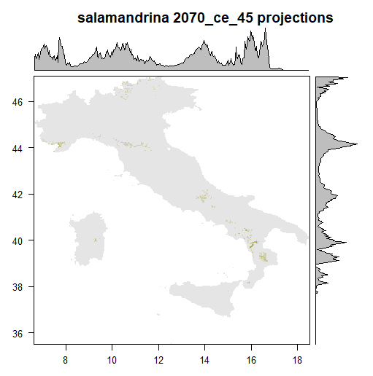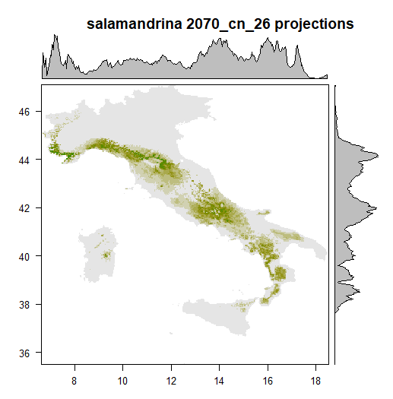
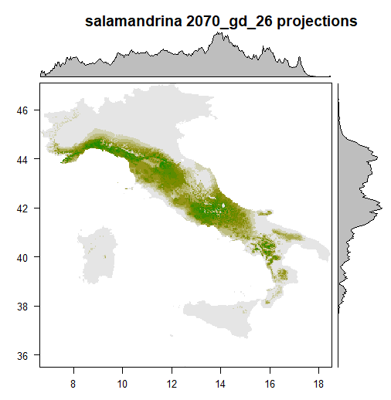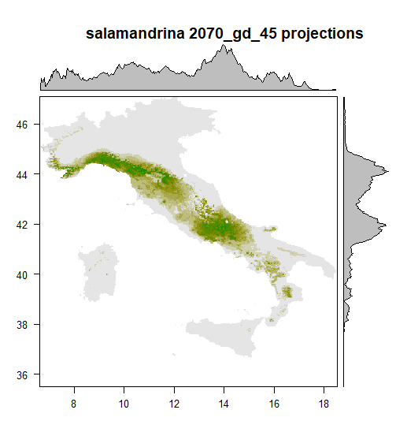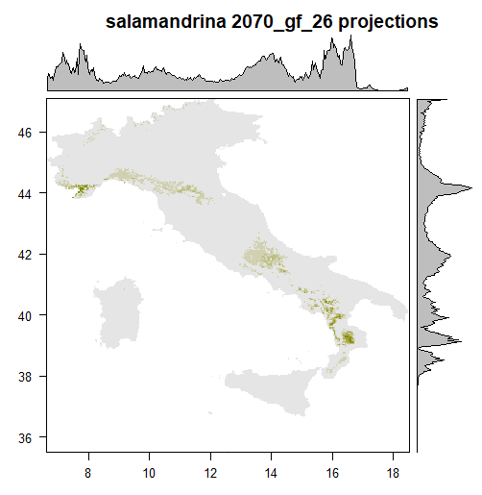

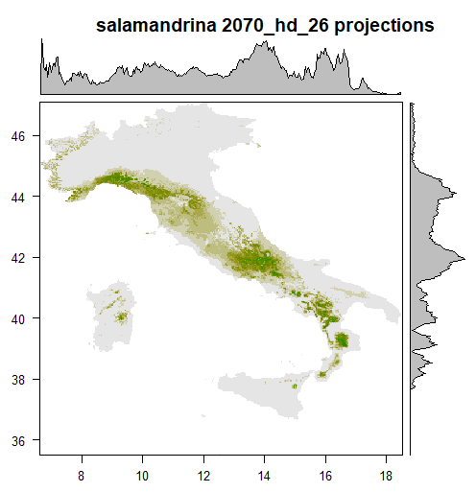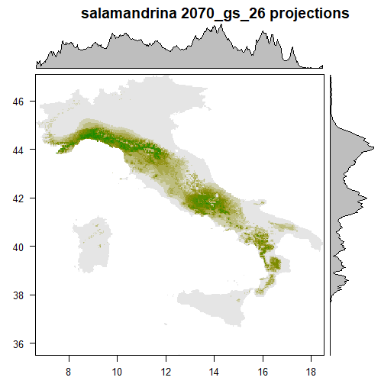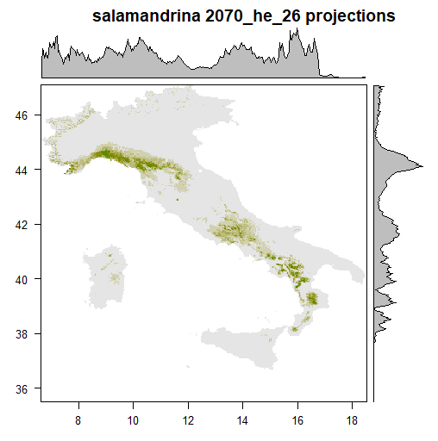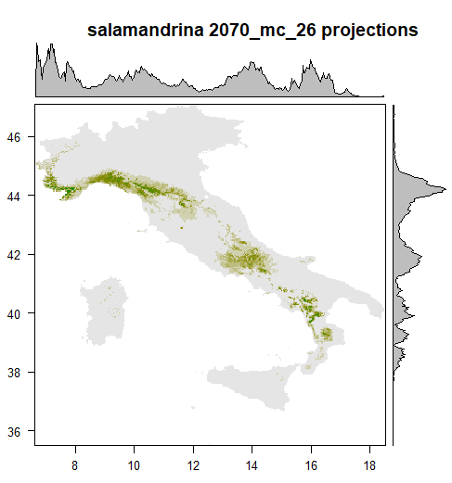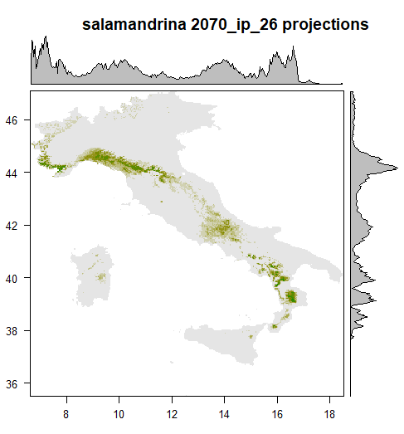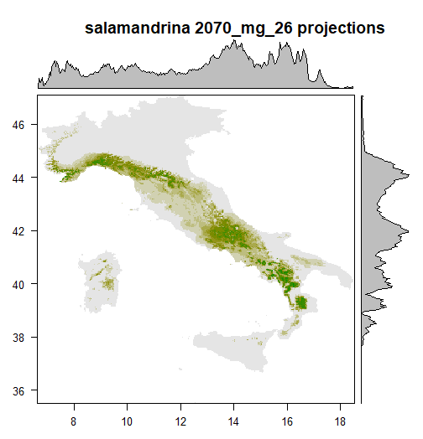
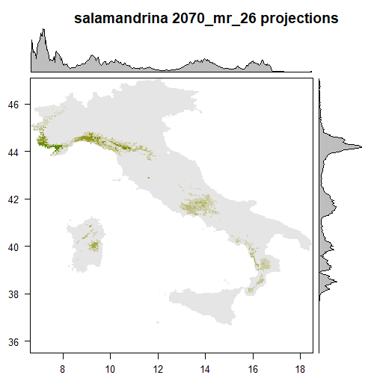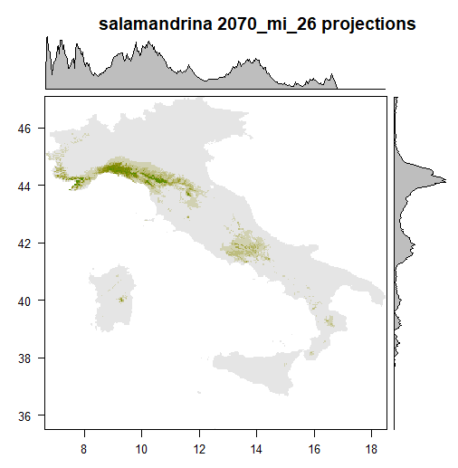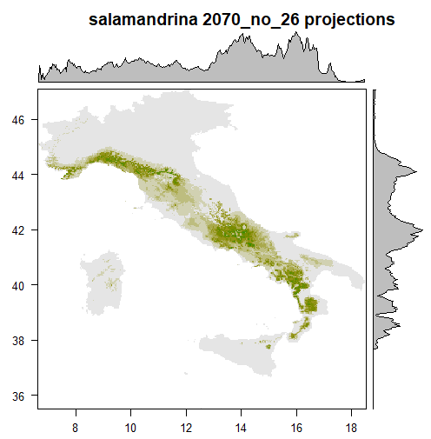

Appendix S5. Ensemble model evaluation obtained through R package ‘biomod2’.
 | salamandrina_EMmeanByTSS_mergedAlgo_mergedRun_mergedData.Testing.data | salamandrina_EMmeanByTSS_mergedAlgo_mergedRun_mergedData.Cutoff | salamandrina_EMmeanByTSS_mergedAlgo_mergedRun_mergedData.Sensitivity | salamandrina_EMmeanByTSS_mergedAlgo_mergedRun_mergedData.Specificity
TSS | 0.977 | 533 | 98.843 | 98.875

Appendix S6. Histograms showing the distribution of Salamandrina versus different bioclimatic variables (from WorldClim2.1). Temperatures are expressed in Celsius degrees, and precipitation is measured in mm. Temperature and precipitation seasonality are as defined in Appendix S1.
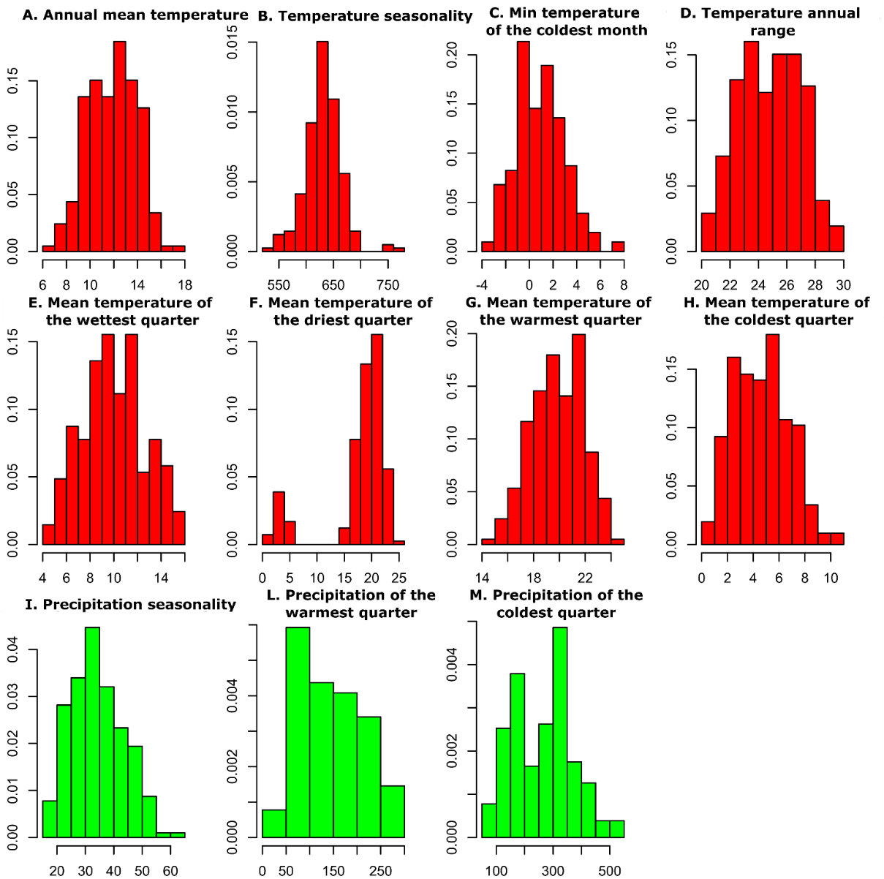

Appendix S7. List of contributors of presence data of Salamandrina spp. to the "Commissione Atlante" of the Societas Herpetologica Italica:

Gaspare Adinolfi
Alessandro Ammann
Guido Baldi
Rosario Balestrieri
Daniele Baroni
Remo Bartolomei
Angelo Battaglia
Franco Bernini
Domenico Bevacqua
Emanuele Biggi
Alex Borrini
Andrea Boscherini
Adam Bouderka
Stefano Brigidi
Giacomo Bruni
Fabrizio Bulgarini
Giovanni Capobianco
Elena Cecchinelli
Stefano Celletti
Carlo Ciani
Luca Colonnelli
Gianluca Congi
Luca Coppari
Michele Coppola
Andrea Costa
Renato Cottalasso
Federico Crovetto
Anna Rita Di Cerbo
Matteo di Nicola
Stefano Doglio
Dario Domeneghetti
David Fiacchini
Giovanni Fontanesi
Carlo Fracasso
Egidio Fulco
Ilaria Guj
Alfonso Iorio
Arnaldo Iudici
Sara Lefosse
Giorgio Leoni
Cristiano Liuzzi
Guglielmo Londi
Enrico Lunghi
Paolo Malenotti
Antonio Mancuso
Raoul Manenti
Giovanni Marcantonio
Maurizio Marrese
Fabio Mastropasqua
Francesca Montioni
Marco Morbidelli
Sergio Muratore
Moreno Nalin
Veronica Nanni
Nicola Norante
Tommaso Notomista
Dario Ottonello
Mario Pellegrini
Emanuela Peria
Fabrizio Petrassi
Jerry Pieri
Lucia Pizzocaro
Ranieri Raimondi
Edoardo Razzetti
Stefano Risa
Giuseppe Romeo
Diego Rubolini
Andrea Russo
Dario Salemi
Roberto Santopaolo
Bruno Santucci
Stefano Sarrocco
Valerio Sbordoni
Silvia Sgrosso
Roberto Sindaco
Adrien Sprumont
Giovanni Talpone
Stefano Tito
Domenico Verducci
Marco Zuffi

