Supplementary Note 1
Supplementary Figures
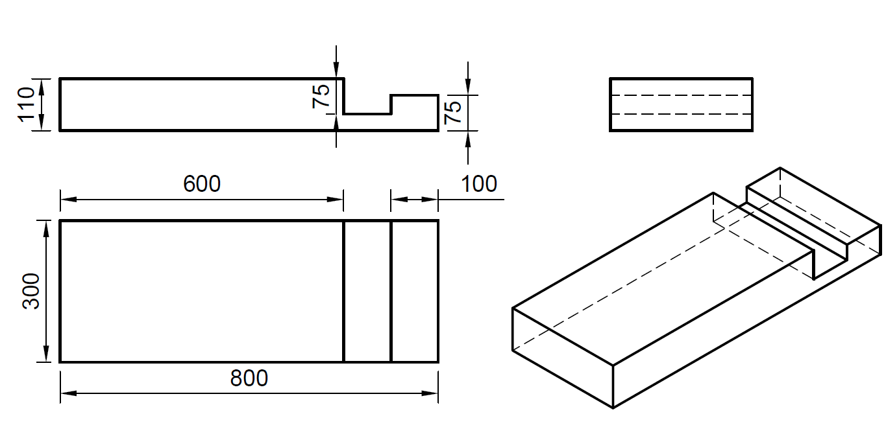
(a)
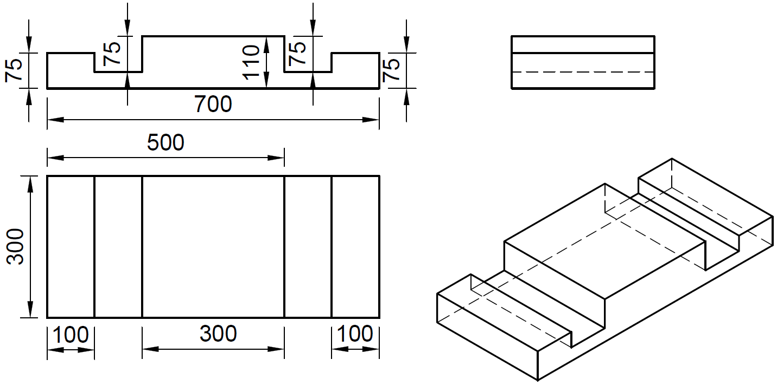
(b)

Supplementary Fig. 1| Dimensions of moulds. a, Dimensions of type A mould and b, Dimensions of type B mould in mm

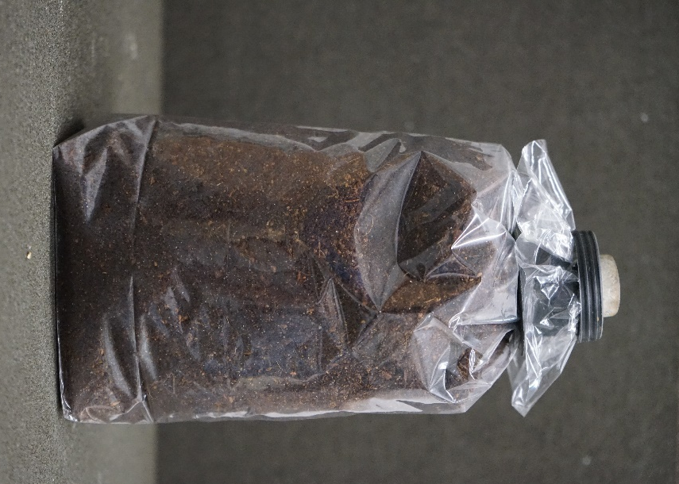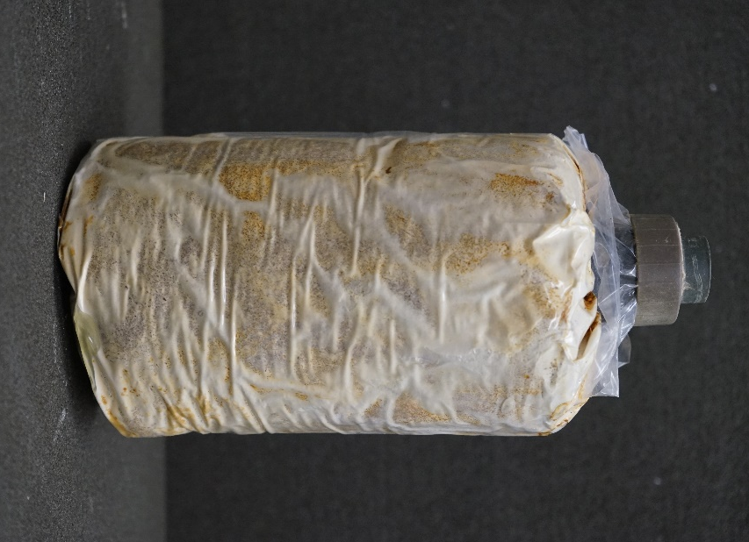
(a)
(b)
Supplementary Fig. 2|Inoculated sawdust bags. a, before growth and b, after growth

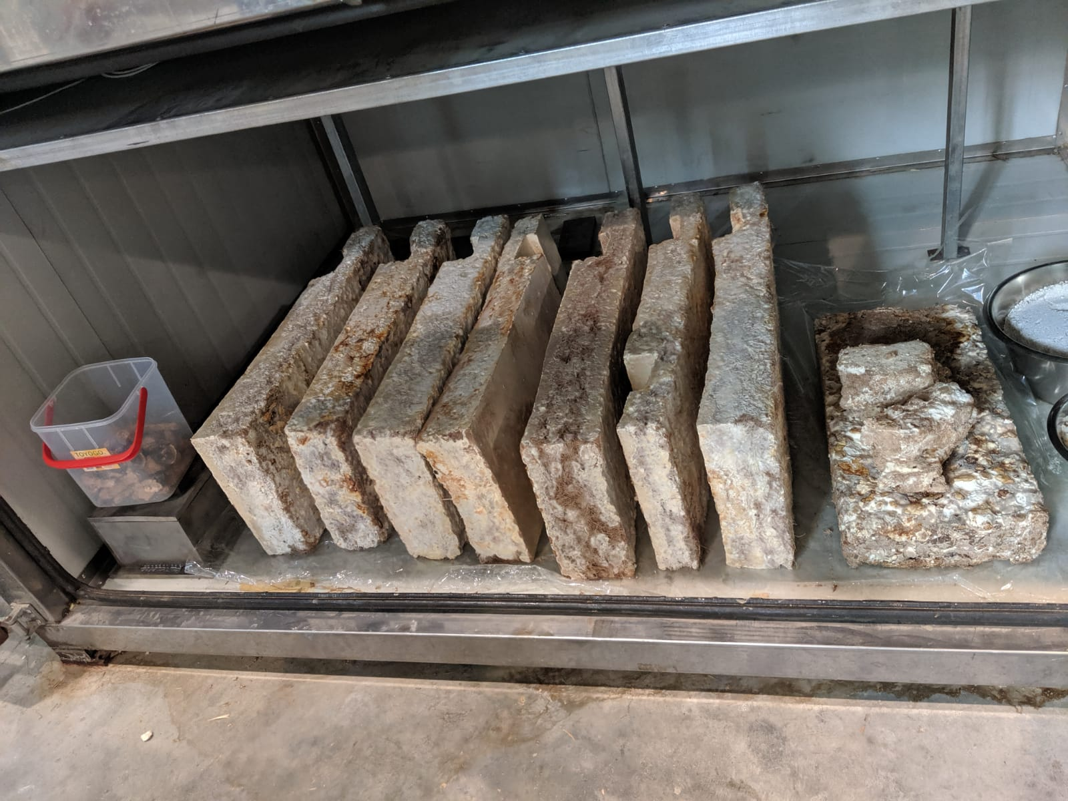
Supplementary Fig. 3|Dried Mycelium blocks
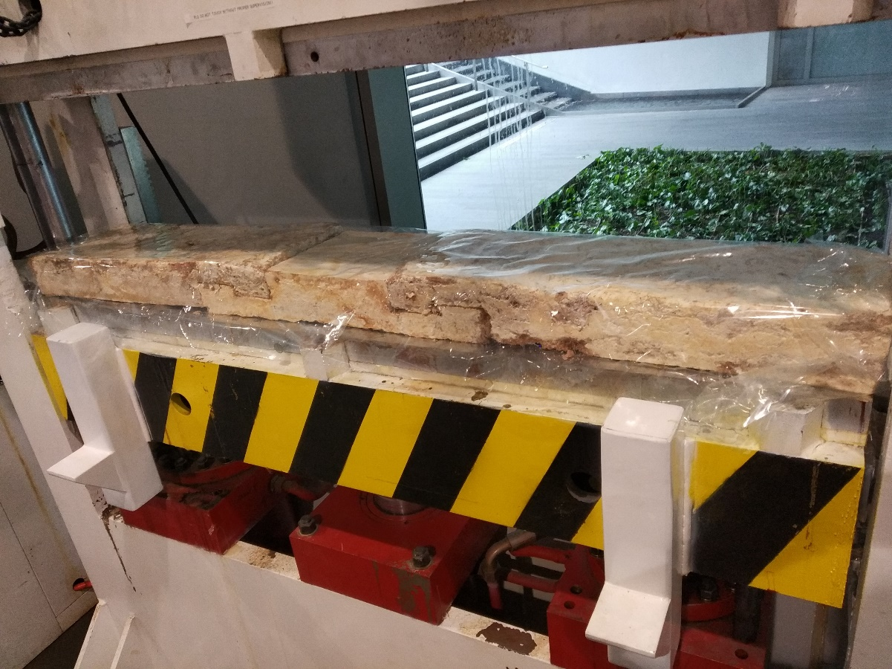

Supplementary Fig. 4|Production of DMC under heat and pressure.

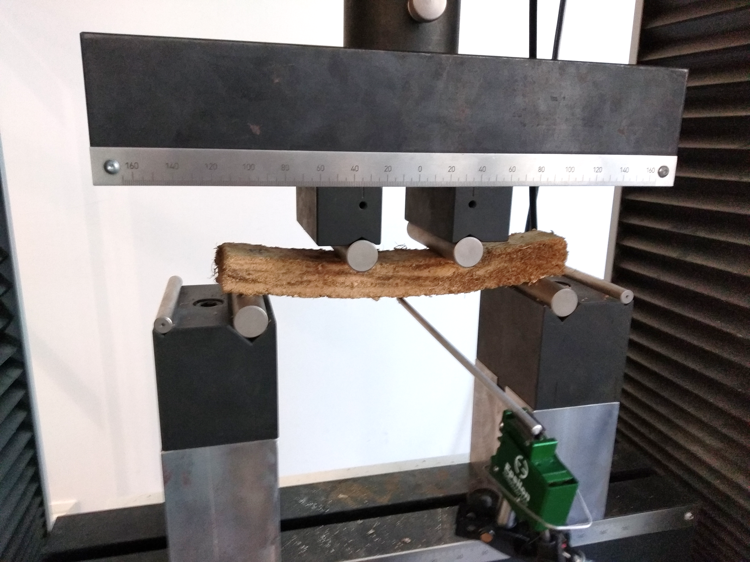
Supplementary Fig. 5|Sample under 4-point bending test

Supplementary Note 2
Supplementary Tables.
Supplementary Table 1|R_{b} raw data and ANOVA results
R_{b} raw data
 | Day 0 | Day 7 | Day 21 | Day 35
Uncoated group | 2.07 | 2.27 | 1.26 | 1.11
Uncoated group | 2.76 | 2.76 | 1.80 | 1.01
Uncoated group | 3.21 | 2.27 | 2.12 | 1.19
Coated group | 1.45 | 1.74 | 1.50 | 1.22
Coated group | 2.75 | 2.71 | 2.04 | 1.85
Coated group | 3.39 | 2.53 | 2.23 | 1.79
ANOVA
Source of Variation | df | F | P-value
Between groups | 1 | 0.30 | 0.59

Supplementary Table 2|R_{c} raw data and ANOVA results
R_{c} raw data
 | Day 0 | Day 7 | Day 21 | Day 35
Uncoated group | 2.68 | 1.28 | 2.55 | 0.62
Uncoated group | 7.61 | 2.15 | 1.65 | 0.50
Uncoated group | 3.04 | 3.33 | 1.66 | 1.01
Coated group | 2.96 | 1.31 | 1.52 | 1.49
Coated group | 4.89 | 2.94 | 2.26 | 3.59
Coated group | 2.24 | 2.06 | 2.38 | 1.55
ANOVA
Source of Variation | df | F | P-value
Between groups | 1 | 0.03 | 0.86

Supplementary Table 3|R_{t} raw data and ANOVA results
R_{t} raw data
 | Day 0 | Day 7 | Day 21 | Day 35
Uncoated group | 1.90 | 0.39 | 0.70 | 0.47
Uncoated group | 1.03 | 0.80 | 0.58 | 0.28
Uncoated group | 1.72 | 0.63 | 0.33 | 0.22
Coated group | 1.35 | 0.81 | 1.00 | 0.78
Coated group | 1.91 | 1.06 | 0.92 | 0.82
Coated group | 1.33 | 0.46 | 0.68 | 0.82
ANOVA
Source of Variation | df | F | P-value
Between groups | 1 | 5.22 | 0.04

E_{t} raw data
 | Day 0 | Day 7 | Day 21 | Day 35
Uncoated group | 872.95 | 49.86 | 127.70 | 163.46
Uncoated group | 536.67 | 213.64 | 84.51 | 100.47
Uncoated group | 530.79 | 136.31 | 20.47 | 84.42
Coated group | 485.11 | 293.20 | 190.96 | 281.15
Coated group | 696.95 | 521.76 | 386.14 | 388.43
Coated group | 624.64 | 40.15 | 168.42 | 188.60
ANOVA
Source of Variation | df | F | P-value
Between groups | 1 | 4.19 | 0.06
Supplementary Table 4|E_{t} raw data and ANOVA results

