Supplementary Figures
A 3D primary cell based in vitro model of non-alcoholic steatohepatitis for efficacy testing of clinical drug candidates
Simon Ströbel*, Radina Kostadinova*, Katia Fiaschetti-Egli, Jana Rupp, Manuela Bieri, Agnieszka Pajak, Donna Busler, Thomas Hofstetter, Katarzyna Sanchez, Sue Grepper, Eva Thoma
Affiliation: InSphero AG, Wagistrasse 27A, Schlieren, CH
*These authors contributed equally to this work
Corresponding author: Simon Ströbel simon.stroebel@insphero.com

Supplementary Figure 1

Supplementary Figure 1. Model stability over time. LDH release measured on days 3, 5, 7 and 10 of culture. Chlorpromazine (CHL) was used as a positive cell toxicity control.

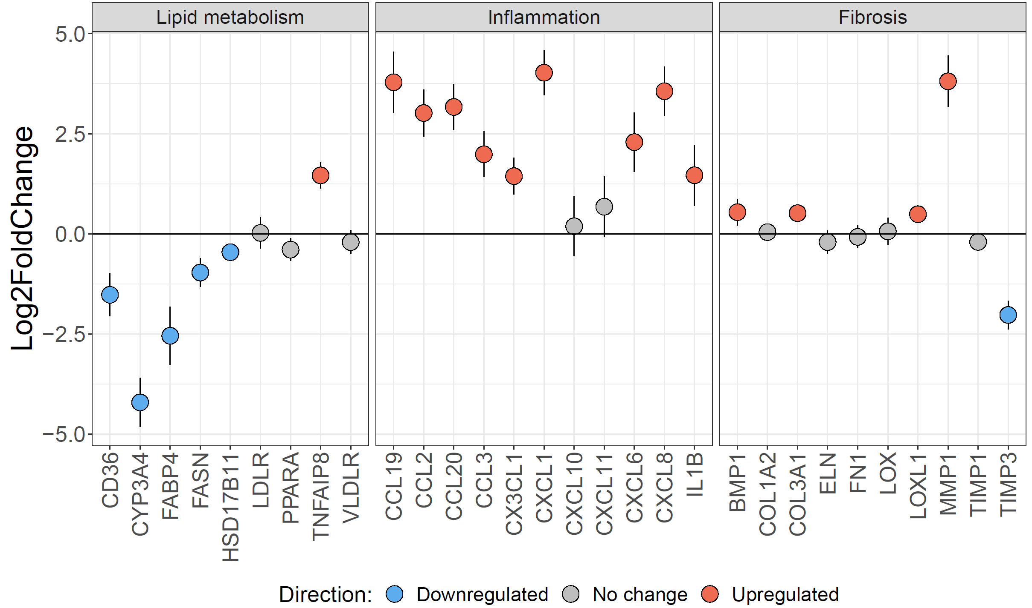
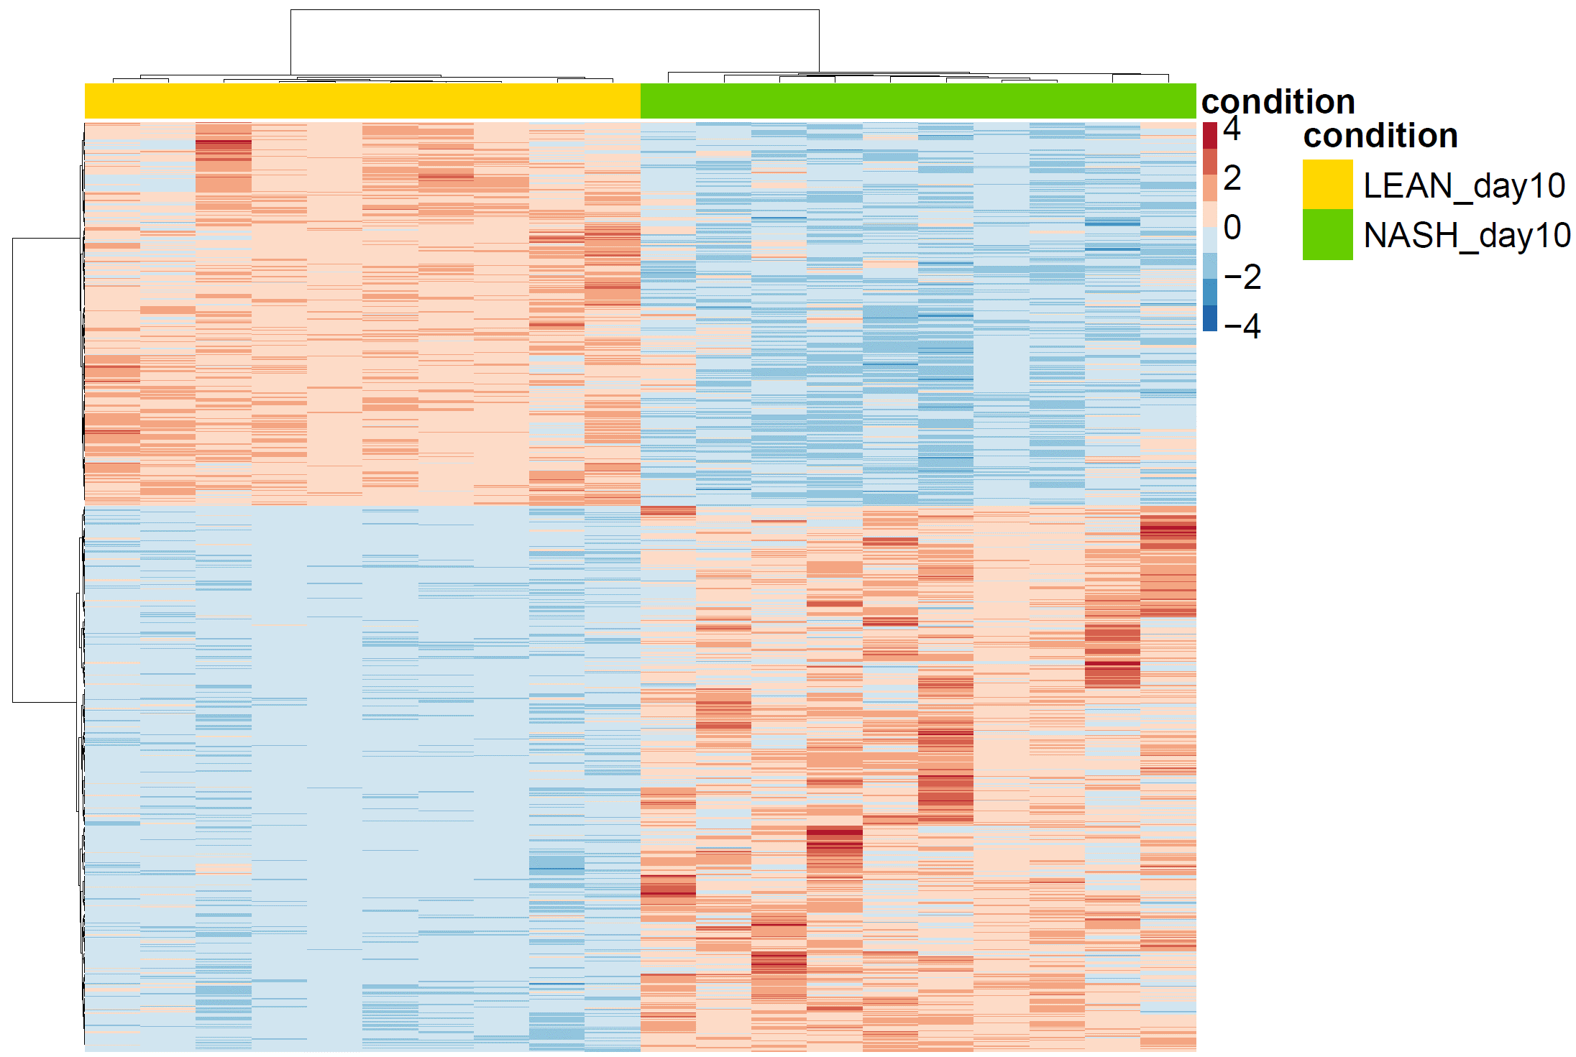
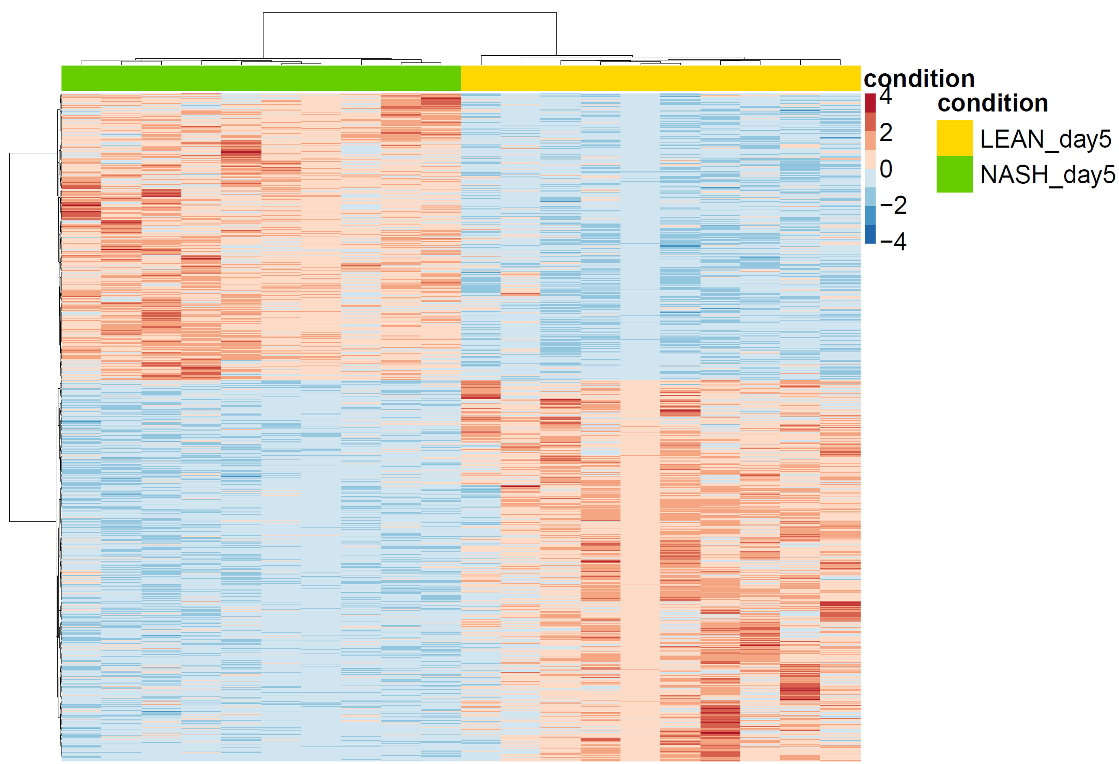
Supplementary Figure 2
a
b
c
d
Day 5
Day 5
Day 10
Day 10

Supplementary Figure 2. Transcriptomic profiling of 3D NASH hLiMTs. (a, b) Heatmaps for differentially expressed genes (log2 >1, FDR <0.05) between NASH and LEAN hLiMTs on day 5 (a) and day 10 (b) of treatment. Columns represent samples, and rows are genes. Row-wise Z-score transformation was performed on log2 expression values for each gene, with blue denoting a lower and red a higher expression level according to the average expression level. (c, d) Expression profile of key genes associated with lipid metabolism, inflammation and fibrosis. Plots show log2 fold change between NASH and LEAN hLiMTs on day 5 (c) and day 10 (d) of treatment. Error bars represent 95% confidence intervals associated with log2 fold change values. Blue indicates significant downregulation and red significant upregulation in NASH hLiMTs (FDR < 0.05). Data points are derived from single hLiMTs (n = 10), results from one of two independent experiments are shown.

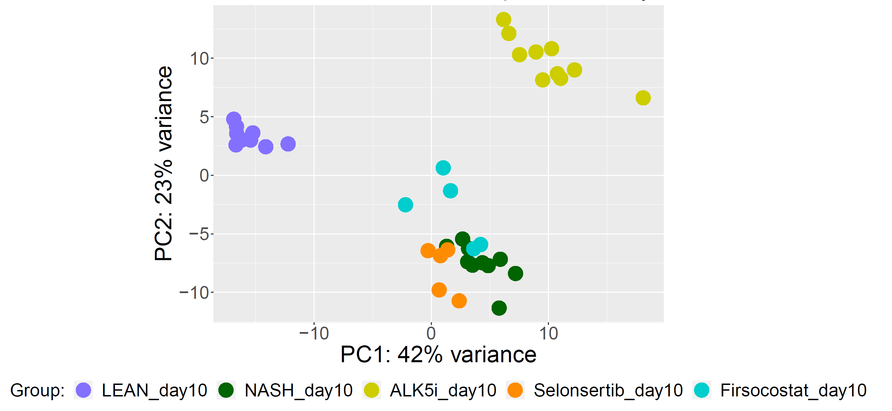
Supplementary Figure 3
Alk5i
Selonsertib
Firsocostat
a
b
c
d
Adipogenesis
Inflammatory response
Collagen formation

Supplementary Figure 3: Transcriptomic profiling of compound treatment in 3D NASH hLiMTs confirms mechanism of action of clinical compounds, Firsocostat and Selonsertib, and reference compound, ALK5i. (a) Principal component analysis of whole-transcriptome expression profiles from NASH, LEAN and compound-treated NASH hLiMTs on day 10. Distinct clusters for treatment groups suggest different mechanisms of actions for each compound. (b-d) Heatmaps of NASH, LEAN and compound treated NASH samples on day 10 for gene sets associated with hallmarks of NASH, namely adipogenesis (Hallmark, top row), inflammatory response (Hallmark, middle row) and collagen formation (Reactome, bottom row). Heatmaps are shown for treatment with 10 µM Firsocostat (b), 2 µM Selonsertib (c) and 0.5 µM ALK5i (d). In each heatmap, columns represent samples, and rows are genes. Row-wise Z-score transformation was performed on log2 expression values for each gene, with blue denoting a lower and red a higher expression level according to the average expression level. Data points are derived from single microtissues (n = 5-10).

Supplementary Tables
code | gene_set
A1 | HALLMARK_TNFA_SIGNALING_VIA_NFKB
A2 | REACTOME_BIOLOGICAL_OXIDATIONS
A3 | WP_METAPATHWAY_BIOTRANSFORMATION_PHASE_I_AND_II
A4 | REACTOME_SIGNALING_BY_INTERLEUKINS
A5 | KEGG_DRUG_METABOLISM_CYTOCHROME_P450
A6 | HALLMARK_INFLAMMATORY_RESPONSE
A7 | KEGG_METABOLISM_OF_XENOBIOTICS_BY_CYTOCHROME_P450
A8 | HALLMARK_INTERFERON_GAMMA_RESPONSE
A9 | KEGG_RETINOL_METABOLISM
A10 | KEGG_CYTOKINE_CYTOKINE_RECEPTOR_INTERACTION
A11 | WP_IL18_SIGNALING_PATHWAY
A12 | REACTOME_PHASE_I_FUNCTIONALIZATION_OF_COMPOUNDS
A13 | WP_OXIDATION_BY_CYTOCHROME_P450
A14 | KEGG_NOD_LIKE_RECEPTOR_SIGNALING_PATHWAY
A15 | KEGG_DRUG_METABOLISM_OTHER_ENZYMES
A16 | REACTOME_FATTY_ACID_METABOLISM
A17 | KEGG_CHEMOKINE_SIGNALING_PATHWAY
A18 | REACTOME_METABOLISM_OF_AMINO_ACIDS_AND_DERIVATIVES
A19 | HALLMARK_FATTY_ACID_METABOLISM
A20 | REACTOME_PHASE_II_CONJUGATION_OF_COMPOUNDS
A21 | REACTOME_INTERLEUKIN_10_SIGNALING
A22 | KEGG_STEROID_HORMONE_BIOSYNTHESIS
A23 | WP_TAMOXIFEN_METABOLISM
A24 | REACTOME_CLASS_A_1_RHODOPSIN_LIKE_RECEPTORS
A25 | HALLMARK_IL6_JAK_STAT3_SIGNALING
A26 | REACTOME_GPCR_LIGAND_BINDING
A27 | REACTOME_PEPTIDE_LIGAND_BINDING_RECEPTORS
A28 | WP_AMINO_ACID_METABOLISM
A29 | REACTOME_INTERLEUKIN_4_AND_INTERLEUKIN_13_SIGNALING
A30 | REACTOME_METABOLISM_OF_STEROIDS

Supplementary Table 1: Enrichment map legend for GSEA comparing NASH versus LEAN at day 5 (Figure 5c). Legend shows full pathway names assigned to nodes.

code | gene_set
B1 | HALLMARK_INTERFERON_GAMMA_RESPONSE
B2 | REACTOME_PEPTIDE_LIGAND_BINDING_RECEPTORS
B3 | WP_IL18_SIGNALING_PATHWAY
B4 | REACTOME_GPCR_LIGAND_BINDING
B5 | REACTOME_CLASS_A_1_RHODOPSIN_LIKE_RECEPTORS
B6 | HALLMARK_TNFA_SIGNALING_VIA_NFKB
B7 | KEGG_CYTOKINE_CYTOKINE_RECEPTOR_INTERACTION
B8 | REACTOME_SIGNALING_BY_INTERLEUKINS
B9 | REACTOME_CHEMOKINE_RECEPTORS_BIND_CHEMOKINES
B10 | HALLMARK_INFLAMMATORY_RESPONSE
B11 | REACTOME_INTERLEUKIN_10_SIGNALING
B12 | KEGG_CHEMOKINE_SIGNALING_PATHWAY
B13 | WP_SARSCOV2_INNATE_IMMUNITY_EVASION_AND_CELLSPECIFIC_IMMUNE_RESPONSE
B14 | WP_LUNG_FIBROSIS
B15 | HALLMARK_IL6_JAK_STAT3_SIGNALING
B16 | HALLMARK_INTERFERON_ALPHA_RESPONSE
B17 | WP_MIRNAS_INVOLVEMENT_IN_THE_IMMUNE_RESPONSE_IN_SEPSIS
B18 | REACTOME_SIGNALING_BY_GPCR
B19 | WP_FOLATE_METABOLISM
B20 | WP_PLATELETMEDIATED_INTERACTIONS_WITH_VASCULAR_AND_CIRCULATING_CELLS
B21 | REACTOME_REGULATION_OF_CHOLESTEROL_BIOSYNTHESIS_BY_SREBP_SREBF
B22 | HALLMARK_EPITHELIAL_MESENCHYMAL_TRANSITION
B23 | KEGG_NOD_LIKE_RECEPTOR_SIGNALING_PATHWAY
B24 | KEGG_RETINOL_METABOLISM
B25 | REACTOME_METABOLISM_OF_STEROIDS
B26 | REACTOME_INTERLEUKIN_4_AND_INTERLEUKIN_13_SIGNALING
B27 | WP_SELENIUM_MICRONUTRIENT_NETWORK
B28 | KEGG_STEROID_BIOSYNTHESIS
B29 | REACTOME_COMPLEMENT_CASCADE
B30 | WP_REGULATION_OF_TOLLLIKE_RECEPTOR_SIGNALING_PATHWAY

Supplementary Table 2: Enrichment map legend for GSEA comparing NASH versus LEAN at day 10 (Figure 5d). Legend shows full pathway names assigned to nodes.

code | gene_set
E1 | WP_METAPATHWAY_BIOTRANSFORMATION_PHASE_I_AND_II
E2 | HALLMARK_TNFA_SIGNALING_VIA_NFKB
E3 | KEGG_RETINOL_METABOLISM
E4 | KEGG_METABOLISM_OF_XENOBIOTICS_BY_CYTOCHROME_P450
E5 | REACTOME_BIOLOGICAL_OXIDATIONS
E6 | KEGG_DRUG_METABOLISM_CYTOCHROME_P450
E7 | REACTOME_PHASE_I_FUNCTIONALIZATION_OF_COMPOUNDS
E8 | WP_OXIDATION_BY_CYTOCHROME_P450
E9 | REACTOME_XENOBIOTICS
E10 | REACTOME_CYTOCHROME_P450_ARRANGED_BY_SUBSTRATE_TYPE
E11 | KEGG_STEROID_HORMONE_BIOSYNTHESIS
E12 | WP_CONSTITUTIVE_ANDROSTANE_RECEPTOR_PATHWAY
E13 | REACTOME_METABOLISM_OF_STEROIDS
E14 | WP_TAMOXIFEN_METABOLISM
E15 | HALLMARK_INFLAMMATORY_RESPONSE
E16 | HALLMARK_INTERFERON_GAMMA_RESPONSE
E17 | WP_PREGNANE_X_RECEPTOR_PATHWAY
E18 | KEGG_DRUG_METABOLISM_OTHER_ENZYMES
E19 | WP_CHOLESTEROL_METABOLISM_INCLUDES_BOTH_BLOCH_AND_KANDUTSCHRUSSELL_PATHWAYS
E20 | HALLMARK_XENOBIOTIC_METABOLISM
E21 | HALLMARK_ALLOGRAFT_REJECTION
E22 | KEGG_CYTOKINE_CYTOKINE_RECEPTOR_INTERACTION
E23 | KEGG_LINOLEIC_ACID_METABOLISM
E24 | WP_NUCLEAR_RECEPTORS_IN_LIPID_METABOLISM_AND_TOXICITY
E25 | REACTOME_ACTIVATION_OF_GENE_EXPRESSION_BY_SREBF_SREBP
E26 | REACTOME_SRP_DEPENDENT_COTRANSLATIONAL_PROTEIN_TARGETING_TO_MEMBRANE
E27 | REACTOME_CHOLESTEROL_BIOSYNTHESIS
E28 | REACTOME_REGULATION_OF_CHOLESTEROL_BIOSYNTHESIS_BY_SREBP_SREBF
E29 | WP_CYTOPLASMIC_RIBOSOMAL_PROTEINS
E30 | REACTOME_SIGNALING_BY_INTERLEUKINS

Supplementary Table 3: Enrichment map legend for GSEA comparing Firsocostat-treated samples to NASH samples at day 10 (Figure 6e). Legend shows full pathway names assigned to nodes.

code | gene_set
D1 | HALLMARK_TNFA_SIGNALING_VIA_NFKB
D2 | WP_ALLOGRAFT_REJECTION
D3 | WP_SARSCOV2_INNATE_IMMUNITY_EVASION_AND_CELLSPECIFIC_IMMUNE_RESPONSE
D4 | REACTOME_PEPTIDE_LIGAND_BINDING_RECEPTORS
D5 | REACTOME_CLASS_A_1_RHODOPSIN_LIKE_RECEPTORS
D6 | HALLMARK_INFLAMMATORY_RESPONSE
D7 | REACTOME_GPCR_LIGAND_BINDING
D8 | HALLMARK_INTERFERON_GAMMA_RESPONSE
D9 | HALLMARK_IL6_JAK_STAT3_SIGNALING
D10 | KEGG_CYTOKINE_CYTOKINE_RECEPTOR_INTERACTION
D11 | REACTOME_INTERLEUKIN_10_SIGNALING
D12 | REACTOME_CHEMOKINE_RECEPTORS_BIND_CHEMOKINES
D13 | WP_MIRNAS_INVOLVEMENT_IN_THE_IMMUNE_RESPONSE_IN_SEPSIS
D14 | KEGG_TOLL_LIKE_RECEPTOR_SIGNALING_PATHWAY
D15 | WP_TOLLLIKE_RECEPTOR_SIGNALING_PATHWAY
D16 | REACTOME_SELENOAMINO_ACID_METABOLISM
D17 | WP_REGULATION_OF_TOLLLIKE_RECEPTOR_SIGNALING_PATHWAY
D18 | HALLMARK_IL2_STAT5_SIGNALING
D19 | REACTOME_SRP_DEPENDENT_COTRANSLATIONAL_PROTEIN_TARGETING_TO_MEMBRANE
D20 | REACTOME_SIGNALING_BY_INTERLEUKINS
D21 | KEGG_NOD_LIKE_RECEPTOR_SIGNALING_PATHWAY
D22 | PID_TCPTP_PATHWAY
D23 | REACTOME_METABOLISM_OF_AMINO_ACIDS_AND_DERIVATIVES
D24 | REACTOME_KERATINIZATION
D25 | REACTOME_FORMATION_OF_THE_CORNIFIED_ENVELOPE
D26 | HALLMARK_INTERFERON_ALPHA_RESPONSE
D27 | WP_IL18_SIGNALING_PATHWAY
D28 | WP_CYTOPLASMIC_RIBOSOMAL_PROTEINS
D29 | REACTOME_SIGNALING_BY_GPCR
D30 | REACTOME_NEGATIVE_REGULATION_OF_MET_ACTIVITY

Supplementary Table 4: Enrichment map legend for GSEA comparing Selonsertib-treated samples to NASH samples at day 10 (Figure 7d). Legend shows full pathway names assigned to nodes.

code | gene_set
C1 | HALLMARK_EPITHELIAL_MESENCHYMAL_TRANSITION
C2 | REACTOME_EXTRACELLULAR_MATRIX_ORGANIZATION
C3 | REACTOME_COLLAGEN_FORMATION
C4 | REACTOME_COLLAGEN_BIOSYNTHESIS_AND_MODIFYING_ENZYMES
C5 | KEGG_RETINOL_METABOLISM
C6 | REACTOME_ECM_PROTEOGLYCANS
C7 | REACTOME_ASSEMBLY_OF_COLLAGEN_FIBRILS_AND_OTHER_MULTIMERIC_STRUCTURES
C8 | KEGG_METABOLISM_OF_XENOBIOTICS_BY_CYTOCHROME_P450
C9 | PID_AVB3_INTEGRIN_PATHWAY
C10 | REACTOME_COLLAGEN_CHAIN_TRIMERIZATION
C11 | KEGG_DRUG_METABOLISM_CYTOCHROME_P450
C12 | REACTOME_COLLAGEN_DEGRADATION
C13 | REACTOME_ELASTIC_FIBRE_FORMATION
C14 | WP_METAPATHWAY_BIOTRANSFORMATION_PHASE_I_AND_II
C15 | REACTOME_DEGRADATION_OF_THE_EXTRACELLULAR_MATRIX
C16 | REACTOME_MOLECULES_ASSOCIATED_WITH_ELASTIC_FIBRES
C17 | HALLMARK_MYOGENESIS
C18 | REACTOME_BIOLOGICAL_OXIDATIONS
C19 | KEGG_DRUG_METABOLISM_OTHER_ENZYMES
C20 | REACTOME_XENOBIOTICS
C21 | PID_SYNDECAN_1_PATHWAY
C22 | KEGG_ECM_RECEPTOR_INTERACTION
C23 | KEGG_STEROID_HORMONE_BIOSYNTHESIS
C24 | KEGG_COMPLEMENT_AND_COAGULATION_CASCADES
C25 | PID_INTEGRIN1_PATHWAY
C26 | WP_OXIDATION_BY_CYTOCHROME_P450
C27 | REACTOME_NON_INTEGRIN_MEMBRANE_ECM_INTERACTIONS
C28 | KEGG_STARCH_AND_SUCROSE_METABOLISM
C29 | HALLMARK_XENOBIOTIC_METABOLISM
C30 | REACTOME_SYNDECAN_INTERACTIONS

Supplementary Table 5: Enrichment map legend for GSEA comparing ALK5i-treated samples to NASH samples at day 10 (Figure 8c). Legend shows full pathway names assigned to nodes.

