SUPPLEMENTARY INFORMATION to:

Developmental features of sleep electrophysiology in family dogs

Vivien Reicher^{1,2*}, Nóra Bunford^{1,3*}, Anna Kis⁴, Cecília Carreiro¹, Barbara Csibra¹, Lorraine Kratz¹, and Márta Gácsi^{1,2}

*These two authors contributed equally to this work.

¹ Institute of Biology, Eötvös Loránd University, Department of Ethology, Budapest, Hungary
² MTA-ELTE Comparative Ethology Research Group, Budapest, Hungary
³ Developmental and Translational Neuroscience Research Group, Institute of Cognitive Neuroscience and Psychology, Research Centre for Natural Sciences, Budapest, Hungary
⁴ Institute of Cognitive Neuroscience and Psychology, Research Centre for Natural Sciences, Budapest, Hungary

Table 1

Data on individual dogs across demographic variables.
Dog | Breed | Age (months) | Sex | Weight (kgs) | EEG technique | Sleep location
1 | cocker spaniel | 1.9 | male | 14.0 | 2 | breeder’s home
2 | miniature schnauzer | 1.9 | male | 7.0 | 2 | breeder’s home
3 | doberman | 2.0 | female | 33.8 | 2 | breeder’s home
4* | German shepherd | 2.1 | male | 35.0 | 2 | breeder’s home
5* | mudi | 2.2 | female | 9.5 | 2 | owner’s home (unfamiliar room)
6* | German shepherd | 2.4 | male | 35.0 | 1 | laboratory
7* | German shepherd | 2.4 | male | 35.0 | 2 | breeder’s home
8 | Nova-S. duck tolling retriever | 2.4 | female | 19.1 | 2 | laboratory
9 | cocker spaniel | 2.5 | female | 12.0 | 2 | breeder’s home
10 | labrador retriever | 2.9 | male | 32.6 | 1 | laboratory
11* | podenco Ibicenco | 3.0 | female | 23.0 | 1 | laboratory
12 | border terrier | 3.3 | female | 5.7 | 1 | laboratory
13 | border collie | 3.6 | male | 19.0 | 1 | laboratory
14 | Tervueren | 3.8 | male | 29.0 | 1 | laboratory
15 | rough collie | 3.9 | female | 22.5 | 1 | laboratory
16 | dachshund | 4.0 | male | 9.0 | 1 | laboratory
17 | boxer | 4.6 | male | 32.6 | 1 | laboratory
18 | golden retriever | 4.6 | female | 27.0 | 1 | laboratory
19 | Australian shepherd | 5.3 | male | 25.9 | 1 | laboratory
20 | golden retriever | 5.3 | female | 27.0 | 1 | laboratory
21 | labrador retriever | 5.8 | female | 28.1 | 1 | laboratory
22 | mongrel | 5.9 | female n. | 15.0 | 1 | laboratory
23 | border collie | 6.0 | female | 17.0 | 1 | laboratory
24 | German shepherd | 6.4 | female | 27.0 | 1 | laboratory
25 | Boston terrier | 6.7 | male | 9.2 | 1 | laboratory
26 | golden retriever | 6.8 | male n. | 31.5 | 1 | laboratory
27 | golden retriever | 6.9 | male | 31.5 | 1 | laboratory
28 | cocker spaniel | 7.1 | female | 12.0 | 1 | laboratory
29 | tosa | 7.2 | female n. | 68.0 | 2 | laboratory
30 | mongrel | 7.3 | female n. | 9.0 | 1 | laboratory
31 | small Munsterlander | 7.3 | female | 24.0 | 1 | laboratory
32 | American staffordshire terrier | 7.6 | female | 22.1 | 1 | laboratory
33 | border collie | 7.6 | female | 17.0 | 1 | laboratory
34 | golden retriever | 7.7 | male | 31.5 | 1 | laboratory
35 | golden retriever | 8.4 | male | 31.5 | 1 | laboratory
36 | Caucasian shepherd | 9.1 | male | 60.8 | 1 | laboratory
37 | dachshund | 9.8 | female n. | 8.0 | 1 | laboratory
38 | mongrel | 10.0 | female n. | 12.5 | 1 | laboratory
39 | mongrel | 10.0 | female n. | 28.0 | 2 | laboratory
40 | miniature German pinscher | 10.2 | male n. | 4.0 | 1 | laboratory
41 | cane corso | 10.2 | female N/A | 42.5 | 1 | laboratory
42 | border collie | 10.7 | male | 19.0 | 1 | laboratory
43 | mongrel | 11.4 | male n. | 11.4 | 2 | laboratory
44 | mongrel | 11.5 | male | 38.3 | 2 | laboratory
45 | Tervueren | 11.6 | female n. | 25.0 | 1 | laboratory
46 | mongrel | 11.7 | male | 19.0 | 1 | laboratory
47 | mongrel | 11.8 | female n. | 8.2 | 2 | laboratory
48 | mongrel | 12.2 | male n. | 32.0 | 1 | laboratory
49 | cocker spaniel | 12.3 | male n. | 14.0 | 2 | laboratory
50 | Moscow watchdog | 12.3 | female | 55.0 | 2 | laboratory
51 | border collie | 13.0 | female n. | 17.0 | 2 | laboratory
52 | golden retriever | 13.1 | female n. | 27.0 | 2 | laboratory
53 | border collie | 13.3 | male | 19.0 | 1 | laboratory
54 | golden retriever | 13.4 | male | 31.5 | 2 | laboratory
55 | border collie | 13.5 | male | 19.0 | 2 | laboratory
56 | mongrel | 13.7 | female n. | 18.5 | 2 | laboratory
57 | border collie | 13.8 | female | 17.0 | 2 | laboratory
58 | white Swiss shepherd | 13.8 | male | 35.0 | 2 | laboratory
59 | dachshund | 14.1 | female n. | 11.0 | 2 | laboratory
60 | border collie | 14.3 | female | 17.0 | 2 | laboratory
61 | border collie | 14.7 | female n. | 17.0 | 2 | laboratory
62 | Hungarian vizsla | 16.0 | female n. | 23.0 | 2 | laboratory
63 | mudi | 16.1 | male n. | 12.0 | 2 | friend’s home (unfamiliar room)
64 | border collie | 16.3 | male | 19.0 | 3 | laboratory
65 | springer spaniel | 16.6 | female | 19.1 | 2 | laboratory
66 | labrador retriever | 18.6 | female n. | 28.1 | 2 | laboratory
67 | bichon Havanese | 18.8 | female n. | 6.0 | 2 | laboratory
68 | mongrel | 19.1 | male n. | 13.0 | 2 | laboratory
69 | German shepherd | 19.7 | female n. | 27.0 | 2 | laboratory
70 | mongrel | 20.2 | male | 31.5 | 3 | laboratory
71 | border collie | 20.7 | male | 19.0 | 2 | laboratory
72 | Bordeaux dog | 20.7 | male | 58.0 | 2 | laboratory
73 | mongrel | 21.9 | male n. | 32.0 | 2 | laboratory
74 | Australian shepherd | 22.4 | female n. | 21.2 | 2 | laboratory
75 | Hungarian vizsla | 22.6 | male | 25.9 | 2 | laboratory
76 | Chinese crested | 22.8 | male n. | 6.0 | 2 | hotel room
77 | golden retriever | 22.8 | female n. | 27.0 | 2 | laboratory
78 | Shetland sheepdog | 23.0 | male | 9.0 | 2 | laboratory
79 | golden retriever | 24.0 | male N/A | 31.5 | 3 | laboratory
80 | border terrier | 24.0 | female | 5.7 | 3 | laboratory
81 | Moscow watchdog | 25.0 | female N/A | 55.0 | 2 | laboratory
82 | mongrel | 25.9 | female N/A | 15.0 | 3 | laboratory
83 | Spanish water dog | 26.2 | male n. | 20.0 | 2 | laboratory
84 | mongrel | 26.4 | male n. | 30.0 | 3 | laboratory
85 | puli | 26.9 | female n. | 11.5 | 3 | laboratory
86 | Australian shepherd | 27.0 | male n. | 25.9 | 2 | laboratory
87 | Hungarian vizsla | 27.4 | male | 25.9 | 2 | laboratory
88 | mongrel | 27.8 | female n. | 28.0 | 1 | laboratory
89 | border collie | 28.7 | female n. | 17.0 | 2 | laboratory
90 | American staffordshire terrier | 28.8 | female n. | 22.1 | 2 | laboratory
91 | mongrel | 29.9 | female n. | 14.0 | 2 | laboratory
Note. The ordering of subjects is according to ascending age. Dogs 1-60 are included in the Young sample and all dogs (1-91) are included in the Extended sample. Age was calculated as (birth date - recording date)/30. Weight was calculated based on the Federation Cynologique Internationale/ American Kennel Club database for purebred dogs and was based on owner-report for mixed breed dogs. The numbers in case of EEG techniques indicate the three technical arrangements with which recordings were obtained: (1) NuAmps amplifier, (2) SAM 25 R MicroMed Headbox, (3) Flat Style SLEEP La Mont Headbox.
*=young dogs with great variability regarding time spent in REM sleep (see Results). n.=neutered, N/A=no information on neutered/spayed status.

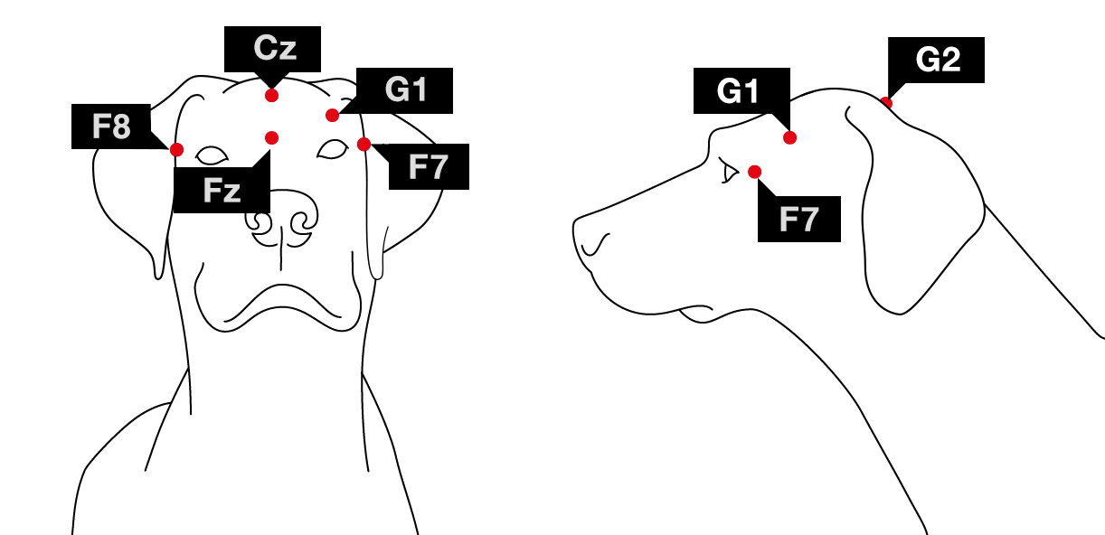
Figure S1. Electrode placement (Fz-Cz: frontal and central midline; F8 and F7: right and left electrodes placed on the zygomatic arch; G2: reference electrode; G1: ground electrode).

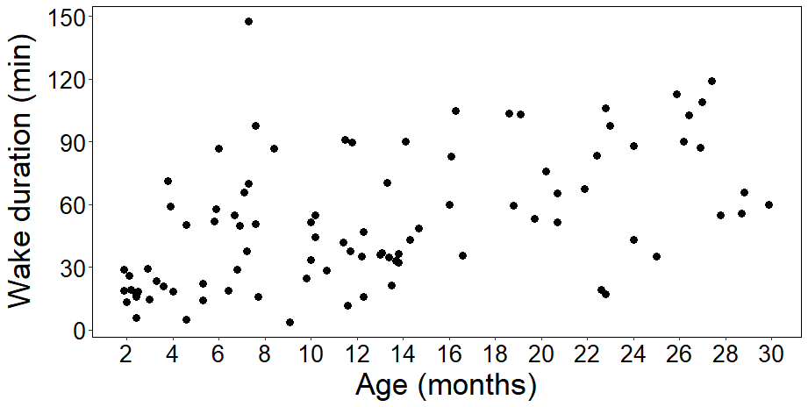
Figure S2: Time spent awake during the entire sleep recording across ages (Extended sample).
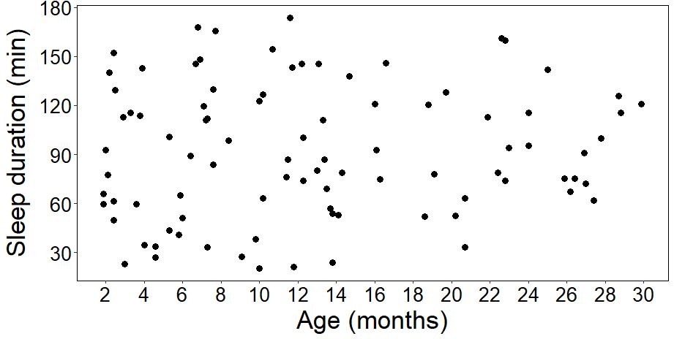
Figure S3: Time spent asleep during the entire sleep recording across ages (Extended sample).

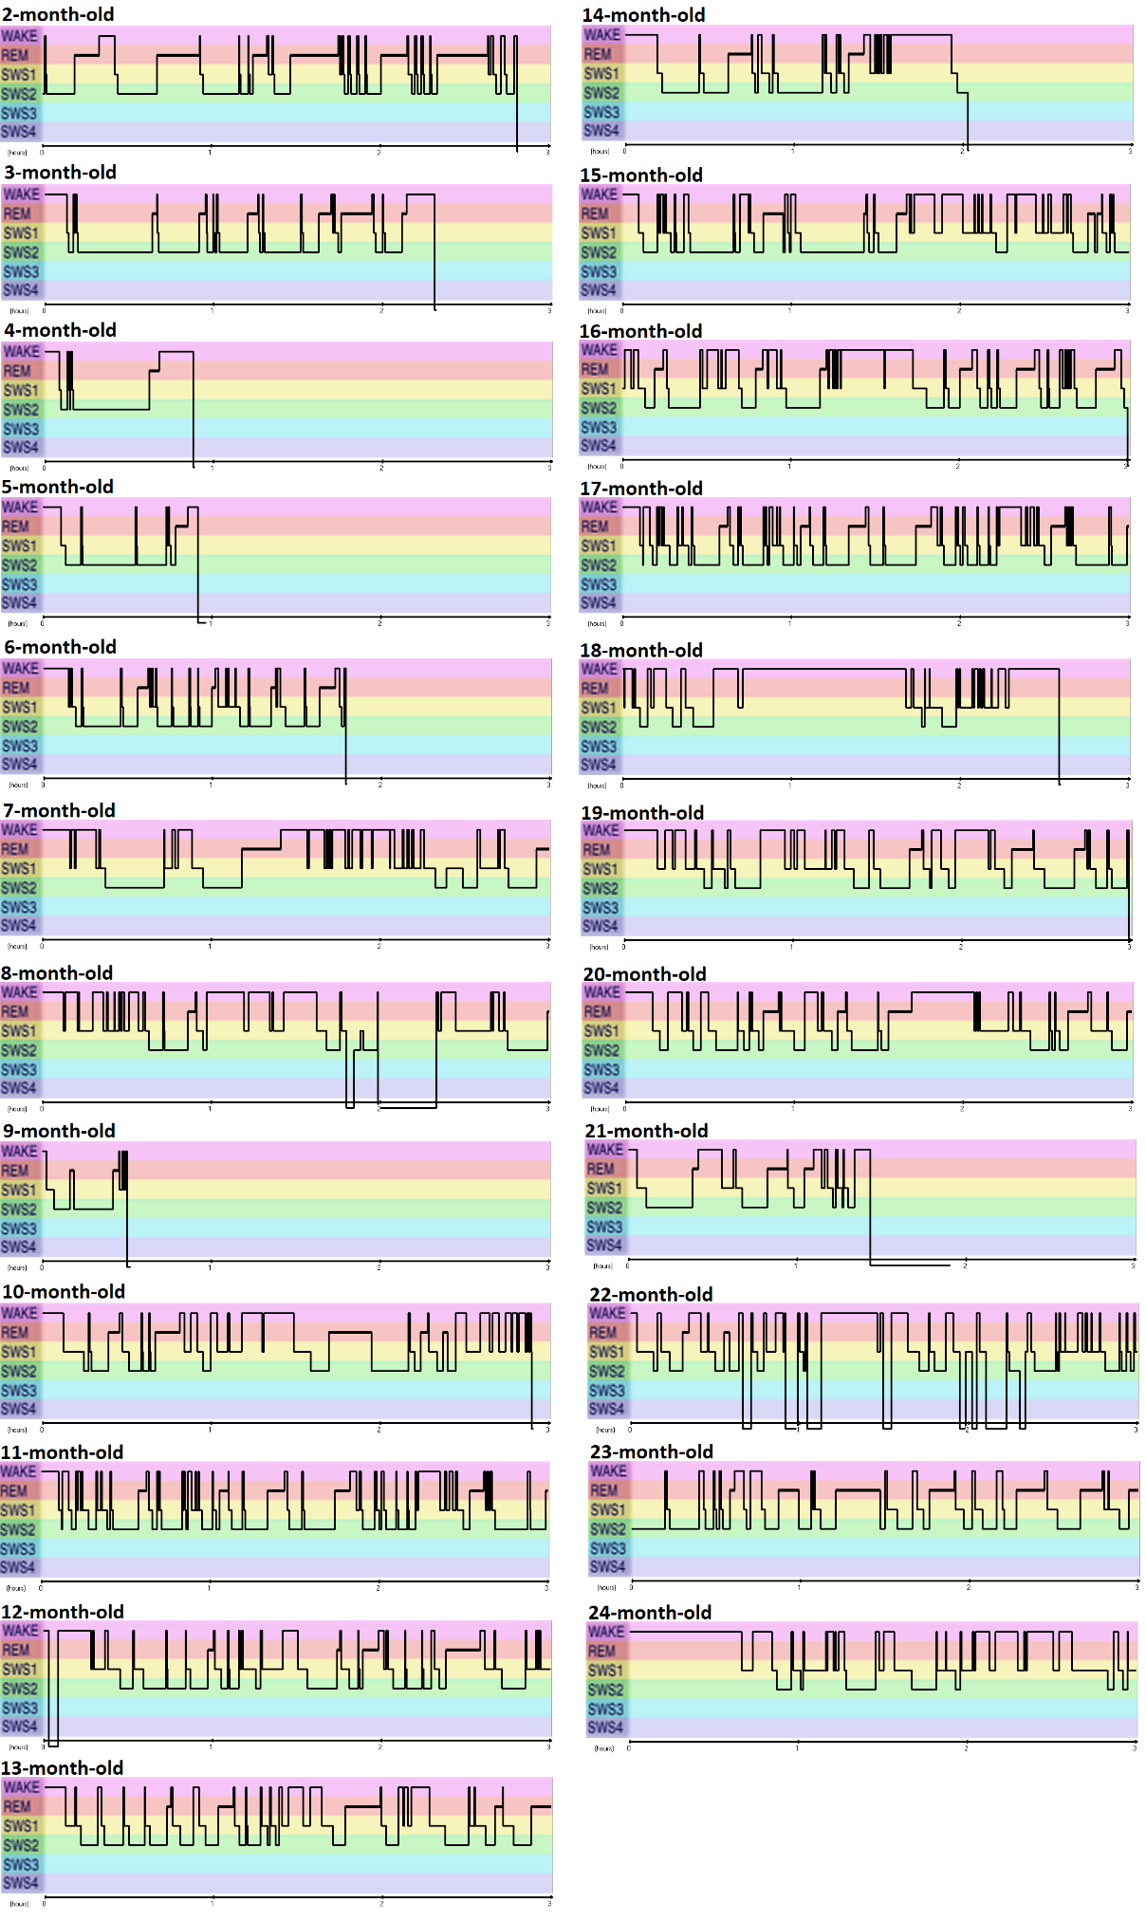
Figure S4: Example hypnograms of dogs from different ages. SWS1 indicates drowsiness, SWS2 indicates NREM sleep. SWS3 and 4 are not present in dogs.

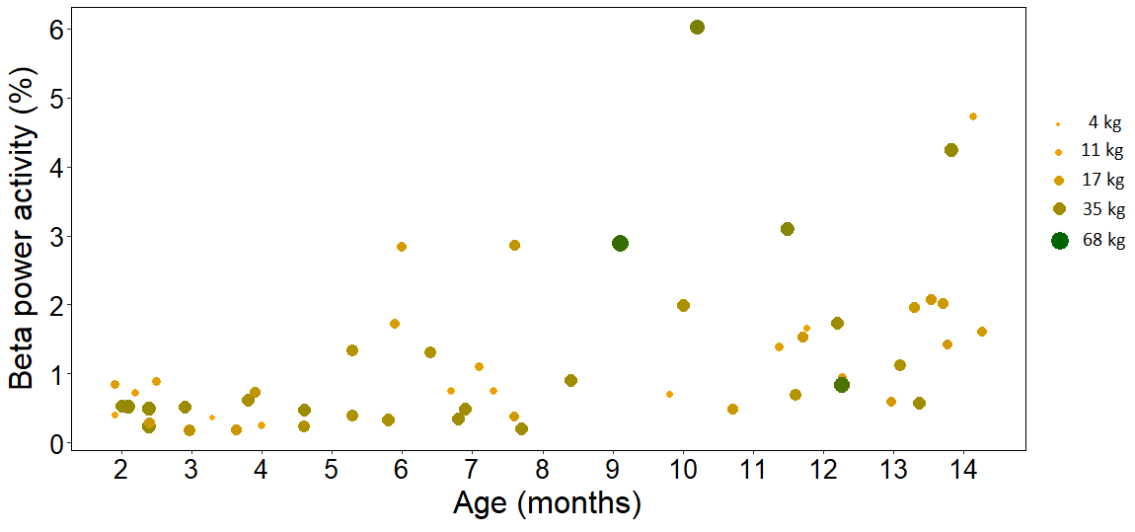
Figure S5: The association between age and beta power activity given weight. Darker and larger dots indicate larger dogs.

Spectral analysis excluding mix breed dogs (n=48):
Further, we examined the interaction effect of age and weight on delta, alpha and beta power activity without mix breed dogs (n=9) to control for possible effects of their body condition. With this subsample, age, weight and the interaction of age and weight had no effect on delta and alpha power activity (all ps>0.05). Regarding beta power activity, age was positively associated with beta power activity (F=29.725, p<.001) and weight and no effect (F=0.206, p=.653).

