Table S1. Response for water dispersible granules developed with combination of different substrates, bulking agent, dispersing agent and wetting agent.
Combination | Substrate | Bulking agent | Dispersing agent | Wetting agent | Response
I | Silica | China clay | Napthalene sulphonate | Sodium lauryl sulphate | Very low dispersion rate
II | Maize flour | China clay | Napthalene sulphonate | Sodium lauryl sulphate | No dispersion
III | Wheat flour | China clay | Napthalene sulphonate | Sodium lauryl sulphate | No dispersion
IV | Wheat bran | China clay | Napthalene sulphonate | Sodium lauryl sulphate | No dispersion
V | Silica | Vermiculite | Napthalene sulphonate | Sodium lauryl sulphate | No dispersion
VI | Talcum powder | Talcum powder | Alginic acid | Acacia gum | Dispersion
VII | Talcum powder | Talcum powder | Micro-crystalline cellulose | Acacia gum | Very low dispersion rate

Table S2. Inhibition of biocontrol agents with chemicals used in preliminary development of water dispersible granules (± standard deviation, n= 3)
Reagent | Percentage inhibition on bacterial colonies (in %) | Percentage inhibition on radial mycelial growth of Trichoderma harzianum (in %)
Napthalene sulphonate (1%) | No inhibition | No inhibition
Napthalene sulphonate (2%) | 25.7 ± 2 | 29.4 ± 1.9
Sodium lauryl sulphate (1%) | No inhibition | No inhibition
Sodium lauryl sulphate (2%) | No inhibition | No inhibition
Sodium lauryl sulphate (3%) | No inhibition | No inhibition
Sodium lauryl sulphate (4%) | No inhibition | No inhibition
Sodium lauryl sulphate (5%) | No inhibition | No inhibition
Sodium lauryl sulphate (6%) | 38.4 ± 2.6 | 34.2 ± 2.3
Sodium lauryl sulphate (7%) | 42.3 ± 3.7 | 39.1 ± 5.4

Table S3. ANOVA analysis for (a) response 1 [wetting time (s)], (b) [dispersing time (s)] and (c) response 3 [Suspensibility (%)]
(a)
Source | Sum of squares | df | Mean square | F-value | P-value | Remark
Model | 22.54 | 5 | 4.51 | 40.50 | < 0.0001 | Significant
A-Acacia gum | 0.0011 | 1 | 0.0011 | 0.0100 | 0.9231
B-Alginic acid | 9.28 | 1 | 9.28 | 83.39 | < 0.0001
AB | 0.9801 | 1 | 0.9801 | 8.81 | 0.0209
A² | 11.95 | 1 | 11.95 | 107.38 | < 0.0001
B² | 1.04 | 1 | 1.04 | 9.30 | 0.0186
Residual | 0.7791 | 7 | 0.1113
Lack of Fit | 0.6416 | 3 | 0.2139 | 6.22 | 0.0549 | Not significant
Pure error | 0.1375 | 4 | 0.0344
Cor total | 23.32 | 12

(b)
Source | Sum of squares | df | Mean square | F-value | P-value | Remark
Model | 112.54 | 5 | 22.51 | 20.95 | 0.0004 | Significant
A-Acacia gum | 47.28 | 1 | 47.28 | 44.00 | 0.0003
B-Alginic acid | 12.39 | 1 | 12.39 | 11.53 | 0.0115
AB | 0.7482 | 1 | 0.7482 | 0.6963 | 0.4316
A² | 46.48 | 1 | 46.48 | 43.26 | 0.0003
B² | 10.52 | 1 | 10.52 | 9.79 | 0.0166
Residual | 7.52 | 7 | 1.07
Lack of Fit | 5.95 | 3 | 1.98 | 5.04 | 0.0761 | Not significant
Pure error | 1.57 | 4 | 0.3935
Cor total | 120.06 | 12

(c)
Source | Sum of squares | df | Mean square | F-value | P-value | Remark
Model | 116.67 | 5 | 23.33 | 14.62 | 0.0014 | Significant
A-Acacia gum | 0.9013 | 1 | 0.9013 | 0.5646 | 0.4769
B-Alginic acid | 2.31 | 1 | 2.31 | 1.45 | 0.2679
AB | 40.90 | 1 | 40.90 | 25.62 | 0.0015
A² | 66.73 | 1 | 66.73 | 41.80 | 0.0003
B² | 11.98 | 1 | 11.98 | 7.50 | 0.0290
Residual | 11.17 | 7 | 1.60
Lack of Fit | 4.72 | 3 | 1.57 | 0.9746 | 0.4878 | Not significant
Pure error | 6.46 | 4 | 1.61
Cor total | 127.85 | 12

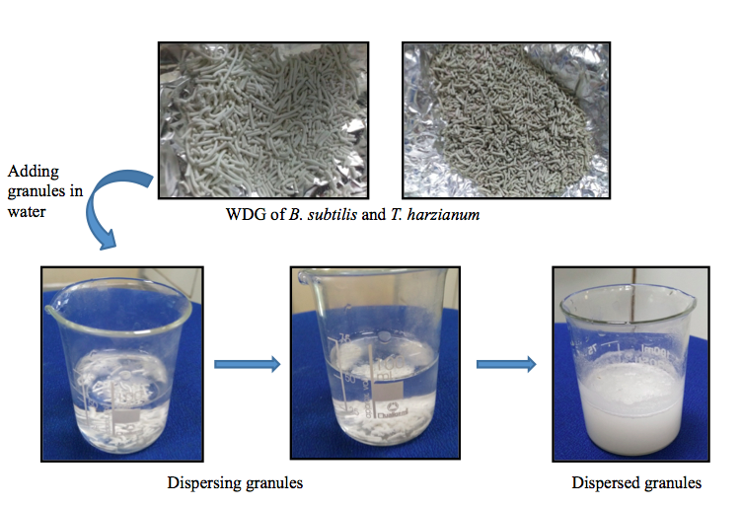
Fig. S1 Dispersion of water dispersible granules (WDG) developed with optimized concentration of wetting agent and dispersing agent

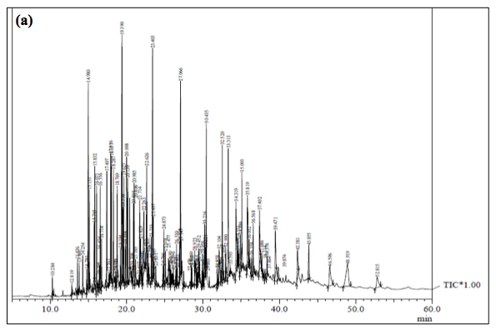
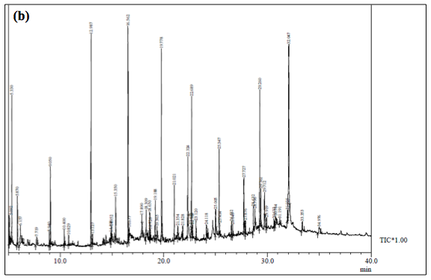

Fig. S2 Chromatogram of volatile organic compounds produced by (a) Bacillus subtilis and (b) Trichoderma harzianum extracted with ethyl acetate and identified by GC-MS with their retention time.

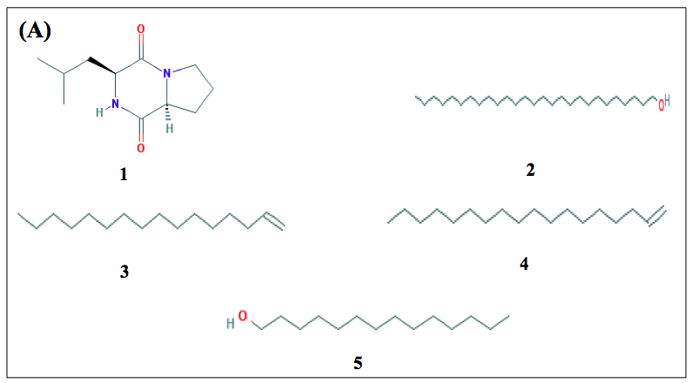
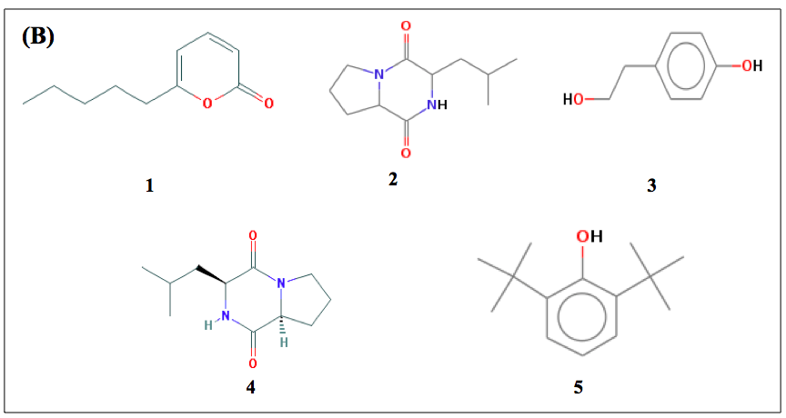
Fig. S3 Structures of major compounds in culture filtrate of (A) Bacillus subtilis and (B) Trichoderma harzianum identified by GC-MS in ethyl acetate extract. For name of the compound refer to Table 4.

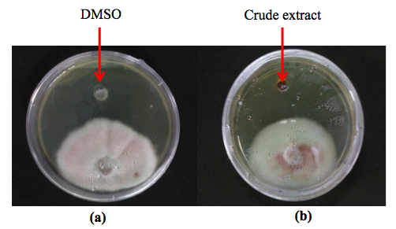
Fig. S4 Antifungal activity of ethyl acetate extract (dissolved in DMSO) of Bacillus subtilis against Fusarium oxysporum in agar well diffusion assay with (a) control (blank DMSO), and (b) crude extract of ethyl acetate.

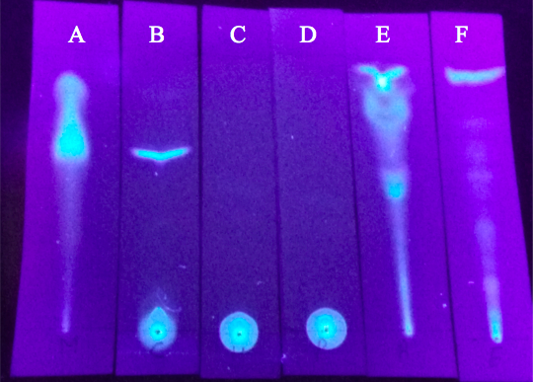
Fig. S5 Thin layer chromatography for standardization of solvent system for ethyl acetate crude extract of Bacillus subtilis where A = methanol, B = chloroform, C = hexane, D = petroleum ether, E = acetone, and F = ethyl acetate.

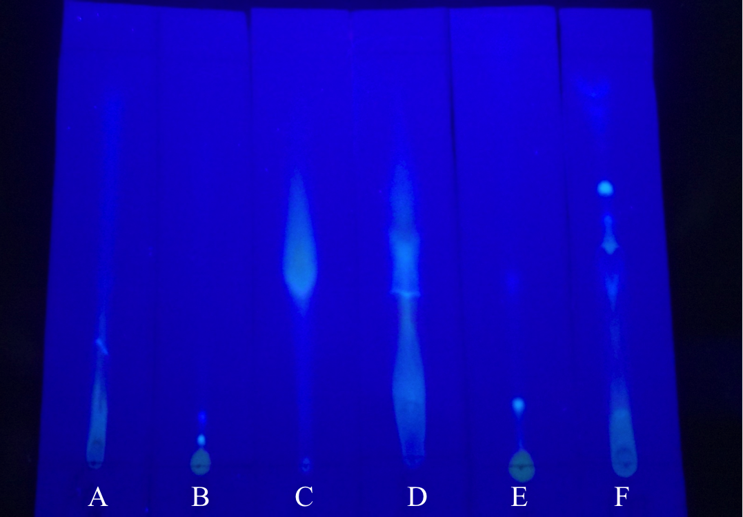
Fig. S6 Thin layer chromatography for standardization of solvent system for ethyl acetate crude extract of Trichoderma harzianum where A = ethyl acetate, B = petroleum ether, C = methanol, D = acetone, E= hexane, and F = chloroform.

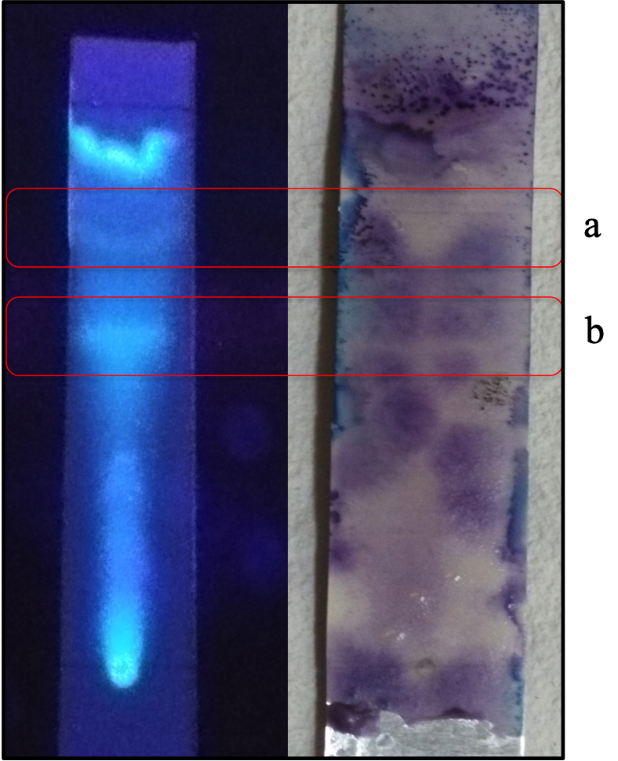
Fig. S7 Direct bioautography for Bacillus subtilis with ethyl acetate as the mobile phase for developing TLC. ‘a’ and ‘b’ depict white inhibition zone with retention factor of 0.475 and 0.625, respectively.

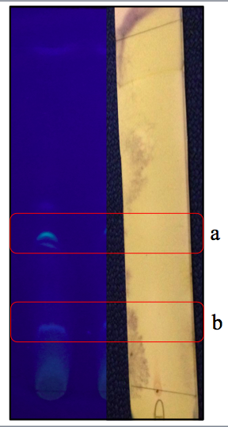
Fig. S8 Direct bioautography for Trichoderma harzianum with mixture of chloroform and petroleum ether (8:2) as the mobile phase for developing TLC. ‘a’ and ‘b’ denote white inhibition zone with retention factor of 0.175 and is 0.4125, respectively.

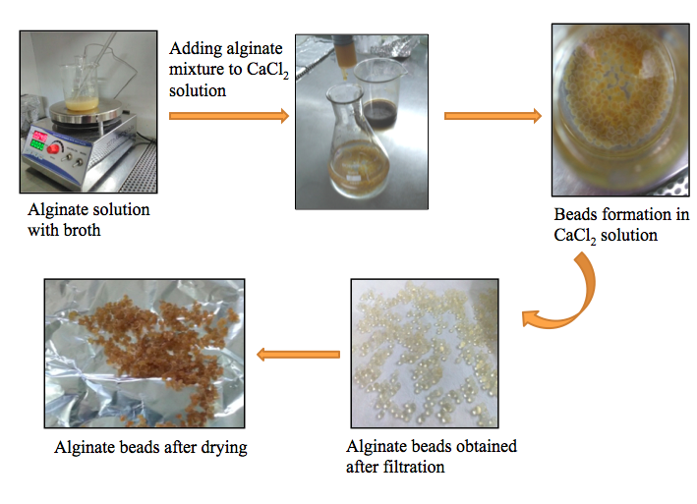
Fig. S9 Schematic diagram showing the steps for development of alginate beads

Table S4. Experimental design employed in the response surface methodology (RSM) using a central composite design matrix for increasing efficiency of water dispersible granules

Run | Variable A  Wetting agent (g) | Variable B  Dispersing agent (g)
1 | 0.76 | 10
2 | 5 | 10
3 | 2 | 16
4 | 8 | 16
5 | 5 | 10
6 | 2 | 4
7 | 9.24 | 10
8 | 5 | 18.49
9 | 5 | 10
10 | 8 | 4
11 | 5 | 10
12 | 5 | 1.51
13 | 5 | 10

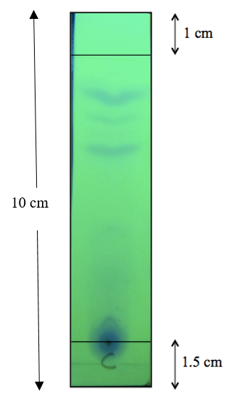
Fig. S10 Illustration of a developed thin layer chromatography

