Supplementary Information for

The first true millipede—1,306 legs long

Paul E. Marek*, Bruno Buzatto, William A. Shear, Jackson C. Means, Dennis G. Black, Mark S. Harvey, Juanita Rodriguez

*Corresponding author: Paul E. Marek
Email: paulemarek@gmail.com

Supplementary Text
Phylogenetic results. The ultrafast bootstrap consensus tree largely resembled the topology obtained by ref. 1, with Pentazonia branching-off early and sister to Helminthomorpha. Within Helminthomorpha, Colobognatha is sister to Eugnatha. Within Eugnatha, Juliformia is sister to Stemmiulida+Polydesmida. Within Colobognatha, Siphonophorida is sister to Polyzoniida+Platydesmida. Eumillipes persephone is confidently placed within Polyzoniida and closely related to Rhinotus (Figure 2). The evolution of super-elongation (>180 segments) was reconstructed on the phylogeny with parsimony character optimization criterion in Mesquite [2].

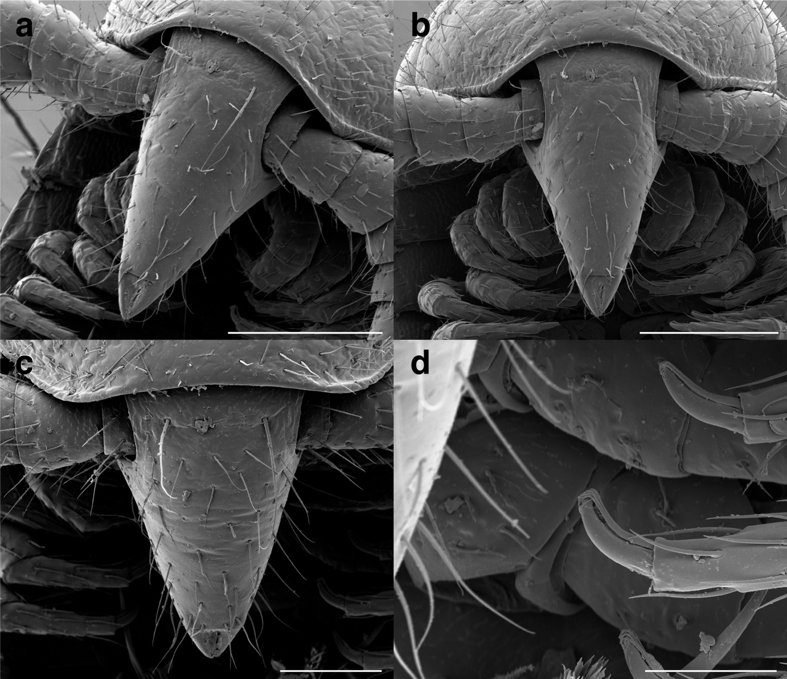
Supplementary figure S1. Eumillipes persephone male holotype (T147101). A. Head, oblique view, showing eyeless cone-shaped head. (Scale bar = 200 μm). B. Head, dorsal view. (Scale bar = 200 μm). C. Head, dorsal view, showing two macrosetae. (Scale bar = 100 μm). D. Seventh leg with tarsal claw with long sigmoid-shaped accessory claw at its base that exceeds the claw in length. (Scale bar = 50 μm).

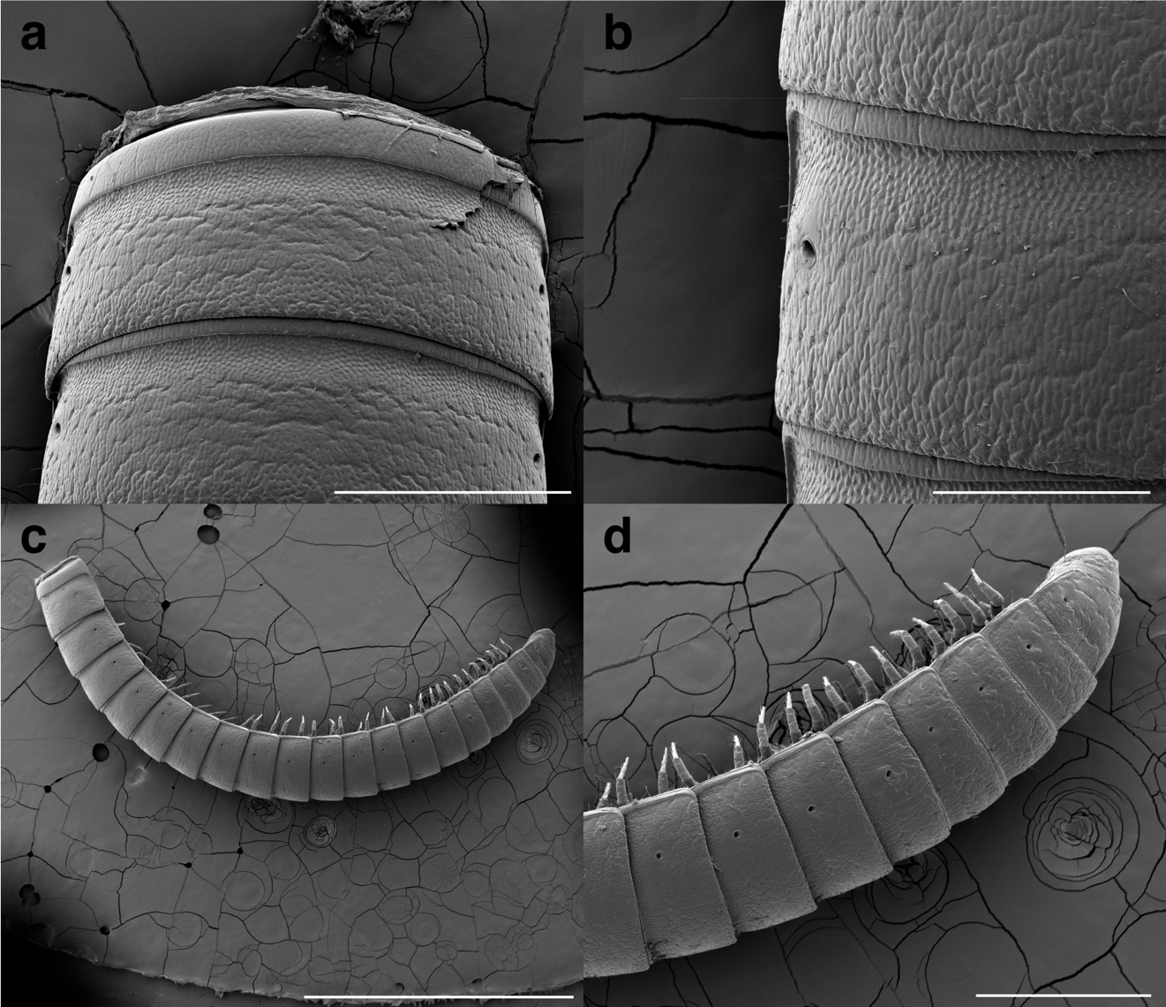
Supplementary figure S2. Eumillipes persephone male holotype (T147101). A. Mid-length trunk segments, dorsal view, with prozonites and metazonites of trunk rings the same width. (Scale bar = 400 μm). B. Mid-length trunk segment, dorsal view of ozopore. (Scale bar = 200 μm). C. Posterior-most 19 segments + telson, lateral view (Scale bar = 2 mm). D. Posterior-most 9 segments + telson, lateral view. (Scale bar = 500 μm).

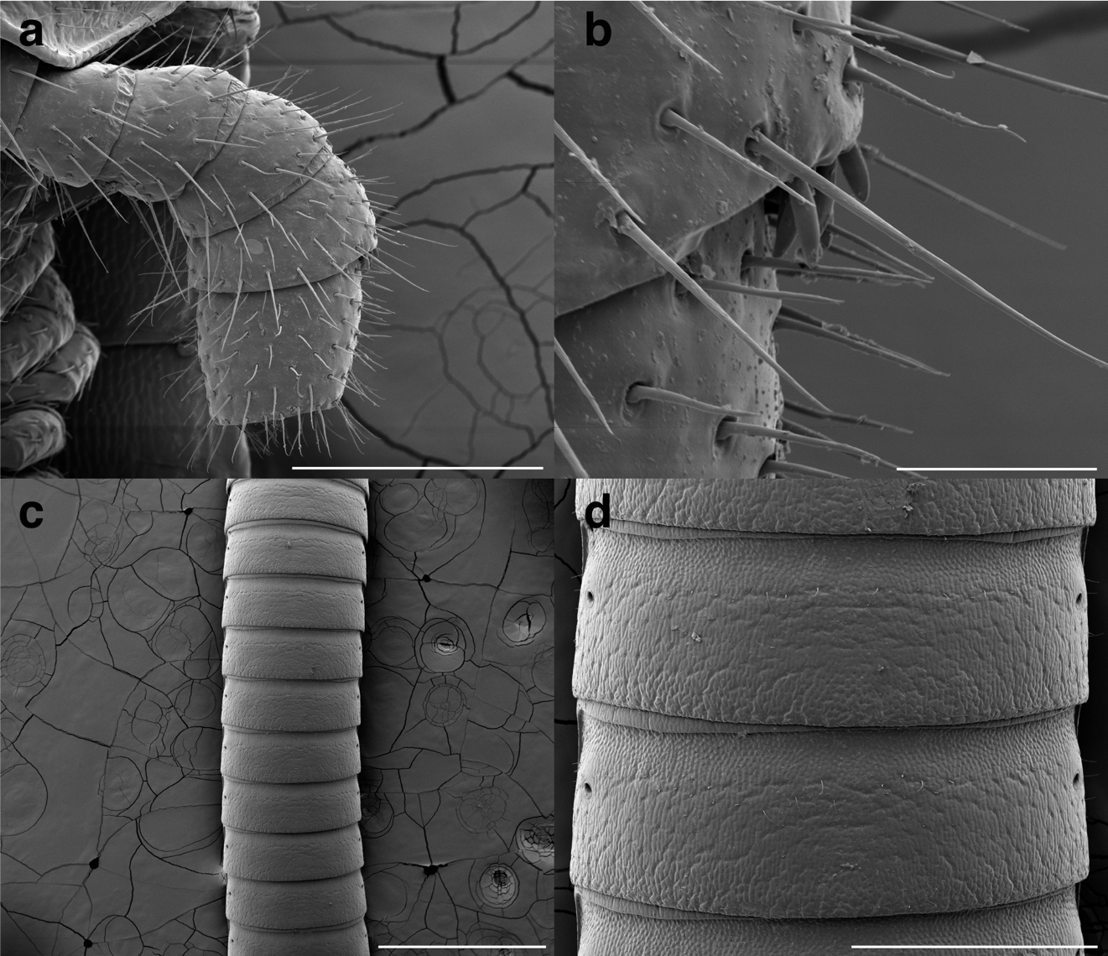
Supplementary figure S3. Eumillipes persephone. A. Female paratype (T146684), left antenna. (Scale bar = 200 μm). B. Female paratype (T146684), left antenna showing small basiconic sensilla on antennomere 6. (Scale bar = 30 μm). C. Male holotype (T147101), mid-length trunk segments, dorsal view. (Scale bar = 1 mm). D. Male holotype (T147101), mid-length trunk segments, dorsal view. (Scale bar = 400 μm).

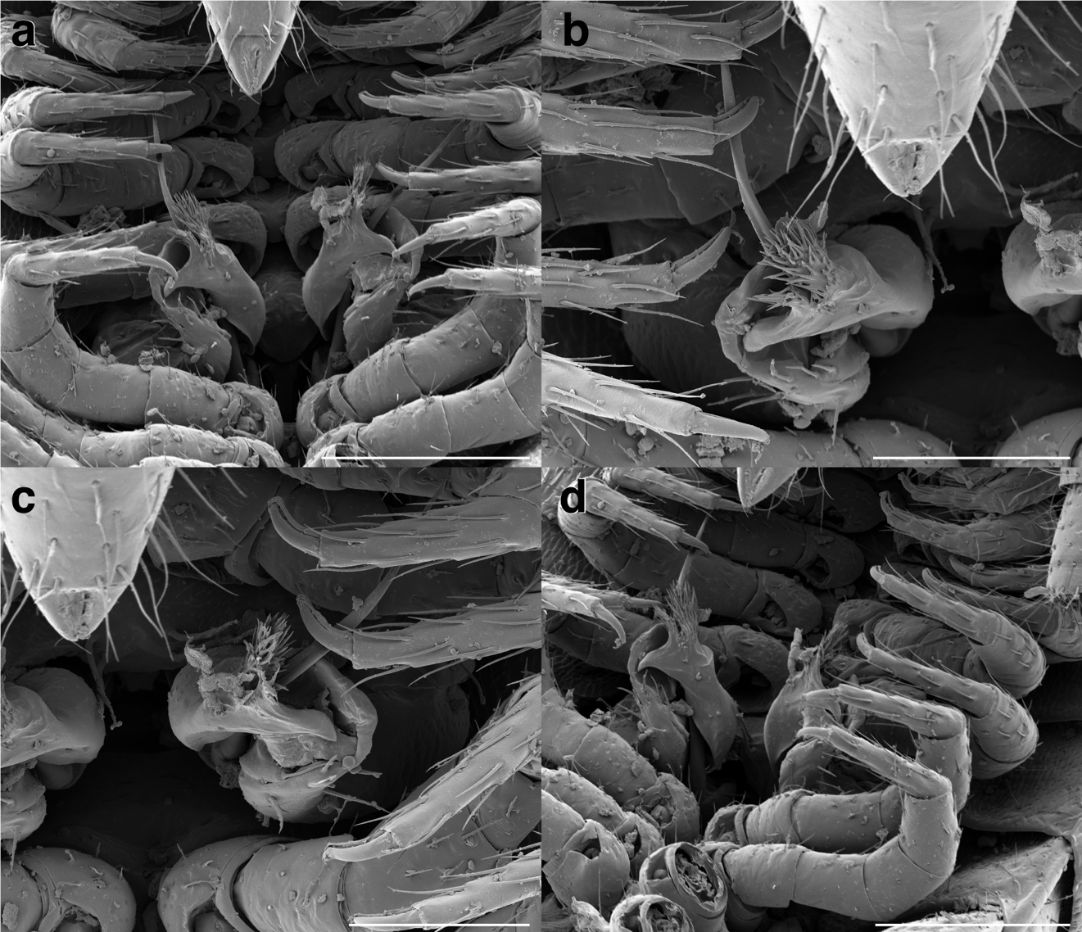
Supplementary figure S4. Eumillipes persephone male holotype (T147101). A. Ventral view of gonopods. (Scale bar = 200 μm). B. Ventral view of right gonopods. (Scale bar = 100 μm). C. Ventral view of left gonopods. (Scale bar = 100 μm). D. Oblique-ventral view of gonopods showing anterior gonopods distinctly bifurcated into two processes. (Scale bar = 200 μm).

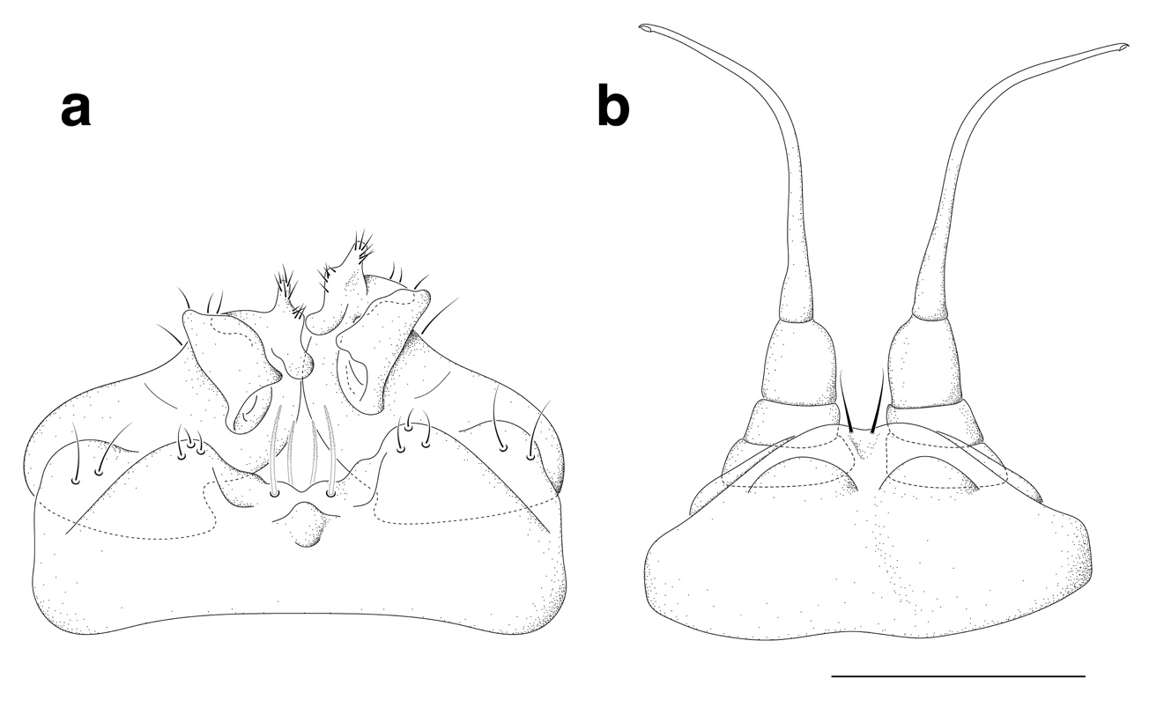
Supplementary figure S5. Eumillipes persephone male paratype (T147100). Anterior view of anterior and posterior gonopods. A. Anterior gonopods (9th leg pair). B. Posterior gonopods (10th leg pair). (Scale bar = 200 μm).

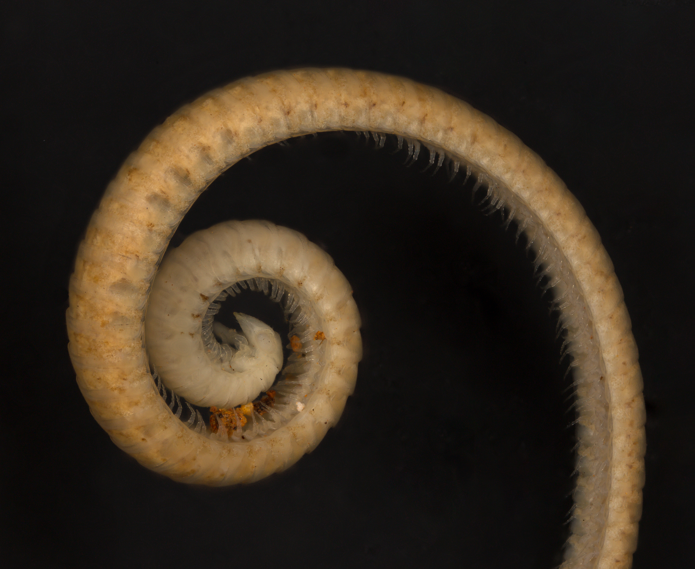
Supplementary figure S6. Anteriormost 64 segments of a female paratype of Eumillipes persephone with 330 rings and 1,306 legs (T147124).

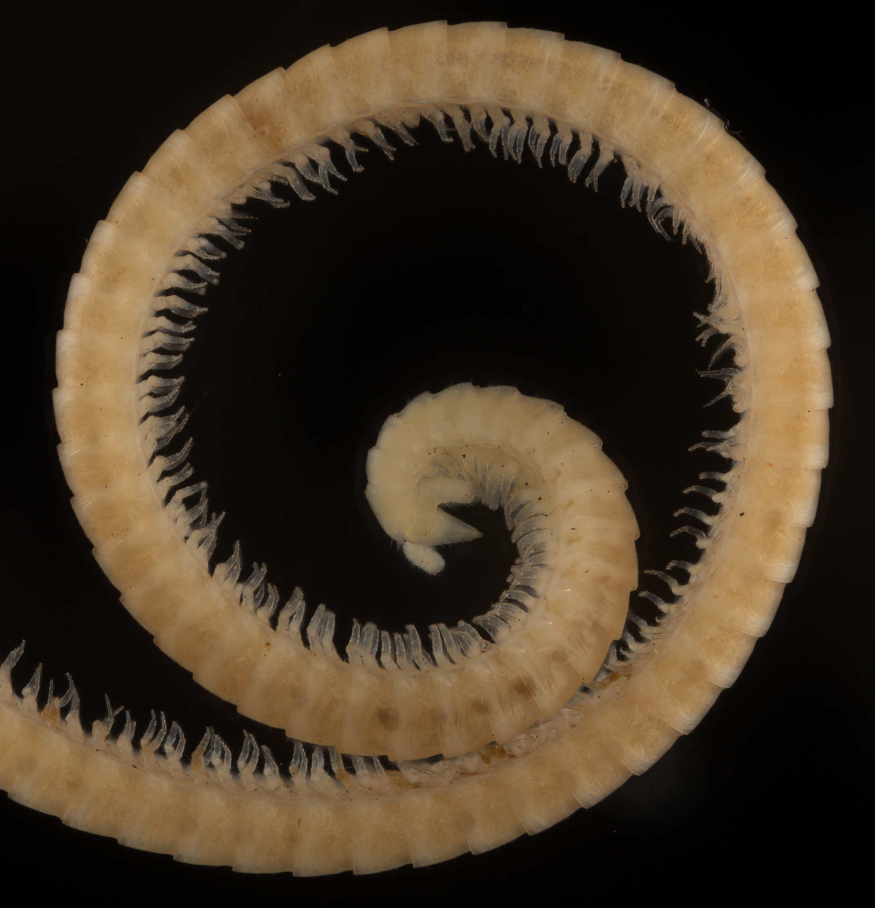
Supplementary figure S7. Anteriormost 66 segments of the male holotype of Eumillipes persephone with 198 rings and 778 legs (T147101).

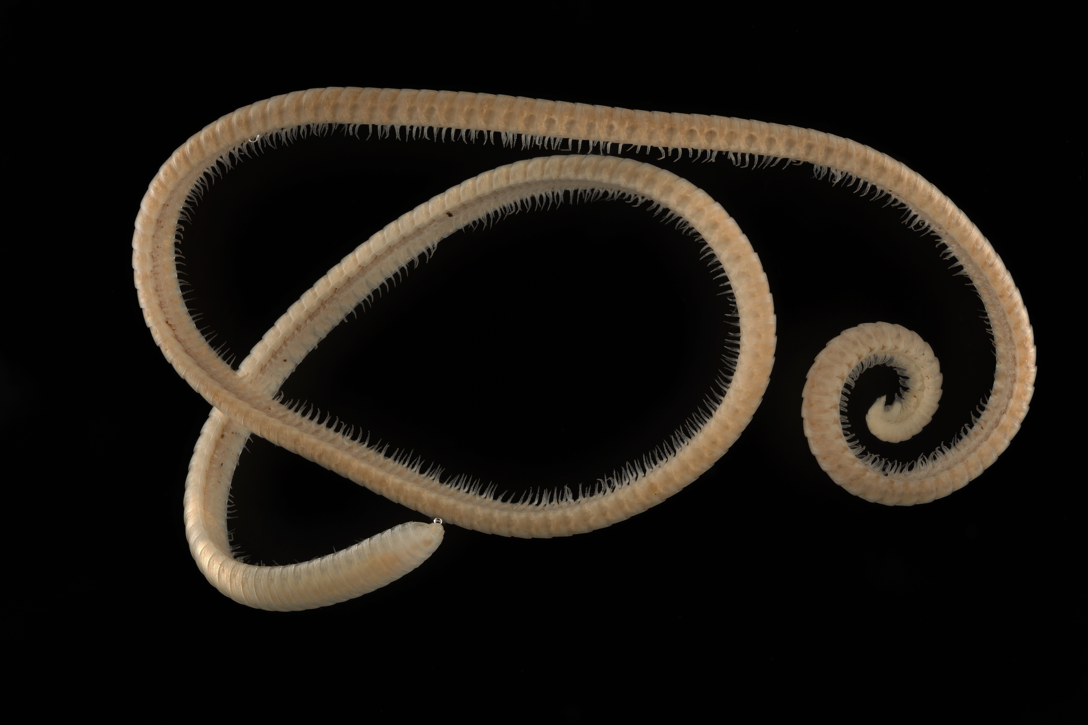
Supplementary figure S8. Eumillipes persephone male paratype specimen with 208 rings and 818 legs (T147100).

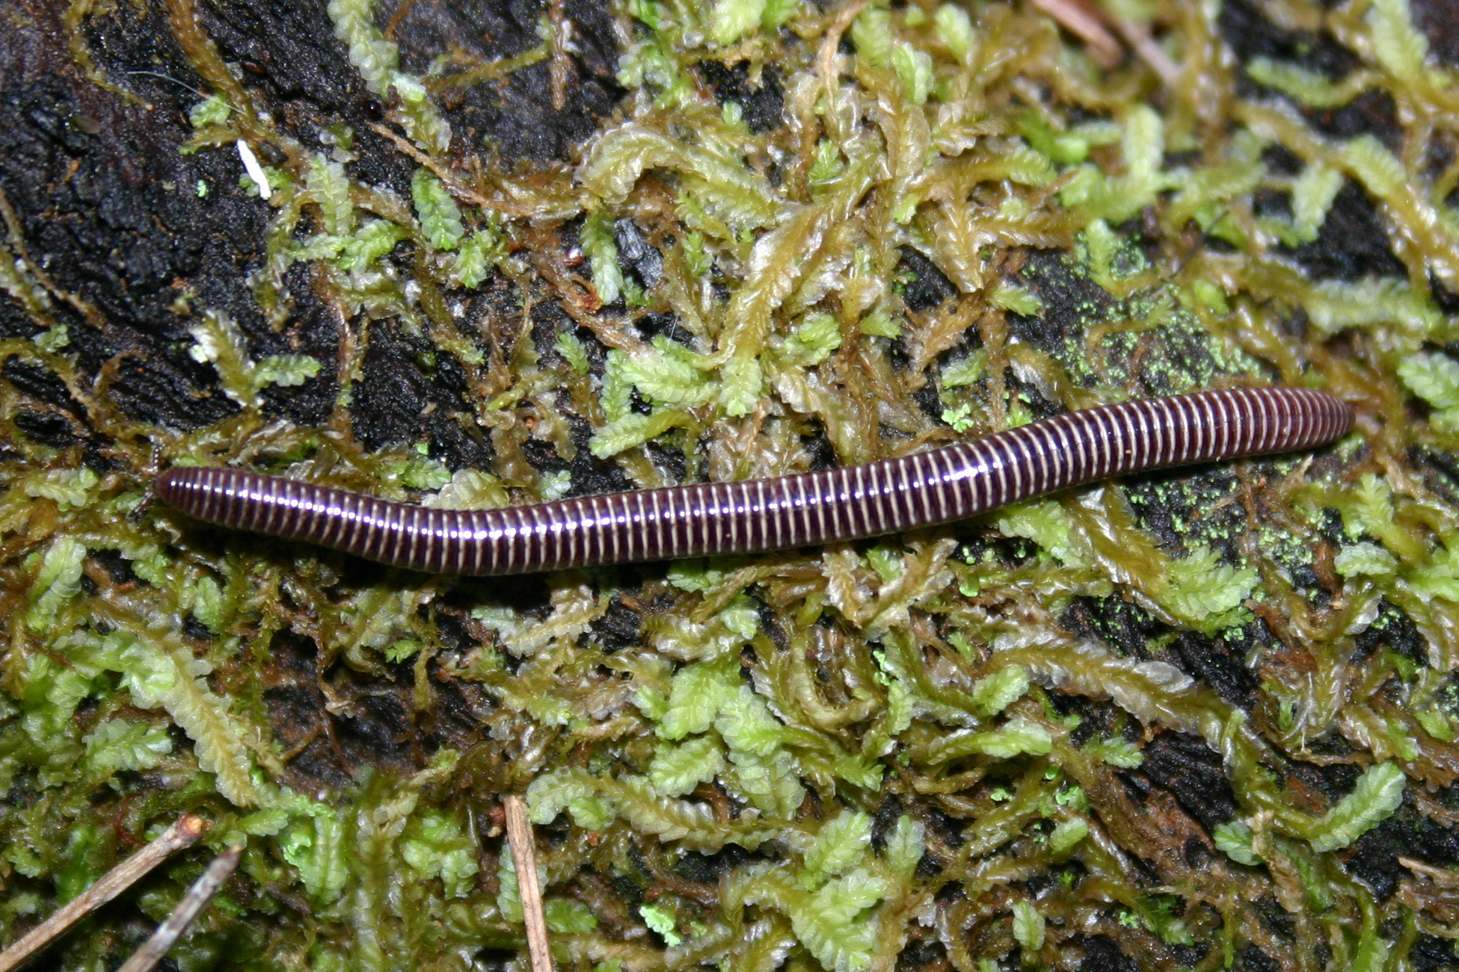
Supplementary figure S9. An undescribed genus and species of surface-dwelling polyzoniidan millipede from Walpole, Australia with 90 segments (family Siphonotidae).

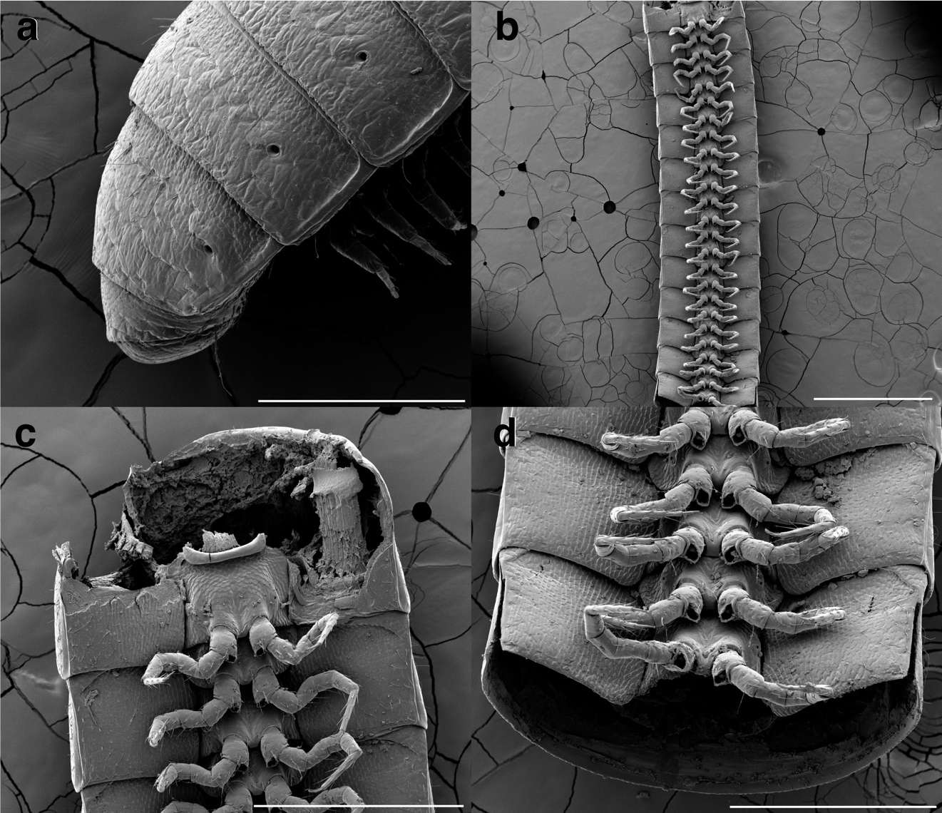
Supplementary figure S10. Eumillipes persephone male holotype (T147101). A. Posterior-most 4 segments + telson, lateral view, showing telson a complete ring around the anal valves. (Scale bar = 300 μm). B. Mid-length trunk segments, ventral view. (Scale bar = 1 mm). C. Mid-length trunk segments, ventral view, showing free sternites and pleurites (large longitudinal muscle visible through fractured pleurite). (Scale bar = 500 μm). D. Mid-length trunk segments, ventral view, showing free sternites and pleurites, and large coxal/eversible sacs. (Scale bar = 400 μm).

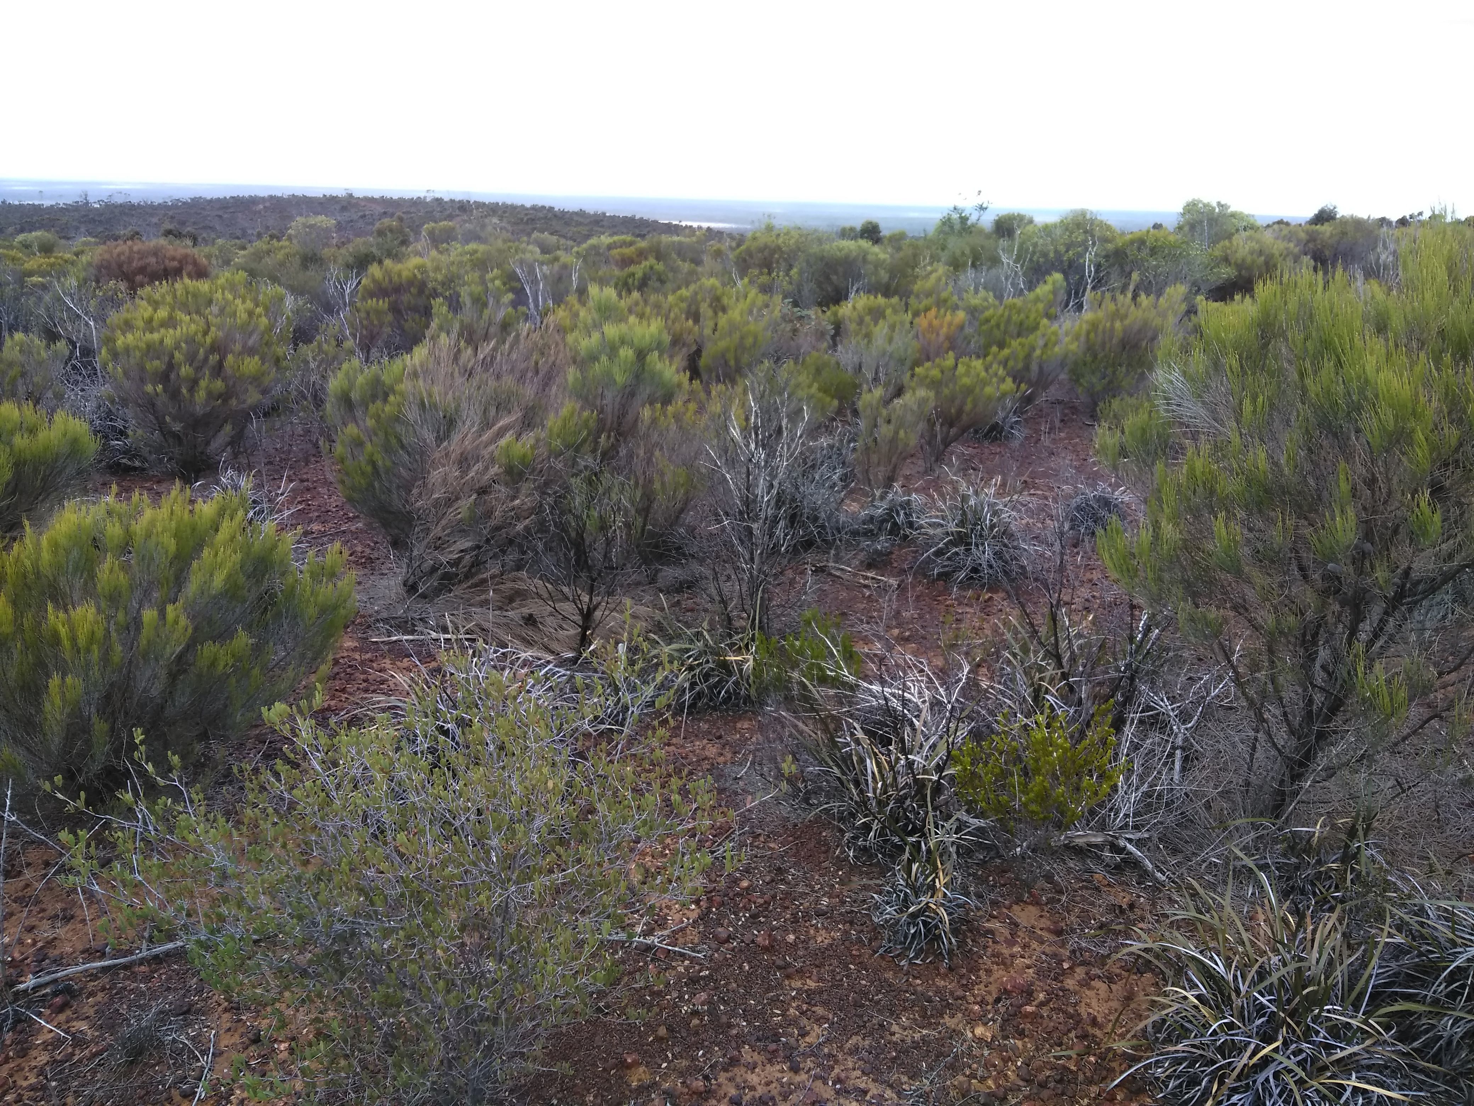
Supplementary figure S11. Sheoak shrubland on the surface of Eumillipes persephone habitat.

Table S1. Measurements of type specimens. Abbreviations: p = number of podous rings, a = number of apodous rings, l = number of legs; the following in millimeters — BL = body width, HW = head width, HL = head length (measured from the posterior margin of the antennal socket to the labral tip), AW = antenna width, CW = collum width, W1 = segment width, H1 = segment height.

Specimen | sex | p | a | l | BL | HW | HL | AW | CW | W1 | H1
T146684 | female | 252 | 1 | 998 | 72.9 | 0.21 | 0.35 | 0.13 | 0.57 | 1.00 | 0.54
T147124 | female | 329 | 1 | 1306 | 95.7 | 0.24 | 0.44 | 0.12 | 0.53 | 0.95 | 0.51
T147100 | male | 207 | 1 | 818 | 59.4 | 0.25 | 0.37 | 0.15 | 0.55 | 1.00 | 0.43
T147101 | male | 197 | 1 | 778 | 54.7 | 0.21 | 0.40 | 0.12 | 0.52 | 0.92 | 0.43

Supplementary References

- Rodriguez, J. et al. Step-wise evolution of complex chemical defenses in millipedes: a phylogenomic approach. Sci. Rep. 8, 1-10. https://doi.org/10.1038/s41598-018-19996-6 (2018).
- Maddison, W. & Maddison, D. R. Mesquite: a molecular system for evolutionary analysis. Version 3.5. http://mesquiteproject.org/ (2010).

