Table S1. Respiratory, haemodynamic and oxygenation effects of PEEP trial in the whole population.

Variables | PEEP +5 | PEEP +15
Respiratory parameters
Tidal volume (mL/kg of PBW) | 5.9 [5.7-6.1] | 5.9 [5.7-6.1]
Respiratory rate (cycles/min) | 30 [25-32] | 30 [25-32]
Total PEEP (cmH2O) | 6 [5-6] | 16 [15-16]*
Plateau pressure (cmH2O) | 16 [15-19] | 27 [25-29]*
Driving pressure (cmH2O) | 11 [8-14] | 11 [10-13]
Respiratory system compliance (mL/cmH2O) | 33 [25-50] | 33 [27-41]
Haemodynamic parameters
Heart rate (bpm) | 87 [74-103] | 86 [73-104]
Systolic arterial pressure (mmHg) | 106 [99-124] | 104 [95-123]*
Diastolic arterial pressure (mmHg) | 56 [50-58] | 55 [49-60]
Mean arterial pressure (mmHg) | 73 [62-80] | 72 [66-79]
Dosage of norepinephrine (µg/kg/min) | 0.27 [0.13-0.66] | 0.37 [0.15-0.66]*
Lactate (mmol/L) | 1.2 [0.9-2.0] | 1.2 [0.9-2.1]
Biological parameters
SpO₂ (%) | 93 [90-95] | 96 [93-98]*
SaO₂ (%) | 91 [88-95] | 96 [92-98]*
PaO₂/FiO₂ ratio | 115 [84-174] | 177 [119-215]*
PaO₂ (mmHg) | 66 [58-80] | 84 [65-123]*
PaCO₂ (mmHg) | 44 [41-50] | 47 [41-52]*
Carboxyhaemoglobin (%) | 0.9 [0.7-1.2] | 0.8 [0.7-1.2]*
Methaemoglobin (%) | 0.7 [0.6-0.8] | 0.7 [0.6-0.8]
Haemoglobin (g/dL) | 10.9 [9.0-12.0] | 11.0 [9.0-13.0]
Temperature (°C) | 37.0 [36.5-37.9] | 37.0 [36.8-37.6]
pH | 7.36 [7.31-7.39] | 7.33 [7.29-7.38]*
Bicarbonates (mmol/L) | 24.6 [22.6-27.6] | 25.2 [21.9-27.8]
n=55, variables are expressed as median [interquartile].
* p<0.05 PEEP +15 vs. PEEP +5 cmH2O.
Formulas: driving pressure=plateau pressure-total PEEP; respiratory system compliance= tidal volume/(plateau pressure-total PEEP)
Abbreviations: PaO₂: partial arterial pressure of oxygen; PaCO₂: partial arterial pressure of carbon dioxide; PBW: predicted body weight; PEEP: positive end-expiratory pressure; SaO₂: arterial oxygen saturation; SpO₂: pulse oximetry

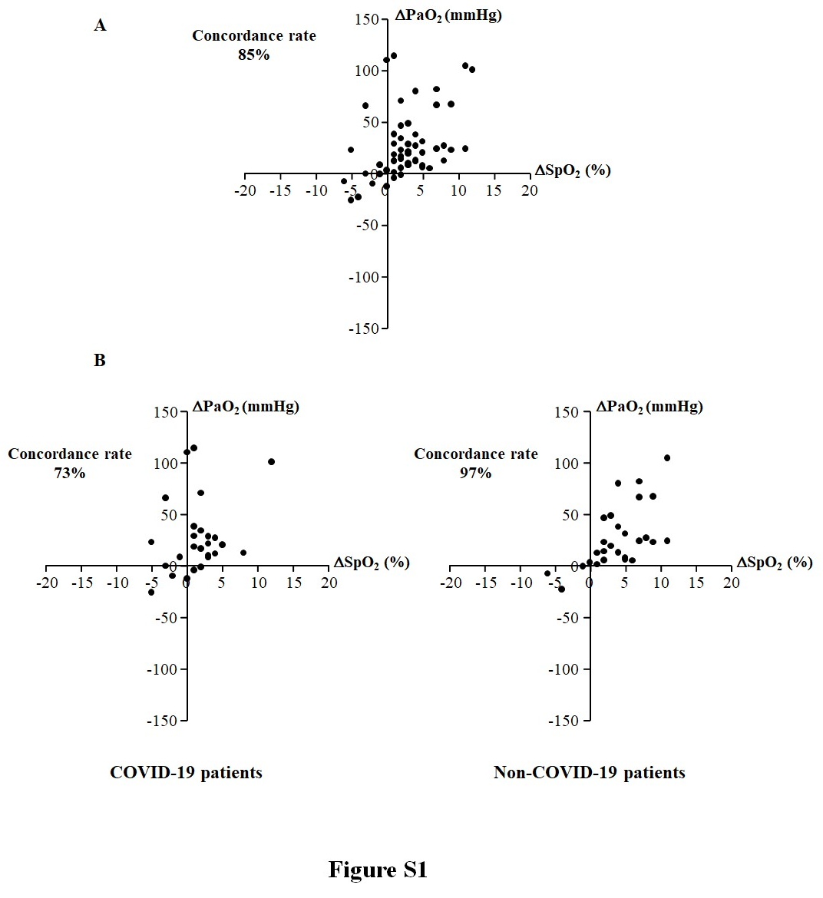

Supplemental Figure Legends
Figure S1
Trending ability of pulse oximetry (SpO₂) against arterial oxygen partial pressure (PaO₂) measurements during a positive end-expiratory pressure trial based on four-quadrant concordance analysis. Panel A: in the whole population (n=55). Panel B: in COVID-19 (n=26) and non-COVID-19 (n=29) patients.

