SUPPLEMENTARY INFORMATION

Thoracic skeletal muscle quantification using computed tomography and prognosis of elderly ICU patients

Authors:
Sung Woo Moon, Song Yee Kim, Ji Soo Choi, Ah Young Leem, Su Hwan Lee, Moo Suk Park, Young Sam Kim, Kyung Soo Chung

Figure legends
Supplementary Fig 1. Distribution of cross-sectional area of pectoralis muscles.
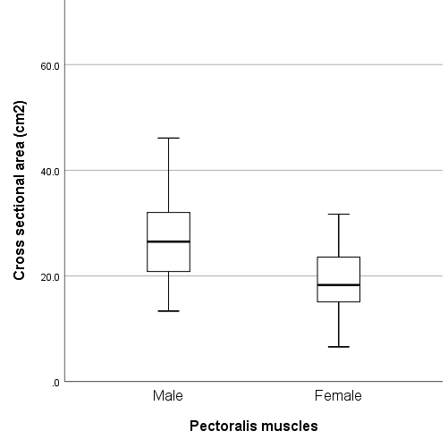
Median values for CSA of pectoralis muscles are 26.5 cm² in men, and 18.3 cm² in women, respectively.
Supplementary Fig 2. SOFA score changes during the follow up period.
Abbreviations; SOFA, sequential organ failure assessment

Supplementary Fig 3. Flow diagram of subjects in this study.
Abbreviations; ICU, intensive care unit; CT, computed tomography; PM_{CSA}, cross-sectional area of pectoralis muscle area at the T4 level; T4_{CSA}, cross-sectional area of pectoralis, intercostalis, paraspinals, serratus, and latissimus muscles at the T4 level.
