Supplementary Figure 1

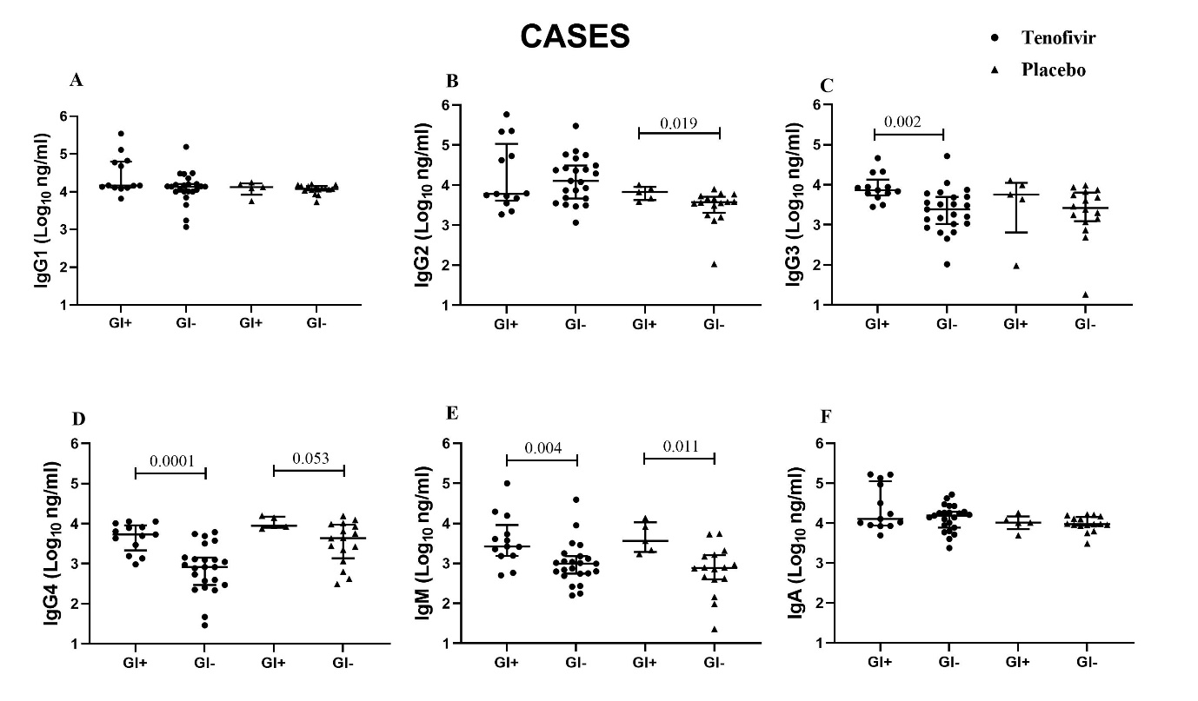
Supplementary Figure 1. Comparison of mucosal IgG subclasses and isotypes in cases stratified for presence of genital inflammation (GI+) or absence of genital inflammation (GI-) within tenofovir and placebo groups. Each data point represents an individual sample, the line-bars represents medians and interquartile ranges. Mann-Whitney U test and unpaired t-tests were used to compare between groups and p<0.05 were considered statistically significant. ● represent tenofovir use and ▲ represent placebo.

Supplementary Figure 2
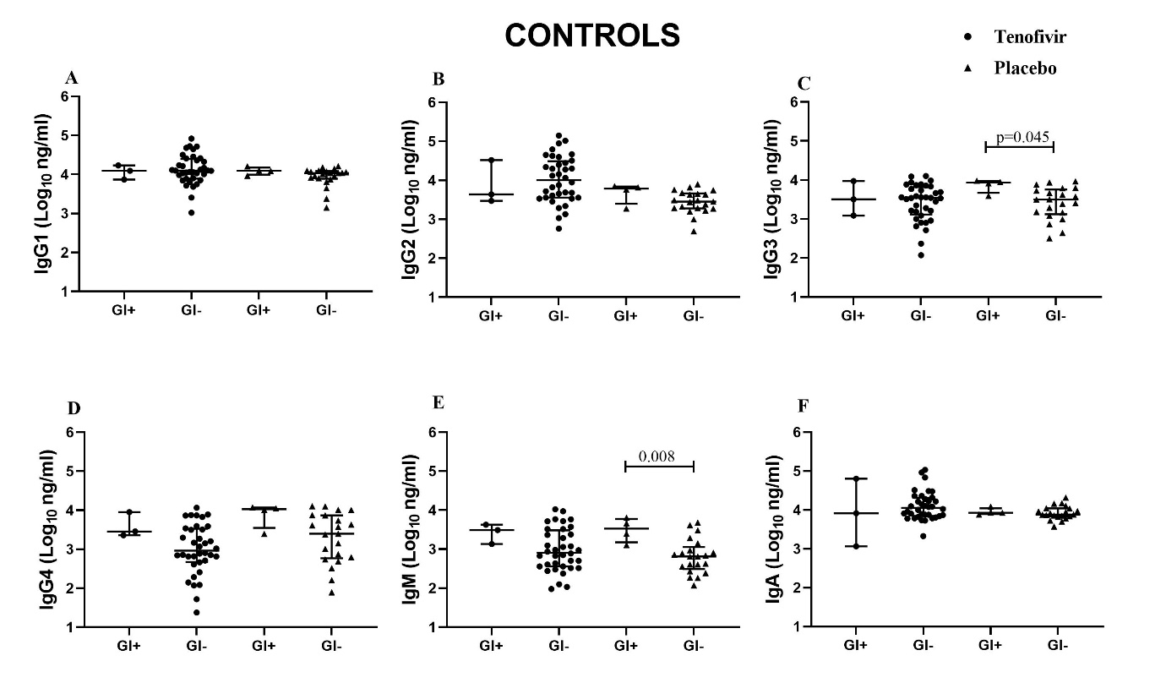
Supplementary Figure 2. Comparison of mucosal IgG subclasses and isotypes in controls stratified for presence of genital inflammation (GI+) or absence of genital inflammation (GI-) within tenofovir and placebo groups. Each data point represents an individual sample, the line-bars represents medians and interquartile ranges. Mann-Whitney U test and unpaired t-tests were used to compare between groups and p<0.05 were considered statistically significant. ● represent tenofovir use and ▲ represent placebo.

