Supporting Information for

Short - chain aurachin D derivatives are selective inhibitors of E. coli cytochrome bd-I and bd-II oxidases

Contents

1. Compound screening results 2
2. Dose response curves: K_{i}^{app} determination 3
3. Synthesis 7

Compound screening results

Inhibitory activity at 250µM
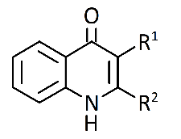
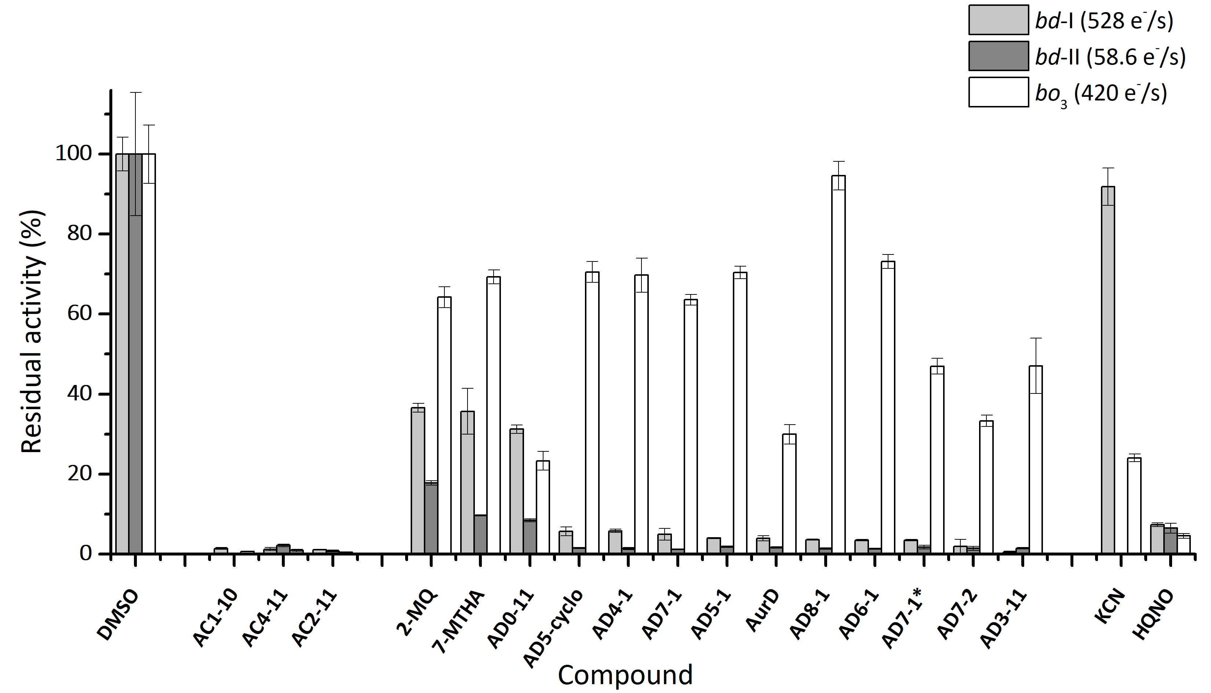
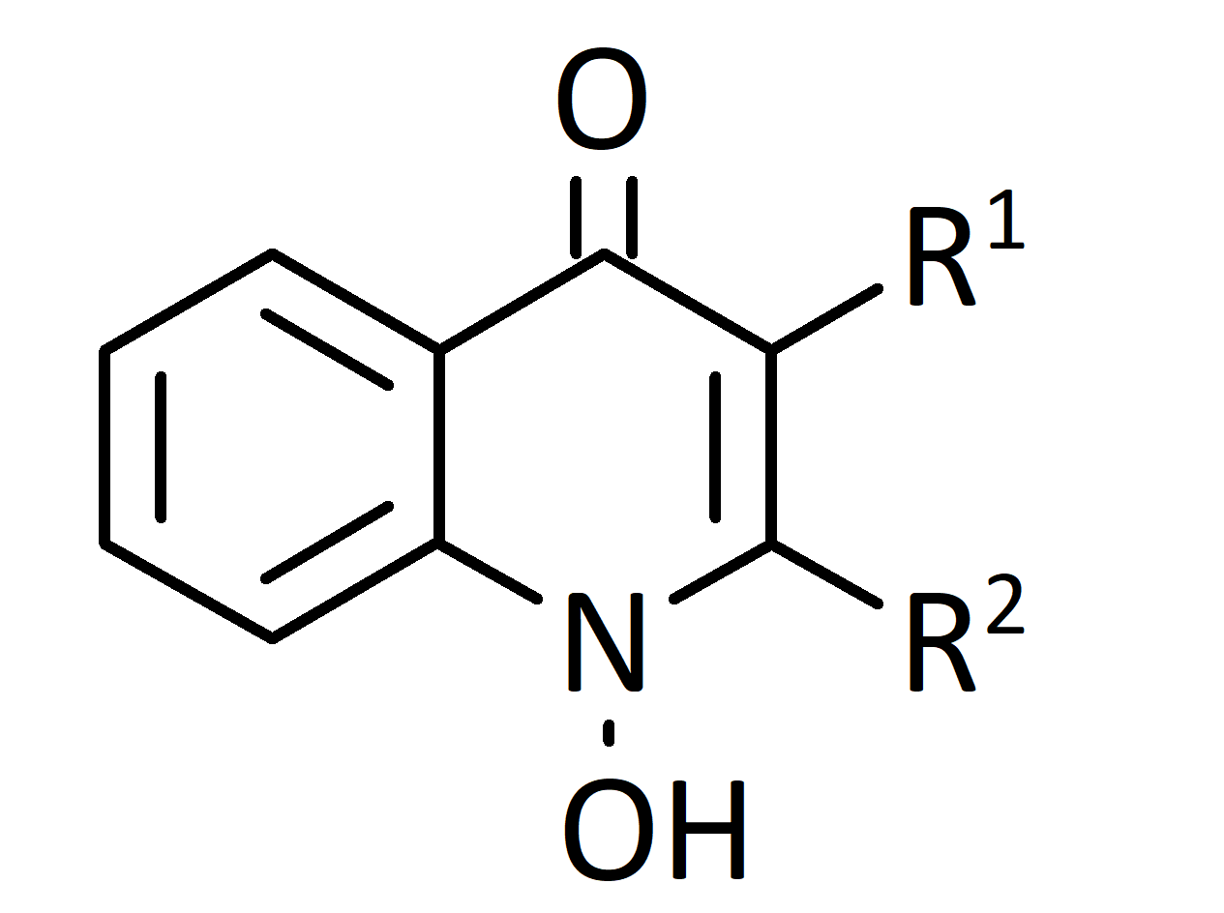
Aurachin D Type (AurD)
Aurachin C Type (AurC)
Figure S-1. Screening results for bd-I (light-grey), bd-II (dark-grey) and bo₃ (white) with decreasing residual activity for bd-I from left to right. Inhibition assay using test compounds at 250µM in presence of 200µM ubiquinone-1 and 5mM dithiothreitol. Oxygen reduction activity was calculated from oxygen consumption rates at 30nM (bd-I, bo₃) or 120nM (bd-II) oxidase at RT for each experiment. 100% activity = adding corresponding volume of DMSO. KCN at 20µM (bd-I, bo₃), was used as a bo₃ selective inhibitor. HQNO at 250µM represents an active, non-selective inhibitor for all three oxidases. Presented data are mean ± S.E.M. (n=3) For detailed data, please refer to Supplement Information Table SI-1.
Table S-1. Bioactivity of AurC-type and AurD-type compounds at 250µM. Residual quinol oxygen reduction activity for E. coli cytochrome bd-I, bd-II and bo₃ oxidase. Inhibition assay using test compounds at 250µM in presence of 200µM ubiquinone-1 and 5mM dithiothreitol. Oxygen reduction activity was calculated from oxygen consumption rates at 30nM (bd-I, bo₃) or 120nM (bd-II) at RT for each experiment. 100% activity = adding corresponding volume of DMSO. KCN at 20µM (bd-I, bo₃) was used as a cytochrome bo₃ selective inhibitor (*10mM for bd-II). HQNO at 250µM represents an active, non-selective inhibitor for all three oxidoreductases. Presented data are mean ± S.E.M. (n=3)
Compound | Rest activity in % of control activity
Compound | bd-I | bd-II | bo₃
DMSO | 100 ± 4.2 | 100 ± 15.4 | 100 ± 7.3
AC1-10 | 1.39 ± 0.19 | n.a. | 0.626 ± 0.08
AC4-11 | 1.19 ± 0.42 | 2.14 ± 0.35 | 0.863 ± 0.29
AC2-11 | 1.09 ±0.09 | 0.73 ± 0.21 | 0.445 ± 0.08
2-MQ | 36.6 ±1.1 | 17.8 ± 0.55 | 64.2 ± 2.6
7-MTHA | 35.7 ± 5.7 | 9.6 ± 0.16 | 69.3 ± 1.7
AD5-cyclo | 5.67 ± 1.14 | 1.51 ± 0.15 | 70.5 ± 2.6
AD0-11 | 31.2 ±1.1 | 8.4 ± 0.36 | 23.3 ± 2.3
AD4-1 | 5.80 ± 0.39 | 1.33 ± 0.26 | 69.7 ± 4.3
AD7-1 | 4.90 ± 1.5 | 1.18 ± 0.12 | 63.6 ± 1.3
AD5-1 | 4.00 ± 0.13 | 1.85 ± 0.18 | 70.4 ± 1.5
AD8-1 | 3.59 ± 0.11 | 1.36 ± 0.21 | 94.6 ± 3.6
AD6-1 | 3.45 ± 0.19 | 1.30 ± 0.17 | 73.2 ± 1.7
AD7-1* | 3.46 ± 0.17 | 1.71 ± 0.48 | 47.0 ± 1.9
AD7-2 | 1.89 ± 1.8 | 1.40 ± 0.49 | 33.3 ± 1.4
AurD | 3.93 ± 0.64 | 1.62 ± 0.19 | 29.9 ± 2.4
AD3-11 | 0.453 ± 0.28 | 1.45 ± 0.18 | 47.1 ± 7.0
KCN | 91.8 ± 4.7 | 12.2 ± 1.5 * | 24.03 ± 0.98
HQNO | 7.29 ± 0.45 | 6.44 ± 1.3 | 4.53 ± 0.58

Dose response curves: K_{i}^{app} determination
Parameter initialization
A1 | = bottom asymptote | : fixed at 0
A2 | = top asymptote | : fixed at 1
LOG_{x}0 | = center | : automated parameter initialization
p | = hill slope | : automated parameter initialization
Derived parameters
EC50 | = 10^Log_{x}0 | : K_{i}^{app} in µM
Dose response curves were created to rank the compounds due to their inhibition potency. Inhibitors were titrated in presence of 30nM bd-I. From Clark-type electrode monitored oxygen consumption, resulting oxygen reduction activity with 200µM Q1, reduced with 2mM DTT, was calculated as turnover in e⁻/s. Turnover values were normalized, followed by a curve fitting with DoseResp Fit (1) in Origin LabPro9.5 (Additive GmbH, Germany). Data points are mean of minimum three independent measurements ± S.E.M.

- $y=A1+\frac{A1-A2}{1+{10}^{({Log}_{x}0-x)p}}$

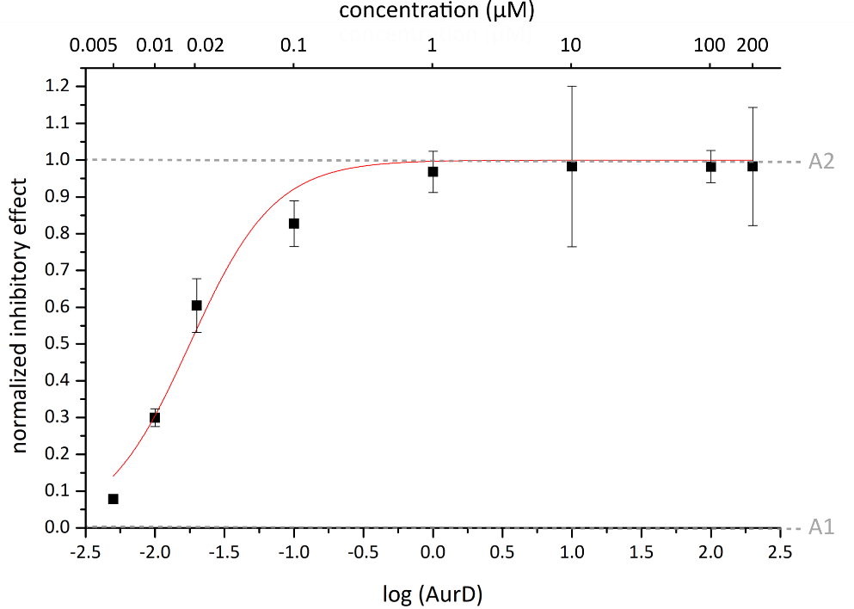
AurD K_{i}^{app} 0.018 ± 0.002µM
Figure S-2: K_{i}^{app} determination for AurD and E. coli bd-I. Half-logarithmic plotting of normalized inhibitory effect on bd-I over AurD concentration (1nM - 200µM), followed by sigmoidal fit (red line) with DoseResp fit (Origin LabPro9.5). Each point represents mean ± S.E.M. (n=3).

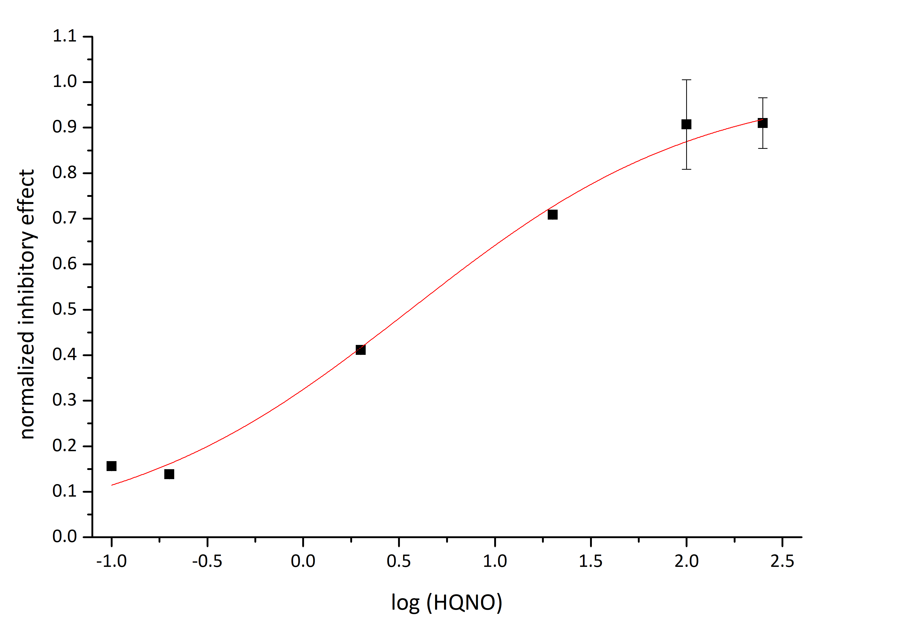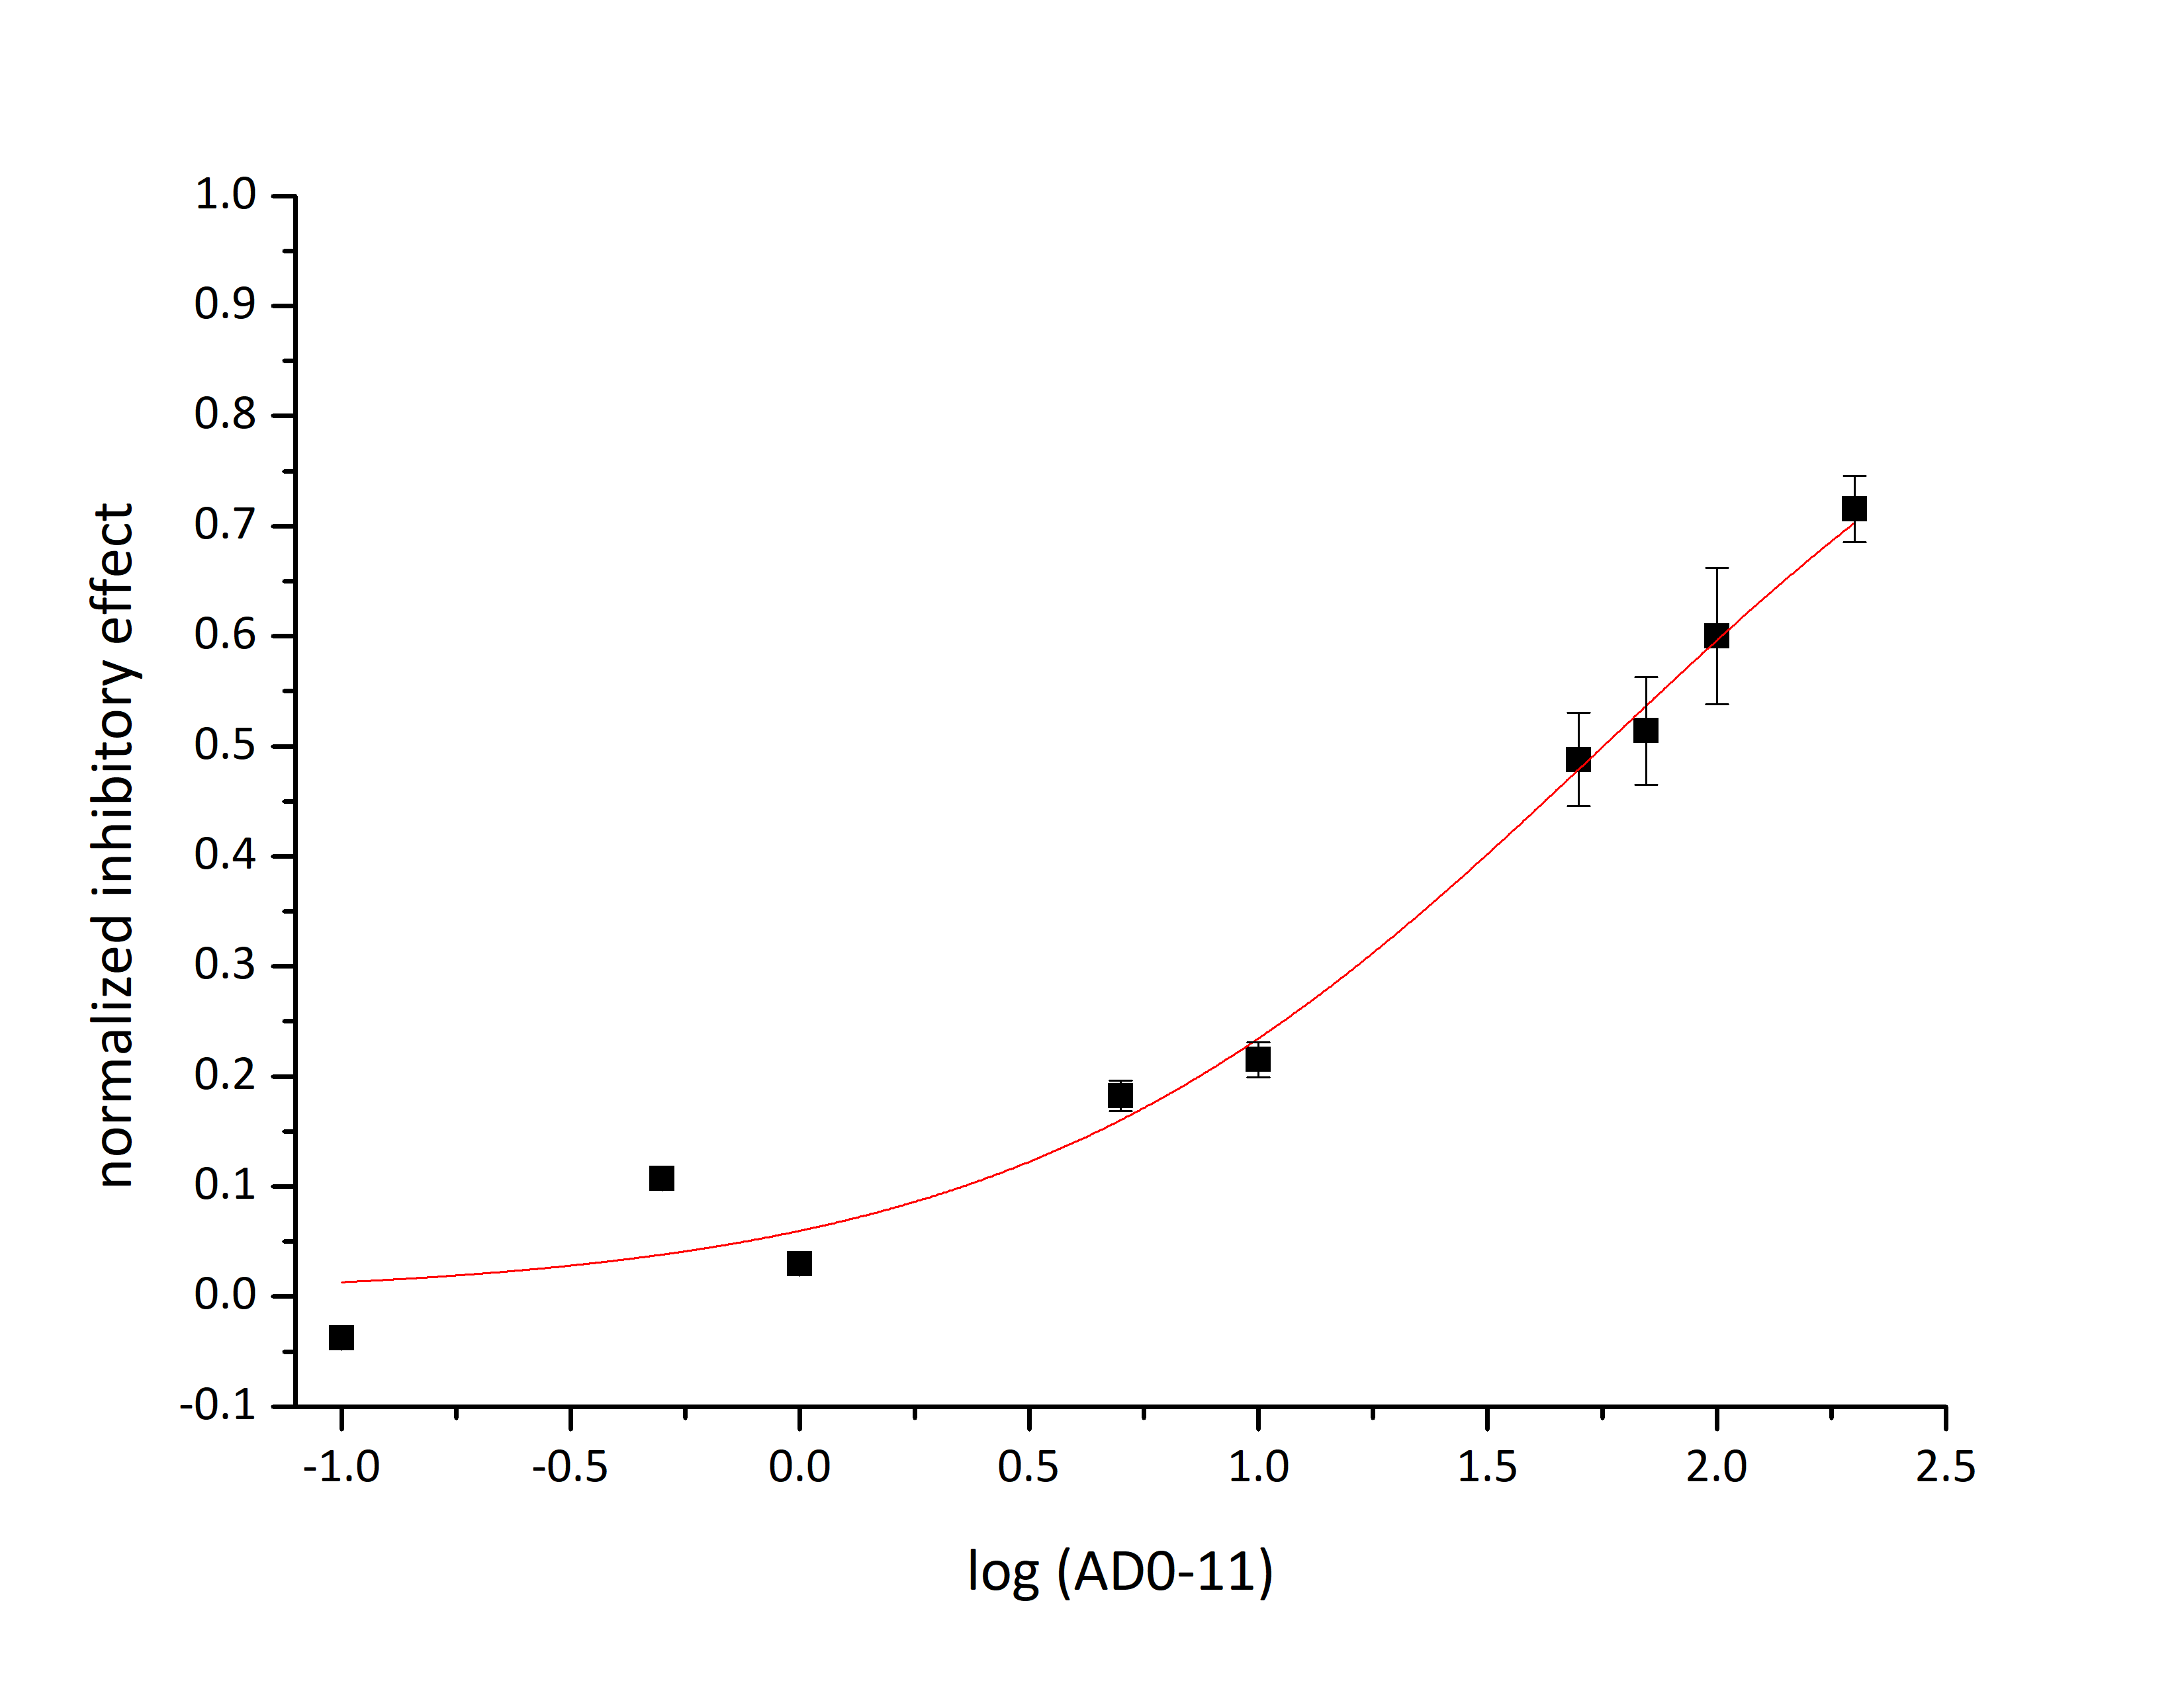
HQNO K_{i}^{app} 3.6 ± 0.5µM
AD0-11 K_{i}^{app} 56.6 ± 5.9µM
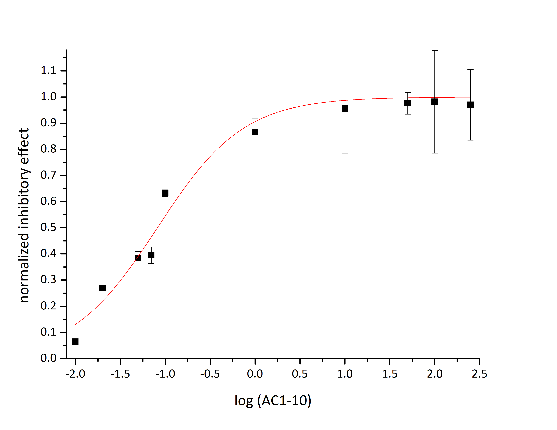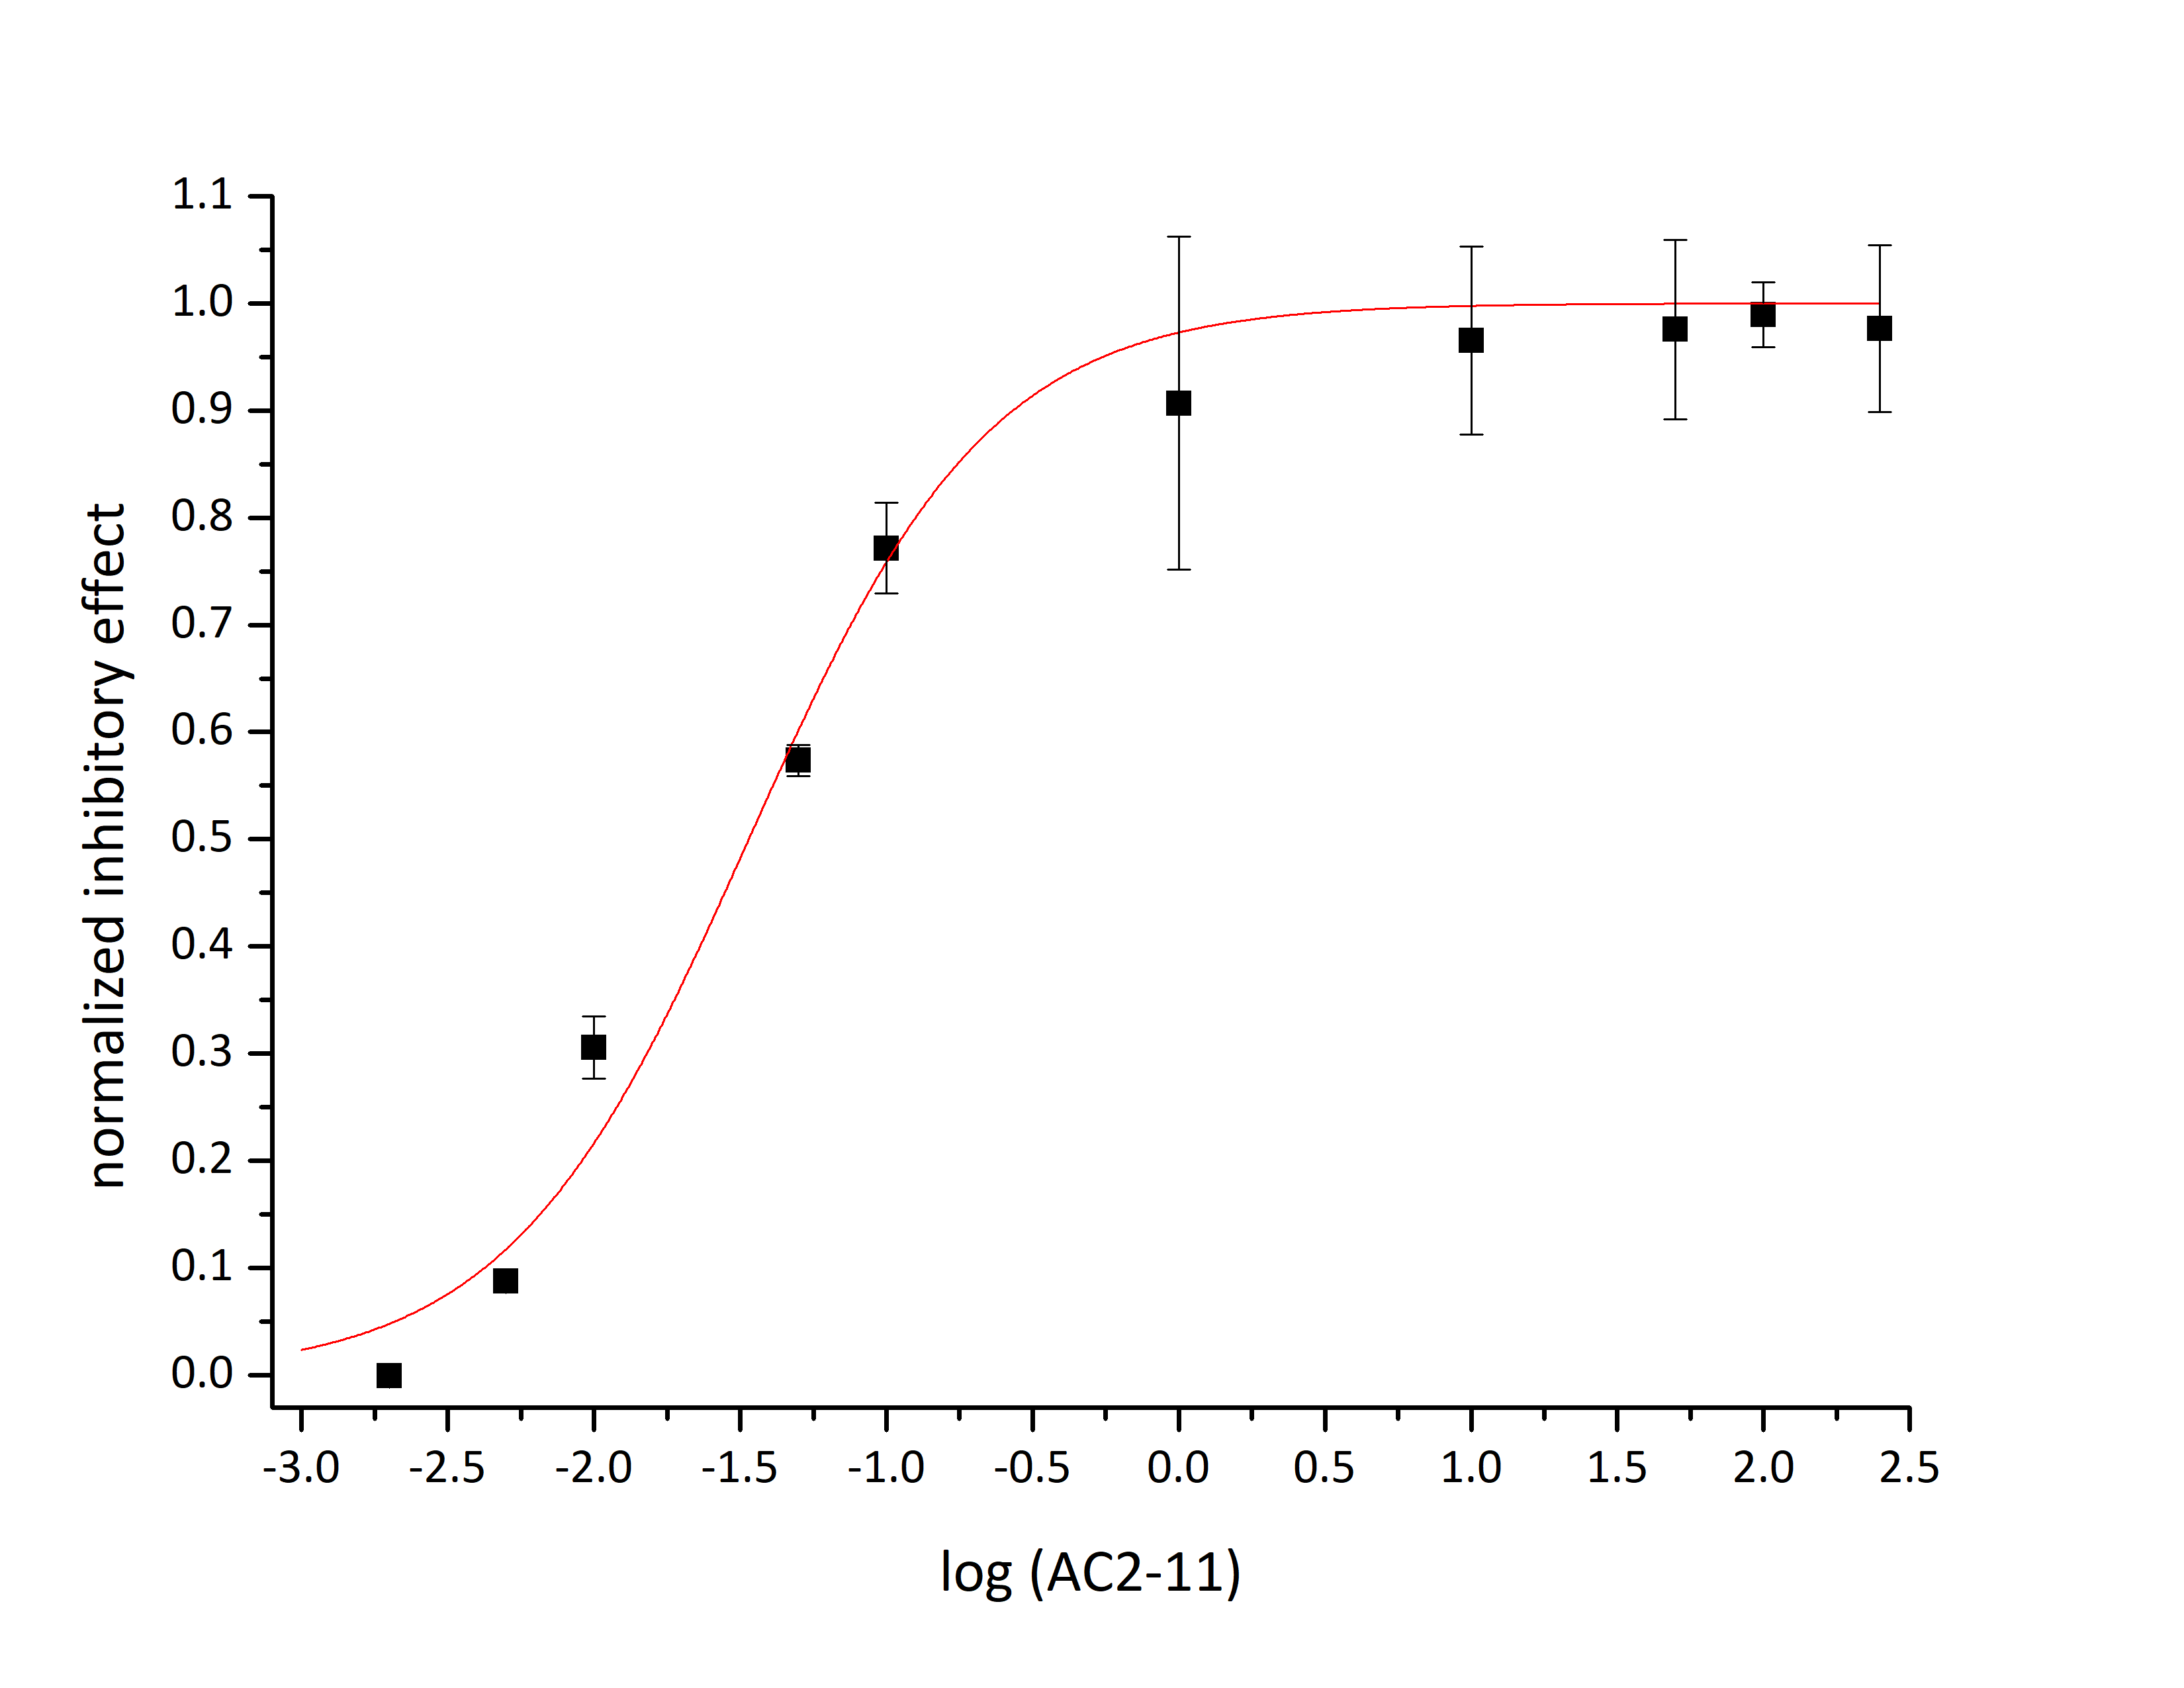
AC2-11 K_{i}^{app} 0.034 ± 0.006µM
AC1-10 K_{i}^{app} 0.082 ± 0.011µM
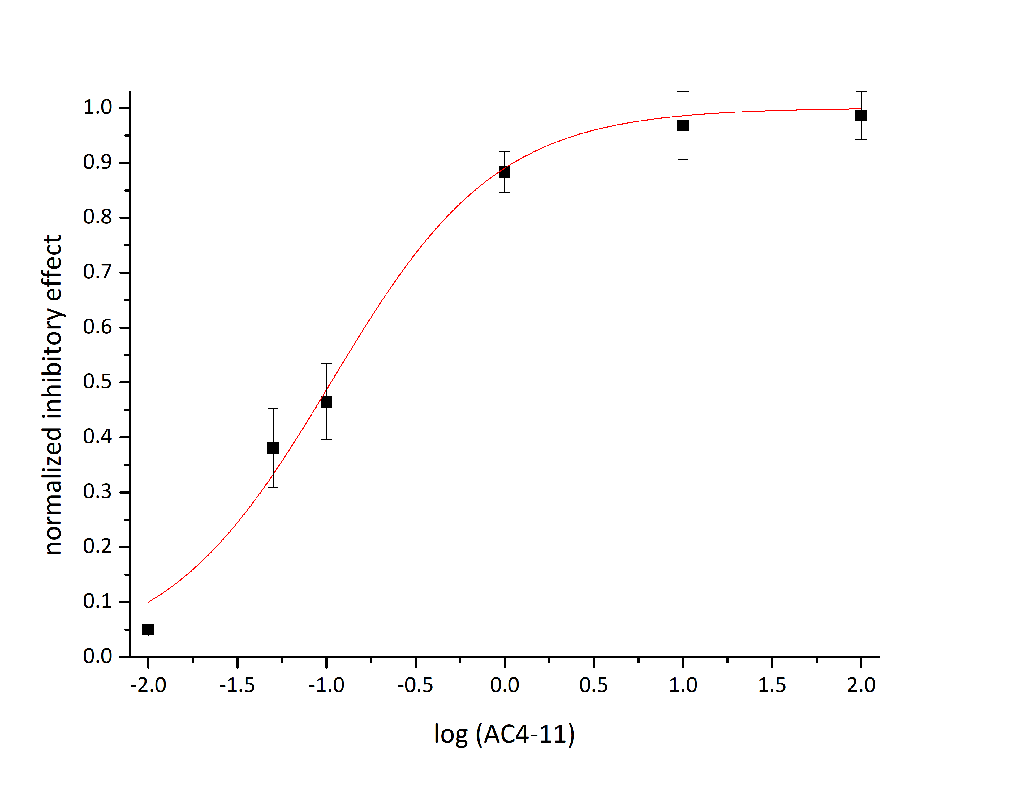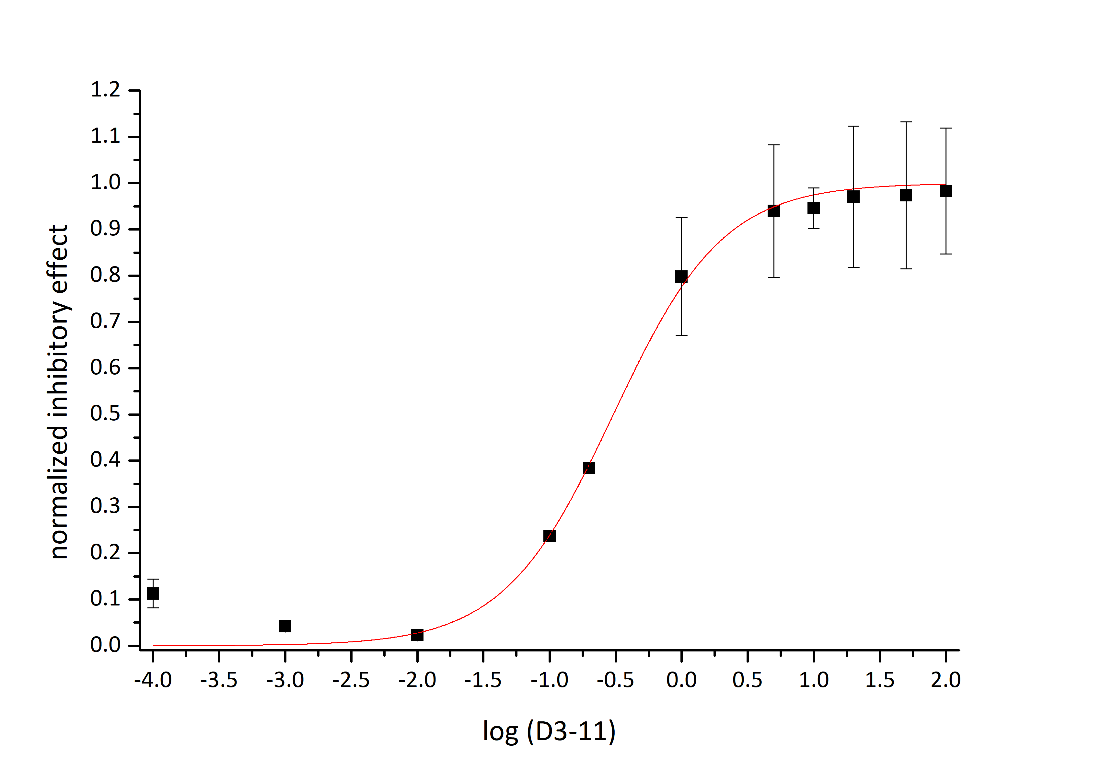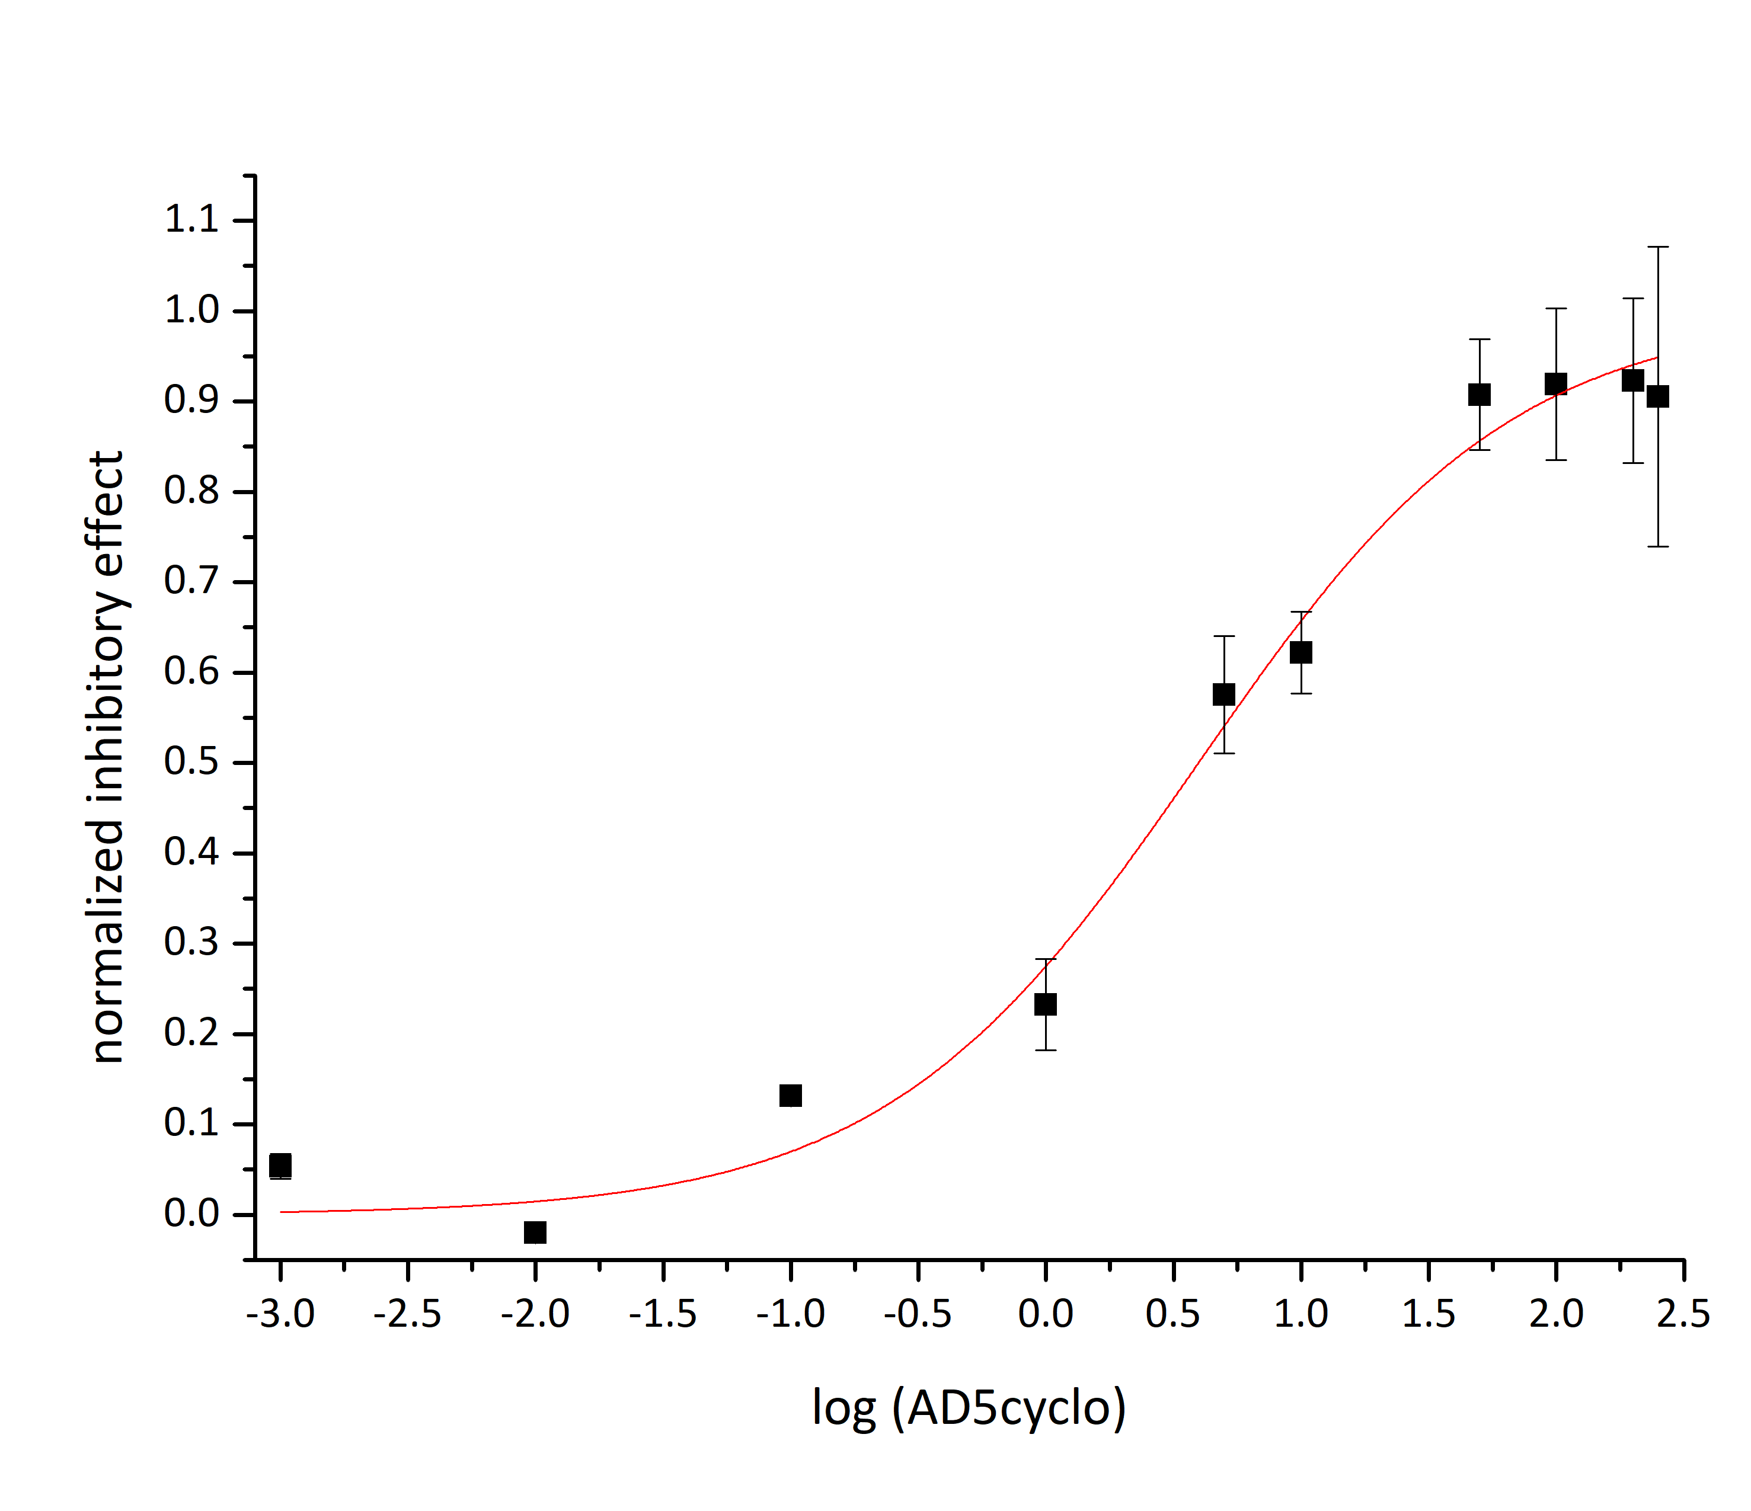 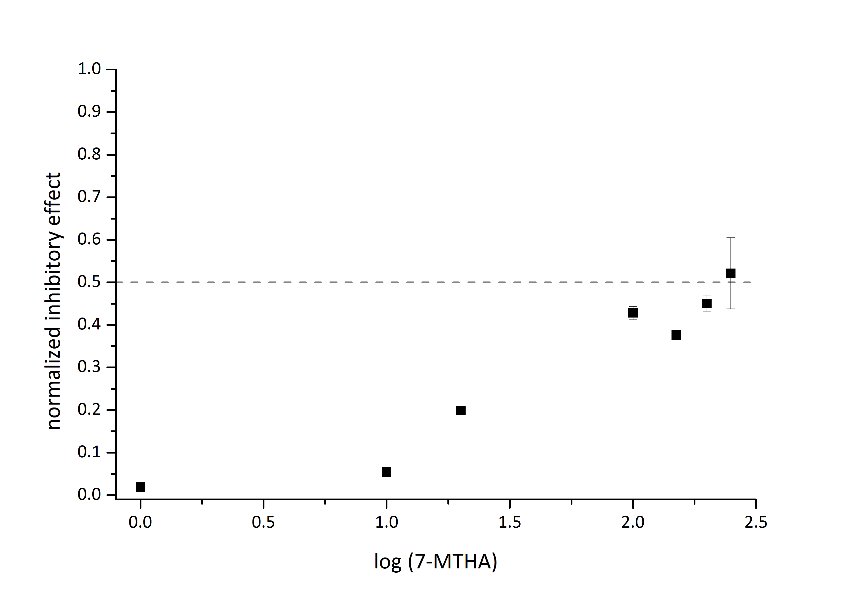
Figure S-3: Half- logarithmic dose response curves for E. coli cytochrome bd-I oxidase. K_{i}^{app} determined by functional oxygen reductase assay as for AurD. 30nM bd-I in presence up to 250µM inhibitor. Each point represents mean ± S.E.M. (n=3). Sigmoidal fit (red line) with DoseResp fit (Origin LabPro9.5).
y = 0.5
7-MTHA K_{i}^{app} > 250µM
AD5cyclo K_{i}^{app} 4.0 ± 0.6µM
AD3-11 K_{i}^{app} 0.30 ± 0.04µM
AC4-11 K_{i}^{app} 0.106 ± 0.013µM
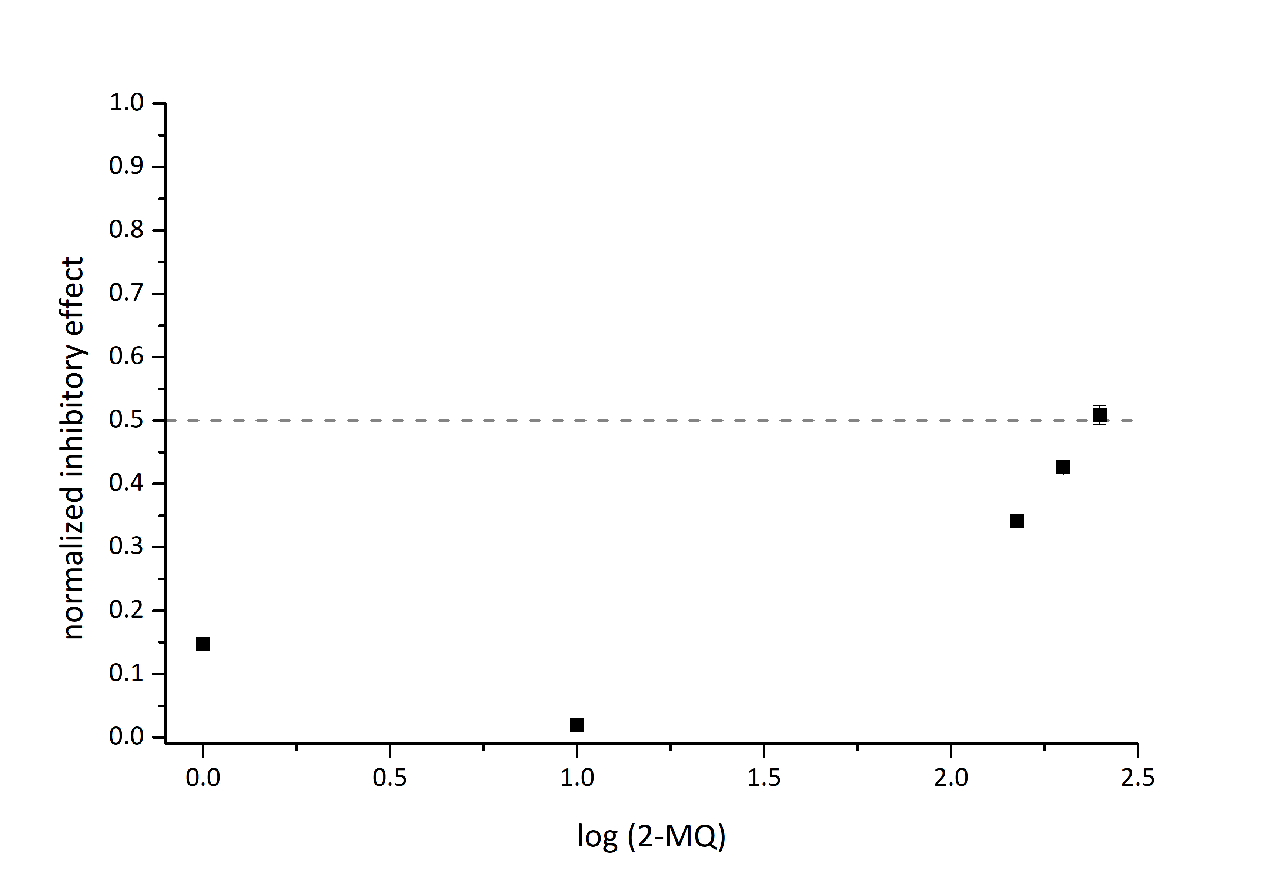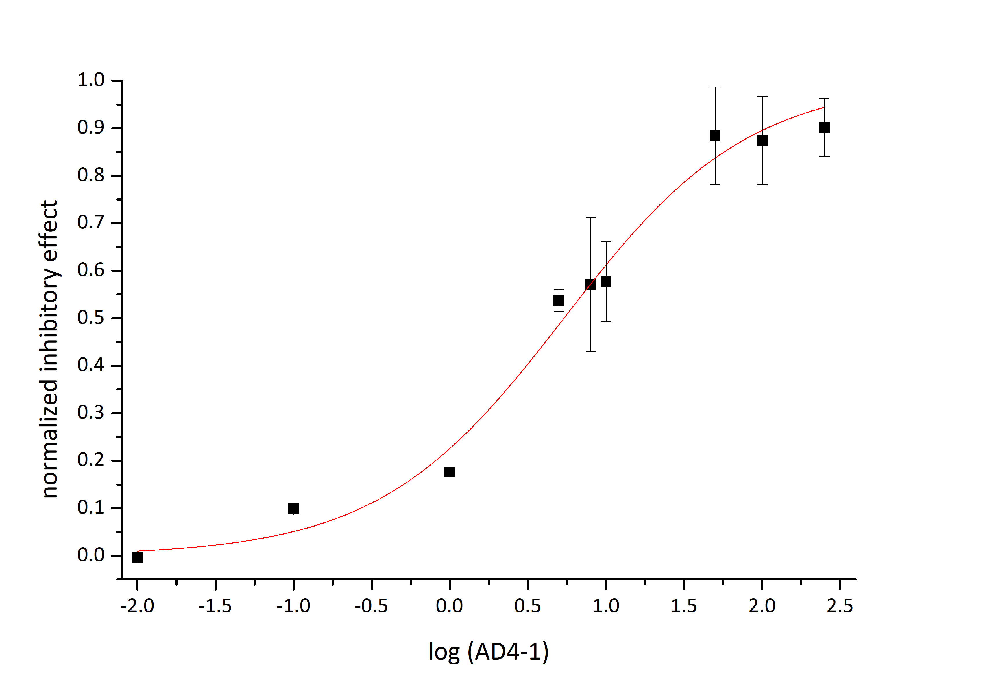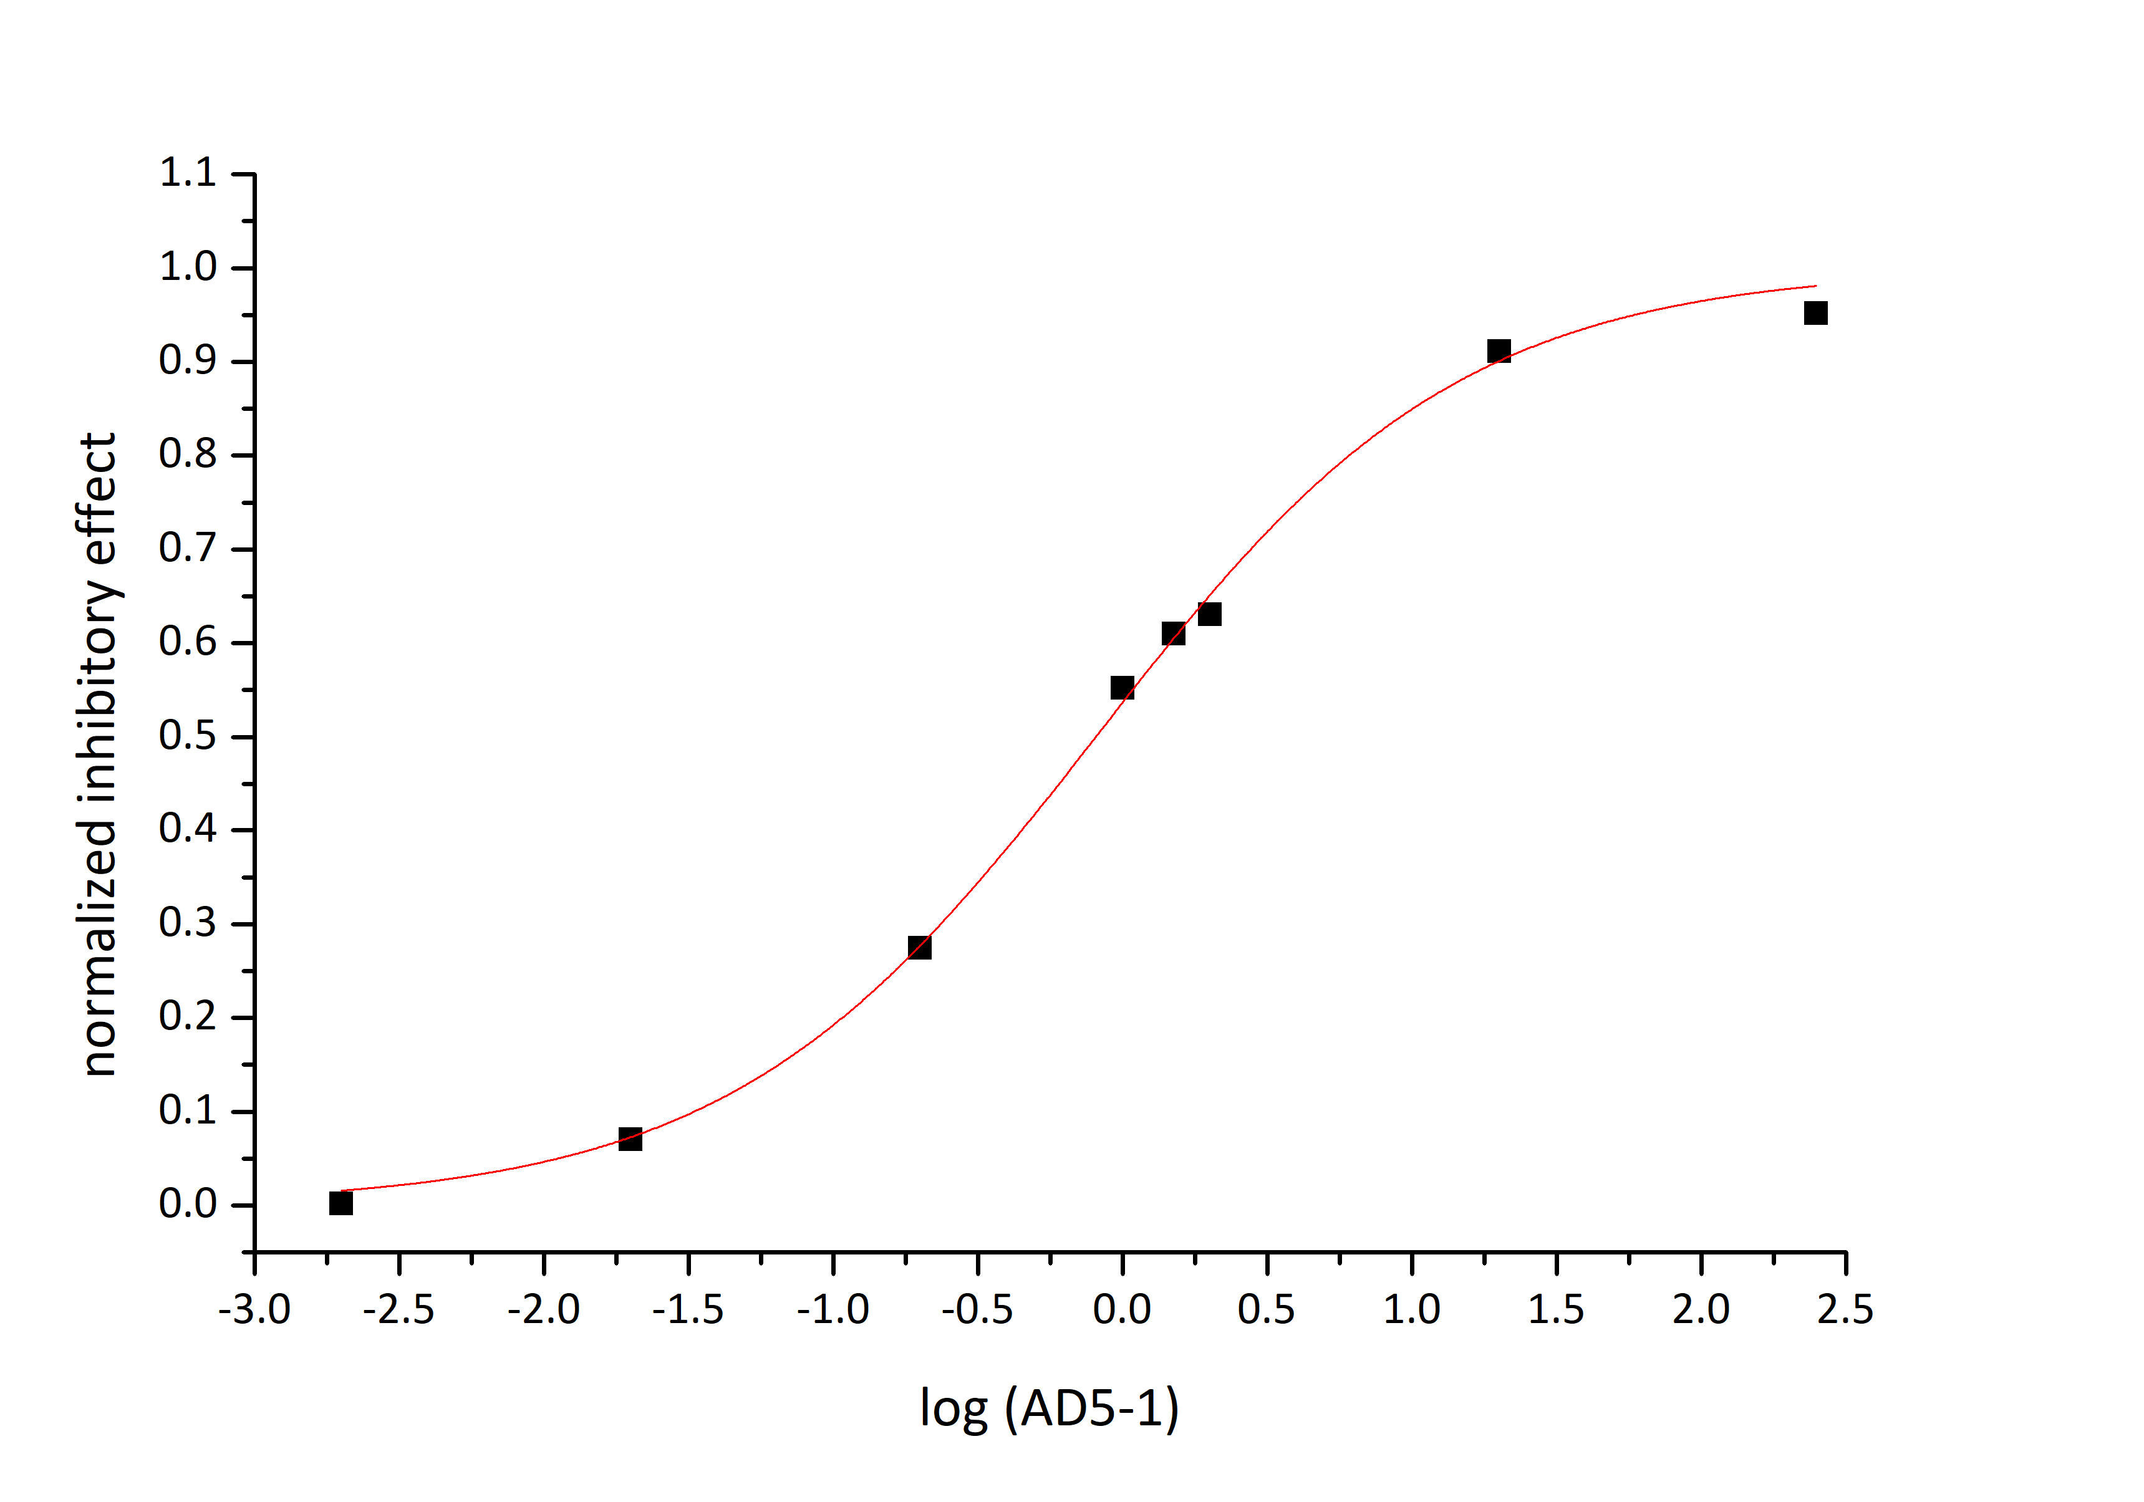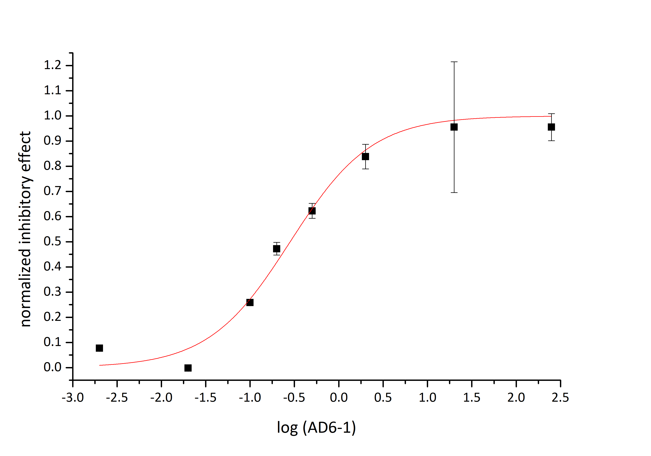
y = 0.5
AD4-1 K_{i}^{app} 5.4 ± 0.7µM
2-MQ K_{i}^{app} > 250µM
AD6-1 K_{i}^{app} 0.28 ± 0.04µM
AD5-1 K_{i}^{app} 0.81 ± 0.04µM
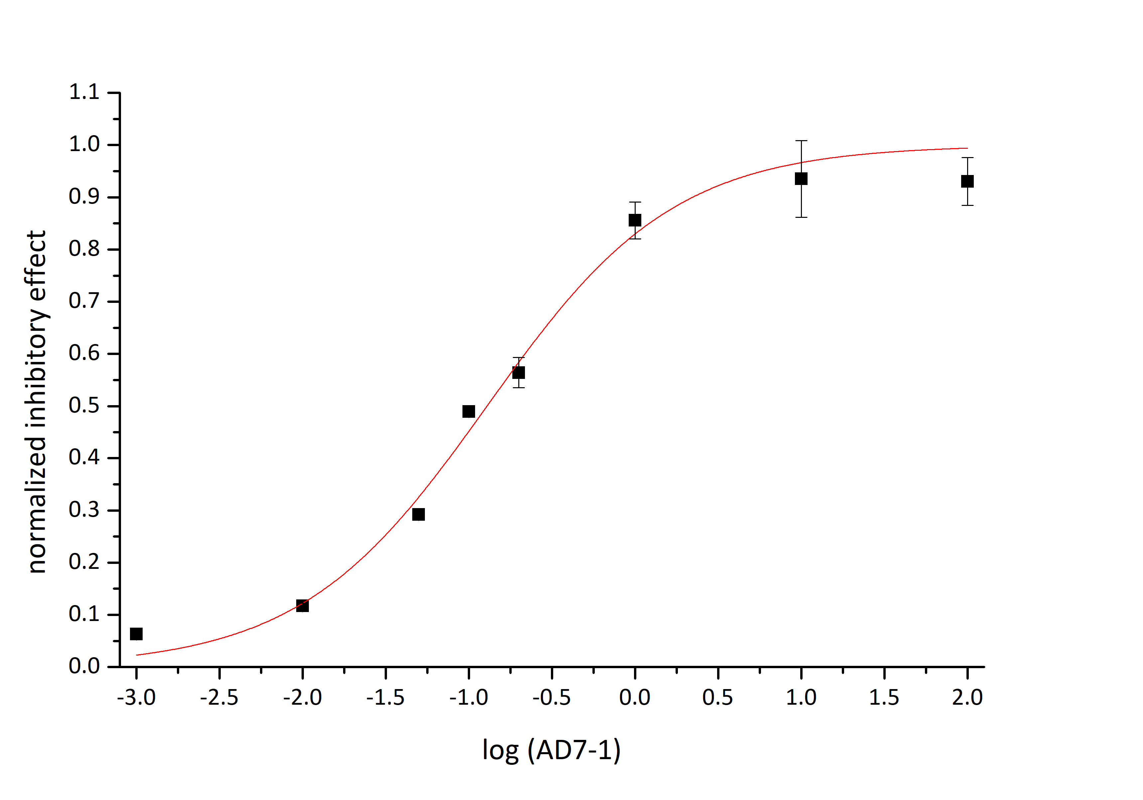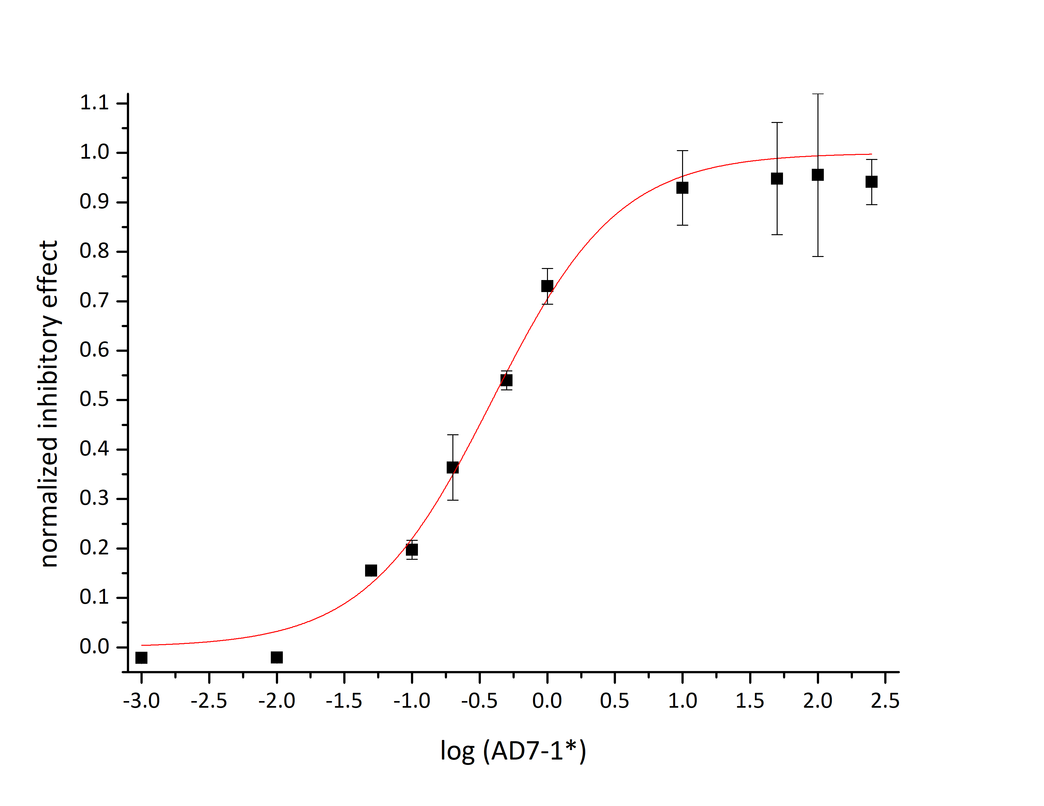
AD7-1* K_{i}^{app} 0.39 ± 0.04 µM
AD7-1 K_{i}^{app} 0.13 ± 0.02µM
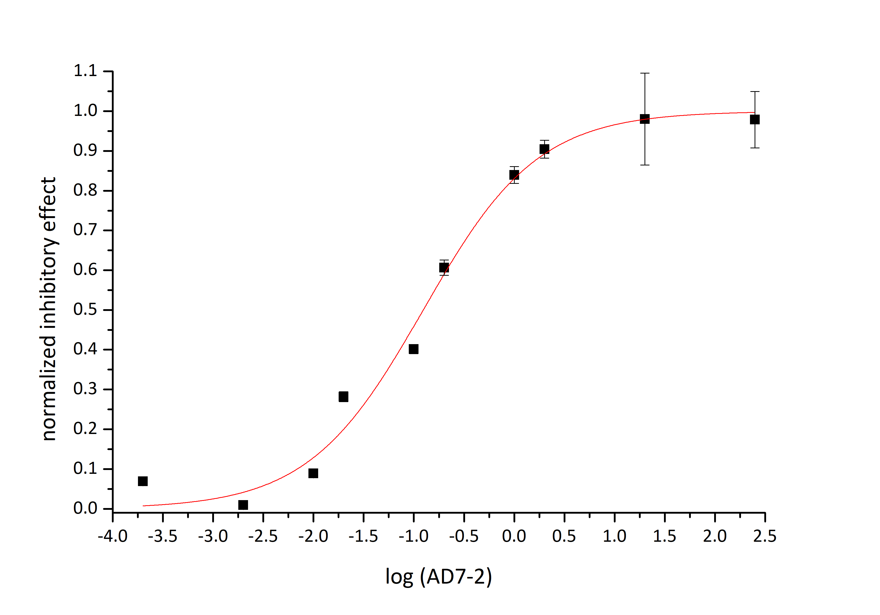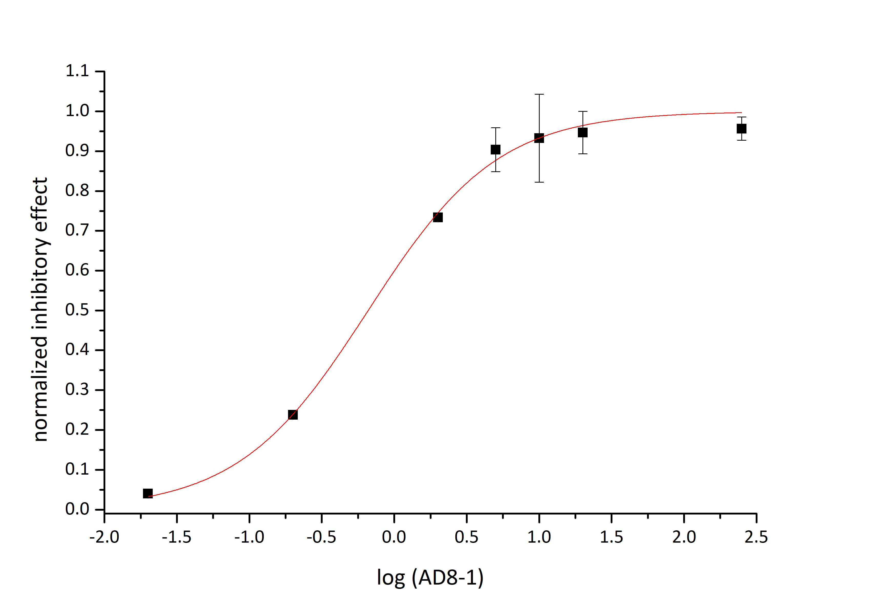
AD7-2 K_{i}^{app} 0.12 ± 0.02µM
AD8-1 K_{i}^{app} 0.66 ± 0.06µM
Figure S-4: Half- logarithmic dose response curves for E. coli cytochrome bd-I oxidase. K_{i}^{app} determined by functional oxygen reductase assay as for AurD. 30nM bd-I in presence up to 250µM inhibitor. Each point represents mean ± S.E.M. (n=3). Sigmoidal fit (red line) with DoseResp fit (Origin LabPro9.5).
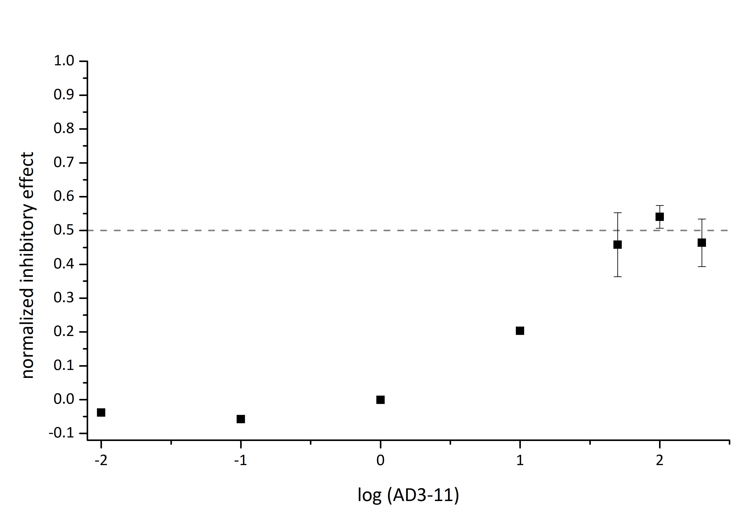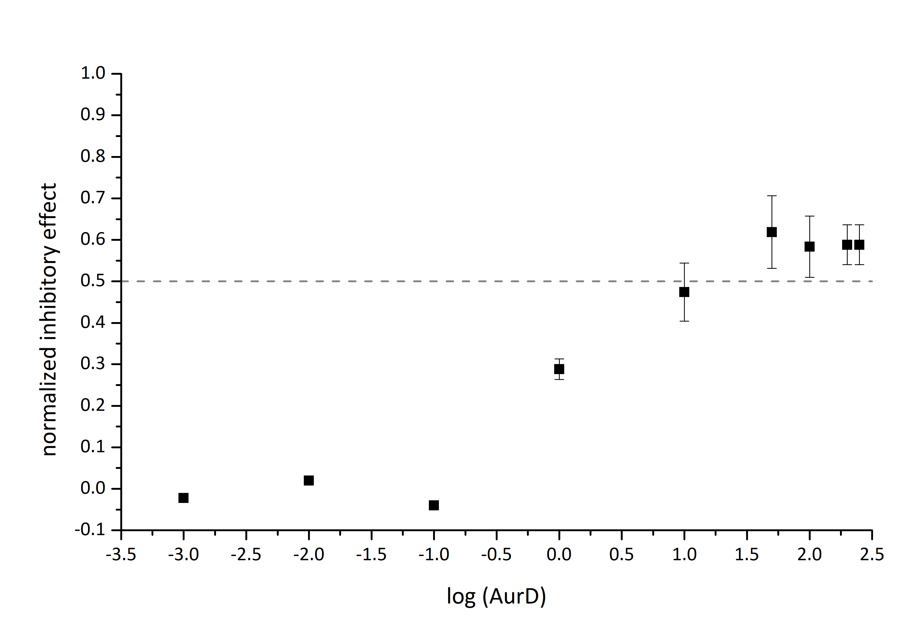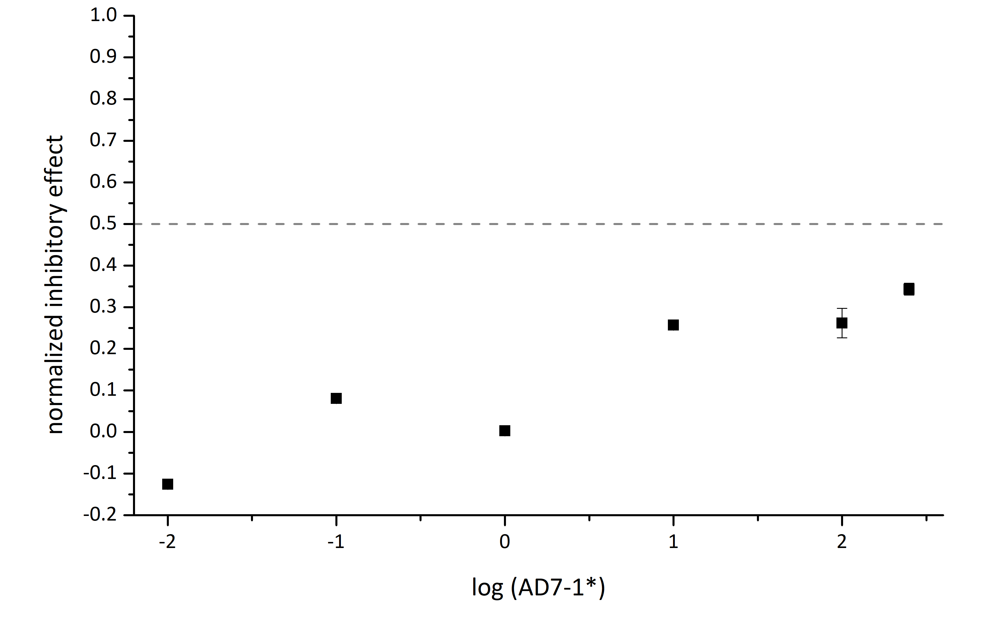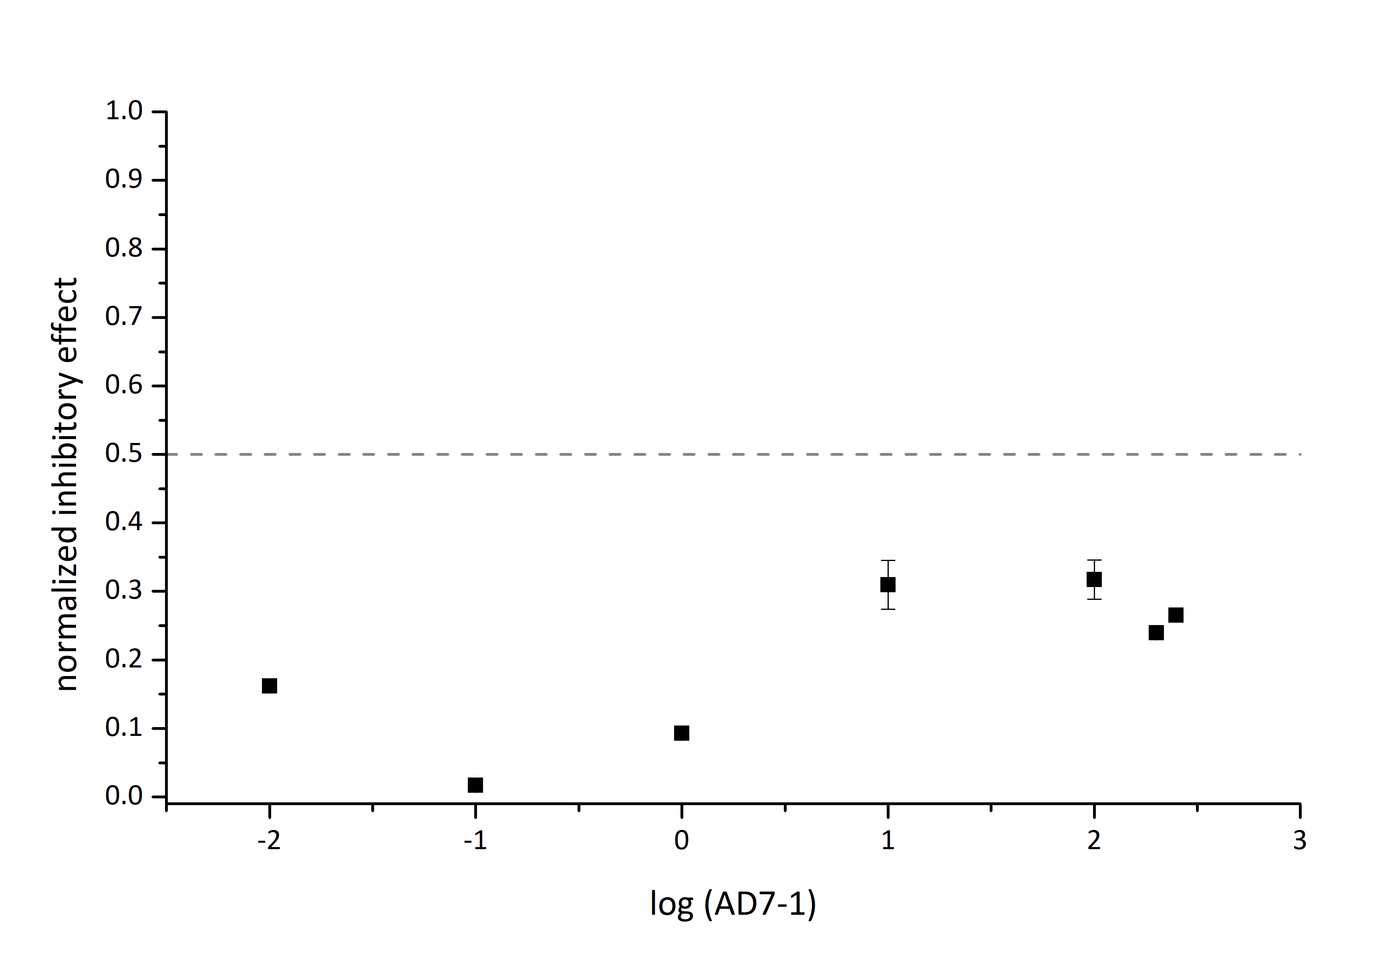
y = 0.5
y = 0.5
y = 0.5
y = 0.5
AD7-1 K_{i}^{app} > 250µM
AD7-1* K_{i}^{app} > 250µM
AD3-11 K_{i}^{app} > 50µM
AurD K_{i}^{app} > 10µM
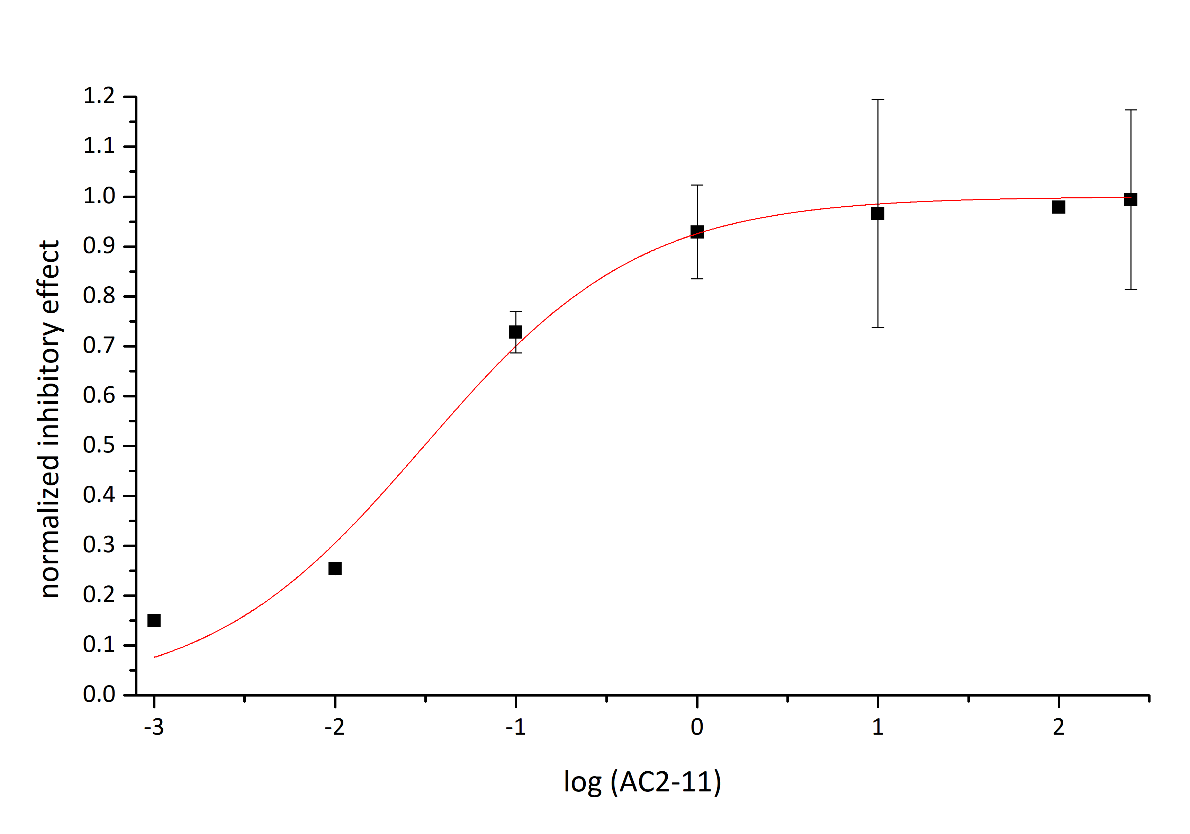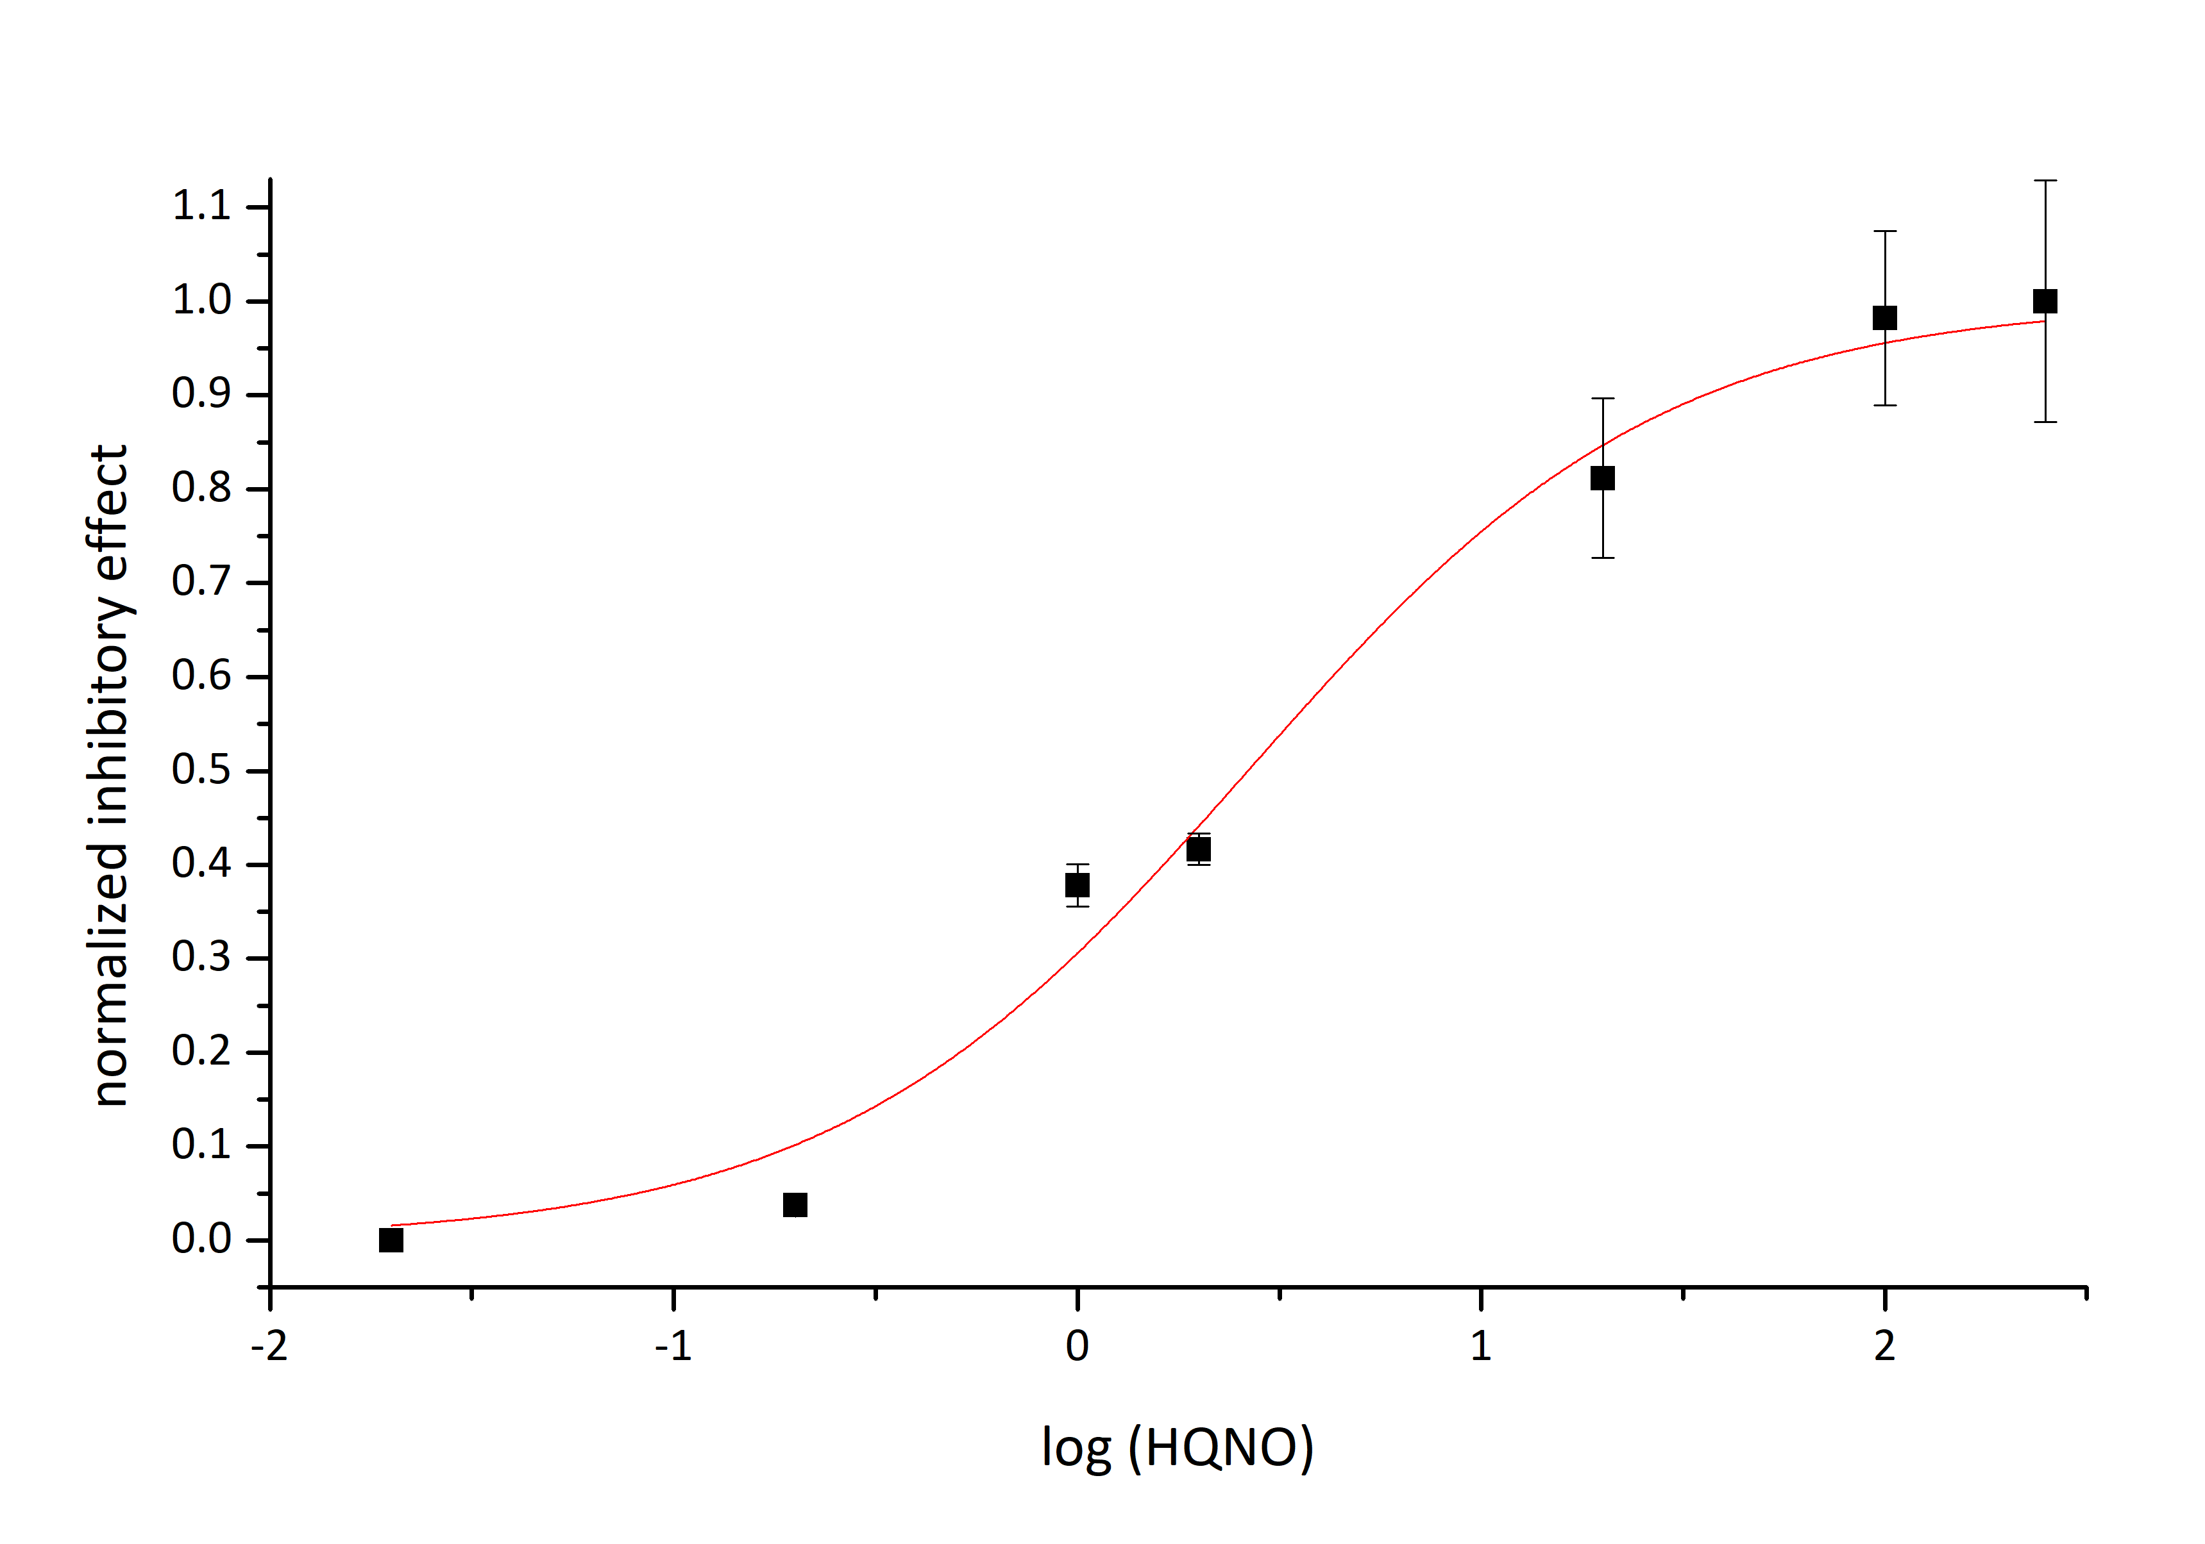
HQNO K_{i}^{app} 2.6 ± 0.4µM
AC2-11 K_{i}^{app} 0.031 ± 0.006µM
Figure S-5: Half- logarithmic dose response curves for E. coli cytochrome bo₃ oxidase. K_{i}^{app} determined by functional oxygen reductase assay. 30nM bo₃ in presence up to 250µM inhibitor. Each point represents mean ± S.E.M. (n=3). Sigmoidal fit (red line) with DoseResp fit (Origin LabPro9.5).

Synthesis
The experimental procedures for the bromination of allyl alcohols, the substitution of ethyl acetoacetate with the obtained allyl bromides, and the preparation of the corresponding enamines and, finally the Conrad-Limpach cyclization to obtain the substituted aurachin D derivatives were performed as described in the publication of Dejon et al. ¹

General procedure for the synthesis of allyl bromides from allyl alcohols

Mesyl chloride (MsCl) (1mmol, 1.3eq.) as well as triethylamine (ET₃N) (1mmol, 2eq.) were successively added dropwise to a -40°C cooled solution of allyl alcohol (1 mmol, 1.0eq) in dry THF (1.5ml). The reaction mixture was then stirred under argon atmosphere for one hour at the same temperature. Subsequently, the reaction was quenched by adding LiBr (4mmol, 4eq.) before the suspension was stirred at 0°C for another hour. The suspension was then diluted with ice-cold water and extracted three times with chilled diethyl ether, which was then washed twice with sodium hydrogen carbonate and brine respectively. The solution was then dried with MgSO₄ and the solvent was removed under vacuum. The obtained allyl bromide was then used for further steps without further purification.

General procedure for the substitution of ethyl acetoacetate with synthesized allyl bromides

Ethyl acetoacetate (1mmol, 1.0eq.) was added dropwise to a suspension of sodium hydride (60% in oil, 1.1 mmol) in anhydrous THF cooled to 0°C. After stirring at 0°C for 20min, a solution of (1.1mmol, 1.1eq.) in dry THF (250µl) was added and the reaction mixture was stirred overnight at room temperature. The crude product was washed with water and brine, extracted twice with diethyl ether, and purified by column chromatography (Cy. hexane/ethyl acetate 5:1)

General procedure for the synthesis of aurachin derivatives

Step 1: Synthesis of enamine intermediates
Aniline (1mmol, 1eq.) and catalytic amount of ceric ammonium nitrate were added to the previously synthesized 2-allyl acetoacetate (1mmol, 1eq.) dissolved in abs. ethanol (2ml). The obtained mixture was stirred at room temperature for 1h. It was then washed three times in succession with water and brine, extracted with dichloromethane and dried over MgSO₄. Evaporation of the solvent yielded the desired enamine, which was used in the cyclization step.
Step 2: Conrad-Limpach cyclization to aurachin derivatives
The synthesized enamines were rapidly added to diphenyl ether heated to 250°C without further purification and stirred for 30min. The precipitated white solid contains diphenyl ether, which was removed by chromatographic separation with cyclohexane and ethyl acetate (9:1, 6:1, 3:1).

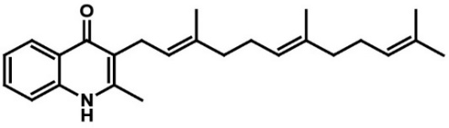
Aurachin-D, ¹H NMR (DMSO-d₆, 400 MHz): δ = 11.41 (br, 1H), 8.11 (d, ³J(H,H) = 8.0 Hz, 1H), 7.58 (td, ³J(H,H) = 6.7 Hz, ⁴J(H,H) = 1.3 Hz, 1 H), 7.48 (d, ³J(H,H) = 8.2 Hz, 1H), 7.25 (td, ³J(H,H) = 6.6 Hz, ⁴J(H,H) = 1.1 Hz 1H), 5.03 (m, 3H), 3.24 (d, ³J(H,H) = 6.6 Hz, 2H), 2.35 (s, 3H), 1.86-2.06 (m, 8H), 1.74 (s, 3H), 1.61 (s, 3H), 1.53(s, 1H), 1.51 (s, 1H) ppm. ¹³C NMR: (DMSO-d₆, 100.6 MHz): δ = 175.2, 146.2, 146.1, 139.1, 134.3, 134.2, 133.6, 133.5, 130.8, 130.8, 130.8, 130.5, 125.1, 124.9, 124.1, 123.8, 123.4, 123.0, 123.0, 122.3, 118.2, 117.4 ppm. MS (ESI): m/z calcd for C₂₅H₃₃NO: 362.26 [M - H] ⁻; found 362.30. Purity grade: 98%, TLC-Rf (CyH:EE,3:1): 55%.

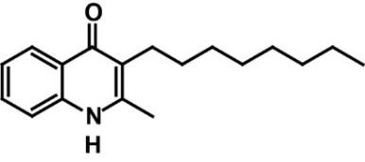
AD8-1, ¹H NMR (DMSO-d₆, 400 MHz): δ = 11.35 (br, 1H), 8.04 (d, ³J(H,H) = 7.7 Hz, 1H), 7.57 (td, ³J(H,H) = 7.6 Hz, ⁴J(H,H) = 1.3 Hz, 1 H), 7.46 (d, ³J(H,H) = 8.3 Hz, 1H), 7.24 (t, ³J(H,H) = 7.6 Hz, 1H), 2.48 (t, ³J(H,H) = 7.5 Hz, 2H), 2.39 (s, 3H), 1.20 – 1.44 (m, 12H), 0.86 (t, ³J(H,H) = 6.6 Hz, 3H), ppm. MS (ESI): m/z calcd for C₁₈H₂₅NO: 270.19 [M - H] ⁻; found 270.34. Purity grade: 99%, TLC-Rf (CyH:EE,3:1): 44%.
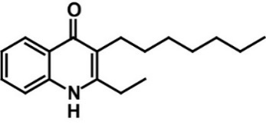
AD7-2, ¹H NMR (DMSO-d₆, 400 MHz): δ = 11.26 (br, 1H), 8.04 (d, ³J(H,H) = 8.0 Hz, 1H), 7.56 (tt, ³J(H,H) = 7.6 Hz, ⁴J(H,H) = 1.5 Hz, 1 H), 7.49 (d, ³J(H,H) = 8.6 Hz, 1H), 7.21-7.25 (tt, ³J(H,H) = 7.5 Hz, ⁴J(H,H) = 1.5 Hz, 1H), 2.68 (q, ³J(H,H) = 8.3 Hz, 2H), 1.20 – 1.44 (m, 12H), 0.86 (t, ³J(H,H) = 7.1 Hz, 4H) ppm. MS (ESI): m/z calcd for C₁₈H₂₅NO: 271.19 [M - H] ⁻; found 270.30. Purity grade: 96%, TLC-Rf (CyH:EE,3:1): 59%.

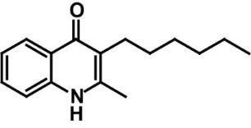
AD6-1, ¹H NMR (DMSO-d₆, 250 MHz): δ = 11.4 (br, 1H), 8.04 (dd, ³J(H,H) = 8.1 Hz, ⁴J(H,H) = 1.2 Hz, 1H), 7.60 (td, ³J(H,H) = 7.6 Hz, ⁴J(H,H) = 1.5 Hz, 1 H), 7.5 (d, ³J(H,H) = 7.9 Hz, 1H), 7.28 (tt, ³J(H,H) = 7.4 Hz, ⁴J(H,H) = 1.1 Hz, 1H), 2.43 (s, 3H), 1.28 – 1.46 (m, 7H), 0.86-0.94 (m, ³H) ppm. MS (ESI): m/z calcd for C₁₆H₂₁NO: 243.16 [M - H] ⁻; found 244.22. Purity grade: 98%, TLC-Rf (CyH:EE,3:1): 50%.

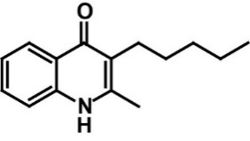
AD5-1, ¹H NMR (DMSO-d₆, 250 MHz): δ = 11.35 (br, 1H), 8.04 (dd, ³J(H,H) = 8.1 Hz, ⁴J(H,H) = 1.2 Hz, 1H), 7.57 (td, ³J(H,H) = 7.6 Hz, ⁴J(H,H) = 1.5 Hz, 1 H), 7.50 (d, ³J(H,H) = 8.0 Hz, 1H), 7.24 (tt, ³J(H,H) = 7.4 Hz, ⁴J(H,H) = 1.2 Hz, 1H), 2.39 (s, 3H), 1.26 – 1.52 (m, 6H), 0.88(t, ³J(H,H) = 6.3 Hz) ppm. MS (ESI): m/z calcd for C₁₅H₁₉NO: 229.15 [M - H] ⁻; found 230.20. Purity grade: 98.5%, TLC-Rf (CyH:EE,3:1): 48%.

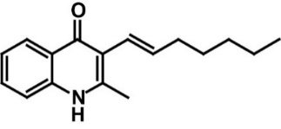
AD7-1*, ¹H NMR (DMSO-d₆, 400 MHz): δ = 11.27 (br, 1H), 8.04 (d, ³J(H,H) = 8.0 Hz, 1H), 7.57 (tt, ³J(H,H) = 7.6 Hz, ⁴J(H,H) = 1.5 Hz, 1 H), 7.49 (d, ³J(H,H) = 8.6 Hz, 1H), 7.23 (tt, ³J(H,H) = 7.5 Hz, ⁴J(H,H) = 1.5 Hz, 1H), 2.68 (q, ³J(H,H) = 8.3 Hz, 2H), 1.20 – 1.44 (m, 12H), 0.86 (t, ³J(H,H) = 7.1 Hz, 4H) ppm.
MS (ESI): m/z calcd for C₁₈H₂₅NO: 254.16. Purity grade: 99.5%, TLC-Rf (CyH:EE,3:1): 53%.

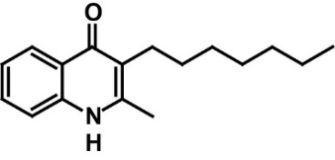
AD7-1, ¹H NMR (DMSO-d₆, 500 MHz): δ = 11.35 (br, 1H), 8.04 (d, ³J(H,H) = 8.3 Hz, 1H), 7.56 (td, ³J(H,H) = 7.6 Hz, ⁴J(H,H) = 1.5 Hz, 1 H), 7.46 (d, ³J(H,H) = 8.1 Hz, 1H), 7.23 (t, ³J(H,H) = 7.5 Hz, 1H), 2.48 (t, ³J(H,H) = 7.5 Hz, 2H), 2.1 (s, 3H), 1.20 – 1.44 (m, 9H), 0.86 (t, ³J(H,H) = 6.6 Hz, 3H), ppm. ¹³C NMR: (DMSO-d₆, 100.6 MHz): δ = 176.0, 170.8, 146.1, 139.6, 131.3, 125.6, 123.8, 122.7. 119.6, 117.9, 62.1, 31.7, 25.5, 25.3, 21.3, 18.0, 17.9 ppm. MS (ESI): m/z calcd for C₁₈₇H₂₃NO: 256.2 [M - H] ⁻; found 256.34.
Purity grade: 99.5%, TLC-Rf (CyH:EE,3:1): 50%.

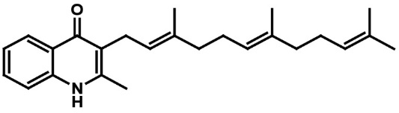
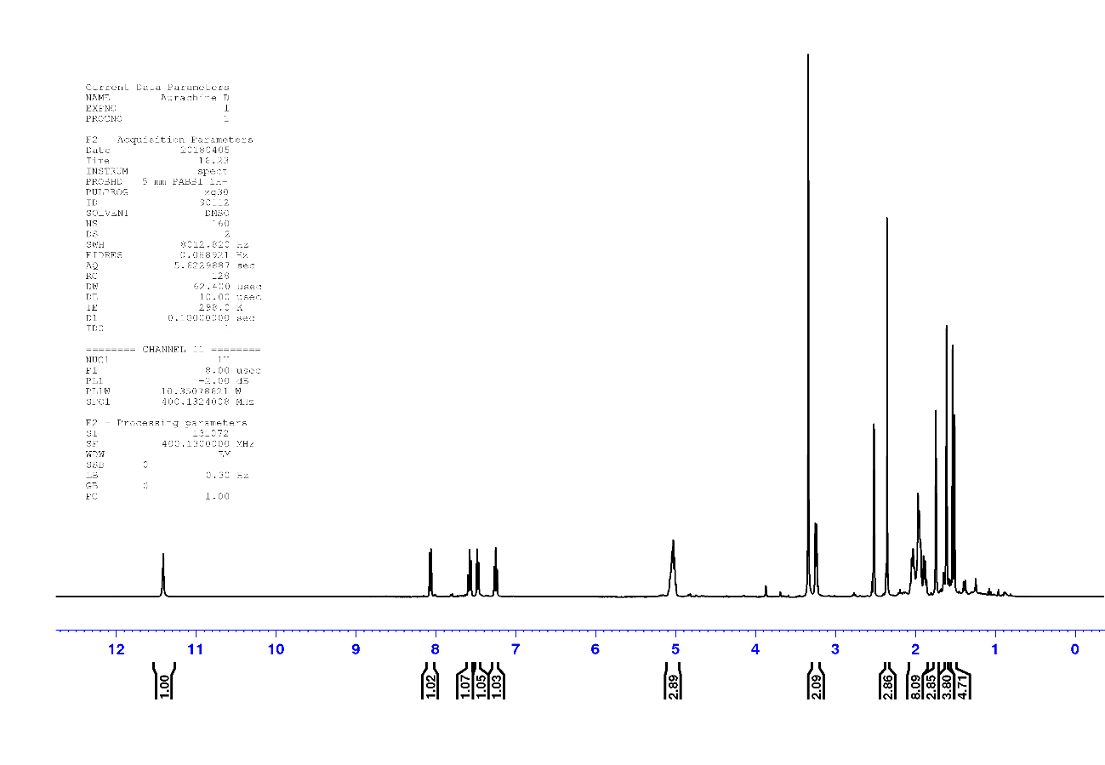
Aurachin D
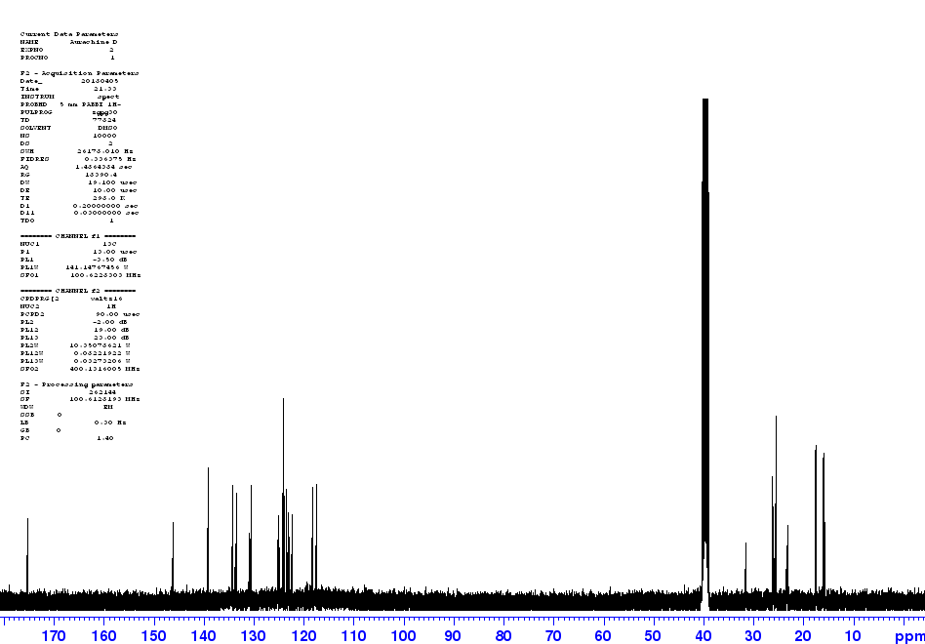

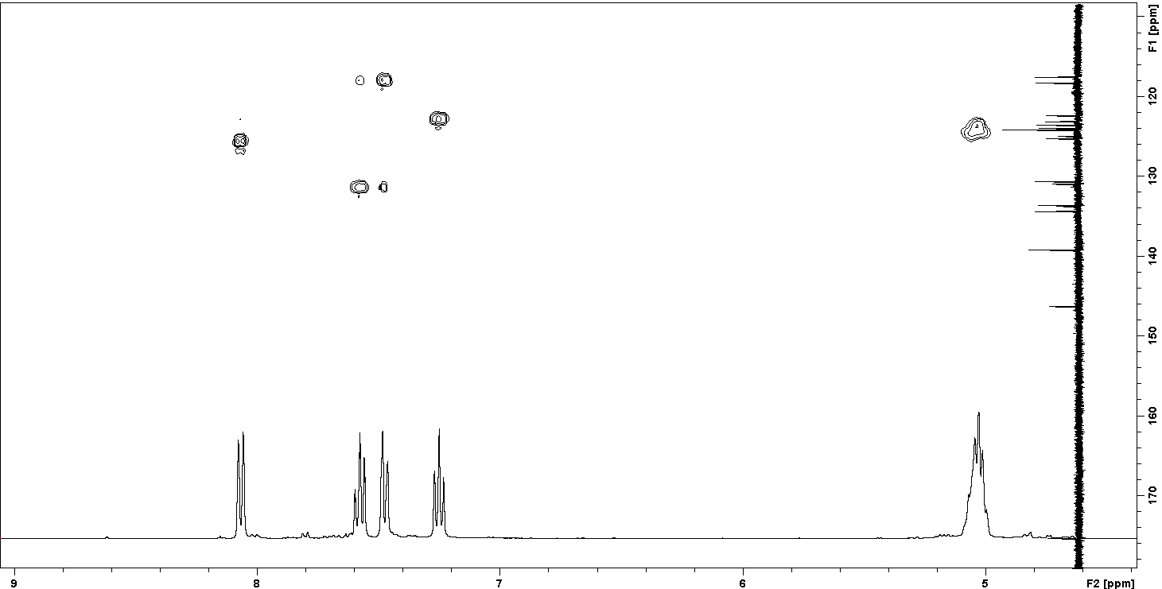

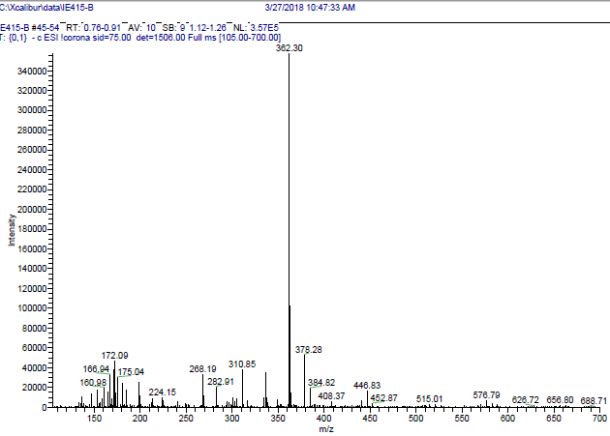

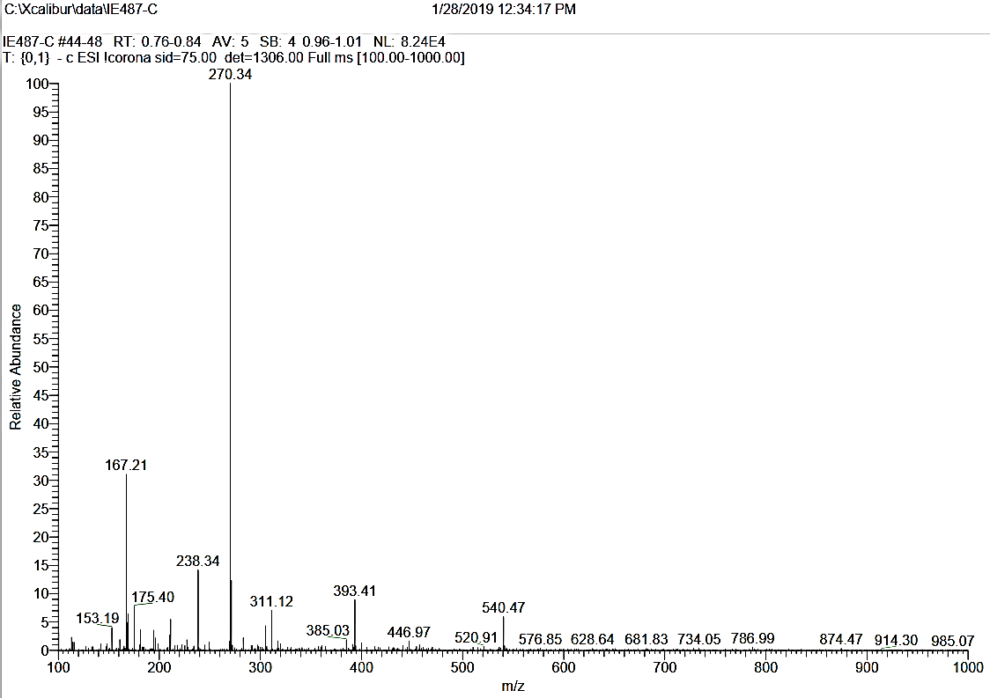
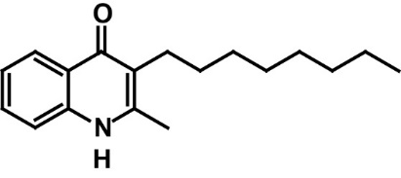
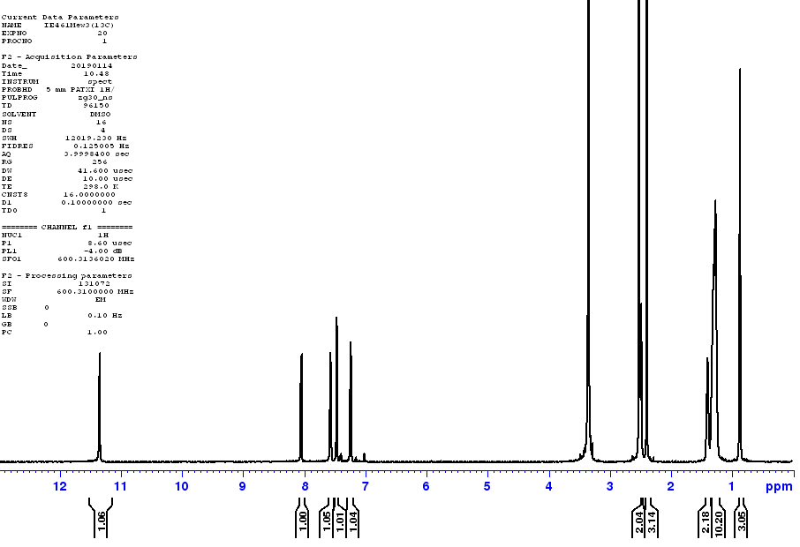
AD8-1

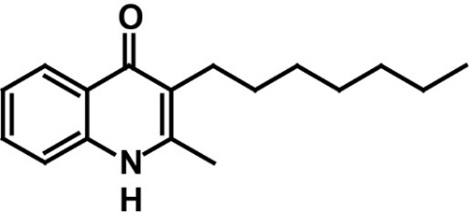
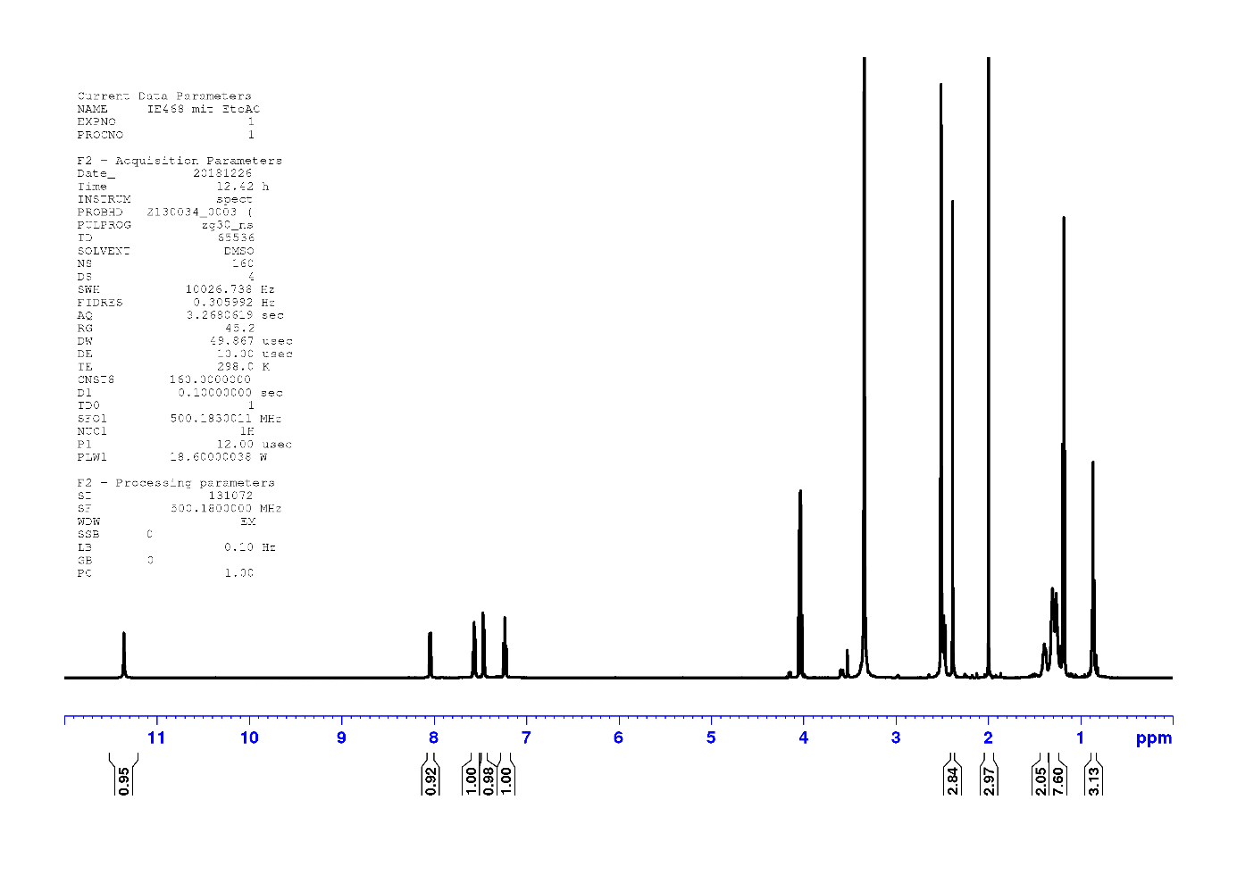
AD7-1
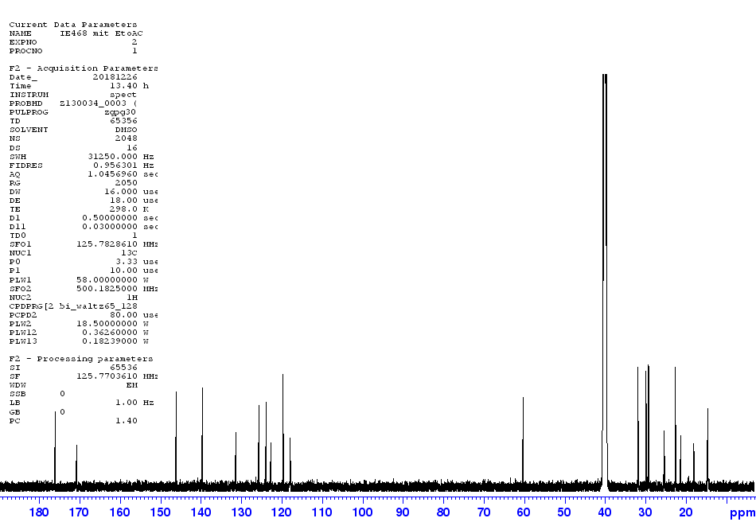

AD7-2
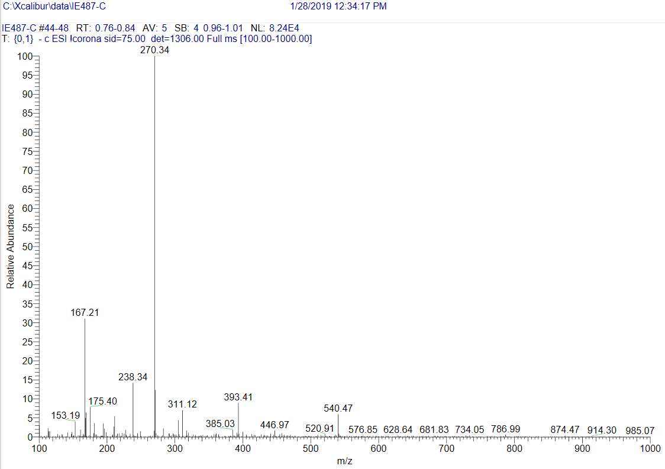
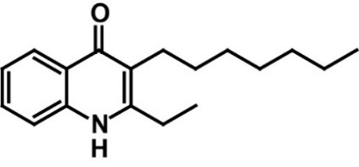
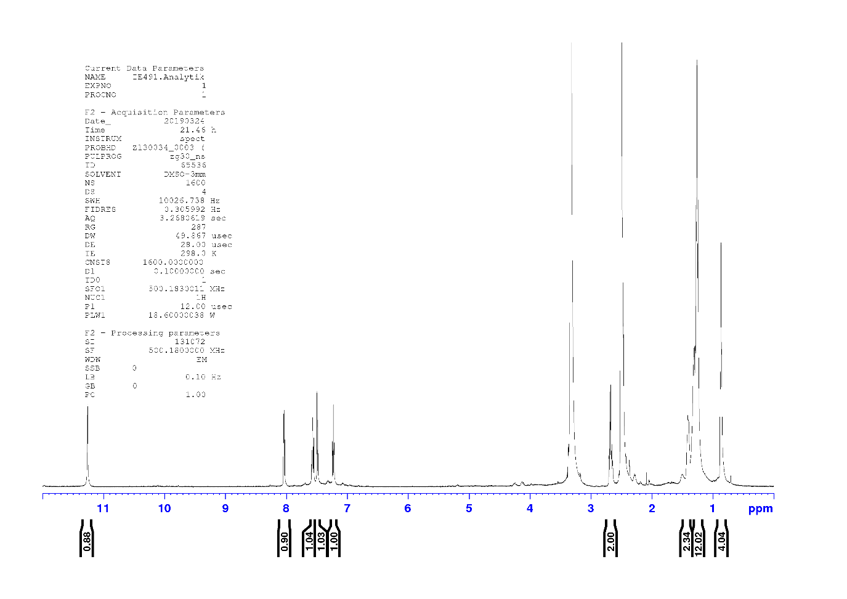

AD6-1
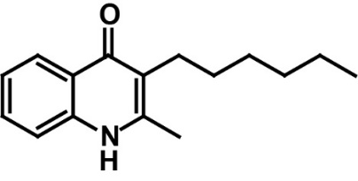
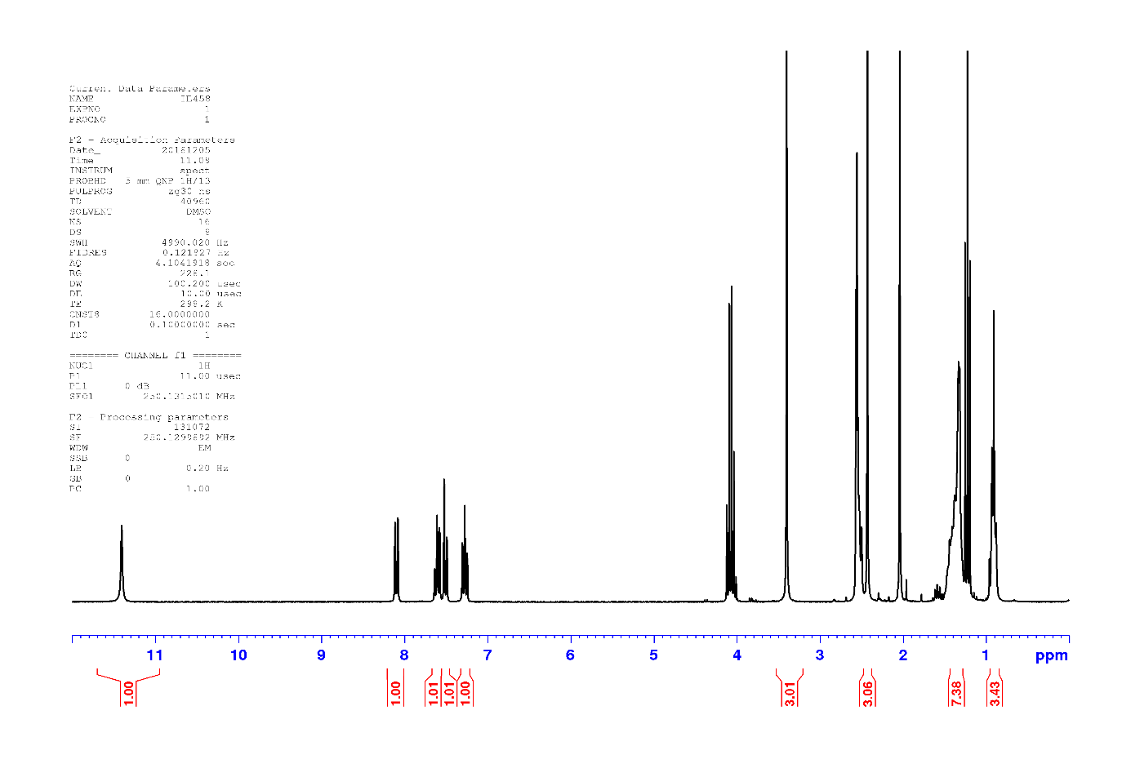
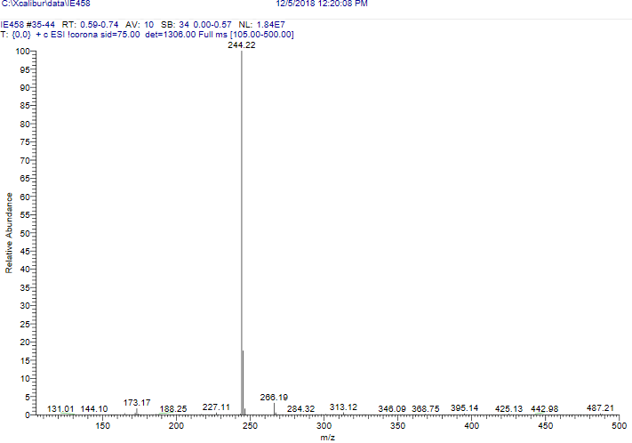

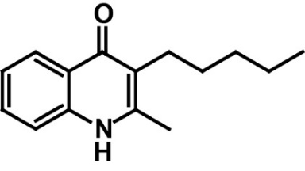
AD5-1
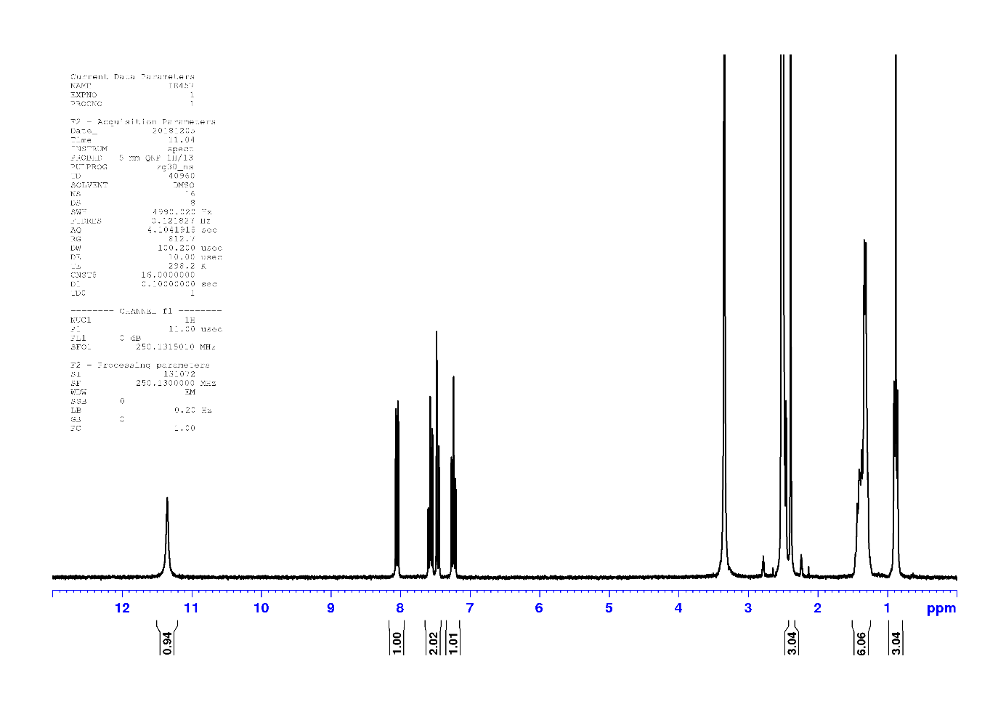
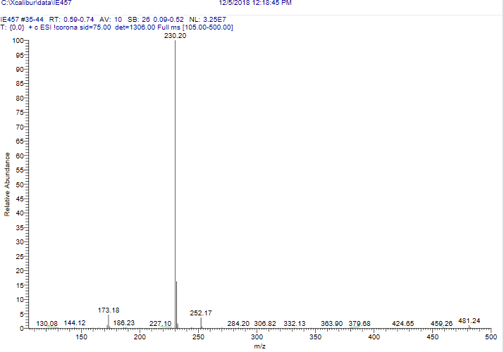
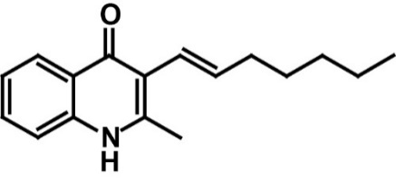
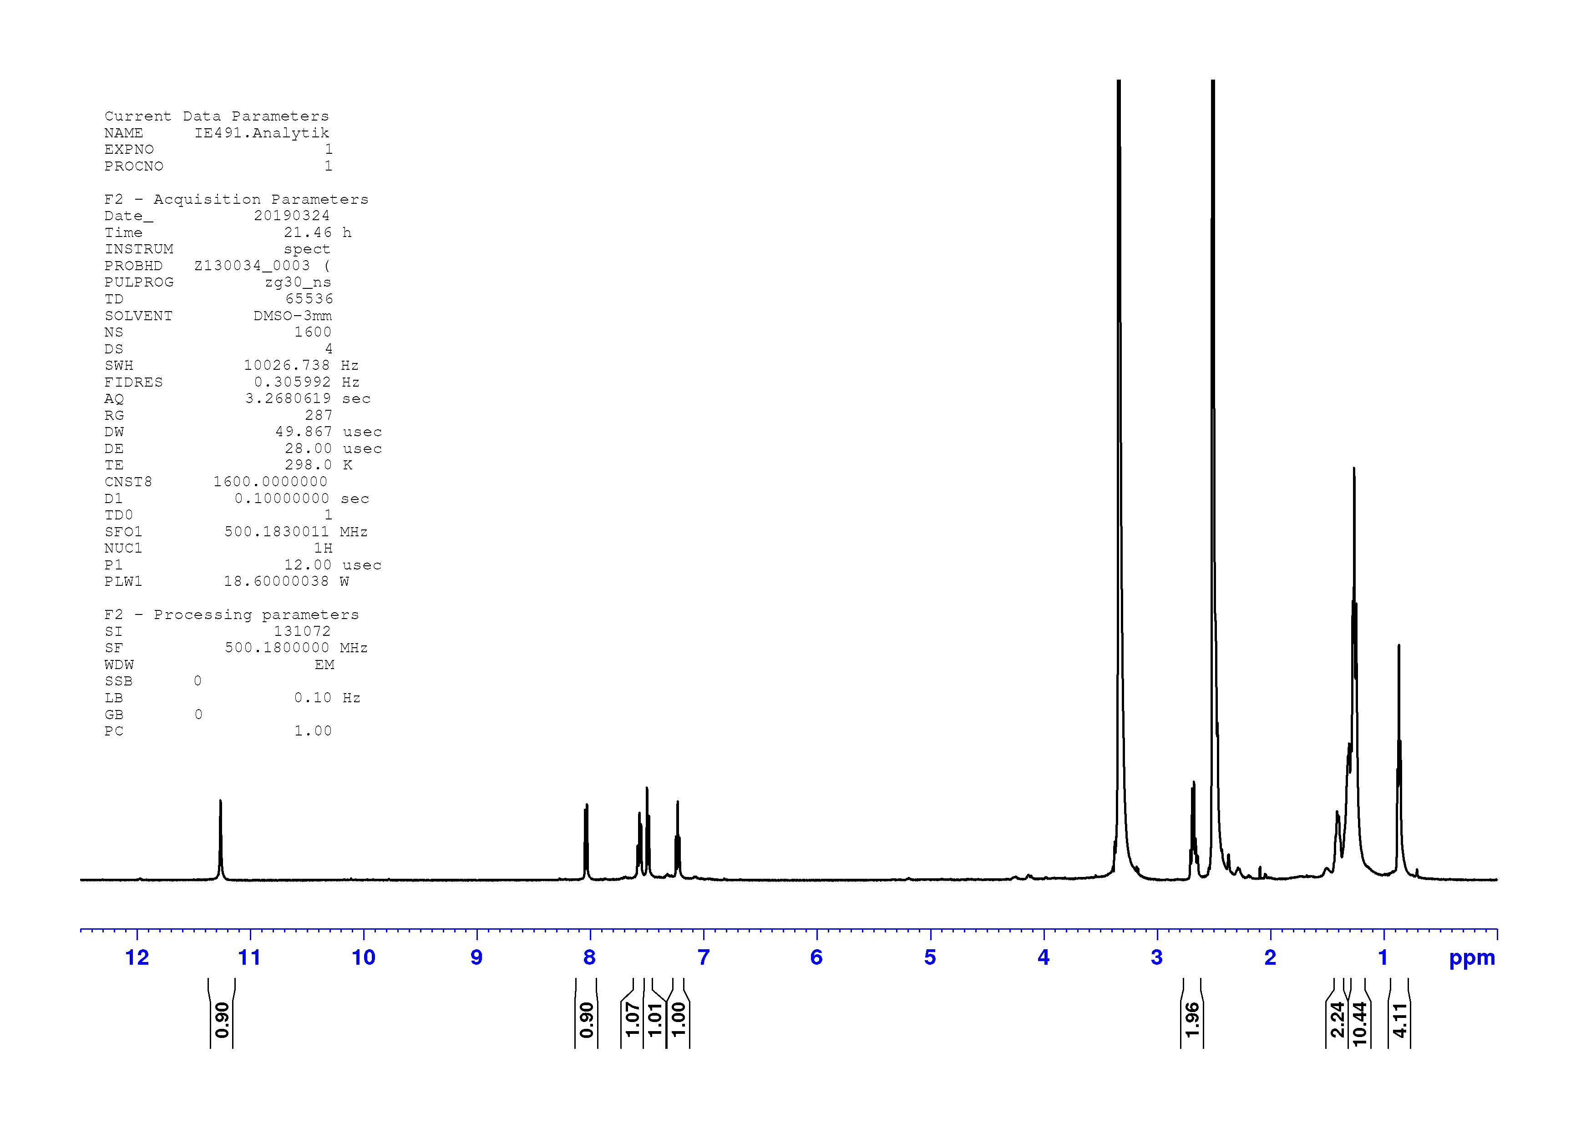
AD7-1*

References

1. Dejon, L. & Speicher, A. Synthesis of aurachin D and isoprenoid analogues from the myxobacterium Stigmatella aurantiaca. Tetrahedron Lett. 54, 6700–6702 (2013).

