SUPPLEMENTARY FIGURES

Zooplankton diversity monitoring strategy for the urban coastal region using metabarcoding analysis

Chi-une Song¹, Hyeongwoo Choi¹, Min-Seung Jeon¹, Eun-Jeong Kim¹, Sung Kim², Choong-gon Kim², Hyenjung Hwang², Dayu Wiyati Purnaningtyas^{2,3}, Seok Lee, Seong-il Eyun^{1*}, Youn-Ho Lee^{2*}

¹Department of Life Science, Chung-Ang University, Seoul 06974, Korea
²Korea Institute of Ocean Science and Technology, Busan 49111, Korea
³KIOST School, University of Science and Technology, Busan 49111, Korea

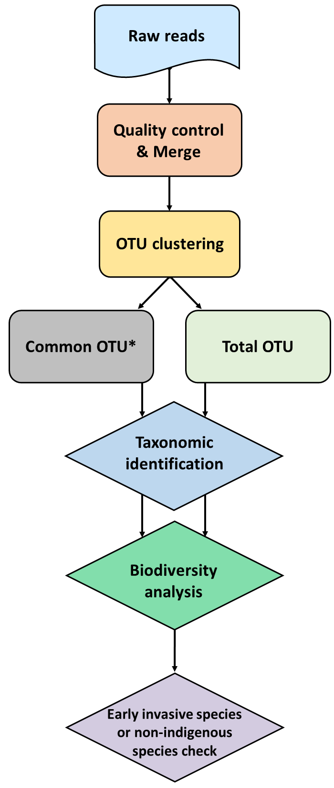

Figure S1. Schematic Flowchart of the metagenomics analysis in this study.

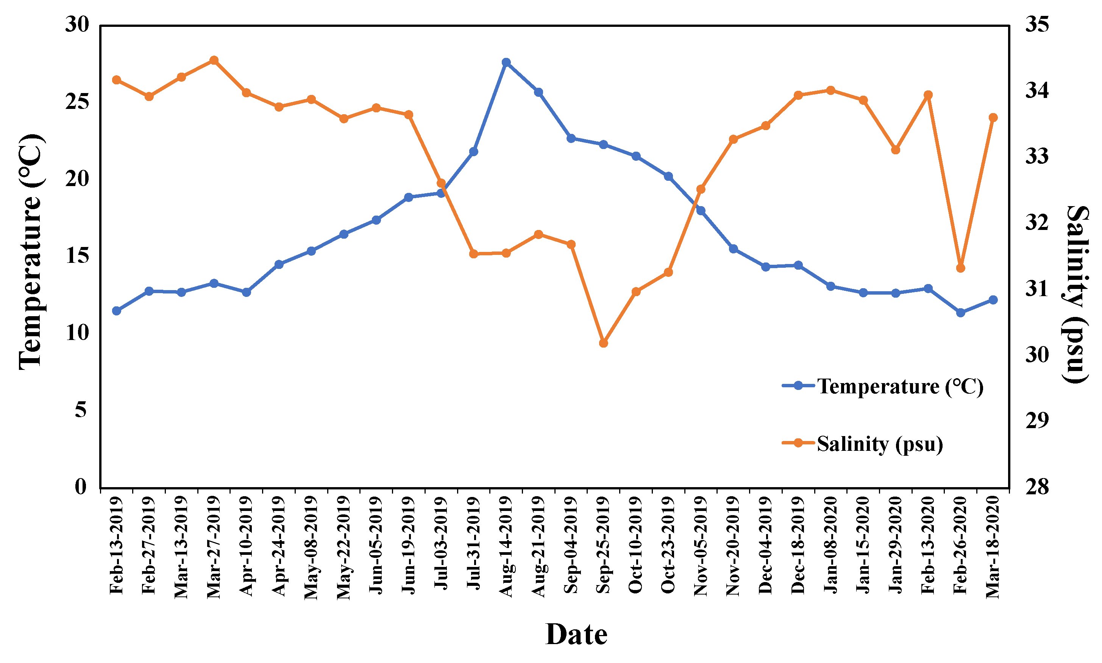

Figure S2. Temporal distribution of the environmental conditions. The blue marks and lines indicate temperature (℃) and orange indicates salinity (psu).
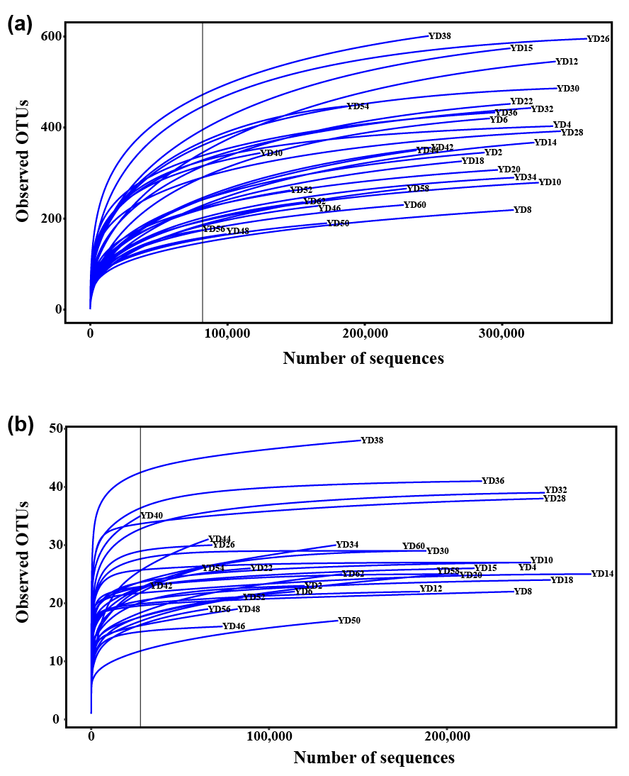

Figure S3. Rarefaction curve for “common zooplankton” and “total zooplankton” samples. (a) Rarefaction curve for “total zooplankton” sample with OTU level. (b) “Common zooplankton” samples for zooplankton level. Black vertical lines indicate the minimum sample size. Figures were produced using R (v4.0.3, https://www.R-project.org).
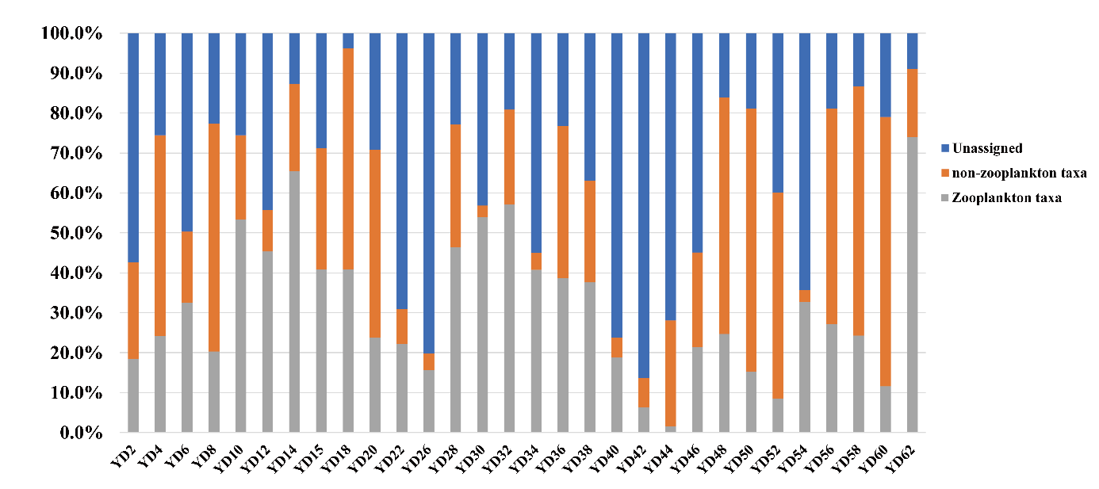

Figure S4. Proportion of reads for the zooplankton communities. Figures were produced using R (v4.0.3, https://www.R-project.org).

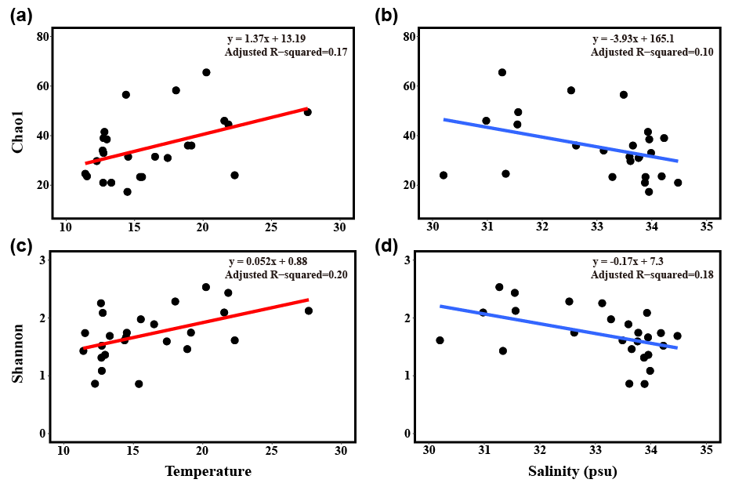

Figure S5. Linear correlation between the α-diversity index and environmental conditions. (a) Chao1 index and temperature. (b) Chao1 index and salinity. (c) Shannon index and temperature. (d) Shannon index and salinity. Regression equations and the adjusted R² values are shown in the plot. Figures were produced using R (v4.0.3, https://www.R-project.org).

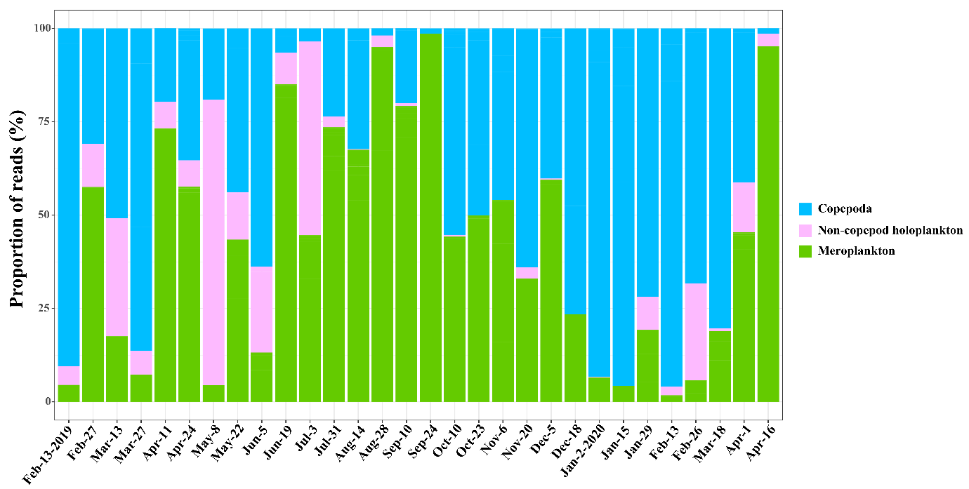

Figure S6. Seasonal pattern of the three main groups (copepods, meroplankton, and non-copepod holoplankton). Figures were produced using R (v4.0.3, https://www.R-project.org).

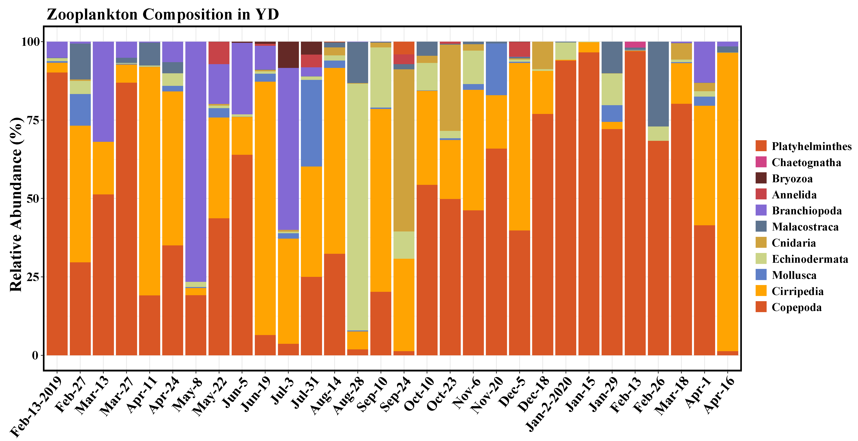

Figure S7. Taxonomic composition of zooplankton for 30 “common zooplankton” samples with 11 taxonomic groups. The relative abundances were calculated as the proportion of corresponding group’s read counts to the total number of reads in the samples. Figures were produced using R (v4.0.3, https://www.R-project.org).
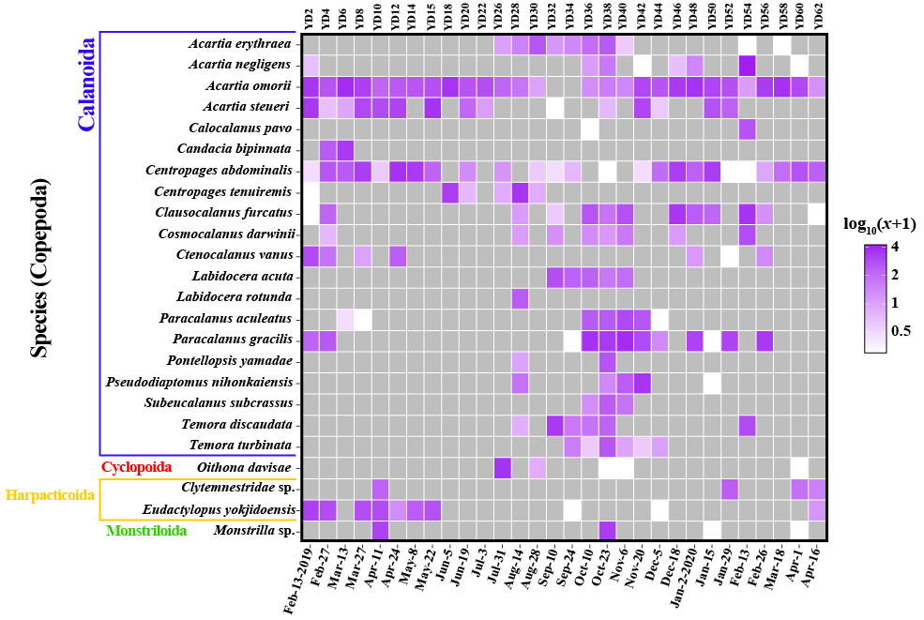

Figure S8. Heatmap of subclass Copepoda for common species. Each read count is transformed log₁₀(abundance+1). The colors indicate relative abundance from high (purple) to low (white) and gray is 0. Figures were produced using R (v4.0.3, https://www.R-project.org).

