Integrated bioinformatics and network pharmacology to identify the therapeutic target and molecular mechanisms of Huangqin Decoction on Ulcerative Colitis
Yi Wu^{a,b,*} Xinqiao Liuª Guiwei Li ª
ª First Teaching Hospital of Tianjin University of Traditional Chinese Medicine Tianjin 300000
^{b} National Clinical Research Center for Chinese Medicine Acupuncture and Moxibustion Tianjin 300000
*Corresponding author: Yi Wu
- mail：wuyi_96@qq.com
Phone: +86 18202246621
Supplementary tables:
Table S1. Active components of HQD
MOL ID | Molecule name | OB  (%) | DL | Molecular  Structure | Herb
MOL001689 | acacetin | 34.97 | 0.24 | 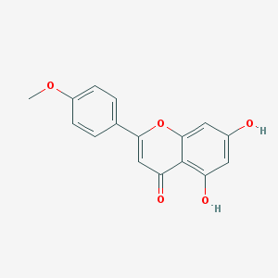 | SR
MOL000173 | wogonin | 30.68 | 0.23 | 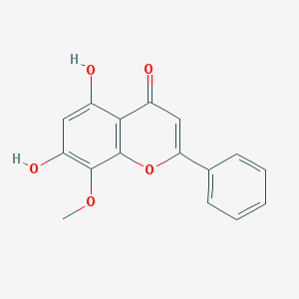 | SR
MOL000228 | (2R)-7-hydroxy-5-methoxy-2-phenylchroman-4-one | 55.23 | 0.2 | 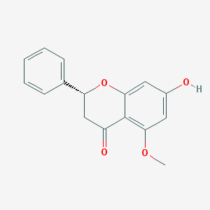 | SR
MOL002714 | baicalein | 33.52 | 0.21 | 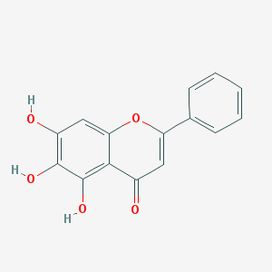 | SR
MOL002908 | 5,8,2'-Trihydroxy-7-methoxyflavone | 37.01 | 0.27 | 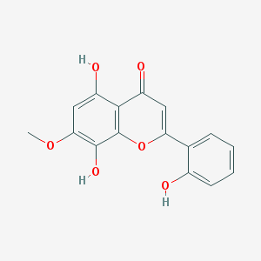 | SR
MOL002909 | 5,7,2,5-tetrahydroxy-8,6-dimethoxyflavone | 33.82 | 0.45 | 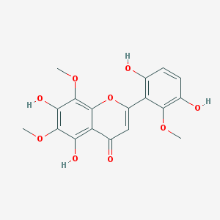 | SR
MOL002910 | Carthamidin | 41.15 | 0.24 | 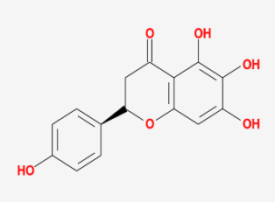 | SR
MOL002911 | 2,6,2',4'-tetrahydroxy-6'-methoxychaleone | 69.04 | 0.22 | 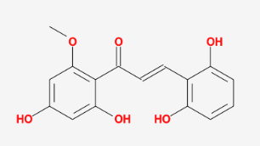 | SR
MOL002913 | Dihydrobaicalin_qt | 40.04 | 0.21 | 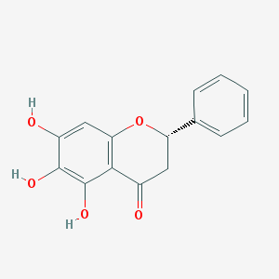 | SR
MOL002914 | Eriodyctiol (flavanone) | 41.35 | 0.24 | 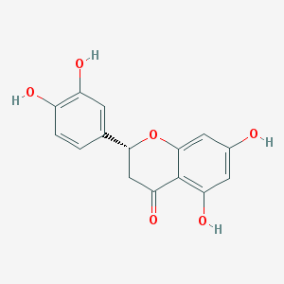 | SR
MOL002915 | Salvigenin | 49.07 | 0.33 | 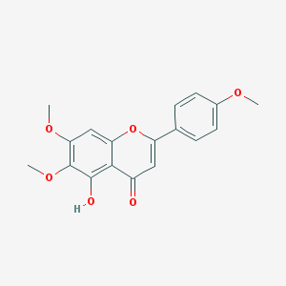 | SR
MOL002917 | 5,2',6'-Trihydroxy-7,8-dimethoxyflavone | 45.05 | 0.33 | 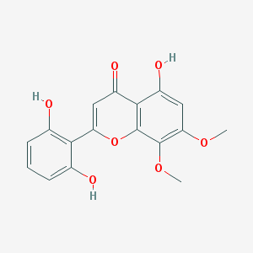 | SR
MOL002925 | 5,7,2',6'-Tetrahydroxyflavone | 37.01 | 0.24 | 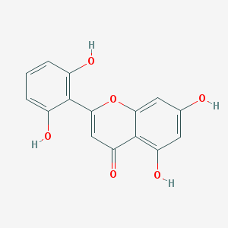 | SR
MOL002926 | dihydrooroxylin A | 38.72 | 0.23 | 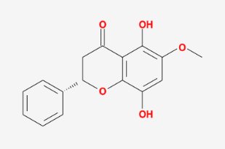 | SR
MOL002927 | Skullcapflavone II | 69.51 | 0.44 | 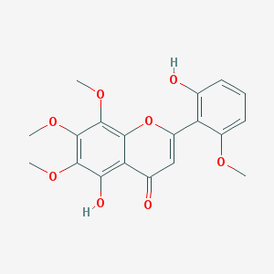 | SR
MOL002928 | oroxylin a | 41.37 | 0.23 | 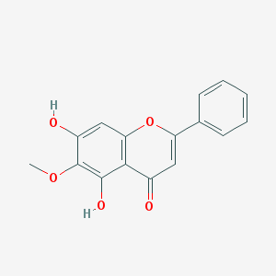 | SR
MOL002932 | Panicolin | 76.26 | 0.29 | 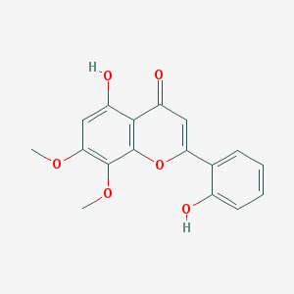 | SR
MOL002933 | 5,7,4'-Trihydroxy-8-methoxyflavone | 36.56 | 0.27 | 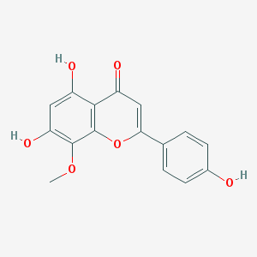 | SR
MOL002934 | NEOBAICALEIN | 104.34 | 0.44 | 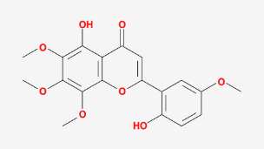 | SR
MOL002937 | DIHYDROOROXYLIN | 66.06 | 0.23 | 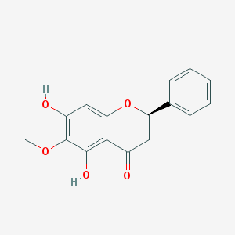 | SR
MOL000358 | beta-sitosterol | 36.91 | 0.75 | 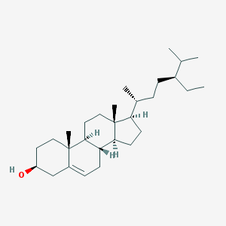 | SR,  PRA,  JF
MOL000359 | sitosterol | 36.91 | 0.75 | 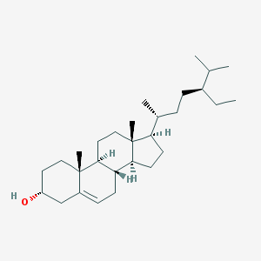 | SR,  PRA,  GL
MOL000525 | Norwogonin | 39.4 | 0.21 | 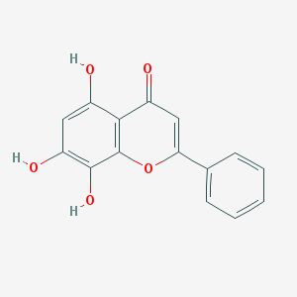 | SR
MOL000552 | 5,2'-Dihydroxy-6,7,8-trimethoxyflavone | 31.71 | 0.35 | 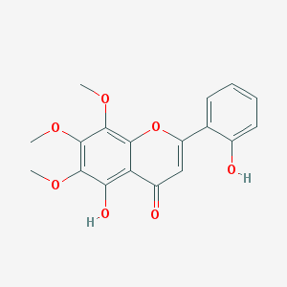 | SR
MOL000073 | ent-Epicatechin | 48.96 | 0.24 | 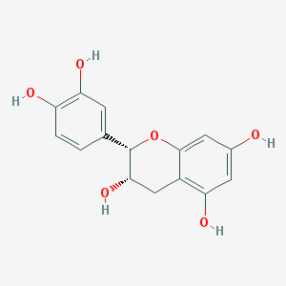 | SR
MOL000449 | Stigmasterol | 43.83 | 0.76 | 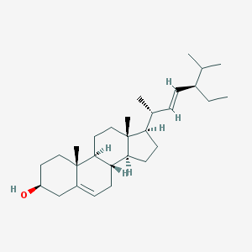 | SR,  JF
MOL001458 | coptisine | 30.67 | 0.86 | 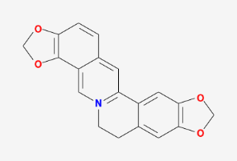 | SR
MOL001490 | bis[(2S)-2-ethylhexyl] benzene-1,2-dicarboxylate | 43.59 | 0.35 | 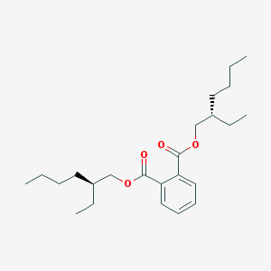 | SR
MOL001506 | Supraene | 33.55 | 0.42 | 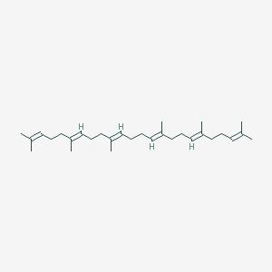 | SR
MOL002879 | Diop | 43.59 | 0.39 | 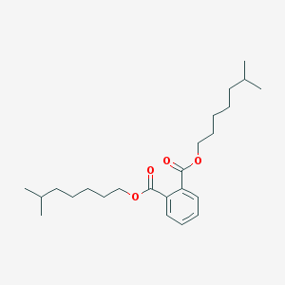 | SR
MOL002897 | epiberberine | 43.09 | 0.78 | 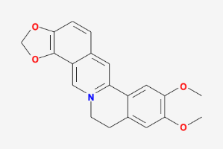 | SR
MOL008206 | Moslosooflavone | 44.09 | 0.25 | 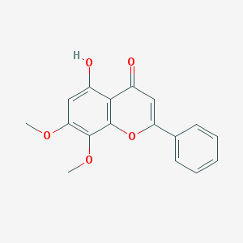 | SR
MOL010415 | 11,13-Eicosadienoic acid, methyl ester | 39.28 | 0.23 | 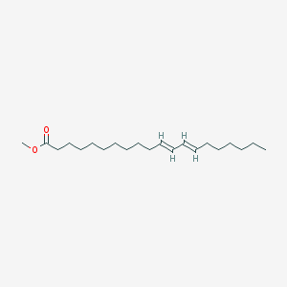 | SR
MOL012245 | 5,7,4'-trihydroxy-6-methoxyflavanone | 36.63 | 0.27 | 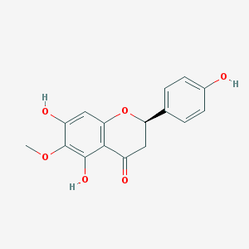 | SR
MOL012246 | 5,7,4'-trihydroxy-8-methoxyflavanone | 74.24 | 0.26 | 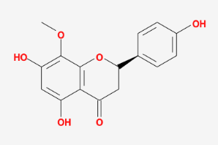 | SR
MOL012266 | rivularin | 37.94 | 0.37 | 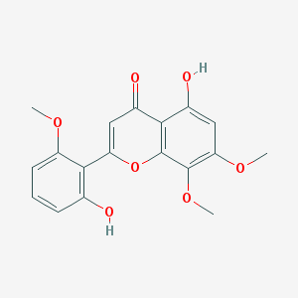 | SR
MOL001910 | 11alpha,12alpha-epoxy-3beta-23-dihydroxy-30-norolean-20-en-28,12beta-olide | 64.77 | 0.38 | 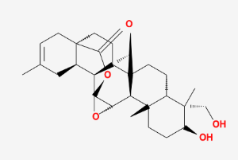 | PRA
MOL001918 | paeoniflorgenone | 87.59 | 0.37 | 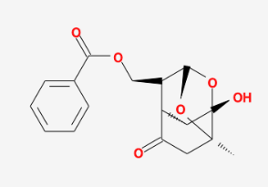 | PRA
MOL001919 | (3S,5R,8R,9R,10S,14S)-3,17-dihydroxy-4,4,8,10,14-pentamethyl-2,3,5,6,7,9-hexahydro-1H-cyclopenta[a]phenanthrene-15,16-dione | 43.56 | 0.53 | 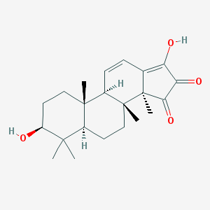 | PRA
MOL001921 | Lactiflorin | 49.12 | 0.8 | 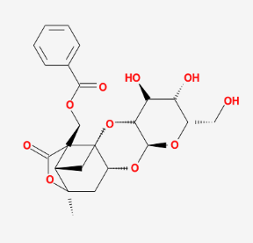 | PRA
MOL001924 | paeoniflorin | 53.87 | 0.79 | 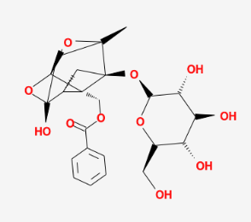 | PRA
MOL001925 | paeoniflorin_qt | 68.18 | 0.4 | 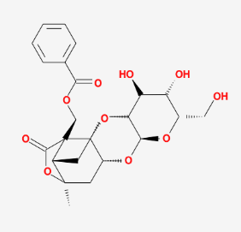 | PRA
MOL001928 | albiflorin_qt | 66.64 | 0.33 | 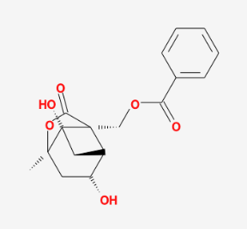 | PRA
MOL001930 | benzoyl paeoniflorin | 31.27 | 0.75 | 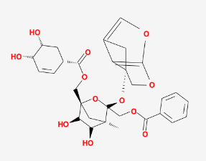 | PRA
MOL000211 | Mairin | 55.38 | 0.78 | 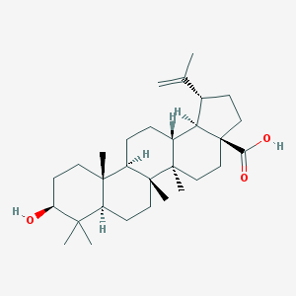 | PRA,  JF,  GL
MOL000422 | kaempferol | 41.88 | 0.24 | 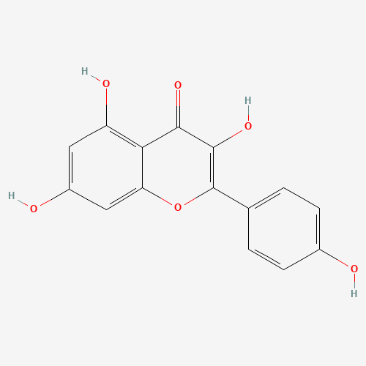 | PRA,  GL
MOL000492 | (+)-catechin | 54.83 | 0.24 | 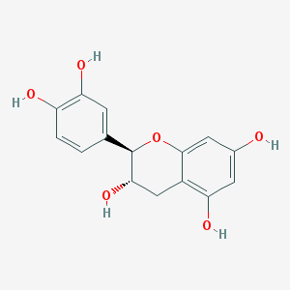 | PRA,  JF
MOL012921 | stepharine | 31.55 | 0.33 | 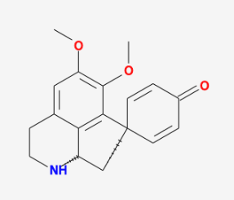 | JF
MOL012940 | Spiradine A | 113.52 | 0.61 | 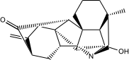 | JF
MOL012946 | zizyphus saponin I_qt | 32.69 | 0.62 | 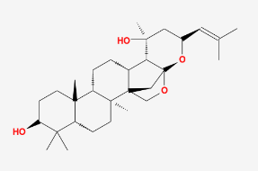 | JF
MOL012961 | jujuboside A_qt | 36.67 | 0.62 | 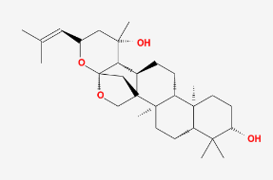 | JF
MOL012976 | coumestrol | 32.49 | 0.34 | 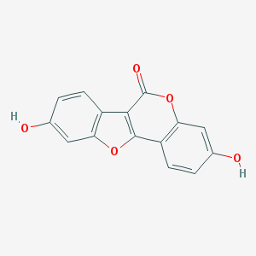 | JF
MOL012980 | Daechuine S6 | 46.48 | 0.79 | 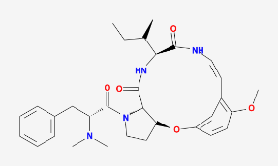 | JF
MOL012981 | Daechuine S7 | 44.82 | 0.83 | 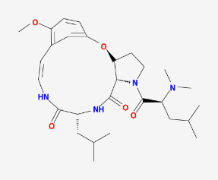 | JF
MOL012986 | Jujubasaponin V_qt | 36.99 | 0.63 | 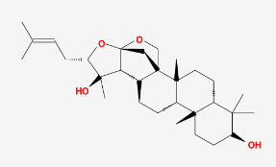 | JF
MOL012989 | Jujuboside C_qt | 40.26 | 0.62 | 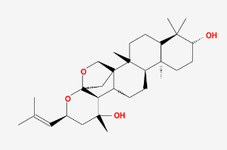 | JF
MOL012992 | Mauritine D | 89.13 | 0.45 | 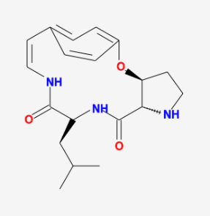 | JF
MOL001454 | berberine | 36.86 | 0.78 | 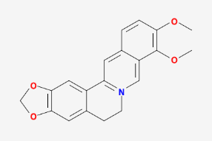 | JF
MOL001522 | (S)-Coclaurine | 42.35 | 0.24 | 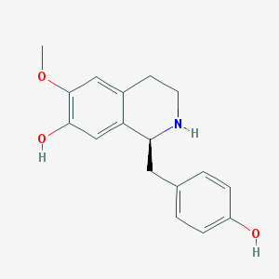 | JF
MOL003410 | Ziziphin_qt | 66.95 | 0.62 | 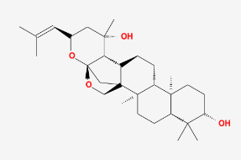 | JF
MOL004350 | Ruvoside_qt | 36.12 | 0.76 | 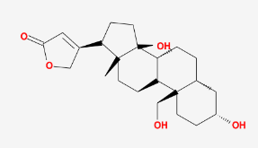 | JF
MOL000492 | (+)-catechin | 54.83 | 0.24 |  | JF
MOL005360 | malkangunin | 57.71 | 0.63 | 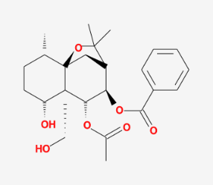 | JF
MOL000627 | Stepholidine | 33.11 | 0.54 | 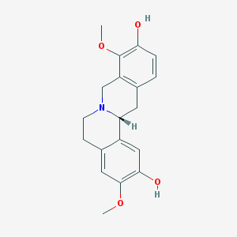 | JF
MOL007213 | Nuciferin | 34.43 | 0.4 | 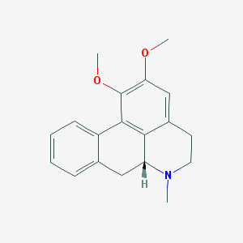 | JF
MOL000783 | Protoporphyrin | 30.86 | 0.56 | 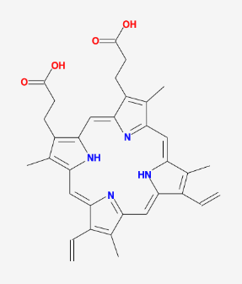 | JF
MOL000787 | Fumarine | 59.26 | 0.83 | 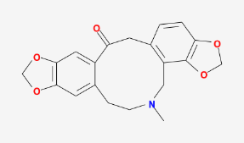 | JF
MOL008034 | 21302-79-4 | 73.52 | 0.77 | 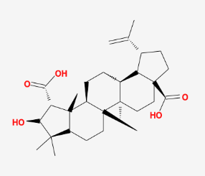 | JF
MOL008647 | Moupinamide | 86.71 | 0.26 | 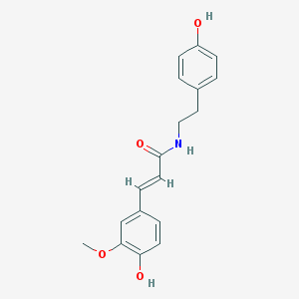 | JF
MOL002773 | beta-carotene | 37.18 | 0.58 | 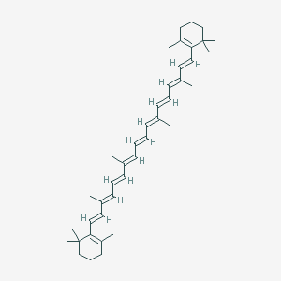 | JF
MOL000096 | (-)-catechin | 49.68 | 0.24 | 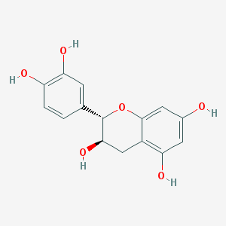 | JF
MOL000098 | quercetin | 46.43 | 0.28 | 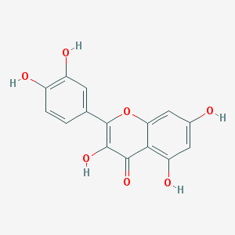 | JF,  GL
MOL013357 | (3S,6R,8S,9S,10R,13R,14S,17R)-17-[(1R,4R)-4-ethyl-1,5-dimethylhexyl]-10,13-dimethyl-2,3,6,7,8,9,11,12,14,15,16,17-dodecahydro-1H-cyclopenta[a]phenanthrene-3,6-diol | 34.37 | 0.78 | 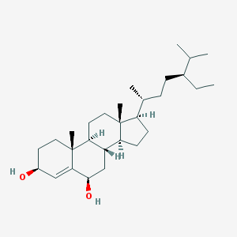 | JF
MOL001484 | Inermine | 75.18 | 0.54 | 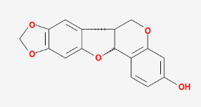 | GL
MOL001792 | DFV | 32.76 | 0.18 | 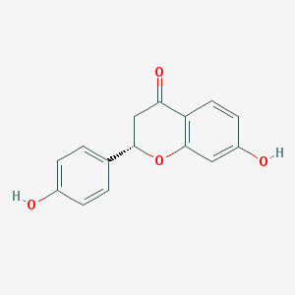 | GL
MOL002311 | Glycyrol | 90.78 | 0.67 | 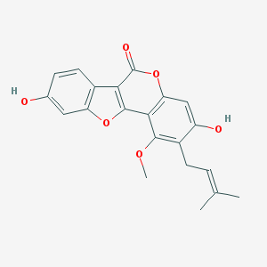 | GL
MOL000239 | Jaranol | 50.83 | 0.29 | 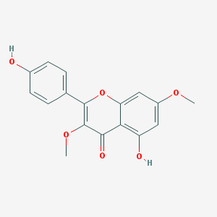 | GL
MOL002565 | Medicarpin | 49.22 | 0.34 | 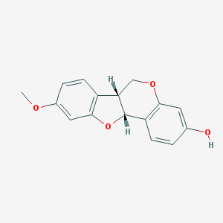 | GL
MOL000354 | isorhamnetin | 49.6 | 0.31 | 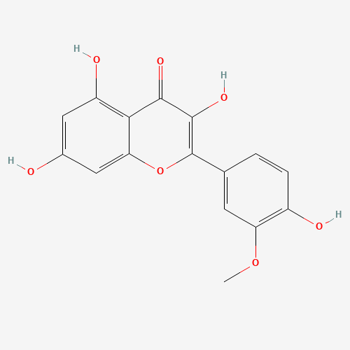 | GL
MOL003656 | Lupiwighteone | 51.64 | 0.37 | 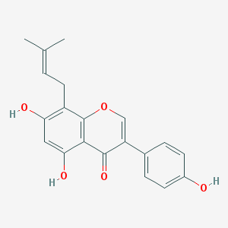 | GL
MOL003896 | 7-Methoxy-2-methyl isoflavone | 42.56 | 0.2 | 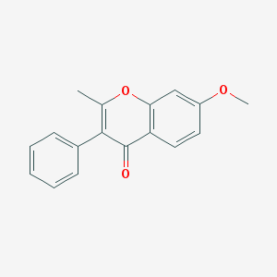 | GL
MOL000392 | formononetin | 69.67 | 0.21 | 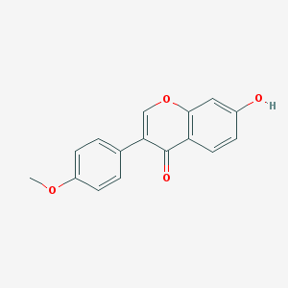 | GL
MOL000417 | Calycosin | 47.75 | 0.24 | 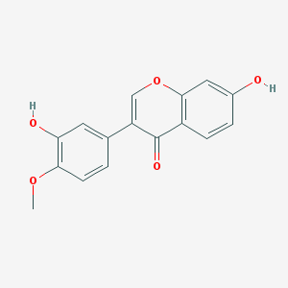 | GL
MOL004328 | naringenin | 59.29 | 0.21 | 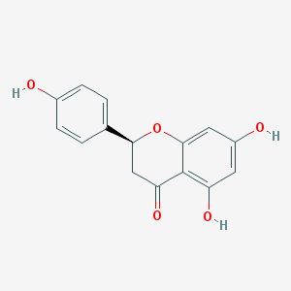 | GL
MOL004805 | (2S)-2-[4-hydroxy-3-(3-methylbut-2-enyl)phenyl]-8,8-dimethyl-2,3-dihydropyrano[2,3-f]chromen-4-one | 31.79 | 0.72 | 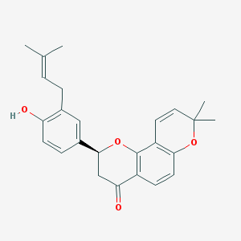 | GL
MOL004806 | euchrenone | 30.29 | 0.57 | 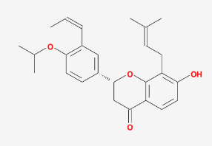 | GL
MOL004808 | glyasperin B | 65.22 | 0.44 | 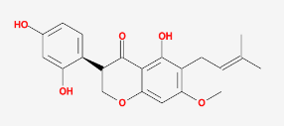 | GL
MOL004810 | glyasperin F | 75.84 | 0.54 | 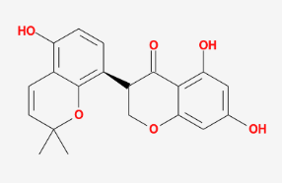 | GL
MOL004811 | Glyasperin C | 45.56 | 0.4 | 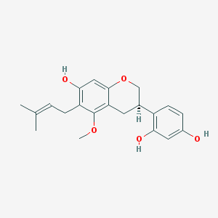 | GL
MOL004814 | Isotrifoliol | 31.94 | 0.42 | 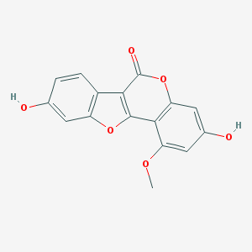 | GL
MOL004815 | (E)-1-(2,4-dihydroxyphenyl)-3-(2,2-dimethylchromen-6-yl)prop-2-en-1-one | 39.62 | 0.35 | 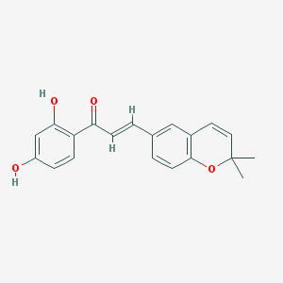 | GL
MOL004820 | kanzonols W | 50.48 | 0.52 | 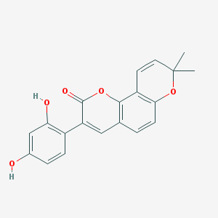 | GL
MOL004824 | (2S)-6-(2,4-dihydroxyphenyl)-2-(2-hydroxypropan-2-yl)-4-methoxy-2,3-dihydrofuro[3,2-g]chromen-7-one | 60.25 | 0.63 | 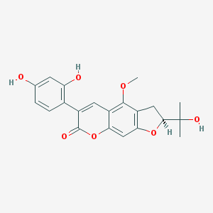 | GL
MOL004827 | Semilicoisoflavone B | 48.78 | 0.55 | 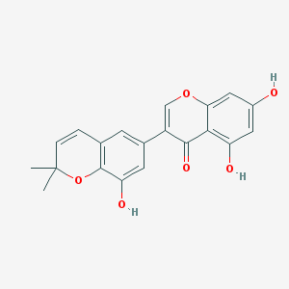 | GL
MOL004828 | Glepidotin A | 44.72 | 0.35 | 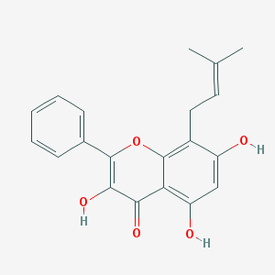 | GL
MOL004829 | Glepidotin B | 64.46 | 0.34 | 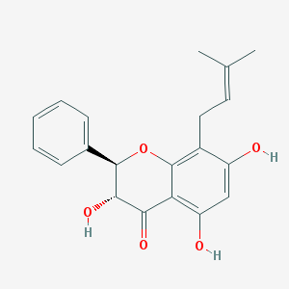 | GL
MOL004833 | Phaseolinisoflavan | 32.01 | 0.45 | 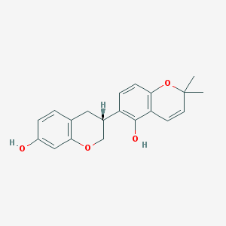 | GL
MOL004835 | Glypallichalcone | 61.6 | 0.19 | 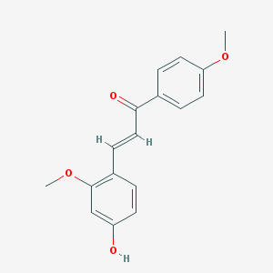 | GL
MOL004838 | 8-(6-hydroxy-2-benzofuranyl)-2,2-dimethyl-5-chromenol | 58.44 | 0.38 | 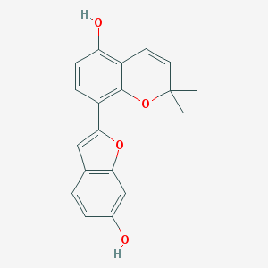 | GL
MOL004841 | Licochalcone B | 76.76 | 0.19 | 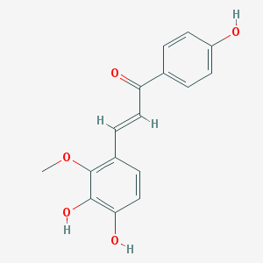 | GL
MOL004848 | licochalcone G | 49.25 | 0.32 | 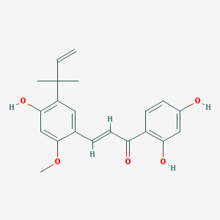 | GL
MOL004849 | 3-(2,4-dihydroxyphenyl)-8-(1,1-dimethylprop-2-enyl)-7-hydroxy-5-methoxy-coumarin | 59.62 | 0.43 | 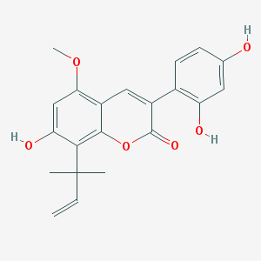 | GL
MOL004855 | Licoricone | 63.58 | 0.47 | 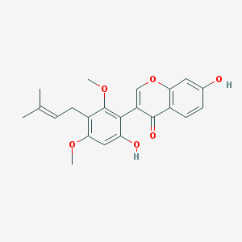 | GL
MOL004856 | Gancaonin A | 51.08 | 0.4 | 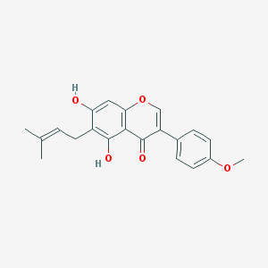 | GL
MOL004857 | Gancaonin B | 48.79 | 0.45 | 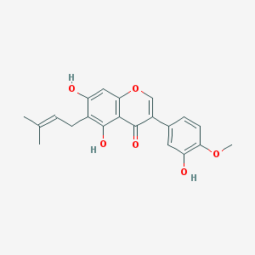 | GL
MOL004860 | licorice glycoside E | 32.89 | 0.27 | 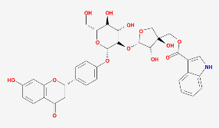 | GL
MOL004863 | 3-(3,4-dihydroxyphenyl)-5,7-dihydroxy-8-(3-methylbut-2-enyl)chromone | 66.37 | 0.41 | 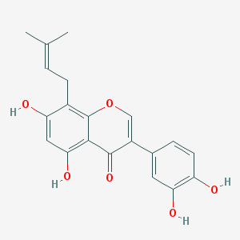 | GL
MOL004864 | 5,7-dihydroxy-3-(4-methoxyphenyl)-8-(3-methylbut-2-enyl)chromone | 30.49 | 0.41 | 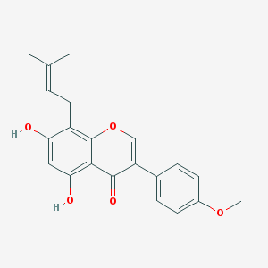 | GL
MOL004866 | 2-(3,4-dihydroxyphenyl)-5,7-dihydroxy-6-(3-methylbut-2-enyl)chromone | 44.15 | 0.41 | 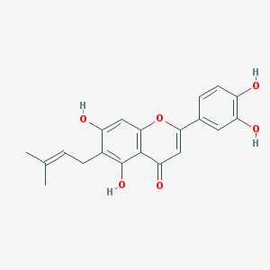 | GL
MOL004879 | Glycyrin | 52.61 | 0.47 | 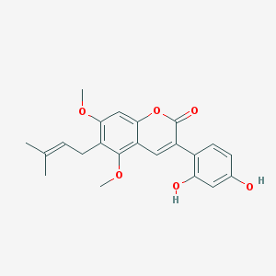 | GL
MOL004882 | Licocoumarone | 33.21 | 0.36 | 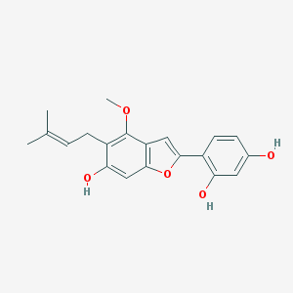 | GL
MOL004883 | Licoisoflavone | 41.61 | 0.42 | 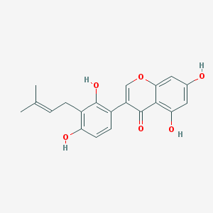 | GL
MOL004884 | Licoisoflavone B | 38.93 | 0.55 | 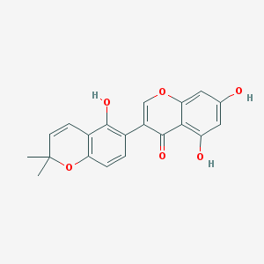 | GL
MOL004885 | licoisoflavanone | 52.47 | 0.54 | 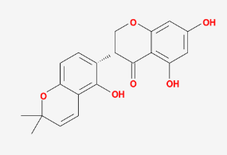 | GL
MOL004891 | shinpterocarpin | 80.3 | 0.73 | 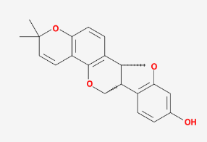 | GL
MOL004898 | (E)-3-[3,4-dihydroxy-5-(3-methylbut-2-enyl)phenyl]-1-(2,4-dihydroxyphenyl)prop-2-en-1-one | 46.27 | 0.31 | 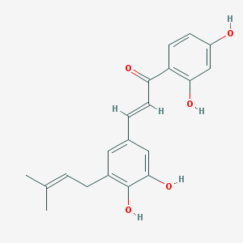 | GL
MOL004903 | liquiritin | 65.69 | 0.74 | 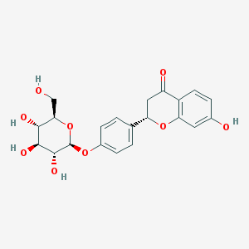 | GL
MOL004904 | licopyranocoumarin | 80.36 | 0.65 | 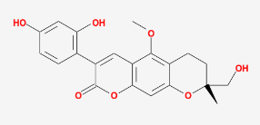 | GL
MOL004905 | 3,22-Dihydroxy-11-oxo-delta(12)-oleanene-27-alpha-methoxycarbonyl-29-oic acid | 34.32 | 0.55 | 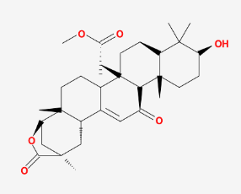 | GL
MOL004907 | Glyzaglabrin | 61.07 | 0.35 | 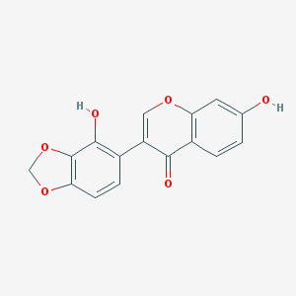 | GL
MOL004908 | Glabridin | 53.25 | 0.47 | 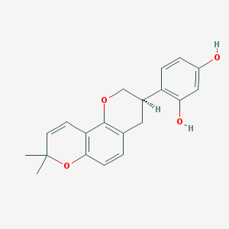 | GL
MOL004910 | Glabranin | 52.9 | 0.31 | 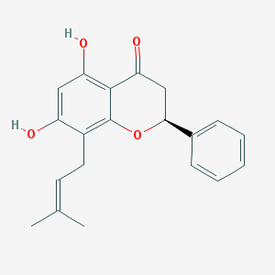 | GL
MOL004911 | Glabrene | 46.27 | 0.44 | 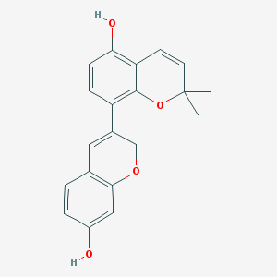 | GL
MOL004912 | Glabrone | 52.51 | 0.5 | 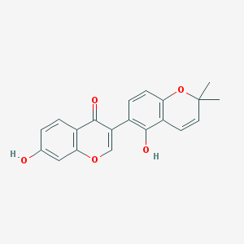 | GL
MOL004913 | 1,3-dihydroxy-9-methoxy-6-benzofurano[3,2-c]chromenone | 48.14 | 0.43 | 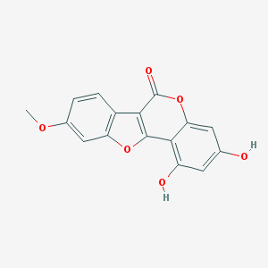 | GL
MOL004914 | 1,3-dihydroxy-8,9-dimethoxy-6-benzofurano[3,2-c]chromenone | 62.9 | 0.53 | 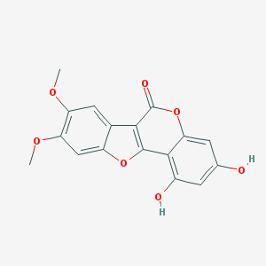 | GL
MOL004915 | Eurycarpin A | 43.28 | 0.37 | 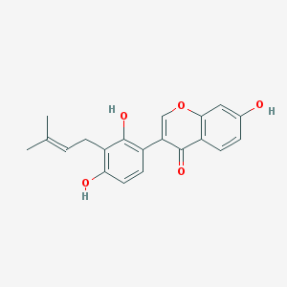 | GL
MOL004917 | glycyroside | 37.25 | 0.79 | 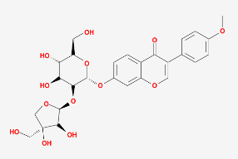 | GL
MOL004924 | (-)-Medicocarpin | 40.99 | 0.95 | 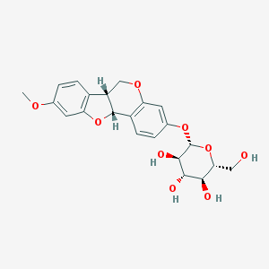 | GL
MOL004935 | Sigmoidin-B | 34.88 | 0.41 | 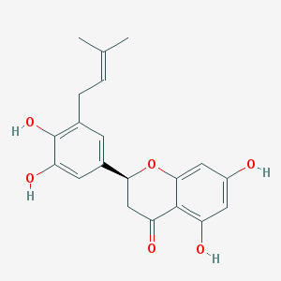 | GL
MOL004941 | (2R)-7-hydroxy-2-(4-hydroxyphenyl)chroman-4-one | 71.12 | 0.18 | 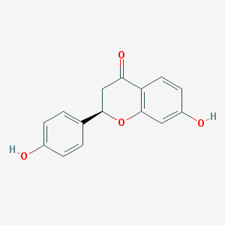 | GL
MOL004945 | (2S)-7-hydroxy-2-(4-hydroxyphenyl)-8-(3-methylbut-2-enyl)chroman-4-one | 36.57 | 0.32 | 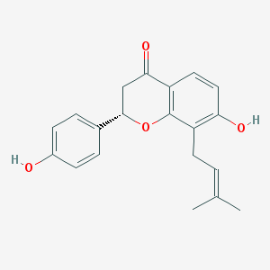 | GL
MOL004948 | Isoglycyrol | 44.7 | 0.84 | 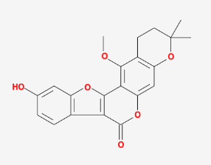 | GL
MOL004949 | Isolicoflavonol | 45.17 | 0.42 | 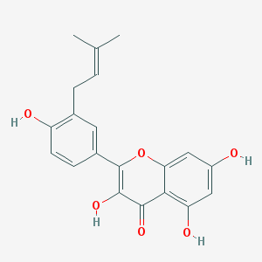 | GL
MOL004957 | HMO | 38.37 | 0.21 | 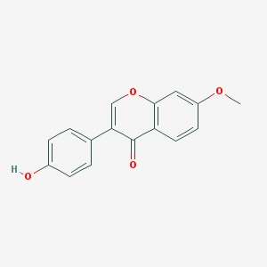 | GL
MOL004959 | 1-Methoxyphaseollidin | 69.98 | 0.64 | 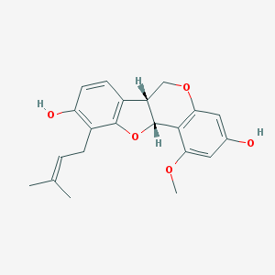 | GL
MOL004961 | Quercetin der. | 46.45 | 0.33 | 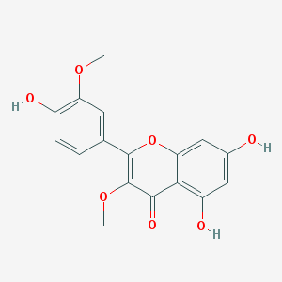 | GL
MOL004966 | 3'-Hydroxy-4'-O-Methylglabridin | 43.71 | 0.57 | 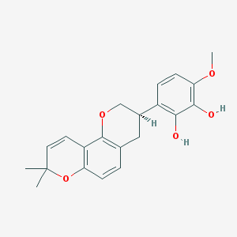 | GL
MOL000497 | licochalcone a | 40.79 | 0.29 | 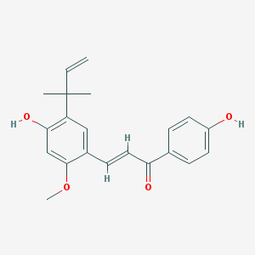 | GL
MOL004974 | 3'-Methoxyglabridin | 46.16 | 0.57 | 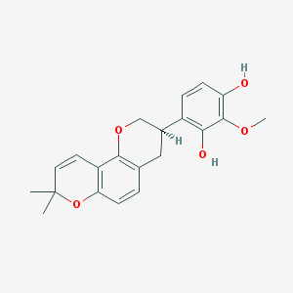 | GL
MOL004978 | 2-[(3R)-8,8-dimethyl-3,4-dihydro-2H-pyrano[6,5-f]chromen-3-yl]-5-methoxyphenol | 36.21 | 0.52 | 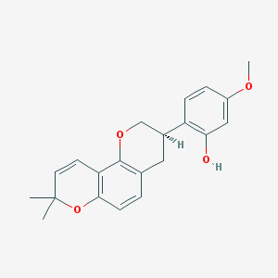 | GL
MOL004980 | Inflacoumarin A | 39.71 | 0.33 | 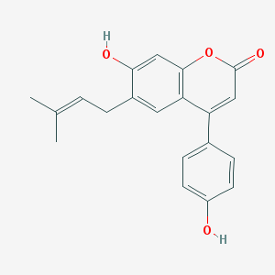 | GL
MOL004985 | icos-5-enoic acid | 30.7 | 0.2 | 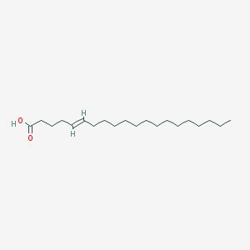 | GL
MOL004988 | Kanzonol F | 32.47 | 0.89 | 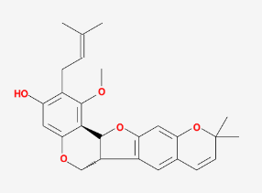 | GL
MOL004989 | 6-prenylated eriodictyol | 39.22 | 0.41 | 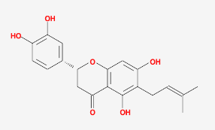 | GL
MOL004990 | 7,2',4'-trihydroxy－5-methoxy-3－arylcoumarin | 83.71 | 0.27 | 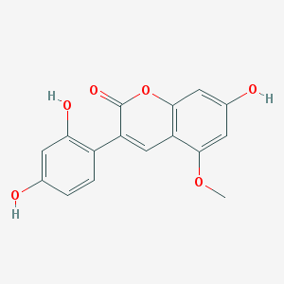 | GL
MOL004991 | 7-Acetoxy-2-methylisoflavone | 38.92 | 0.26 | 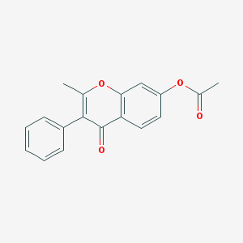 | GL
MOL004993 | 8-prenylated eriodictyol | 53.79 | 0.4 | 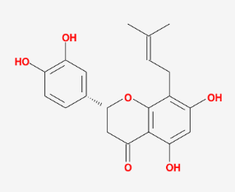 | GL
MOL004996 | gadelaidic acid | 30.7 | 0.2 | 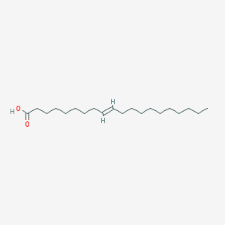 | GL
MOL000500 | Vestitol | 74.66 | 0.21 | 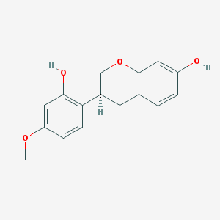 | GL
MOL005000 | Gancaonin G | 60.44 | 0.39 | 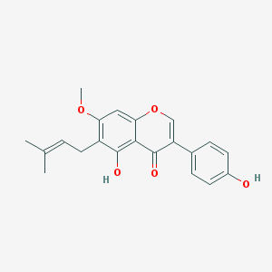 | GL
MOL005001 | Gancaonin H | 50.1 | 0.78 | 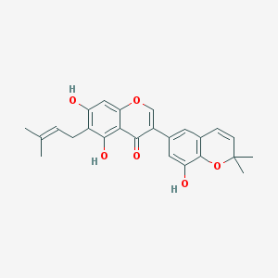 | GL
MOL005003 | Licoagrocarpin | 58.81 | 0.58 | 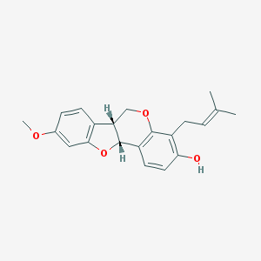 | GL
MOL005007 | Glyasperins M | 72.67 | 0.59 | 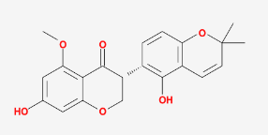 | GL
MOL005008 | Glycyrrhiza flavonol A | 41.28 | 0.6 | 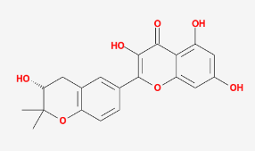 | GL
MOL005012 | Licoagroisoflavone | 57.28 | 0.49 | 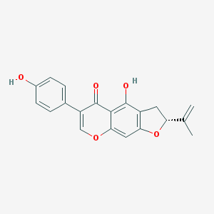 | GL
MOL005013 | 18α-hydroxyglycyrrhetic acid | 41.16 | 0.71 | 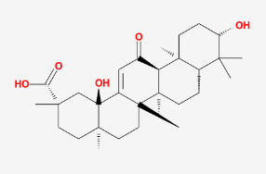 | GL
MOL005016 | Odoratin | 49.95 | 0.3 | 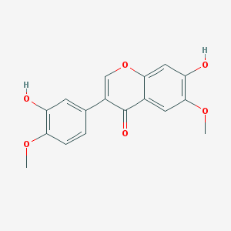 | GL
MOL005017 | Phaseol | 78.77 | 0.58 | 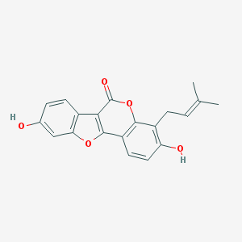 | GL
MOL005018 | Xambioona | 54.85 | 0.87 | 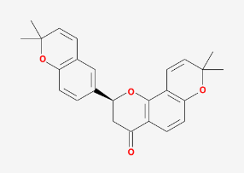 | GL
MOL005020 | dehydroglyasperins C | 53.82 | 0.37 | 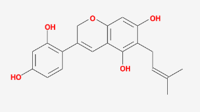 | GL
MOL000098 | quercetin | 46.43 | 0.28 |  | GL

Table S2. Upregulated and downregulated genes in DEGs
Upregulated genes | adj.P.Val | logFC
GABRP | 8.04E-34 | 3.177064
SLC6A14 | 1.26E-32 | 5.036665
MMP7 | 2.85E-31 | 4.840438
CHI3L1 | 2.98E-31 | 4.52905
CXCR6 | 4.4E-31 | 1.279379
PECAM1 | 2.28E-30 | 1.097425
DUOX2 | 2.39E-30 | 4.098422
PARP8 | 2.97E-30 | 1.465191
LMAN1 | 9.22E-30 | 1.747889
UBE2L6 | 1.07E-29 | 1.14
C2 | 1.53E-29 | 1.693065
CXCL1 | 2.23E-29 | 3.239323
CD55 | 2.39E-29 | 1.628693
HLA-DMA | 3.48E-29 | 1.200115
LPCAT1 | 4.59E-29 | 1.473197
DUOXA2 | 6.24E-29 | 4.184928
TIMP1 | 6.99E-29 | 1.922829
VNN1 | 9.62E-29 | 4.214382
KYNU | 1.43E-28 | 2.608016
OLFML2B | 2.16E-28 | 2.001578
CEP112 | 4.87E-28 | 1.59049
FEZ1 | 7.62E-28 | 1.8292
CTSK | 8.52E-28 | 1.418005
PSMB9 | 1.25E-27 | 1.025861
PMEPA1 | 2.07E-27 | 1.158377
PLA1A | 2.16E-27 | 2.345466
GBP4 | 2.38E-27 | 1.638995
IFNG | 2.55E-27 | 2.161213
CXCL1 | 3.79E-27 | 2.812999
CD44 | 3.81E-27 | 1.235131
IFI44 | 6.66E-27 | 1.399831
FSTL1 | 8.44E-27 | 1.069115
RBPMS | 8.44E-27 | 1.473072
DAPP1 | 8.5E-27 | 2.102443
SAA1 | 9.94E-27 | 4.222814
PDE4B | 1.17E-26 | 1.980138
MGP | 1.61E-26 | 1.681287
SELP | 1.62E-26 | 2.377924
SAA1 | 1.74E-26 | 4.605455
FKBP11 | 2.33E-26 | 1.34343
IGHG1 | 2.39E-26 | 1.819643
BGN | 2.74E-26 | 1.910916
PCDH17 | 3.8E-26 | 2.221486
IGHG3 | 4.1E-26 | 2.163073
TGM2 | 4.48E-26 | 2.031049
TRIM22 | 5.13E-26 | 1.473744
ZFPM2 | 6E-26 | 1.692793
TMEM158 | 6.55E-26 | 1.690826
PIM2 | 6.58E-26 | 1.71802
MMP10 | 6.98E-26 | 4.300694
PRRX1 | 9.94E-26 | 2.974124
IKBIP | 1.04E-25 | 1.451263
FAP | 1.1E-25 | 2.721456
ROBO1 | 1.12E-25 | 1.132206
LST1 | 1.31E-25 | 1.041831
CFB | 1.67E-25 | 1.813111
GBP5 | 1.75E-25 | 2.209124
ARHGEF3 | 1.78E-25 | 1.125181
CHST3 | 2.02E-25 | 1.395368
MMP3 | 2.24E-25 | 4.787171
ROR2 | 2.36E-25 | 1.069094
ELK3 | 2.76E-25 | 1.193848
MTCL1 | 3.11E-25 | 1.786016
SLFN11 | 3.11E-25 | 1.101099
CXCL3 | 3.18E-25 | 2.588236
SLC6A6 | 3.18E-25 | 1.201819
MR1 | 3.31E-25 | 1.073987
IDO1 | 3.53E-25 | 3.081441
BACE2 | 3.8E-25 | 1.184828
RGS5 | 4.01E-25 | 1.743159
ASPHD2 | 4.01E-25 | 1.154301
PDZK1IP1 | 4.27E-25 | 1.637714
ARHGAP23 | 6.31E-25 | 1.335545
OSBPL3 | 7.46E-25 | 1.273451
CXCL8 | 7.77E-25 | 3.87441
CLCN4 | 8.31E-25 | 1.517615
XAF1 | 8.48E-25 | 1.012095
LPIN1 | 1.1E-24 | 1.025008
RPS6KA2 | 1.4E-24 | 1.121057
SULF1 | 1.46E-24 | 1.343226
IGFBP7 | 1.47E-24 | 1.527432
ENTPD1 | 1.78E-24 | 1.088933
C4BPB | 1.81E-24 | 2.158451
KLHL5 | 2.52E-24 | 1.337351
CXCL6 | 2.79E-24 | 3.732429
RAB31 | 3.95E-24 | 1.129124
XBP1 | 4.39E-24 | 1.15815
VEGFC | 4.48E-24 | 1.453938
RGCC | 4.76E-24 | 1.353738
EDNRA | 5.48E-24 | 1.739904
LYN | 6.35E-24 | 1.092461
PLA2G4D | 6.35E-24 | 1.377006
OAS2 | 6.88E-24 | 1.392692
CTLA4 | 7.14E-24 | 2.748758
ABCA12 | 8.51E-24 | 2.763819
KDELR3 | 8.73E-24 | 1.489952
SRD5A3 | 9.32E-24 | 1.20357
CIITA | 9.76E-24 | 1.94878
CALU | 9.81E-24 | 1.232787
ZBP1 | 1.07E-23 | 2.353037
ECSCR | 1.18E-23 | 1.400398
MME | 1.38E-23 | 2.215393
BAG2 | 1.4E-23 | 1.202202
B9D1 | 1.42E-23 | 1.085815
PHLDA1 | 1.47E-23 | 1.420579
STAT1 | 1.52E-23 | 1.429294
THY1 | 1.6E-23 | 1.858481
APOL1 | 1.8E-23 | 1.419819
IL33 | 1.82E-23 | 1.771913
C1R | 1.96E-23 | 1.355023
APOL3 | 2.01E-23 | 1.176993
ANXA1 | 2.05E-23 | 1.274228
HAPLN3 | 2.16E-23 | 2.320996
NOD2 | 2.34E-23 | 1.594294
GUCY1B3 | 2.49E-23 | 1.762665
TRIB2 | 2.61E-23 | 1.644559
S100A8 | 2.78E-23 | 3.268689
DUSP4 | 2.82E-23 | 1.727724
CREM | 3.27E-23 | 1.017344
BCL2A1 | 3.56E-23 | 1.854979
SLC6A20 | 3.87E-23 | 2.531085
PI3 | 3.87E-23 | 2.511879
PITPNC1 | 4.07E-23 | 1.346955
FPR1 | 4.07E-23 | 2.735661
TMEM45A | 4.37E-23 | 1.168853
LRP8 | 4.43E-23 | 1.859367
FAIM2 | 4.56E-23 | 1.626023
MEOX1 | 4.69E-23 | 1.789129
PEA15 | 5.06E-23 | 1.01448
DYSF | 5.58E-23 | 1.574731
CDH3 | 5.84E-23 | 3.444634
MEOX2 | 6.59E-23 | 2.001845
IGKV3-20 | 7.01E-23 | 1.820463
ELL2 | 7.23E-23 | 1.149941
TNIP3 | 7.62E-23 | 3.704103
CXCL2 | 8E-23 | 2.519453
FCGR3B | 8.29E-23 | 3.664859
FILIP1L | 8.9E-23 | 1.151768
RILPL2 | 9.61E-23 | 1.160012
LRFN5 | 9.74E-23 | 1.347913
SAMD9L | 1.01E-22 | 1.381639
PDPN | 1.12E-22 | 2.298568
ADAMTS6 | 1.38E-22 | 1.743252
GBP1 | 1.46E-22 | 1.598153
DRAM1 | 1.56E-22 | 1.182002
NOS2 | 1.59E-22 | 2.771874
THEMIS2 | 1.88E-22 | 1.303396
BHLHE40 | 1.94E-22 | 1.203752
SLC41A1 | 2.48E-22 | 1.165085
IGKV3-11 | 2.52E-22 | 1.622186
SLFN5 | 2.53E-22 | 1.067907
SYT11 | 2.6E-22 | 1.526633
COL6A3 | 2.65E-22 | 1.018028
BHLHE22 | 2.73E-22 | 1.992546
LCN2 | 2.83E-22 | 1.837586
EBF3 | 2.96E-22 | 2.352812
CXCL9 | 3.22E-22 | 3.057563
FGR | 3.35E-22 | 2.11506
SRGN | 3.46E-22 | 1.329702
SAA2-SAA4 | 3.52E-22 | 4.134945
DUOXA1 | 3.59E-22 | 2.021991
AKAP2 | 4.09E-22 | 1.046072
LCP2 | 4.18E-22 | 1.272784
CFI | 4.2E-22 | 2.150675
ST3GAL1 | 5.89E-22 | 1.368467
ANGPT2 | 6.03E-22 | 1.3518
CDH11 | 6.19E-22 | 1.282326
GPR4 | 6.26E-22 | 1.881367
COL4A1 | 6.3E-22 | 1.342993
IGDCC4 | 6.49E-22 | 1.395931
COL1A2 | 7.46E-22 | 1.269398
TMEM263 | 7.46E-22 | 1.052867
CSF2RB | 8.13E-22 | 1.176322
IGKC | 8.29E-22 | 1.877314
TMTC1 | 8.85E-22 | 1.11972
TCN1 | 9.09E-22 | 3.324194
KCNN3 | 9.74E-22 | 1.89468
SGIP1 | 9.97E-22 | 1.696871
PTPN13 | 9.99E-22 | 1.168831
LAX1 | 1E-21 | 2.084294
EML1 | 1.18E-21 | 1.262443
GABBR1 | 1.2E-21 | 2.582863
DEFB4A | 1.28E-21 | 4.826482
FAM110B | 1.29E-21 | 1.123402
SNCAIP | 1.74E-21 | 1.274344
PLEK | 1.79E-21 | 1.442324
PLAU | 1.79E-21 | 1.777092
CCL4 | 1.93E-21 | 1.530024
TMEM92 | 2.03E-21 | 1.429398
ADGRE2 | 2.07E-21 | 1.826762
STX11 | 2.12E-21 | 1.539421
SMARCA1 | 2.26E-21 | 1.129909
GPX8 | 2.42E-21 | 1.284965
CST7 | 2.68E-21 | 1.332879
GPX7 | 2.68E-21 | 1.555727
SMCO2 | 2.74E-21 | 1.45631
CHN1 | 2.76E-21 | 1.613519
FBN1 | 2.84E-21 | 1.150529
CD38 | 2.9E-21 | 1.897327
TDO2 | 2.95E-21 | 1.953332
NCF2 | 3.04E-21 | 1.235748
GZMB | 3.06E-21 | 1.951928
PDCD1LG2 | 3.1E-21 | 1.403938
ADAMTS4 | 3.64E-21 | 2.606969
TDRP | 3.66E-21 | 1.139504
HEG1 | 3.91E-21 | 1.237148
DUSP10 | 4.01E-21 | 1.15099
DERL3 | 4.05E-21 | 1.693087
CYSLTR1 | 4.1E-21 | 1.184284
MEI1 | 4.11E-21 | 1.427472
BTN2A2 | 4.2E-21 | 1.109616
CTHRC1 | 4.29E-21 | 1.939923
AQP3 | 4.61E-21 | 1.174935
GNA15 | 4.72E-21 | 1.578652
SLC2A14 | 4.78E-21 | 1.590315
SMOX | 5.09E-21 | 1.019684
CATSPERB | 5.85E-21 | 2.091893
VCAM1 | 6.05E-21 | 1.036584
ITGAX | 6.15E-21 | 1.671641
RHOQ | 6.79E-21 | 1.044846
ARNTL2 | 7.02E-21 | 1.688351
KCNJ8 | 7.75E-21 | 1.689902
TWIST1 | 8.35E-21 | 1.88897
FUT8 | 9.34E-21 | 1.039294
IL1RN | 9.71E-21 | 2.838027
CCDC69 | 9.77E-21 | 1.154543
FPR2 | 1.1E-20 | 3.335234
CALCRL | 1.15E-20 | 1.544714
NXPE3 | 1.19E-20 | 1.461334
CPXM1 | 1.3E-20 | 1.649808
EIF5A2 | 1.38E-20 | 1.38103
WISP1 | 1.45E-20 | 2.454049
PIK3R3 | 1.5E-20 | 1.054257
STC1 | 1.51E-20 | 2.074943
IRAK3 | 1.54E-20 | 1.306073
GUCY1A3 | 1.58E-20 | 1.422448
TNFSF13B | 1.69E-20 | 1.162225
SNX10 | 1.75E-20 | 1.294246
ICAM2 | 1.83E-20 | 1.120272
ALPL | 1.89E-20 | 1.714369
LIPG | 2.05E-20 | 1.027998
RASGRP1 | 2.08E-20 | 1.395226
ARHGAP29 | 2.19E-20 | 1.076427
FCRL5 | 2.35E-20 | 1.898678
GPR65 | 2.51E-20 | 1.221017
DBN1 | 2.61E-20 | 1.05975
ADGRL2 | 2.65E-20 | 1.352515
FYN | 2.68E-20 | 1.225501
CCL2 | 2.84E-20 | 1.456568
SLPI | 3.11E-20 | 1.586223
C2CD4B | 3.16E-20 | 1.811555
SAA2 | 3.21E-20 | 3.702905
CHRDL2 | 3.23E-20 | 2.397442
IFI16 | 3.29E-20 | 1.066663
SLAMF1 | 3.35E-20 | 1.350636
AQP9 | 3.37E-20 | 3.379475
SLC7A5 | 3.37E-20 | 1.471095
ZNF333 | 4.17E-20 | 1.412277
GPR176 | 4.31E-20 | 1.465111
PDE10A | 4.57E-20 | 1.524221
MMP9 | 4.81E-20 | 2.083022
CPZ | 4.92E-20 | 1.267525
PLA2G2A | 5.25E-20 | 1.922737
ADPRH | 5.63E-20 | 1.082304
DOC2B | 5.74E-20 | 1.602486
PVRL4 | 5.9E-20 | 1.111475
TPK1 | 5.98E-20 | 1.109745
FCGR3A | 6.08E-20 | 2.481253
ELOVL5 | 6.1E-20 | 1.053847
PDGFRB | 6.34E-20 | 1.261595
GLCCI1 | 6.65E-20 | 1.121525
SGMS1 | 7.33E-20 | 1.182521
SERPINB5 | 7.46E-20 | 3.445761
RAB8B | 7.46E-20 | 1.111976
CYYR1 | 7.49E-20 | 1.067417
MZB1 | 7.58E-20 | 1.731738
REG1A | 7.59E-20 | 4.394503
C17orf107 | 7.62E-20 | 1.049126
IQCG | 7.79E-20 | 1.056767
REG3A | 8.59E-20 | 4.899805
EGR3 | 9.05E-20 | 2.148426
CSGALNACT1 | 1.03E-19 | 1.38478
CXCR2 | 1.05E-19 | 2.03851
CRNDE | 1.17E-19 | 1.377167
ST3GAL5 | 1.21E-19 | 1.083815
GFPT2 | 1.26E-19 | 1.741827
CLEC4E | 1.29E-19 | 2.276165
FAM155A | 1.32E-19 | 1.24712
SERPINI1 | 1.33E-19 | 1.290556
IGHM | 1.41E-19 | 2.612634
FBXO16 | 1.42E-19 | 1.022799
FOXP3 | 1.44E-19 | 1.553925
IL1B | 1.52E-19 | 2.626654
SERPING1 | 1.61E-19 | 1.259382
CHST11 | 1.67E-19 | 1.088147
RAMP3 | 1.68E-19 | 1.241504
ODF3B | 1.84E-19 | 1.173204
CLEC1A | 1.87E-19 | 1.030244
S100P | 1.99E-19 | 1.61475
FCGR3A | 2.03E-19 | 2.102728
PCSK1 | 2.13E-19 | 2.561728
TNFRSF9 | 2.24E-19 | 1.531424
ITGA5 | 2.31E-19 | 1.458513
GMFG | 2.55E-19 | 1.023964
TRIM29 | 3.06E-19 | 2.614203
CXCL11 | 3.16E-19 | 2.513238
PRF1 | 3.26E-19 | 1.051923
RAB36 | 3.29E-19 | 1.080452
FFAR2 | 3.34E-19 | 1.975059
PCOLCE | 3.45E-19 | 1.283829
TFAP2C | 3.45E-19 | 1.598216
RAC2 | 3.52E-19 | 1.193971
DEFA6 | 3.58E-19 | 4.575058
IGFBP5 | 3.66E-19 | 1.334653
SACS | 3.76E-19 | 1.072747
CXCR2 | 3.78E-19 | 2.532938
SERPINE1 | 3.79E-19 | 2.154067
NR4A3 | 3.84E-19 | 2.216241
SAMSN1 | 4.17E-19 | 1.133799
LDLRAD3 | 4.26E-19 | 1.18009
GRHL1 | 4.49E-19 | 1.447936
CD40 | 4.79E-19 | 1.440936
CHST2 | 4.98E-19 | 1.759968
ICOS | 5.15E-19 | 1.796394
IL1A | 5.28E-19 | 2.242508
NNMT | 5.29E-19 | 1.708599
CD2 | 5.52E-19 | 1.2605
RTEL1-TNFRSF6B | 5.65E-19 | 1.515133
S100A9 | 5.66E-19 | 2.101816
RASSF5 | 5.75E-19 | 1.252796
PLS3 | 5.93E-19 | 1.021373
STMN3 | 6.16E-19 | 1.243357
TMEM200C | 6.64E-19 | 1.800162
KLF7 | 7E-19 | 1.102041
C2CD4A | 7.03E-19 | 2.681377
FADS1 | 7.07E-19 | 1.595222
ME1 | 7.28E-19 | 1.238877
IGKV1-12 | 7.93E-19 | 1.476425
MMRN1 | 8.12E-19 | 1.854074
REG4 | 8.22E-19 | 1.878659
NOTCH3 | 8.52E-19 | 1.342593
THBD | 8.61E-19 | 1.252434
WARS | 9.11E-19 | 1.366419
IL26 | 9.65E-19 | 1.703893
EBF1 | 9.93E-19 | 1.468219
ADGRF5 | 9.93E-19 | 1.199176
CADM1 | 1.19E-18 | 2.034873
FCGR1A | 1.21E-18 | 1.7759
GIMAP4 | 1.23E-18 | 1.143592
CDH5 | 1.25E-18 | 1.293489
TNC | 1.25E-18 | 2.267624
ORAI2 | 1.29E-18 | 1.41929
PPP1R18 | 1.35E-18 | 1.159805
MAGEH1 | 1.42E-18 | 1.057079
TCF4 | 1.42E-18 | 1.156187
LSAMP | 1.46E-18 | 1.2663
SELPLG | 1.49E-18 | 1.03627
SOCS1 | 1.52E-18 | 1.743409
LILRB2 | 1.54E-18 | 1.659734
SPOCK2 | 1.57E-18 | 1.196186
CD93 | 1.63E-18 | 1.294893
DPYSL3 | 1.64E-18 | 1.34512
ITGAM | 1.69E-18 | 1.160087
CARD6 | 1.71E-18 | 1.515158
STRA6 | 1.98E-18 | 1.668179
CLDN2 | 2.03E-18 | 2.687711
SLC9B2 | 2.06E-18 | 1.248531
AMOTL1 | 2.13E-18 | 1.034179
WIPF1 | 2.22E-18 | 1.142501
ATP8B2 | 2.37E-18 | 1.17072
ANGPTL2 | 2.43E-18 | 1.55677
THSD7A | 2.53E-18 | 1.257933
ZC3H12A | 2.55E-18 | 1.424896
GJC1 | 2.58E-18 | 1.621004
SLA | 2.72E-18 | 1.492869
CCDC3 | 2.79E-18 | 1.816834
MNDA | 2.85E-18 | 1.739313
APOBEC3G | 2.98E-18 | 1.414411
APCDD1 | 3.05E-18 | 1.124269
TRPS1 | 3.18E-18 | 1.061157
EDEM1 | 3.22E-18 | 1.035415
ADAM19 | 3.27E-18 | 1.13802
TAL1 | 3.32E-18 | 1.0626
SOCS3 | 3.46E-18 | 2.089667
PAPLN | 3.49E-18 | 1.120921
SERPINA3 | 3.56E-18 | 2.804339
PLEKHO2 | 3.57E-18 | 1.04592
FAM124A | 3.64E-18 | 1.265929
CH25H | 3.77E-18 | 1.570186
OSMR | 3.8E-18 | 1.30342
SERPINB9 | 4.17E-18 | 1.099578
TTC9 | 4.21E-18 | 2.046173
ADA | 4.31E-18 | 1.248262
NTNG2 | 4.48E-18 | 1.147274
EGR2 | 4.48E-18 | 1.845487
S1PR1 | 4.63E-18 | 1.475783
RGS4 | 5.02E-18 | 2.072619
SIX4 | 5.61E-18 | 1.20428
KLHL6 | 5.62E-18 | 1.2526
CD82 | 5.65E-18 | 1.027278
SLC7A11 | 5.69E-18 | 1.346101
PRDM1 | 6.23E-18 | 1.42273
PRKCH | 6.54E-18 | 1.042622
G0S2 | 6.97E-18 | 1.363719
ZG16B | 8.1E-18 | 1.236897
BCL6B | 8.39E-18 | 1.087061
NOX4 | 8.77E-18 | 1.254817
LILRB1 | 9.02E-18 | 1.594742
C17orf96 | 9.85E-18 | 1.24576
STEAP4 | 1.01E-17 | 1.350478
SH3BP5 | 1.04E-17 | 1.062253
APLNR | 1.11E-17 | 1.195146
ADAMTS1 | 1.18E-17 | 1.406484
RORA | 1.19E-17 | 1.024956
EMP3 | 1.28E-17 | 1.013331
AJUBA | 1.31E-17 | 1.115764
ABCC9 | 1.36E-17 | 1.655751
AIM2 | 1.36E-17 | 1.805721
CYP4X1 | 1.36E-17 | 1.331848
LDB2 | 1.4E-17 | 1.004686
TMEM154 | 1.46E-17 | 1.200878
FAM49A | 1.62E-17 | 1.148128
CYP7B1 | 1.66E-17 | 1.406637
LRRC8C | 1.7E-17 | 1.168844
COL5A2 | 1.84E-17 | 1.184678
SLC17A9 | 1.93E-17 | 1.411457
CXCL10 | 1.97E-17 | 2.493637
PTPRC | 2.06E-17 | 1.230559
JAK3 | 2.14E-17 | 1.739376
LOC102724428 | 2.18E-17 | 1.781165
ICAM1 | 2.2E-17 | 1.508282
PLEKHS1 | 2.27E-17 | 1.314177
VNN3 | 2.31E-17 | 2.022511
LAMP3 | 2.42E-17 | 1.880446
ERO1A | 2.44E-17 | 1.213106
FAM83A | 2.48E-17 | 1.559679
ADAMTS9 | 2.51E-17 | 1.15557
F2RL2 | 2.58E-17 | 1.869963
SP110 | 2.71E-17 | 1.082677
ANTXR1 | 2.78E-17 | 1.351655
PF4 | 2.92E-17 | 1.091881
IL23A | 2.95E-17 | 1.081615
ANKRD36 | 3E-17 | 1.28479
LTBP2 | 3.14E-17 | 1.64254
IGKV2-28 | 3.25E-17 | 1.672714
C4A | 3.4E-17 | 1.593915
FAM92B | 3.43E-17 | 1.94111
GPR183 | 3.51E-17 | 1.460839
CCR6 | 3.77E-17 | 1.858863
SOD3 | 3.84E-17 | 1.144053
OLFM1 | 3.84E-17 | 1.700675
ESR1 | 3.89E-17 | 1.245349
FAM126A | 3.91E-17 | 1.073227
CACNA1C | 3.94E-17 | 1.296675
PNOC | 4.01E-17 | 1.624665
KDR | 4.02E-17 | 1.089141
CMTM7 | 4.05E-17 | 1.164039
SORD | 4.18E-17 | 1.038538
SLC28A3 | 4.23E-17 | 1.187466
TACSTD2 | 4.25E-17 | 1.872145
CLDN11 | 4.53E-17 | 1.274233
FCGR1B | 4.95E-17 | 1.348406
MMP12 | 5.06E-17 | 1.584231
SERPINA1 | 5.07E-17 | 2.393757
SLC35G2 | 5.12E-17 | 1.177382
ANKRD36BP2 | 5.16E-17 | 1.167579
ADORA2A | 5.37E-17 | 1.085567
SLC5A1 | 6.47E-17 | 1.089488
PTGFR | 6.49E-17 | 1.236007
ADCYAP1 | 6.56E-17 | 2.275292
ADRBK2 | 6.81E-17 | 1.006619
AGPAT4 | 7.56E-17 | 1.379915
VNN2 | 7.74E-17 | 1.497612
HCLS1 | 7.98E-17 | 1.164355
LCP1 | 8.09E-17 | 1.112336
GPR171 | 8.41E-17 | 1.006979
SH2D1A | 8.46E-17 | 1.553302
COL22A1 | 8.69E-17 | 1.562043
IRAK2 | 8.97E-17 | 1.252022
KLF2 | 9.09E-17 | 1.219638
TFPI | 9.51E-17 | 1.055915
IGK | 9.54E-17 | 1.231792
ESM1 | 9.62E-17 | 1.498001
TNFAIP8 | 9.73E-17 | 1.10828
HTRA1 | 9.97E-17 | 1.000197
SPINK4 | 1.1E-16 | 1.56636
KCNE4 | 1.13E-16 | 1.161296
IFNAR2 | 1.19E-16 | 1.126415
SEMA4A | 1.2E-16 | 1.076926
CD3D | 1.23E-16 | 1.263392
CXCL17 | 1.24E-16 | 1.749258
RASSF2 | 1.24E-16 | 1.119492
EMCN | 1.25E-16 | 1.060041
IGLJ3 | 1.39E-16 | 1.848069
BASP1 | 1.5E-16 | 1.055893
BATF3 | 1.52E-16 | 1.12319
CHST15 | 1.53E-16 | 1.027041
HECW2 | 1.54E-16 | 1.300473
ITGB2 | 1.65E-16 | 1.116481
CLCF1 | 1.66E-16 | 1.0636
BNC2 | 1.7E-16 | 1.263945
NLRP1 | 1.71E-16 | 1.292307
ITPR1 | 1.81E-16 | 1.057226
VGLL3 | 1.83E-16 | 1.257762
EVI2B | 2.01E-16 | 1.15988
NRIP2 | 2.04E-16 | 1.066804
ELMO1 | 2.21E-16 | 1.009414
FLRT2 | 2.31E-16 | 1.440556
PPP1R16B | 2.31E-16 | 1.312434
MAFF | 2.33E-16 | 1.126832
ANXA6 | 2.34E-16 | 1.090632
ST8SIA1 | 2.37E-16 | 1.24045
HLA-DOA | 2.41E-16 | 1.240556
MLLT11 | 2.48E-16 | 1.126492
ADGRL4 | 2.48E-16 | 1.202785
CD86 | 2.55E-16 | 1.006937
PALMD | 2.64E-16 | 1.178244
RFTN1 | 2.71E-16 | 1.185699
COL1A1 | 2.85E-16 | 1.601894
SP140 | 2.89E-16 | 1.738514
IL12RB1 | 2.91E-16 | 1.118194
ADAM12 | 2.92E-16 | 1.179028
CSRP2 | 3.09E-16 | 1.314912
RBP5 | 3.12E-16 | 1.085851
IGHM | 3.17E-16 | 1.109244
SPARC | 3.19E-16 | 1.052447
PTGDS | 3.44E-16 | 2.06458
SH2D2A | 3.47E-16 | 1.003053
ARL4C | 3.55E-16 | 1.054935
FMNL1 | 3.86E-16 | 1.380219
ACKR4 | 4.23E-16 | 1.642591
FXYD5 | 4.25E-16 | 1.029437
RNF183 | 4.27E-16 | 1.476802
DOCK8 | 4.33E-16 | 1.176744
CETP | 4.43E-16 | 1.492322
FGF7 | 4.44E-16 | 1.071462
SLCO4A1 | 4.47E-16 | 1.273507
TMPRSS3 | 4.81E-16 | 1.28206
RAMP2 | 5.11E-16 | 1.273164
LRRK2 | 5.12E-16 | 1.39459
KCNA3 | 5.91E-16 | 1.279424
FGFR1 | 6.01E-16 | 1.100658
ENKUR | 6.28E-16 | 1.989241
SLC16A4 | 6.3E-16 | 1.531946
MCAM | 6.44E-16 | 1.168597
SLCO5A1 | 6.84E-16 | 1.120335
HLA-DPB1 | 6.96E-16 | 1.060865
TOX2 | 7.12E-16 | 1.33183
LAMC2 | 7.15E-16 | 1.006749
TPTE2 | 7.19E-16 | 1.067148
HHEX | 7.24E-16 | 1.154993
LYPD5 | 7.3E-16 | 1.585176
ACKR1 | 7.31E-16 | 1.02885
C4BPA | 7.97E-16 | 2.625567
DMBT1 | 8.24E-16 | 2.167561
HSD11B1 | 8.48E-16 | 1.812739
SEC14L2 | 8.62E-16 | 1.155739
HLA-DOB | 9.27E-16 | 1.801371
CFP | 9.66E-16 | 1.099058
DEFA5 | 1.01E-15 | 4.079678
EFEMP1 | 1.04E-15 | 1.037151
HMSD | 1.04E-15 | 1.097176
PTP4A3 | 1.1E-15 | 1.501101
SLAMF7 | 1.1E-15 | 1.044024
CD248 | 1.14E-15 | 1.097308
FAM167A | 1.14E-15 | 1.422191
IGLL5 | 1.16E-15 | 1.478897
GLIPR1 | 1.3E-15 | 1.135748
MMP19 | 1.35E-15 | 1.418334
KMO | 1.36E-15 | 1.434507
CD34 | 1.37E-15 | 1.070403
IFIT3 | 1.44E-15 | 1.055781
SELL | 1.44E-15 | 2.332916
CYTIP | 1.45E-15 | 1.279645
MXRA5 | 1.55E-15 | 1.060849
NXN | 1.61E-15 | 1.076716
VCAN | 1.71E-15 | 1.019061
IL2RB | 1.75E-15 | 1.101274
UNC5CL | 1.84E-15 | 1.030409
TLL2 | 1.86E-15 | 1.135569
PRSS2 | 1.91E-15 | 3.195317
ASRGL1 | 2.05E-15 | 1.056805
CDK14 | 2.06E-15 | 1.075819
B3GALNT1 | 2.06E-15 | 1.183818
LGI2 | 2.3E-15 | 2.054696
PIK3CD | 2.37E-15 | 1.2072
FAM20A | 2.4E-15 | 1.308284
CXorf36 | 2.41E-15 | 1.03504
LILRA6 | 2.47E-15 | 1.369683
CD80 | 2.5E-15 | 1.592103
SIRPB1 | 2.51E-15 | 1.268357
EHD3 | 2.52E-15 | 1.148424
ARID5A | 2.58E-15 | 1.116109
GEM | 2.6E-15 | 1.353986
CD1B | 2.62E-15 | 1.553416
ZNF469 | 2.74E-15 | 1.062504
RHOH | 2.74E-15 | 1.445287
MOXD1 | 2.75E-15 | 1.146067
CD27 | 2.93E-15 | 1.311756
NEBL | 2.97E-15 | 1.046158
TIGIT | 3.53E-15 | 1.227766
F5 | 3.54E-15 | 1.271821
EMB | 3.56E-15 | 1.205133
MX2 | 3.61E-15 | 1.156589
TMEM163 | 4.04E-15 | 2.241182
CLDN14 | 4.13E-15 | 1.048163
TLR8 | 4.15E-15 | 1.041051
NFAM1 | 4.19E-15 | 1.028466
TIMP3 | 4.42E-15 | 1.273897
ARHGAP25 | 4.5E-15 | 1.062064
C3 | 4.75E-15 | 2.135828
IFI44L | 4.77E-15 | 1.259459
VSIG1 | 5.1E-15 | 1.937856
STRIP2 | 5.14E-15 | 1.430374
SLC1A3 | 5.26E-15 | 1.302073
RAB39B | 5.32E-15 | 1.512388
CBR3 | 5.45E-15 | 1.091876
FIBIN | 5.72E-15 | 1.733803
NLRP7 | 5.84E-15 | 1.546372
IL21R | 6.38E-15 | 1.690789
TMEM71 | 6.46E-15 | 1.157819
OLFM4 | 6.49E-15 | 1.647672
TESC | 6.83E-15 | 1.135037
TREM1 | 7.27E-15 | 1.736061
STS | 7.55E-15 | 1.197634
SPAG4 | 7.61E-15 | 1.518194
P2RY8 | 7.8E-15 | 1.253795
ST8SIA4 | 8.03E-15 | 1.001734
TRBC1 | 8.52E-15 | 1.217587
LILRB4 | 8.79E-15 | 1.316
BMP7 | 8.91E-15 | 1.30989
LOXL2 | 9.01E-15 | 1.085692
TRBC2 | 9.18E-15 | 1.149303
TUBB6 | 9.35E-15 | 1.132238
LOC100129518 | 9.7E-15 | 1.117417
CYR61 | 9.85E-15 | 2.372353
TAGAP | 1.07E-14 | 1.095115
SELE | 1.08E-14 | 2.328468
PROK2 | 1.08E-14 | 2.682521
MICB | 1.18E-14 | 1.040654
LIMD2 | 1.23E-14 | 1.546642
IL6 | 1.27E-14 | 2.329172
EOMES | 1.27E-14 | 1.509195
CASP1 | 1.29E-14 | 1.025482
SNPH | 1.37E-14 | 1.035384
KRT6B | 1.39E-14 | 2.333316
COL12A1 | 1.45E-14 | 1.432642
P2RY13 | 1.45E-14 | 1.121303
KIAA0125 | 1.5E-14 | 1.513121
SH3TC2 | 1.52E-14 | 1.169666
CHI3L2 | 1.54E-14 | 1.975606
TSHZ2 | 1.61E-14 | 1.149321
AGT | 1.62E-14 | 1.417366
SLAMF6 | 1.73E-14 | 1.341866
ECM2 | 1.82E-14 | 1.099886
EMB | 1.85E-14 | 1.076031
VWA1 | 1.94E-14 | 1.045869
GJA4 | 1.95E-14 | 1.289477
ARHGAP30 | 1.96E-14 | 1.273434
IL2RA | 2.07E-14 | 1.668662
TRAC | 2.11E-14 | 1.177764
LILRA1 | 2.14E-14 | 1.040811
VWF | 2.17E-14 | 1.360623
ISLR | 2.17E-14 | 1.131108
PRR16 | 2.19E-14 | 1.354807
FCN1 | 2.23E-14 | 1.415436
AIF1L | 2.26E-14 | 1.075116
KIAA0895 | 2.39E-14 | 1.081828
PRSS1 | 2.41E-14 | 2.944016
LILRB1 | 2.52E-14 | 1.255414
PSAT1 | 2.59E-14 | 1.140033
PTPN7 | 2.82E-14 | 1.195131
IGLV1-41 | 2.83E-14 | 1.315204
LPL | 2.96E-14 | 1.530732
PLN | 2.98E-14 | 1.083181
GZMK | 3.11E-14 | 1.647678
ALPK2 | 3.15E-14 | 1.690493
HCAR2 | 3.33E-14 | 2.356491
SYTL1 | 3.54E-14 | 1.079757
RGS16 | 4.01E-14 | 1.198723
SASH3 | 4.03E-14 | 1.268063
RAPGEF4 | 4.04E-14 | 1.261894
YME1L1 | 4.22E-14 | 1.110559
CSTA | 4.55E-14 | 1.189321
KCNA2 | 4.57E-14 | 1.285455
LBH | 4.57E-14 | 1.143283
DUOX1 | 4.63E-14 | 1.23775
MRAS | 4.67E-14 | 1.001412
CD79A | 4.71E-14 | 1.924477
RELT | 4.77E-14 | 1.093097
CD53 | 4.94E-14 | 1.14773
ADGRE1 | 5.03E-14 | 1.045091
ITLN2 | 5.35E-14 | 3.257352
PSTPIP1 | 5.42E-14 | 1.023436
LYZ | 5.52E-14 | 1.324614
PTGS2 | 5.63E-14 | 2.018696
RASIP1 | 5.7E-14 | 1.044363
IL13RA2 | 5.94E-14 | 2.234203
GJA5 | 6.24E-14 | 1.342788
FMNL3 | 6.38E-14 | 1.132325
CREB5 | 6.41E-14 | 1.55386
ACPP | 6.6E-14 | 1.293125
SLAIN1 | 6.61E-14 | 1.217579
CXCL5 | 6.85E-14 | 3.75453
ADGRG6 | 6.99E-14 | 1.255068
CCL18 | 7.32E-14 | 2.151955
THBS2 | 7.65E-14 | 1.872967
ITK | 7.76E-14 | 1.364339
PRDM8 | 7.91E-14 | 1.06137
PARVG | 8.29E-14 | 1.108783
DMKN | 8.51E-14 | 1.188909
CD5 | 9.14E-14 | 1.277738
CCDC80 | 9.4E-14 | 1.126435
RUNX3 | 9.45E-14 | 1.144287
PPM1K | 9.98E-14 | 1.04625
FER1L4 | 1.01E-13 | 1.60013
IKZF1 | 1.02E-13 | 1.171251
CCL3 | 1.03E-13 | 1.37502
TWIST2 | 1.06E-13 | 1.032646
APIP | 1.08E-13 | 1.119943
SDR16C5 | 1.09E-13 | 1.342328
ITGAL | 1.09E-13 | 1.15242
AFAP1L1 | 1.12E-13 | 1.028408
FKBP10 | 1.17E-13 | 1.036157
SORCS2 | 1.18E-13 | 1.101073
S100B | 1.18E-13 | 1.126984
LHX6 | 1.22E-13 | 1.283552
WAS | 1.22E-13 | 1.157966
CLEC5A | 1.25E-13 | 1.458001
CR1 | 1.29E-13 | 1.677328
NCS1 | 1.35E-13 | 1.105276
SIRPG | 1.38E-13 | 1.522036
PILRA | 1.42E-13 | 1.008286
FGF2 | 1.42E-13 | 1.008772
TSPAN11 | 1.43E-13 | 1.122286
LAIR2 | 1.58E-13 | 1.995848
PLXDC1 | 1.66E-13 | 1.259065
SLC26A4 | 1.67E-13 | 1.85671
COL18A1 | 1.68E-13 | 1.201482
MMP1 | 1.69E-13 | 1.968965
CALD1 | 1.7E-13 | 1.247656
GPSM3 | 1.71E-13 | 1.073007
ARHGAP9 | 1.88E-13 | 1.165317
S100A7 | 1.9E-13 | 2.653042
RERG | 1.92E-13 | 1.122274
CD52 | 2.05E-13 | 1.144248
CORO1A | 2.27E-13 | 1.173253
TLR2 | 2.27E-13 | 1.111491
TNFRSF10C | 2.7E-13 | 1.249391
FAM65B | 2.91E-13 | 1.727737
ERMN | 3E-13 | 1.066973
ADGRG3 | 3.21E-13 | 1.296584
PLEKHO1 | 3.44E-13 | 1.052293
KIFC3 | 3.6E-13 | 1.118071
ETV7 | 3.62E-13 | 1.364319
SKAP1 | 3.64E-13 | 1.068344
IL7R | 4.03E-13 | 1.329657
TPRG1 | 4.43E-13 | 1.314451
CLDN1 | 4.53E-13 | 1.529227
PKHD1L1 | 4.81E-13 | 1.126535
ADM | 4.93E-13 | 1.046785
TBXA2R | 4.94E-13 | 1.067089
CCL3L1 | 5.13E-13 | 1.373952
PRKCDBP | 5.31E-13 | 1.047393
REG1B | 5.99E-13 | 4.147405
ERP27 | 6.03E-13 | 1.253447
SH2D3C | 6.05E-13 | 1.039599
APBA2 | 6.68E-13 | 1.063924
LEF1 | 7.08E-13 | 1.085074
HBD | 7.33E-13 | 1.217641
ZBED2 | 8.43E-13 | 1.513133
TENM4 | 8.49E-13 | 1.122876
LAMC1 | 8.69E-13 | 1.049468
CLEC12A | 8.85E-13 | 1.061802
ANK1 | 9.57E-13 | 1.03429
ARSJ | 9.58E-13 | 1.029498
CTSE | 9.69E-13 | 1.420659
PHGDH | 1.01E-12 | 1.089341
DOK3 | 1.02E-12 | 1.332657
LOC728392 | 1.28E-12 | 1.061376
GNLY | 1.34E-12 | 1.243946
PTRF | 1.35E-12 | 1.021136
COL4A4 | 1.38E-12 | 1.33862
FAM26F | 1.42E-12 | 1.273275
CLDN18 | 1.43E-12 | 1.702826
S100A3 | 1.43E-12 | 1.122687
TNFSF9 | 1.43E-12 | 1.041993
PLA2G2D | 1.44E-12 | 2.119721
IL17F | 1.51E-12 | 1.438358
GREM1 | 1.52E-12 | 2.430697
BTK | 1.71E-12 | 1.17002
NMNAT2 | 1.72E-12 | 1.117177
RGS1 | 1.8E-12 | 1.396278
LYPD6B | 1.85E-12 | 1.261011
FAM129A | 1.86E-12 | 1.123282
PDLIM7 | 1.91E-12 | 1.098617
KRT7 | 1.94E-12 | 1.260934
CSF3R | 1.97E-12 | 1.605076
FSCN1 | 1.98E-12 | 1.132544
FCN3 | 2.03E-12 | 1.270745
CYTH4 | 2.19E-12 | 1.023408
ADGRG5 | 2.28E-12 | 1.096316
KCNJ10 | 2.57E-12 | 1.325848
TRAF3IP3 | 2.68E-12 | 1.143767
CR1 | 2.92E-12 | 2.094308
SPNS2 | 2.97E-12 | 1.3623
CLEC4D | 3.04E-12 | 1.399412
CCL11 | 3.3E-12 | 1.599747
HVCN1 | 3.32E-12 | 1.317981
CXCR1 | 3.45E-12 | 1.571818
IL24 | 3.6E-12 | 2.070285
TRBV9 | 3.63E-12 | 1.237157
CD72 | 3.65E-12 | 1.934031
SEMG1 | 3.7E-12 | 1.52294
TNF | 3.87E-12 | 1.163945
RND1 | 4.13E-12 | 1.210179
COL14A1 | 5.21E-12 | 1.003266
GAS1 | 5.37E-12 | 1.672681
RASL11B | 5.53E-12 | 1.207966
CD48 | 5.69E-12 | 1.016647
CD3E | 5.83E-12 | 1.094919
TFF1 | 5.98E-12 | 1.2627
CD180 | 6.33E-12 | 1.203346
LCK | 7.3E-12 | 1.05612
SNAP25 | 7.32E-12 | 1.096909
XKR9 | 7.6E-12 | 1.397834
GPR84 | 7.76E-12 | 1.242752
P2RY10 | 8.86E-12 | 1.452092
CD3G | 8.92E-12 | 1.056978
NFATC1 | 1.02E-11 | 1.408627
TMEM156 | 1.06E-11 | 1.028757
SLC16A14 | 1.28E-11 | 1.012877
TRAF1 | 1.35E-11 | 1.084915
KIAA0922 | 1.41E-11 | 1.165384
DAZL | 1.43E-11 | 1.156393
NLRC3 | 1.48E-11 | 1.015959
PYHIN1 | 1.5E-11 | 1.152863
LTB | 1.58E-11 | 1.512887
RSPO3 | 1.86E-11 | 1.789126
MAP4K1 | 1.96E-11 | 1.067441
IL16 | 2.01E-11 | 1.144867
CELSR1 | 2.19E-11 | 1.047912
CD28 | 2.22E-11 | 1.268463
SERPINB7 | 2.46E-11 | 3.184352
TRAT1 | 2.49E-11 | 1.249917
TRAV12-3 | 2.61E-11 | 1.446285
CLCA3P | 2.62E-11 | 1.581276
KLK12 | 2.88E-11 | 1.428748
CXCR4 | 3.15E-11 | 1.338729
S100A7 | 3.31E-11 | 2.024092
CDKN2A | 3.34E-11 | 1.288885
ALDH1A2 | 3.35E-11 | 2.277419
IL17A | 4.05E-11 | 1.060729
IGF2BP3 | 4.2E-11 | 1.441552
PPP4R4 | 4.26E-11 | 1.262182
APBB1IP | 4.4E-11 | 1.174981
RNF43 | 4.59E-11 | 1.252948
GALNT14 | 4.78E-11 | 1.215042
FCMR | 4.8E-11 | 1.946369
CD83 | 4.98E-11 | 1.369431
FYB | 5.04E-11 | 1.25451
CBLN3 | 5.76E-11 | 1.201238
BTLA | 5.78E-11 | 1.229746
GZMH | 5.84E-11 | 1.116109
DNM1 | 5.98E-11 | 1.146329
CCL22 | 6.21E-11 | 1.861203
CMTM2 | 6.31E-11 | 1.406641
P2RX5 | 6.75E-11 | 1.740626
WDFY4 | 7.2E-11 | 1.284024
PCED1B | 7.27E-11 | 1.212905
FAM25BP | 7.55E-11 | 1.555856
MEDAG | 7.73E-11 | 1.207661
ACAP1 | 9.31E-11 | 1.191988
SLCO1B3 | 9.69E-11 | 1.960765
HGF | 9.82E-11 | 1.093183
LTF | 1.05E-10 | 1.926546
SLC2A6 | 1.19E-10 | 1.072567
SUSD3 | 1.26E-10 | 1.064747
IDO2 | 1.35E-10 | 1.106923
IGLV8-61 | 1.42E-10 | 1.498862
OSM | 1.54E-10 | 1.138045
SIT1 | 1.62E-10 | 1.10264
DCN | 1.65E-10 | 1.005204
PARP15 | 1.7E-10 | 1.462684
GATA3 | 1.84E-10 | 1.033528
CEMIP | 1.86E-10 | 1.641804
CD1A | 1.9E-10 | 1.521706
ART3 | 2.1E-10 | 1.392032
KCNJ15 | 2.17E-10 | 1.808565
RASAL3 | 2.28E-10 | 1.089444
LILRA2 | 2.75E-10 | 1.236304
TUSC3 | 2.79E-10 | 1.009527
HS6ST2 | 2.91E-10 | 1.026292
EPHA3 | 3.15E-10 | 1.163709
GAPT | 3.31E-10 | 1.09442
PRKCB | 3.31E-10 | 1.038803
CD37 | 3.48E-10 | 1.417325
KLK11 | 3.53E-10 | 1.430026
TNFSF11 | 3.7E-10 | 1.807994
NDP | 3.7E-10 | 1.092159
KRT17 | 3.94E-10 | 1.52623
MADCAM1 | 4.09E-10 | 1.421468
TLR10 | 4.19E-10 | 1.678426
CCL4L1 | 4.26E-10 | 1.202842
CRTAM | 4.59E-10 | 1.102956
DTX1 | 4.83E-10 | 1.181744
SYNPO2 | 5.64E-10 | 1.029772
SPP1 | 5.94E-10 | 1.626806
TESPA1 | 5.96E-10 | 1.233192
BCAT1 | 6.61E-10 | 1.008641
CD69 | 6.65E-10 | 1.003925
CD1E | 6.82E-10 | 1.291275
ASPN | 7.49E-10 | 1.146288
POU2F2 | 8.49E-10 | 1.243037
MFAP5 | 1.01E-09 | 1.572897
SYNPR | 1.05E-09 | 1.181676
NRG1 | 1.05E-09 | 1.345233
GLT1D1 | 1.09E-09 | 1.186067
TBC1D10C | 1.16E-09 | 1.236283
IRF4 | 1.21E-09 | 1.157485
C11orf21 | 1.24E-09 | 1.176319
ROBO4 | 1.46E-09 | 1.01909
CD300E | 1.51E-09 | 1.027168
KCNMB1 | 1.51E-09 | 1.021373
BANK1 | 1.58E-09 | 1.929508
CD79B | 1.62E-09 | 1.461502
S100A12 | 1.65E-09 | 2.31314
ATF3 | 1.88E-09 | 1.184404
FCRL3 | 2.17E-09 | 1.888684
PLA2G3 | 2.19E-09 | 1.175785
PCDH7 | 2.29E-09 | 1.120874
TTN | 2.67E-09 | 1.276271
TNFAIP6 | 2.84E-09 | 1.038528
CD19 | 3.37E-09 | 1.838677
CD84 | 3.72E-09 | 1.013803
LTA | 3.88E-09 | 1.021705
LY9 | 3.96E-09 | 1.099767
GAL | 4.11E-09 | 1.485752
FAM177B | 4.84E-09 | 1.114694
PSMA8 | 5.14E-09 | 1.088902
NCOA7 | 5.59E-09 | 1.089582
ADGRF1 | 6.45E-09 | 1.56997
RNASE2 | 6.66E-09 | 1.234081
NMUR2 | 6.7E-09 | 1.936312
NR4A1 | 8.85E-09 | 1.223712
COL7A1 | 9.46E-09 | 1.241784
ST3GAL4 | 1.18E-08 | 1.366448
NR4A2 | 1.2E-08 | 1.200653
FN1 | 1.24E-08 | 1.032179
HDC | 1.33E-08 | 1.065845
S100A7A | 2.02E-08 | 1.254492
EGR1 | 2.14E-08 | 1.319049
DSG3 | 2.2E-08 | 1.159311
ANKRD55 | 2.36E-08 | 1.086362
TMC8 | 2.49E-08 | 1.140186
OLR1 | 3.4E-08 | 1.143709
FCGR2B | 3.47E-08 | 1.097686
FAM129C | 4.69E-08 | 2.096343
FDCSP | 5.04E-08 | 2.650921
CD1C | 5.15E-08 | 1.135531
CCR7 | 6.71E-08 | 1.637605
AHNAK2 | 7.12E-08 | 1.067137
RASGRP2 | 7.45E-08 | 1.283639
IGLV3-10 | 7.58E-08 | 1.57319
FOS | 8.55E-08 | 1.04969
SPINK5 | 8.57E-08 | 1.136847
NRCAM | 1.08E-07 | 1.262684
CCR3 | 1.09E-07 | 1.143433
IKZF3 | 1.11E-07 | 1.224392
STAP1 | 1.19E-07 | 1.281511
SIGLEC5 | 1.73E-07 | 1.020869
TFF2 | 1.8E-07 | 1.263506
FOLH1 | 2.08E-07 | 1.339883
PRTG | 2.16E-07 | 1.022617
TPO | 2.55E-07 | 1.15728
MS4A1 | 2.8E-07 | 2.172146
ADGRG2 | 3.05E-07 | 1.113313
CR2 | 3.66E-07 | 1.784012
MASP1 | 4.89E-07 | 1.267704
CXCL13 | 5.2E-07 | 2.199128
IGHV3-13 | 5.82E-07 | 1.125289
CCL20 | 6.63E-07 | 1.225223
SERPINB3 | 6.99E-07 | 1.704925
FCRL2 | 7.18E-07 | 1.041098
BCAS4 | 7.31E-07 | 1.058206
KRT6A | 7.93E-07 | 1.551696
CD22 | 1.01E-06 | 1.574158
SPRR1B | 1.04E-06 | 1.616009
PLLP | 1.06E-06 | 1.022942
OR51E2 | 1.12E-06 | 1.100076
SFTPA2 | 1.13E-06 | 1.325788
IL22RA2 | 1.13E-06 | 1.055786
FCRL1 | 1.33E-06 | 1.517887
C1orf228 | 1.5E-06 | 1.066793
TFPI2 | 1.64E-06 | 1.170824
TCL1A | 1.69E-06 | 1.822891
FOXQ1 | 1.73E-06 | 1.350329
CCL19 | 1.79E-06 | 1.801312
MYEOV | 2.4E-06 | 1.263334
SERPINB3 | 2.42E-06 | 1.5691
SULT1C2 | 3.01E-06 | 1.429049
KLK10 | 3.6E-06 | 1.904365
SNX22 | 3.87E-06 | 1.176817
BACH2 | 3.98E-06 | 1.295905
HOXD13 | 4.28E-06 | 2.312193
CXCR5 | 6.31E-06 | 1.246175
MUC17 | 1.08E-05 | 1.123742
PDX1 | 1.11E-05 | 1.088658
PRAC1 | 1.27E-05 | 2.737324
HOXB13 | 1.48E-05 | 2.057803
KLK6 | 1.99E-05 | 1.318592
VPREB3 | 0.000027 | 1.352383
FOSB | 3.25E-05 | 1.532827
FCRLA | 3.83E-05 | 1.275963
GALNTL6 | 4.55E-05 | 1.265659
ALDOB | 5.46E-05 | 1.453445
TRIM40 | 0.000081 | 1.19431
PRELP | 8.91E-05 | 1.111377
CCL21 | 0.000364 | 1.177475
IRX2 | 0.000437 | 1.013648
NPSR1 | 0.0011 | 1.067382
VIP | 0.00183 | 1.07917
SLC28A2 | 0.002 | 1.143756
GLDN | 0.00828 | 1.113522

Downregulated genes | adj.P.Val | logFC
ABCG2 | 8.04E-34 | -3.45406
CCNJL | 8.45E-30 | -1.97325
SLC23A1 | 8.92E-30 | -2.52775
AQP7 | 9.22E-30 | -1.67883
LRRN2 | 9.5E-30 | -2.12097
AQP7 | 2.78E-29 | -3.15935
SLC25A33 | 3.48E-29 | -1.01228
TMEM63C | 4.49E-29 | -1.52677
MS4A10 | 4.54E-29 | -3.48755
PDXP | 4.59E-29 | -1.16296
MEP1B | 7.05E-28 | -3.22202
OSBPL1A | 9.09E-28 | -1.33565
SLC25A34 | 1.1E-27 | -1.8837
SLC35G1 | 1.1E-27 | -1.91509
GCNT2 | 1.63E-27 | -1.65793
DNAJB3 | 1.63E-27 | -2.27317
METTL7B | 2E-27 | -1.94729
SLC23A3 | 2.55E-27 | -2.02016
ANKH | 3.06E-27 | -1.12048
PLCD3 | 4.05E-27 | -1.00157
FAM213A | 4.42E-27 | -1.40041
LPCAT3 | 4.54E-27 | -1.05233
EPB41L1 | 4.72E-27 | -1.26975
ETFDH | 5.16E-27 | -1.05958
PADI2 | 5.98E-27 | -1.81303
ZSWIM3 | 6.39E-27 | -1.03001
ZNF575 | 8.44E-27 | -2.01852
OTOP2 | 8.44E-27 | -2.46111
TNNC2 | 1.39E-26 | -1.20144
MGAT4B | 1.39E-26 | -1.16939
PRKG2 | 1.62E-26 | -2.04016
ACOX1 | 2.39E-26 | -1.3122
SGK2 | 2.43E-26 | -2.07839
DNAJB3 | 2.73E-26 | -2.15936
KCNK5 | 2.89E-26 | -1.28812
KALRN | 4.24E-26 | -1.21777
PHLPP2 | 4.62E-26 | -1.452
SLC38A4 | 6.2E-26 | -4.26881
TEX11 | 6.76E-26 | -2.47292
ACSF2 | 7.62E-26 | -1.86135
SUGCT | 7.79E-26 | -2.01658
BMP3 | 9.99E-26 | -1.44786
SLC52A3 | 1.09E-25 | -1.21075
MOCS1 | 1.12E-25 | -1.80799
LOC339166 | 1.14E-25 | -2.1531
TECPR2 | 1.67E-25 | -1.4302
DDAH2 | 2.25E-25 | -1.02941
RHOU | 2.53E-25 | -1.43626
AQP8 | 3.11E-25 | -4.83037
FXYD3 | 3.11E-25 | -1.03028
PAQR5 | 3.47E-25 | -1.35748
HSPB3 | 3.85E-25 | -2.94775
BSG | 4.27E-25 | -1.1008
DEPDC7 | 5.4E-25 | -1.54015
RETSAT | 5.65E-25 | -1.33548
SERPINA6 | 6.16E-25 | -1.94199
NAT8B | 7.46E-25 | -1.6652
KCNV1 | 7.86E-25 | -1.31539
RBKS | 7.95E-25 | -1.08063
MOBP | 1.05E-24 | -2.05613
IQGAP2 | 1.1E-24 | -1.01118
ACADS | 1.35E-24 | -1.38067
SERF1A | 1.47E-24 | -1.04397
ANK3 | 1.47E-24 | -1.31128
SLC17A8 | 1.55E-24 | -2.15629
SLC1A7 | 2.63E-24 | -1.26411
CMBL | 2.67E-24 | -1.23425
SLC22A5 | 3.18E-24 | -1.58514
HSD17B2 | 3.21E-24 | -1.57329
AMACR | 3.72E-24 | -1.51596
FAM151A | 3.95E-24 | -1.20086
ABCB1 | 4.59E-24 | -1.37922
FAM195A | 5.04E-24 | -1.1214
LANCL3 | 5.04E-24 | -1.58432
NAALADL1 | 5.42E-24 | -1.42684
SLC36A1 | 5.57E-24 | -1.03198
CYP2B6 | 6.7E-24 | -1.56288
ME3 | 6.75E-24 | -1.06059
ASB13 | 6.76E-24 | -1.13016
ALDH18A1 | 7E-24 | -1.20178
CDKN2B-AS1 | 8.6E-24 | -2.60709
RUNDC3B | 9.6E-24 | -1.64946
PPARG | 1.1E-23 | -1.75196
G6PC | 1.14E-23 | -2.80136
TGFA | 1.33E-23 | -1.19454
VIL1 | 1.4E-23 | -1.1807
CA1 | 1.41E-23 | -1.58387
ACOT4 | 1.43E-23 | -1.27236
CYP4F12 | 1.48E-23 | -1.32691
DNAJB7 | 1.66E-23 | -1.77385
RMDN2 | 1.67E-23 | -1.43378
PLA2G12B | 1.8E-23 | -1.58904
ENPP1 | 1.8E-23 | -1.28586
SLC45A2 | 2.14E-23 | -1.27188
SEMA5A | 2.46E-23 | -1.43747
NLN | 2.85E-23 | -1.03046
CNTFR | 2.93E-23 | -1.64964
BTBD3 | 4.05E-23 | -1.18794
NCKAP5 | 4.08E-23 | -1.22562
FAM47E-STBD1 | 4.27E-23 | -1.43678
ABAT | 4.84E-23 | -1.15916
SLC3A1 | 5.07E-23 | -1.64194
UGT1A1 | 5.27E-23 | -1.61285
MYL5 | 5.38E-23 | -1.22701
MYO1D | 5.38E-23 | -1.16969
LGI4 | 5.5E-23 | -1.40983
RPS6KA6 | 6.41E-23 | -1.2836
RAPGEFL1 | 7.01E-23 | -1.24969
NEURL1B | 7.34E-23 | -1.41562
CES2 | 8E-23 | -1.28202
SPHK2 | 1.04E-22 | -1.11791
SPINT1 | 1.25E-22 | -1.20093
DHRS11 | 1.26E-22 | -1.93443
GCOM1 | 1.39E-22 | -1.21061
SLC51A | 1.39E-22 | -4.01462
NR1I2 | 1.58E-22 | -1.30979
PEX11A | 1.59E-22 | -1.20173
CDK20 | 1.83E-22 | -1.22101
TMEM38B | 1.87E-22 | -1.04699
AP3S2 | 2.03E-22 | -1.16315
PXMP2 | 2.03E-22 | -1.44203
CPT2 | 2.24E-22 | -1.05062
PDE6A | 2.37E-22 | -2.86663
GOLT1A | 2.43E-22 | -1.81477
RCN3 | 2.58E-22 | -1.40741
RAB6B | 2.7E-22 | -1.86534
UGT2B10 | 2.7E-22 | -1.09646
FRMD1 | 2.72E-22 | -1.5299
CYP2B6 | 2.78E-22 | -1.38735
CPT1A | 2.84E-22 | -1.16256
CHP1 | 2.88E-22 | -1.16231
AUH | 3.11E-22 | -1.03577
ENTPD5 | 3.19E-22 | -1.26209
TUBAL3 | 3.2E-22 | -2.00194
B4GALNT2 | 4.79E-22 | -2.02719
SFXN1 | 5.29E-22 | -1.0194
SLC19A3 | 5.32E-22 | -2.00454
CDKN2AIPNL | 5.32E-22 | -1.14518
CDKN2B | 5.62E-22 | -1.54899
AMACR | 6.25E-22 | -1.53817
CRYBB2 | 6.26E-22 | -1.02674
BLOC1S1-RDH5 | 6.38E-22 | -1.04573
FGFR2 | 7.19E-22 | -1.63159
CNNM4 | 7.34E-22 | -1.07063
SLC26A2 | 7.37E-22 | -3.48196
WDR78 | 8.13E-22 | -1.26232
TRHDE | 8.32E-22 | -2.14525
LTK | 8.53E-22 | -1.04933
MROH7 | 9.73E-22 | -1.54646
PLCE1 | 1.05E-21 | -1.17488
TMEM253 | 1.05E-21 | -1.17172
INPP5J | 1.13E-21 | -1.12501
CTSV | 1.15E-21 | -1.38651
SLC16A9 | 1.38E-21 | -2.24349
GLB1L2 | 1.63E-21 | -1.4615
PLEKHG6 | 1.85E-21 | -1.53276
MARVELD3 | 1.94E-21 | -1.354
TMEM171 | 1.95E-21 | -1.31037
EDA | 1.95E-21 | -1.56211
LUZP2 | 2.16E-21 | -2.50717
PDZD3 | 2.43E-21 | -1.85108
MPST | 2.54E-21 | -1.02577
ANPEP | 2.75E-21 | -2.82029
CLCN2 | 3.08E-21 | -1.18376
ACKR2 | 3.5E-21 | -1.38399
SLC6A4 | 3.63E-21 | -1.0787
CBS | 3.7E-21 | -1.63438
SLC39A2 | 3.96E-21 | -2.2115
EHHADH | 4.13E-21 | -1.1485
PLIN1 | 4.4E-21 | -2.01724
MPP7 | 4.48E-21 | -1.03681
SHOX | 4.7E-21 | -1.05485
RAVER2 | 4.8E-21 | -1.019
SRI | 5.49E-21 | -1.08879
SLC17A4 | 5.71E-21 | -1.94418
CELF5 | 5.73E-21 | -1.4524
TNFRSF1A | 6.15E-21 | -1.05238
PPP2R3A | 6.8E-21 | -1.08383
C1orf115 | 1.07E-20 | -1.25914
SLC16A1 | 1.22E-20 | -2.2503
C7orf31 | 1.49E-20 | -1.21953
TMEM56 | 1.52E-20 | -1.32416
CYP27A1 | 1.62E-20 | -1.21659
TAT | 1.75E-20 | -1.61976
MYZAP | 1.82E-20 | -1.15007
ITPKA | 1.91E-20 | -1.32063
SLC10A2 | 1.96E-20 | -1.72575
MAPRE3 | 2.09E-20 | -1.15388
GPR39 | 2.09E-20 | -1.10732
ETHE1 | 2.13E-20 | -1.05866
PCK1 | 2.27E-20 | -2.90753
ALPI | 2.4E-20 | -1.48281
BDH1 | 2.55E-20 | -1.07585
TSEN2 | 2.91E-20 | -1.07035
CHP2 | 2.92E-20 | -2.53878
ELAVL2 | 2.97E-20 | -1.75812
TSPAN7 | 3E-20 | -1.29262
MTMR11 | 3.14E-20 | -1.08837
CDK3 | 3.19E-20 | -1.06518
COBL | 3.37E-20 | -1.07467
GLYCTK | 3.5E-20 | -1.0366
LIPC | 3.7E-20 | -1.99251
FSIP1 | 4.43E-20 | -1.71274
CNTN4 | 4.74E-20 | -1.21348
CLIP2 | 6.24E-20 | -1.09263
HNF4A | 6.71E-20 | -1.24784
TPRN | 7.34E-20 | -1.087
PLCD1 | 7.49E-20 | -1.49181
DDC | 7.79E-20 | -1.14926
CA12 | 8.59E-20 | -1.66742
PHYH | 8.74E-20 | -1.12268
EPB41L5 | 9.72E-20 | -1.06761
CELA3A | 9.91E-20 | -2.86887
VLDLR | 1.04E-19 | -1.89614
OAF | 1.11E-19 | -1.33984
TNMD | 1.18E-19 | -1.43387
VIPR1 | 1.18E-19 | -1.19845
HMGCS2 | 1.22E-19 | -2.60376
PDK2 | 1.22E-19 | -1.52945
TLN2 | 1.23E-19 | -1.02391
IGSF9 | 1.39E-19 | -1.88815
YBX2 | 1.4E-19 | -1.31873
KLB | 1.46E-19 | -1.50032
BCL2L10 | 1.96E-19 | -1.44087
PGAP3 | 2.27E-19 | -1.06431
MIER3 | 2.49E-19 | -1.5505
MXI1 | 2.52E-19 | -1.31163
PTPRF | 2.94E-19 | -1.02948
PEX26 | 3.08E-19 | -1.07697
LRRC75A | 3.27E-19 | -1.11372
SLC51B | 3.35E-19 | -1.67316
ESPN | 4.36E-19 | -1.50861
CYP4F2 | 5.02E-19 | -1.22135
APOH | 5.13E-19 | -1.13598
XK | 5.59E-19 | -1.08478
SYN3 | 5.73E-19 | -1.03493
GNA11 | 6.28E-19 | -1.16812
DPP10 | 6.54E-19 | -1.84534
CYP2B7P | 6.95E-19 | -3.00799
DEFB1 | 7E-19 | -2.33049
EDN1 | 8.01E-19 | -1.16839
PPFIA3 | 8.42E-19 | -1.21011
NPY | 8.52E-19 | -1.68183
FMO4 | 9.12E-19 | -1.2196
MSI1 | 9.29E-19 | -1.13563
CRYL1 | 1.07E-18 | -1.03795
AGFG2 | 1.12E-18 | -1.61758
ADIRF | 1.44E-18 | -1.44603
GBA3 | 1.48E-18 | -2.79829
STEAP3 | 1.53E-18 | -1.00693
EDN2 | 1.84E-18 | -1.32082
CNTNAP2 | 1.94E-18 | -1.19732
MAST2 | 2.3E-18 | -1.13676
CLU | 2.68E-18 | -1.70439
NDRG1 | 2.92E-18 | -1.39279
UGDH | 2.93E-18 | -1.1114
PRAP1 | 3E-18 | -2.65803
LOC729966 | 3.03E-18 | -1.6027
SLC25A23 | 3.22E-18 | -1.15022
GUCA2B | 4.16E-18 | -2.65734
ACOX2 | 5.44E-18 | -1.17961
DAO | 5.96E-18 | -1.45361
HSD3B2 | 6.56E-18 | -2.824
KCNG1 | 6.67E-18 | -1.05767
CLYBL | 6.83E-18 | -1.09555
APPL2 | 6.95E-18 | -1.02242
ERBB2 | 9.2E-18 | -1.01775
HSD17B3 | 9.98E-18 | -1.30195
APOBEC3A | 1.09E-17 | -1.63416
ADORA2B | 1.09E-17 | -1.00342
ZBTB7C | 1.17E-17 | -1.09803
MESP1 | 1.19E-17 | -1.10169
PKIB | 1.19E-17 | -1.51832
GDPD2 | 1.35E-17 | -1.90702
GXYLT2 | 1.42E-17 | -1.52187
CHN2 | 1.49E-17 | -1.48743
TRIM36 | 1.85E-17 | -1.24662
ETNK1 | 1.87E-17 | -1.55408
C2orf54 | 2.16E-17 | -1.25285
MAGI1 | 2.18E-17 | -1.0337
EPB41L4B | 2.27E-17 | -1.31214
CHRNA1 | 2.42E-17 | -1.81582
CNNM2 | 2.52E-17 | -1.20546
SLC30A10 | 2.56E-17 | -1.89009
HTR3C | 2.59E-17 | -1.14764
P2RX4 | 2.98E-17 | -1.00688
SLC46A1 | 3.44E-17 | -1.02904
TMEM37 | 4.16E-17 | -1.4999
GJB1 | 4.29E-17 | -1.11192
HPGD | 4.95E-17 | -1.13885
MT3 | 4.95E-17 | -1.13295
NHEJ1 | 5.11E-17 | -1.09658
SCUBE2 | 5.5E-17 | -1.56109
EDN3 | 5.94E-17 | -1.37733
AIFM3 | 6.04E-17 | -1.63041
TINAG | 6.19E-17 | -1.52418
ACSS2 | 6.81E-17 | -1.06741
TM6SF2 | 6.83E-17 | -1.4011
DUSP21 | 7.07E-17 | -1.04774
ARHGAP44 | 7.2E-17 | -1.19664
SHD | 7.49E-17 | -1.18305
BTNL3 | 9.42E-17 | -1.18672
SLC39A5 | 9.93E-17 | -1.31769
STAP2 | 1.09E-16 | -1.05066
EFNA1 | 1.19E-16 | -1.27787
SLC22A18AS | 1.27E-16 | -1.16857
OTC | 1.28E-16 | -1.97633
FREM2 | 1.29E-16 | -1.02722
CPA2 | 1.39E-16 | -1.20384
SVOPL | 1.46E-16 | -1.74433
SLC4A4 | 1.51E-16 | -1.01523
KIAA2022 | 1.61E-16 | -1.31999
AVIL | 1.74E-16 | -1.02376
LRRC19 | 1.8E-16 | -1.31388
PLIN2 | 1.91E-16 | -1.28014
FCGRT | 1.92E-16 | -1.07478
DQX1 | 2.01E-16 | -1.02359
NRG4 | 2.13E-16 | -1.4743
CNGA1 | 2.25E-16 | -1.79217
MIPOL1 | 2.61E-16 | -1.5549
C11orf52 | 2.69E-16 | -1.1442
AQP12A | 2.74E-16 | -1.36746
GDA | 2.98E-16 | -1.13077
ABLIM2 | 3.09E-16 | -1.03855
C9orf24 | 3.11E-16 | -1.04595
ADPRHL1 | 3.86E-16 | -1.07644
FAM47E | 3.92E-16 | -1.19058
SGK223 | 4.17E-16 | -1.13256
AKR1B10 | 5.35E-16 | -1.27161
PLA2R1 | 5.53E-16 | -1.01176
ABHD5 | 5.6E-16 | -1.03023
SEMA6A | 6.37E-16 | -1.0329
TMCC3 | 6.56E-16 | -1.04116
SPIRE2 | 7.23E-16 | -1.07861
GRPR | 9.96E-16 | -1.12471
HOXA6 | 1.06E-15 | -1.11072
RAB17 | 1.08E-15 | -1.01784
RPL10L | 1.12E-15 | -1.10488
NPY1R | 1.36E-15 | -1.4671
TP53TG1 | 1.38E-15 | -1.08893
AKR1B15 | 1.44E-15 | -1.14527
MEP1A | 1.49E-15 | -1.40212
MOGAT3 | 1.63E-15 | -1.0206
ERBB3 | 1.64E-15 | -1.03318
CCDC183 | 1.97E-15 | -1.6298
RIMKLA | 2E-15 | -1.34314
KRT12 | 2.05E-15 | -2.12591
PPARGC1A | 2.16E-15 | -1.34987
MT1F | 2.18E-15 | -1.20239
AKR1B10 | 2.31E-15 | -1.05137
KCNG3 | 2.41E-15 | -1.21367
RBP2 | 2.59E-15 | -1.34575
CNKSR3 | 2.72E-15 | -1.0429
ADH6 | 2.97E-15 | -1.21202
MOGAT2 | 3.05E-15 | -1.05032
ABCC13 | 3.51E-15 | -1.67479
SLC4A10 | 3.52E-15 | -1.62841
SHISA9 | 4.05E-15 | -1.27036
PBLD | 4.4E-15 | -1.59071
KANK4 | 4.43E-15 | -1.30062
GNG4 | 4.49E-15 | -1.69257
SCIN | 5.08E-15 | -1.22535
UGT2A3 | 5.53E-15 | -1.82613
MYO1A | 5.75E-15 | -1.06046
VSTM2A | 6.2E-15 | -1.92939
NWD2 | 6.56E-15 | -1.51419
THBS1 | 7.02E-15 | -1.11744
PPP1R14C | 7.27E-15 | -1.30371
TRPM4 | 7.34E-15 | -1.06319
BAIAP2L2 | 7.6E-15 | -1.0065
PTPRR | 1.06E-14 | -1.37422
MAOA | 1.06E-14 | -1.35875
CYP2S1 | 1.09E-14 | -1.01744
ISX | 1.12E-14 | -1.28726
LRRC31 | 1.37E-14 | -1.21805
ATOH7 | 1.38E-14 | -1.09433
GRAMD3 | 1.54E-14 | -1.00565
CGN | 1.61E-14 | -1.12149
CROT | 1.61E-14 | -1.00902
ZNF385B | 1.84E-14 | -1.07408
PKDCC | 1.9E-14 | -1.17559
HAVCR1 | 1.91E-14 | -1.16501
USP2 | 2.01E-14 | -1.35383
FAM189A1 | 2.06E-14 | -1.73364
PIGZ | 2.12E-14 | -1.55087
CDHR5 | 2.16E-14 | -1.2871
KCNK10 | 2.36E-14 | -1.01862
NETO2 | 2.49E-14 | -1.64654
SSTR1 | 2.95E-14 | -1.23768
ABCA8 | 3.11E-14 | -1.69851
CDH13 | 3.11E-14 | -1.0652
SLC13A2 | 3.23E-14 | -1.29
GRAMD1C | 3.32E-14 | -1.14619
GPR37L1 | 3.51E-14 | -1.42232
RNF152 | 3.73E-14 | -1.25091
SELENBP1 | 4.21E-14 | -1.20596
CYP4F2 | 4.4E-14 | -1.13974
TLE2 | 4.4E-14 | -1.002
ADAMTSL1 | 4.54E-14 | -1.05821
KLK3 | 4.86E-14 | -1.17126
P2RY1 | 5.64E-14 | -1.42618
SLC5A11 | 6.26E-14 | -1.12492
CWH43 | 6.95E-14 | -2.1991
EXPH5 | 9.12E-14 | -1.34223
ARHGEF37 | 9.44E-14 | -1.02191
HOXA5 | 1.1E-13 | -1.13101
RNF157 | 1.16E-13 | -1.24759
MB | 1.28E-13 | -1.2734
APOBEC3B | 1.33E-13 | -1.72107
THRB | 1.35E-13 | -1.05073
MGLL | 1.48E-13 | -1.03213
SOWAHA | 1.52E-13 | -1.14217
TMIGD1 | 1.54E-13 | -2.3321
SSTR2 | 1.68E-13 | -1.28531
TMEM252 | 1.98E-13 | -1.01119
ZG16 | 2.11E-13 | -1.64952
CEACAM8 | 2.14E-13 | -1.16793
IHH | 2.54E-13 | -1.08567
GUCA2A | 2.85E-13 | -2.01045
CHAD | 3.16E-13 | -1.55544
ACVR1C | 3.33E-13 | -1.54131
SETD9 | 3.51E-13 | -1.12206
TCEA3 | 4.52E-13 | -1.09417
NR1H4 | 5.28E-13 | -2.41973
MCOLN2 | 5.3E-13 | -1.03585
MMP28 | 5.31E-13 | -1.07103
PITX2 | 5.94E-13 | -3.73061
MT1H | 6.27E-13 | -1.64169
FAM135B | 6.6E-13 | -1.0889
SATB2 | 7.5E-13 | -1.09534
AGMO | 7.77E-13 | -1.49538
CYP4F3 | 7.96E-13 | -1.15032
C2orf88 | 1.24E-12 | -1.18232
C6orf222 | 1.44E-12 | -1.04004
CELP | 1.5E-12 | -1.40298
TMEM236 | 1.54E-12 | -1.37673
EMP1 | 2.42E-12 | -1.02899
TRPM6 | 2.78E-12 | -2.0677
MT1G | 2.87E-12 | -1.02901
KCTD4 | 3.32E-12 | -1.26334
LDHD | 3.79E-12 | -1.4368
BEST4 | 4.72E-12 | -2.01463
TM4SF5 | 4.87E-12 | -1.07777
ASXL3 | 4.89E-12 | -1.08343
NAGS | 5.17E-12 | -1.14622
ASPA | 5.41E-12 | -1.14324
CDHR1 | 5.88E-12 | -1.6297
LAMA1 | 7.46E-12 | -1.67112
AKR7L | 8.28E-12 | -1.014
CYP2C9 | 9.17E-12 | -1.31501
SLC22A4 | 1.16E-11 | -1.25925
LRIT2 | 1.29E-11 | -1.38391
MUC20 | 1.33E-11 | -1.25473
A1CF | 1.37E-11 | -1.0554
NXPE2 | 1.62E-11 | -1.24405
CAPN13 | 1.86E-11 | -1.86237
HAS3 | 2.59E-11 | -1.71254
PTGDR | 2.76E-11 | -1.06801
FMO5 | 3.41E-11 | -1.03043
LINC01559 | 3.98E-11 | -1.68871
HRCT1 | 4.43E-11 | -1.31353
XPNPEP2 | 5.77E-11 | -1.69312
TMEM72 | 5.83E-11 | -1.83722
SLCO4C1 | 7.08E-11 | -1.02424
LOC102724562 | 8.7E-11 | -1.6055
CA7 | 8.96E-11 | -1.68079
BEST2 | 9.21E-11 | -1.7964
SLC22A3 | 9.27E-11 | -1.18082
MT1JP | 1.05E-10 | -1.11759
OASL | 1.27E-10 | -1.07656
GSTA1 | 1.33E-10 | -1.44673
PNLIPRP2 | 1.96E-10 | -1.90442
DISP2 | 1.98E-10 | -1.11267
LHFPL3 | 2.18E-10 | -1.38638
CYP3A4 | 2.58E-10 | -1.31009
CKB | 3.74E-10 | -1.57661
LYPD8 | 5.59E-10 | -1.23826
EYA2 | 1.03E-09 | -1.28775
MT1JP | 1.19E-09 | -1.83148
CNTN3 | 1.2E-09 | -1.16508
LOC105376948 | 1.2E-09 | -1.15636
HTR3E | 1.35E-09 | -1.23719
BRINP3 | 1.49E-09 | -1.36423
MT1M | 1.84E-09 | -1.52475
FAM150B | 1.9E-09 | -1.0799
ADH1C | 1.98E-09 | -1.03784
DMRTA1 | 2.01E-09 | -1.26398
GULP1 | 2.22E-09 | -1.06999
ATP6V0D2 | 2.24E-09 | -1.06461
SLC1A1 | 3.35E-09 | -1.16144
KCNE2 | 4.02E-09 | -1.18149
NXPE4 | 4.16E-09 | -1.10769
ENPEP | 7.94E-09 | -1.00726
CHDH | 7.94E-09 | -1.00461
HEPACAM2 | 1.25E-08 | -1.08191
PLP1 | 1.84E-08 | -1.12385
CEACAM7 | 3.25E-08 | -1.28335
GABRA2 | 3.41E-08 | -1.16833
FAM183A | 4.37E-08 | -1.05002
SLC6A19 | 6.04E-08 | -1.29566
KLK15 | 1.06E-07 | -1.02326
CD177 | 1.35E-07 | -1.97629
TRIM9 | 1.59E-07 | -1.04206
TMED6 | 1.74E-07 | -1.11785
FABP2 | 2.01E-07 | -1.04943
SH2D6 | 2.92E-07 | -1.17708
CEACAM1 | 4.85E-07 | -1.01401
ERVK3-2 | 5.18E-07 | -1.14172
DEPDC5 | 7E-07 | -1.00029
TRPV3 | 8.38E-07 | -1.05269
SLC37A2 | 8.99E-07 | -1.08959
POPDC3 | 1.06E-06 | -1.033
CLDN8 | 1.95E-06 | -2.59125
SCNN1B | 6.72E-06 | -1.14584
NTRK2 | 1.65E-05 | -1.06636
KNG1 | 1.97E-05 | -1.09003
SCN9A | 3.45E-05 | -1.06239
PCDH20 | 0.000512 | -1.02925

Table S3. Topological analysis in PPI network
Target | Degree | Betweenness | Closeness
IL6 | 45 | 684.4984 | 0.29411766
TNF | 45 | 779.93317 | 0.29182878
IL1B | 40 | 400.18173 | 0.28625953
PTGS2 | 33 | 523.231 | 0.2788104
MMP9 | 33 | 260.1599 | 0.2747253
CCL2 | 32 | 134.04642 | 0.2757353
ESR1 | 31 | 740.9644 | 0.27272728
VCAM1 | 27 | 92.65536 | 0.26408452
KDR | 25 | 174.57202 | 0.26595744
IFNG | 24 | 65.20235 | 0.2669039
PPARG | 23 | 370.8105 | 0.2669039
SERPINE1 | 23 | 45.263935 | 0.26223776
MMP1 | 20 | 26.919462 | 0.25862068
SELE | 20 | 25.283207 | 0.25773194
MMP3 | 20 | 29.698782 | 0.25862068
COL1A1 | 19 | 126.071144 | 0.25862068
STAT1 | 19 | 38.07298 | 0.26132405
PDGFRB | 19 | 129.62054 | 0.25684932
TNFRSF1A | 18 | 10.62183 | 0.2542373
PLAU | 17 | 11.274889 | 0.25510204
MMP7 | 16 | 19.996086 | 0.25510204
CYP3A4 | 15 | 264.08136 | 0.2533784
CXCR2 | 15 | 90.85626 | 0.25083613
NOS2 | 14 | 287.0907 | 0.25167784
MMP10 | 14 | 10.719313 | 0.24834438
CTSK | 13 | 65.07744 | 0.24834438
CASP1 | 12 | 0.5 | 0.24834438
CXCR1 | 12 | 61.866943 | 0.24429968
LCK | 12 | 18.653141 | 0.24590164
ABCB1 | 11 | 31.757565 | 0.25083613
CYP2C9 | 11 | 76.29152 | 0.24350649
NR1H4 | 11 | 85.808556 | 0.24671052
NOX4 | 11 | 0.14874142 | 0.24752475
MMP12 | 11 | 1.2518148 | 0.24509804
JAK3 | 11 | 13.75364 | 0.24115756
FYN | 11 | 14.664024 | 0.24271844
SLC6A4 | 9 | 159.75836 | 0.24752475
THBD | 9 | 0.16666667 | 0.2388535
IDO1 | 9 | 62.873436 | 0.24350649
CD38 | 9 | 2.7982905 | 0.2388535
ABCG2 | 8 | 31.070547 | 0.23219815
CYP2B6 | 8 | 15.696218 | 0.23291926
NTRK2 | 8 | 57.354816 | 0.24671052
ADORA2A | 7 | 148.29683 | 0.23961662
FPR2 | 7 | 0.7459014 | 0.23961662
PLA2G2A | 7 | 13.052753 | 0.24350649
PIK3CD | 7 | 5.171022 | 0.22522523
MME | 6 | 2.191111 | 0.24271844
PRSS1 | 6 | 0.125 | 0.22058824
HSD11B1 | 5 | 145.23215 | 0.24350649
ADORA2B | 4 | 0 | 0.23364486
MGLL | 4 | 146.0619 | 0.23076923
GSTA1 | 4 | 0 | 0.21008404
HSD17B2 | 4 | 3.5333333 | 0.2238806
STS | 4 | 3.5333333 | 0.2238806
MAOA | 4 | 22.94386 | 0.2173913
FGFR1 | 4 | 3.4007015 | 0.2265861
CES2 | 3 | 0 | 0.20775624
ALPL | 3 | 0.7532467 | 0.22058824
DNM1 | 3 | 14.625389 | 0.20547946
GABRA2 | 3 | 9.015894 | 0.20380434
HSD17B3 | 3 | 0 | 0.2173913
DAO | 2 | 144 | 0.20380434
FAP | 2 | 0 | 0.21367522
CTSV | 2 | 0 | 0.2186589
ABAT | 1 | 0 | 0.17045455
PDE10A | 1 | 0 | 0.19480519
AKR1B10 | 1 | 0 | 0.18891688
CA1 | 1 | 0 | 0.013333334
CA7 | 1 | 0 | 0.013333334
CA12 | 1 | 0 | 0.21613833
EDNRA | 1 | 0 | 0.22796352
FADS1 | 1 | 0 | 0.21246459
SERPINA6 | 1 | 0 | 0.19736843
PDE4B | 1 | 0 | 0.22796352
PTGFR | 1 | 0 | 0.21994135

