Table S1. Optimal features for implemented models.
Optimum value/feature | Search range | Hyperparametr | Model
80 | 1-100 | Max_depth | RandomForest
3 | 2-5 | Max_features | RandomForest
100 | 1−500 | n_estimators | RandomForest
True | True-False | bootstrap | RandomForest
800 | 1−2000 | n_estimators | LightGBM
0.1 | 0.01−0.9 | Learing_rate | LightGBM
0.8 | 0.1−1 | Subsample | LightGBM
12 | 1−14 | Max_depth | LightGBM
400 | 1−2000 | n_estimators | XGBoost
0.1 | 0.01−0.9 | Learing_rate | XGBoost
0.9 | 0.1−1 | Subsample | XGBoost
5 | 1−16 | Max_depth | XGBoost
0.9 | 0.4−0.95 | Feature_fraction | XGBoost
400 | 1−4000 | n_estimators | CatBoost
0.15 | 0.01−0.9 | Learing_rate | CatBoost
0.8 | 0.1−1 | Subsample | CatBoost
5 | 1−16 | Max_depth | CatBoost

Figures
Fig. S1. A schematic illustration of Leaf-wise growth of trees in LightGBM.
Fig. S2. A schematic illustration of random forest algorithm.‎
Fig. S3. Crossplots of the proposed machine learning models in this study.
Fig. S4. Error distribution plots of machine learning models for training and test sets.
Fig. S5. RSME values corresponding to each model.
Fig. S6. The prediction capability of the implemented models for Mg₂(dobdc) at 313 K.
Fig. S7. Comparison between different isotherms and XGBoost model for CO₂ adsorption by Mg-MOF-74.at 313 K.

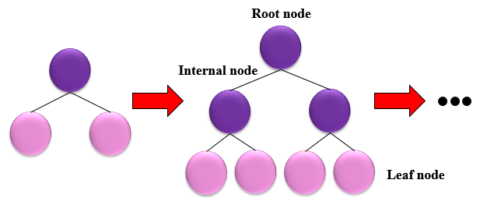
Fig. S1.
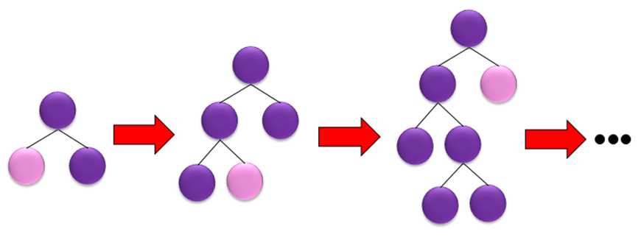
Fig. S2.

Fig. S3.

Fig. S4.

Fig. S5.

Fig. S6.

Fig. S7.

